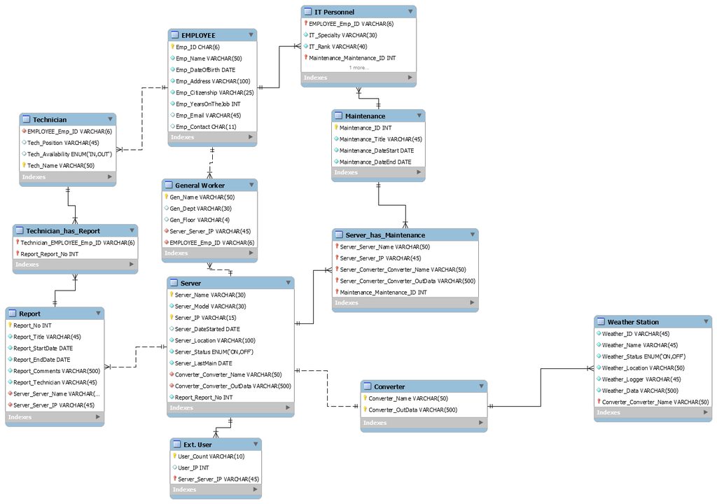

TECHNICIAN

TechName

TechPosition

TechAvailability

EMPLOYEE

EmpID

EmpName

EmpDateOfBirth

EmpAddress

EmpCitizenship

EmpYearsOnTheJob

EmpEmail

EmpContact

MAINTENANCE

MaintenanceID

MaintenanceTitle

MaintenanceDateStartMaintenanceDateEnd

TECHNICIAN

TechName

TechPosition

TechAvailability

IT PERSONNEL

ITSpecialty

ITRank

SERVER

S_Name

S_Model

S_IP

S_DateStarted

S_Location

S_Status

S_LastMaintenance

WEATHER STATION

WeatherID

WeatherName

WeatherStatus

WeatherLocation

WeatherLogger

WeatherData

REPORT

ReportNo.

ReportTitle

ReportStartDate

ReportEndDate

ReportComments

ReportsTechnician