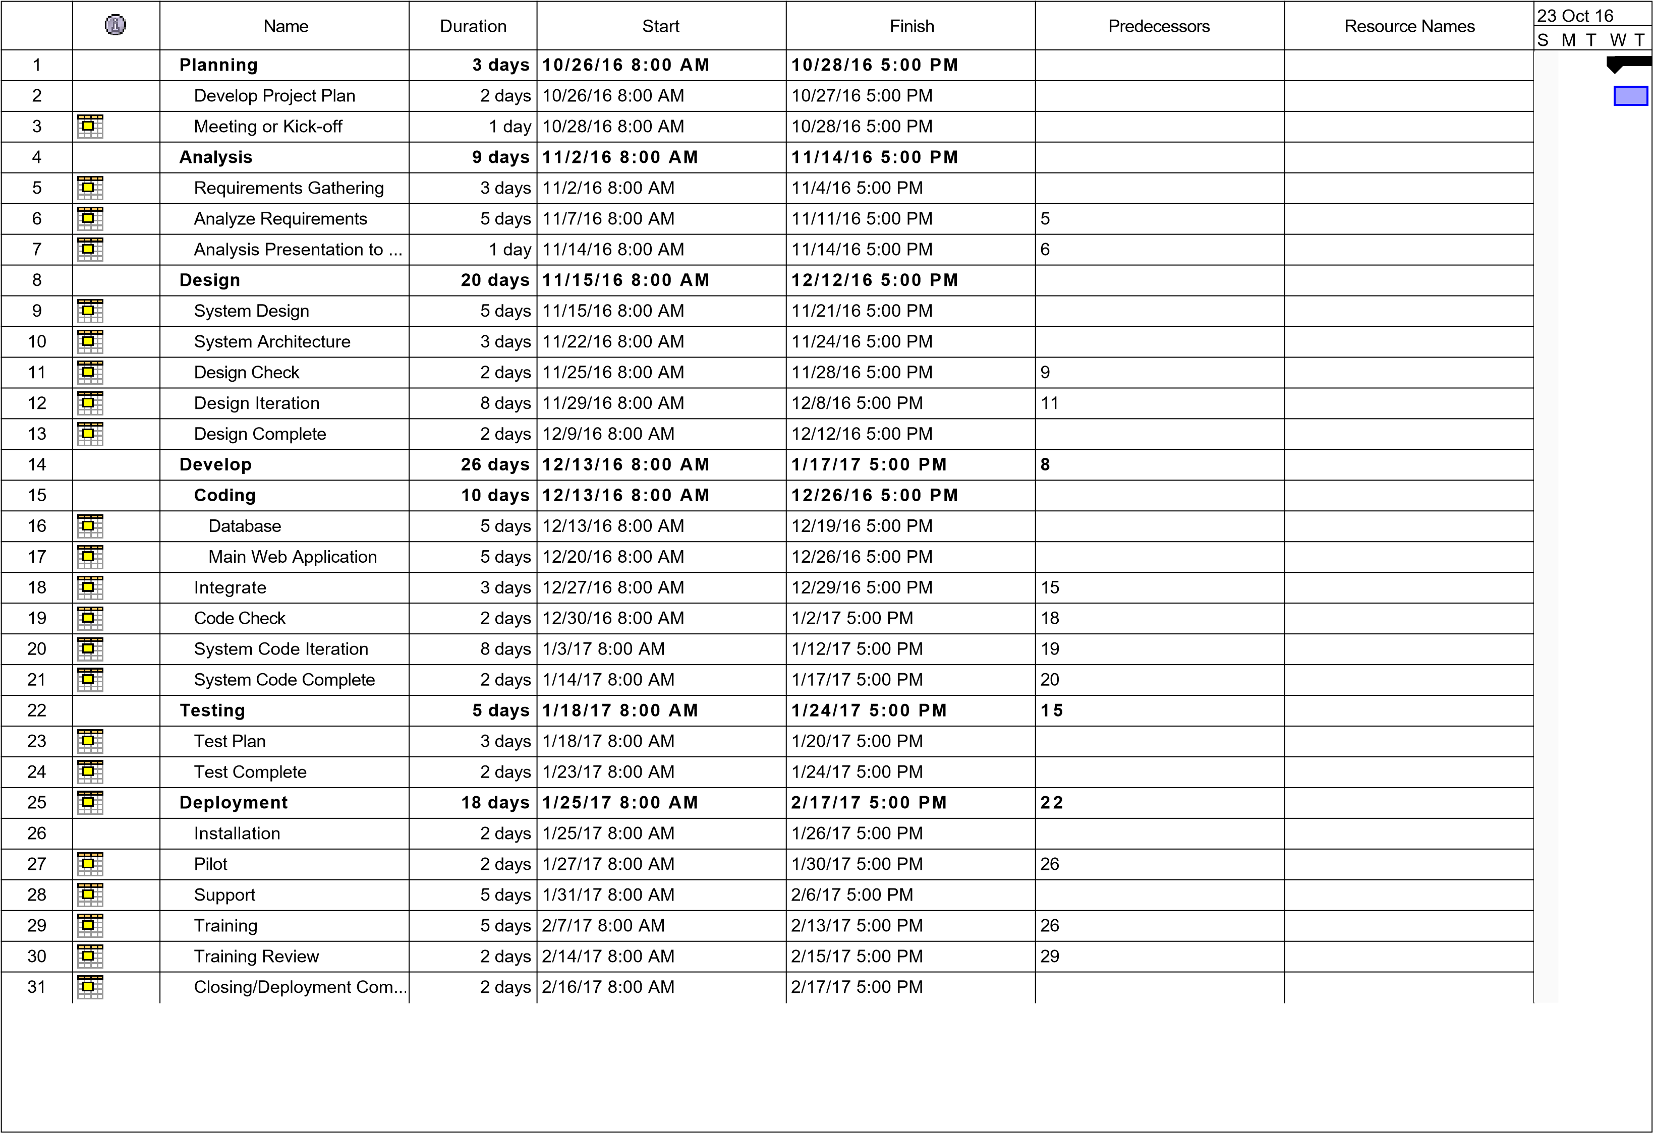

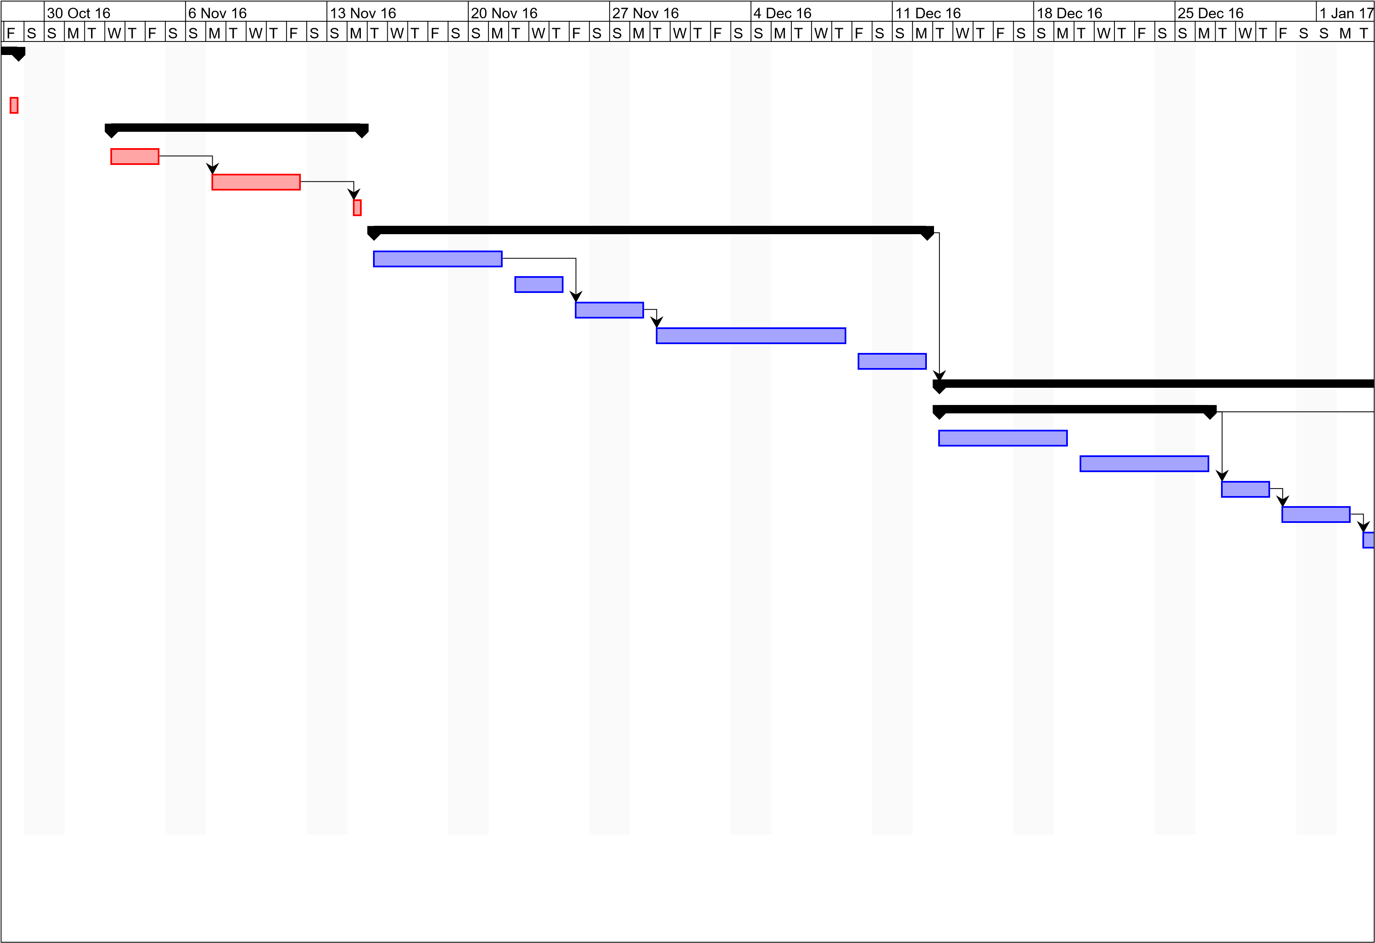

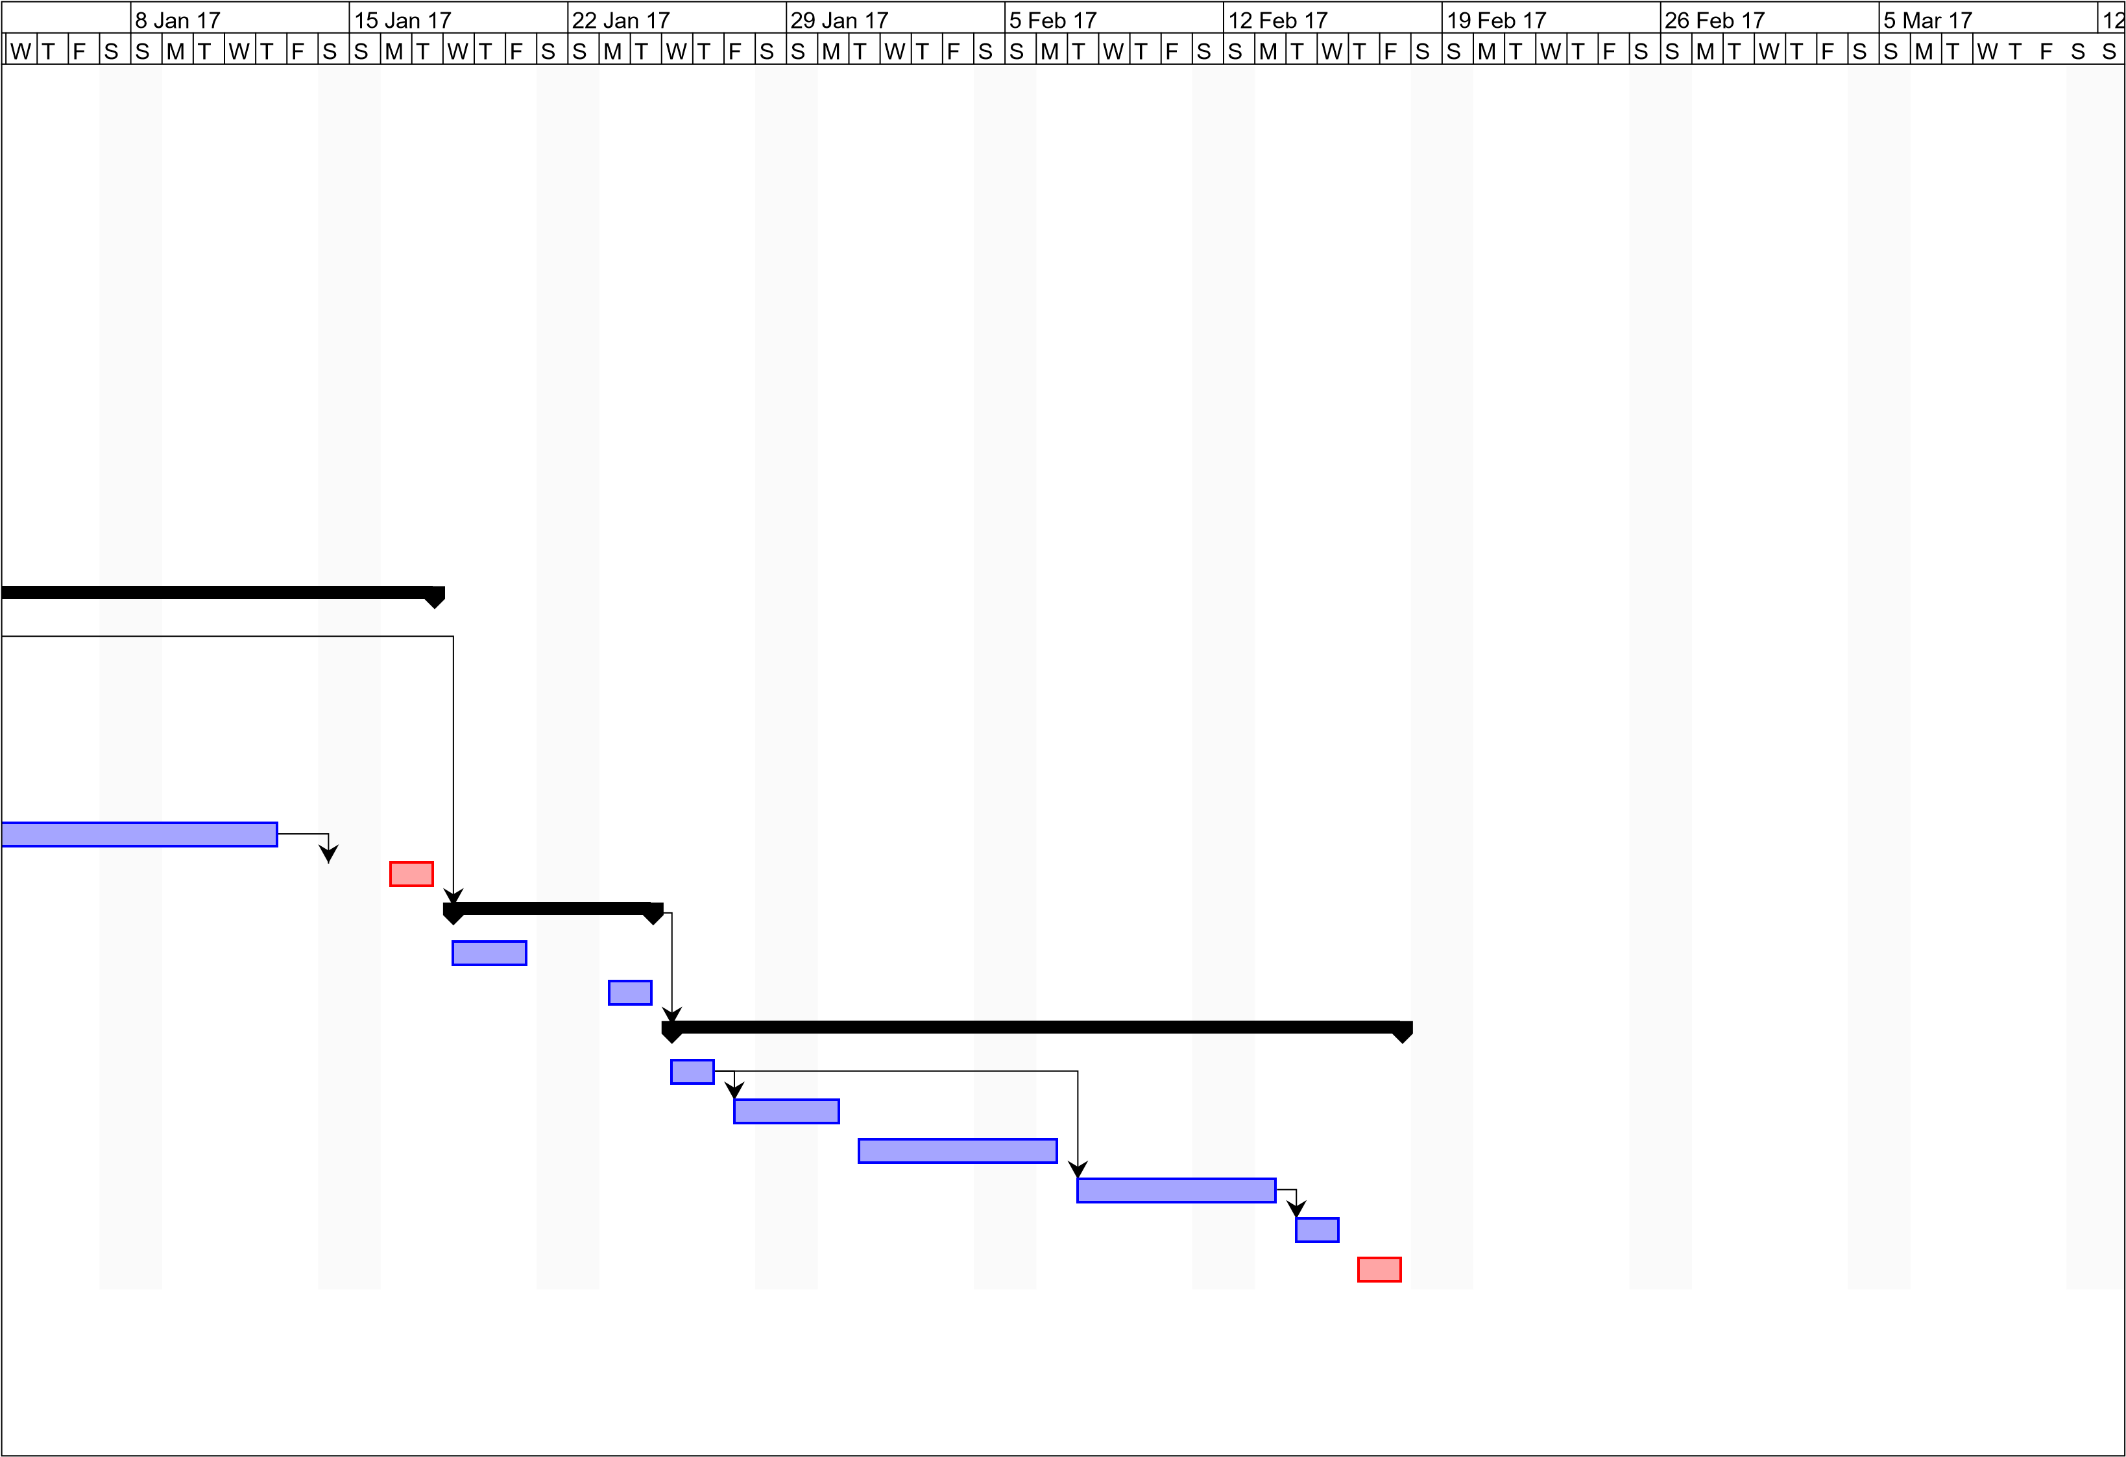

|  |  |  |  |  |  |  |  |
| --- | --- | --- | --- | --- | --- | --- | --- |
| Mar 17 | | | | | | 19 | |
| M | T | W | T | F | S | | S | |
|  | | | |  | | | |
|  | | | | | | | |
|  | | | | | | | |