MMcL Mackie Control Surface for Cakewalk by BandLab
Latest Update: 24th December 2022

History

The MMcL Mackie Control Surface is an enhancement to the MackieControl.dll shipped with Cakewalk by BandLab.

When Cakewalk Inc. initially developed support for hardware surfaces for SONAR, they made the Cakewalk Control Surface SDK available to the public so that hardware manufacturers could develop support for their hardware for use within SONAR.

The original SDK can be found on GitHub: https://github.com/Cakewalk/Cakewalk-Control-Surface-SDK

Azslow3 was the first to make enhancements to the MackieControl with his own fork on GitHub: https://github.com/Azslow3/Cakewalk-Control-Surface-SDK. Azslow3 added support for the ProChannel EQ/Compressor, some fixes for the C4, and greater control over the initial handshake.

Msmcleod has taken Azslow3’s changes and added further enhancements. Msmcleod’s version of the MackieControl can be found on GitHub: https://github.com/msmcleod/Cakewalk-Control-Surface-SDK

October 2019 Updates

Control of Synth Rack Synths
The MMcL Mackie Control surface now allows control of the synth parameters of all synths in your Synth Rack.

Cakewalk presents the Synth Rack an additional strip, in the same way your Tracks, Buses and Master outputs are seen as strips. In the case of the Synth Rack however there is only one channel, and each synth is seen as a separate entry in its effects bin.

To access the Synth Rack:
On the Mackie Control MCU: Hold down M1 and press Plugin
On the Mackie C4: Hold down Track button and select “SynthR” from the menu
On other surfaces: Hold down Cycle or Scrub* and press Channel 4 Solo button

While in Synth Rack mode, the Mackie MCU/C4 cursor keys allow navigation through the synths within the rack, and their parameters. The up/down cursor keys navigate through each instrument in the synth rack; the left/right cursor keys navigate between through the banks of parameters.

On surfaces without cursor keys, pressing the mute keys and record arm keys while holding down the “cycle” (loop on/loop off) or the Scrub button will allow you to select which synth to control and its bank of parameters. E.g.:

Cycle or Scrub + Channel 1 Mute selects the first synth in the synth rack
Cycle or Scrub + Channel 2 Mute selects the second synth in the synth rack
Cycle or Scrub + Channel 1 Rec (arm) selects parameters 1-8 of the currently selected synth
Cycle or Scrub + Channel 2 Rec (arm) selects parameters 9-16 of the currently selected synth

The channel V-Pots (i.e. pan controls) are used to alter the parameter values.

*NOTE: On the Korg nanoKONTROL Studio, you must use the Scrub button (labelled as Scene), having first used the Korg KONTROL editor software to configure the Scene button as Scrub.

Improved Mode Switching for Mackie Compatible Surfaces
For surfaces which lack the buttons for accessing many of the MCU functions, the following key combinations can be used when the Cycle (loop on/off) or Scrub* button is held down:
Cycle or Scrub + Channel 1 Solo: Control Tracks
Cycle or Scrub + Channel 2 Solo: Control Buses
Cycle or Scrub + Channel 3 Solo: Control Main Outputs
Cycle or Scrub + Channel 4 Solo: Control Synth Rack
Cycle or Scrub + Channel 7 Solo: Channel Parameter Mode (also toggles between single/multi cha)
Cycle or Scrub + Channel 8 Solo: Plugin Parameter Mode (also toggles between single/multi chan)

Improved Plugin Effects Navigation on MCU / Compatibles
While controlling plugins on the MCU, the cursor keys now navigate through the plugins and their parameters rather than controlling the cursor keys within Cakewalk. Note that Edit mode on the MCU must still be engaged to navigate through the banks of parameters*
On surfaces without cursor keys, pressing the mute keys and record arm keys while holding down the “cycle” (loop on/loop off) or Scrub button will allow you to select the parameter bank or effect.

For example:
Cycle or Scrub + Channel 1 Mute selects the first effect in the effect bin**
Cycle or Scrub + Channel 2 Mute selects the second effect in the effect bin**
…
Cycle or Scrub + Channel 2 Mute selects the eighth effect in the effect bin**

Cycle or Scrub + Channel 1 Rec-arm selects parameters 1-8 of the currently selected synth
Cycle or Scrub + Channel 2 Rec-arm selects parameters 9-16 of the currently selected synth
…
Cycle or Scrub + Channel 2 Rec-arm selects parameters 57-64 of the currently selected synth

The channel V-Pots (i.e. pan controls) are used to alter the parameter values.

*Using Cycle/Scrub + Ch.4 Solo to enter synth mode, or Cycle/Scrub + Ch.8 Solo to engage Plugin Parameter mode will also automatically invoke edit mode. Pressing Cycle/Scrub + Ch.7 to engage Channel Parameter mode will also leave edit mode.

**The Pro Channel EQ and Pro Channel Compressor will appear before any effects in the effects bin.

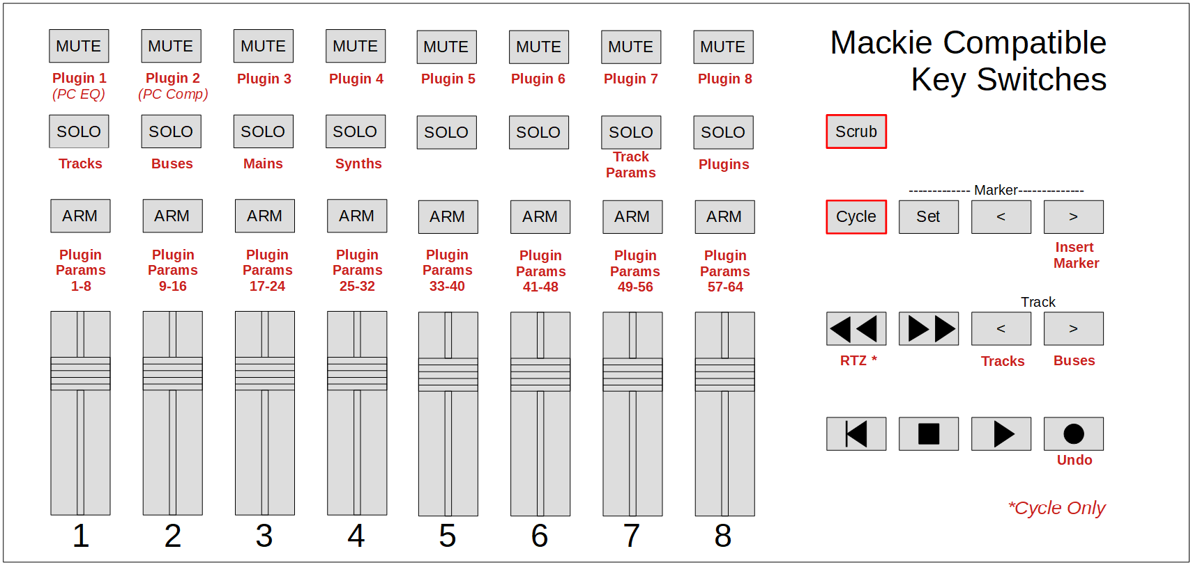

Enhancements

The MMcL Mackie Control surface has some new options:

Original Cakewalk MackieControl Surface | MMcL MackieControl Surface
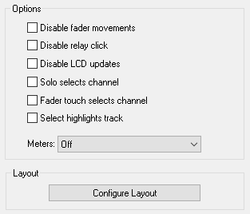 | 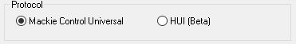

Protocol
You can now select between the Mackie Control Universal protocol (the default protocol), or the HUI protocol, which was originally designed for the Mackie HUI device for ProTools. If your device does not support the MCU protocol but supports the HUI protocol, you can choose this option.

If your device supports both the MCU & HUI protocols, it is recommended that you choose MCU.

Double-click to select
This option is aimed at users of the Korg nanoKONTROL Studio control surface, and is used in conjunction with the “Select highlights track” option.

Although the nanoKONTROL Studio’s track select buttons operate properly when the “Select highlights track” option is checked, the highlighted track is also changed every time a fader is moved. This is because the Korg nanoKONTROL Studio sends a “select track” message not only when a track select button is pressed, but also when a track’s fader is moved.

When “Double-click to select” is checked, fader movements no longer change the highlighted track, however the user can “double click” the select button (i.e. press it twice) to change the highlighted track.

Disable Handshake*
This option disables the initial handshake with the hardware control surface when Cakewalk/SONAR loads the control surface.

Earlier SONAR would hang if the control surfaces weren’t plugged in at the time of the initial handshake, or the hardware in question didn’t fully support the MCU handshaking protocol. Enabling this option prevents this behaviour.

If your control surface does not have a specific mode to support SONAR or Cakewalk, select this option.

This option is always enabled when using the HUI protocol.

*Originally developed by Azslow3

Exclude filters from plug-ins*
By default, support is enabled for the ProChannel EQ, Track Compressor and Bus Compressor, when using the EQ or Dynamics buttons on the MCU or C4.

Checking this option disables this support.

*Originally developed by Azslow3

Use Scrub+Bank Down/Up to select Tracks/Buses
This option is aimed at users of the Korg nanoKONTROL Studio.

The Korg nanoKONTROL Studio has no buttons to switch between controlling Tracks and Buses, and is set to control Tracks by default.

Enabling this option gives the following behaviour:

Scene button + Bank Down button : Control Tracks
Scene button + Bank Up button : Control Buses

NOTE: For this to work, the Korg nanoKONTROL Studio must be configured to use the Scene button as the Scrub button, by enabling the “Use Scene Button as Scrub” Global Parameter, using the KORG KONTROL Editor software.

HUI Keypad controls keypad keys
When checked, the HUI numerical keypad will simulate the keypad of your PC keyboard.
When unchecked, the HUI numerical keypad will simulate the standard numerical keys (i.e. the ones above the QWERTY keys).
This option is aimed at users of the Mackie Human Interface Controller (HUI), and is only available when the HUI protocol is selected.

Automatic Fader Offset Assignment
If you have more than one Mackie Control device (e.g. Mackie XT + Mackie MCU + Mackie C4), the MMcL Mackie Control will now automatically assign the fader offsets for XT and MCU units based on the order you add them within Cakewalk’s Control Surfaces preferences.

This is useful for control surfaces that do not have vpots, or for control surfaces that do not have a display making it difficult to use the “Configure Layout” mode.

If your XT unit(s) are to the left of your MCU, make sure you add your XT surfaces first, e.g:

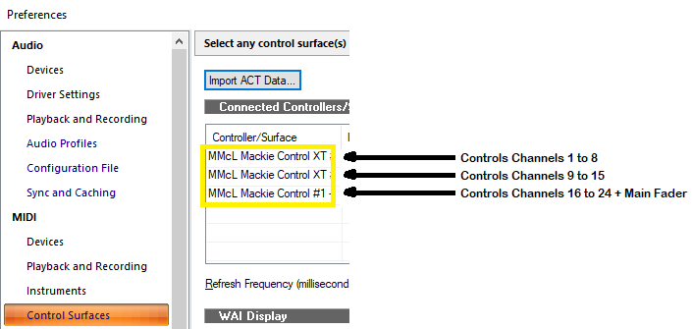

If your XT unit(s) are to the right of your MCU, make sure you add your MCU first e.g.:
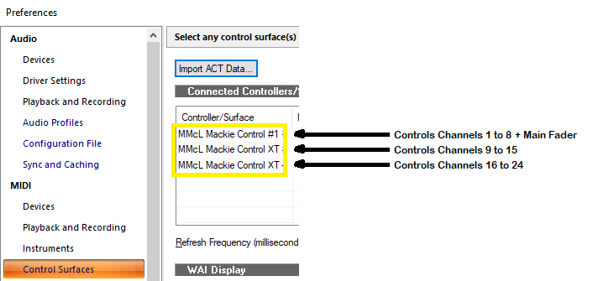

The fader offset assignment is made at the time you add your controllers within Cakewalk’s Control Surfaces preferences, so you can override the automatic fader offset assignment by using the “Configure Layout” button.

If your controller does not have a display or vpots, and you wish to change fader offset assignment, it may be easier to remove all the controllers from the list within Cakewalk’s Control Surfaces preferences and add them in the desired order.

The automatic fader offset does not affect the Mackie C4, and its order within the Control Surfaces Preferences.

Key Press support

In addition to the standard list of commands, the MCU function buttons and foot switches can now be configured to send a key press to Cakewalk:
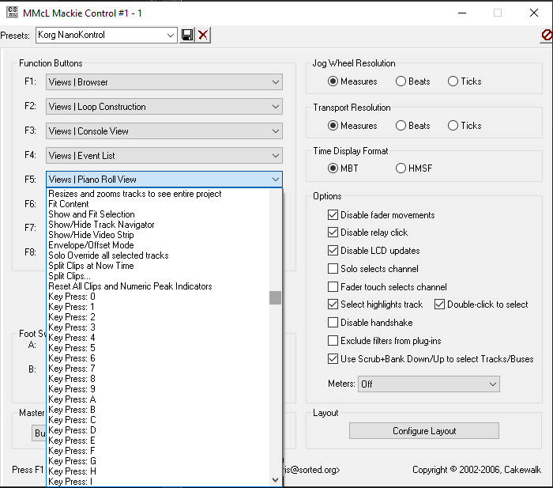

When used in conjunction with the Key Bindings within Cakewalk, this can greatly enhance the functionality of the function buttons over the standard list of commands, e.g. by configuring an MCU function button to run a CAL script.

Additional Button Mapping:

F1/CUT, F2/COPY and F3/PASTE buttons now have extra modifier behaviour (in red below):

 |  | M1 | M2 | M3 (beta) | M4
F1/CUT | F1 | Cut | Cut Special |  | Reload  Plugin  Mappings
F2/COPY | F2 | Copy | Copy Special | Export track template & save as  __mcu-temp-track-template__.cwx | Copy Special & press OK
F3/PASTE | F3 | Paste | Paste Special | Imports template  __mcu-temp-track-template__.cwx | Paste Special  & press OK

WARNING: Saving / Importing the track templates using the M3 modifier will clear the current clipboard.

Additional modifiers can now be used with the Save and Tracks buttons:

 |  | M1 | M2 | M3 | M4
Save | Save | Save As | Save Copy As | Export Audio
Track | Control  Tracks | Export  Track  Template | Import  Track  Template | Bounce to Tracks | Bounce to Clip(s)

The following behaviour was added for the Korg NanoKONTROL 2:

Cycle + Rewind | Go to Start
Cycle + Record | Undo
Cycle + Marker Navigation Right | Insert Marker
Cycle + Track Down | Control Tracks
Cycle + Track Up | Control Buses

Multiple Surface Support

Up to three independent instances of the MMcL Mackie Control surface are now available, so that multiple control surfaces can be used to independently control the same instance of Cakewalk:

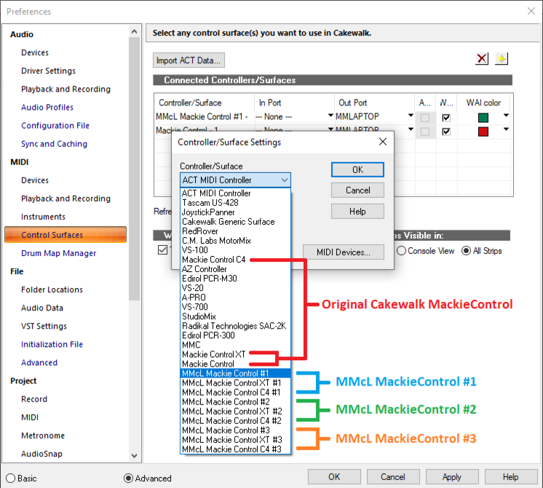
This can be useful if:

- You want one control surface to control your tracks, whilst the other controls your buses
- You have another control surface away from your main desk (e.g. in a vocal booth) and wish to control your tracks/buses and/or transport from there.

NOTE: Both the original Cakewalk Mackie Control surface and the MMcL Mackie Control surfaces share the same settings within MackieControl.ini.

Installer / Uninstall Support
The MMcL Mackie Control now comes as an installer, which automatically installs and registers the new control surfaces. It is no longer necessary to copy over the original Cakewalk MackieControl.dll, or run regsvr32. The new control surfaces will now live alongside the original Cakewalk version.

Once installed, the following files are added to your Control Surface directory in addition to this guide (normally C:\Program Files\Cakewalk\Shared Surfaces):

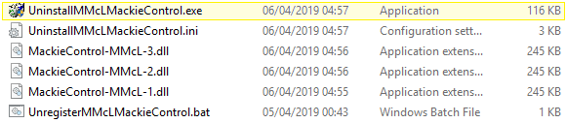

To uninstall, click on the uninstall program highlighted above.

Do not delete any of these files manually, as this will cause the control surfaces to look like they are still available, and could cause Cakewalk to crash.

If you do get your system into this state, re-install the MMcL Mackie Control Surface and use the uninstall program highlighted above.

Fader Reset on Close
Motorised faders now return to zero on close of project or when closing Cakewalk.

Alternative Label Support
You can now specify alternative label names for your parameters within MackieControl.ini. This may be useful if the automatic abbreviated 6 character label isn’t as readable as you’d like.

The alternative labels are still limited to 6 characters (as this is the limit of characters for each strip on the Mackie devices), but you can now specify your own by adding them to the bottom of each plugin section in the following format:

VPotLabeln=p,name

Where:
n = the number of the vpot
p = the number of the VST parameter whose label you which to override
name = the new label

e.g.
VPotLabel0=17,HiGain
VPotLabel1=18,HiFreq
M1VPotLabel2=19,Hi Q

HUI Support (Beta)

The MMcL MackieControl now supports the HUI protocol for use with the Mackie Human Interface Controller (HUI), or devices that only support HUI and not MCU.

HUI support is currently beta. Although many functions have been implemented, there are many that have not. It’s also worth noting that I do not have access to a real Mackie HUI, so many of these functions are based on testing with an emulator.

The following buttons/functions should work:
- Channel V-Pot (pan), Arm, Solo, Mute, Select, Faders
- Fader Meters (set Meters to “Signal Leds”)
- The four character channel scribble strip display for track names
- The time code display, and the buttons controlling the time code modes (SMPTE / BEATS)
- Jog Wheel, Scrub button, Zoom button and cursor buttons
- Transport Buttons
- Loop On/Off
- The HUI numeric keypad
- The Channel Up/Down buttons
- The Bank Up/Down buttons
- The Save button
- The button LEDs for all of the above

The following features are NOT supported at present:
- Controlling plugins
- The V-Pots and 40x2 LCD displayed
- Devices with more than 8 channel fader strips
- Switching between buses & tracks

Cubase / Universal Support
The Cakewalk enhancements to support Cubase / Universal button mapping is now available in MMcL MackieControl.
The original Mackie Control came with a set of lexan overlays for various DAW’s which re-label the buttons on the surface to better suit the functions available in those DAW’s. So while the transport, faders and v-pots were standard across all devices, certain buttons would be different depending on which DAW you are using. For example, “enable/disable looping” and “add marker” are invoked from different buttons depending on which DAW you are using.
When control surface manufacturers started offering Mackie emulation, they came with no overlays, but still had to ensure that the correct button press was being sent to the DAW. Most control surfaces do this by offering a separate Mackie mode for each DAW.
If your control surface specifically supports Cakewalk/SONAR you should use this mode. If Cakewalk/SONAR is not specifically supported by your control surface, you should set it to Cubase and set Cubase mode in the Mackie Control dialog. If your control surface has no option to set a DAW, use Universal modei n the Mackie Control dialog.

Editing MackieControl.ini

Note: The following section was taken from an archive of an article written by Chris Boucher (the original developer of the MackieControl.dll). The original article can be found here:
https://web.archive.org/web/20120625023520/http://www.chrisboucher.com/cakewalk/mackiecontrol/
The MackieControl.ini file defines how plugin parameters are mapped across the VPots of the control surface. If a plugin is not listed in the file, its parameters are simply mapped in the order the plugin presents them to Cakewalk. By adding a plugin to the ini file, the parameters can be remapped into a consistent order.
In addition to rearranging the parameters, the ini file also allows the data type/display format (for the Halo of LEDs around each VPot) and default values to be defined for each parameter. A plugin can also be identified as an Equaliser or Dynamics processor for quick access via the EQ and DYN buttons on the control surface.
Finally, for Equaliser plugins, the special frequency/gain mode where the faders control level and the VPots control frequency, can be defined.

How To Add a Plugin
Let's say we want to add a new (fictitious) plugin called EqX, a simple two band equaliser. Firstly, add the plugin to a Cakewalk track and press PLUG-INS twice, to enter SINGLE CHANNEL mode where the plugin parameters are mapped across the VPots.
Using the BANK and CHANNEL buttons (in EDIT mode), we find that there are 9 parameters available:
Parameter Number | Parameter Name
0 | Bypass
1 | Band 1 Enable
2 | Band 1 Gain
3 | Band 1 Frequency
4 | Band 1 Q
5 | Band 2 Enable
6 | Band 2 Gain
7 | Band 2 Frequency
8 | Band 2 Q
Note that the parameters are numbered starting at zero.
The MackieControl.ini file is located in the "Cakewalk\Shared Surfaces" directory, in my default install this is "C:\Program Files\Cakewalk\Shared Surfaces". It's a simple text file, so you can edit it using it using notepad.
Before going any further, take a backup of this file, just to be safe

The first section at the top of the file lists the plugins defined in the file, and looks something like:
[Plugins]
0=FxChorus
1=FxDelay
2=FxEq
3=FxFlange
4=FxReverb
5=CompressorX (Sonar XL)
6=Equalizer (Sonar XL)
7=Track Eq
8=Bus Eq
9=ProChannel EQ
10=Track Compressor
11=Bus Compressor

The first step is to add a new entry for our plugin, so we add the line:
12=EqX
to the end of the[Plugins]section.
Note: the name of the plugin must exactly match the name as shown in Cakewalk and on the desk (if you press PANS and then PLUG-INS the name will be displayed for a couple of seconds).
Now we need to add a new section, defining how the parameters are to be mapped. Add the line:
[EqX]
to the end of the file.
To start with, we're just going to reorder the parameters. We'll be using 9 VPots (since there are 9 parameters), so add the line:
NumVPots=9
And now we'll add the parameters themselves, but change their order:
[EqX]
NumVPots=9
VPot0=3 ; Band 1 Frequency
VPot1=7 ; Band 2 Frequency
VPot2=4 ; Band 1 Q
VPot3=8 ; Band 2 Q
VPot4=2 ; Band 1 Gain
VPot5=6 ; Band 2 Gain
VPot6=1 ; Band 1 Enable
VPot7=5 ; Band 2 Enable
VPot8=0 ; Bypass
Everything after the ; is simply a comment. Like parameters, the VPots are numbered starting at zero.
So now VPot0 (the first VPot) is set to control parameter 3, which in this case is Band 1 Frequency.
Pressing M4-F1 on the Mackie causes the control surface module to reload the ini file and rebind the VPots - very useful for checking that everything is reordered correctly.
We now need to define what type of data each VPot/parameter controls - this information is used to control the Halo of LEDs around the VPots and what happens when a VPot is pressed. The options are: level, pan, freq, switch, boost/cut , spread. and revspread.
Whereas the spread option shows a narrow LED display around the v-pots for low values and a wide LED display for high values, the new revspread option shows the opposite – i.e. a wide LED display around the v-pots for low values and a narrow LED display for high values. This mode may be more appropriate for an EQ “Q” parameter.
The data type is added after the parameter number, separated by a comma:
[EqX]
NumVPots=9
VPot0=3,freq ; Band 1 Frequency
VPot1=7,freq ; Band 2 Frequency
VPot2=4,spread ; Band 1 Q
VPot3=8,spread ; Band 2 Q
VPot4=2,boost/cut ; Band 1 Gain
VPot5=6,boost/cut ; Band 2 Gain
VPot6=1,switch ; Band 1 Enable
VPot7=5,switch ; Band 2 Enable
VPot8=0,switch ; Bypass
For data types other than switch, a default value can also be defined. This is the value assigned to the parameter when the VPot is pressed. Note: the value must be in the range 0.0 - 1.0:
[EqX]
NumVPots=9
VPot0=3,freq,0.25 ; Band 1 Frequency
VPot1=7,freq,0.6 ; Band 2 Frequency
VPot2=4,spread,0.2 ; Band 1 Q
VPot3=8,spread,0.2 ; Band 2 Q
VPot4=2,boost/cut,0.5 ; Band 1 Gain
VPot5=6,boost/cut,0.5 ; Band 2 Gain
VPot6=1,switch ; Band 1 Enable
VPot7=5,switch ; Band 2 Enable
VPot8=0,switch ; Bypass
The switch data type doesn't have a default value, instead pressing the VPot toggles the parameter on and off.
As you turn a VPot, the parameters are adjusted in steps of 0.05. For some parameters this may be too coarse so, finally, the step size for each parameter may be defined. Here I've reduced the step size for the frequency controls to 0.02:
[EqX]
NumVPots=9
VPot0=3,freq,0.25,0.02 ; Band 1 Frequency
VPot1=7,freq,0.6,0.02 ; Band 2 Frequency
VPot2=4,spread,0.2 ; Band 1 Q
VPot3=8,spread,0.2 ; Band 2 Q
VPot4=2,boost/cut,0.5 ; Band 1 Gain
VPot5=6,boost/cut,0.5 ; Band 2 Gain
VPot6=1,switch ; Band 1 Enable
VPot7=5,switch ; Band 2 Enable
VPot8=0,switch ; Bypass

Before going further, we should also define the type of plugin. There are three options 0 (everything else), 1 (equaliser) and 2 (dynamics). If a plugin is type 1, then it can be accessed by pressing the EQ button. Similarly, type 2 plugins can be accessed via the DYN button.
EqX is an equaliser, so:
[EqX]
PluginType=1
NumVPots=9
VPot0=3,freq,0.25,0.02 ; Band 1 Frequency
VPot1=7,freq,0.6,0.02 ; Band 2 Frequency
VPot2=4,spread,0.2 ; Band 1 Q
VPot3=8,spread,0.2 ; Band 2 Q
VPot4=2,boost/cut,0.5 ; Band 1 Gain
VPot5=6,boost/cut,0.5 ; Band 2 Gain
VPot6=1,switch ; Band 1 Enable
VPot7=5,switch ; Band 2 Enable
VPot8=0,switch ; Bypass
You can also rebind the VPots for each of the four MODIFIERS (M1 - M4). For equalisers the convention I've used so far is that if the unmodified VPot controls frequency, then pressing M2 makes it control the corresponding Q, M3 controls Gain and M4 controls the Enable:
[EqX]
PluginType=1
NumVPots=9
VPot0=3,freq,0.25,0.02 ; Band 1 Frequency
VPot1=7,freq,0.6,0.02 ; Band 2 Frequency
VPot2=4,spread,0.2 ; Band 1 Q
VPot3=8,spread,0.2 ; Band 2 Q
VPot4=2,boost/cut,0.5 ; Band 1 Gain
VPot5=6,boost/cut,0.5 ; Band 2 Gain
VPot6=1,switch ; Band 1 Enable
VPot7=5,switch ; Band 2 Enable
VPot8=0,switch ; Bypass
M2VPot0=4,spread,0.2 ; Band 1 Q
M2VPot1=8,spread,0.2 ; Band 2 Q
M3VPot0=2,boost/cut,0.5 ; Band 1 Gain
M3VPot1=6,boost/cut,0.5 ; Band 2 Gain
M4VPot0=1,switch ; Band 1 Enable
M4VPot1=5,switch ; Band 2 Enable
You can rebind M1 too, but as it's normally used to enter fine adjustment mode, it's generally better if you don't.
Custom labels can be assigned to each v-pot using the following syntax:
VPotLabel[vpot number]=[parameter number],[label]
e.g.:
VPotLabel0=161,EqSolo ; eq:solo activate
VPotLabel2=30,HP Slp ; pre:hp slope
M1VPotLabel0=44,gt Thr ; gate:threshold
M1VPotLabel1=46,gt Flr ; gate:floor
M1VPotLabel2=48,gt Cls ; gate:close
Note that the label is limited to 6 characters.

