Project: Heaven Manga Reader
- What exactly is the project?
A web application for anime manga readers in English. Like https://www.crunchyroll.com instead of streaming anime HMR will display anime manga.

- Who is the audience?
Anime manga readers in English.
- What platforms do you want your project to be on?
Desktop, laptop, cellphones(Android and IPhones).
- What programs do you want to use?
?
- What does your logo look like?
?
- What does Log In page (page1) look like?
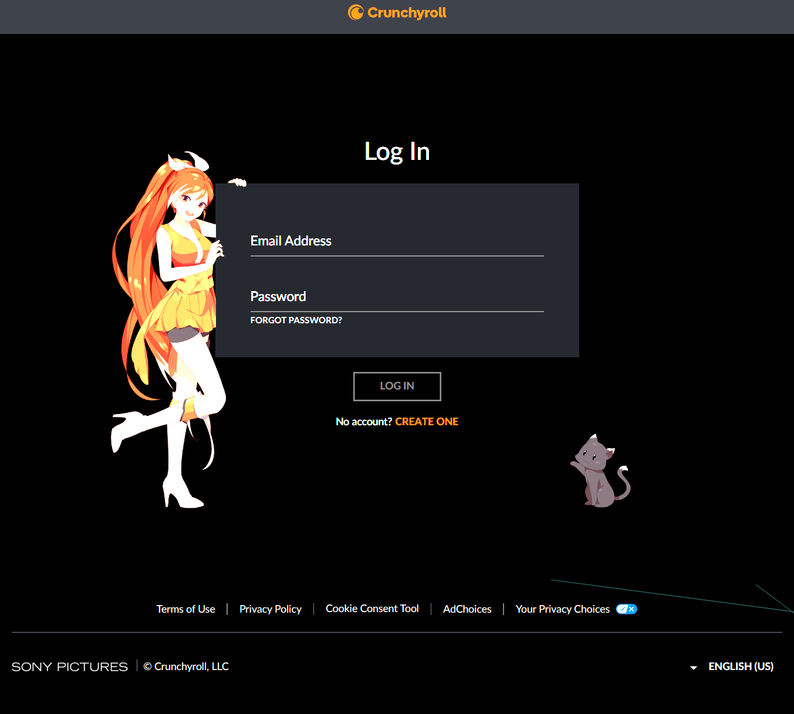
Items page 1 needs:
- Logo to be centered: Done 09/15/2024.
- For existing users Log In section requiring email and password, LOG IN button: undone 09/15/2024.
- No account? CREATE ONE button: undone 09/15/2024.
- Footer Section: Terms of Use, Privacy Policy, Company Logo: undone 09/15/2024.
- What does Create Account (page2) look like?
This is the page if the user currently does not have an account the user can create one.
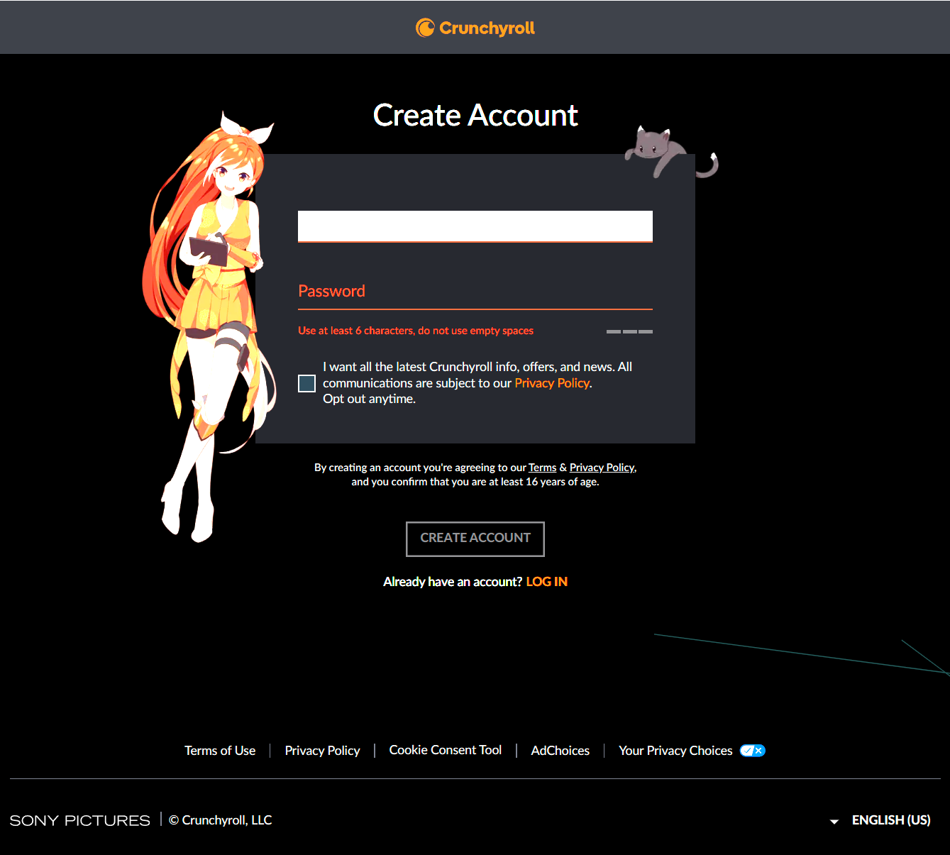
- Enter email address.
- Create a password.
- Create Account button.
  - Send a confirmation email.

- What does Manage Profile (page3) look like?
Profiles page this page displays the users’ profiles max 3.
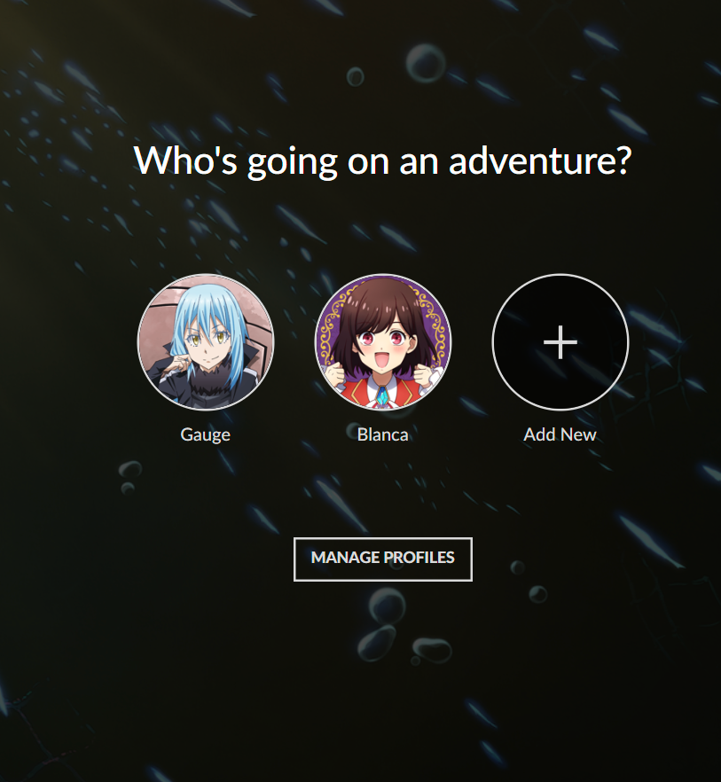
Header “Who’s ready for an adventure?”
Profiles displayed in circles with your choice of avatar.
Users named under avatar.
Circle to Add New with ‘+’ sign.
Manage Profiles button.
- Profiles circles with edit icon
  - 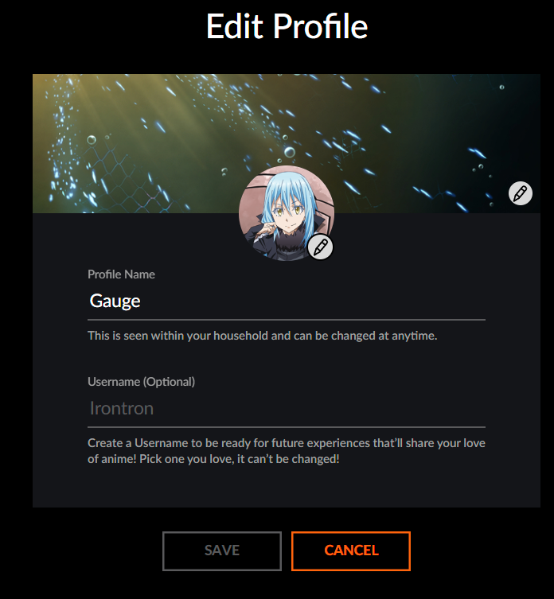
  - Header “Edit Profile”
  - Profile Circle with the following options update Profile name and avatar image.
  - Add New button.
    - 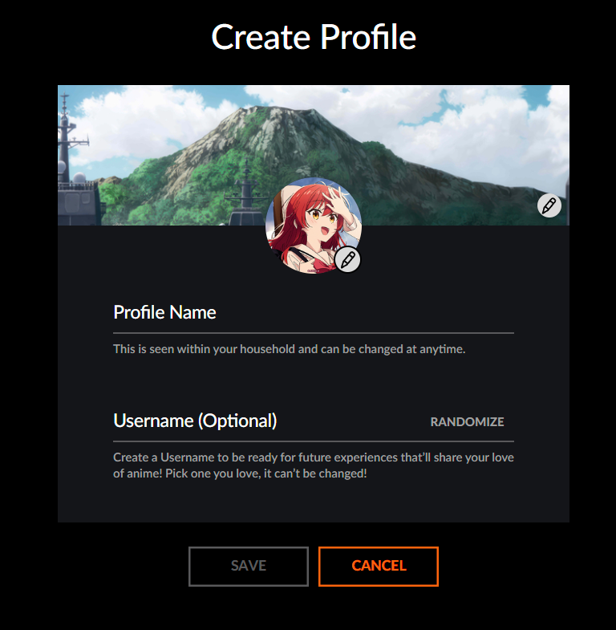
    - Header “Create Profile”
    - Profile Name
    - Select Avatar
    - Save and Cancel buttons
  - Save and Cancel buttons.
- Done button.
- Home Page?
- Login Page Done, Create Account Page Done, testing
  - Create a new account = Successful 09/18/2024
  - Login with credentials = Nothing happens still on Login screen do not know if login was successful or not?
  - Login with correct email wrong password = Nothing happens
  - Login with wrong email correct password = Nothing happens?
  - Create new account with same email = Successful Error populates “Email already in use”
  - Create new account with password and confirm password do not match = Successful Error populates “Passwords do not match.”.

