Question 1)

Shares of A. Corp. pay a $2 dividend at the end of every year on December 31. An investor buys 2 shares of stock on January 1 at a price of $20 each, sells one of those shares for $22 a year later on the next January 1, and sells the second share an additional year later for $19. Find the money-weighted return and time-weighted rates of return on this 2 year investment.

Internal Rate of Return (IRR) is the discount rate that makes the net present value of all cash flows from an investment equal to zero.

Money-Weighted Rate of Return (MWR): the internal rate of return that measures an investor’s actual performance by accounting for the timing and size of all cash flows.
Time-Weighted Rate of Return (TWR): the compound growth rate of an investment that measures the asset’s performance independent of investor cash-flow timing.

- Dividend $2 a share paid each Dec 31
- Buy 2 shares at $20 on Jan t = 0
  - Sell 1 share at $22 Jan t = 1
  - Sell 1 share at $19 Jan t = 2

Cash flow table (investors perspective)
Time | Event | Cash flow
t = 0 | Buy 2 shares @ $20 | –40
t = 1 | Dividend on 2 shares | +4
t = 1 | Sell 1 share @ $22 | +22
t = 2 | Dividend on 1 remaining share | +2
t = 2 | Sell last share @ $19 | +19

Therefore:

CF₀ = –40
CF₁ = 4 + 22 = +26
CF₂ = 2 + 19 = +21

Solution 1)

Money-weighted Rate of Return
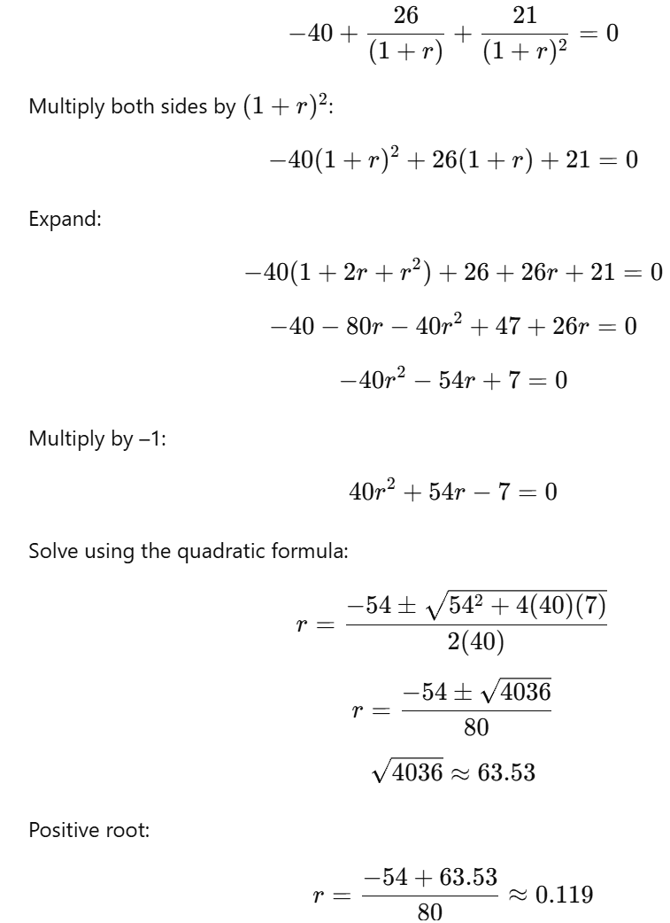

R = 11.9% per year

Now, for the time weighted return, we should break the investment into subperiods which ignores the size of the cash flows.

- Subperiod t = 0 to t = 1
- Initial value 2 * 20 = 40
- Ending value just before selling:
  - Price per share = 22
  - Value = 2 * 22 = 44
- Dividend received during period = 4
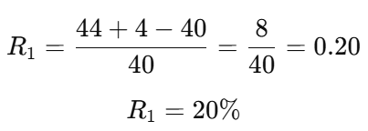
- Subperiod t = 1 to t = 2
- We sold one share so we now hold only 1 share
- Value at start of period = 1 * 22 = 22
- Ending value = 19
- Dividend during period = 2

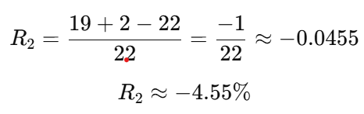
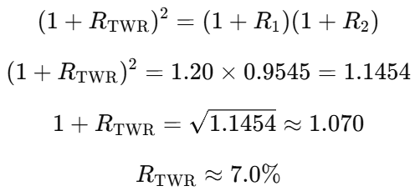

Notes: Time-weighted return isolates asset performance, while money-weighted return reflects investor timing.

