Detective analysis
Identifying industries using common-size balance sheet percentages. Exhibit 3.10 presents common-size balance sheets for five firms. The firms and a description of their activities follow:
(1) Commonwealth Edison: Generates and sells electricity to businesses and households.
(2) Hewlett-Packard: Develops, assembles, and sells computer hardware and printers. The firm outsources many of its computer and printer components.
(3) Household International: Lends money to consumers for periods ranging from several months to several years.
(4) May Department Stores: Operates department store chains and offers its own credit card.
(5) Newmont Mining: Mines for gold and other minerals, utilizing heavy equipment.
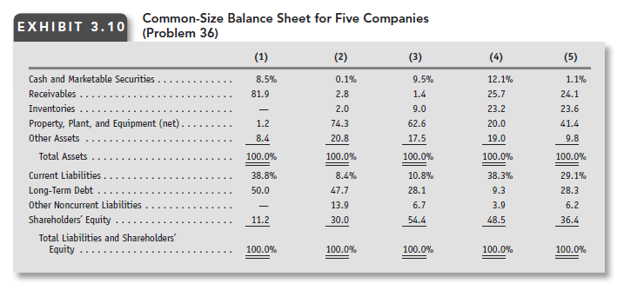
Solution: Identifying industries using common-size balance sheet percentages
Firm (1) has a high percentage of receivables among its assets and substantial borrowing in its capital structure. This mix of assets and financing is typical of the finance company, Household International. Why the capital markets allow a finance company to have such a high proportion of borrowing in its capital structure? The answer is threefold: (1) finance companies have contractual rights to receive cash flows in the future from borrowers; the cash flow tends to be highly predictable, (2) finance companies lend to many different individuals, which diversifies their risk, and (3) borrowers often pledge collateral to back up the loan, which provides the finance companies with an alternative for collecting cash if borrowers default on their loans.
Firms (2) and (3) have a high proportion of their assets in property, plant, and equipment. Commonwealth Edison and Newmont Mining are both capital intensive. These firms differ primarily with respect to their financing. Firm (2) has a higher proportion of long-term debt and Firm (3) has a higher proportion of financing from shareholders' equity. Commonwealth Edison has essentially a monopoly position in its market area and is subject to regulation with respect to rates charged. The reasonably assured cash flows permit it to take on more debt than Newmont Mining. Newmont Mining faces uncertainties with respect to the amount of gold and other minerals that it will discover and the price it will obtain for gold and minerals sold. Its high proportion of fixed costs in its cost structure means that its earnings can vary significantly as revenues increase and decrease over time. This larger business risk for Newmont Mining suggest that it should take on less long-term debt than Commonwealth Edison. Thus, Firm (2) is Commonwealth Edison and Firm (3) is Newmont Mining.
This leaves Hewlett Packard and May Department Stores and Firms (4) and (5). Firms (4) and (5) both have substantial receivables and inventories, which we would expect for both firms. Firm (4) has a lower proportion of property, plant, and equipment than Firm (5). Hewlett-Packard outsources the manufacturing of components and then assembles the components in its factories. The outsourcing reduces somewhat its need for fixed assets. May Department Stores, on the other hand, has fixed assets from its retail stores. This suggests that Firm (4) is Hewlett-Packard and Firm (5) is May Department Stores. The financing provides additional evidence for this pairing. Technological change reduces the product life cycles of computers and printers. Long-term lenders are reluctant to lend when substantial uncertainty exists about the long-term sales potential of a firm's products. The land and buildings of department stores serve as collateral for borrowing and permit a higher level of long-term debt in the capital structure. Firm (4) has a lower proportion of long-term debt than Firm (5), consistent with Firm (4) being Hewlett-Packard and Firm (5) being May Department Stores.

