STROKE PREDICTION USING MACHINE LEARNING

____________________

##### 

##### 

##### 

##### 

##### **STROKE PREDICTION USING MACHINE LEARNING**

##### **A Major Project Report**

***in partial fulfilment for the award of the degree***

***of***

##### **BACHELOR OF TECHNOLOGY**

***In***

**COMPUTER SCIENCE ENGINEERING**

###### **by**

**Mayank Singh (00420907218)**

**Pritika Rana (02420902717)**

**Shivam Rathi (03220902717)**

**Guided by**

**Dr SUNITA TIWARI**

**Assistant Professor**



**DEPARTMENT OF COMPUTER SCIENCE AND ENGINEERING**

**G.B. PANT GOVT. ENGINEERING COLLEGE, NEW DELHI.**

(AFFILIATED TO GURU GOBIND SINGH INDRAPRASTHA UNIVERSITY, DELHI)

**MAY 2021**

**CANDIDATE’S DECLARATION**

I hereby certify that the work which is being presented in the Major Project entitled **“Stroke Prediction Using Machine Learning”** in partial fulfilment for the award of the Degree of Bachelor of Technology in Computer Science and Engineering affiliated to **Guru Gobind Singh Indraprastha University, New Delhi** and submitted to the Department of Computer Science and Engineering G. B. Pant Govt. Engineering College is an authentic record of my work carried out during a period from March 2021 to May 2021. The matter represented in this report has not been submitted by me for the award of any other degree of this or any other institute/university.

**Date: - 10-05-2021 Name and Roll No:**

**Mayank Singh (00420907218)**

**Pritika Rana (02420902717)**

**Shivam Rathi (03220902717)**

This is to certify that the above statement made by the candidate is correct to the best of our knowledge.

#### *Signature of Supervisor*

#### **Date: - Dr. Sunita Tiwari**

Assistant Professor (GBPEC)

**TABLE OF CONTENTS**

**CHAPTER NO. TITLE PAGE NO.**

**LIST OF FIGURES i**

**ACKNOWLEDGMENT iv**

**ABSTRACT v**

**CHAPTER 1. INTRODUCTION 1**

1.1 OVERVIEW 1

1.2 MOTIVATION 7

1.3 PROBLEM STATEMENT 8

1.4 SCOPE OF PROJECT 8

1.5 ACCESS TO USERS 8

**CHAPTER 2. RELATED WORKS 9**

2.1 INTRODUCTION 9

2.2 EXISTING SYSTEM 9

2.3 PROPOSED SYSTEM 13

**CHAPTER 3. PROBLEM DESCRIPTION & SPECIFICATION 14**

3.1 PROBLEM OVERVIEW 14

3.2 SPECIFICATION 14

3.3 REQUIREMENTS 15

3.3.1 SOFTWARE REQUIREMENTS 15

3.3.2 HARDWARE REQUIREMENTS 15

3.3.3 OTHER REQUIREMENTS 16

**CHAPTER 4. SYSTEM DESIGN 17**

4.1 INTRODUCTION 17

4.1.1 DATA SOURCES 17

4.1.2 ML ALGOS USED IN PROJECT 18

4.1.3 MODEL EVALUATION PARAMETERS 18

4.2 ARCHITECTURE DIAGRAM 19

4.3 UML DIAGRAM 20

4.3.1 USE CASE DIAGRAM 20

4.3.2 DATA FLOW DIAGRAM 21

4.4 SEQUENCE DIAGRAM 22

4.5 FLOW CHART DIAGRAM24

**CHAPTER 5. IMPLEMENTATION AND RESULT 25**

5.1 OVERVIEW 25

5.2 IMPORTING NECESSARY LIBRARIES 25

5.3 BASIC DATA ANALYSIS 26

5.4 PANDAS PROFILING 28

5.5 COORELATION 29

5.6 ANAMOLY DETECTION 30

5.7 HANDLING MISSING VALUES 32

5.8 ENCODING 34

5.9 SPLITING THE DATASET 36

5.10 COMPUTING TRAINING SCORES 38

5.11 MODEL SELECTION & OPTIMIZATION 45

5.12 WEB APP DEVELOPMENT 50

5.13 CONNECTING FRONTEND & BACKEND50

**CHAPTER 6. CONCLUSION AND FUTURE SCOPE 53**

6.1 CONCLUSION 53

6.2 FUTURE SCOPE53

**CHAPTER 7. REFERENCES 55**

**APPENDICES 60**

**APPENDIX 1: DETAILED TEST STRATEGY AND TEST CASES 60**

**APPENDIX 2: USER GUIDE 62**

**List of Figures**

**Figure No. Figure Title Page No.**

|  |  |  |
| --- | --- | --- |
| Figure 1.1 | [CT scan](https://en.wikipedia.org/wiki/CT_scan) of the brain showing a prior right-sided [ischemic](https://en.wikipedia.org/wiki/Ischemic) stroke from blockage of an artery. Changes on a CT may not be visible early on. | 2 |
| Figure 1.2 | Figure representing blockage of tissue as happens in case of ischemic stroke | 3 |
| Figure 1.3 | Figure representing rapture of tissue as happens in hemorrhagic stroke | 3 |
| Figure 1.4 | Figure representing transient blockage in case of TIA. | 4 |
| Figure 1.5 | Stroke deaths per million persons in 2012 | 6 |
| Figure 1.6 | [Disability-adjusted life year](https://en.wikipedia.org/wiki/Disability-adjusted_life_year) for cerebral vascular disease per 100,000 inhabitants in 2004. | 6 |
| Figure 3.1 | Process Flow Diagram | 15 |
| Figure 4.1 | Output showing the dataset information | 18 |
| Figure 4.2 | Architecture of the Stroke prediction model | 20 |
| Figure 4.3 | Use Case Diagram for stroke prediction system | 20 |
| Figure 4.4 | DFD level 0 | 21 |
| Figure 4.5 | DFD level 1 | 21 |
| Figure 4.6 | DFD level 2 | 22 |
| Figure 4.7 | Sequence Diagram of the system | 23 |
| Figure 4.8 | Flow chart for the stroke prediction system | 24 |
| Figure 5.1 | Code snippet showing the import of libraries used in the project | 25 |
| Figure 5.2 | 10 Sample data from the dataset | 26 |
| Figure 5.3 | Code snippet and resultant table after dropping the id column | 26 |
| Figure 5.4 | Visual representation of dataset | 28 |
| Figure 5.5 | Code snippet showing pandas profiling | 28 |
| Figure 5.6 | Sample output showing the heatmap of correlation | 29 |
| Figure 5.7 | Sample output showing the distribution of values for each attribute in their domains | 30 |
| Figure 5.8 | Output showing the detection of outliers | 31 |
| Figure 5.9 | Resultant table after anomaly detection and rectification | 32 |
| Figure 5.10 | Output showing the rows where BMI value is null | 32 |
| Figure 5.11 | Output showing the boxplot grouped by gender | 33 |
| Figure 5.12 | Code snippet and output showing that none of the field contains null or missing values | 33 |
| Figure 5.13 | Sample output showing the table doesn’t contain categorial variables | 36 |
| Figure 5.14 | Output containing accuracy, precision, recall, F1 score, specificity and confusion matrix of various ML algorithms | 44 |
| Figure 5.15 | Graphical output of train-validation- test score of models | 45 |
| Figure 5.16 | Code snippet and output showing the accuracy of each model | 45 |
| Figure 5.17 | Graphical output after implementing K-Fold Cross validation | 47 |
| Figure 5.18 | Layout of the webpage (User form) | 50 |
| Figure 5.19 | Sample results displayed at the Web Platform when using the model for prediction | 52 |
| Figure A1 | Image of histogram showing the comparison of train, test and validation score | 60 |
| Figure A2 | Comparison Score of different models representing scores of accuracies, precision, recall, and F1 score | 61 |

**ACKNOWLEDGEMENT**

We would like to express our sincere gratitude to my supervisor’s **Dr Sunita Tiwari** & **Dr Anu Saini** for providing their invaluable guidance, comments and suggestions throughout the project. We would specially thank Dr Sunita Tiwari for constantly motivating us to work harder and suggesting us different ways to tackle the problems encountered.

Also, We would like to thank all of our mentors for their assistance in the project. We would like to express our gratitude for the Department of Computer Science Engineering, Gobind Ballabh Pant Government Engineering college to provide us with the opportunity to work on this project and to all the teachers and mentors guiding along the way.

* Mayank Singh (00420907218)
* Pritika Rana (02420902717)
* Shivam Rathi (03220902717)

**ABSTRACT**

The project Stroke Prediction Using Machine Learning provides user an ability to check the chances of stroke to him/her, based on different parameters asked to him/her. The user interacts with the project with the help of a Web Platform which contains a form having different key parameters which constitutes in stroke. On providing these inputs the model predicts the chances of stroke to him/her.

Stroke is a deadly disease and a leading cause of death. In most of the case the patient suffers grave consequences, along with the patient the family and relatives also suffer a lot. But studies suggest that 80 percent of stroke can be pre-diagnosed and, in that scenario, patient can be saved. There are some key parameters which contributes to chances of stroke. There parameter includes age, gender, hypertension, blood pressure, heart disease, average glucose level, BMI, smoking habits, work type, place of residence, marital status, previous history of stroke or heart attack etc. of the patient. As a patient is mostly well aware of these factors, he/she can get a diagnosis in the case of suspicion about chances of stroke. A lot of machine learning methods are developed and are currently under research to predict the chances of stroke based on different parameters.

In this project we have taken 10 different machine learning classifiers and tested them on our dataset “Stroke dataset” for accuracy. Then selected the best one for prediction. We have also performed k-fold validation and hyper-parameter optimization on the model. Along with that we have tried to identify the best features for the classifiers. The inputs gathered from user via the web platform is provided to the model using the flask backend system and the saved model is used for predicting the output which is displayed to the user on the result page.

The project provides user the facility to check the chances of stroke to them based on inputs features at the choice of location and time through their web enabled devices. The project will be hosted online on web app or mobile app and can be used by user from anywhere. Along with this our objective is also to compare various machine learning algorithm and learn how they perform on the dataset for predicting the stroke risk. What are differences among different model and also understand which classifiers performs best and what may be the reasons behind it.

**CHAPTER-1**

**INTRODUCTION**

* 1. **OVERVIEW**

# **1.1.1 Stroke:**

A stroke occurs when the blood supply to part of your brain is interrupted or reduced, preventing brain tissue from getting oxygen and nutrients. Brain cells begin to die in minutes. Stroke is a medical emergency, and prompt treatment is crucial. Early action can reduce brain damage and other complications. In 2018, 1 in every 6 deaths from cardiovascular disease was due to stroke. Someone in the United States has a stroke every 40 seconds. Every 4 minutes, someone dies of stroke. Every year, more than 795,000 people in the United States have a stroke.[70]

Signs and symptoms of a stroke may include an [inability to move or feel](https://en.wikipedia.org/wiki/Hemiplegia) on one side of the body, [problems understanding](https://en.wikipedia.org/wiki/Receptive_aphasia) or [speaking](https://en.wikipedia.org/wiki/Expressive_aphasia), [dizziness](https://en.wikipedia.org/wiki/Dizziness), or [loss of vision to one side](https://en.wikipedia.org/wiki/Homonymous_hemianopsia). Signs and symptoms often appear soon after the stroke has occurred. If symptoms last less than one or two hours, the stroke is a [transient ischemic attack](https://en.wikipedia.org/wiki/Transient_ischemic_attack) (TIA), also called a mini-stroke. A [hemorrhagic stroke](https://en.wikipedia.org/wiki/Subarachnoid_hemorrhage) may also be associated with a [severe headache](https://en.wikipedia.org/wiki/Thunderclap_headache). The symptoms of a stroke can be permanent. Long-term complications may include [pneumonia](https://en.wikipedia.org/wiki/Pneumonia) and [loss of bladder control](https://en.wikipedia.org/wiki/Urinary_incontinence). Without oxygen, brain cells and tissue become damaged and begin to die within minutes.

[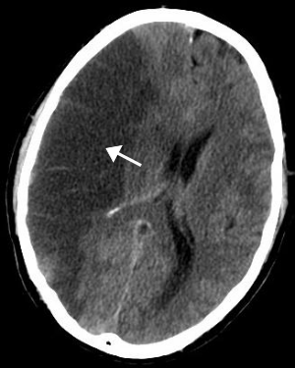](https://en.wikipedia.org/wiki/File:MCA_Territory_Infarct.svg)

Figure 1.1 [CT scan](https://en.wikipedia.org/wiki/CT_scan) of the brain showing a prior right-sided [ischemic](https://en.wikipedia.org/wiki/Ischemic) stroke from blockage of an artery. Changes on a CT may not be visible early on.

The main [risk factor](https://en.wikipedia.org/wiki/Risk_factor) for stroke is [high blood pressure](https://en.wikipedia.org/wiki/Hypertension). Other risk factors include [tobacco smoking](https://en.wikipedia.org/wiki/Tobacco_smoking), [obesity](https://en.wikipedia.org/wiki/Obesity), [high blood cholesterol](https://en.wikipedia.org/wiki/Hypercholesterolemia), [diabetes mellitus](https://en.wikipedia.org/wiki/Diabetes_mellitus), a previous TIA, [end-stage kidney disease](https://en.wikipedia.org/wiki/End-stage_kidney_disease), and [atrial fibrillation](https://en.wikipedia.org/wiki/Atrial_fibrillation).

Stroke symptoms can include:

* paralysis
* numbness or weakness in the arm, face, and leg, especially on one side of the body
* trouble speaking or understanding speech
* confusion
* slurring speech
* vision problems, such as trouble seeing in one or both eyes with vision blackened or blurred, or double vision
* trouble walking
* loss of balance or coordination
* dizziness
* severe, sudden headache with an unknown cause

There are three main categories of stroke:

**Ischemic stroke**

This is the most common type of stroke, making up 87% of all cases. A blood clot prevents blood and oxygen from reaching an area of the brain. It happens when the brain's blood vessels become narrowed or blocked, causing severely reduced blood flow (ischemia). Blocked or narrowed blood vessels are caused by fatty deposits that build up in blood vessels or by blood clots or other debris that travel through your bloodstream and lodge in the blood vessels in your brain.

There are four reasons why this might happen:

1. [Thrombosis](https://en.wikipedia.org/wiki/Thrombosis) (obstruction of a blood vessel by a blood clot forming locally)
2. [Embolism](https://en.wikipedia.org/wiki/Embolism) (obstruction due to an [embolus](https://en.wikipedia.org/wiki/Embolus) from elsewhere in the body),
3. Systemic hypoperfusion (general decrease in blood supply, e.g., in [shock](https://en.wikipedia.org/wiki/Shock_(circulatory)))
4. [Cerebral venous sinus thrombosis](https://en.wikipedia.org/wiki/Cerebral_venous_sinus_thrombosis).

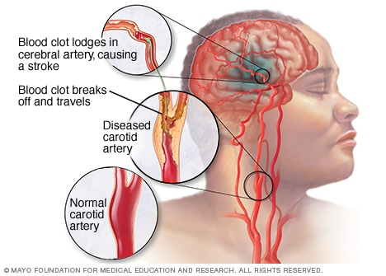

Figure 1.2 Figure representing blockage of tissue as happens in case of ischemic stroke

The symptoms include –

* Sudden numbness or weakness of the face, arm or leg, especially on one side of the body.
* Sudden confusion.
* Sudden trouble speaking.
* Sudden trouble seeing in one or both eyes.
* Sudden trouble walking.
* Sudden dizziness, loss of balance or coordination.
* Sudden, severe headache with no known cause.

Factors related to Ischemic stroke include:

* High blood pressure: This is the primary cause of stroke.
* Diabetes: People with diabetes are four times more likely to have carotid artery disease.
* Atherosclerosis or carotid artery disease: Having either of these conditions or a family history of these conditions can increase the risk of stroke.
* Atrial fibrillation (Afib): Approximately 15% of strokes occur in people who have Afib.
* Cholesterol levels: High levels of “bad” low-density lipoprotein (LDL) cholesterol or low levels of “good” high-density lipoprotein (HDL) cholesterol can contribute to plaque buildup in the arteries.
* A sedentary lifestyle: A lack of physical activity can lead to high blood pressure, high cholesterol, and being overweight. These increase the risk of arterial plaque buildup.
* Being overweight or obese.
* An unhealthful diet: Consuming too many saturated or trans fats and foods high in cholesterol, sodium, and sugar can lead to diabetes, plaque buildup, high blood pressure, and high cholesterol.
* Being over 55 years of age: The risk of stroke increases in people aged over 55 years and increases with each additional decade of life.

**Hemorrhagic stroke**

Hemorrhagic stroke occurs when a blood vessel in your brain leaks or ruptures. Brain hemorrhages can result from many conditions that affect your blood vessels. These are usually the result of aneurysms (an *aneurysm* refers to a weakening of an artery wall that creates a bulge, or distention, of the artery). Figure 1.3 shows figure representing rapture of tissue as happens in hemorrhagic stroke.

There are few reasons why this might happen:

* High blood pressure
* Injury
* Bleeding disorders
* Cocaine use
* Abnormal blood vessels (AVMs)
* Aneurysm (a weak area in a blood vessel that breaks open)

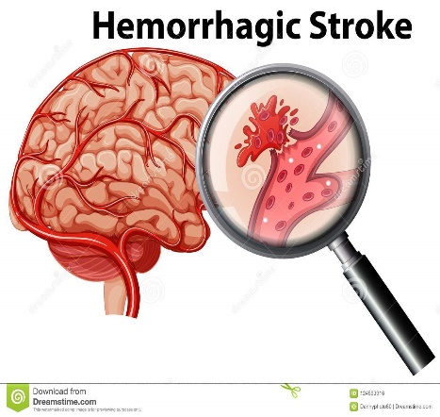

Figure 1.3 Figure representing rapture of tissue as happens in hemorrhagic stroke

Symptoms of Hemorrhagic stroke -

* Paralysis of one side of the body
* Sensitivity to light
* Stiffness in the neck or neck pain
* Frequent fluctuations in the heartbeat and breathing
* Hand tremors
* Difficulty swallowing
* Abnormal taste in the mouth
* Loss of balance or coordination
* Weakness, inability to move or numbness in an arm or leg
* Seizures

Factors related to hemorrhagic stroke include:

* Bulges at weak spots in your blood vessel walls (aneurysms)
* Uncontrolled high blood pressure.
* Overtreatment with blood thinners (anticoagulants).
* Trauma (such as a car accident)
* Protein deposits in blood vessel walls that lead to weakness in the vessel wall (cerebral amyloid angiopathy)
* Ischemic stroke leading to hemorrhage

**Transient ischemic attack (TIA)**

This occurs when blood flow to a part of the brain is inadequate for a brief period of time. It is a temporary period of symptoms similar to those you'd have in a stroke. Normal blood flow resumes after a short amount of time, and the symptoms resolve without treatment. Some people call this a [ministroke](https://www.medicalnewstoday.com/articles/164038.php). A TIA doesn't cause permanent damage. They're caused by a temporary decrease in blood supply to part of your brain, which may last as little as five minutes.

Causes –

* smoking
* high blood pressure (hypertension)
* obesity
* high cholesterol levels
* diabetes
* excessive alcohol consumption

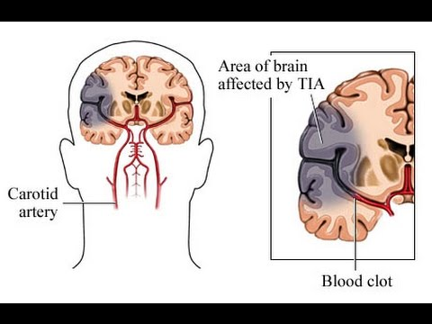

Figure 1.4 Figure representing transient blockage in case of TIA.

Symptoms –

* Weakness, numbness or paralysis in your face, arm or leg, typically on one side of your body
* Slurred or garbled speech or difficulty understanding others
* Blindness in one or both eyes and double vision
* Vertigo or loss of balance or coordination

Factors –

* age – although TIAs can happen at any age (including in children and young adults), they're most common in people over 55
* ethnicity – people of south Asian, African or Caribbean descent have a higher TIA risk, partly because rates of diabetes and high blood pressure are higher in these groups
* medical history – other health conditions such as diabetes can increase your risk of a TIA
* weight and diet – your risk of having a TIA is higher if you are overweight and/or have an unhealthy diet high in fat and salt
* smoking and alcohol – smoking and/or regularly drinking excessive amounts of alcohol can increase your TIA risk

Prevention includes decreasing risk factors, [surgery to open up the arteries to the brain](https://en.wikipedia.org/wiki/Carotid_endarterectomy) in those with problematic [carotid narrowing](https://en.wikipedia.org/wiki/Carotid_stenosis), and [warfarin](https://en.wikipedia.org/wiki/Warfarin) in people with [atrial fibrillation](https://en.wikipedia.org/wiki/Atrial_fibrillation). [Aspirin](https://en.wikipedia.org/wiki/Aspirin) or [statins](https://en.wikipedia.org/wiki/Statin) may be recommended by physicians for prevention. A stroke or TIA often requires emergency care.

**An ischemic stroke, if detected within three to four and half hours, may be treatable with a** [**medication**](https://en.wikipedia.org/wiki/Thrombolytic_drug) **that can** [**break down the clot**](https://en.wikipedia.org/wiki/Thrombolysis)**.** Some hemorrhagic strokes benefit from [surgery](https://en.wikipedia.org/wiki/Neurosurgery). Treatment to attempt recovery of lost function is called [stroke rehabilitation](https://en.wikipedia.org/wiki/Stroke_rehabilitation), and ideally takes place in a stroke unit; however, these are not available in much of the world.

In 2013, approximately 6.9 million people had an ischemic stroke and 3.4 million people had a hemorrhagic stroke. In 2015, there were about 42.4 million people who had previously had a stroke and were still alive. Between 1990 and 2010 the number of strokes which occurred each year decreased by approximately 10% in the [developed world](https://en.wikipedia.org/wiki/Developed_world) and increased by 10% in the developing world. In 2015, stroke was the second most [frequent cause of death](https://en.wikipedia.org/wiki/List_of_causes_of_death_by_rate) after [coronary artery disease](https://en.wikipedia.org/wiki/Coronary_artery_disease), accounting for 6.3 million deaths (11% of the total). About 3.0 million deaths resulted from ischemic stroke while 3.3 million deaths resulted from hemorrhagic stroke. About half of people who have had a stroke live less than one year. Overall, two thirds of strokes occurred in those over 65 years old.

### **Imaging**

For diagnosing ischemic (blockage) stroke in the emergency setting:

* CT scans (*without* contrast enhancements)

[sensitivity](https://en.wikipedia.org/wiki/Sensitivity_(tests))= 16% (less than 10% within first 3 hours of symptom onset)

[specificity](https://en.wikipedia.org/wiki/Specificity_(tests))= 96%

* MRI scan

sensitivity= 83%

specificity= 98%

For diagnosing hemorrhagic stroke in the emergency setting:

* CT scans (*without* contrast enhancements)

sensitivity= 89%

specificity= 100%

* MRI scan

sensitivity= 81%

specificity= 100%

For detecting chronic hemorrhages, MRI scan is more sensitive.

### **Risk factors**

The most important modifiable risk factors for stroke are **high blood pressure** and **atrial fibrillation** although the size of the effect is small with 833 people have to be treated for 1 year to prevent one stroke. Other modifiable risk factors include **high blood cholesterol levels**, [**diabetes mellitus**](https://en.wikipedia.org/wiki/Diabetes_mellitus)**,** [**end-stage kidney disease**](https://en.wikipedia.org/wiki/End-stage_kidney_disease)**, cigarette smoking** (active and passive), **heavy** [**alcohol**](https://en.wikipedia.org/wiki/Alcohol_consumption_and_health) use**, drug use**, **lack of** [**physical activity**](https://en.wikipedia.org/wiki/Physical_activity)**,** [**obesity**](https://en.wikipedia.org/wiki/Obesity)**, processed** [**red meat**](https://en.wikipedia.org/wiki/Red_meat) **consumption, and unhealthy diet**. **Smoking just one cigarette per day increases the risk more than 30%.**

## **Epidemiology**

[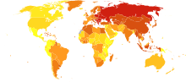](https://en.wikipedia.org/wiki/File:Stroke_world_map-Deaths_per_million_persons-WHO2012.svg)

Figure 1.5 Stroke deaths per million persons in 2012

  58–316

  317–417

  418–466

  467–518

  519–575

  576–640

  641–771

  772–974

  975-1,683

  1,684–3,477

[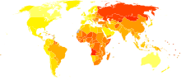](https://en.wikipedia.org/wiki/File:Cerebrovascular_disease_world_map_-_DALY_-_WHO2004.svg)

Figure 1.6 [Disability-adjusted life year](https://en.wikipedia.org/wiki/Disability-adjusted_life_year) for cerebral vascular disease per 100,000 inhabitants in 2004.

|  |  |
| --- | --- |
| no data    <250    250–425    425–600    600–775    775–950    950–1125 | 1125–1300    1300–1475    1475–1650    1650–1825    1825–2000    >2000 |

Stroke was the second most frequent cause of death worldwide in 2011, accounting for 6.2 million deaths (~11% of the total). Approximately 17 million people had a stroke in 2010 and 33 million people have previously had a stroke and were still alive. Between 1990 and 2010 the number of strokes decreased by approximately 10% in the developed world and increased by 10% in the developing world. Overall, two-thirds of strokes occurred in those over 65 years old. South Asians are at particularly high risk of stroke, accounting for 40% of global stroke deaths.

**The risk of stroke** [**increases exponentially**](https://en.wikipedia.org/wiki/Exponential_growth) **from 30 years of age, and the cause varies by age.** Advanced age is one of the most significant stroke risk factors. **95% of strokes occur in people age 45 and older, and two-thirds of strokes occur in those over the age of 65**. A person's risk of dying if he or she does have a stroke also increases with age. However, stroke can occur at any age, including in childhood.

Family members may have a genetic tendency for stroke or share a lifestyle that contributes to stroke. Higher levels of [Von Willebrand factor](https://en.wikipedia.org/wiki/Von_Willebrand_factor) are more common amongst people who have had ischemic stroke for the first time. The results of this study found that the only significant genetic factor was the person's [blood type](https://en.wikipedia.org/wiki/Blood_type). Having had a stroke in the past greatly increases one's risk of future strokes.

**Men are 25% more likely to suffer strokes than women, yet 60% of deaths from stroke occur in women**. Since women live longer, they are older on average when they have their strokes and thus more often killed. Some risk factors for stroke apply only to women. Primary among these are pregnancy, childbirth, [menopause](https://en.wikipedia.org/wiki/Menopause), and the treatment thereof ([HRT](https://en.wikipedia.org/wiki/Hormone_replacement_therapy_(menopause))).

**1.2 MOTIVATION**

The stroke prediction model provides the chances of stroke to the user. This is done by collecting the inputs from user from the web platform and use the trained model to predict the chance of stroke to the user. It is easy to use and always available and can be accessed from anywhere and anytime through the web enabled device. Whenever a person feels symptoms of stroke like loss in vision in one eye, inability to move or feel on one side of the body, problem in understanding or speaking, dizziness these could be symptoms of stroke. There are some key risk factors like blood pressure, smoking habits, high blood cholesterol, obesity, diabetes, kidney problem etc. which are often know to user. In this case he/she can do a self-diagnosis test for chances for stroke risk to him/her and then consult a doctor. Timely detection can help to a large extend and can even save life in some instances. The easy to access app will provide ease to user. Also, the project will help us understand the capability and factors useful for machine learning classifiers for predicting such results.

**1.3 PROBLEM STATEMENT**

To compare various machine learning classifiers based on accuracy and select the best one to build a system for predicting stroke risk.

**1.4 SCOPE OF PROJECT**

This project provides user an easy to access website which they can use to check the probability according to their present health situation of having a stroke. The aim of the project is to make such app available to everyone. This project also plans to learn which machine learning classifiers are best suited for this kind of job and understand the reason behind it.

**1.5 ACCESS TO USERS**

The project aims to host the web app or mobile app for the users making it easily available for everyone at all time. The interface aims to be very basic and user friendly. The major objective is this app can be used by users on phone instantaneously and does not require any expertise.

Chapter 2 contains all the work related to our stroke prediction model. It defines what the current models developed can do and what we propose to do with the help of this project.

Chapter 3 contains the description of our project and contains information about the specification of the project and its hardware and software requirements.

Chapter 4 contains the system design, details about the algorithms implemented in our project, the parameters on which our project is based upon and how the data flow works in the project.

Chapter 5 contains the implementational details of our project work and snippets of program code and working of the project.

Chapter 6 concludes the project with presenting future scope of what we are planning to implement in our project.

**CHAPTER – 2**

**RELATED WORK**

**2.1 INTRODUCTION**

In this section, we will look into some of the earlier works presented in the direction of this project. There has been a lot of work that has already happened in the field of prediction in the medical department. While preparing this project we have gathered ideas from different research materials and models. Here, we are going to enlist them.

**2.2 EXISTING SYSTEM**

Lately a lot of research has been done on predicting strokes. The research can be briefly categorized into three different categories including the dataset collection, algorithm comparison and efficient & accurate stroke rate prediction.

Machine learning strategies for examination of neuro imaging information are utilized to help analyze stroke. Diagnosis and treatment of stroke disease are very complex, developing nations, due to the absence of diagnostic devices as well as a shortage of doctors and many other resources that affect adequate prediction and medication of heart patients. Recently, computer technology and machine learning methods are facing this concern, to improve the system to support doctors in the preliminary stage in making decisions about disease. Many systems have been developed in recent times to for stroke predictions differing by small factors. Some of which we covered are discussed below.

Yu et al. [52] have implemented the machine learning techniques by considering the decision tree algorithm of C4.5. The proposed methodology of this work uses 13 features rather than 18 stroke scale features for determining and analysing the stroke classification. The data collected from the database of the National Institutes of Health Stroke Scale (NIHSS) for the study of cerebrovascular strokes among people affected over age 65 years. Out of total samples, 75% of subjects were used for training, and 25% of subjects were used for testing. Based on the hypothetical solutions 91.11% decent accuracy is obtained through the decision tree algorithm.

Monteiro et al. [53] have implemented a machine learning methodology to determine the practical results of the patients affected with ischemic stroke when admitted for three weeks. Among different types of strokes, Ischemic stroke acts as a major purpose of disorder and death all over the world among people of 65 years and in adults. The proposed methodology is succeeded on an outcome of the outlined superior AUC value of 0.808± 0.085 when compared to the foremost point score of 0.771 ± 0.056 with 70% subjects used for training and 30% subjects used for testing. On the other hand, the model keeps on increasing the additional features depending upon particular timing along with the increase in the AUC score by setting the point score of above 0.90. The Baseline feature sets used under experiment -1 produced a ‘good’ outcome with 51.3% and a ‘poor’ outcome with 48.7% accuracies on 425 samples. By obtaining the conclusions and validating the results taken at the time of admission and by making a priority of the use of technological methods whenever required.

Sung et al. [54] have proposed a methodology that can be examined for automated phenotyping by further classifying the ischemic stroke into 4 subdivisions. This model depending upon the structured and unstructured data taken from the electronic medical records (EMRs). It works on the records of 4640 patients who have been diagnosed with the mild symptoms of Ischemic stroke and also been taken for examining the results. The sub-divisions structured data has National Institutes of Health stroke scale whereas unstructured data has clinical narratives which are refined through a heatmap. The conclusion of stroke scale data from EMRs could make the process clear and smooth phenotyping of ischemic stroke when integrated with the structures data. However, diminishing the different levels of class issues into binary classification work along with the congregation of classifies solution helps in increasing the performance by taking 66% subjects on training and 34% subjects on testing.

Xie et al. [55] have proposed a model to combine common stroke biomarkers by developing machine learning techniques and to analyze the complete recovery of the ischemic stroke patient within three months. In this work, to predict the recovery terms of the patient Extreme gradient boosting (XGB) and Gradient Boosting Machine (GBM) models were implemented to identify modified ranking scale (mRS) scores by using biomarkers availability within 24 hours of the admitting of the patient. A total of 512 patients records were taken into consideration for analysis with fivefold cross-validation for identifying the improvements of the model. These records are categorized into 80% on training and 20% on testing. Under the binary analysis of an mRS score which is larger than 2 considering biomarkers which are provided during the time of admitting, XGB and GBM include AUC of scores 0.746 and 0.748 accordingly.

Wang et al. [56] have implemented a machine learning model in the configuration of the risk of symptomatic intracerebral haemorrhage (sICH) after the thrombolysis of the stroke. The risk factors of sICH are theoretically used after stroke thrombolysis. Based on this study, a total of 2578 thrombolysis-treated ischemic stroke patients were recognized from January 2013 and December 2016. Out of which 70% were taken into training modules and 30% considered under nominal data test sets. In order to analyse the risk of sICH, these machine learning modules were helped to increase the performance analysis metrics through the area under curve (AUC) with 0.82.

Lin et al. [57] have proposed a hybrid neural network model with 10 cross folds for evaluating the stroke outcome. The data collected from “Taiwan Stroke Registry” is given for the model with 70% on training and 30% on testing.

Sung et al. [58] have implemented machine learning algorithms to analyse the stroke outcome with acute minor stroke. Among 739 patients, 61 patients having a negative outcome after a stroke at 90 days. The data is categorized into 89.4% for no END and the remaining 10.6% for END This database related to patients was taken from NIHSS with a score of ≤ 3. Pre indication of the neurological deterioration tells us that diminishing of the NIHSS score within days of the admission of the patient. The inimical score was determined from the modified Ranking scale score of ≥ 2. In this work, four machine learning models such as bootstrap decision forest, boosted trees, Logistic Regression, and Deep neural network was used in analysing the early signs of neurological deterioration and examined with a decent accuracy of 94.6%.

Govindarajan et al. [60] conducted a study to categorize stroke disorder using a text mining combination and a machine learning classifier and collected data for 507 patients. For their analysis, they used various machine learning approaches for training purposes using ANN, and the SGD algorithm gave them the best value, which was 95%.

Amini et al. [61] conducted research to predict stroke incidence, collected 807 healthy and unhealthy subjects in their study categorized 50 risk factors for stroke, diabetes, cardiovascular disease, smoking, hyperlipidemia, and alcohol use. They used two techniques that had the best accuracy from c4.5 decision tree algorithm, and it was 95%, and for K-nearest neighbor, the accuracy was 94%.

Cheng et al. [62] published a report on the estimation of the ischemic stroke prognosis. In their analysis, 82 ischemic stroke patient data were used, two ANN models were used to find precision, and 79% and 95% were used.

Cheon et al. [63] performed a study to predict stroke patient mortality. In their study, they used 15099 patients to identify stroke occurrence. They used a deep neural network approach to detect strokes. The authors used PCA to extract medical record history and predict stroke. They have got an area under the curve (AUC) value of 83%.

Singh et al. [64] performed a study on stroke prediction applied to artificial intelligence. In their research, they used a different method for predicting stroke on the cardiovascular health study (CHS) dataset. And they took the decision tree algorithm to feature extract to principal component analysis. They used a neural network classification algorithm to construct the model they got 97% accuracy.

Chin et al. [65] performed a study to detect an automated early ischemic stroke. In their study, the main purpose was to develop a system using CNN to automated primary ischemic stroke. They collected 256 images to train and test the CNN model. In their system image prepossessing remove the impossible area that can’t occur of stroke, they used the data prolongation method to raise the collected image. Their CNN method has given 90% accuracy.

Sung et al. [69] performed a study to develop a stroke severity index. They collected 3577 patient’s data with acute ischemic stroke. For their predicting models, they used various data mining techniques and linear regression. Their prediction feature got the best result from the k-nearest neighbor model (95% CI).

Monteiro et al. [66] performed a study to get a functional outcome prediction of ischemic stroke using machine learning. In their research, they apply this technique to a patient who was passing three months after admission. They got the AUC value above 90%.

Kansadub et al. [67] performed a study to predict stroke risk. In the study, the authors employed Naive Bayes, Decision Tree, and Neural Network to analyze data to predict stroke. In their study, they used accuracy and AUC as their pointer’s assessment. All of this algorithm, they classified decision tree and naive Bayes gave the most accurate.

Adam et al. [68] performed a study to classify ischemic stroke. They used two models: a k-nearest neighbor and a decision tree algorithm to classified ischemic stroke. In their research, the decision tree algorithm was more usable for medical specialists who used it to classify stroke.

**2.3 PROPOSED SYSTEM**

In this project, we will be going through a five-step process for creating our project:

1. Evaluating data from “Stroke Prediction Dataset” using Matplotlib, seaborn & Plotly libraries.

2. Comparing different machine learning classifiers on the basis of accuracy on our dataset.

3. Performing k-Fold Cross-Validation and Hyper Parameter optimization on the model with highest accuracy. Also, identifying the best features for the model.

4. Preparing a backend model using Flask and the using the best saved model for prediction.

5. Getting input from the user using web app hosted on Heroku and predicting chances of stroke to him/her.

**CHAPTER – 3**

**PROBLEM DESCRIPTION AND SPECIFICATION**

**3.1 PROBLEM DESCRIPTION**

To compare various machine learning algorithms based on their accuracy of stroke prediction and build a system for the same.

**3.2 SPECIFICATION**

Stroke prediction is a task that involves machine learning concepts to recognize the possible factors contributing to the conditions developing strokes and to help prevent them using analytics to analyses the possible scenarios to stop or prevent it.

The aim of Stroke prediction is to apply various machine learning algorithms on the “Stroke Prediction Dataset and evaluate the models based on their accuracy. Also, create an interface where a user can provide his medical details and the prediction model will provide the chances of the stroke to him. Moreover, a comparison between various machine learning algorithms helps us in determining the most suitable algorithm for the prediction model. This prediction model can aid in clinical decision making and help patients to have an improved and reliable stroke risk prediction. In future, we can use more risk factors to train our model and enhance the accuracy of the model. The web interface will be friendly and also, we can provide valuable suggestions to users as per their stroke risk.

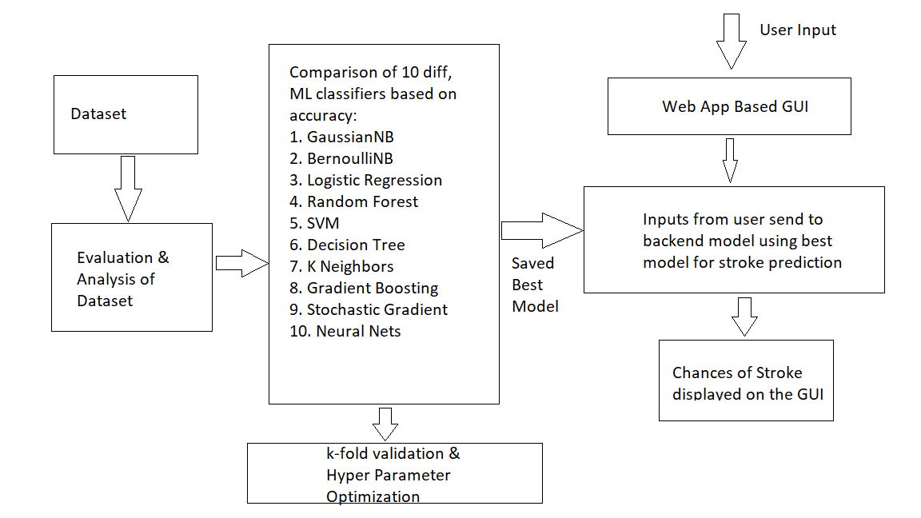

Figure 3.1: Process Flow Diagram

**3.3 REQUIREMENTS**

**3.3.1 SOFTWARE REQUIREMENTS**

* Python Version 3.6+
* IDE: JupyterLab or PyCharm
* Frameworks: -
  + Flask
  + Bootstrap
* Python Libraries: -
  + Scikit-learn
  + Seaborn
  + NumPy: 1.18.5
  + Pandas: 1.1.14

**3.3.2 HARDWARE REQUIREMENTS**

* Processor: - Intel i3+ or AMD A6+
* RAM: - 2GB/+
* Hard Disk Space: - 2GB

**3.3.3 OTHER REQUIREMENTS**

* Stroke Prediction Dataset
* For training the model - Kaggle Notebook/Google Colab/JupyterLab should be preferred (Recommended)

**CHAPTER – 4**

**SYSTEM DESIGN**

**4.1 INTRODUCTION**

According to World Health Organization (WHO) stroke is the 2nd leading cause of death globally, responsible for approximately 11% of the total deaths. Through this project we will compare various machine learning algorithms based on their accuracy of stroke prediction and build the system for the same.

The model will consist of a front-end GUI for collecting data. Flask file to connect the model to backend model. For the backend model we will be comparing 10 different ML algorithms for their accuracy. Select the best one and perform K-fold Cross validation and hyper-parameter optimization on it.

**4.1.1. Data Sources**

We had selected “Stroke-prediction dataset” obtained from Kaggle as our dataset. This dataset contains of 5110 records having 12 attributes (id, age, gender, hypertension, heart disease, marital status, residence type, work type, average glucose level, BMI, smoking status and stroke occurrence). The below image provides the info about the dataset.

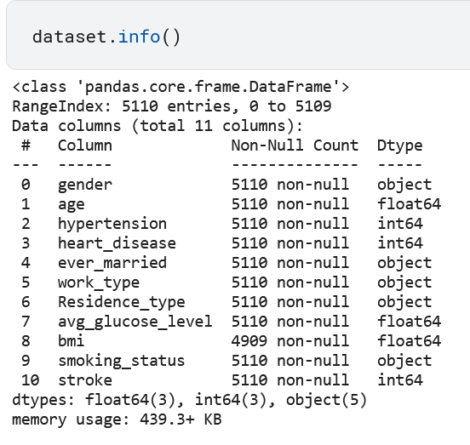

Figure 4.1: Output showing the dataset information

**4.1.2. MACHINE LEARNING ALGORITHMS USED IN THE PROJECT**

In this project we are going to train our dataset on 10 different machine learning algorithms and based on their performance we will select the best model and further use it in building the stroke prediction system. The 10 machine learning algorithms used in this project are: -

1. Gaussian Naive Bayes
2. Bernoulli naïve Bayes
3. Logistic Regression
4. Support Vector Machines
5. Random Forest
6. Decision Tree classifier
7. K-Nearest Neighbor
8. Gradient Boosting
9. Stochastic Gradient Descent
10. Neural nets

**4.1.3. MODEL EVALUATION PARAMETERS**

A model parameter is a configuration variable that is internal to the model and whose value can be estimated from data. The various parameters we computed for the machine learning algorithms we covered are: -

* 1. Accuracy- The accuracy of a machine learning classification algorithm is one way to measure how often the algorithm classifies a data point correctly. Accuracy is the number of correctly predicted data points out of all the data points.
  2. Precision- Precision (also called positive predictive value) is the fraction of relevant instances among the retrieved instances.

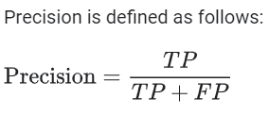

Where, TP is True positives

FP is False Negatives

* 1. Recall- Recall (also known as sensitivity) is the fraction of relevant instances that were retrieved.

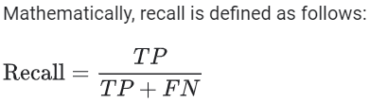

* 1. F1 Score- In statistical analysis of binary classification, the F-score or F-measure is a measure of a test's accuracy. It is calculated from the precision and recall of the test.

The formula for F1 Score is-

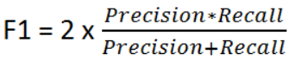

* 1. Specificity- Specificity (True Negative rate) measures the proportion of negatives that are correctly identified (i.e., the proportion of those who do not have the condition (unaffected) who are correctly identified as not having the condition).

Mathematically specificity is given by-



**4.2 ARCHITECTURE DIAGRAM**

The stroke predicition system using machine learning predicts the risk of stroke to the user based on the various symptom information the user gives, such as age, gender, marital status, hypertension, prior heart disease and smoking status. The architecture of the stroke risk prediction using machine learning consists of the dataset through which we will compare the symptoms of the user. Model is trained using the dataset. The classification algorithms process the data and predicts the risk of stroke. The diagram below explains about the system in perception of overview of the system.

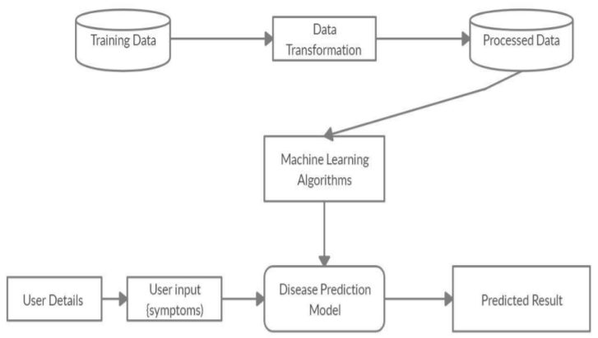

Figure 4.2: Architecture of the Stroke prediction model

**4.3 UNIFIED MODELING LANGUAGE(UML)**

**4.3.1 USE CASE DIAGRAM**

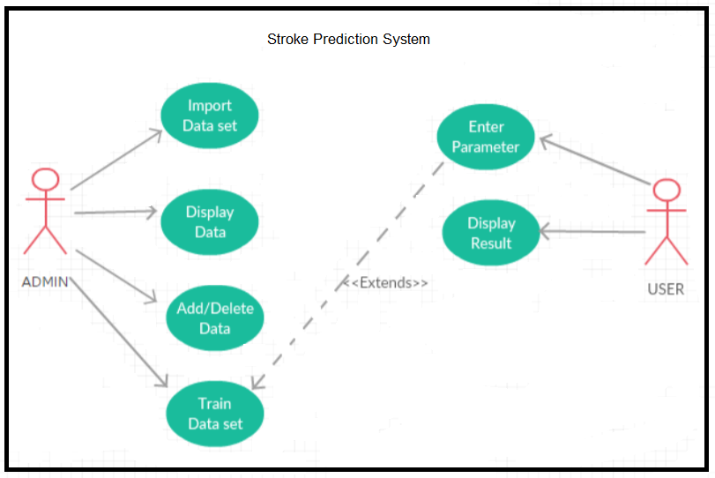

Figure 4.3: Use Case Diagram for stroke prediction system

The Use Case diagram of the project stroke prediction using machine learning consist of all the various aspects a normal use case diagram requires. This use case diagram shows how from starting the model flows from one step to another, the user fills all the medical details as asked in the form, the system compares with the prediction model and if true is predicts the appropriate results otherwise it shows the details where the user if gone wrong while entering the. Here the use case diagram of all the entities is linked to each other where the user gets started with the system.

**4.3.2 DATA FLOW DIAGRAM**

The entire working or the flow of the data can be divided into three groups for better understanding. They are- 1. DFD-L0 2. DFD-L1 3. DFD-L2

**4.3.2.1 Data Flow Diagram Level 0**

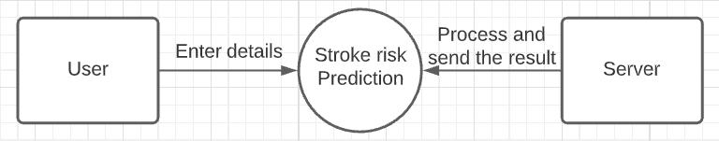

Figure 4.4: DFD level 0

This is the initial idea for the flow of the data. The data has to be flown from user to server and from server to the user for the prediction of the stroke risk by entering details and sending the data. Communication is done between user and the server.

**4.3.2.2 Data Flow Diagram Level 1**

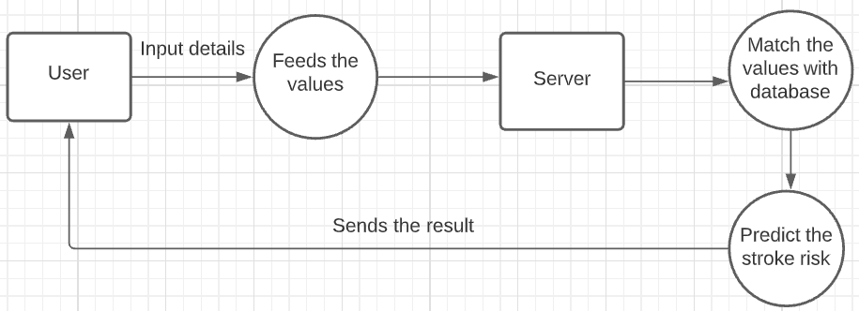

Figure 4.5: DFD level 1

This is the process or the idea where the data has been used to predict the disease by following steps like Feed the values (entering the medical parameters), Server (to store them), match the values (Finding probability) and finally predict the risk of stroke (Final result).

**4.3.2.3 Data Flow Diagram Level 2**

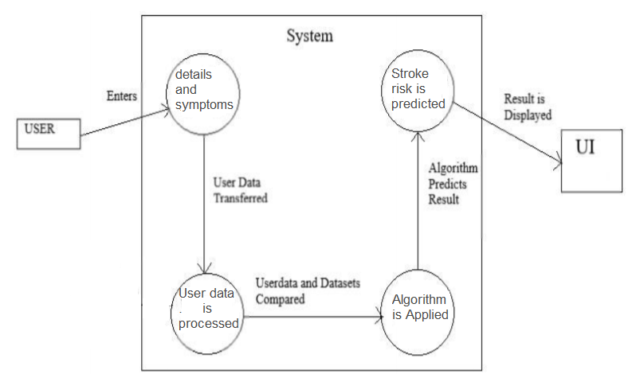

Figure 4.6: DFD level 2

The level 2 dataflow diagram of the project stroke prediction using machine learning consists of all the various aspects a normal flow diagram requires. This dataflow diagram shows how from starting the model flows from one step to another, like the user fills all the required form information regarding his medical information as asked in the form. The user data is processed and the trained model predicts the risk of stroke. The result is finally displayed in the webpage.

**4.4 SEQUENCE DIAGRAM**

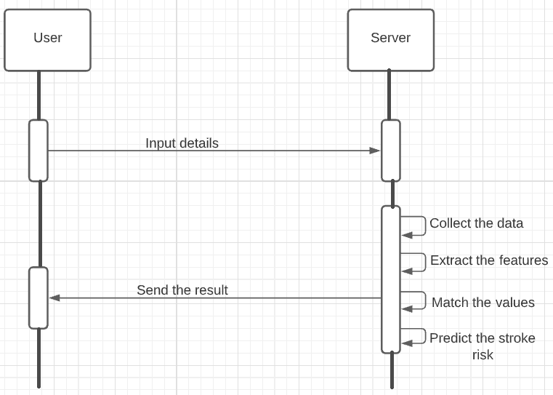

Figure 4.7: Sequence Diagram of the system

Sequence diagrams describe interactions among classes in terms of an exchange of messages over time. It shows how different events take place. In our project it follows a very straight forward approach the user visiting the web app inputs the values, which are passed to the server where the prediction model predicts the results which are then again sent back to the user on the web app.

**4.5 FLOW CHART FOR STROKE PREDICTION PROCESS**

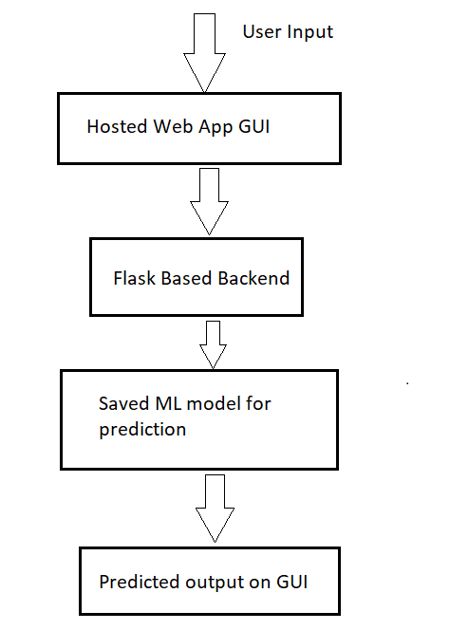

Figure 4.8: Flow chart for the stroke prediction system

Figure 9 shows the overall flow of work in the stroke prediction system. Initially user data is collected using web-based GUI platform. The data fetched from the web app is passed to prediction model in numerical form via flask backend model. The model processes the data and return 0 for no risk and 1 for risk of stroke which again is given to flask model which then displays the result based on values from the prediction model to the web app. This result is displayed to the user on a web-page.

**CHAPTER – 5**

**IMPLEMENTATION AND RESULT**

**5.1 OVERVIEW**

In this section, we are going to cover all the steps we have taken while implementing the program. The whole program consists of different sections giving a brief about the program implementation and their respective outputs.

**5.2 IMPORTING THE NECESSARY LIBRARIES AND DATASET**

We have used a number of python libraries in our project. Below is a snap of some of the main libraries used in the project.

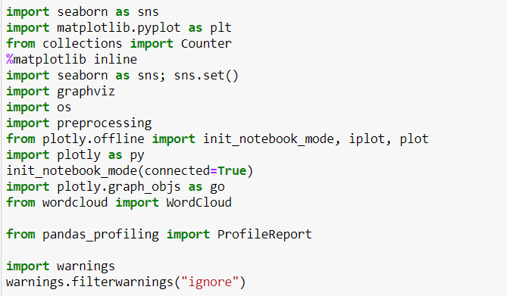

Figure 5.1: Code snippet showing the import of libraries used in the project



Figure: Code snippet to read the dataset

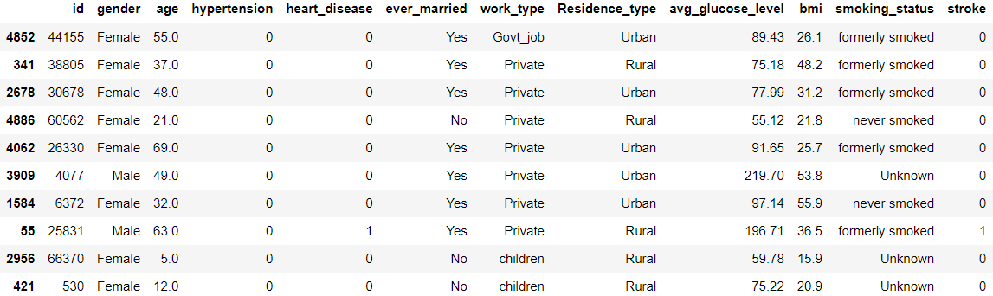

Figure 5.2: 10 Sample data from the dataset

We’ll drop the ‘id’ column as it may cause unwanted correlation.

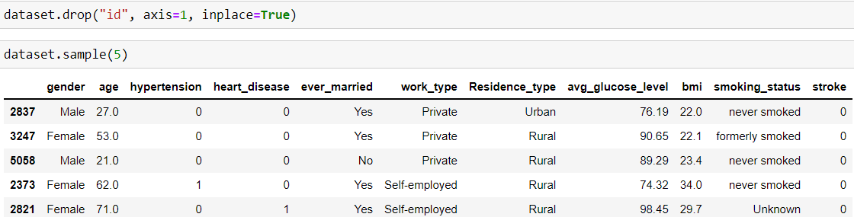

Figure 5.3: - Code snippet and resultant table after dropping the id column

**5.3 BASIC DATA ANALYSIS**

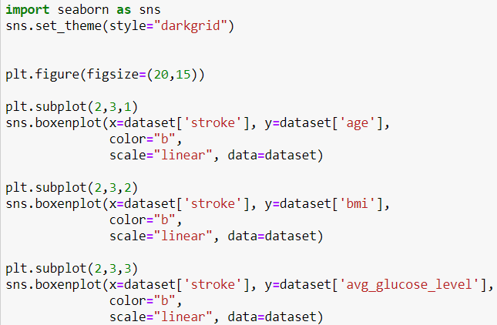

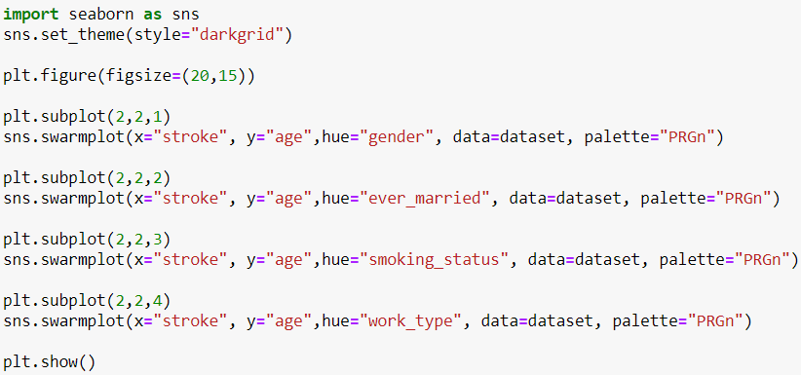

Figure: Code snippet to visualize the dataset

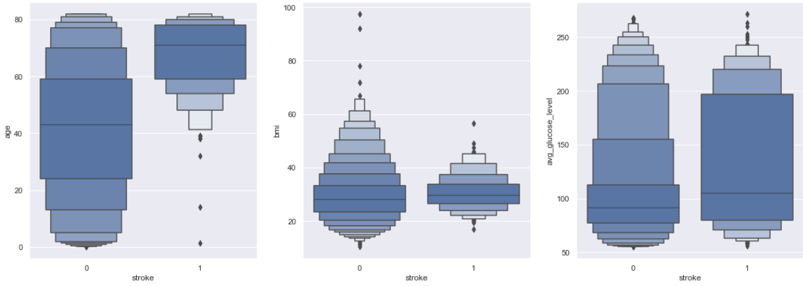

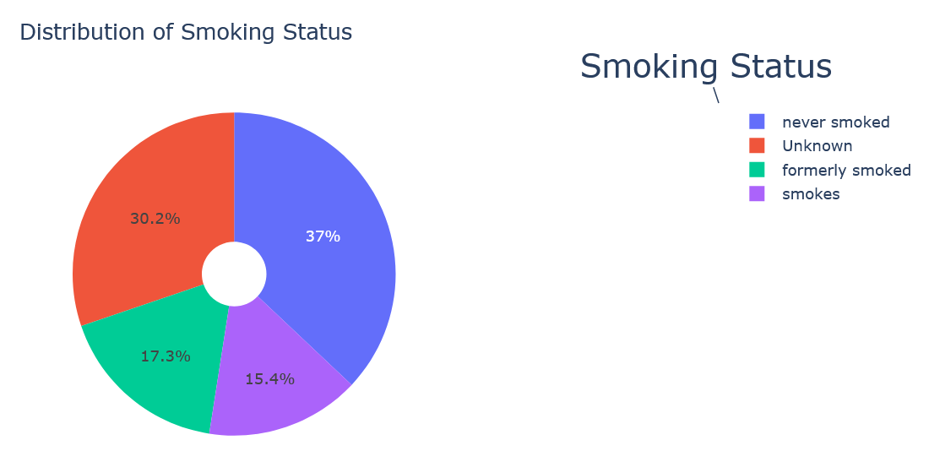

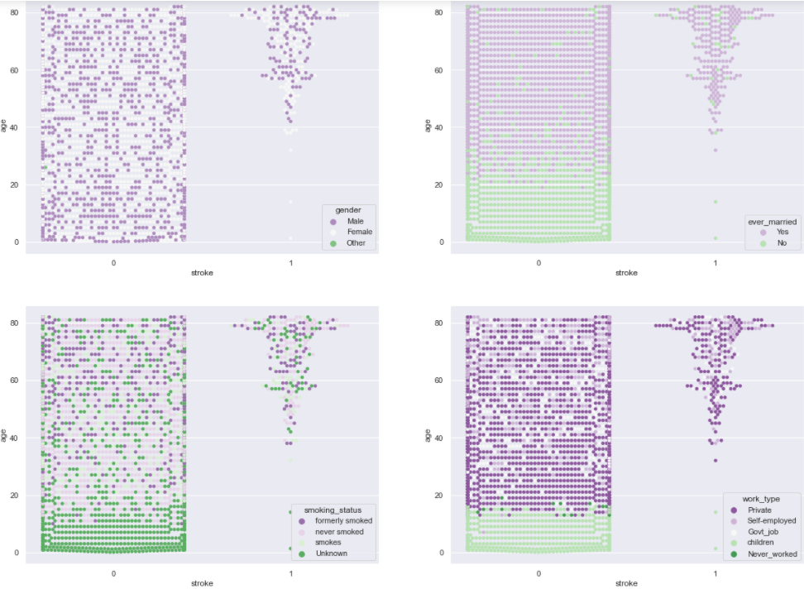

Figure 5.4: Visual representation of dataset

**5.4 PANDAS PROFILING**

Pandas profiling is a useful library that generates interactive reports about the data. With using this library, we can see types of data, distribution of data and various statistical information. This tool has many features for data preparing. Pandas Profiling includes graphics about specific feature and correlation maps too.



Figure 5.5: Code snippet showing pandas profiling

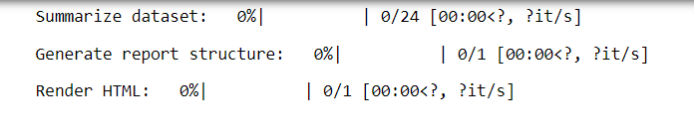

Figure: Pandas profile report

**5.5 CORRELATION**

Correlation explains how one or more variables are related to each other. These variables can be input data features which have been used to forecast our target variable.

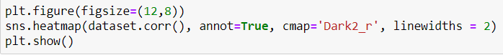

Figure: Code snippet to show correlation

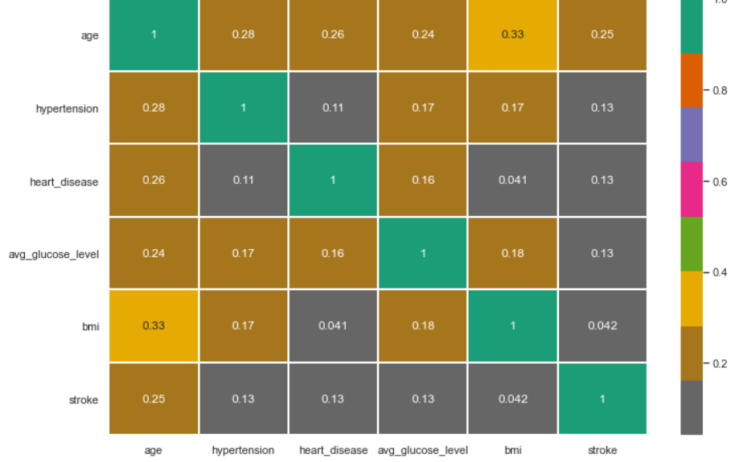

Figure 5.6: Sample output showing the heatmap of correlation



Figure: Code snippet for pairplot representing how different attributes are related to each other

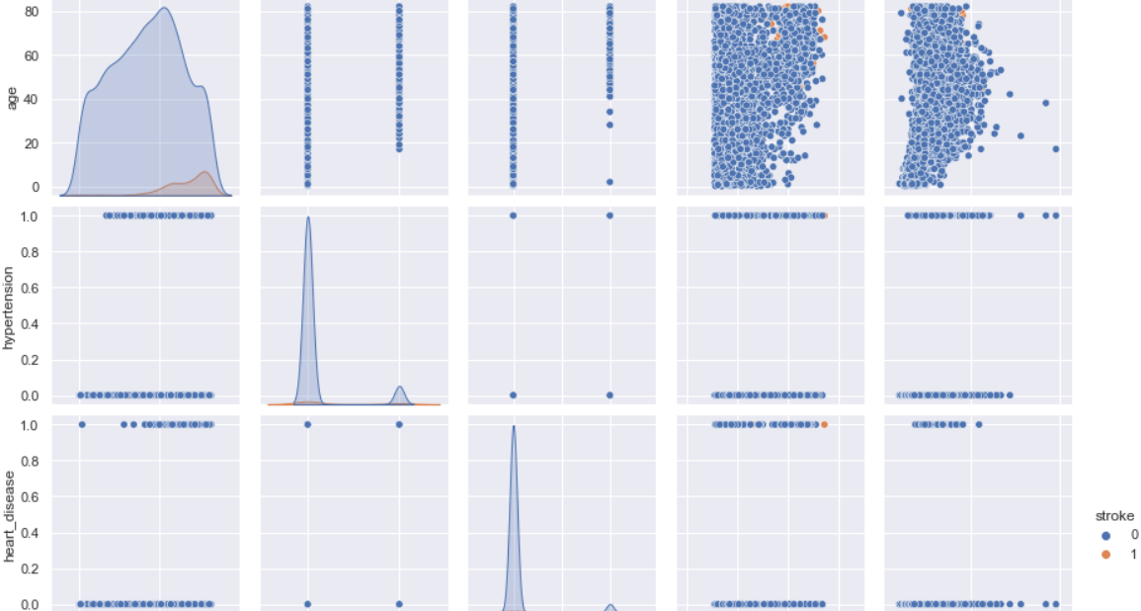

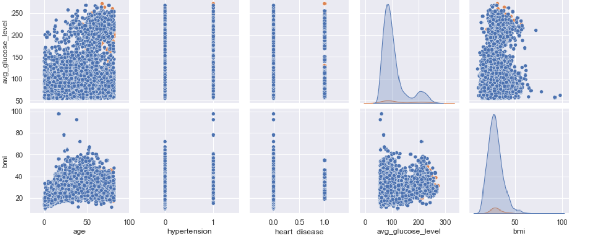

Figure 5.7: Sample output showing the distribution of values for each attributes in their domains

**5.6 ANAMOLY DETECTION**

Anomaly is one that differs / deviates significantly from other observations in the same sample. An anomaly detection pattern produces two different results. The first is a categorical tag for whether the observation is abnormal or not; the second is a score or trust value. Score carries more information than the label. Because it also tells us how abnormal the observation is. The tag just tells you if it's abnormal. While labeling is more common in supervised methods, the score is more common in unsupervised and semi supervised methods.

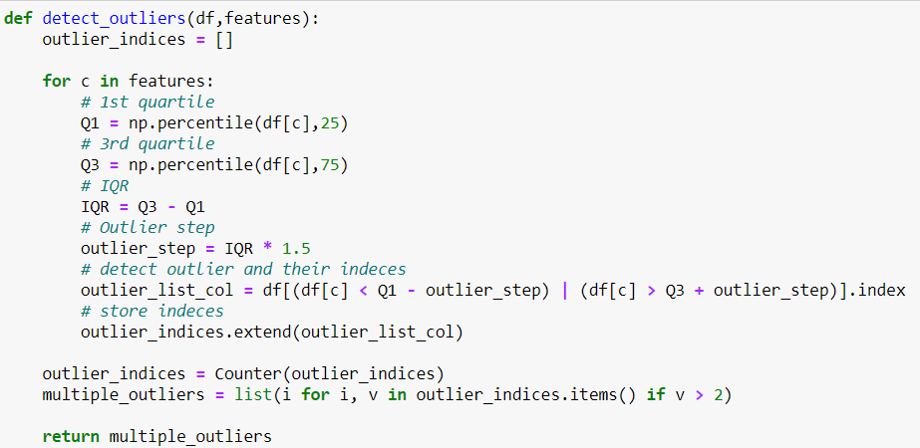

Figure: Code snippet showing the detection of outliers

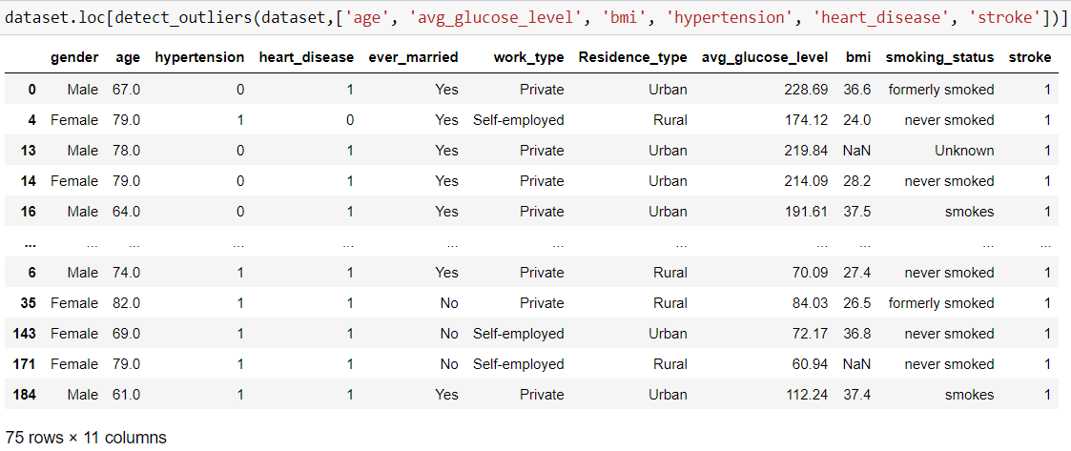

Figure 5.8: Output showing the detection of outliers

dataset = dataset.drop(detect_outliers(dataset,['age', 'avg_glucose_level', 'bmi', 'hypertension', 'heart_disease', 'stroke']),axis = 0).reset_index(drop = True)

Figure: Code snippet to drop the dataset containing outliers

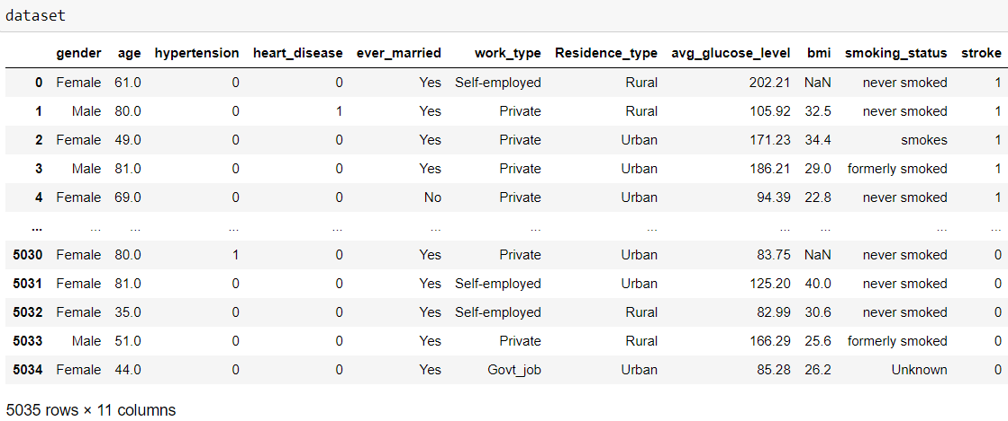

Figure 5.9: Resultant table after anomaly detection and rectification

**5.7 HANDLING MISSING VALUES**

We have 201 null values in total. After anomaly detection it reduced to 193.



Figure: Code snippet to check for missing bmi values.

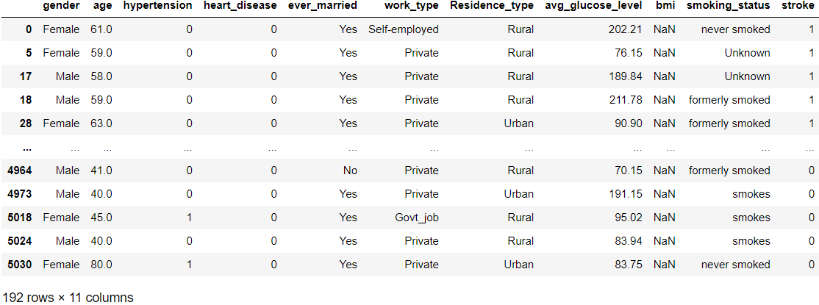

Figure 5.10: Output showing the rows where BMI value is null.

To handle missing values, we selected BMI based on different genders. We obtained the mean for male, female and other gender and then assigned this means to the missing values in the section of BMI against the respective gender.

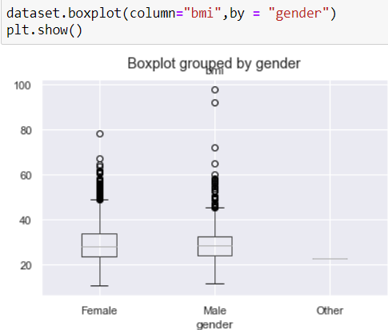

Figure 5.11: Output showing the boxplot grouped by gender

We get different BMI averages for women and men, although not very large. So, we assigned the total BMI mean as there are very few examples for the Others gender.

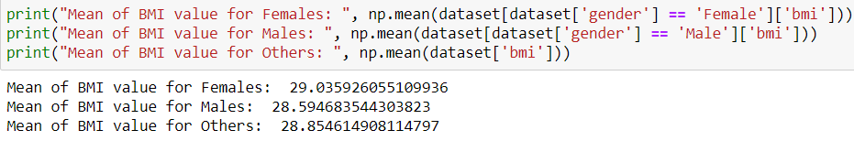

Figure: Code snippet and output showing the mean BMI based on gender

We fill the BMI field with null values to 0.

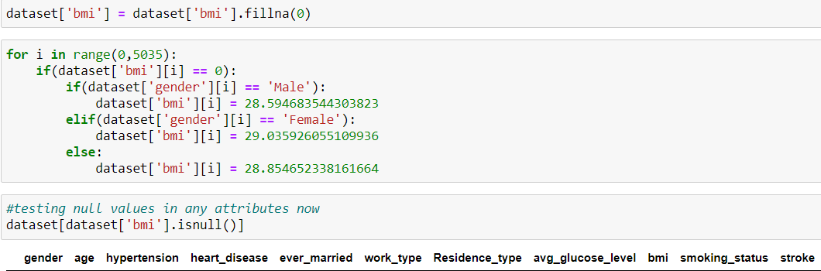

Figure 5.12: Code snippet and output showing that none of the field contains null or missing values

**5.8 ENCODING**

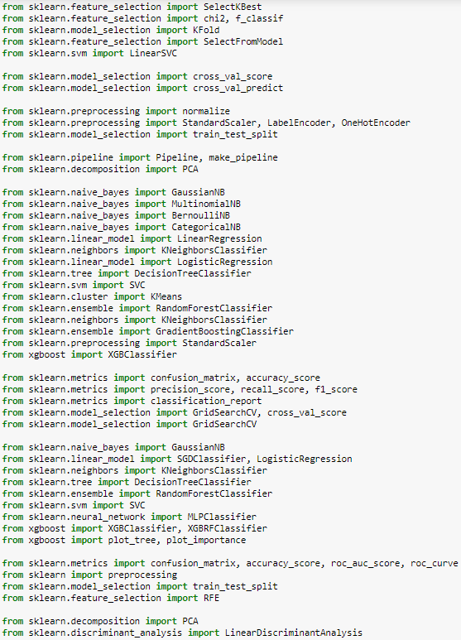

Figure: Code snippet for encoding

First, we will handle categorial values.

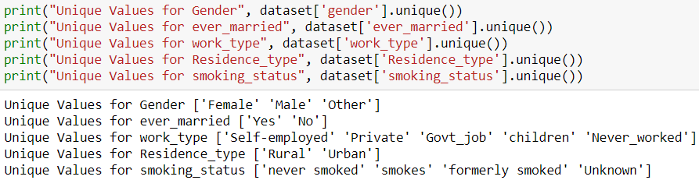

Figure: Code snippet and output for handling categorial values

**5.8.1 LABEL ENCODING**

Label Encoding is an encoding technique for handling categorical variables. In this technique, each data is assigned a unique integer.

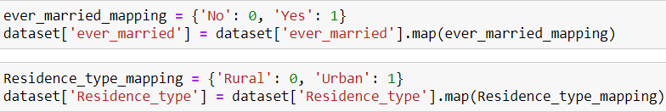

Figure: Code snippet to implement label encoding

**5.8.2 ONE HOT ENCODING**

One Hot Encoding is the binary representation of categorical variables. This process requires categorical values to be mapped to integer values first. Next, each integer value is represented as a binary vector with all values zero except the integer index marked with 1.

One Hot Encoding makes the representation of categorical data more expressive and easier. Many machine learning algorithms cannot work directly with categorical data, so categories must be converted to numbers. This operation is required for input and output variables that are categorical.

Here, we converted categorical data to the binary values. This operation increases the accuracy.

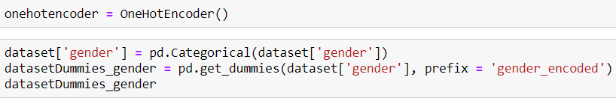





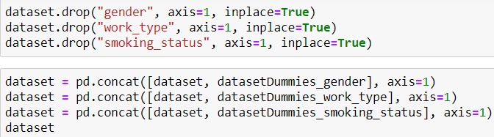

Figure: Code snippet for implementing one hot encoding

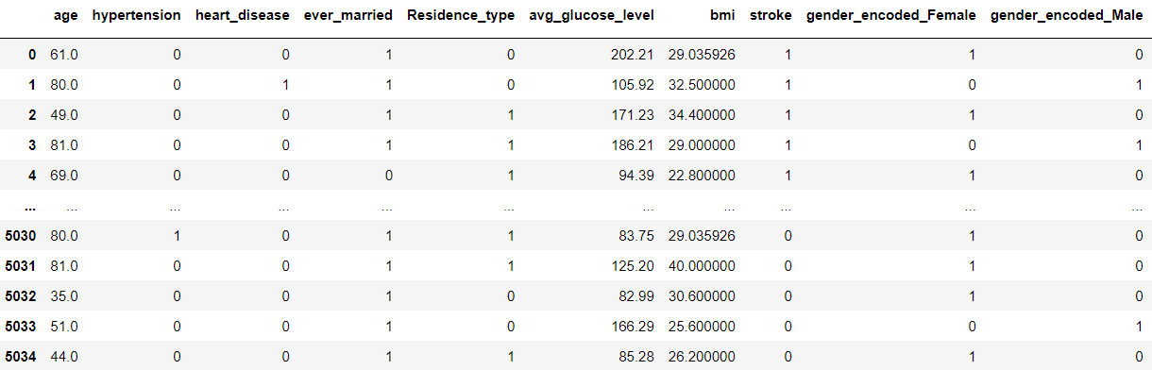

Figure 5.13: Sample output showing the table doesn’t contain categorial variables.

Dataset is now ready for implementing machine learning algorithms.

**5.9 SPLITING THE DATASET FOR TRAINING & TESTING**

Here we split the dataset in the ratio of 80:10:10 for train, validation and testing respectively. To maintain the variation in dataset we have selected the random samples using random attribute in the train_test split function of the scikit learn.

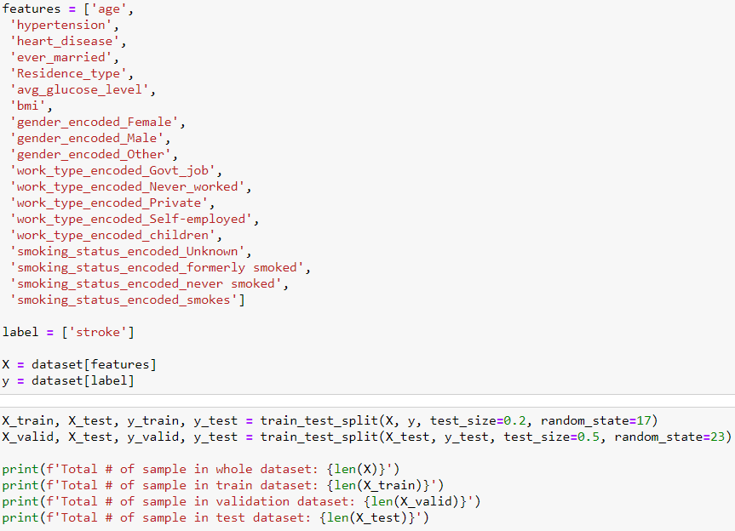

Figure: Code snippet showing the dataset is split for the purpose of training, testing and validation.

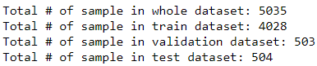

Figure: Output showing the amount of data used for training, testing and validation

**5.9.2 STANDARDIZATION**

Standardization is a method in which the mean value is 0 and the standard deviation is 1, and the distribution approaches the normal. The formula is as follows, we subtract the average value from the value we have, then divide it by the variance value.

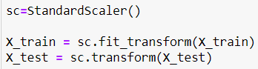

Figure: Code snippet to implement Standardization

**5.9.3 SAVING THE SCALER OBJECT**

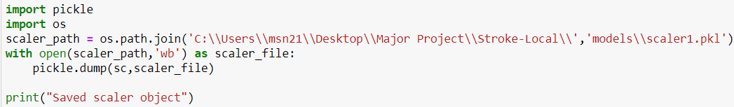

Figure: Code snippet for saving the scaler object

We have the model which has given us the highest accuracy for using it as the prediction model for the project.

**5.10 COMPUTING TRAINING SCORE OF MODELS**

The following are the ML algorithms that will apply to dataset. Results will contain train-validation-test scores, confusion matrix, statistical information and classification reports for each algorithm.

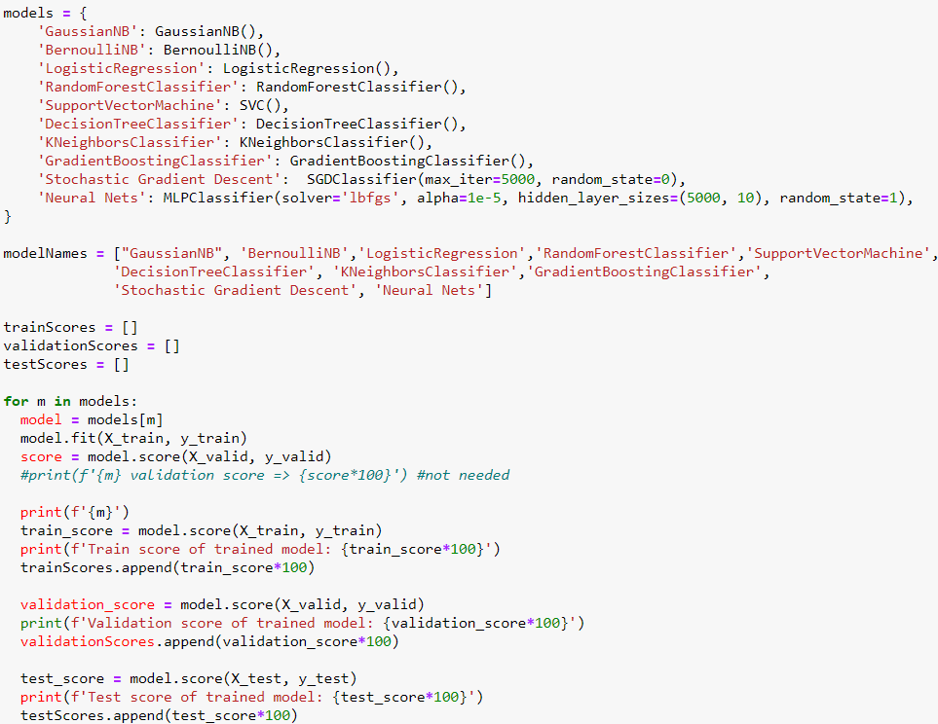

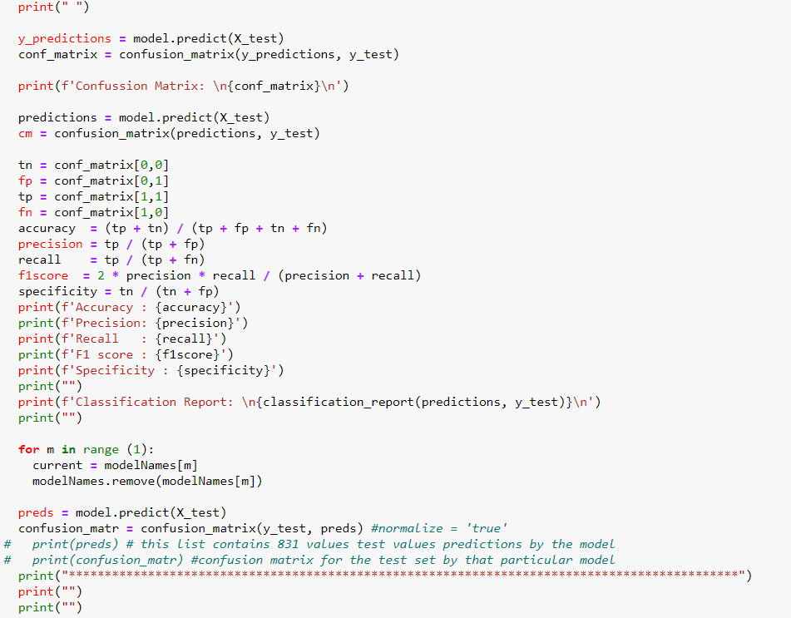

Figure: Code snippet for computing accuracy, precision, recall, F1 score, specificity and confusion matrix of various ML algorithms

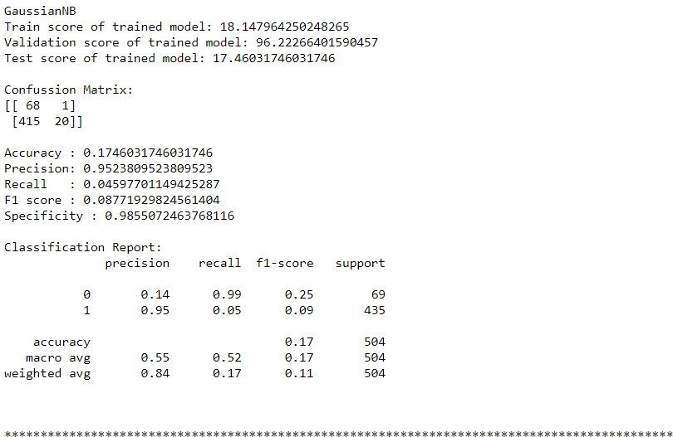

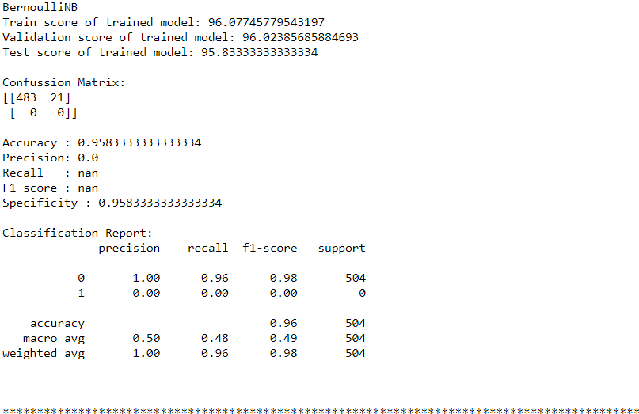

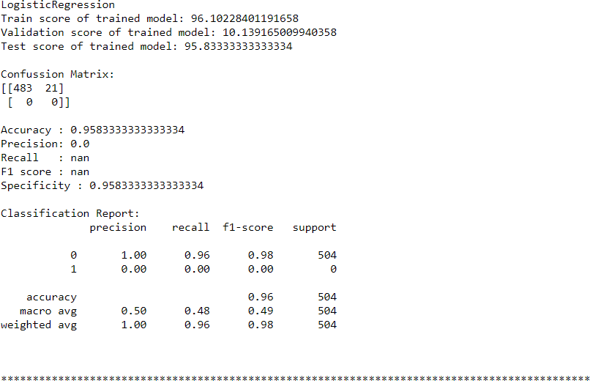

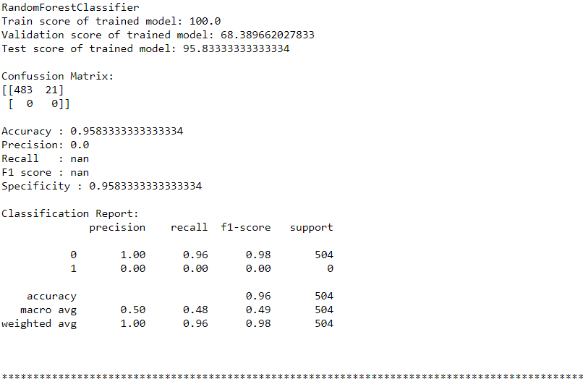

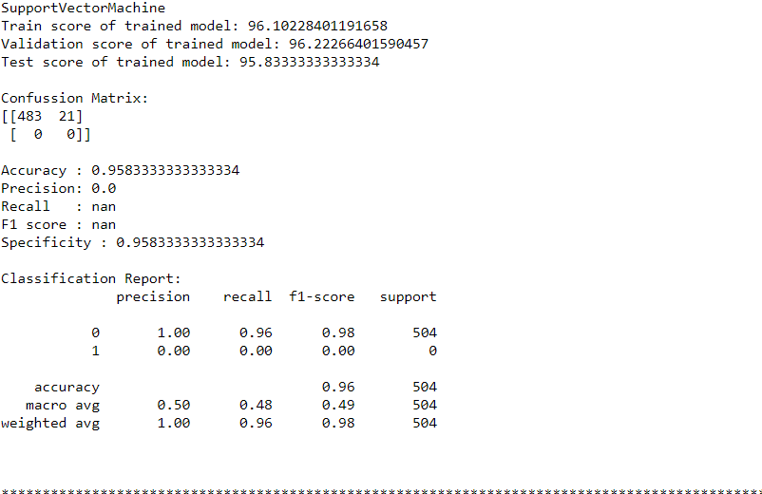

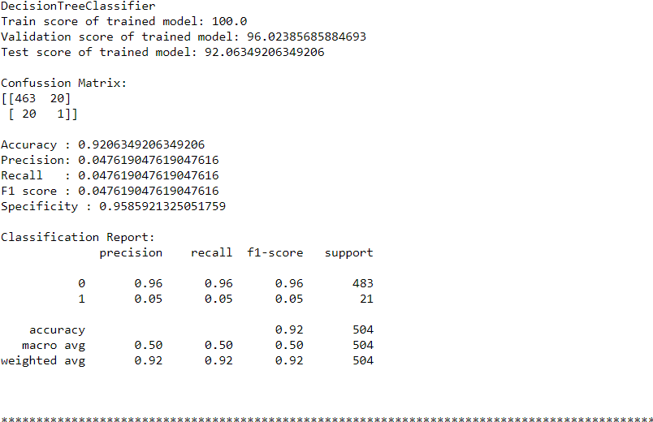

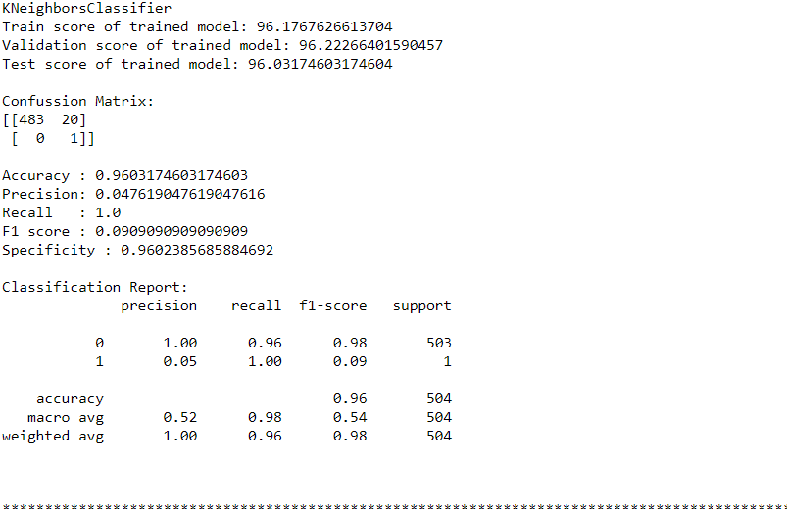

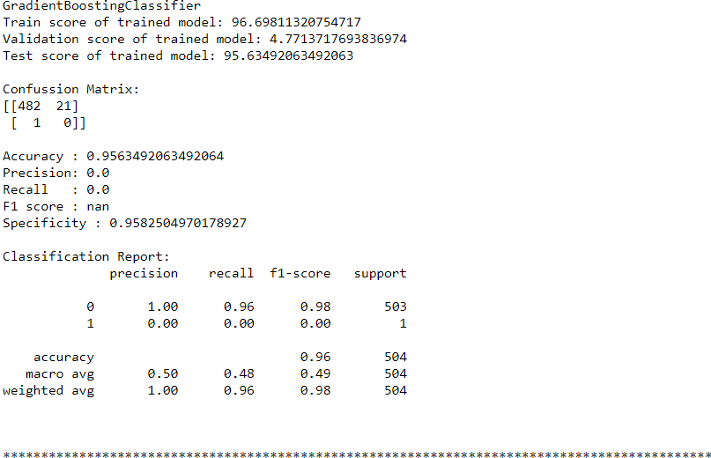

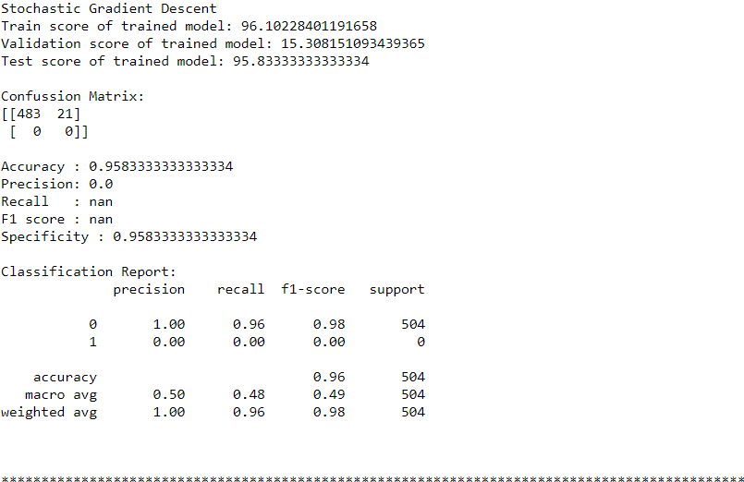

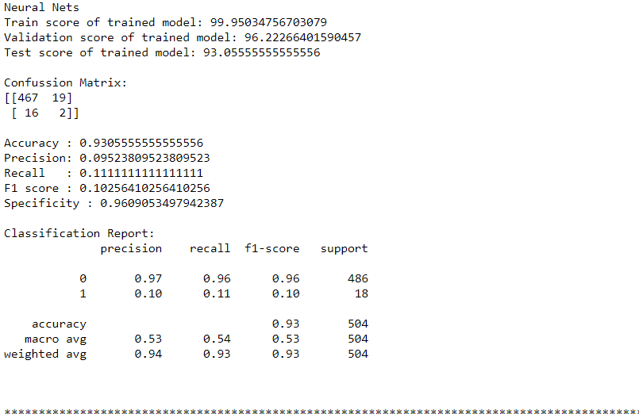

Figure 5.14: Output containing accuracy, precision, recall, F1 score, specificity and confusion matrix of various ML algorithms

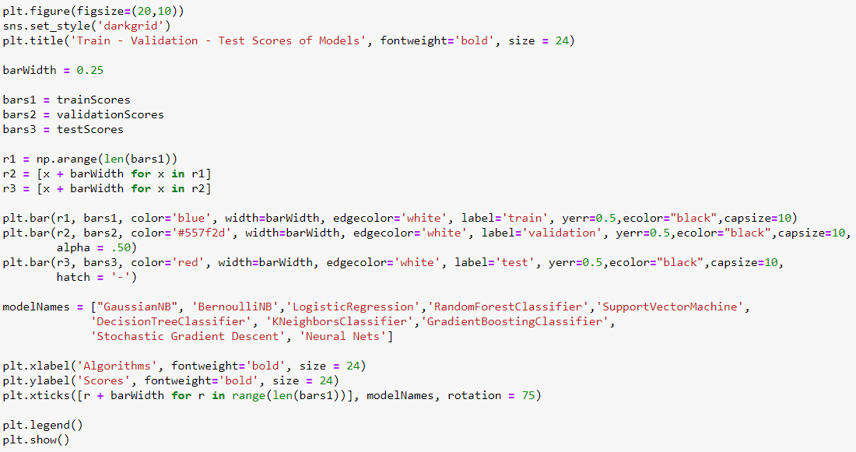

Figure: Code snippet to graphically visualize the train-validation-test score of models

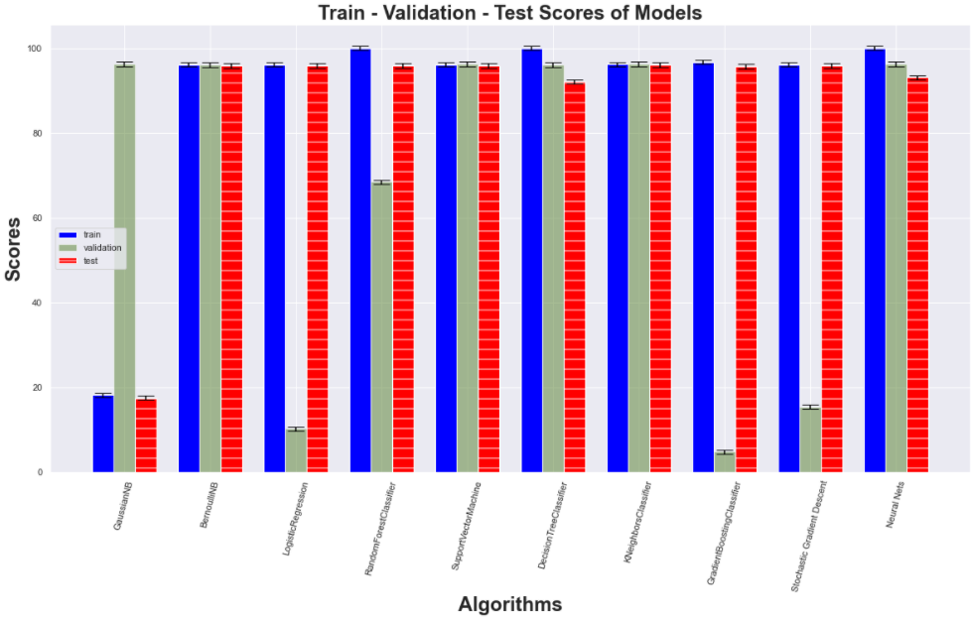

Figure 5.15: Graphical output of train-validation- test score of models

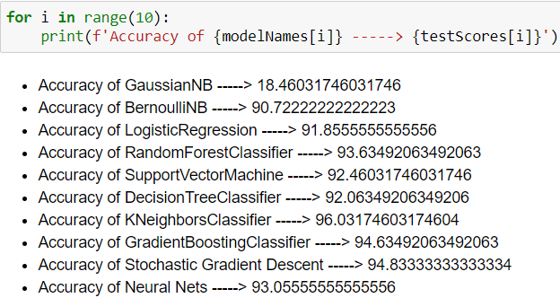

Figure 5.16: Code snippet and output showing the accuracy of each model

We observed that K Neighbors Classifier has the highest accuracy of 96.03174603174604

**5.11 MODEL SELECTION AND OPTIMIZATION**

We evaluated these models according to their accuracies, precision, recall, F1 score, specificity and created their confusion matrix. Selecting model based on parameter accuracy, Best algorithm is KNN with highest accuracy of 96.03%. Now we will make k-Fold Cross Validation and Hyper-Parameter Optimization for KNN algorithm**.**

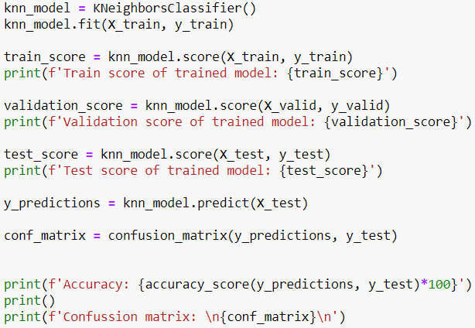

Figure: Code snippet for model selection and training for optimization

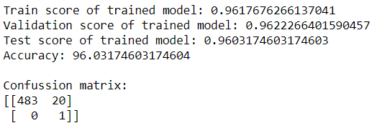

Figure: K Neighbors Classifier score along with accuracy and confusion matrix

**5.11.1 SAVING THE BEST MODEL**

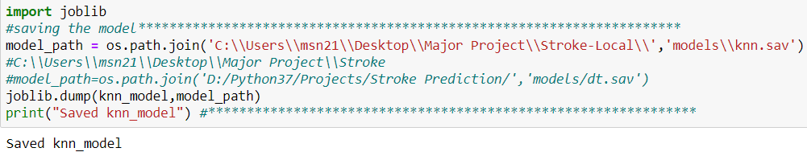

Figure: Code snippet for saving the KNN Model

**5.11.2 MODEL OPTIMIZATION: K-FOLD CROSS VALIDATION**

Cross Validation will enable us to see whether we are facing an overfitting problem and also to see the quality of our model. Thus, it will enable us to test the performance of our model before encountering high error rates in the test data set that we have not seen yet. It is a method that is frequently used because it is easy to apply.

**cv = 10 means k = 10 for KNN.**

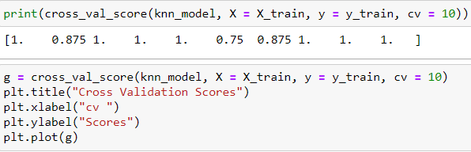

Figure: Code snippet to implement K-Fold Cross validation

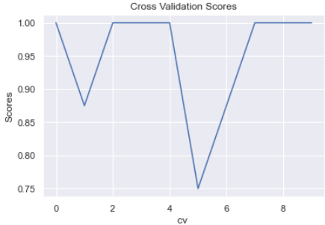

Figure 5.17: Graphical output after implementing K-Fold Cross validation

**MEAN ABSOLUTE ERROR**

In statistics, mean absolute error (MAE) is a measure of errors between paired observations expressing the same phenomenon. Examples of Y versus X include comparisons of predicted versus observed, subsequent time versus initial time, and one technique of measurement versus an alternative technique of measurement.



Figure: Code snippet to compute MAE after applying K-Fold Cross Validation



Figure: Output showing MAE and std

**5.11.3 MODEL OPTIMIZATION: HYPERPARAMETER OPTIMIZATION**

Unlike parameters, hyperparameters are not learned during training the model. They are determined by the data scientist before the modeling phase. For example, KNN algorithm, which is one of the non-parametric classification algorithms, makes classification by looking at the nearest k neighbors to the desired value. Here, the k number (n_neighbors:) and the distance metric (metric:) to be used are the hyperparameters that should be specified by the data scientist before the modeling, which increases the performance of the model.

**Hyperparameter optimization** is the process of finding the most suitable hyperparameter combination according to the success metric specified for a machine learning algorithm.

Given that there are dozens of hyperparameters for a machine learning algorithm and dozens of values these hyperparameters can take, it's clear how difficult it will be to try all combinations one by one and pick the best combination. For this reason, different methods have been developed for hyperparameter optimization. GridSearcCV and RandomizedSearchCV are among these methods.

### **GridSearchCV:** For the hyperparameters and their values that are desired to be tested in the model, a separate model is established with all combinations and the most successful hyperparameter set is determined according to the specified metric.

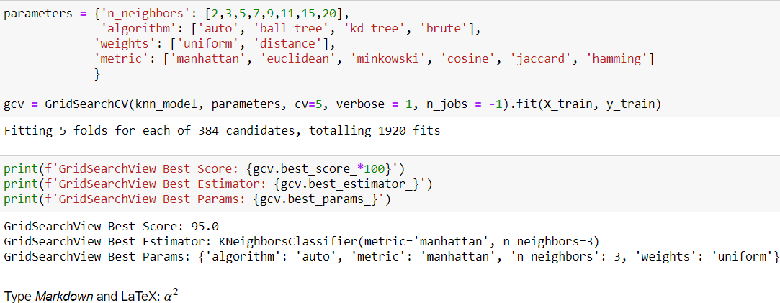

Figure: Code snippet and sample output after applying GridSearchCV

### **RandomizedSearchCV:** A set of hyperparameters is randomly selected and tested by cross-validation and the model set up. These steps continue until the specified calculation time limit or the number of iterations is reached.

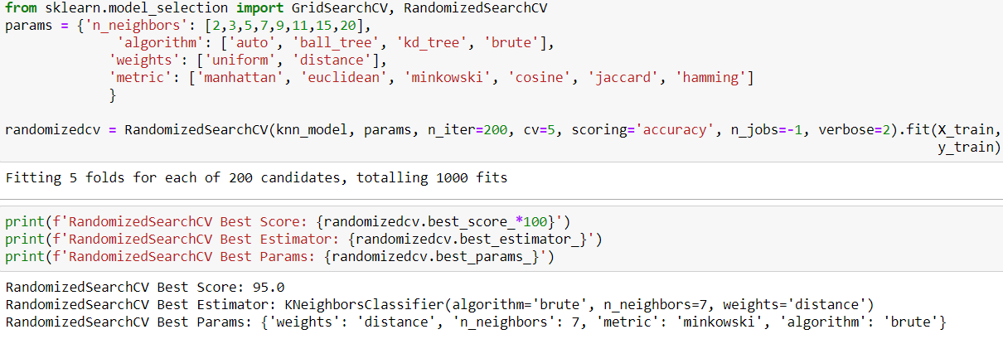

Figure: Code snippet and sample output after applying RandomizedSearchCV

**5.11.4 BEST FEATURE SELECTION**

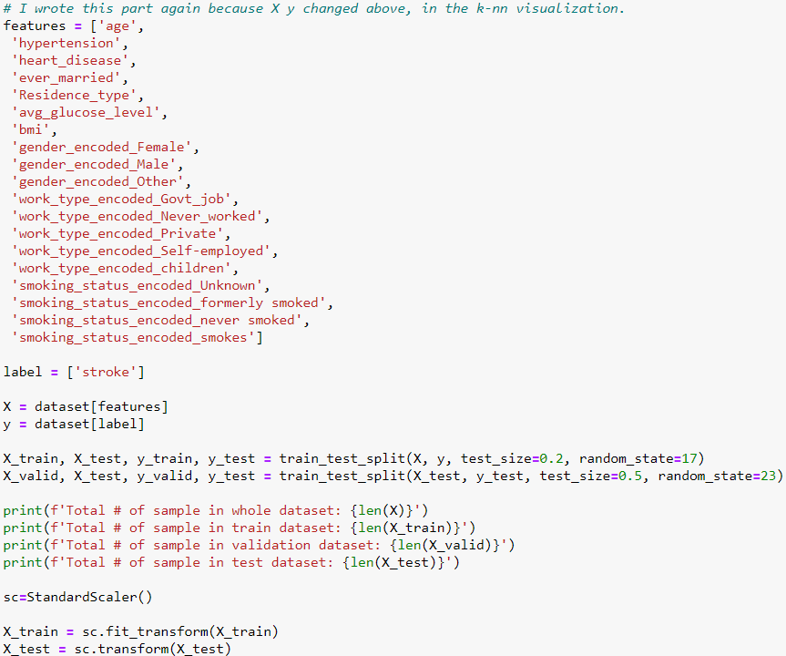

Figure: Code snippet for best feature selections

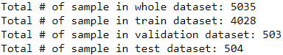

Figure: Sample output

**5.12 WEB PAGE DEVELOPMENT**

For the purpose of providing interfaces to users, we needed to develop a platform. Thus, we chose web development for this. In this project, we created a web app using Python and its web framework flask, which reduces development time and allows us to build faster and smarter. For the Frontend, we have created a simple webpage which consist of a form which is to be filled by the user.

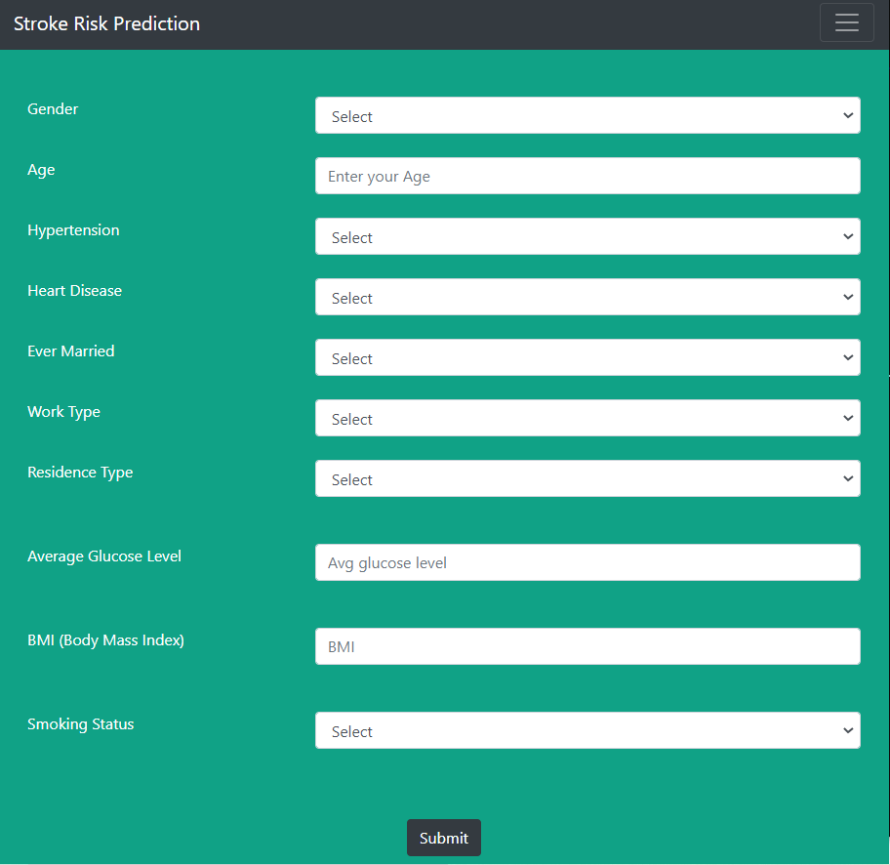

Figure 5.18: Layout of the webpage (User form)

**5.13 CONNECTING MODEL WITH FRONTEND AND PYTHON CODE**

The backend and frontend both work together to serve a single goal. It’s pretty helpful to keep it in mind at all times. They are made, so a user can access them.

WORKING OF WEBSITE

The user points their browser to one of your website’s URLs and waits for the browser to render the page. The user sees a useful and usable page. The user interacts with the page.

Thus, till now, our website was working as static. In order to connect it to our working python code, we used flask i.e., micro-framework of python. In this, we created several routes using route decorator and thus it helped us in hosting it to a local server - http://localhost:7000/

**5.14 PREDICTING THE RISK OF STROKE**

The index() function is decorated with @app.route so that it is invoked when the browser sends a POST request. Using the request module of Flask, it creates an object of the file and saves it in local storage. At the same time, it sends that filled parameters to python code by calling its function which in response returns the output string, which is then displayed on the webpage.

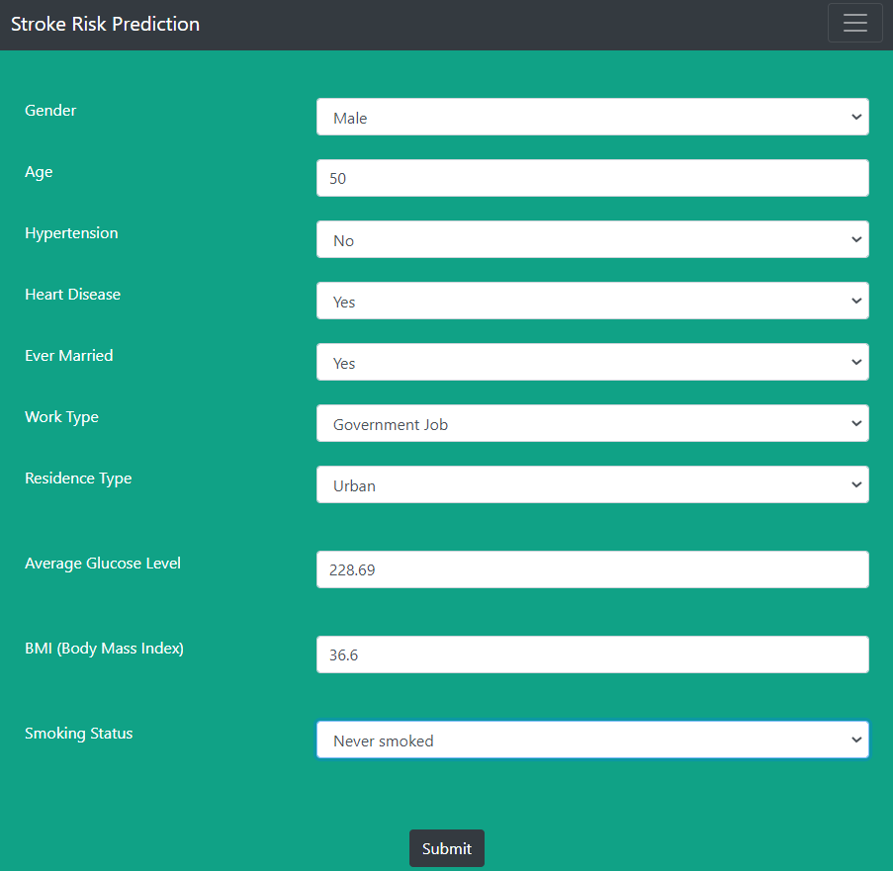

Figure: Sample input data filled in the Form

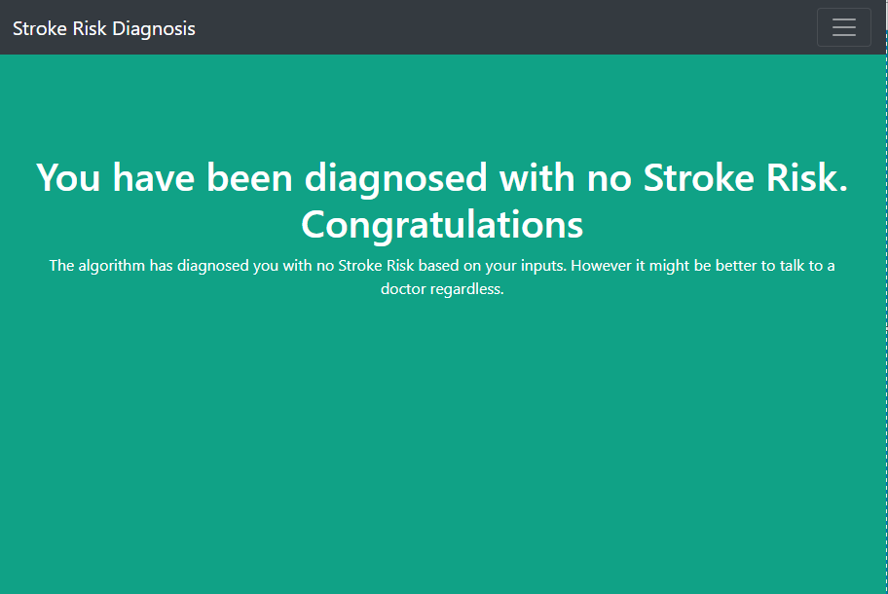

Figure 5.19: Sample results displayed at the Web Platform when using the model for prediction

Figure shows the front page of the Web App as visible to the user. Here he/she can fill the form based on their medical history and click on the submit button. The model functions in the background and provide the stroke risk which is shown on the Web App as shown in figure. Flask library is used to fetch the result predicted by the model and display it on the Web Page.

**CHAPTER – 6**

**CONCLUSIONS AND FUTURE SCOPE**

**6.1 CONCLUSIONS**

Through this project, we were able to build a system that can be used by user from the timing, location of his/her choice and check for chances of stroke to him. We compared 10 different machine learning classifiers based on accuracy on our dataset, used the best one and performed k-fold validation and hyper-parameter optimization on it too. We were able to understand the different and working of different classifiers and reason behind there particular behavior on our dataset. We are ultimately able to achieve our objective of learning about various machine learning classifier, comparing them and using the best one to build a system which can be used by anyone from anywhere to test the chances of stroke to him/her.

**6.2 FUTURE SCOPE**

There is a huge feature approach for this model some of which are enlisted below:

* The model is currently trained and tested for accuracy on a small dataset of approx. 5k records. We believe training it on any other dataset, which is bigger in size would enhance or prediction capability even more.
* Right now, the user is only asked for details in the form. We plan to enhance the web platform to display more information and statistics about the stroke.
* An android app for same purpose can be really useful and handy, we will this could be a potential future scope.
* Right now, the model uses 10 parameters for predicting the chances of stroke, adding more crucial parameters which play role in stroke and its prediction could be a really nice enhancement to the model.
* Adding more information about what stroke actually is, it causes, symptoms and other related and relevant information on the web page is also a nice and useful scope.
* Adding functionality to fetch all health record data and then use patient history for predicting chances of stroke could be a super huge enhancement.

**CHAPTER - 7**

**REFERENCES**

**Datasets:**

[1] “Dataset: Cardiovascular health study (CHS).” https://biolincc.nhlbi.nih.gov/studies/chs/. Accessed: 2016-05-8.

[2] "Stroke Prediction Dataset - (fedesoriano)." https://www.kaggle.com/fedesoriano/stroke-prediction-dataset

**Model Classifiers: -**

[3] Scikit-learn Supervised Models - https://scikit-learn.org/stable/supervised_learning.html

[4] Tony F.Chan, Gene H. Golub, Randall J. LeVeque:-Dept. Of CS, Standord NOV,1979 – “GaussianNB - UPDATING FORMULAE AND A PAIR-WISE ALGORITHM FOR COMPUTING SAMPLE VARIANCES” - {<https://scikit-learn.org/stable/modules/generated/sklearn.naive_bayes.GaussianNB.html> }

[5] MultinomialNB - {<https://nlp.stanford.edu/IR-book/html/htmledition/naive-bayes-text-classification-1.html> } {<https://scikit-learn.org/stable/modules/generated/sklearn.naive_bayes.MultinomialNB.html> }

[6] BernoulliNB - {<https://nlp.stanford.edu/IR-book/html/htmledition/the-bernoulli-model-1.html> } {<https://scikit-learn.org/stable/modules/generated/sklearn.naive_bayes.BernoulliNB.html> }

[7] CategoricalNB - {<https://scikit-learn.org/stable/modules/generated/sklearn.naive_bayes.CategoricalNB.html> }

[8] LinearRegression - {<https://scikit-learn.org/stable/modules/generated/sklearn.linear_model.LinearRegression.html> }

[9] KNeighborsClassifier - {<https://en.wikipedia.org/wiki/K-nearest_neighbors_algorithm> } {<https://scikit-learn.org/stable/modules/generated/sklearn.neighbors.KNeighborsClassifier.html> }

[10] Mark Schmidt, Nicolas Le Roux, Francis Bach - 10 May 2016 – “Logistic Regression - Minimizing Finite Sums with the Stochastic AverageGradient” - {<https://hal.inria.fr/hal-00860051v2> }

[11] Logistic Regression - {<https://en.wikipedia.org/wiki/Logistic_regression> } {<https://scikit-learn.org/stable/modules/generated/sklearn.linear_model.LogisticRegression.html> }

[12] Aaron Defazio, Francis Bach, Simon Lacoste-Julien - 16 Dec 2014 - “Logistic Regression - SAGA: A Fast Incremental Gradient Method With Support for Non-Strongly Convex Composite Objectives” - {arXiv:1407.0202v3,{<https://arxiv.org/pdf/1407.0202.pdf> }

[13] Hsiang-Fu Yu, Fang-Lan Huang, Chih – Jen Lin – “Logistic Regression - Dual Coordinate Descent Methods for Logistic Regression and Maximum Entropy Models” - {<https://www.csie.ntu.edu.tw/~cjlin/papers/maxent_dual.pdf> }

[14] Francesco Mola- 1998 – “Decision Tree Classifier - Classification and Regression Trees Software and New Developments”-{<https://sci-hub.se/10.1007/978-3-642-72253-0_42> }

[15] Decision Tree Classifier - {<https://en.wikipedia.org/wiki/Decision_tree_learning> } {<https://scikit-learn.org/stable/modules/generated/sklearn.tree.DecisionTreeClassifier.html> }

[16] Decision Tree Classifier - The Elements of statistical Learning Ebook- {<https://web.stanford.edu/~hastie/Papers/ESLII.pdf> }

[17] Tarun Gupta - Oct 2020 – “Decision Tree Classifier - Understanding Decision Tree Classifier Blog” - {<https://towardsdatascience.com/understanding-decision-tree-classifier-7366224e033b> }

[18] Support Vector Classification (SVC) - {<https://scikit-learn.org/stable/modules/generated/sklearn.svm.SVC.html> }

[19] Chih - Chung Chang and Chih Jen Lin - Jan 2021 – “SVC - LIBSVM: A Library for Support Vector Machines”- {<https://www.csie.ntu.edu.tw/~cjlin/papers/libsvm.pdf> }

[20] John C. Platt - 1999 - “SVM - Probabilistic Outputs for Support Vector Machines and Comparisons to Regularized Likelihood Methods”- {<http://citeseer.ist.psu.edu/viewdoc/summary?doi=10.1.1.41.1639> }

[21] Avinash Navlani - Dec 2019 - “SVM - Support Vector Machines with Scikit-learn Blog” {<https://www.datacamp.com/community/tutorials/svm-classification-scikit-learn-python>

[22] KMeans-{<https://scikit-learn.org/stable/modules/generated/sklearn.cluster.KMeans.html> }

[23] KMeans Clustering - {<https://en.wikipedia.org/wiki/K-means_clustering> }

[24] Imad Dabbura - Sept 2018 – “KMeans - K-means Clustering: Algorithm, Applications, Evaluation Methods, and Drawbacks” - {<https://towardsdatascience.com/k-means-clustering-algorithm-applications-evaluation-methods-and-drawbacks-aa03e644b48a> }

[25] Random Forest Classifier - {<https://scikit-learn.org/stable/modules/generated/sklearn.ensemble.RandomForestClassifier.html> }

[26] LEO BREIMAN - 2001 – “Random Forest Classifier - Random Forest” - {<https://link.springer.com/content/pdf/10.1023/A:1010933404324.pdf> }

[27] Random Forest Classifier - {<https://en.wikipedia.org/wiki/Random_forest> }

[28] Tony Yiu- Jun 2019 – “Random Forest Classifier - Understanding Random Forest - How the Algorithm Works and Why It Is So Effective Blog” - {<https://towardsdatascience.com/understanding-random-forest-58381e0602d2> }

[29] Avinash Navlani - May 2018 - “Random Forest Classifier - Understanding Random Forests Classifiers in Python Blog” - {<https://www.datacamp.com/community/tutorials/random-forests-classifier-python> }

[30] Gradient Boosting Classifier - {<https://scikit-learn.org/stable/modules/generated/sklearn.ensemble.GradientBoostingClassifier.html> }

[31] StandardScaler - {<https://scikit-learn.org/stable/modules/generated/sklearn.preprocessing.StandardScaler.html> }

[32] Jason Brownlee - Aug 2016- “XGBClassifier - How to Develop Your First XGBoost Model in Python Blog” - {<https://machinelearningmastery.com/develop-first-xgboost-model-python-scikit-learn/> }

[33] Jason Brownlee - May 2018 – “k-Fold Cross Validation - A Gentle Introduction to k-fold Cross-Validation Blog” {<https://machinelearningmastery.com/k-fold-cross-validation/> }

[34] k-Fold Cross Validation - Cross-validation: evaluating estimator performance - {<https://scikit-learn.org/stable/modules/cross_validation.html> }

[35] Markus Ojala, Gemma C. Garriga - Jun 2010 – “k-Fold Cross Validation - Permutation Tests for Studying Classifier Performance” - {<https://www.jmlr.org/papers/volume11/ojala10a/ojala10a.pdf> }

[36] k-Fold Cross Validation - {<https://scikit-learn.org/stable/modules/generated/sklearn.model_selection.KFold.html> }

[37] Sanjay M- Nov 2018 – “k-Fold Cross Validation - Why and how to Cross Validate a Model? Importance and types of Cross-validation techniques Blog”- {<https://towardsdatascience.com/why-and-how-to-cross-validate-a-model-d6424b45261f> }

[38] Hyper-Parameter Optimization - {<https://en.wikipedia.org/wiki/Hyperparameter_optimization> }

[39] Pier Paolo Ippolito - Sept,2019 – “Hyper-Parameter Optimization - An introduction on how to fine-tune Machine and Deep Learning models using techniques such as: Random Search, Automated Hyperparameter Tuning and Artificial Neural Networks Tuning” - {<https://towardsdatascience.com/hyperparameters-optimization-526348bb8e2d> }

[40] James Bergstra, Yoshua Bengio - 2012 – “Hyper-Parameter Optimization - Random Search for Hyper-Parameter Optimization” - {<https://www.jmlr.org/papers/volume13/bergstra12a/bergstra12a> }

[41] James Bergstra, Yoshua Bengio, Remi Bardenet, Balazs Kegl - Nov,2011 – “Hyper-Parameter Optimization - Algorithms for Hyper-Parameter Optimization” - {<https://hal.inria.fr/hal-00642998/file/draft1.pdf> }

[42] Yufei Xiaa, Chuanzhe Liua, Yu Ying Lib, Nana Liua - Feb,2017 – “Hyper-Parameter Optimization - A boosted decision tree approach using Bayesian hyper-parameter optimization for credit scoring” - {<https://sci-hub.se/10.1016/j.eswa.2017.02.017> }

[43] GridSearchCV - {<https://scikit-learn.org/stable/modules/generated/sklearn.model_selection.GridSearchCV.html> }

[44] RandomizedSearchCV -{<https://scikit-learn.org/stable/modules/generated/sklearn.model_selection.RandomizedSearchCV.html> }

[45] Papa Moryba Kouate - Sept,2020 – “GridSearchCV - Machine Learning: GridSearchCV & RandomizedSearchCV - Hyperparameter tuning with GridSearchCV and RandomizedSearchCV Blog” - {<https://towardsdatascience.com/machine-learning-gridsearchcv-randomizedsearchcv-d36b89231b10>}

[46] Benjamin Letham, Cynthia Rudin, Tyler H. Mccormick And David Madigan – 2015-“Interpretable Classifiers Using Rules And Bayesian Analysis: Building A Better Stroke Prediction Model”

[47] Luis Garcia-Terriza, Jose L. Risco-Martin, Jose L. Ayala, Gemma Reig Rosello, Juan M. Camarasaltas - April 2019 – “Comparison of Different Machine Learning Approaches To Model Stroke Subtype Classification And Risk Prediction”

[48] Ibrahim Abuaqel, Abdullah Alsaif, Mohammed Almulhim, Mohammed Aljallal, Musab Alghuraibi, Mujahid Alzahrani, Abdulrahman AlHarby, Sunday O. Olatunji. - 2017

“Prediction Models Aided Postoperative Decision Making Based on Neural Network and Support Vector Machines”

[49] Pattanapong Chantamit-o-pas and Madhu Goyal – 2017 – “Prediction of Stroke Using Deep Learning Model”

[50] Priya Govindarajan, Ravichandran Kattur Soundarapandian, Amir H. Gandomi, Rizwan Patan, Premaladha Jayaraman, Ramachandran Manikandan - Nov 2018- “Classification of stroke disease using machine learning algorithms”

[51] Aditya Khosla, Yu Cao, Cliff Chiung-Yu Lin, Hsu-Kuang Chiu, Junling Hu, Honglak Lee - July 2017 – “An Integrated Machine Learning Approach to Stroke Prediction”

[52] Yu, J., Park, S., Lee, H., Pyo, C.S., Lee, Y.S. (2020). An elderly health monitoring system using machine learning and in-depth analysis techniques on the NIH stroke scale. Mathematics, 8(7): 1-16. <https://doi.org/10.3390/math8071115>

[53] Monteiro, M., Fonseca, A.C., Freitas, A.T., Melo, T.P., Francisco, A.P., Ferro, J.M., Oliveira, A.L. (2018). Using machine learning to improve the prediction of functional outcome in ischemic stroke patients. IEEE/ACM Transactions on Computational Biology and Bioinformatics, 15(6): 1953-1959. <https://doi.org/10.1109/TCBB.2018.2811471>

[54] Sung, S.F., Lin, C.Y., Hu, Y.H. (2020). EMR-based phenotyping of ischemic stroke using supervised machine learning and text mining techniques. IEEE Journal of Biomedical and Health Informatics, 24(10):2922-2931. <https://doi.org/10.1109/JBHI.2020.2976931>

[55] Xie, Y., Jiang, B., Gong, E., Li, Y., Zhu, G., Michel, P., Wintermark, M., Zaharchuk, Z. (2019). Use of gradient boosting machine learning to predict patient outcome in acute ischemic stroke on the basis of imaging, demographic, and clinical information. American Journal of Roentgenology, 212(1): 44-51. <https://doi.org/10.2214/AJR.18.20260>

[56] Wang, F., Huang, Y., Xia, Y., Zhang, W., Fang, K., Zhou, X., Yu, X., Cheng, X., Li, G., Wang, X., Luo, G., Wu, D., Liu, X., Campbell, B.C.V., Dong, Q., Zhao, Y. (2020). Personalized risk prediction of symptomatic intracerebral hemorrhage after stroke thrombolysis using a machine-learning model. Therapeutic Advances in Neurological Disorder, 13: 1-10. <https://doi.org/10.1177/1756286420902358>

[57] Lin, C.H., Hsu, K.C., Johnson, K.R., Fann, Y.C., Tsai,

C.H., Sun, Y., Lien, L.M., Chang, W.L., Lin, C.L., Hsu, C.Y., Registry, T.S. (2020). Evaluation of machine learning methods to stroke outcome prediction using a nationwide disease registry. Computer Methods and Programs in Biomedicine, 190: 105381. <https://doi.org/10.1016/j.cmpb.2020.105381>

[58] Sung, S.M., Kang, Y.J., Cho, H.J., Kim, N.R., Lee, S.M., Choi, B.K., Cho, G. (2020). Prediction of early neurological deterioration in acute minor ischemic stroke by machine learning algorithms. Clinical Neurology and Neurosurgery, 195: 105892. <https://doi.org/10.1016/j.clineuro.2020.105892>

[59] Bandi, V., Midhunchakkaravarthy, D., Bhattacharyya, D. (2020). Stroke Analysis. Mendeley Data. <https://doi.org/10.17632/jpb5tds9f6.1>

[60] P. Govindarajan, R. K. Soundarapandian, A. H. Gandomi, R. Patan, P. Jayaraman, and R. Manikandan, “Classification of stroke disease using machine learning algorithms,” Neural Computing and Applications, vol. 32, no. 3, pp. 817–828, Feb. 2020.

[61] S. M. Reza, M. M. Rahman, and S. Al Mamun, “A new approach for road networks-a vehicle xml device collaboration with big data,” in 2014 International Conference on Electrical Engineering and Information & Communication Technology. IEEE, 2014, pp. 1–5.

[62] C.-A. Cheng, Y.-C. Lin, and H.-W. Chiu, “Prediction of the prognosis of ischemic stroke patients after intravenous thrombolysis using artificial neural networks,” Studies in Health Technology and Informatics, vol. 202, pp. 115–118, 2014.

[63] S. Cheon, J. Kim, and J. Lim, “The Use of Deep Learning to Predict Stroke Patient Mortality,” International Journal of Environmental Research and Public Health, vol. 16, no. 11, 2019.

[64] M. S. Singh and P. Choudhary, “Stroke prediction using artificial intelligence,” in 2017 8th Annual Industrial Automation and Electromechanical Engineering Conference (IEMECON), Aug. 2017, pp. 158–161.

[65] C. Chin, B. Lin, G. Wu, T. Weng, C. Yang, R. Su, and Y. Pan, “An automated early ischemic stroke detection system using CNN deep learning algorithm,” in 2017 IEEE 8th International Conference on Awareness Science and Technology (iCAST), Nov. 2017, iSSN: 2325-5994.

[66] M. Monteiro, A. C. Fonseca, A. T. Freitas, T. Pinho e Melo, A. P. Francisco, J. M. Ferro, and A. L. Oliveira, “Using Machine Learning to Improve the Prediction of Functional Outcome in Ischemic Stroke Patients,” IEEE/ACM Transactions on Computational Biology and Bioinformatics, vol. 15, pp. 1953–1959, Nov. 2018.

[67] T. Kansadub, S. Thammaboosadee, S. Kiattisin, and C. Jalayondeja, “Stroke risk prediction model based on demographic data,” in 2015 8th Biomedical Engineering International Conference (BMEiCON), Nov. 2015, pp. 1–3.

[68] S. Y. Adam, A. Yousif, and M. B. Bashir, “Classification of Ischemic Stroke using Machine Learning Algorithms,” International Journal of Computer Applications, vol. 149, no. 10, pp. 26–31, Sep. 2016.

[69] S.-F. Sung, C.-Y. Hsieh, Y.-H. Kao Yang, H.-J. Lin, C.-H. Chen, Y.- W. Chen, and Y.-H. Hu, “Developing a stroke severity index based on administrative data was feasible using data mining techniques,” Journal of Clinical Epidemiology, vol. 68, no. 11, pp. 1292–1300, Nov. 2015.

[70] https://www.cdc.gov/stroke/facts.htm

[71] https://www.healthline.com/health/stroke

[72] https://www.medicalnewstoday.com/articles/318098#risk-factors

[73] https://www.cedars-sinai.org/health-library/diseases-and-conditions/i/ischemic-stroke.html

[74] source – https://www.cedars-sinai.org/health-library/diseases-and-conditions/h/hemorrhagic-stroke.html

[75] https://www.nhs.uk/conditions/transient-ischaemic-attack-tia/causes/

[76] https://www.mayoclinic.org/diseases-conditions/transient-ischemic-attack/symptoms-causes/syc-20355679

**APPENDICES**

**APPENDIX 1**

**1.1 DETAILED TEST STRATEGY AND TEST CASES**

Our project is based on medical data collected from different hospitals. The testing and validation of model is performed using the scikit-learn functions.



Figure A1: Image of histogram showing the comparison of train, test and validation score.

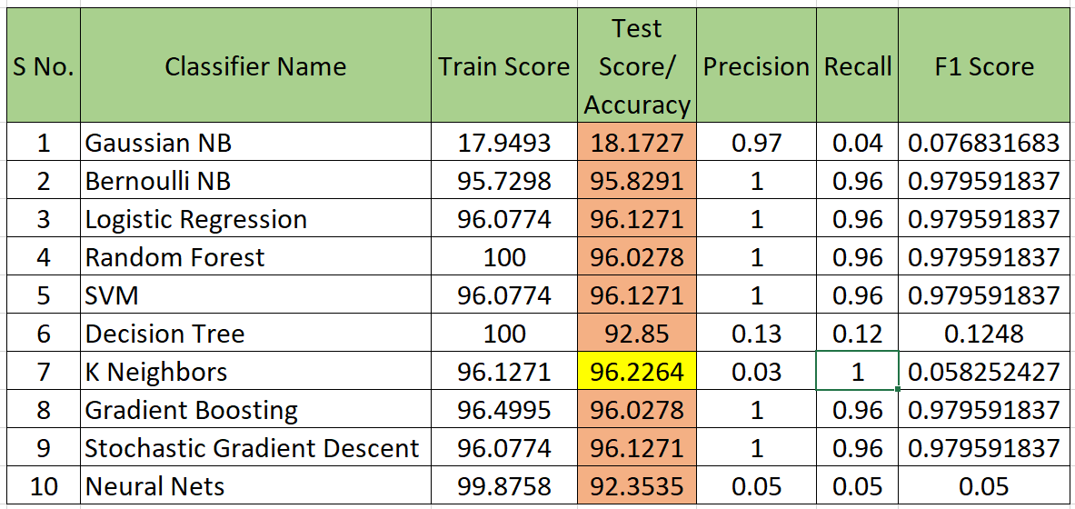

Figure A2. Comparison Score of different models representing scores of accuracies, precision, recall, and F1 score.

The detailed report for performance of different models is attached in chapter 5. About the testing in real life scenario, it is to be done on field.

**APPENDIX 2**

**2.1 USER GUIDE**

The user needs to follow the below-mentioned procedure for using the model to predict the chances of stroke to him/her.

Step 1: Visit to the webpage using “https://strokemsp.herokuapp.com”

Step 2: Fill in all the details asked.

Step 3: Click on submit button and wait for a moment for the model to predict.

Step 4: Within a few moments the model will predict the results which is being displayed to you on a new web page.

Step 5: If the model predicts you to have stroke risk, we recommend you to pay a visit to a doctor.

Step 6: Done. If the model predicts you having no risk of stroke; and still, you feel any of the symptoms we recommend you to talk to a doctor.

**EOF**