URL - <http://udacity-c2-image-filter-dev.us-east-2.elasticbeanstalk.com/filteredimage?image_url=https://homepages.cae.wisc.edu/~ece533/images/airplane.png>

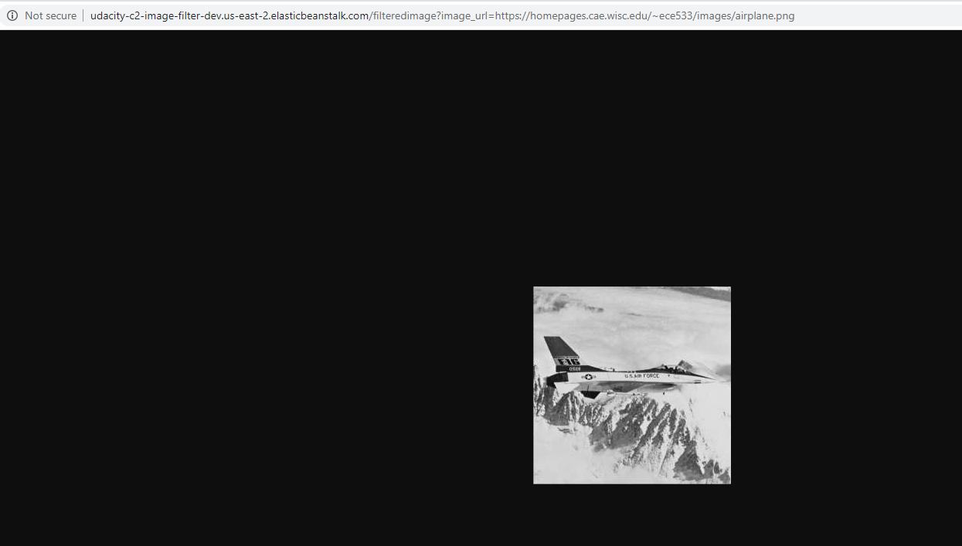

GIThub - <https://github.com/msnanda/udacity-c2-image-filter-dev.us-east>