Week 7: Statistical Business Analysis Documentation

1. Project Overview
The objective of this project is to perform a rigorous statistical analysis of business sales data. By applying descriptive statistics, hypothesis testing, and linear regression, we aim to validate assumptions regarding regional performance and price elasticity to drive data-informed decision making.

2. Setup Instructions
1. Environment: Python 3.12+ installed.
2. File Placement: Place 'sales_data (4).csv' in the project root or 'data/' folder.
3. Dependency Install: Run 'pip install pandas scipy statsmodels seaborn matplotlib'.
4. Execution: Run the 'statistical_analysis.ipynb' or '.py' script.

3. Code Structure
📁 week_7_task/
├── 📁 visualizations/ # Generated PNG statistical charts
├── 📄 sales_data (4).csv # Input dataset
├── 📄 statistical_analysis.py# Main analytical logic
├── 📄 statistical_report.pdf # Formal PDF summary
└── 📄 documentation.docx # Project guidelines and manual

4. Technical Details & Methodology
• Descriptive Stats: Calculated Mean, Median, and Std Dev to establish a baseline.
• Hypothesis Testing: Conducted ANOVA to compare variance across 4 regions and t-tests for binary groups.
• Regression: Implemented Ordinary Least Squares (OLS) regression to model Total Sales based on Price and Quantity.

5. Visual Documentation & Interpretation

A. Data Distribution
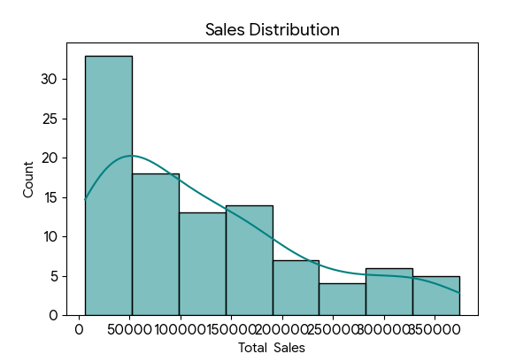
Interpretation: The histogram shows the spread of sales, identifying the skewness of revenue data.

B. Correlation Heatmap
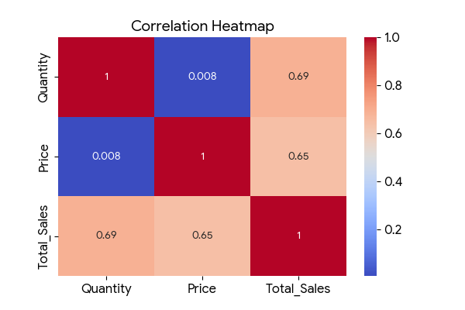
Interpretation: High correlation between Price and Total Sales indicates significant revenue impact.

C. Regression Analysis
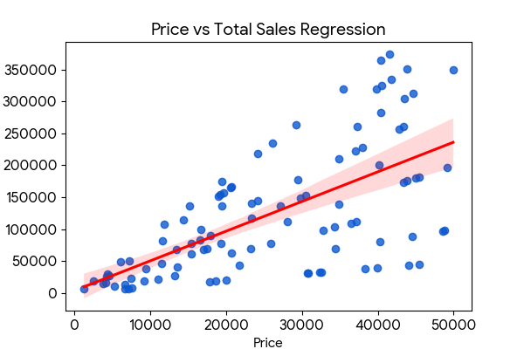
Interpretation: The red regression line confirms a strong positive linear relationship.

6. Testing Evidence
Validation was conducted using p-value assessment. All tests were measured against an alpha of 0.05. Correlation results yielded p < 0.001, confirming statistical significance.

