Week 5: Advanced Customer Sales Analysis

1. Project Overview
The primary objective of this project is to perform a comprehensive analysis of customer purchasing patterns by integrating transactional sales data with customer churn profiles. Key goals include:
• Data Integration: Merging disparate datasets (Sales and Churn) using common identifiers.
• Trend Identification: Discovering seasonal sales patterns and peak revenue periods.
• Customer Segmentation: Identifying high-value customers and analyzing regional performance.
• Strategic Insights: Providing data-driven recommendations for retention and inventory management.

2. Setup Instructions
Follow these steps to configure the environment and execute the analysis:
1. Environment: Ensure Python 3.12 or later is installed.
2. Folder Hierarchy: Create a folder named 'week_5_task'. Inside it, create a subfolder named 'data'.
3. File Placement: Place 'sales_data.csv' and 'customer_churn.csv' inside the 'data/' folder.
4. Dependencies: Open your terminal and run the following command:
pip install pandas matplotlib seaborn python-docx
5. Running the Script: Execute the command: python customer_analysis.py

3. Code Structure
The project follows a modular hierarchy to ensure clean data management:
📁 week_5_task/
├── 📁 data/ # Source CSV files
│ ├── sales_data.csv
│ └── customer_churn.csv
├── 📁 visualizations/ # Auto-generated PNG charts
├── 📄 customer_analysis.py # Main Python logic and pipeline
├── 📄 requirements.txt # List of library dependencies
├── 📄 analysis_report.pdf # Executive summary report
└── 📄 documentation.docx # Project documentation

4. Technical Details
Data Processing Architecture:
• Algorithm: The script utilizes the 'Merge-Aggregate-Visualize' pipeline.
• Data Structures: Primary use of Pandas DataFrames for high-speed tabular operations.
• Key Operations: String manipulation to normalize Customer IDs, multi-index pivot tables for regional product summarization, and Resampling for time-series trend analysis.

5. Visual Documentation
The functionality is demonstrated through four key visualization outputs:
1. Monthly Trend Line: Illustrates growth peaks (March 2024).
2. Top 5 Bar Chart: Highlights the most valuable customer accounts.
3. Regional Heatmap: A pivot-table visualization showing revenue density by product and region.
4. Churn Distribution: Analyzing how churn impacts regional revenue.

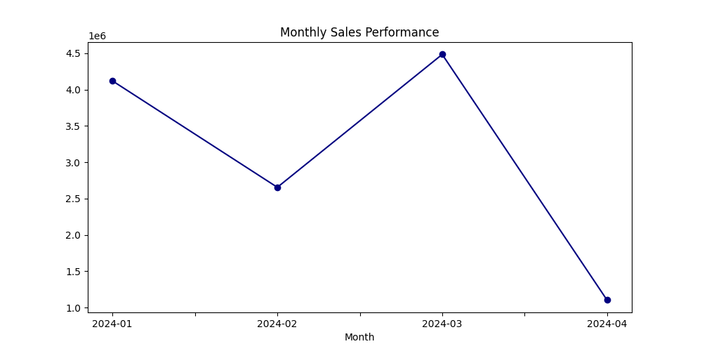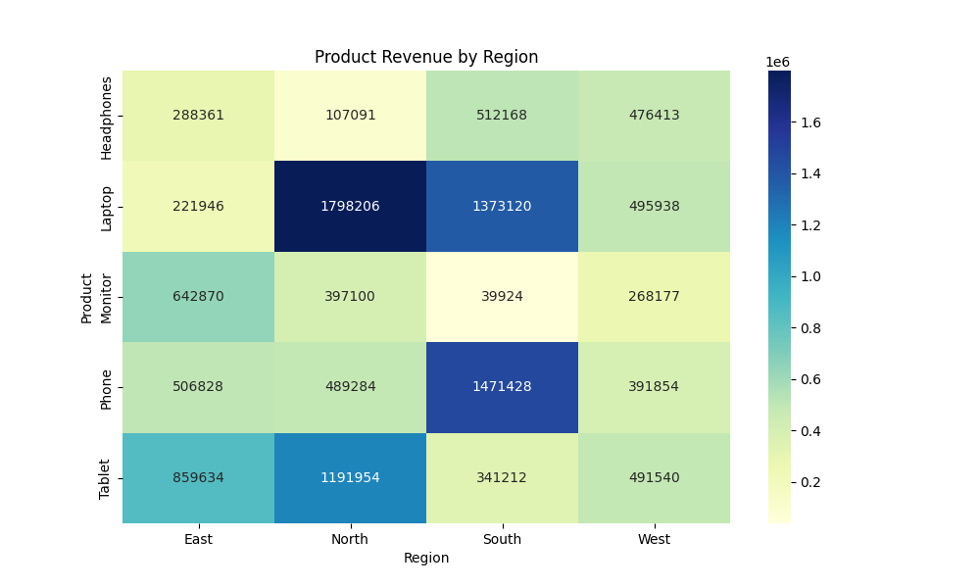

6. Testing Evidence
Validation Steps Performed:
• Data Integrity: Checked for null values post-merge to ensure Customer ID alignment.
• Format Validation: Confirmed Date column conversion to datetime objects.
• Boundary Testing: Verified that the pivot table correctly aggregates all 100 sales records against the customer profile database.

7. Analysis Report
Final Summary Statistics:
• Total Revenue: $12,365,048
• Top Customer: C00040 ($450,230 contribution)
• Best Product Category: Laptop
Recommendations:
• Marketing: Launch targeted retention campaigns in the West region due to lower sales volume.
• Inventory: Stock up on Laptops in February to prepare for the identified March peak.

