E8
Elev8 Comply
User Manual
How the system works, where to find what you need, and what to do when something breaks — for admins, reviewers, dispatchers, technicians and clients.
www.elev8comply.com
Version 1.0 · October 2026
Contents
1. Overview 4
Who uses it 4
How work flows 4
2. Getting Started 6
Your invite email 6
Signing in 6
Forgot your password 6
My Account (staff) and Profile (clients) 6
3. Admin Guide 8
Dashboard 8
Add a notice yourself 8
Properties and client accounts 8
People and settings 8
4. Reviewer Guide 9
When a new notice comes in 9
Review and send the proposal 9
When the client answers 9
5. Dispatcher Guide 10
The Dispatch page: your to-do list 10
Confirm a work date 10
Create a work order 10
Assign and dispatch a technician 10
The 48-hour advance notice 11
Generate Cal/OSHA forms 11
6. Technician Guide 12
Your work 12
Update the status as you go 12
Your license numbers 12
7. Client Portal Guide 13
Overview and My Jobs 13
Send us a new Cal/OSHA notice 13
Review a proposal 13
Pick a work date 13
Your profile 13
8. Settings & Administration 14
Add a user 14
Edit a user 14
Deactivate or reactivate a user 14
Resend an invite 15
Technician licenses 15
Cal/OSHA form templates 15
Company details on forms 15
9. Emails & Text Messages 16
Emails 16
Text messages (SMS) 16
10. Troubleshooting 18
Anyone can fix 18
Admin / technical 18
Known limitations (current version) 19
11. Behind the Scenes 20
The services 20
How a change goes live 21
Settings (Vercel → elev8 → Settings → Environment Variables) 21
Email domain (DNS) 22
Logs: where to look when something fails 22
Phone apps 22
Test accounts 23

If the page numbers above look out of date after editing, right-click the contents and choose Update Field → Update entire table.

1. Overview
Elev8 Comply turns a Cal/OSHA elevator notice into finished, documented work: it reads the notice, drafts the proposal, gets the client's approval and date, dispatches a technician, and fills in the official state forms. It runs in any web browser at www.elev8comply.com — on a computer, tablet or phone.

Who uses it
Role | Who they are | Their main job in the app
Admin | Office owner / manager | Everything, plus users, properties and settings
Reviewer | Estimator / compliance reviewer | Checks parsed notices and AI-drafted proposals, sends proposals to clients
Dispatcher | Scheduler | Confirms dates, creates work orders, assigns and dispatches technicians, generates forms, tracks 48-hour notices
Technician | Field mechanic | Sees assigned work orders and updates status from the field
Client | Property manager / building owner | Uploads notices, approves proposals, requests work dates, follows job progress

How work flows
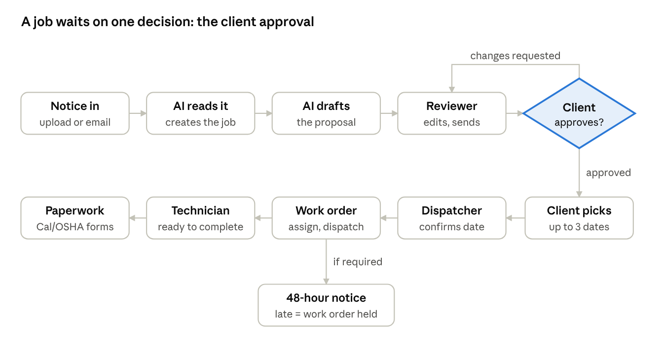
How a job moves from notice to filed paperwork
Everything before the client's approval is office work on the proposal; everything after is scheduling, the field visit and the state paperwork.
- Notice in. A Cal/OSHA order (Order to Comply / preliminary order) arrives as a PDF: uploaded by staff, uploaded by the client, or forwarded by email.
- AI reads it. The app extracts the property, State No., deadline, violations, required tests, urgency and whether a 48-hour advance notice is needed. A job is created and assigned to a reviewer.
- Proposal drafted. The AI writes a draft proposal (letter and priced line items). The reviewer gets an email, checks and edits it, and clicks Send to Client.
- Client decides. The client approves, requests changes, or declines in the client portal.
- Date set. After approving, the client requests up to three preferred dates. The dispatcher confirms one and the client is emailed.
- Work order and dispatch. The dispatcher creates a work order, finds and assigns a technician, and dispatches the job. The technician gets an email with the dispatch packet (and a text if they opted in to SMS).
- 48-hour notice. Before an annual or five-year test the state may witness, the Cal/OSHA district office needs 48 hours' notice (form EU-787). The app tracks that deadline, warns staff, and holds the work order if the notice is late.
- In the field. The technician marks the work order Ready, En Route, On Site, and Complete.
- Paperwork. The dispatcher generates the official Cal/OSHA forms (EU-632, DOSH-100, EU-787 and others), filled in with job, technician and company details.

Job stages you will see: Notice Received → Proposal Drafted → Proposal Sent → Approved → Scheduled → Dispatched. A job goes to Under Review if the client requests changes or declines. All dates and times in the app are California (Pacific) time.

2. Getting Started
Everyone gets into Elev8 Comply the same way: an administrator adds you, you get an invite email, and you set your own password. You never need to share a password with anyone.

Your invite email
- Look for an email from Elev8 Comply <no-reply@elev8comply.com> with the subject You're invited to Elev8 Comply. Check spam if it isn't there after a few minutes.
- Click Accept Invitation & Set Password.
- On the page that opens, click Continue. (This extra click protects the link from company email scanners, which open links automatically and would otherwise use it up.)
- Choose a password of at least 8 characters, type it twice, and click Update Password. You land in the app, already signed in.

The link works once. If it has expired or was already used, ask your administrator to click Resend invite on your user page.

Signing in
- Go to www.elev8comply.com/login, enter your email and password, and click Sign In.
- After sign-in, each role lands on its home page: admin and reviewer on Dashboard, dispatcher on Jobs, technician on My Work, client on the client portal.
- Do not reply to any email from Elev8 Comply. Replies are not read. Every email has a button that takes you to the right page.

Forgot your password
- On the sign-in page, click Forgot password?
- Enter your email and click Send Reset Link. The page always says "If that email has an account, we've sent it a password reset link" — it never reveals who has an account.
- Open the email Reset your Elev8 Comply password, click Reset Password, then Continue, and choose a new password.

You can request one reset email per minute. A deactivated account gets no email.

My Account (staff) and Profile (clients)
Staff open My Account at the bottom of the left menu. Clients open Profile in the client portal menu. Both pages have the same sections:
Section | What you can change | Notes
Profile | Full name, phone | Click Save Profile. Your name updates everywhere, including technician records.
Sign-in Email | The email you sign in with | Enter the new address and click Send Confirmation Link. Nothing changes until you click Confirm New Email in the email sent to the new address. The old address gets a warning email. The link lasts 24 hours.
License Numbers (technicians only) | CCCM License #, QEI Number | Your CCCM number fills in on Cal/OSHA forms for jobs you're assigned to. Leave QEI blank if you aren't QEI certified.
Password | New password | At least 8 characters, typed twice. Click Change Password.
SMS Notifications | Opt in or out of text messages | Texts go only to people who opt in, at the number they enter here. Technicians get texts about assigned and dispatched work; admins and dispatchers get 48-hour notice alerts. Clients currently get email only. Reply STOP to any text to stop texts.

Your role (admin, reviewer, dispatcher, technician, client) can only be changed by an administrator.

3. Admin Guide
Admins see the whole menu: Dashboard, Notices, Jobs, Dispatch, Work Orders, Documents, Properties, Settings, My Account. Admins can do everything a reviewer and dispatcher can (sections 4 and 5), plus the tasks below.

Dashboard
Four counters (Active Jobs, Critical, Proposals to Review, Overdue Actions), the job pipeline by stage, and the latest notices and jobs. New Notice starts an upload.

Add a notice yourself
- Notices → New Notice.
- Pick the Account, optionally the Property, attach the PDF, and click Register Notice.
- Click Parse with AI. In under a minute the notice shows its parsed details, a job is created, and an AI proposal draft is ready.

On a notice's page: View PDF opens the original; Mark Reviewed records that a person checked the parsed details. Only use Re-Parse if parsing failed or came out wrong — each re-parse creates another job and draft.

Properties and client accounts
Properties holds each client company (account) and its buildings.
- Add New Account: company name, email, phone, address. The account email is where proposal emails go, so keep it current.
- Add Property: name, address, building type, elevator count. The pencil icon edits.
- Import CSV: download the template, fill it in, upload. Accounts are matched by name and must already exist.
- Delete a property only if it has no notices or jobs; deleting is immediate and is not blocked.

People and settings
Adding, editing and deactivating users, technician license numbers, and Cal/OSHA form templates are covered in section 8.

4. Reviewer Guide
Reviewers see Dashboard, Notices, Jobs, My Account. Your job: check what the AI read from each notice and get a correct proposal to the client.

When a new notice comes in
You get an email [URGENCY] AI Proposal Ready — property with a link to the draft. Critical notices go to an admin instead of a reviewer.
- Open Notices and click the notice. Compare the parsed panels — Property & Equipment, Key Compliance Requirements, Action Plan, Violation Items — against the PDF (View PDF).
- If the parse is right, click Mark Reviewed. If it failed (status Parse Failed) or is badly wrong, click Re-Parse once.
- Watch the job's risk flags: missing info, low parse confidence and critical urgency mean the AI was unsure — check those fields by hand.

Review and send the proposal
- Jobs shows a banner AI Proposals Awaiting Review. Open the job and click Review & Send → (or open the proposal from the job's Proposals list).
- Edit the Proposal Title, Proposal Letter and Line Items (description, quantity, unit price). Add Line adds a row; the total recalculates. Draft with AI rewrites the draft.
- Click Save Proposal, then Send to Client. The client company's email (set on the account in Properties) gets Proposal Ready for Review with a button straight to the proposal.

No AI draft? On the job, click New Proposal, then Draft with AI or type it yourself, and Create Proposal.

When the client answers
Client action | What happens | What you do
Approve Proposal | Job becomes Approved; client is asked to pick dates | Nothing — the dispatcher takes over
Request Changes (with a note) | Proposal becomes Revision Requested; job goes to Under Review; you get a Revision Requested email | Open the proposal, read the revision notes, edit, Save Proposal, Send to Client again
Decline | Proposal Rejected; job Under Review; staff get Proposal Declined | Contact the client by phone

The Jobs page banner Client Requested Changes lists every job waiting on you.
Proposals show an expiry date 30 days after sending; it turns red when passed, but the client can still approve — follow up by phone on old ones.

5. Dispatcher Guide
Dispatchers see Notices, Jobs, Dispatch, Work Orders, Documents, My Account and land on Jobs after sign-in. Your job: turn approved jobs into scheduled, dispatched work with the paperwork done.

The Dispatch page: your to-do list
Section | What it lists | What you do
Action Plans Pending Dispatch Review | Parsed notices waiting to become work orders | Review & Approve
48-Hour Notices Requiring Action | Work orders whose 48-hour notice is due within 48 hours or overdue | Send the notice, then Mark Notice as Sent
Scheduling Confirmation Needed | Client date requests waiting for you | Open and confirm a date
Active Work Orders | Everything in progress | Open to assign, dispatch or hold

Approve Action Plan & Create Work Order marks the notice reviewed and takes you straight to a new work order for that job.

Confirm a work date
You get a New Scheduling Request email when a client picks dates.
- Open it from Dispatch → Scheduling Confirmation Needed.
- Read the client's preferred dates and notes. Enter Confirmed Start, Confirmed End (Pacific time), any access notes and compliance notes.
- Click Confirm Date & Notify Client. The client gets Work Date Confirmed with your company phone for changes.

To change a confirmed date, call the client and agree a new one; the app has no reschedule button yet.

Create a work order
- Open the job and click Create Work Order.
- Check Scheduled Start / End (filled from the confirmed date), choose Region and Required Skill, switch on 48-Hour Advance Notice Required if the work includes a state-witnessed annual or five-year test, and add Dispatch Notes.
- Click Create Work Order. It starts as Draft with a dispatch packet, and the job moves to Dispatched.

Assign and dispatch a technician
- On the work order, click Find Technicians. Each technician gets a match score (skill + region + availability); 4 or more is marked Best match.
- Click Assign on the right person. The work order becomes Assigned and the technician gets a text if they opted in to SMS.
- When ready, click Dispatch to Technician. They get an email (plus a text if they opted in to SMS) Dispatch: date — property with the full packet.

Dispatch is blocked while a required 48-hour notice is overdue. Hold pauses a work order that is Assigned, Dispatched, Ready or En Route; Release Hold puts it back to Assigned (or Draft if no technician is assigned).

The 48-hour advance notice
Before an annual or five-year test that the state may witness, the Cal/OSHA district office expects at least 48 hours' notice, given on form EU-787 (Annual and 5 Year Test Notification). The 48 hours is standard practice rather than a figure written in the regulation, so follow your district office's instructions. For work orders with the 48-hour switch on, the app sets the deadline to 48 hours before the confirmed start and checks every 30 minutes.
- 24 hours before the deadline: admins and dispatchers get one alert email (and a text, if they opted in to SMS). They get one more, marked URGENT, when 4 hours are left.
- Past the deadline: the notice becomes Overdue, the work order is put on Held, and admins and dispatchers get an escalation.

To clear it: generate the notice (Documents → 48-Hr Notice, or Generate 48-Hr Notice on the job), send it, then click Mark Notice as Sent on the work order. If the work order was already put on Held because the notice was late, marking it sent lifts the hold automatically and the work order goes back to Assigned.

Generate Cal/OSHA forms
- Documents lists parsed notices under Select a Preliminary Order to Generate Documents, with a button per form (EU787, EU776A, EU776B, DOSH100, EU632, 48-Hr Notice). A greyed-out button means that blank form isn't uploaded yet (admin: section 8).
- Review the pre-filled fields, change anything under Additional Field Overrides, choose Flatten form fields for a final copy, and click Generate … — Official Cal/OSHA Form.
- Click Download … PDF and save it in your job files.

What fills in automatically: property, State No. and owner from the notice; the assigned technician's CCCM number; your company's CQCC number; your company name, address, phone and email. The 48-hour notice PDF is also saved to the Document Vault (bottom of Documents); the other forms are download-only, so keep your copy.
Notices disappear from the generate list once someone clicks Mark Reviewed; generate forms before that, or use the job page's Generate EU-787 / DOSH-100 / EU-632 buttons.

6. Technician Guide
Technicians see My Work and My Account. Everything works on a phone browser or the Elev8 Comply phone app.

Your work
- When a work order is dispatched to you, you get an email Dispatch: date — property with the full packet. If you opted in to SMS (My Account → SMS Notifications), you also get a text when a job is assigned and when it's dispatched.
- My Work lists Active Work Orders and Recently Completed. Tap one to see the dispatch packet: property, address, scheduled time, access notes, required work and the dispatcher's notes.

Update the status as you go
- Mark Ready — you have what you need and are ready to go.
- En Route — on your way.
- On Site — arrived at the building.
- Complete Job — type your completion notes (what was done, anything left open), then Confirm Completion.

The office sees each update right away.
If a work order shows Held, don't start the work — the 48-hour notice wasn't sent in time. Call the dispatcher.

Your license numbers
My Account → License Numbers: enter your CCCM License # and, only if you're QEI certified, your QEI Number, then Save License Numbers. Your CCCM number prints on the Cal/OSHA forms for your jobs, so keep it exact.

7. Client Portal Guide
Clients see Overview, My Jobs, Upload Notice, Profile. You only ever see your own company's jobs.
The first time you open the portal, a box asks whether you want SMS updates. Choose either; you can change it later under Profile.

Overview and My Jobs
The overview counts Active Jobs, Awaiting Approval, Pending Schedule and Completed, and lists your jobs. Review Now jumps to proposals waiting for you. Open a job to see its stage, its proposal, the scheduling status and recent updates.

Send us a new Cal/OSHA notice
- Upload Notice.
- Choose the Property and attach the notice PDF.
- Click Submit Notice. We read it automatically and you'll get a proposal by email.

The notes box on this page is not saved yet — call the office with anything we need to know.

Review a proposal
You'll get an email Proposal Ready for Review with a button to the proposal. It shows the letter, the Pricing Breakdown, the total, and when it was sent and expires.
- Approve Proposal — accepts it. You'll get a Proposal Approved email and go straight to scheduling.
- Request Changes — type what should change (at least a sentence) and click Send Request. You'll get a revised proposal by email.
- Decline → Confirm Decline — turns it down. We'll be in touch.

Pick a work date
- After approving, click Schedule Your Job → (or Request Scheduling on the job).
- Enter up to three preferred dates and any notes (access, contacts, building rules).
- Click Submit Scheduling Request.

You'll get Work Date Confirmed once we lock in a date. To change it, call the number in that email — please don't reply to it.

Your profile
Profile lets you change your name, phone, sign-in email (confirmed by email) and password, and turn SMS on or off. See section 2.

8. Settings & Administration
Only admins see Settings in the menu. Everything about people — adding, editing, deactivating — happens under Settings → All Users. Nobody is ever deleted, so past jobs and signed forms always keep the right name.

Add a user
- Settings → All Users → Add User.
- Fill in Full Name, Email, Role and (optional) Phone. Role Client also needs a Company Account (the property-management company they belong to). Role Technician shows CCCM License # and QEI Number; both are optional, and the technician can add them later from My Account.
- Click Add User & Send Invite. They get an invite email and set their own password.

If the page says "User added, but the invitation email failed", open the user and click Resend invite.
Role | What they can open
Admin | Everything, including Settings and user management
Reviewer | Dashboard, Notices, Jobs
Dispatcher | Notices, Jobs, Dispatch, Work Orders, Documents
Technician | My Work (their assigned work orders)
Client | Client portal only: their company's jobs, proposals and notices

Every staff role also has My Account; clients have Profile.

Edit a user
- Settings → All Users, then click the person's name or Edit.
- Change any of: name, sign-in email, role, phone, company account (clients), CCCM / QEI (technicians).
- Click Save Changes. The change applies everywhere at once — sign-in, user list and technician record.

Things to know:
- Changing someone's email here takes effect immediately, with no confirmation email. They sign in with the new address and the same password.
- Changing a technician to another role takes them off dispatch; their past work orders keep their name.
- You cannot change your own role, so there is always at least one admin.

Deactivate or reactivate a user
- On the user's page, Access → Deactivate user → Deactivate. They are signed out, cannot sign in, and see "This account has been deactivated" if they try. Technicians drop off dispatch.
- Reactivate user restores access with the same password.
- You cannot deactivate yourself.

Resend an invite
On the user's page, Access → Resend invite emails a fresh "set your password" link. Use it when an invite expired, went to spam, or someone is locked out.

Technician licenses
Settings → Technician Licenses lists every technician with two cards, CCCM License Numbers and QEI Numbers.
- Click Add (empty) or Edit (has a number) on a row, type the number, and press Enter or the check mark.
- Add Technician (top right) opens Add User with the Technician role already chosen.
- Dispatchers can open this page and edit numbers too, but only admins can add people.

Number | What it is | Where it prints
CCCM | California Certified Competent Conveyance Mechanic license, issued by the state to the mechanic | Cal/OSHA forms such as EU-632
QEI | Qualified Elevator Inspector certification (ASME QEI-1), issued by accredited bodies such as NAESA International — only for certified inspectors | Kept on the technician's record for reference; California's elevator forms don't ask for it

Cal/OSHA form templates
Settings → Official Cal/OSHA Form Templates → Manage Form Templates holds the blank official PDFs the app fills in. The app fills the real state forms, not look-alikes.
- Each form has Download from Cal/OSHA (dir.ca.gov) to get the official blank, then Upload Official Form.
- When the state publishes a new version, download it and click Replace with New Version.
- The banner shows how many of the 11 forms are uploaded; generating a form whose template is missing won't work.

Company details on forms
Company name, address, phone and email on the forms, and the company CQCC license number (48-hour notice and the forms' CQCC fields), come from the hosting settings (see Behind the Scenes), not from a page in the app.
The CQCC license is currently a placeholder (12345) — replace it with the real number as soon as you have it.

9. Emails & Text Messages
Every email comes from Elev8 Comply <no-reply@elev8comply.com> and has a button to the exact page it's about. Replies go nowhere, and every email footer says so. Every email and text is logged (see section 11).

Emails
Email (subject) | Sent to | When | Button opens
You're invited to Elev8 Comply | New user | Admin adds them | Set-password page
Set your Elev8 Comply password | User | Admin clicks Resend invite | Set-password page
Reset your Elev8 Comply password | User | They use Forgot password | Set-password page
Confirm your new Elev8 Comply email address | The new address | User changes their sign-in email | Confirm page
Your Elev8 Comply sign-in email change was requested | The old address | Same | (warning only)
[URGENCY] AI Proposal Ready — property | Assigned reviewer (admin if critical) | A notice is parsed | Proposal draft
Proposal Ready for Review — job | Client company email | Staff click Send to Client | Client's proposal page
Proposal Approved — job | Client | Client approves | Client's job page
Revision Requested | Admins, dispatchers, reviewer | Client requests changes | Proposal
Proposal Declined | Staff | Client declines | Proposal
New Scheduling Request | Admins, dispatchers | Client submits dates | Scheduling page
Work Date Confirmed — job | Client | Dispatcher confirms a date | Client's job page; includes the office phone
Dispatch: date — property | Technician | Dispatcher dispatches | Technician's work order
48-hour notice alert / overdue escalation | Admins, dispatchers | 48-hour deadline within 24 hours, or missed | Work order

Text messages (SMS)
Text | Sent to | When
Work order assigned | Technician | Dispatcher clicks Assign
Work order dispatched | Technician | Dispatcher clicks Dispatch to Technician
48-hour notice due soon (URGENT at 4 hours) | Admins, dispatchers who opted in | Once at 24 hours before the deadline, once more at 4 hours
48-hour notice overdue | Admins, dispatchers | Deadline missed

Clients currently receive emails only, no texts. Texts go only to people who opted in to SMS, at the number they opted in with. Anyone can reply STOP to a text to stop all texts from our number.

10. Troubleshooting
Find the symptom, try the fix in the first table, and if it's still broken pass it to your admin with the time it happened — that's what they need to find it in the logs.

Anyone can fix
Symptom | Likely cause | Fix
"Incorrect email or password" | Typo, or the email was changed | Check the address; use Forgot password?
"This account has been deactivated" | An admin deactivated you | Ask an admin to reactivate you
"That link has expired or was already used" | Invite / reset links work once; email scanners can use them up | Use Forgot password?, or ask an admin to Resend invite
No invite or reset email | Spam folder, typo in your address, or sent within the last minute | Check spam, wait 1–2 minutes, try again; ask an admin to check your email on your user page
Email change didn't happen | You must click the link sent to the new address, within 24 hours | Request it again from My Account / Profile
"Link no longer valid" on the email-confirm page | Link used, expired, or your email changed since | Request a new confirmation link
Page opens but you're bounced to another page | That page isn't part of your role | Ask an admin if your role is right
A form button is greyed out | That blank Cal/OSHA form hasn't been uploaded | Ask an admin (Settings → Form Templates)
"Application error" or a blank page | A temporary server problem | Reload after a minute; if it persists, tell an admin the time and page
Work order shows Held | The 48-hour notice deadline was missed | Don't start work; call the dispatcher

Admin / technical
Symptom | Where to look | Fix
Nobody is receiving emails | Vercel Logs ([Email] Resend rejected message); Resend → Domains | elev8comply.com must show Verified in Resend; RESEND_FROM_EMAIL must be an @elev8comply.com address; the 4 DNS records (section 11) must exist
Email buttons go to a broken site | NEXT_PUBLIC_APP_URL | Must be exactly https://www.elev8comply.com; fix it and Redeploy
One person isn't getting emails | Resend → Emails (bounced / suppressed?) | Fix their address on their user page; Resend may need the address removed from its suppression list
Many pages show "Application error" at once | Vercel Logs: max clients reached / EMAXCONNSESSION | Database connections ran out; the app uses Supabase's transaction pooler to prevent this. If it returns, check DATABASE_URL points at the Supabase pooler and redeploy
Notice stuck on Parse Failed | Notice page shows the error; OpenAI → Usage / billing | Out of OpenAI credit, or a scanned image without text; add credit or enter details manually, then Re-Parse once
Proposal email went to the wrong person | Properties → the account's email | Proposals go to the account's email; correct it and send again
Forms print the wrong company details or CQCC | Vercel → Environment Variables (COMPANY_*) | Correct the value and Redeploy
A work order is stuck on Held | The work order page | Late 48-hour notice: send it and click Mark Notice as Sent (the hold lifts). Any other hold: click Release Hold
Texts not arriving | Twilio console → Messaging logs | The person must be opted in (My Account → SMS Notifications) with the right number; check A2P registration
A bad release broke the site | Vercel → Deployments | Promote the last good deployment to Production
Someone left the company | Settings → their user | Deactivate user (never share or reuse their login)

Known limitations (current version)
These are gaps in the software today, so nobody wastes time looking for a button that isn't there:
- Notices forwarded by email land under an "unmatched" account and can't be reassigned from the screen.
- Re-Parse creates a duplicate job and draft each time.
- Job stages stop at Dispatched: completing a work order doesn't mark the job Completed, and there is no manual stage change or internal-notes box.
- Expired proposals can still be approved; nothing marks them Expired.
- No reschedule button for a confirmed date and no cancel button for a work order.
- Technician skills, regions and availability can't be edited, so Find Technicians matching is rough.
- Times entered before October 14, 2026 were saved 7–8 hours early (a server time-zone bug, now fixed); re-enter any of those still in use.
- Generated Cal/OSHA forms (except the 48-hour notice) aren't saved to the Document Vault — keep your downloads.
- The client's notes on Upload Notice aren't saved.
- Deleting a property isn't blocked when it has notices or jobs.

11. Behind the Scenes
Elev8 Comply is a web app hosted on Vercel, with its data, sign-ins and files in Supabase. Five outside services do the rest. You need an account on each to fix problems there; nothing in this section is done from inside the app.
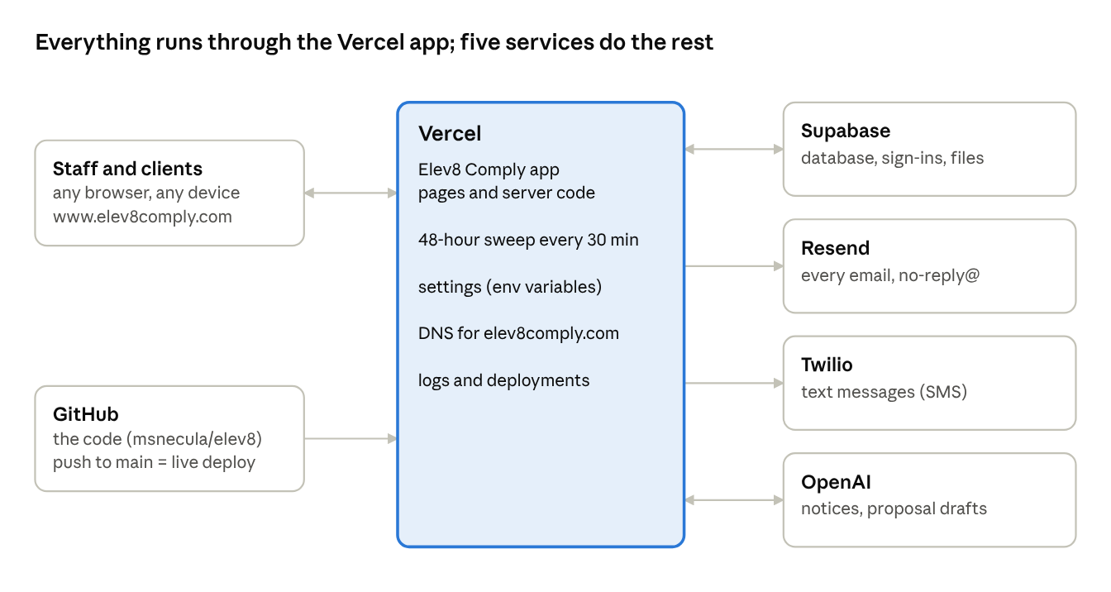
The app on Vercel and the services it uses
If the site itself is down, start at Vercel; if one kind of message or data is wrong, go straight to that service.

The services
Service | What it does for Elev8 | Where to look
Vercel (project elev8) | Hosts the website, runs the server code, builds every new version, runs the 48-hour sweep every 30 minutes, hosts the DNS for elev8comply.com | vercel.com → elev8 → Deployments, Logs, Settings → Environment Variables; Domains for DNS
Supabase | Database (all jobs, notices, users…), sign-in accounts, file storage (uploaded notices, form templates, generated documents) | supabase.com → project → Table Editor, Authentication → Users, Storage, Logs
Resend | Sends every email from no-reply@elev8comply.com (invites, password resets, proposals, alerts) | resend.com → Emails (delivery status, bounces), Domains (elev8comply.com must stay Verified)
Twilio | Sends SMS (technician assign/dispatch texts, 48-hour alerts) to people who opted in | twilio.com console → Messaging logs; A2P 10DLC registration
OpenAI | Reads uploaded Cal/OSHA notices and drafts proposals | platform.openai.com → Usage, API keys, billing
GitHub (msnecula/elev8) | Holds the code. Every push to the main branch deploys to the live site automatically | github.com/msnecula/elev8

How a change goes live
- Code is pushed to the main branch on GitHub.
- Vercel builds it (about 1 minute) and switches www.elev8comply.com to the new version only if the build succeeds. A failed build leaves the previous version running.
- Any other branch gets its own Preview deployment (login-protected) for testing first.
- To undo a bad release: Vercel → Deployments → pick the last good one → Promote to Production.

Changing a setting (environment variable) in Vercel does not affect the running site until the next deployment. Use Redeploy on the latest deployment after changing one.

Settings (Vercel → elev8 → Settings → Environment Variables)
Setting | What it controls | Notes
NEXT_PUBLIC_APP_URL | The site address used in every email link | Must be exactly https://www.elev8comply.com. A typo here breaks every link in every email.
NEXT_PUBLIC_APP_NAME | App name shown in the app and emails | Elev8 Comply
COMPANY_NAME, _ADDRESS, _CITY, _STATE, _ZIP, _PHONE, _EMAIL | Your company details printed on Cal/OSHA forms
COMPANY_CQCC_LICENSE | Company CQCC license number on the 48-hour notice and the forms' CQCC fields | Still the placeholder 12345 — update when you have the real number, then redeploy
RESEND_FROM_EMAIL, RESEND_FROM_NAME | Sender of all emails | no-reply@elev8comply.com, Elev8 Comply
RESEND_API_KEY | Lets the app send email | Secret
DATABASE_URL, DIRECT_DATABASE_URL | Database connection | Secret. The app automatically uses Supabase's transaction pooler (port 6543) so it doesn't run out of connections
NEXT_PUBLIC_SUPABASE_URL, NEXT_PUBLIC_SUPABASE_ANON_KEY, SUPABASE_SERVICE_ROLE_KEY | Supabase sign-in and storage | The service role key is secret and has full access
TWILIO_ACCOUNT_SID, TWILIO_AUTH_TOKEN, TWILIO_FROM_NUMBER | SMS | Auth token is secret
OPENAI_API_KEY | Notice reading and proposal drafting | Secret
CRON_SECRET | Protects the 48-hour sweep from outside callers | Secret
EMAIL_INTAKE_WEBHOOK_SECRET | Protects the email-intake endpoint for notices sent by email | Secret

Never paste a Secret value into email, chat or documents. If one leaks, create a new key at the service, update it in Vercel, and redeploy.

Email domain (DNS)
elev8comply.com's DNS is managed in Vercel (Domains → elev8comply.com). Four records let Resend send as elev8comply.com — don't delete them:
Name | Type | Purpose
resend._domainkey | TXT | DKIM signature (proves emails really come from you)
send | CNAME | Sending / SPF
rsend | CNAME | Sending / SPF
_dmarc | TXT | DMARC policy (p=none, monitoring only)

elev8comply.com has no inbox, so mail sent to an @elev8comply.com address bounces. Supabase's own email (custom SMTP through Resend) is set up as a backup, but the app sends invites and password resets itself through Resend.

Logs: where to look when something fails
- Vercel → elev8 → Logs: errors from the app. Failed emails show as [Email] Resend rejected message; database overload shows as EMAXCONNSESSION or max clients reached. Logs are kept for a limited time, so check soon after a problem.
- Resend → Emails: whether each email was delivered, bounced or marked spam.
- Supabase → Table Editor → notifications: every email and text the app tried to send, with status sent or failed and the error. Sign-in links are deliberately not stored there.
- Supabase → Authentication → Users: sign-in accounts; a deactivated user shows as banned.

Phone apps
The iPhone/iPad and Android apps (app name Elev8 Comply, ID com.elev8comply.app) are a thin shell around www.elev8comply.com, kept in the mobile/ folder of the code. Website changes reach the apps instantly; the apps only need rebuilding to change the icon, name or version. Step-by-step build and store instructions are in mobile/README.md.

Test accounts
The live database holds test logins (admin, reviewer, dispatcher, technician, client) used for checking the site. Keep their passwords out of this manual and remove or deactivate them before real customers go live.

