Ad Detection on a Television Program using Audio Video Patterns
Nikita Kodkani Pooja Desai
Software Engineer Software Engineer
Contact No: 9130591291 Contact No: 9986800558
Nikita.Kodkani@gmail.com pooja.desai199126@gmail.com

ABSTRACT: This paper describes a series of research stages in the development process of an automated system, able to detect commercial ads in TV program. Features like Ad logo, text and audio used to identify a commercial Ad. Various algorithms which were originally used were analyzed and new algorithm is proposed which is based on detection of logo, text and audio. The experiments are carried on a recorded TV program. Firstly the conceptual diagram of the system is stated. Theoretical aspects of the recognition process are presented, they are based on image matching algorithms and signal matching algorithms.
AUDIENCE: Anyone interested in image processing could attend the session. It would primarily focus on the problem statement and its solution. This lightening talk could be covered in 5-10 min max. No prior knowledge is needed.
KEYWORDS: Commercial ad, video streaming, image processing, signal processing, pattern matching.
- INTRODUCTION:

  - ADVERTISING
Advertising is a means to introduce a product, publicize it, explain the working of it and demonstrate the same. It gives a wider choice for the customers and allows them to develop a reasonable judgment about the various brands of product. TV advertisements are important because; they reach the customers right in their living room.
1.2 NEED OF ADVERTISEMENT DETECTION
Given a broadcast video, an automated way to detect the advertisements in that video is defined as advertisement detection. Without any manual intervention, it should be able to detect an advertisement in a broadcast video. The output of this process should be count of Ads occurred in video in a particular time slot.
There are a lot of practical applications for advertisement detection. Based on the end-user, there are three types of applications of advertisement detection. The end users are the TV viewer, advertiser and broadcast regulator.
First, the TV viewer might want to record some programs for later viewing which are interesting. In such cases, it will be very irritating to see the advertisements in the recorded video.
Secondly, the advertiser might want data about the timings of the airing of the advertisements of his brand. This will help in making an informed decision regarding the ratings of the advertisement, the influence of that advertisement and further ways to improve the advertisement.
Thirdly, the broadcast regulator wants data about the quantum of advertisements, their timings, their quality, their length and decency so as to have an eye on the advertisers whether they are following the various regulations regarding advertisement broadcasting.
1.3 REVIEW OF RELATED WORK
Advertisement detection is recent but widely approached problem in the research community. Because of its practical uses, various companies are sponsoring research in this area. The approaches used are varied from low-level techniques such as blank frames to high-level techniques such as
In [1] Xiang Wang and Zongming Guo used silent frame detection, shot change and scene change between different commercials, in which they have used short density algorithm.
In [2] Dan Zhao and many other researchers proposed the model based on audio signals to detect Ads. Audio stream is segmented into units based on the energy levels. A unit has lower energy at the start and end and each unit contains one major peak. As commercials start with a short silence, matching of a known commercial in an audio stream is performed at the start of unit.
In [3], the system proposed is a three-state machine changing between the states viz. initialization, program and advertisement. The initialization which occurs only at the start extracts a binary mask that indicates the region where the TV logo is placed. The assumption which is used in this paper is that TV logos disappear during advertisements. The logo search is restricted to the four corners of the frame.
Features of the commercial differ country to country. Previous works mentioned above were limited to certain features. No American commercial detection set can work in Europe and vice versa. Even in Europe, a set used in Germany cannot be used in Japan. Here we are trying to develop the commercial detector which can be used in any country.
- DETECTION SCHEMES:
There are two main categories of methods used to detect commercials:
- Feature-based detection: It relies on general characteristics of commercials to detect their presence such as change in aspect ratio, presence of black frame and silent frame [14], etc.
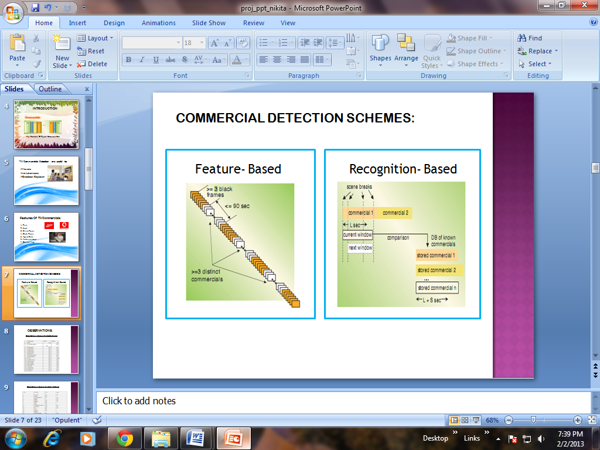
Fig. 2.1 Features based
- Recognition-based detection: It attempts to identify individual commercials in the broadcast as matching commercials it has already learned. For example it stores the predefined logos, text, audio samples and then implements the pattern matching to identify the commercial [14].
Fig. 2.2 Recognition -Based
In this study, our focus is on recognition-based detection. In recognition based method commercial is identified by searching database consisting of known commercials. Recognition based methods are found to be more efficient due to higher detection rate and are more reliable than feature based in detecting particular Ad. For determining the characteristics of commercial in TV and finding the best features for detecting Ad, we had observed the commercials on different channel.
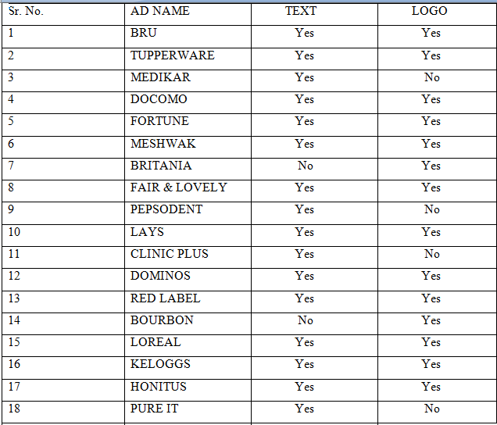
Fig 2.3 Ads observed on COLORS channel
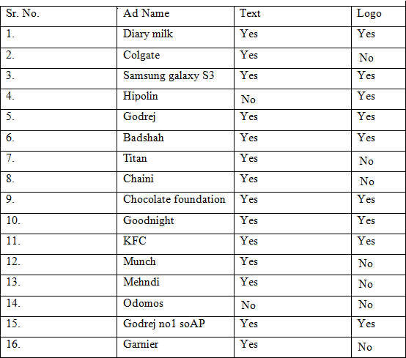
Fig. 2.3 Ads observed on SAB TV channel
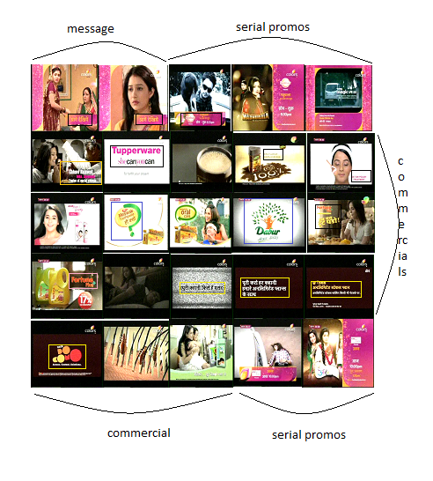
Fig. 2.4 Commercial block
Observations:
i) Every Ad has product or its logo displayed at the end.
ii) In some channels at the start of commercial break upcoming serial promos are shown followed by short commercial Ads and again followed by upcoming serial promos.

- THE PROPOSED METHOD :
The block diagram (Fig 3.1) will give the clear picture of working of the proposed system. Input to the system will be a recorded TV program. Firstly the system will extract the audio and video (only images without sound) separately. They will be separately processed out, but their ultimate result will be combined one. Frame processing block will work on detection of commercial, by performing pattern matching of incoming frame with logo, text and anchor message stored in database. Sampling audio block will detect the presence of commercial by silence detection and its high amplitude features. The combined result based on the probability will give the confirmation of the presence of the Ad.
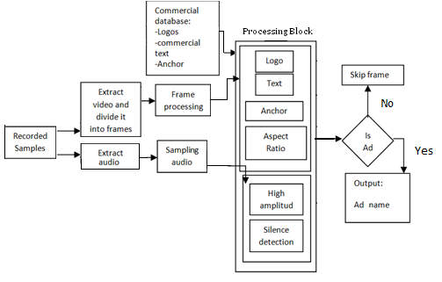
Fig. 3.1 Block diagram
3.1 LOGO PROCESSING AND TEXT PROCESSING
SURF pattern matching technique (Fig 3.2) is used to match each stored logo and text with the incoming frames to detect the individual Ad. If for particular commercial both text and logo are not present then its result will solely depend on its audio features detection.
3.1.1 SURF PATTERN MATCHING:
SURF stands for Speeded up Robust Features. In a given image, SURF tries to find the interest points - the points where the variance is max. It then constructs a 64-variable vector around it to extract the features (A 128-variable one is also possible, but it would consume more time for matching). In this way, there will be as many descriptors in an image as there are interest points. Following steps are followed for every probe image (The image we need to match against):
1. Take a descriptor of the probe image.
2. Compare this with all the descriptors of the gallery image (One of the set of possible matching images).
3. Find the nearest descriptor which is the one with the lowest distance to our descriptor compared to all the other descriptors.
4. The nearest descriptor distance is stored.
5. Take descriptors, other than the one’s already taken from probe image and go to step-2.
6. Now all the nearest descriptor distances are added, and the sum is divided with the total number of probe descriptors. This gives us the average distance.
7. This average distance, along with the name of the gallery image matched, is outputted to a file.
8. For every gallery image, go to step-1.
9. When all the gallery images get over, sort the distances in the outputted file and the one with the lowest distance is the best match for our probe image.
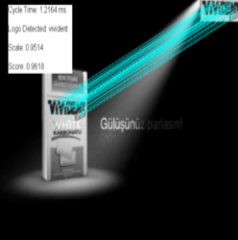
Fig. 3.2 SURF based matching
3.2 AUDIO PROCESSING
It was observed in Fig 3.3, at the start of the commercial block there is the presence of the silent frame which is followed by high increase in the amplitude of the audio signal. So in our system, the commercial is also detected using this feature of the commercial. Experiments were carried out to find the value of the silent frame, that value was termed as threshold value and was compared with remaining frames to detect the presence of the silent frame.
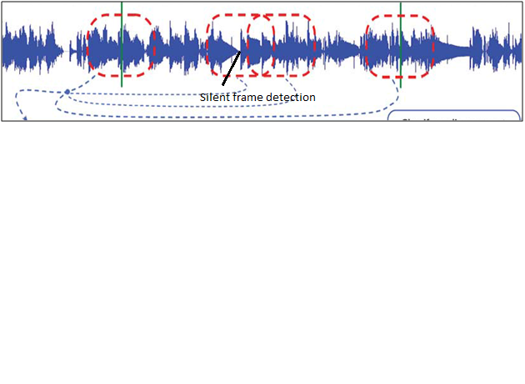
Fig 3.3 Audio Processing
4. CONCLUSION & FUTURE WORK
We have researched about the characteristics of commercial blocks in TV broadcast and have tried to implement the distinguishing parameters of the commercials. Then we have implemented our algorithm for commercial detection. In this paper, we have proposed an approach to automatically detect the commercial based upon the features of commercial such as logo, text and audio detection. For the logo and text detection, SURF pattern matching technique is used and for audio processing we have found the threshold value and then compared with the frames.
Our technique can be improved on several fronts. First of all, in our technique we record the TV broadcast and then worked on offline video. For future studies a system that stores the TV broadcast in a buffer and does the detection and recognition without recording the video can be implemented. In addition the system can be combined with a speech recognition system that recognizes the speech signal throughout the commercial video blocks.
In short, this paper focuses on how we could detect commercials automatically without human intervention.
5. BIO
I have completed my bachelors in computer engineering from Cummins College of Engineering for Women, Pune. I have keen interests in AI, image processing, IoT and virtualization. Currently I am working as DeveOps Engineer in Veritas Technologies LLC, Pune.
REFERENCES:
[1] Xiang Wang, ZongmingGuo, “Novel Real Time Commercial Detection Scheme”, Innovative Computing Information and Contral, 2008. ICICIC’08. 3rd International Conference on 18-20 June 2008.
[2] Dan Zhao, Xiangdong Wang, YueliangQian, Qun Liu, Shousan Lin, “Fast commercial detection based on audio Retrieval”, Multimedia and Expo, 2008 IEEE International Conference on June 23 2008-April 26 2008
[3] Alberto Albiol, Maria Jose Ch.Fulla, Antonio Albiol, Luis Torres, “Detection of TV commercials”, Acoustics, Speech, and Signal Processing, 2004 proceedings. (ICASSP’04). IEEE International Conference on 17-21 May 2004
[4] Nan Liu, Yao Zhao, Zhen Feng Zhu, Hanqing Lu,” Exploiting Visual-Audio-Texual Characteristics for automatic TV commercial Block detection and segmentation”, Multimedia, IEEE Transactions on, Oct. 2011
[5] Venkatesh N, Girish Chandra M, Rageev B, “A Novel commercial break detection and Automatic annotation of TV Programs for content base retrieval”, Signal Processing Systems (ICSPS), 2010 2nd International Conference on 5-7 July 2010.
[6] Jen-HaoYeh , Gun-Chen Shen, Gim-HauKuo, Ja-Ling Wu, “TV commercial detection in News program videos, Circuits and Systems” , 2005. ISCAS 2005. IEEE International Symposium on, 23-26 May 2005
[7] David Conejero, XavieralAnguera, “TV advertising detection and clustering based on acoustic information”, Computational Intelligence for Modeling Control & Automation, 2008 International Conference on, 10-12 Dec. 2008
[8] Vlado Kitanovski, DimitarTaskvoski, “Real-time TV commercial monitoring based on Robust visual hashing”, Visual Information Processing (EUVIP), 2010 2nd European Workshop on, 5-6 July 2010
[9] Li Meng, Yong Cai, Min Wang, Yuan Xing Li, “ TV commercial detection based on shot change and text extraction ”, Image and Signal Processing, 2009. CISP '09. 2nd International Congress on, 17-19 Oct. 2009
[10] GeFei, Shi Ping,” The detection of TV commercial based on multi-feature fusion”, Multimedia Technology (ICMT), 2010 International Conference on, 29-31 Oct. 2010
[11] Bo Zhang, BilanFeng, Peng Ding, Bo Xu, “TV commercial detection using constraint viterbi Algorithm Based on Time Distribution”, Fuzzy Systems and Knowledge Discovery (FSKD), 2012 9th International Conference on, 29-31 May 2012
[12] Lan Liu, Yao Zho, Zhen Feng Zhu, Hanqing Lu, “Multi model characteristic analysis and fusion for TV commercial detection”.
[13] Brandon Satterwhite, oge Marques,” Automatic detection of TV commercial”, Potentials, IEEE, April- May 2004

[14] Book: Television Engineering and Video System
[15] Book: Image processing- Digital Image processing

