How to install
Unzip each version
You can use any IDE that has a python interpreter and kernel, ideally the newest version of python but any python 3 version should work for this. If run in Python Idle installation of the interpreter is not necessary but for running in Vs Code installing the Python extension and selecting the python interpreter is necessary
The only dependencies you need to install is into the terminal of the IDE which you are using. You can use pip install pytest if you want to run the short test module yourself
Other dependencies are used in the project, but they do not need any installation.
Json is imported and Json.load. Flask requests are also used. These dependencies are included with Pythons built in libraries and the Flask library.

To run the finished project, you can go to the terminal of your chosen IDE
And run this statement: PS C:\Users\jshor\Downloads\Computer science Year 1 Term 1\Programming> python "C:\Users\jshor\Downloads\Computer science Year 1 Term 1\Programming\Coursework 2\Version 3\flask_server_ai_player.py" But with your current directory instead of mine so python “C:\your directory. The easiest way to do this is to go to where you are storing the version 3/stage 3 files and right click the ‘flask experimental server. Stage 1 can be accessed by doing the same thing with the game_engine.py file in the stage 1 file in the zip and doing the same command in the terminal with that file instead. The interactivity can be accessed by the command python C:\yourdirectory\game_engine and then inputting (zero indexed) coordinates.
Stage 2 can be run through the same command to the flask_server.py file in the stage 2 subfile
You can access the game and the HTML template without actually saving my version of the html template through HTTP on your local flask server. The app routes allow this to happen. You could write or adapt your own server then use the render template function and your own game board to make it work. Different json could then also be returned on click using the same domain and templates.

The handle to the depository where the ReadMe file and stage 1, stage 2 and finished stage 3 project files are saved is: https://github.com/msnshorenye/ECM1400-Coursework-2

Appendix

Manual Testing for othello programming project

Test number | Versions applicable | Test | Test type | Expected result | Actual result | Evidence | Changed? | Pass or Fail
1 | 1, 2, 3 | Can the player play a move diagonal? | Normal | Dark player can get a diagonal move in all 4 ways | Dark player can correctly flank diagonally in all directions | 1.1  1.2  1.3  1.4  re | No | Pass
2 | 1,2,3 | Can the player flank counters to their right on the same row? | Normal | Dark player can flank to the right on the same row | Yes it worked | 2 | No | Pass
3 | 1,2,3 | Can the dark player flank counters to the left on the same row? | Normal | Dark players can play legal moves where they counter opponents counters on the same row to the left | Yes as expected | 3 | No | Pass
4 | 1,2,3 | Can the dark player flank counters vertically in the same column? | Normal | Can legally flank opposition counters up and down their | Yes as expected | 4.1  4.2 | No | Pass
5 | 1,2, 3 | Can the dark player flank counters in multiple directions at the same time? | Normal | It flanks in several different directions at one time. | Yes the same | 4.2 | No | Pass
6 | 2, 3 | Does the save button work on click? | Normal | Button saves current game | Same as expected | 6 and 7 | No | Pass
7 | 2, 3 | Does the Load button work as intended on the same server and when reloading the web server and program | Normal | Loads the state of the game board when saved was pressed and you can now play from that point | Same as expected | 6 and 7 | No | Pass
8 | 1, 2, 3 | Can the players play and flank discs on the first and last column and rows on the board? | Boundary | Player can flank disks in the first and last columns and the first and last rows | Yes, as expected | 8.1 | No | Pass
9 | 3 | Can the Ai play diagonal moves that overflank? | Normal | Ai can flank in a diagonal direction | Yes as expected where applicable to the ais rule of picking the longest direction | 9 | No | Pass
10 | 3 | Can the Ai make moves that flank in multiple positions | Normal | The Ais legal moves will flank in multiple directions that it should | It only picks one longest direction | 10 |  | Fail
11 | 3 | Can the Ai player make vertical moves in a column? | Normal | The Ai should be able to flank in a column direction | Yes it does the same | 11 | No changes | Pass
12 | 1, 2, 3 | Do the win conditions for the game work? | Normal | It counts the correct amount of counters and winner after the last possible turn is played | It works fully apart from the very last button click | 12 (Lots of examples | Slightly | Somewhat pass
13 | 3 | Can the Ai play on the first and last columns? | Boundary | Ai can play legal moves and flank disks on the first and last columns | The Ai is proven to do this | 12 | No | Pass
14 | 3 | Can Ai flank left and right on the same row | Normal | Ai where applicable can make a legal move and flank counters left and right on the same row | Yes this works where the AI decides to make this move | 14 | No | Pass
15 | 3 | Do they handle an invalid move? | Normal | They should skip the players turn and move onto the next players turn | Yes It works exactly that for stage 2 but against the AI it saves up its moves and plays all their moves when the real player plays their next valid move | 15 |  | Stage 2 Passes  Stage 3 Somewhat passes

Evidence 1.1 Before and After
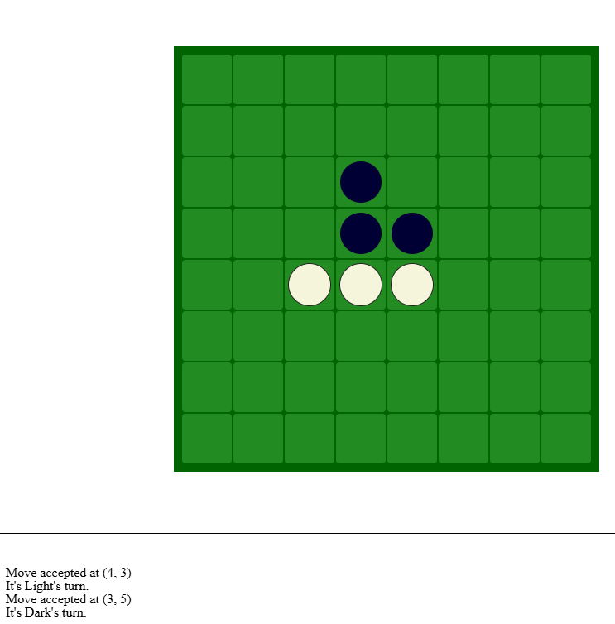

After 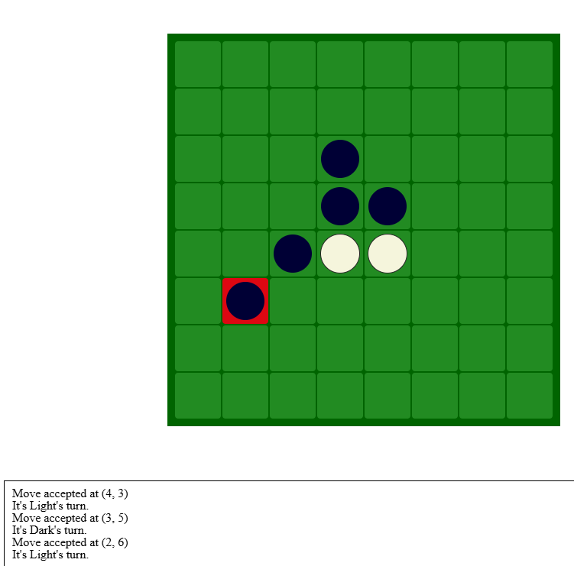

1.2
Before
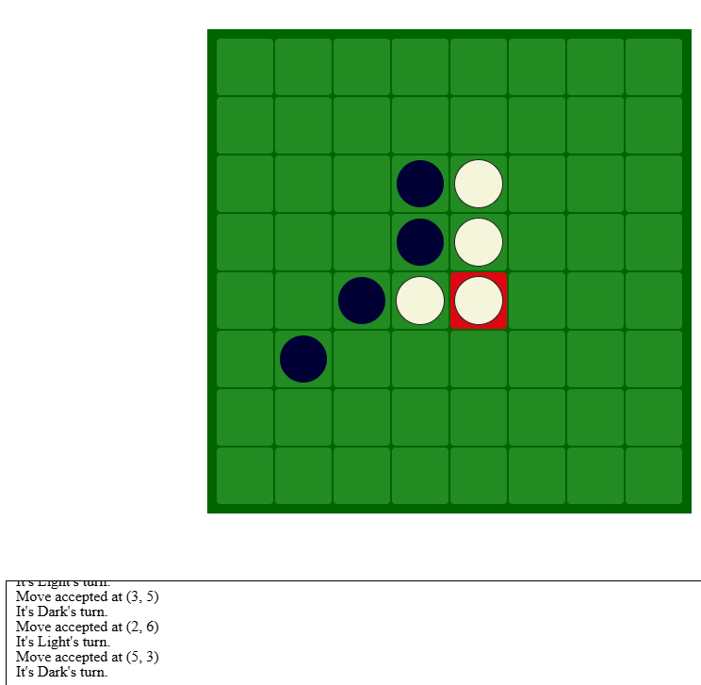
After
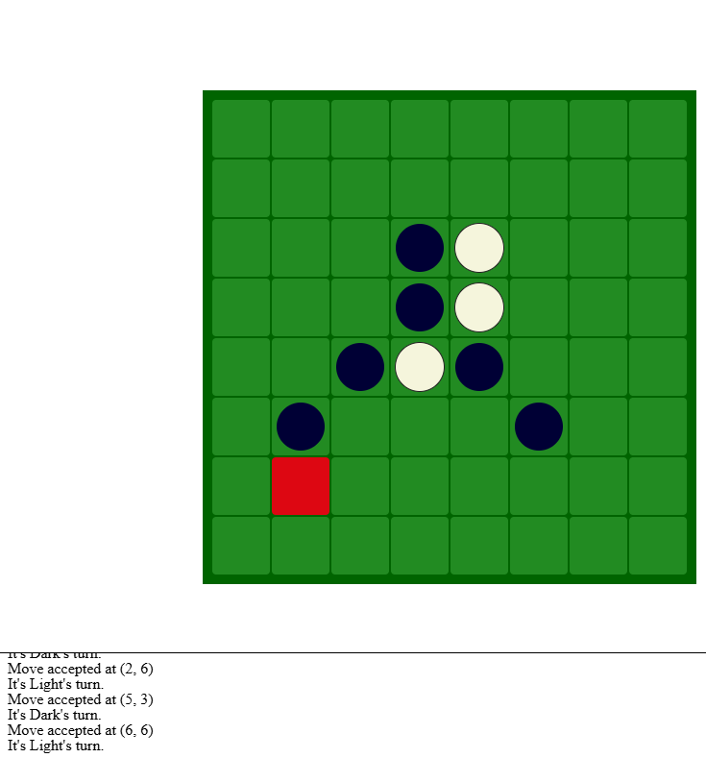
1.3
Before
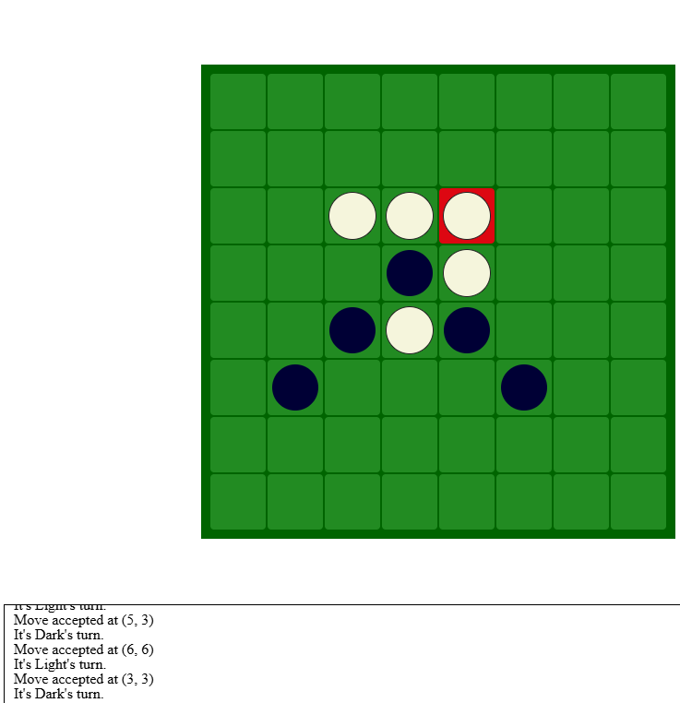
After
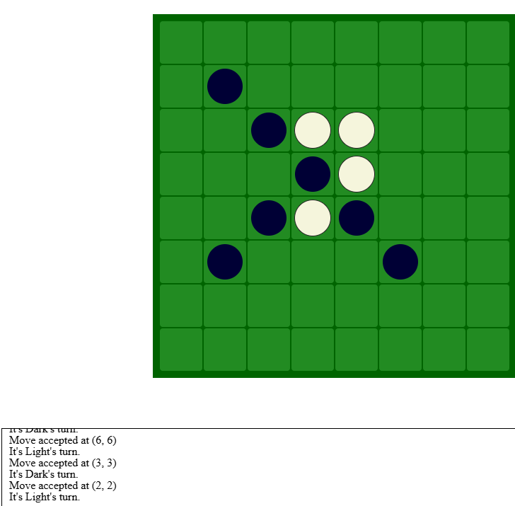
1.4
Before
After
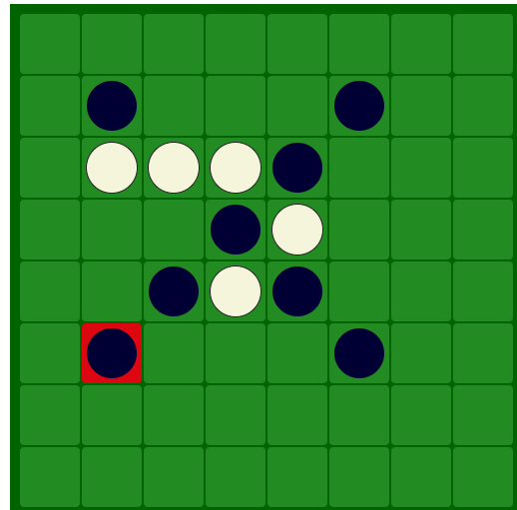

Test 2

Before
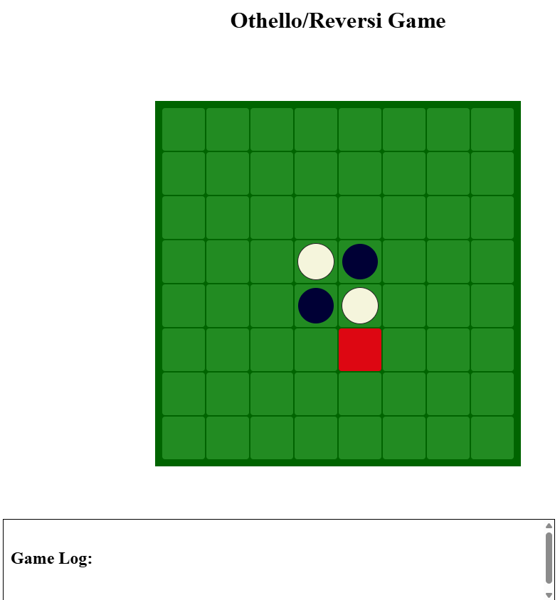
After 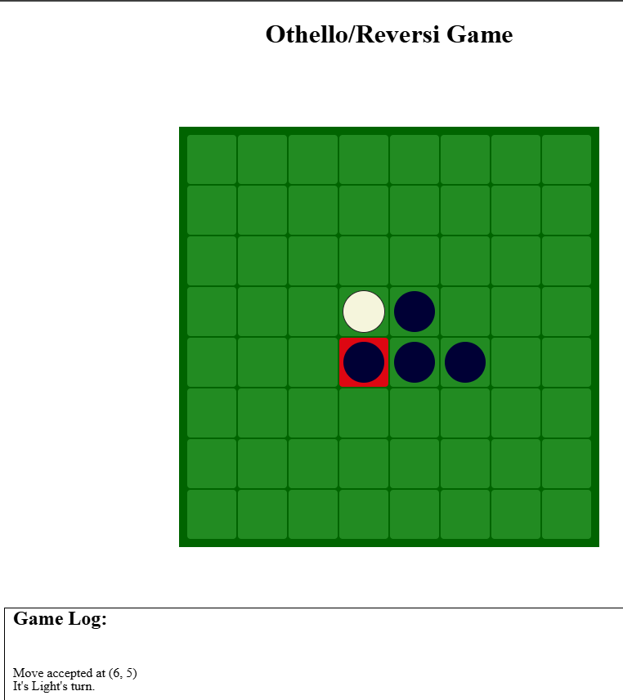

Test 3
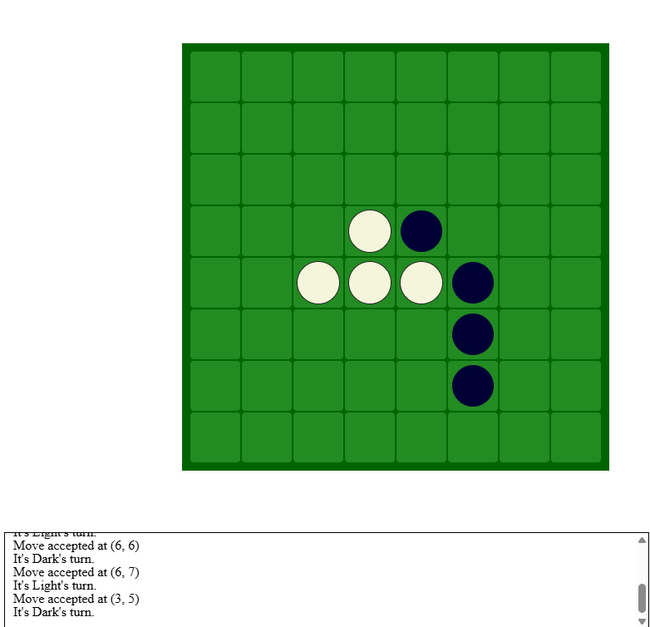
After
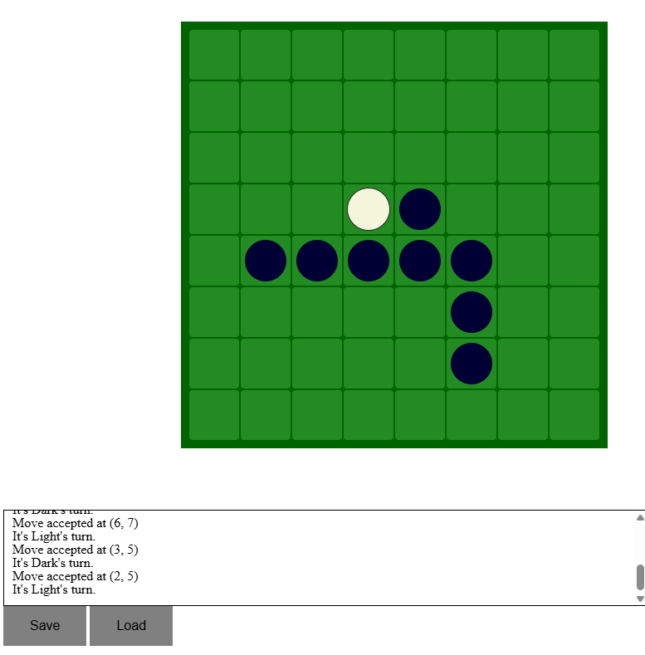
Test 4.1 Before
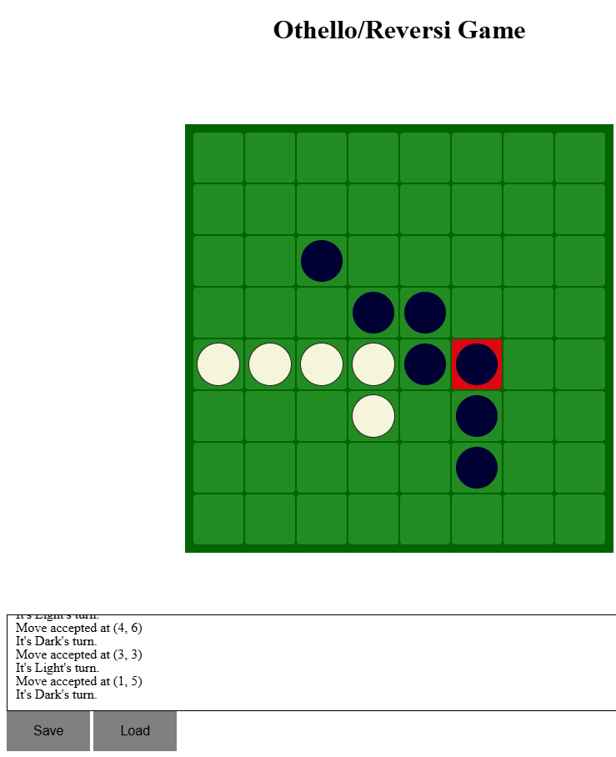
After
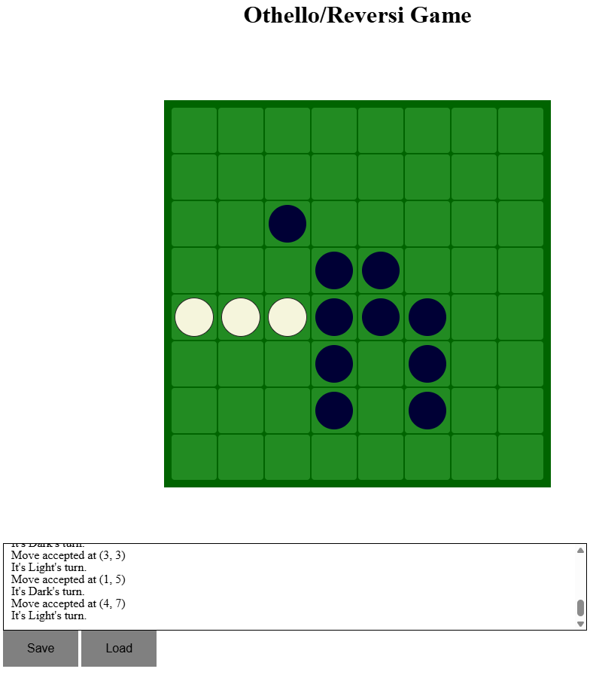
Test 4.2
Before
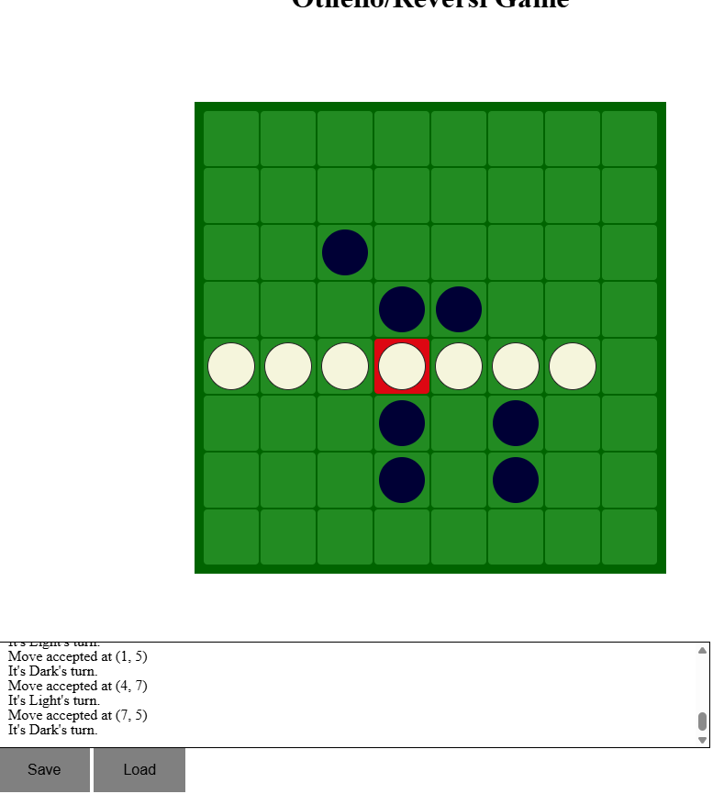
After
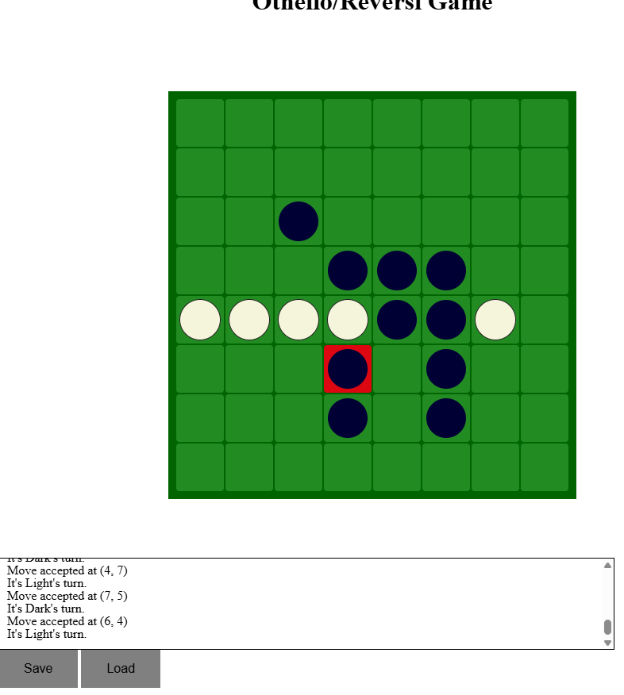
Also evidence for Test 5 as it flanked vertically but also diagonally in a single move

For version 2 there is even more evidence for test 5 as white flanked double diagonally as well in the next move taken in this game
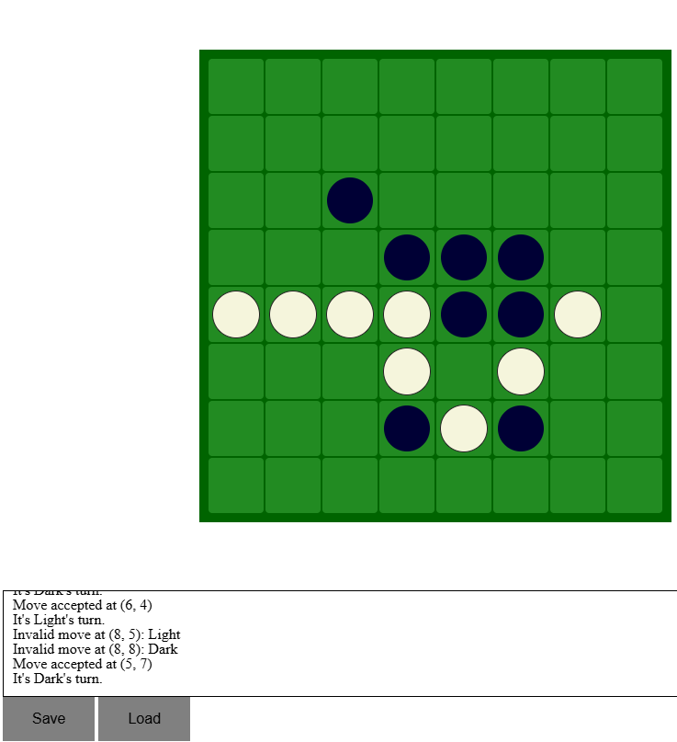

Test 6 and 7

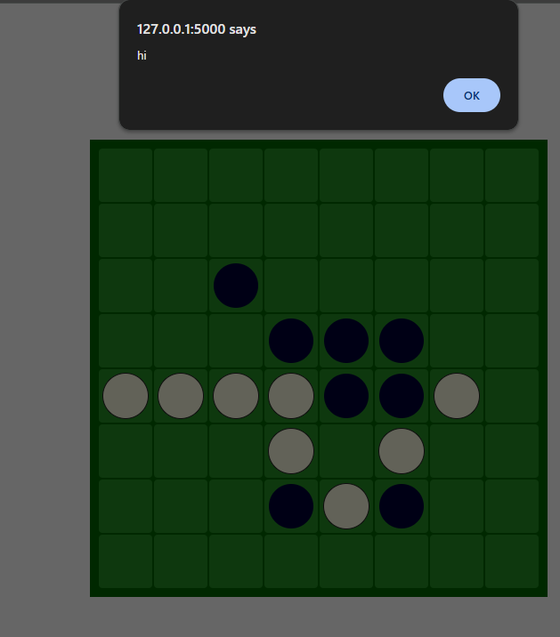
This is the website after clicking save. The alert is place holder in the finished version it will say game saved.

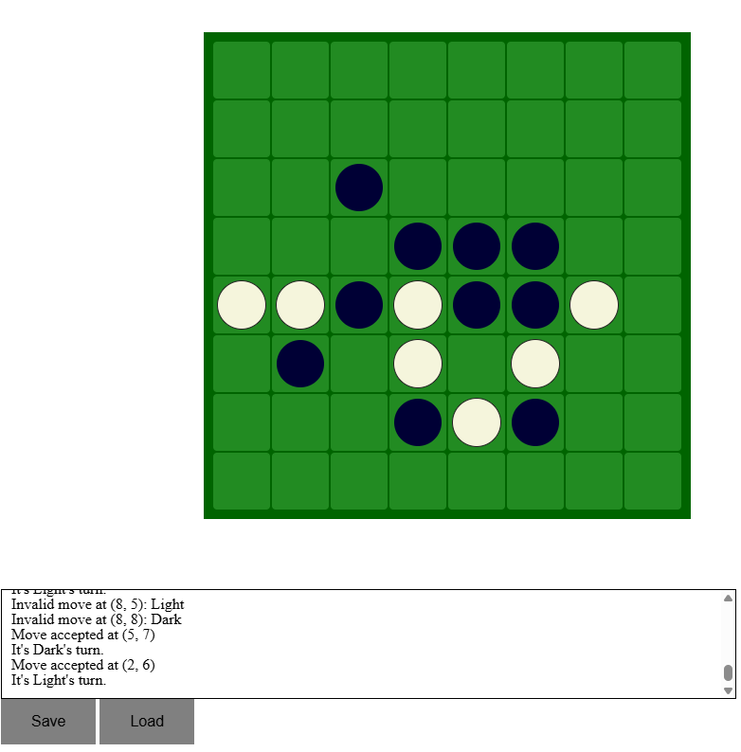
This is a move i played after saving

This is what happened after i saved
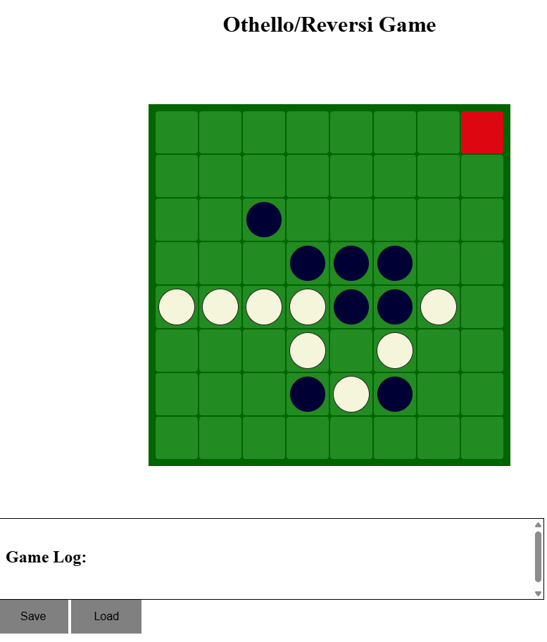
This is the output terminal to prove it

Test 8.1
Before 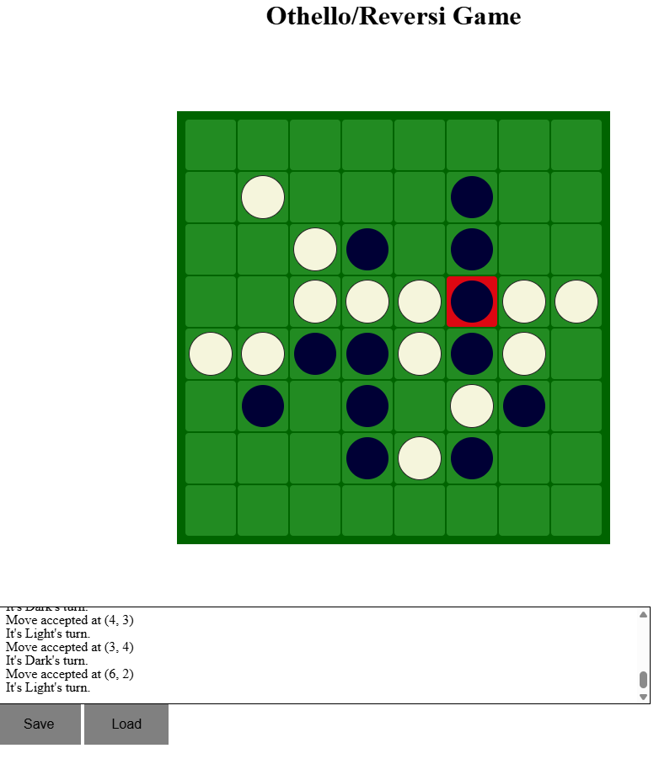
After
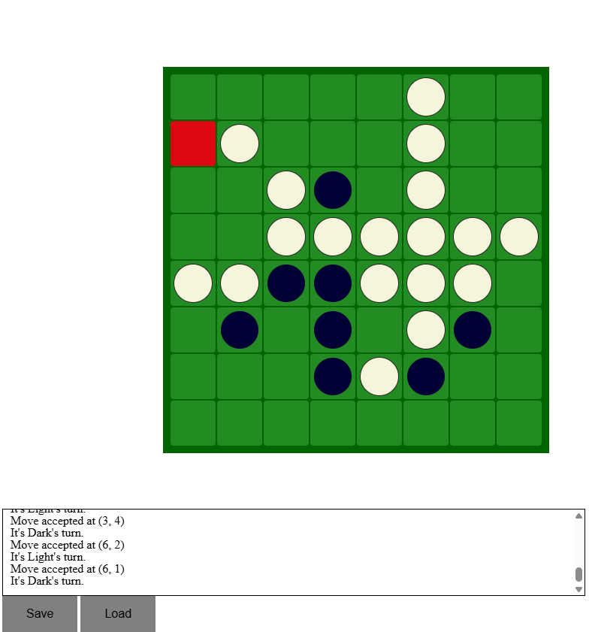

8.2 Proof last column
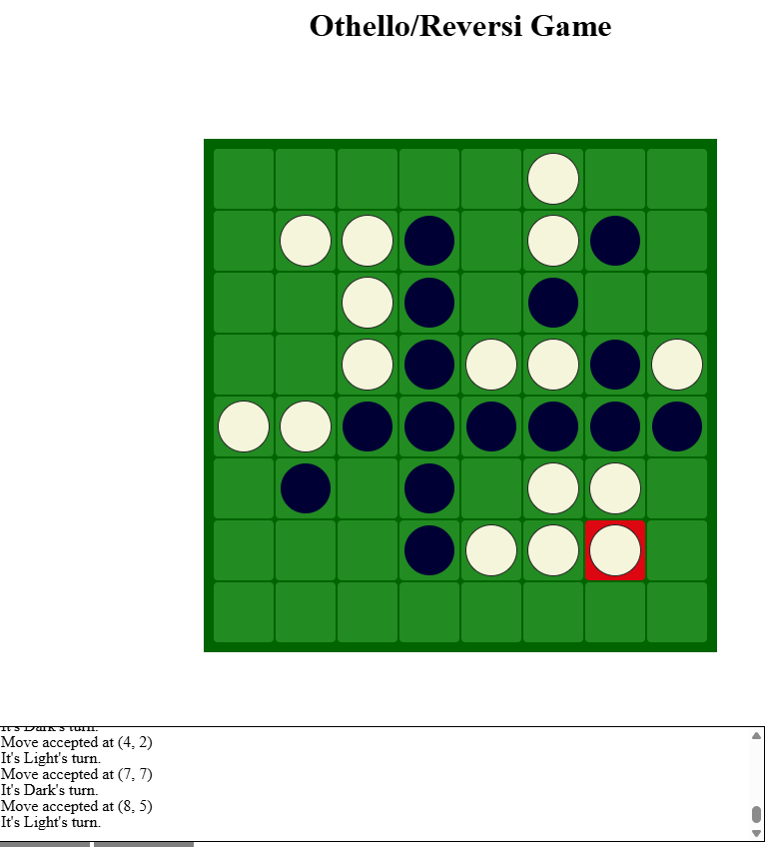
8.3 Before Top row first colum
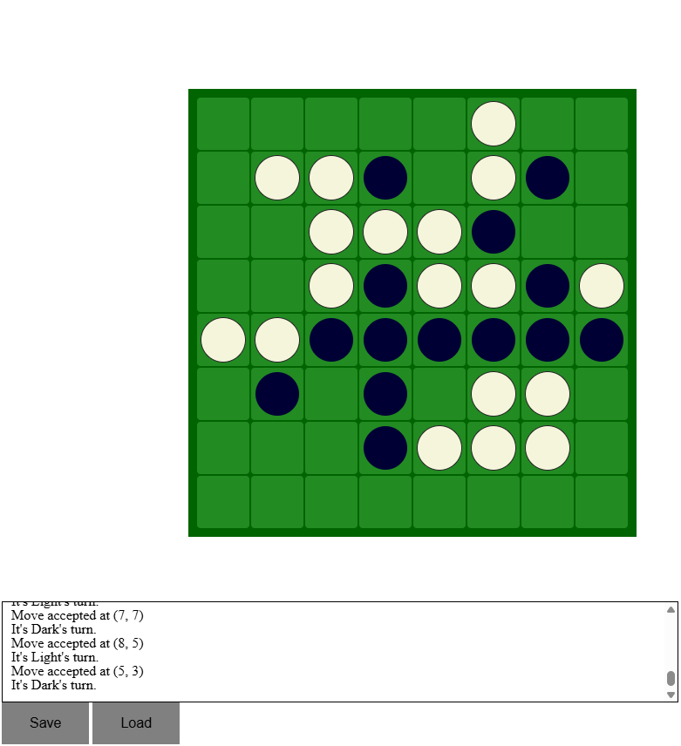
After

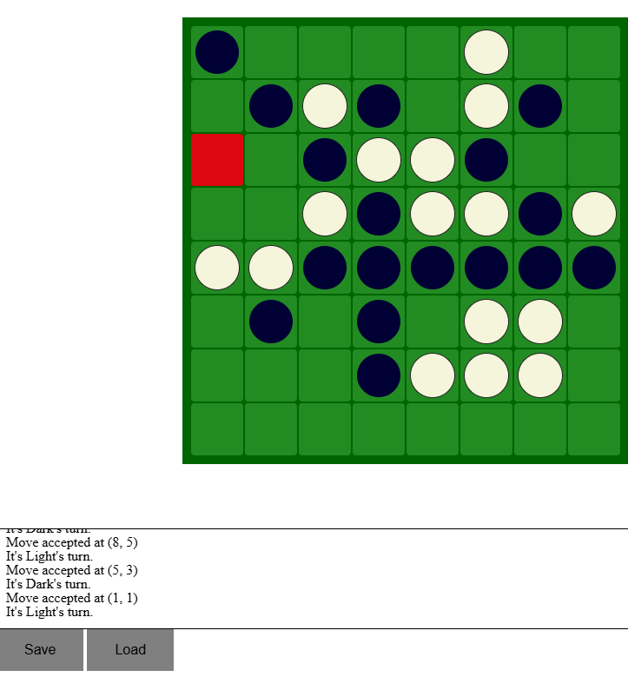

After 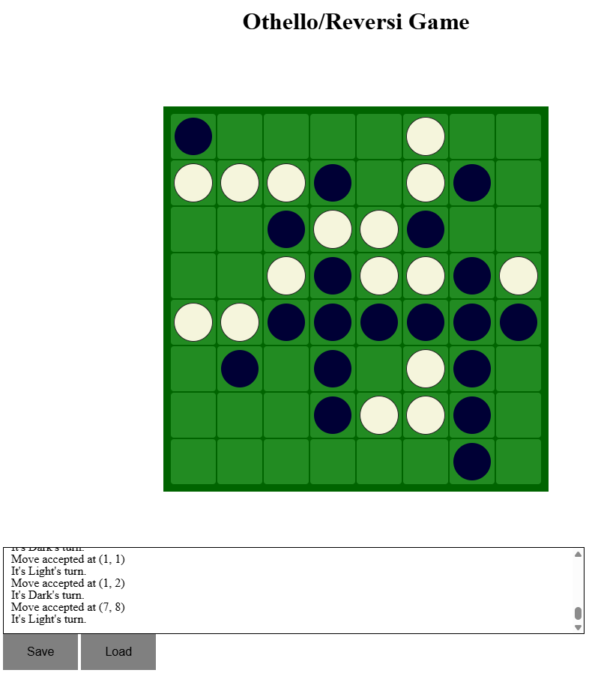

8.5 Last column Last row
(This is in version 2 as white player uses the real human players counter logic)
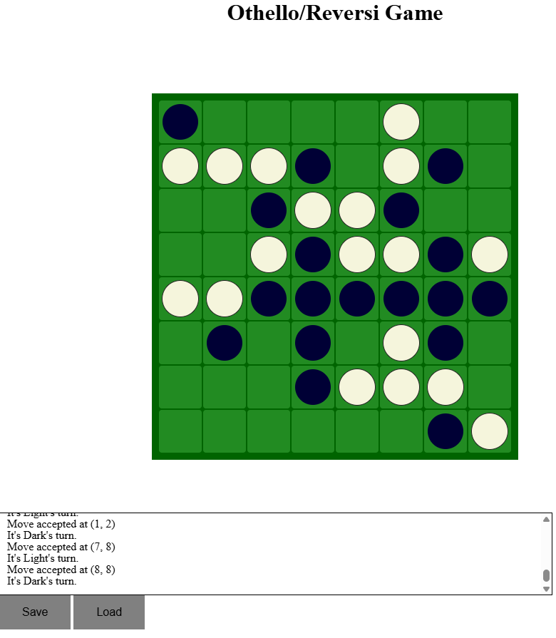

Test 9.

I played move 4, 3 and flanked 4,2 to create a vertical line of three black
The ai the diagonally flanked playing (3, 3) creating a diagonal three white counters
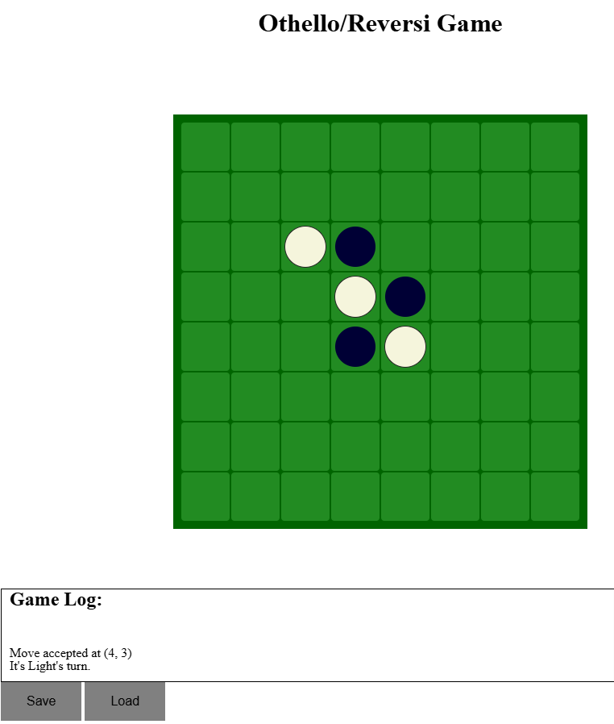

Test 10. This is an unfortunate fail Proved by this screenshot such as in this example
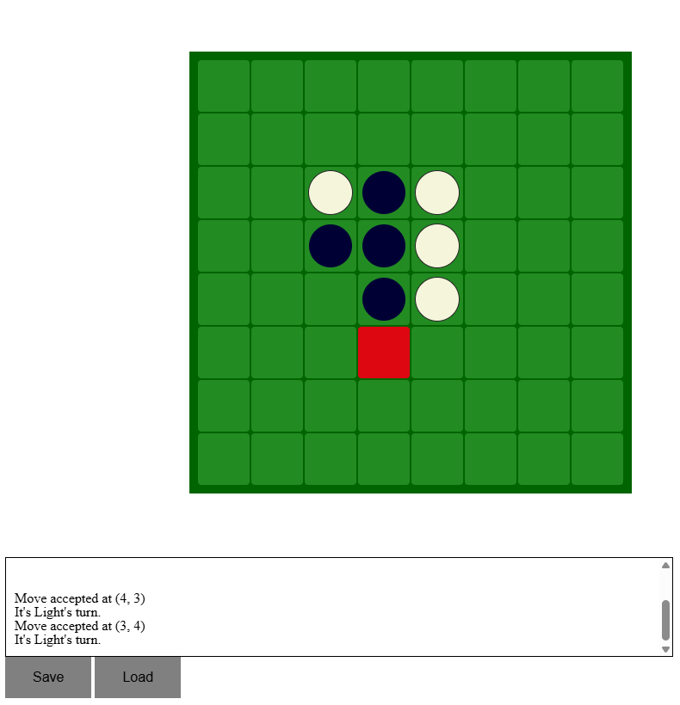
Ligh ai played (5,3)

Test 11.
Carrying on from Test number 9 I played (5,6) flanked the white counter at (5, 5). Then the AI played (4,2) vertically flanking my placing a counter at (4,2)
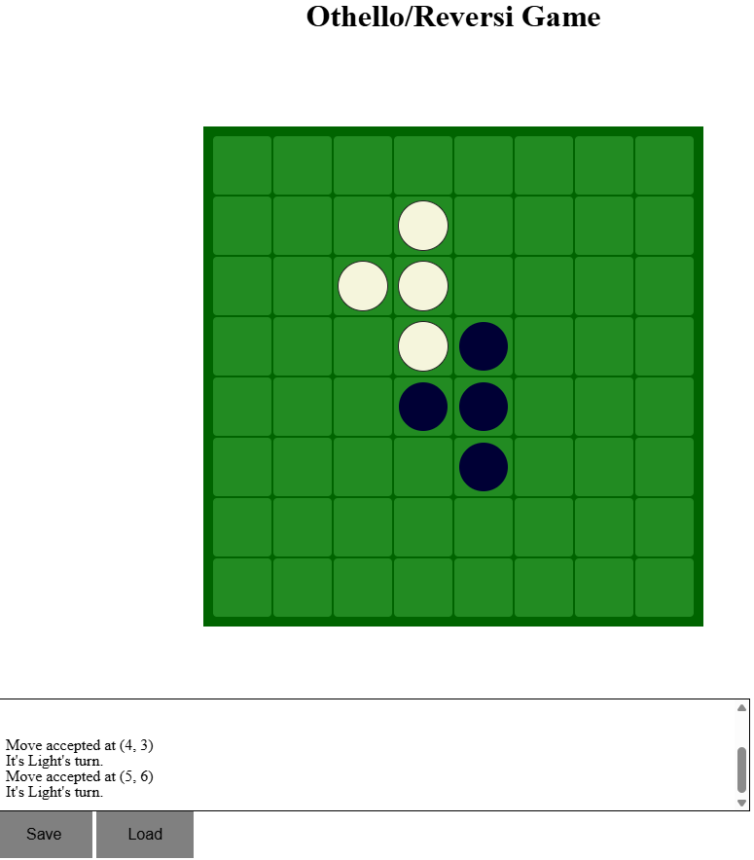
I then played (3, 4) and the ai played (4,6) vertically flanked me.
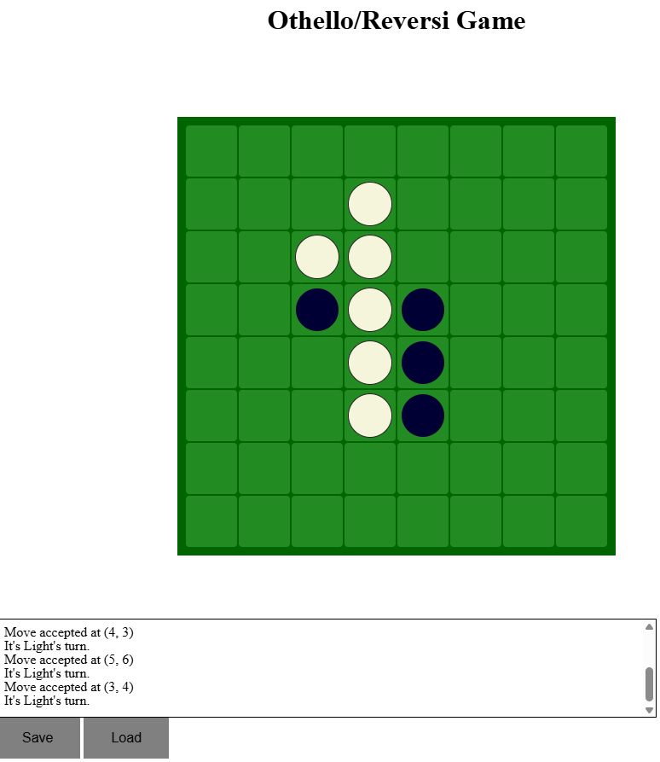

Test 12.

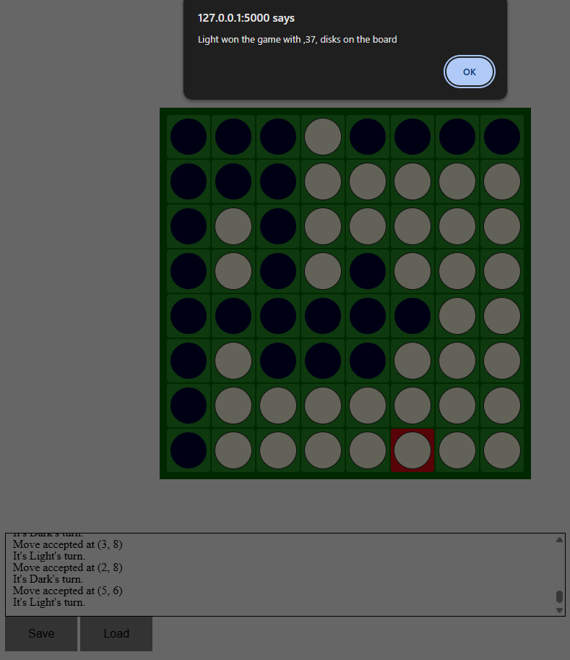
It works however you have to click the button one more time on stage 2 But it Gets the winner and counts correctly.

The ai game counts the win except in the specific case where the last tile is a possible move ai could play but the dark players has no moves so it cuts the game off where the ai could have overflanked and changed the whole overall winner

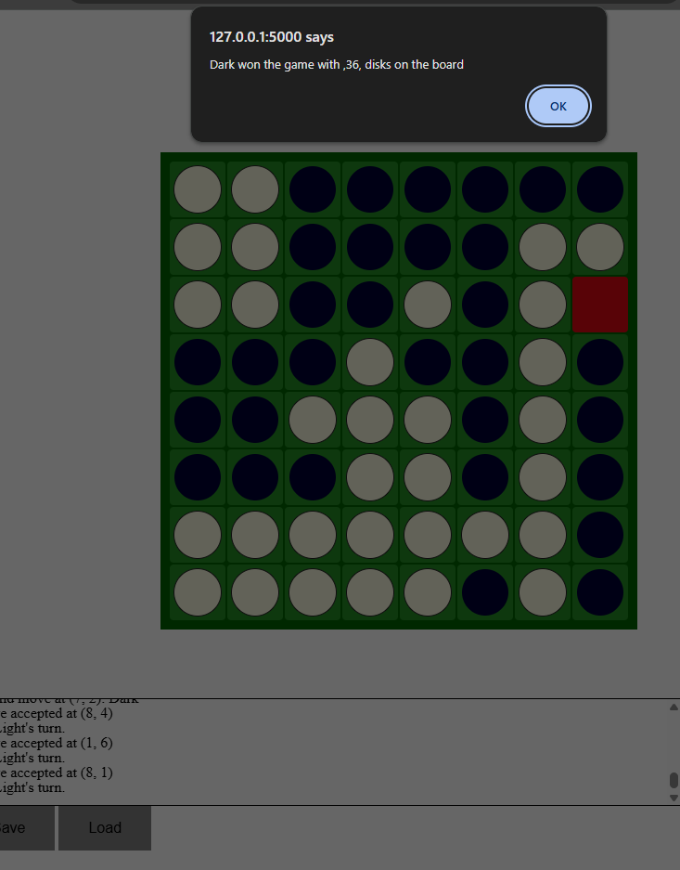
It works more accurately if the black player is winning and flanks after the final move
With changes it allows the game board to be finished but still sends the wrong winner message before the last move however you can still count and see the winner which will probably still be correct. This winning conditions do work when one player or two players cant play any more counters 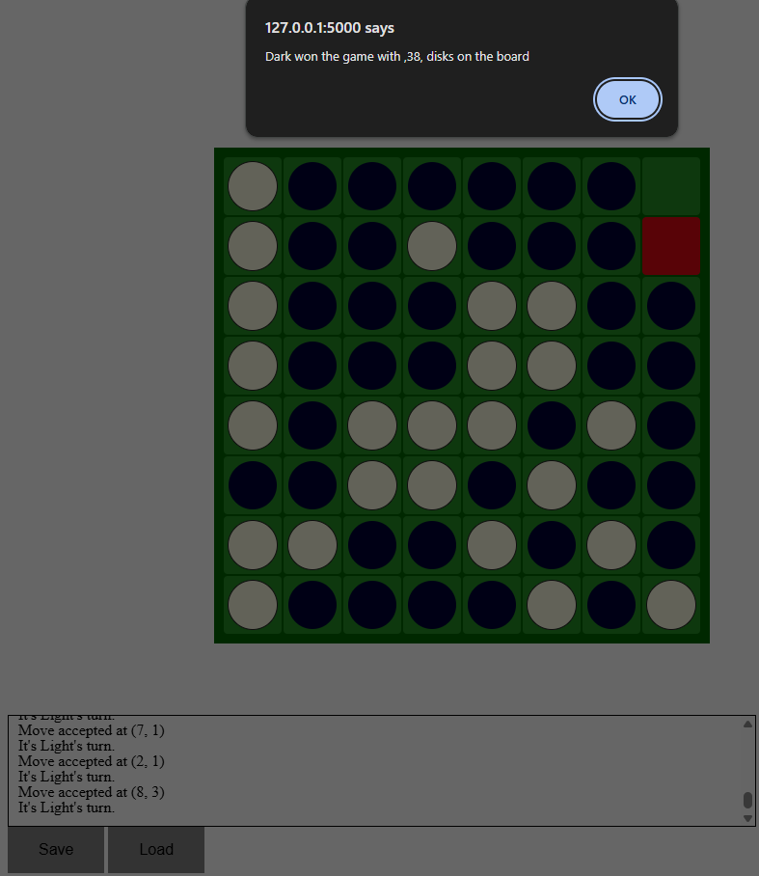
This doesnt work either entirely on the very last move either.
However these test fully

Evidence 14
I played move 3,5 then the ai played 2,5 and flank horizontally proving it can flank from rows.
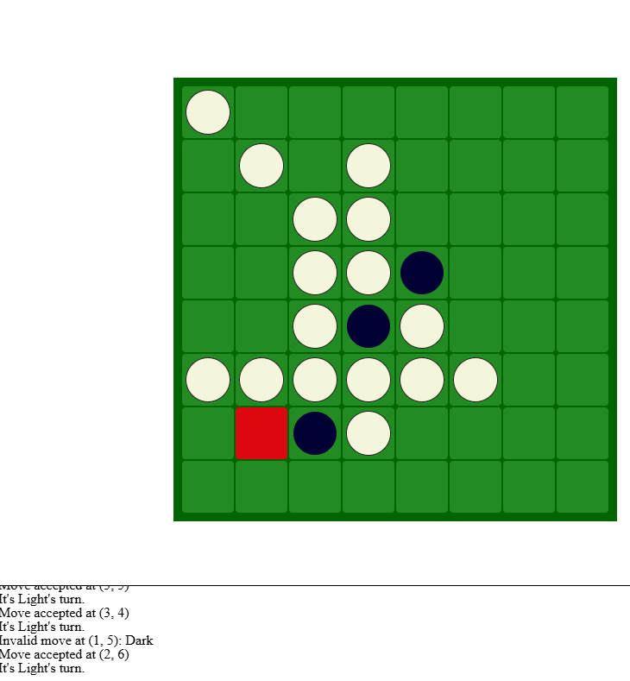
I made an invalid move and then when I played my move 2, 6 White ai plates (6,6)
And (1,6)
Evidence 15 They both accept it without error but the ai version gets an extra turn whereas their turn is skipped in stage 2.
Before You can see I accepted an invalid move
But in stage 2 it works as expected 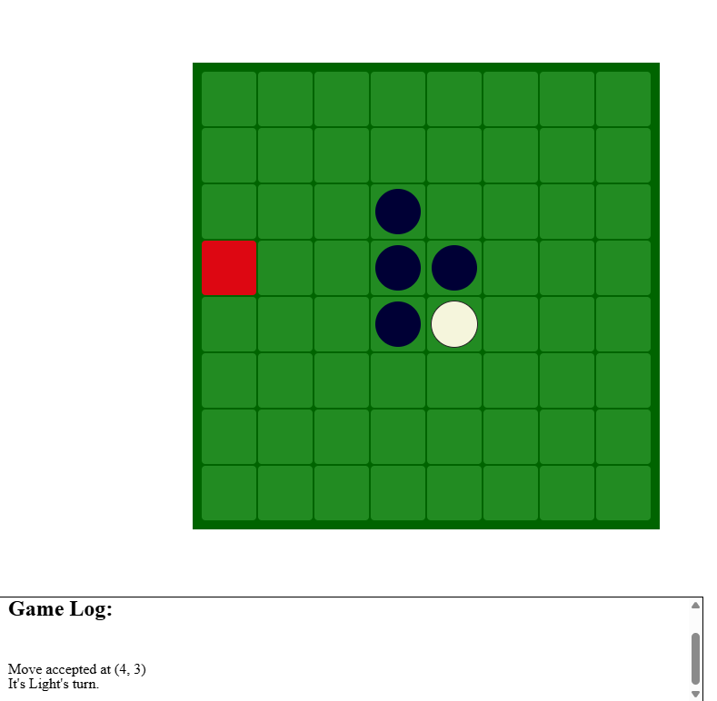This was blacks turn
Then Light makes an invalid move
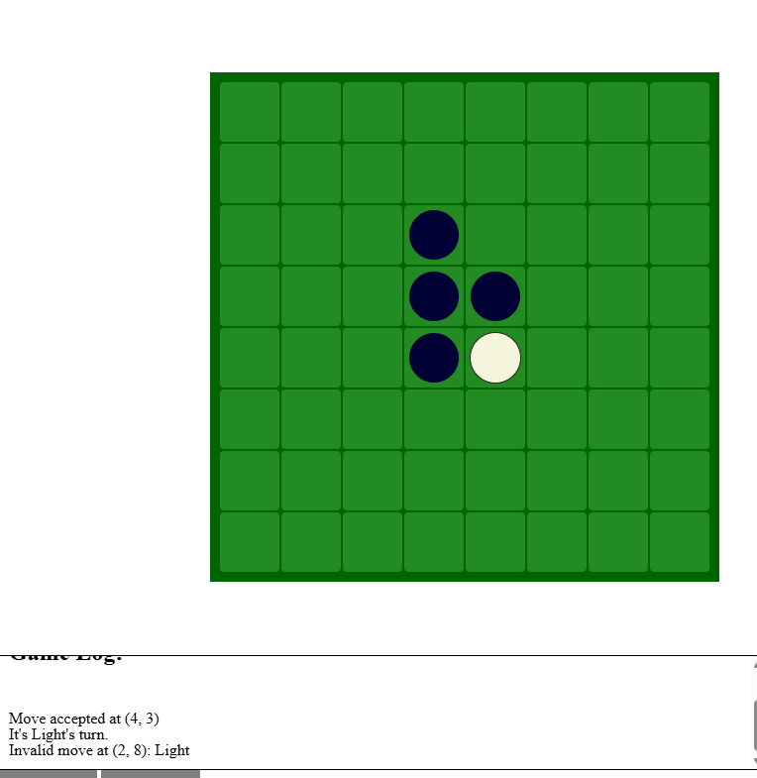
Then dark makes the next turn and can win
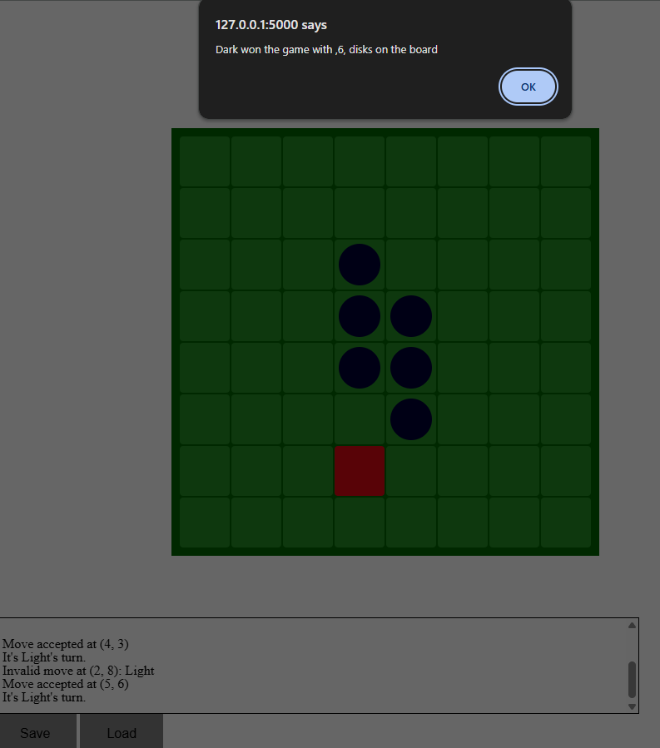
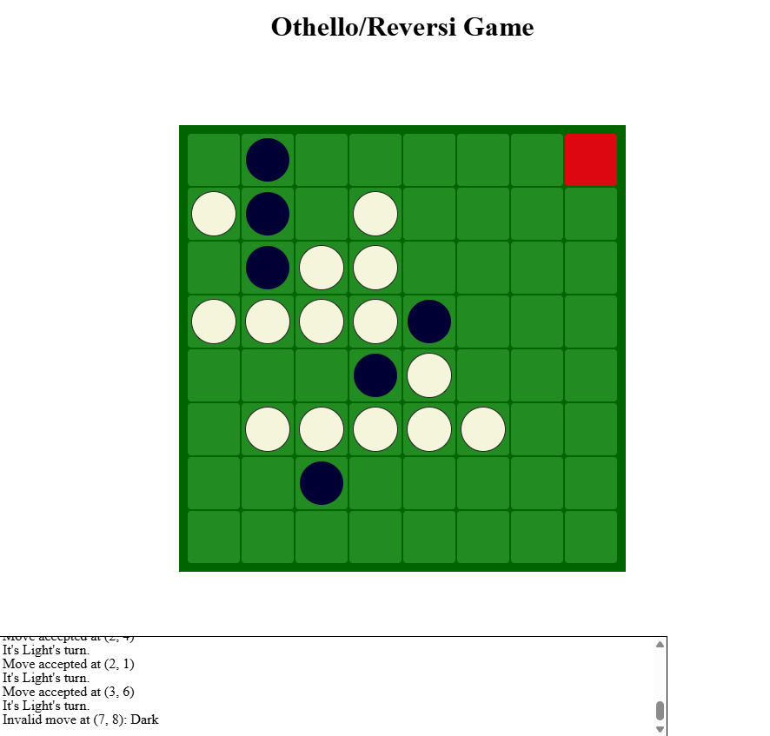
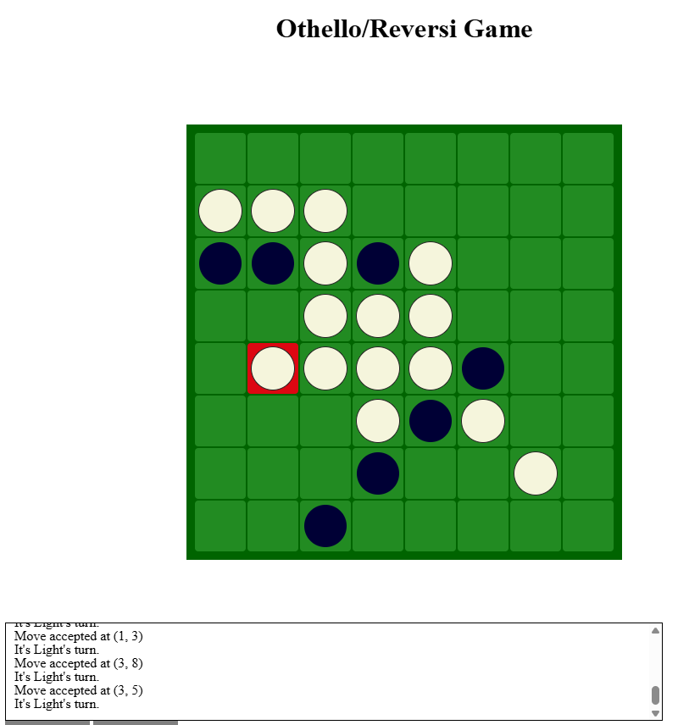

Pytest small test suite
I only test my one module which takes a parameter and does not require a game board. I used manual testing for the rest as they are used in stage 3. It would be sub optimal and artificial to create a whole test case 2d array board just to check a function. 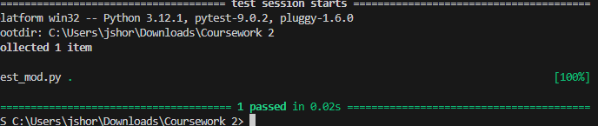
From this pytest function 