Upset Potential in the National Football League (NFL)

Mary J. Snyder

Department of Computer & Information Sciences   
College of Science & Mathematics   
Towson University

msnyde8@students.towson.edu

Advisor: Michael P. McGuire Ph.D.

Department of Computer & Information Sciences   
College of Science & Mathematics   
Towson University

mmcguire@towson.edu

**ABSTRACT**

Fantasy leagues, spread picks, as well as confidence points picks have become popular among fans of a variety of sports today. While the ultimate goal of these activities is to choose all winners, the place to gain a competitive edge over opponents is in picking upsets correctly. Nowhere is this more apparent than in confidence points picks. Placing too much confidence on a game that has a surprise upset could harm the overall score more than picking a few low confidence games incorrectly.

The goal of this project is to determine factors that influence the potential for upsets in the National Football League (NFL) through data mining techniques. Upon successful determination of these factors, I will attempt to predict upsets for current/real-time games.

**Categories and Subject Descriptors**

H.2.8 **[Database Management]** Database Applications – *Data mining*

**Keywords**

National Football League (NFL); Confidence picks; Exploratory Data Analysis; Multivariate; Categorical; Histogram; Scatterplot; Scatterplot Matrix; Binning; K-means; Clustering; Cluster Analysis; Partitioning Approach; k-means; Silhouette Plot; Classification; Naïve Bayes Classification, Decision Tree Classification; Training and Testing; ~~Accuracy; Error Rate; Sensitivity; Specificity; Precision; Recall; F Measure;~~

# INTRODUCTION

## Dataset

The data required for this analysis was widespread and was not already available through one source. The National Football League website (www.nfl.com) contains archived information for game summaries, which normally contain general information such as date game took place, start time, opponents, venue, weather, etc. Unfortunately, this data was not available as a dataset, but rather had to be gleaned manually from individual pages for each game. Information such as days of rest between games was derived from the available date of game information.

Not all game summaries contained weather information. For those particular games, it was necessary to search for archived weather data. Weather for the venue at/near the time of the game start was obtained from a notable weather source such as Weather Underground ([www.wunderground.com](http://www.wunderground.com)). Weather information in addition to just the temperature was also collected, where available, in case it might have been of use in analysis.

Spread or odds information was key in determining an upset, since it would provide the amount by which each team was expected to win/lose. It was advantageous that this particular information was the easiest to find and also available in formats that are easy to digest.

### Data Attributes Selection and Values

The attributes selected for this dataset were chosen for how different each of their influences could be on the game. The amount of rest a team has between games could influence how tired or fresh a team is to play, while the weather could tests a team’s stamina. The dataset consisted 3312 instances with some missing values (usually of data that is N/A for that particular week) and 18 attributes: 11 non-predictive, 7 predictive, and 1 goal.

Non-predictive values include:

*Team* - Name

*Score* – Number of point the team received for a game

*Ending* – Final versus overtime (OT)

*Outcome* – Win (W), Loss (L), or Tie (T)

*Date* – Day the game was played

*GameNum* – The number game for that season per team

*DaysRest* – Number of days since last game played (null for first games of the season)

*Timezone* – Time zone in which the game was or will be played

*Weather+* – Other weather related information, such as high winds, rain, etc.

*Offense* - A representative number for a team’s offense injuries (1 or 2 points for each player injured)

*Defense* – A representative number for a team’s defense injuries (1 or 2 points for each player injured)

Predictive values include:

*AorH* – Away (A) or Home (H)

*Time* – Time at which the game began (home team local time)

*Weather* – Temperature at game time (or “Dome” if played indoors)

*AvgPF* – Average points the team has score against its opponents

*AvgPA* – Average points the team’s opponents have scored against them

*Odds* – Amount by which a team is expected to win/lose

*UpsetAmt* – Magnitude of upset (0 if not an upset)

Goal values:

*Upset* – Yes (Y) or No (N) if the team predicted to win instead lost

### Limitations

Injury data was particularly difficult to standardize. While every team is allowed the same number of starting players, each team has the authority to assign them as they see fit. This means not only the positions that each team starts may vary, but also the number of players in a position may also vary. For example, on offense, every team will have a quarterback (QB) and a center (C), but one team may include a single running back (RB), another may have two running backs, and a third may have three fullbacks (FB). As for defense, some teams may include a nose tackle (NT), others a left/right outside linebacker (LOLB/ROLB), while others may have multiple defensive ends (DE). This made determining critical positions across all teams almost impossible; therefore, I opted to treat all positions with equal importance. Instead, I focused on whether the player for any starting position was probable/doubtful yet still played versus did not play at all. I gave more points towards the team’s total offense and defensive injury total if a player did not play at all versus played in a limited capacity.

## Objective of Analysis

Knowing how factors such as time zone changes, number of days rest between games, overtime games played, weather, or key player injuries can affect the outcome of the game would help teams prepare themselves against an upset. This information can also be used to a team’s advantage by providing them ways to focus their training to upset other teams. The objective of this analysis is to explore the influence the selected factors have on a game’s outcome and suggest possible other factors for future analysis. Then using the information obtain from the analysis and utilizing techniques such as clustering, binning, and classification, I will attempt to predict upsets for current season.

## Risks

~~With a dataset this large, there is a high risk that we will not be able to filter out the “noise” to find a definite answer to our question. There are such a large number of factors contributing to any trends in the data that it may be hard to isolate which is actually the actual cause and what may be red herrings. To be clear, we are aiming to determine correlation and are not confident we will be able to determine causation without a time-lapse analysis. For example, without also utilizing FBI Uniform Crime Report datasets from previous years, we would not be able to analyze how the year-to-year changes in attributes may have resulted in a change to the violent crimes result.~~

# RELATED WORK

~~There has been many studies and papers on the importance of sharing information among law enforcement agencies as well as why the sharing of data is lagging. However, past efforts to solve this issue have failed and the problem still plagues law enforcement. The challenge in the past has simply been how to collect, share, aggregate, and standardize data. This challenge remains today as law enforcement agencies continue to use different standards in reporting crime. The Federal Bureau of Investigation’s Uniform Crime Report data has been the more extensive effort to solve this problem to date. It is not without flaws and oversights, and the interpretation/analysis of this data is highly contentious making all the more difficult for law enforcement agencies to benefit from it. There is also a significant effort to interpret the data into the more standard UCR, which smaller stations may not have the manpower to support. Since there are still large obstacles to overcome in the sharing of data, the analysis of the data becomes cumbersome when looking in several location for the type of data represented in this dataset. Other studies have looked at single types of data or data for a limited number of communities, but not as extensive research could be accomplished for data such as that in this dataset.~~

# METHODOLOGY

~~We will begin by taking an exploratory data analysis approach. We will first visualize the data we have gathered and then begin comparing multiple variables. By comparing multiple variables through histograms, scatter plots, and various other visualization trends, we will note any obvious patterns by examining their two-way interactions. We will try to describe this relationship with a type of relationship that best fits. Once we have completed most of our exploratory data analysis, we will begin to perform testing and cross-validation to determine if classification can be successfully completed on the data. Finally, we will attempt to analyze frequent itemsets to obtain more information about trends in the dataset.~~

## Preprocessing

### UpsetAmt

~~Data binning, sometimes referred to as bucketing, is a technique used in data pre-processing to accommodate algorithms that use categorical rather than continuous variables. Since in our case we wish to not only perform classification, but also frequent itemset analysis, binning will be necessary for the attributes involved.~~

### Weather

~~Data binning, sometimes referred to as bucketing, is a technique used in data pre-processing to accommodate algorithms that use categorical rather than continuous variables. Since in our case we wish to not only perform classification, but also frequent itemset analysis, binning will be necessary for the attributes involved.~~

### Average Points For/Against

~~Data binning, sometimes referred to as bucketing, is a technique used in data pre-processing to accommodate algorithms that use categorical rather than continuous variables. Since in our case we wish to not only perform classification, but also frequent itemset analysis, binning will be necessary for the attributes involved.~~

## Exploratory Data Analysis

~~Included below in Table 1, is a summary of the variables for the dataset including the minimum, maximum, mean, median, and standard deviation for each the field values. The mean and median of acceleration are extremely close to each other (median of 15.50 and mean of 15.52), which is an indicator of possible symmetry. By the same token, the mean and median of displacement (median of 151 and mean of 194.8), horsepower (median 95 and mean 105.08), and weight (median 2822 and mean 2979) are fairly far apart from each other indicating they are not symmetric.~~

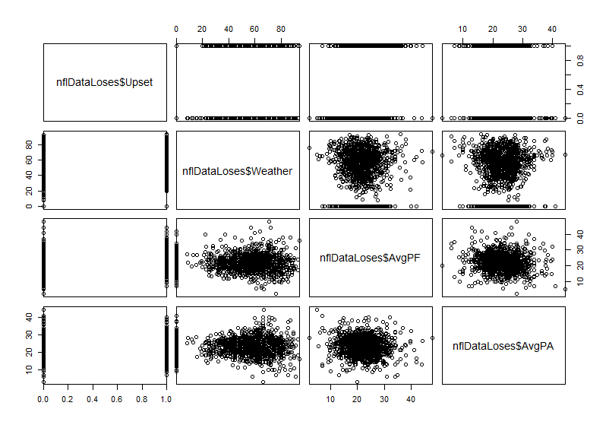

Figure . Scatterplot Matrix of Upset, Weather, Average Points For, and Average Points Against

#### Distribution of Attributes

Even if one was not aware beforehand, by looking at the histograms for cylinders (Figure 2), model year (Figure 7), and origin (Figure 8), one can tell that these variables are multi-valued, but discrete. There are only 5 different values for cylinders, the date range for model year is restricted to between 1970 (70) and 1982 (82), and the origin is one of 3 values. Another interesting distribution is the acceleration (Figure 6) values. These values seem to take on a nice bell curve without any data processing/transformations. The other remaining histograms for MPG (Figure 1), displacement (Figure 3), horsepower (Figure 4), and weight (Figure 5) all seem to have a right-skewed distribution. No histogram was completed for car name since it was specified as a unique identifier.

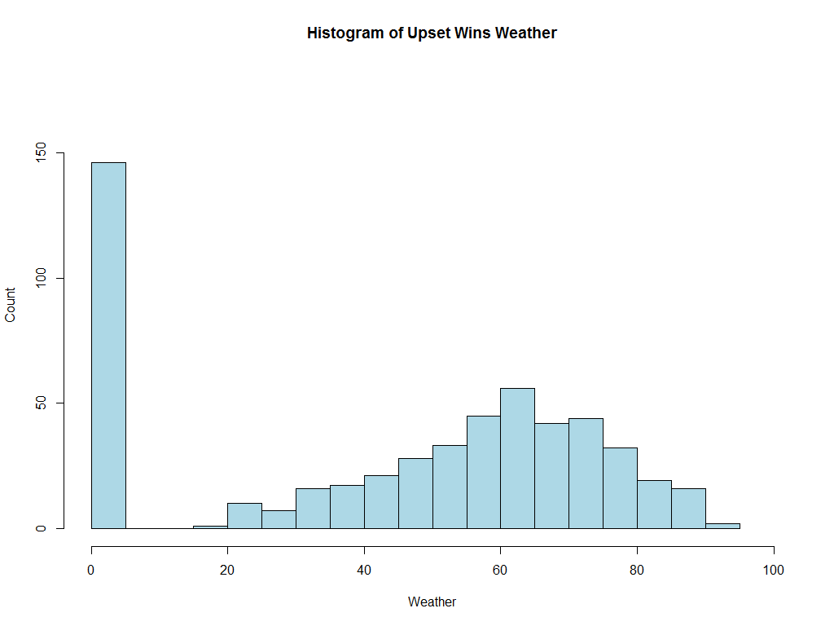

Figure 2. Histogram of Upset Wins Weather

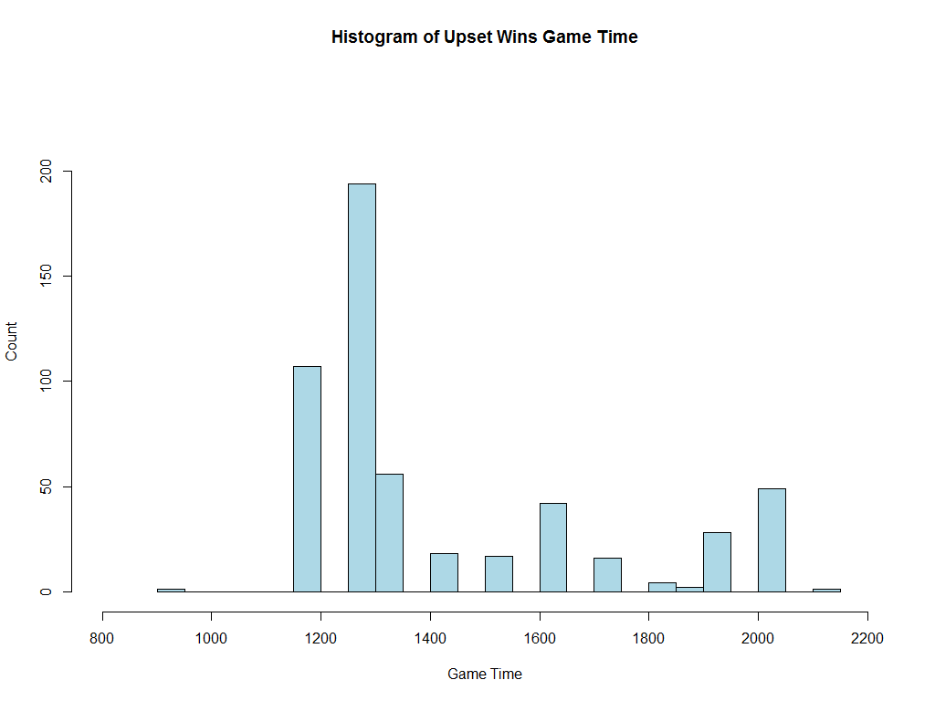

Figure 3. Histogram of Upset Wins Game Time

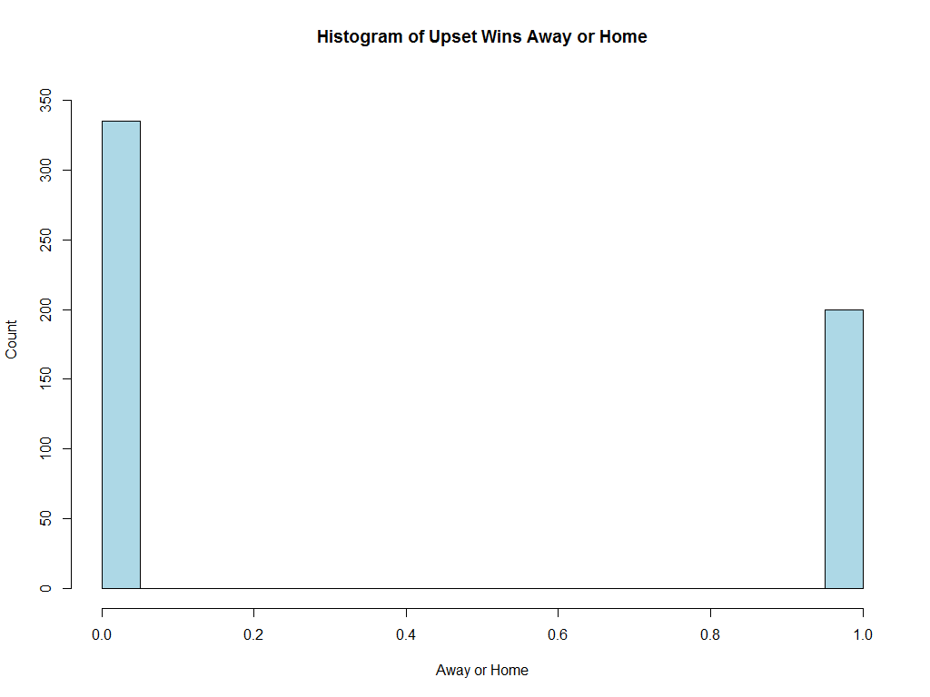

Figure 4. Histogram of Upset Wins Away or Home

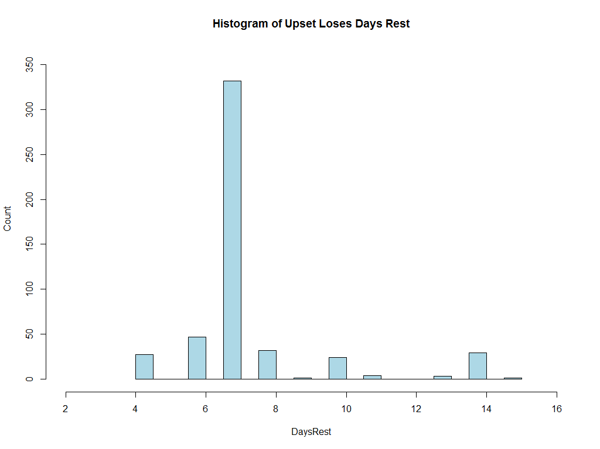

Figure 5. Histogram of Upset Loses Days Rest

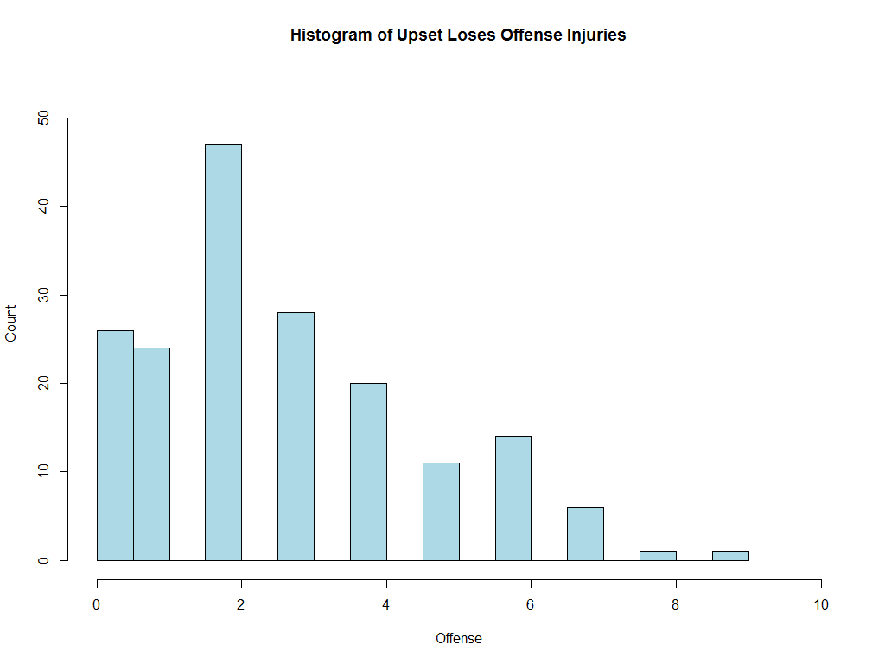

Figure 6. Histogram of Upset Loses Offense Injuries

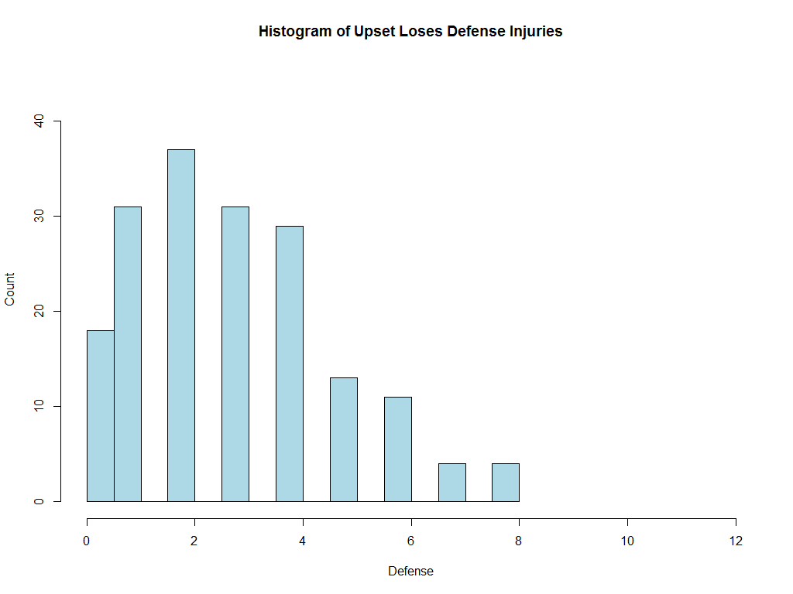

Figure 7. Histogram of Upset Loses Defensive Injuries

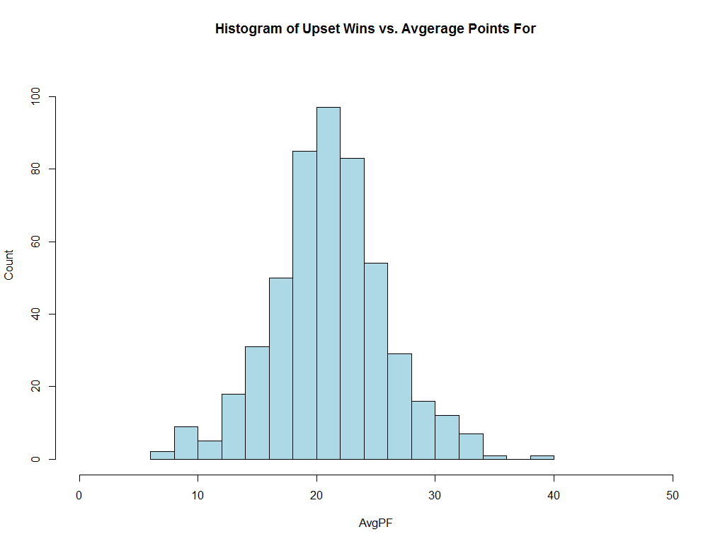

Figure 8. Histogram of Upset Wins Average Points For

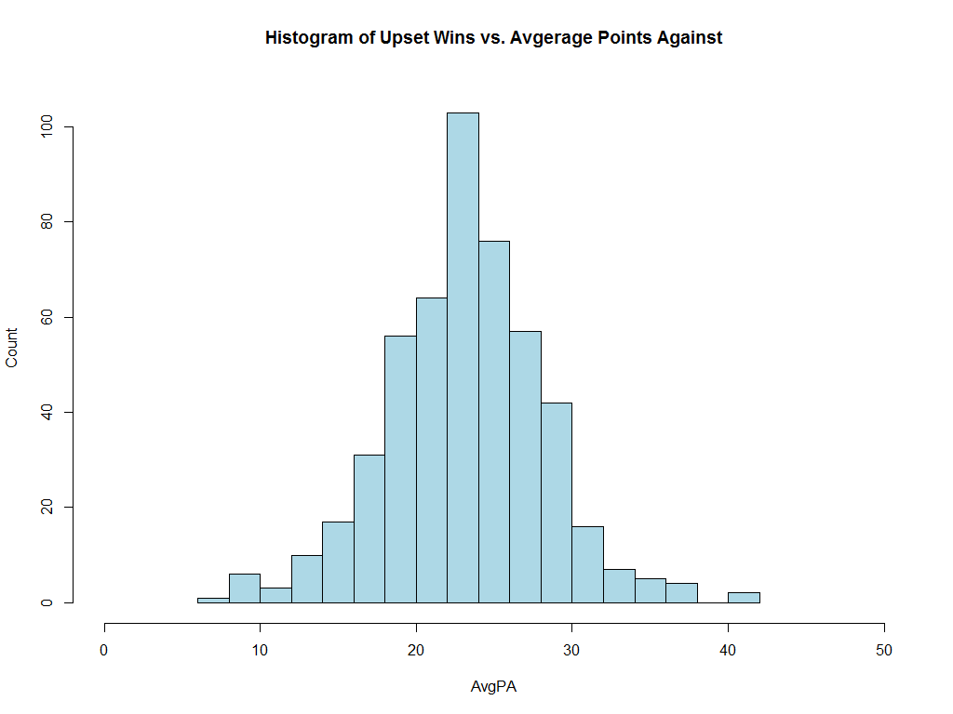

Figure 9. Histogram of Upset Wins Average Points Against

## Experiment Design, Tools, & Approaches

### Clustering

#### Density-based Approach

The density-based approach to clustering is based on specified connectivity and density functions. Unlike other approaches, the density-based approach can handle noise and only require one scan of the data.

Density-based clustering work with two parameters:

Eps: Maximum radius of the neighborhood

MinPts: Minimum number of points in an Eps-neighborhood (NEps) of the point

Density-based approach also uses the concepts of density-reachable and density-connected. A point *p* is defined as density-reachable from a point *q* if there is a chain points such that *pi+1* is directly density-reachable from *pi*. A point *p* is defined as density-connected to a point *q* if there is a point *o* such that both, *p* and *q* are density-reachable from *o*.

##### DBSCAN

Density-Based Spatial Clustering of Applications with Noise (DBSCAN) clusters data into maximal sets of density-connected points. Clusters discovered through DBSCAN for spatial databases with noise will be of arbitrary shape. The DBSCAN algorithm is as follows:

Arbitrarily select a point *p*

Retrieve all points density-reachable from *p* w.r.t. *Eps* and *MinPts*

If *p* is a core point, a cluster is formed

If *p* is a border point, no points are density-reachable from *p* and DBSCAN visits the next point of the dataset

Continue until all of the points have been processed

#### Partitioning Approach

The partitioning approach to clustering evaluates each item in a dataset by some criterion and divides, or partitions, into *k* clusters. The criteria for each chosen partition is chosen so as to optimize/minimize the sum of squared distances or

##### K-means

In k-means partitioning, each cluster is represented by one item at the center of the cluster. Evaluation of each dataset item to determine which cluster they belong to done using the following four steps:

1. Partition the dataset into *k* nonempty subsets
2. Compute the seed points as the mean point or centroid of the clusters current partitioning
3. Assign each object to the cluster with the nearest seed point
4. Repeat from step 2 until the assignments do not change

While K-means is sometimes known as a greedy algorithm, it is efficient running at *O*(*tkn*) where *n* is the number of instances, *k* is the number of clusters, and *t* is the number of iterations. However, k-means is not without its weaknesses. For k-means, the number of clusters in which to divide the data needs to be specified before the algorithm is run, which may require re-running to determine an optimal number of partitions. In addition, k-means can be sensitive to outliers as every item must be place in only the specified number of partitions.

### Classification

#### Training and Testing

The Holdout Method is a type of classification cross validation. For this method, the data set is randomly partitioned into two independent sets of specified size: the training set and the test set. The training set is used for model construction and the test set is used to evaluate the accuracy of the constructed model. For this exercise, two different partitioning techniques for holdout method will be used. For the first holdout method, the training set will consist of past season data and the test set will consist of current season data, trying to use past patterns to predict future/current outcomes. For the second holdout method, the training set will consist of 70% of the total dataset (past and current seasons) and the other 30% in the test set to determine if there is a pattern through all the seasons.

#### Naïve Bayes Classification

Naïve Bayes classification uses simple probabilistic classifiers based on Bayes’ theorem, which describes the probability of an event based on an already observed event.

Bayes’ theorem is formally written as follows:

Given training data **X**, *posteriori probability of a hypothesis* H, P(H|**X**):

The theorem is used to determine the posteriori probability P(H|X) that the hypothesis holds given the observed data sample X, or in simpler terms the likelihood of the hypothesis given prior evidence, for each classification. The data is assigned the classification with the highest probability.

#### Decision Tree

Decision Tree classification uses a flowchart-like tree structure for classification. In the tree, an internal tree node represents each test on an attribute, a tree branch represents each outcome of the attribute test, and each tree leaf node has a classification label. A path from the root to a leaf node is a representation of a classification rule.

The tree is constructed in a divide-and-conquer manner with no backtracking. The training examples are all at the root at the start of tree construction and are partitioned reclusively based on the provided selected attributes as the construction proceeds. Partitioning ends when all the samples for a given node belong to the same class, there are no remaining attributes for further partitioning, and there are no samples left to partition.

# EVALUATION METHODOLOGY

## Evaluation Metrics

### Classification

#### Accuracy and Error Rate

Accuracy is calculated as the percentage of test samples correctly calculated (TP is true positive, TN is true negative):

Error rate is calculated as the opposite, or 1 - accuracy (FP is false positive, FN is false negative):

#### Sensitivity and Specificity

Sensitivity is calculated as the true positive (TP) recognition rate:

Specificity is calculated as the true negative (TN) recognition rate:

Accuracy can be written as a function of both sensitivity and specificity:

#### Precision and Recall

There is an inverse relationship between precision and recall.

Precision is measured as a percentage of the samples classified with a positive label that are actually positive, or exactness:

Recall is measured as a percentage of positive samples actually classified with a positive label, or completeness.

A perfect score would be 1.0 or 100%.

#### F-Measures

F-measure is a type of accuracy measurement, which takes into account both precision and recall, with the resulting score assigned is between 0 and 1.

F-measure can also be a weighted measurement as follows:

# RESULTS

## Magnitude of Upset Analysis

### Clustering

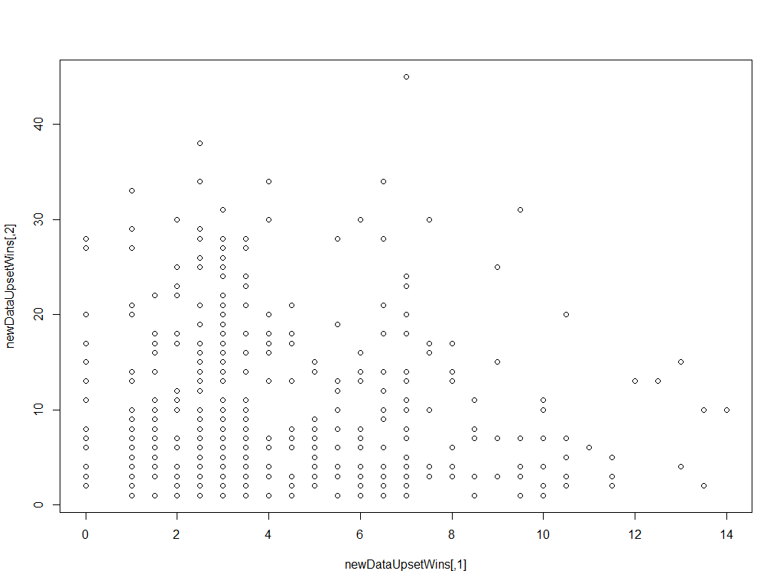

Figure . Odds and UpsetAmt for Clustering

#### Density Approach

##### DBSCAN

~~I first ran the DBSCAN with an Eps value of 5. The results (see Figure 10. DBSCAN Clustering for Eps=5Figure 10) showed some clustering but still many outliers. I then re-ran the DBSCAN with an Eps value of 10. The results (see Figure 11) were much improved; however, there were still a few outliers. I decided to see if it was possible to eliminate the remaining outliers. To do this I again increased the Eps value to 15 and re-ran the test. This result (see Figure 12) was not well clustered at all, so I knew I needed a Eps value closer to the last good clustering or Eps of 10. I tried a few other Eps values (see results for Eps 11 in Figure 13 and Eps 11.5 in Figure 14) until I found the results I considered the best for Eps value of 11.1 (see Figure 15) with as few outliers as possible.~~

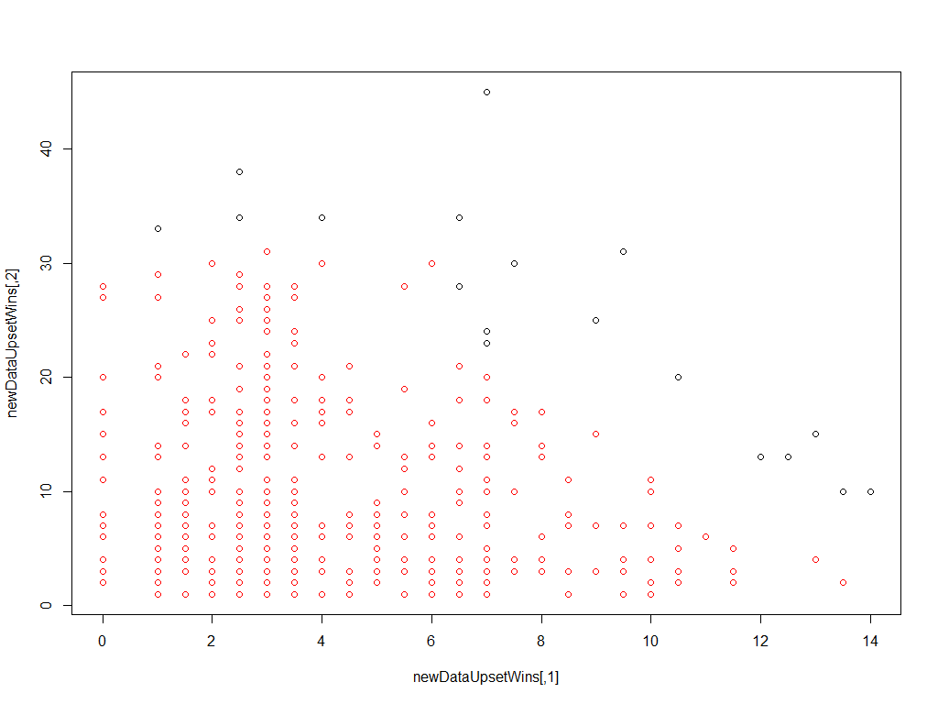

Figure . DBSCAN Clustering for Eps=1.75

#### 

Figure . DBSCAN Silhouette Plot

#### Partitioning Approach

~~For both partitioning methods, a~~ *~~k~~* ~~value for the number of partitions needs to be specified ahead of time. To determine the best value I used the Elbow method, which looks at the sum of squared error (SSE) within groups as a function of the number of clusters (see Figure 3). Looking for the bend of elbow in the plot gives a good indication of a value for~~ *~~k~~*~~. In this case, 8 or 10 clusters seemed to be good bend/elbow locations so I used both those values for~~ *~~k~~* ~~in my analysis.~~

##### 

Figure . Number of Clusters to Determine Best *k* Value

##### K-means

~~Using~~ *~~k=8~~* ~~for the k-means partitioning approach gave the highest average silhouette width (see Figure 16) of the partitioning approaches as well as density-based approaches at 0.53. The silhouette plot shows no outliers and seems to fit the data best.~~

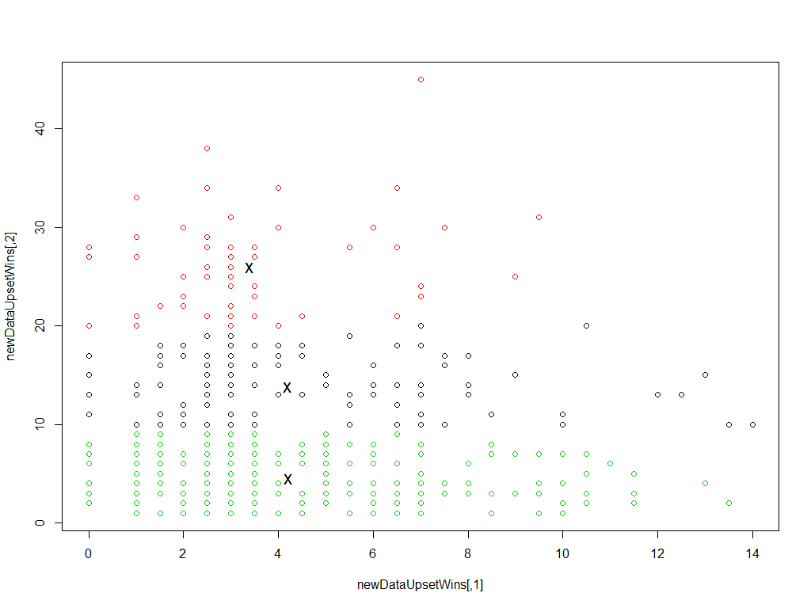

Figure . K-Means Clustering for *k*=3

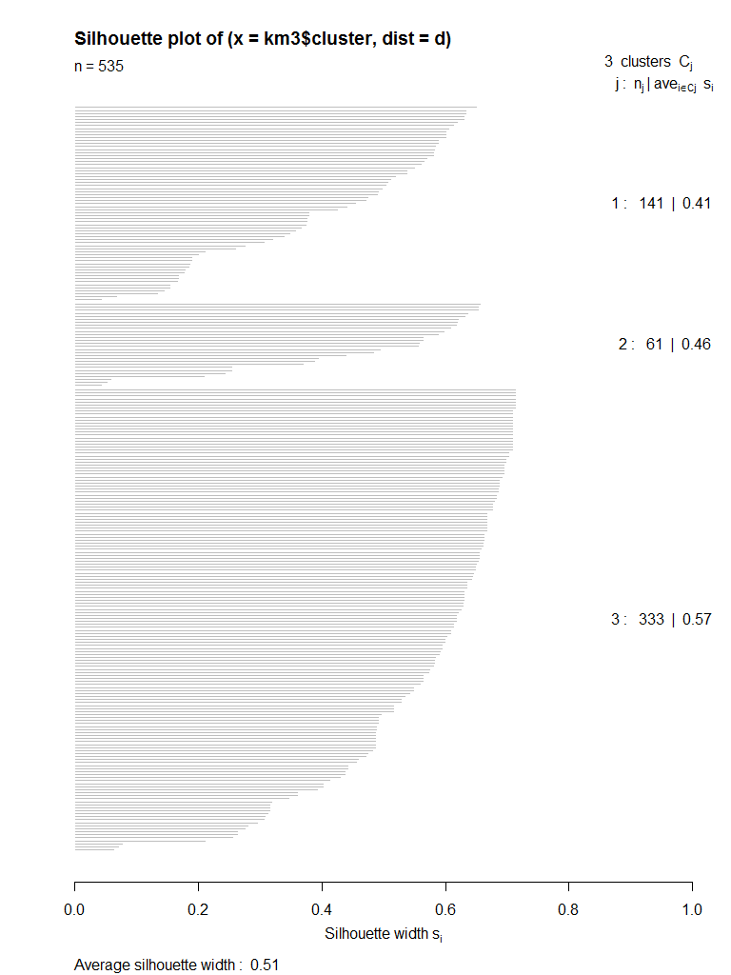

Figure . K-Means Clustering Silhouette Plot for *k*=3

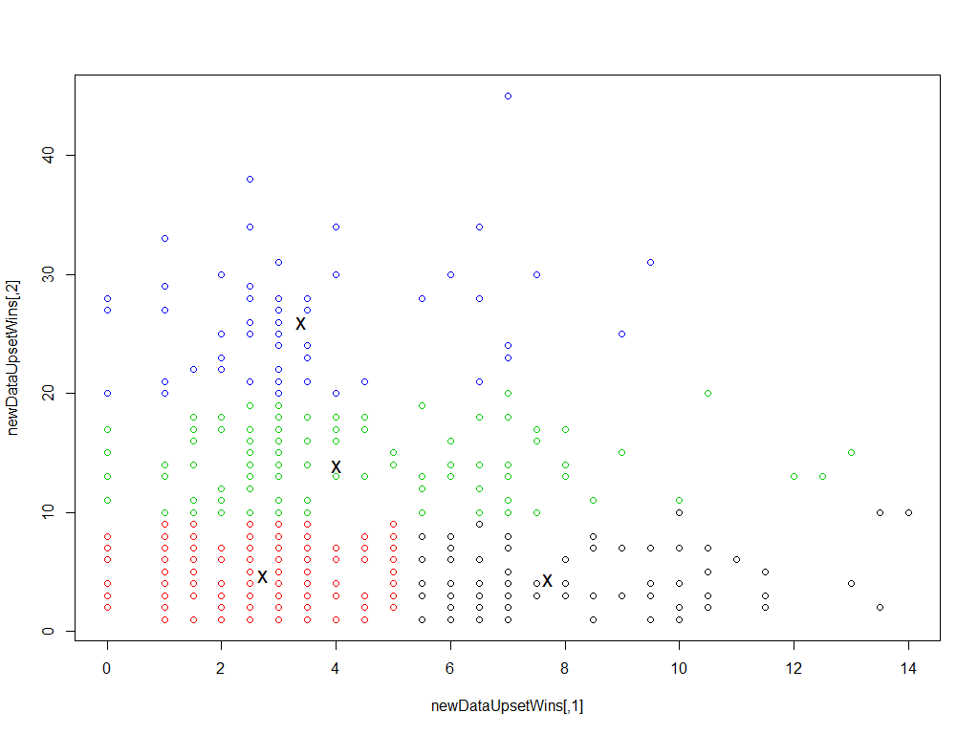

Figure . K-Means Clustering for *k*=4

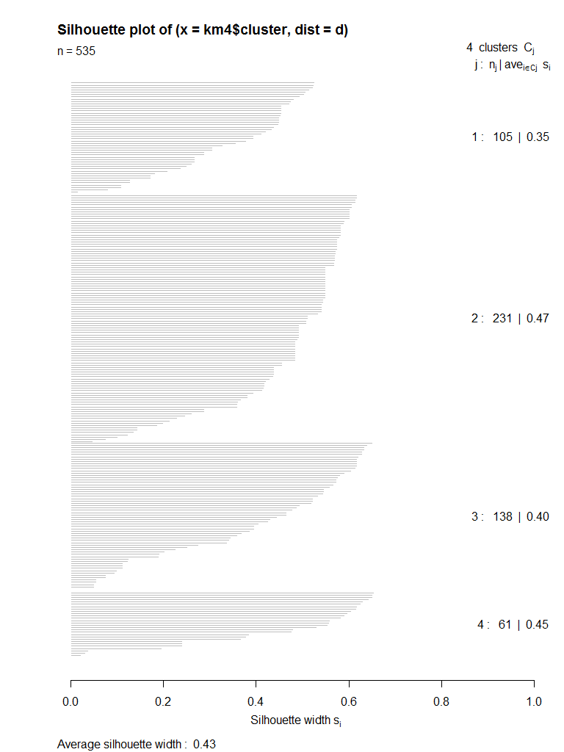

Figure . K-Means Clustering Silhouette Plot for *k*=4

### Classification

#### Training and Testing

As previously mentioned, the holdout method is the type of classification cross validation used for this exercise. For the case of the Magnitude of Upset, only one application of the approach was used in which the training set consisted of previous season data and the test set consisted of current season data. Unfortunately, the test set containing the current season data did not have representation for each classification type; however, it was still a useful exercise in determining how well the prediction worked for these results.

#### Naïve Bayes

Table . Naïve Bayes Confusion Matrix Results

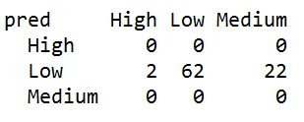

#### Decision Tree

~~The Decision Tree from constructed from the training set was more complicated than I had expected (see Figure 1). When I looked at the below Figure 2 of the relative error and complexity point (CP) it the complexity of the tree made more sense. As the size of the tree grew, the CP continued to decrease as well as the relative error. One interesting part of the resulting tree was even with the increase in tree size, the algorithm still did not determine a great way to classify balanced scales. The resulting Decision Tree from the training set had no leaf nodes with classification balanced despite numerous examples in the training data. The Decision Tree confusion matrix shown in Table 1 also confirms the trouble the Decision Tree classification had showing no balanced classifications for any of the test data.~~

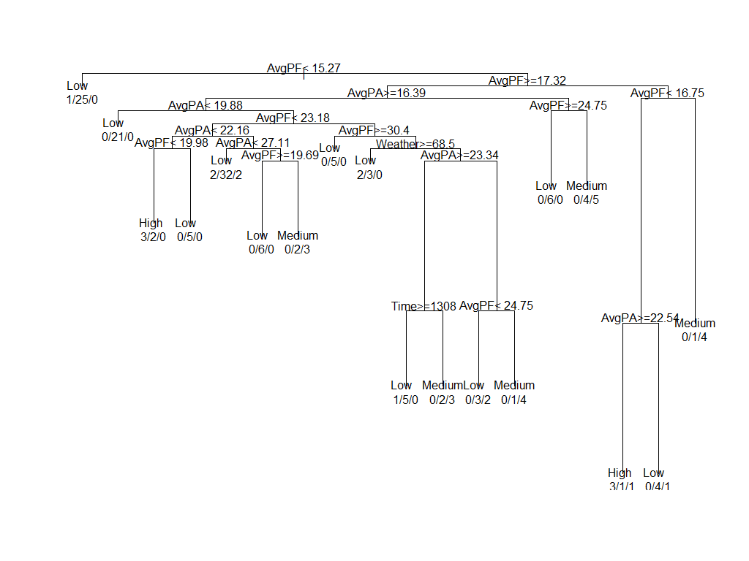

Figure . Decision Tree

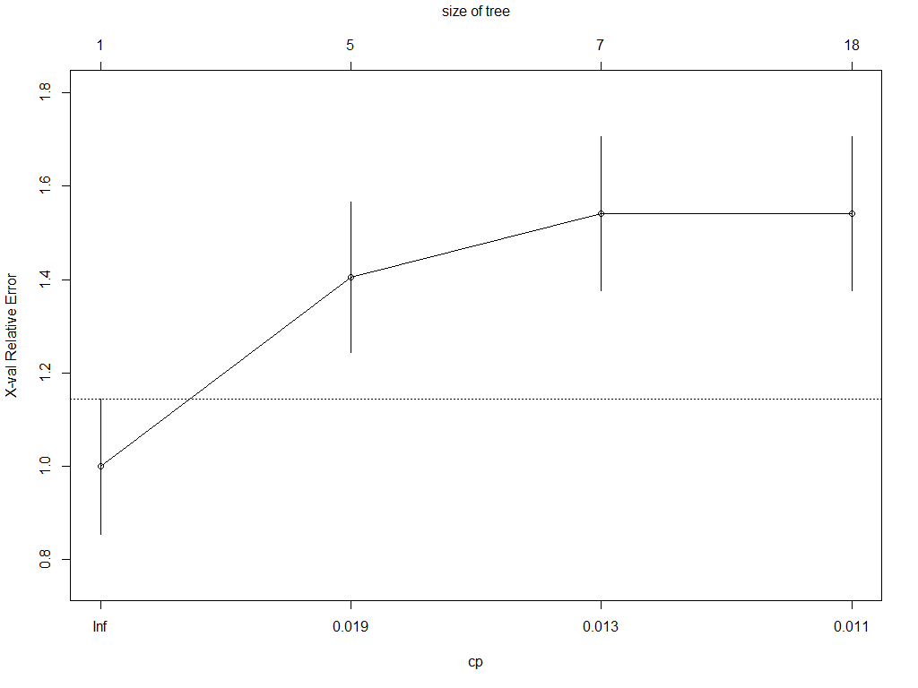

Figure . Relative Error and Complexity Point (CP)

Table . Decision Tree Confusion Matrix Results

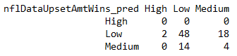

## Upset Analysis

### Classification

#### Training and Testing

~~The Holdout Method is a type of cross validation for classification. In the method, the entire data set is randomly partitioned into two independent sets of specified size: the training set and the test set. The training set is used for model construction and the test set is used to evaluate the accuracy of the constructed model. In the case of our analysis, the data was partitioned with 70% in the training set and 30% in the test set. Both sets contain examples of each classification type.~~

#### Naïve Bayes

#### Decision Tree

~~The Decision Tree from constructed from the training set was more complicated than I had expected (see Figure 1). When I looked at the below Figure 2 of the relative error and complexity point (CP) it the complexity of the tree made more sense. As the size of the tree grew, the CP continued to decrease as well as the relative error. One interesting part of the resulting tree was even with the increase in tree size, the algorithm still did not determine a great way to classify balanced scales. The resulting Decision Tree from the training set had no leaf nodes with classification balanced despite numerous examples in the training data. The Decision Tree confusion matrix shown in Table 1 also confirms the trouble the Decision Tree classification had showing no balanced classifications for any of the test data.~~

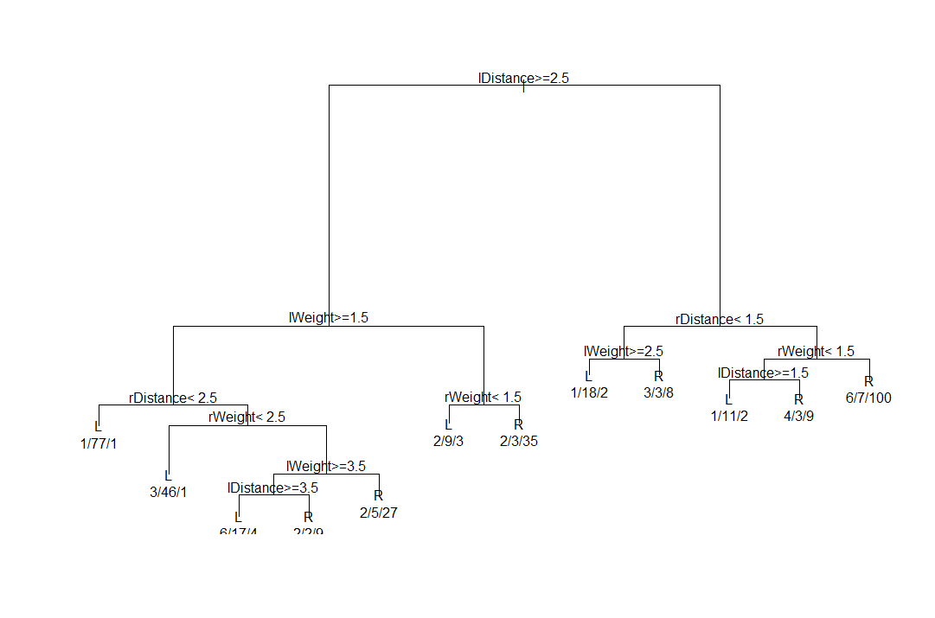

Figure 20. Decision Tree

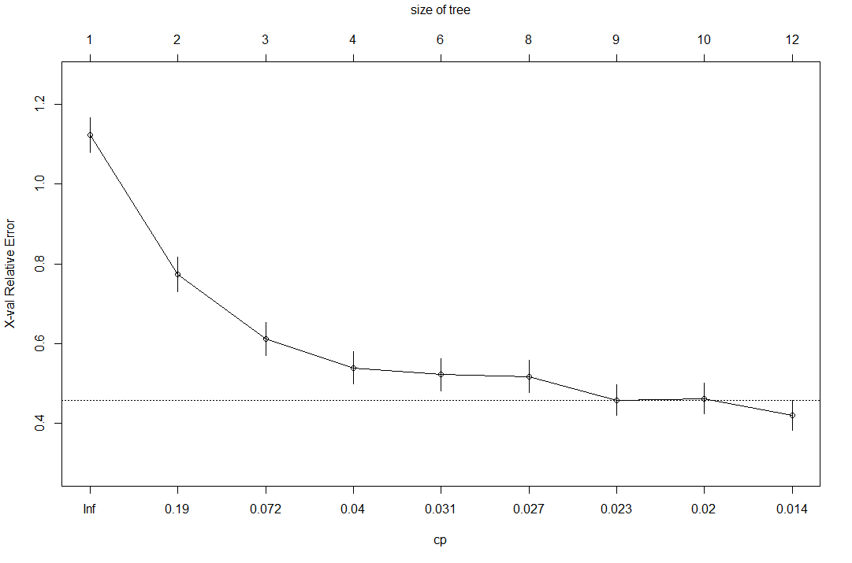

Figure 21. Relative Error and Complexity Point (CP)

Table 5. Decision Tree Confusion Matrix Results

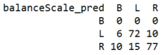

## Analysis

#### Accuracy and Error Rate

~~The overall accuracy for the~~ *~~k~~* ~~of 10 binned data could be calculated using Table 3 as follows:~~

~~(193 + 39 + 21+ 11 + 0 + 0 + 0 + 0 + 0 + 5) / 570~~

~~= 0.467 ≈ 47%~~

~~The overall error rate for the~~ *~~k~~* ~~of 10 binned data could be calculated using Table 3 as follows:~~

~~(37 + 90 + 43 + 32 + 31 + 23 + 23 + 7 + 8 + 7) / 570~~

~~= 0.528 ≈ 53%~~

~~With an error rate greater than the accuracy, we determined it was futile to continuing to calculate the rest of the classification evaluation metrics for~~ *~~k~~* ~~of 10 binned data. As inaccurate and error prone as the~~ *~~k~~* ~~of 10 binned data was obviously at determining classification, it would not provide us useful results. However, we continued the evaluation with the~~ *~~k~~* ~~of 5 binned data.~~

~~The overall accuracy for the~~ *~~k~~* ~~of 5 binned data could be calculated using Table 4 as follows:~~

~~(324 + 49 + 0 + 0 + 9) / 570 = 0.67 ≈ 67%~~

~~The overall error rate for the~~ *~~k~~* ~~of 5 binned data could be calculated using Table 4 as follows:~~

~~(35 + 58 + 54 + 30 + 11) / 570 = 0.33 ≈ 33%~~

~~With an accuracy near 2/3 and an error rate closer to 1/3, the results for~~ *~~k~~* ~~of 5 binned data were much better than those of the~~ *~~k~~* ~~of 10 binned data.~~

#### Sensitivity and Specificity

~~The sensitivity for each value for~~ *~~k~~* ~~of 5 binned data classification can be calculated using Table 4 as follows:~~

~~1: 324 / 395 = 0.82 ≈ 82%~~

~~2: 49 / 103 = 0.32 ≈ 32%~~

~~3 & 4: 0 / 0 so they cannot be calculated~~

~~5: 9 / 22 = 0.41 ≈ 41%~~

~~The specificity for each value for~~ *~~k~~* ~~of 5 binned data classification can be calculated using Table 4 as follows:~~

~~1: 140 / 175 = 0.8 ≈ 80%~~

~~2: 359 / 417 = 0.861 ≈ 86.1%~~

~~3: 516 / 570 = 0.905 ≈ 90.5%~~

~~4: 540 / 570 = 0.95 ≈ 95%~~

~~5: 537 / 570 = 0.98 ≈ 98%~~

#### Precision and Recall

~~The precision for each value for the~~ *~~k~~* ~~of 5 classification can be calculated using Table 4 as follows:~~

~~1: 324 / (324 + 106) = 0.75 ≈ 75%~~

~~2: 49 / (49 + 162) = 0.23 ≈ 23%~~

~~3: 0 / (0 + 54) = 0%~~

~~4: 0 / (0 + 30) = 0%~~

~~5: 9 / (9 + 24) = 0.273 ≈ 27.3%~~

~~The recall for each value for the~~ *~~k~~* ~~of 5 classification can be calculated using Table 4 as follows:~~

~~1: 324 / (324 + 71) = 0.82 ≈ 82%~~

~~2: 49 / (49 + 104) = 0.32 ≈ 32%~~

~~3: 0 / (0 + 0) so it cannot be calculated~~

~~4: 0 / (0 + 0) so it cannot be calculated~~

~~5: 9 / (9 + 13) = 0.41 ≈ 41%~~

#### F-Measures

~~The F-measure for each value for the~~ *~~k~~* ~~of 5 classification can be calculated using Table 4 as follows:~~

~~1: (2 * 0.75 * 0.82) / (0.75 + 0.82) = 0.78 ≈ 78%~~

~~2: (2 * 0.23 * 0.32) / (0.23 + 0.32) = 0.27 ≈ 27%~~

~~3: cannot be calculated since recall could not be calculated~~

~~4: cannot be calculated since recall could not be calculated~~

~~5: (2 * 0.828 * 0.41) / (0.828 + 0.41) = 0.33 ≈ 33%~~

# DISCUSSION

~~We had originally hypothesized that factors such as percentage of police per capita, per capita income, and percentage of population with Bachelor’s degrees or higher would be significant in terms of violent crimes per capita. It turned out that these are indirectly related to the attributes that we found most significant.~~

~~Also in our original hypothesis was the percentage of police per capita. This too was a poor predictor of the incidents of violent crime per capita. We believe this result is biased in that the communities with police departments that had less than 100 police officers were not included in the data set minus a few randomly sampled examples.~~

~~Investment income was one of the attributes we determined to a factor in violent crimes per capita. It is indirectly related to per capita income in that investment income is usually thought of as the difference between income and expenses. It is also common for areas with high incomes per capita to be areas with a very high cost of living. Therefore, if we were to use purely per capita income the perceived wealth/income would be skewed in this scenario. Investment income is a better indicated of how well a community is doing relative to its cost of living.~~

~~In addition, there was not a significant separation between communities with a more educated resident base beyond a high school degree. It is possible that a high school degree was sufficient for a comfortable standard of living in the 1980s and 1990s. It would be interesting to explore this today and see if the threshold has increased to a bachelor’s degree.~~

# CONCLUSIONS

~~In our analysis, we saw a slight proportional relationship between high violent crime per capita and high percentage of divorcees as well as a high percentage of the population without a high school degree. We also saw a slight inverse proportional relationship between high violent crime per capita and communities with higher percentage of investment income as well as largely Caucasian communities.~~

~~When there was lower percentage of the population without a high school degree, a lower percentage of divorcees and higher percentage of Caucasians were found frequently. In addition, a higher percentage of Caucasians in the community was frequently found associated with a higher percentage of the population with investment income. High percentages of Caucasians in a community were also many times found with low to mid percentages of divorcees in the community.~~

~~The error rate for the classification was very high. There were also very few results in our frequent itemset analysis with the low percentage of violent crime per capita the only bin producing results. Even with the large size of the dataset, the fact that there was so much error and so little results does not give us confidence that the attributes we selected do have a strong case for influencing violent crime per capita.~~

~~We feel it would be useful to extend this study to analyze how change in any specific attribute is correlated with an increase or decrease in violent crime per capita. This would require additional datasets in preceding and/or succeeding years. This additional data would also help in determining outliers in the data, which could be used to improve the results of any analysis.~~

# REFERENCES

1. Larose, D. and Larose, C.D. *Discovering Knowledge in Data: An Introduction to Data Mining*. Wiley-Interscience, 2014.
2. Anon. 2014 NFL Weekly League Schedule | Pro-Football-Reference.com. Retrieved August 20, 2016 from <http://www.pro-football-reference.com/years/2014/games.htm>
3. Anon. 2012 Arizona Cardinals season. Retrieved August 20, 2016 from <https://en.wikipedia.org/wiki/2012_Arizona_Cardinals_season>
4. USAToday. Week-by-week 2013 NFL schedule (2013). Retrieved September 20, 2016 from <http://www.usatoday.com/story/sports/nfl/2013/04/18/week-by-week-2013-nfl-schedule/2093613/>
5. Gray, J. NFL schedule 2014: Week by Week. (2014). Retrieved September 20, 2016 from <http://www.sbnation.com/nfl/2014/4/23/5576528/nfl-weekly-schedule-2014>
6. Hirschhorn, J. B. 2015 NFL schedule released. (2015). Retrieved September 20, 1016 from <http://www.sbnation.com/2015/4/21/8341221/2015-nfl-schedule-released-seahawks-patriots-eagles-broncos>
7. Anon. Archived Closing NFL Odds, NFL Lines, NFL Point Spreads. Historical Pro Football: 2006 – Current. Retrieved September 20, 2016 from <http://www.footballlocks.com/archived_nfl_odds_lines_point_spreads.shtml>
8. Anon. National Football League Game Summary. Retrieved September 20, 2016 from <http://www.nfl.com/liveupdate/gamecenter/56954/HOU_Gamebook.pdf>
9. Anon. Weather Forecast & Reports – Long Range & Local | Wunderground | Weather Underground. Retrieved September 20, 2016 form <https://www.wunderground.com/>
10. Anon. 2011 Minnesota Vikings injuries | Pro-Football-Reference.com. Retrieved October 20, 2016 from <http://www.pro-football-reference.com/teams/min/2011_injuries.htm>
11. Anon. 2010 Minnesota Vikings Starters, Roster, & Players | Pro-Football-Reference.com. Retrieved October 20, 2016 from <http://www.pro-football-reference.com/teams/min/2010_roster.htm>