ASSIGNMENT # 01
CS-878: DEEP LEARNING

OSTEOPOROSIS DETECTION
USING MLP FRAMEWORK

SUBMITTED BY:
Muhammad Soban Shaukat
(Registration No: 00000538822)
Master of Science in Artificial Intelligence
Aqdas Hassan
(Registration No: 00000499341)
Master of Science in Software Engineering
Spring-2026

SUBMITTED TO:
Dr. Usman Akram
Prof, CEME, NUST
Date of Submission: 23-Febeuary-2026

Department of Computer Sciences and Engineering, CEME. National University of Sciences & Technology (NUST), Rawalpindi
- Introduction
Osteoporosis is a chronic metabolic bone disorder characterized by reduced bone mineral density and deterioration of bone microstructure, leading to increased fracture risk. It affects over 200 million people worldwide, with one fracture occurring every three seconds globally. Despite its prevalence, osteoporosis remains significantly underdiagnosed because the gold standard diagnostic tool, Dual-Energy X-ray Absorptiometry (DXA), is expensive, limited in availability, and requires trained personnel — particularly in resource-constrained settings like Pakistan.
This assignment investigates whether a Multilayer Perceptron (MLP) neural network can detect osteoporosis using only routine, non-invasive clinical variables such as age, BMI, vitamin D, and calcium levels. The goal is a low-cost, scalable screening framework that classifies patients into three WHO-defined categories: Normal, Osteopenia, and Osteoporosis.

- Dataset
Data was sourced from the National Health and Nutrition Examination Survey (NHANES), a publicly available dataset maintained by the Centers for Disease Control and Prevention (CDC). Survey cycles from 1999 to 2018 were combined, forming a cohort of 11,943 adult samples with 14 clinical features. The dataset is well-balanced across all three classes Normal (4,030), Osteopenia (3,988), and Osteoporosis (3,925) and contains no missing values, making it directly suitable for model training without imputation.
The 14 features used include Age, Gender, BMI, Height, Weight, Serum Vitamin D, Calcium, Alkaline Phosphatase, Hemoglobin, Hematocrit, Menopause Status, Smoking, Diabetes, and Trauma. Spine BMD from DXA was used only to define the target label and was excluded from all predictive features to simulate a realistic non-invasive screening scenario.

- Data Visualization
To understand feature distributions and their relationship with the target variable, three types of plots were generated for four clinically relevant features: Age, BMI, Serum Vitamin D, and Calcium.
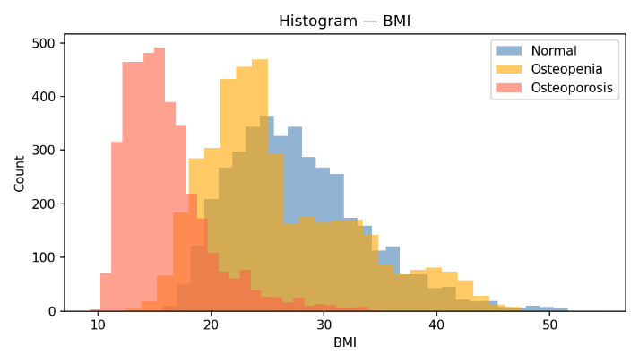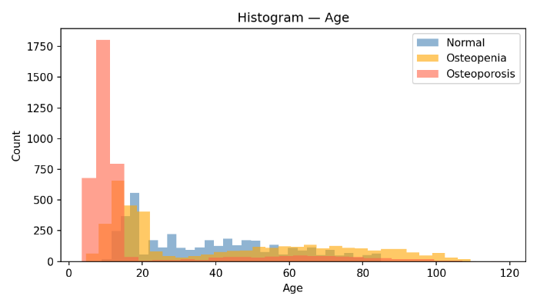
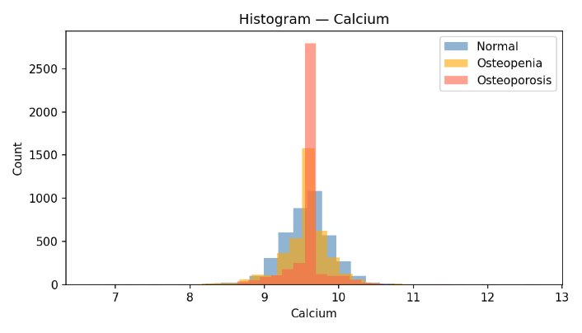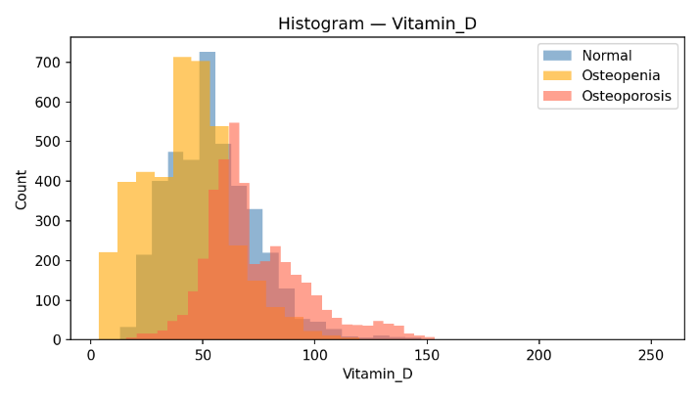
- Osteoporosis patients are concentrated at younger ages due to dataset characteristics. Normal patients show a broader age spread.
- Osteoporosis patients show lower BMI values, consistent with clinical evidence linking low body weight to bone loss.
- Osteopenia patients show the lowest Vitamin D levels, while Osteoporosis patients show a wider spread.
- Calcium is tightly distributed across all classes with Osteoporosis showing a sharper peak around 9.5 mg/dL.

The scatter plots reveal that Age vs BMI shows the clearest class separation, with Osteoporosis patients clustering at low BMI values. Vitamin D vs Calcium shows no strong linear correlation across classes.
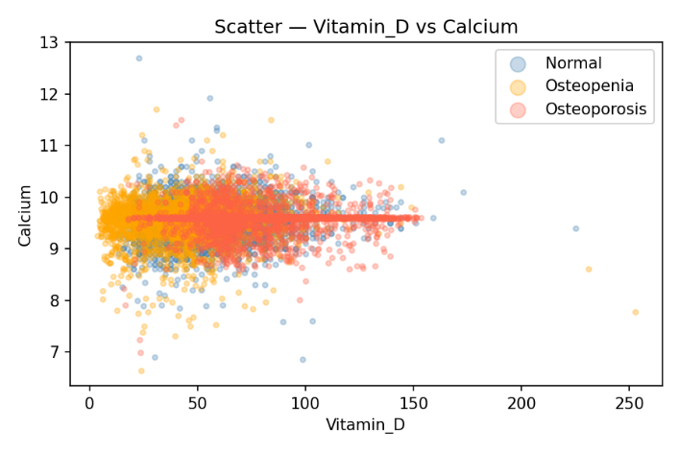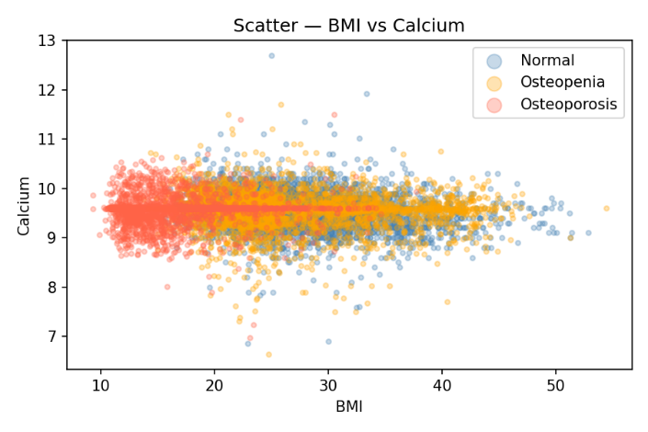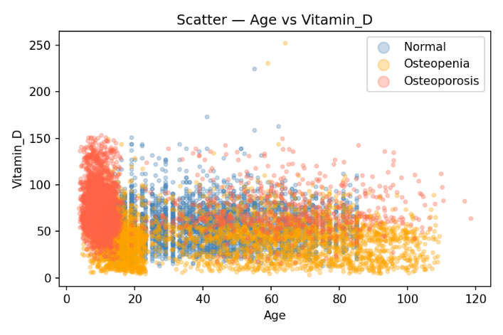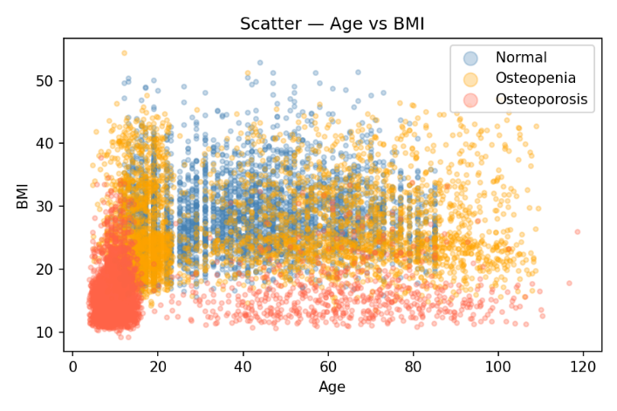
Box plots confirm that BMI and Age show the most visible spread differences between classes, while Calcium has minimal inter-class variation, suggesting it alone is a weak predictor.
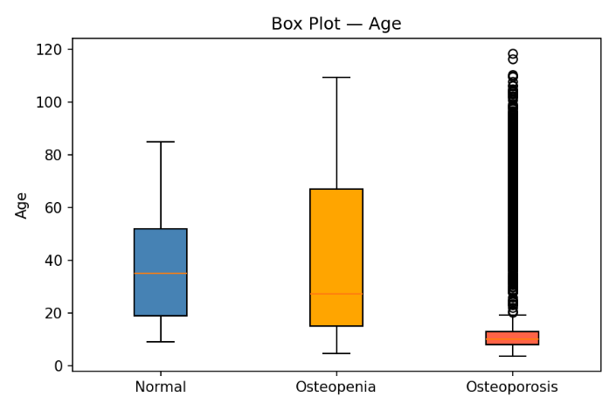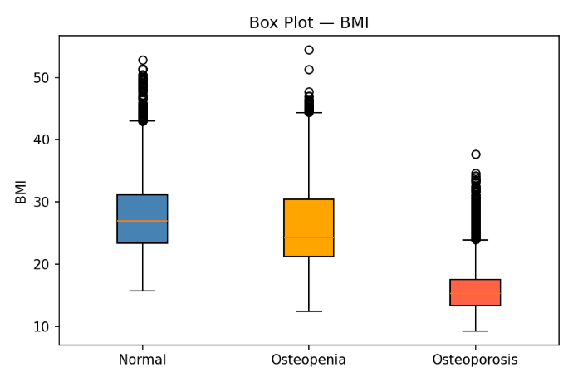
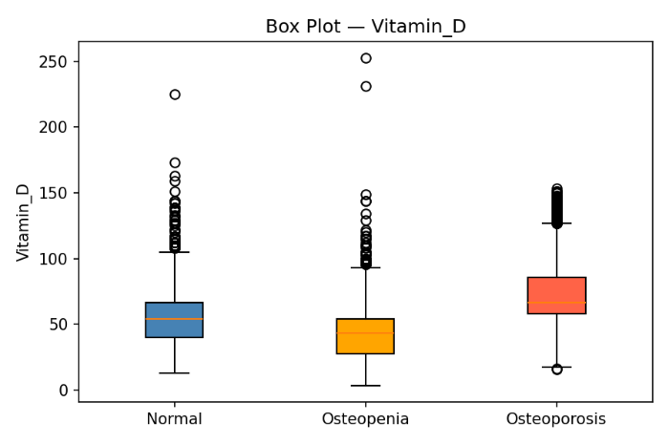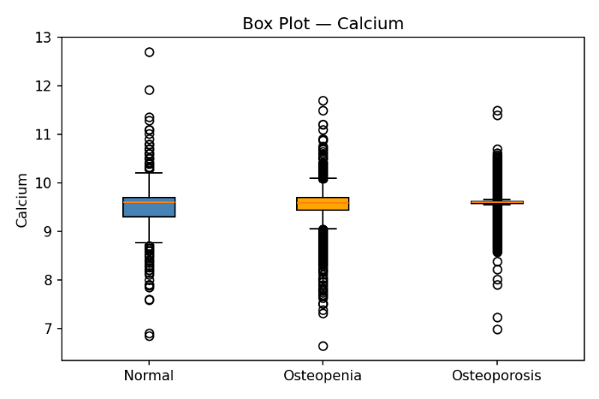

- MLP Implementation & Results
For the classification problem of osteoporosis, we developed a Multilayer Perceptron (MLP) network using PyTorch. The MLP is made flexible and customizable so that we can test different configurations of hidden layers, number of neurons, activation functions, and dropout rates.
The MLP takes the preprocessed numerical variables as input and processes them through multiple fully connected hidden layers. Each hidden layer applies a non-saturating activation function, which we can select from ReLU, Leaky ReLU, Tanh, or Sigmoid activation functions. To reduce overfitting and enhance generalization, we can append a dropout layer after each hidden layer, with a user-specified dropout probability. The output layer has three neurons, representing the three classes of bone density status: Normal, Osteopenia, and Osteoporosis. The network computes raw scores for each class, which are later used with a proper loss function during training.
A Multilayer Perceptron was implemented in PyTorch with a baseline architecture of two hidden layers (64 → 32 neurons), ReLU activation, Adam optimizer, learning rate of 0.001, and trained for 50 epochs using Cross-Entropy loss. The dataset was split into 64% training, 16% validation, and 20% test sets with stratification to preserve class balance.
Parameter | Value
Architecture | Input(14) → 64 → 32 → Output(3)
Activation | ReLU
Optimizer | Adam
Learning Rate | 0.001
Epochs | 50
Loss Function | Cross-Entropy
The baseline model achieved a test accuracy of 87.90%, with strong performance across all three classes. Osteoporosis achieved the highest F1-score of 0.94, while Osteopenia was the hardest class to distinguish at 0.81.

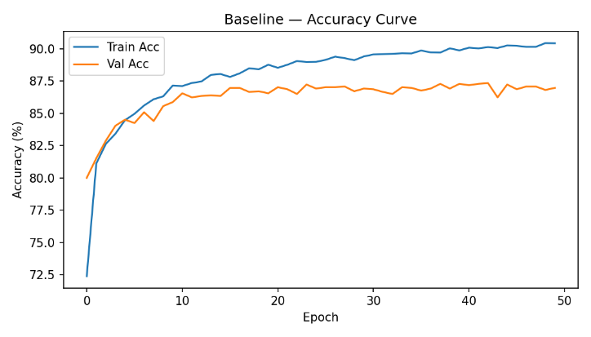
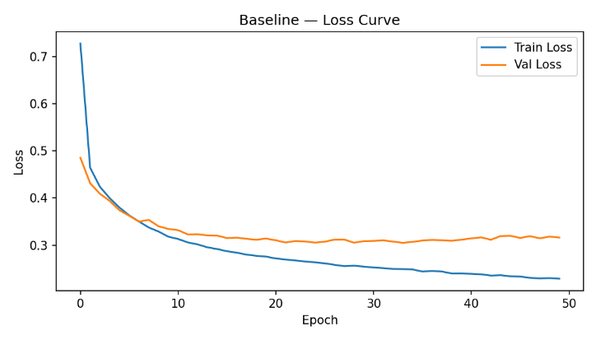
Class | Precision | Recall | F1-Score
Normal | 0.84 | 0.93 | 0.88
Osteopenia | 0.89 | 0.75 | 0.81
Osteoporosis | 0.92 | 0.96 | 0.94
Overall | 0.88 | 0.88 | 0.88
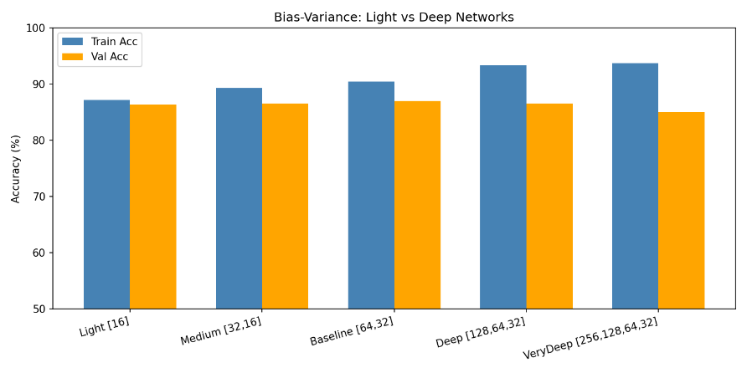
To analyze Bias and Variance, five architectures ranging from Light to VeryDeep were trained. Smaller networks showed high bias (low train accuracy), while larger networks showed high variance (large train-val gap).

Architecture | Neurons | Train Accuracy | Validation Accuracy | Overfitting Gap
Light | [16] | 87.19% | 86.39% | 0.80%
Medium | [32, 16] | 89.27% | 86.55% | 2.72%
Baseline | [64, 32] | 90.42% | 86.97% | 3.45%
Deep | [128, 64, 32] | 93.37% | 86.55% | 6.81%
Very Deep | [256, 128, 64, 32] | 93.75% | 85.09% | 8.66%

The results indicate that the more layers, the better the training accuracy, but not necessarily the better the validation accuracy. The Light model has the smallest overfitting gap (0.80%), which shows excellent generalization capabilities but slightly lower overall performance.
With the increase in model complexity, the training accuracy increases from 87.19% (Light) to 93.75% (Very Deep). Nevertheless, the validation accuracy remains more or less the same and even drops for deeper models. The overfitting gap becomes substantially larger for the Deep and Very Deep models (6.81% and 8.66%), which indicates that the larger models tend to overfit the training data.
In summary, the Baseline model ([64, 32]) offers the best trade-off between performance and generalization capabilities, as it reaches the highest validation accuracy (86.97%) with a moderate overfitting gap.
- Ablation Studies
All ablation studies were conducted by keeping the baseline configuration fixed and changing one parameter at a time.
  - Optimizer: Adam vs SGD
Adam outperformed SGD with a test accuracy of 87.90% vs 85.01%. Adam's adaptive learning rate per parameter allows faster and more stable convergence compared to SGD's fixed learning rate.
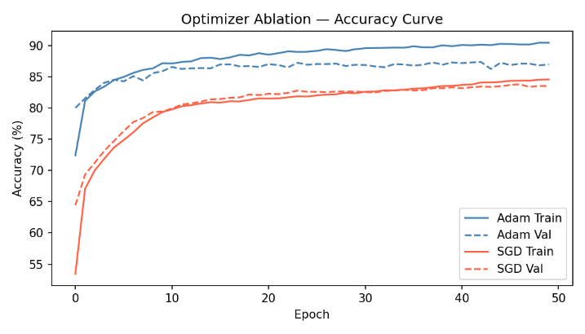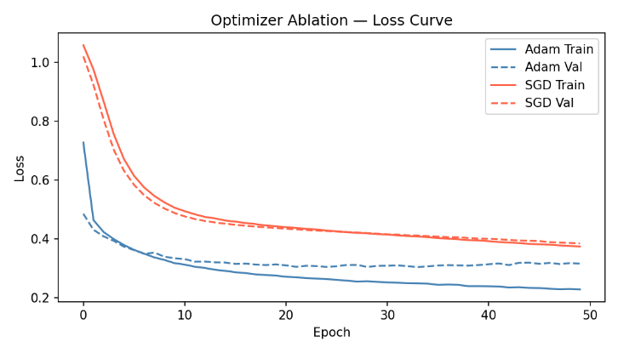

  - Activation Function
In the activation function ablation experiment, four activation functions, namely ReLU, Leaky ReLU, Sigmoid, and Tanh, were compared on the same network architecture to understand their effect on the performance of the model. Among the four activation functions, ReLU reported the highest test accuracy of 87.90%. Leaky ReLU was the second-best activation function with a test accuracy of 87.78%, thus proving that a small gradient for negative inputs does not affect the learning process. Tanh was the third-best activation function with a test accuracy of 87.61%, thus proving that it has excellent generalization capabilities compared to other activation functions. However, Sigmoid reported the lowest test accuracy of 85.39%, thus making it the worst activation function among the four. This is because the vanishing gradient problem hinders the learning process in the deeper network.
Activation Function | Test Accuracy (%)
ReLU | 87.90
Leaky ReLU | 87.78
Tanh | 87.61
Sigmoid | 85.39

  - Architecture: Neurons & Layers
The comparison of the overfitting gaps for different model capacities clearly reveals a relationship between the size of the network and the overfitting gap. The smallest overfitting gaps are shown by the Tiny [16] and Small [32] models, which have overfitting gaps of 0.80% and 1.35%, respectively, and thus demonstrate excellent generalization capabilities but slightly lower overall accuracy because of their low model capacity. With the increase in the complexity of the network, such as in the Baseline [64,32] and Deep [64,32,16] models, the training accuracy increases while the validation accuracy remains relatively stable, and thus the overfitting gaps are moderate (around 3-4%). These models strike a balance between learning capacity and generalization ability. The Wide [128,64] model continues to increase the training accuracy but simultaneously increases the overfitting gap to 5.31%, thus indicating that the model has started to memorize the training data. Finally, the Large [256,128,64] model has the highest training accuracy of 94.95% but the lowest validation accuracy among the larger models, with a substantial overfitting gap of 9.39%, thus clearly indicating that the model has overfit.
Architecture | Train Accuracy (%) | Validation Accuracy (%) | Overfitting Gap (%)
Tiny [16] | 87.19 | 86.39 | 0.80
Small [32] | 87.90 | 86.55 | 1.35
Baseline [64, 32] | 90.42 | 86.97 | 3.45
Wide [128, 64] | 91.81 | 86.50 | 5.31
Deep [64, 32, 16] | 90.83 | 87.13 | 3.70
Large [256, 128, 64] | 94.95 | 85.56 | 9.39

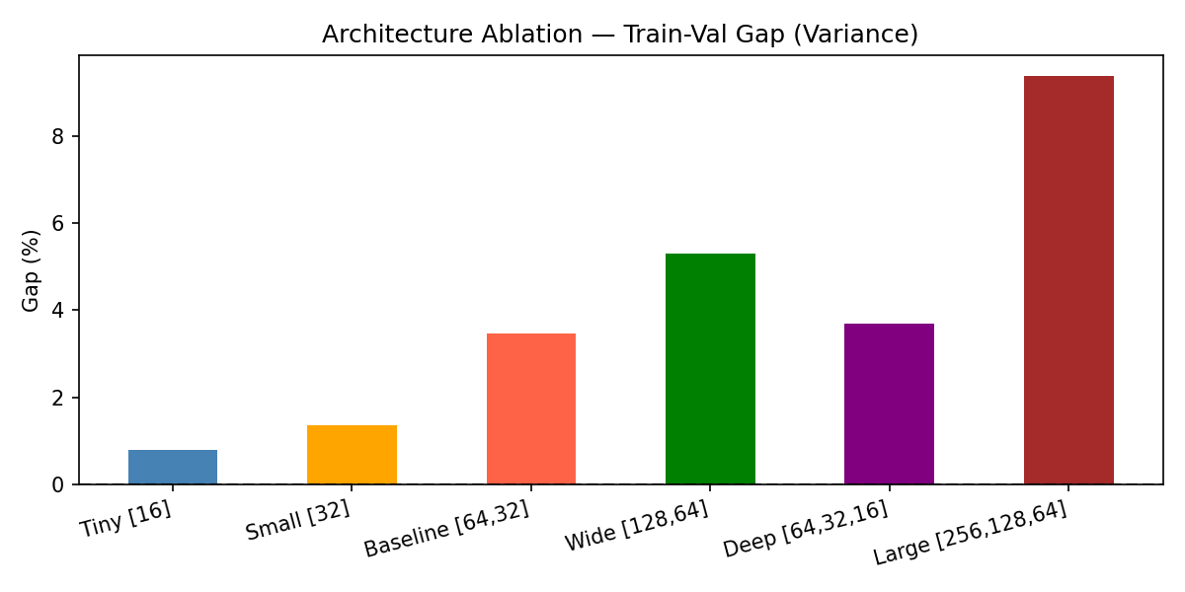

  - Learning Rate
The learning rate analysis demonstrates the effect of step size on convergence and generalization. When the learning rate is 0.01, the training accuracy was the highest (92.74%), but the validation and test accuracy was slightly lower than when the learning rate is 0.001, indicating mild overfitting due to the larger step size that may result in overshooting the optimal minima. The learning rate of 0.001 yielded the best results, resulting in the highest test accuracy (87.90%) and excellent validation accuracy (86.97%), indicating a perfect trade-off between convergence and generalization. On the other hand, the learning rate of 0.0001, which is too small, resulted in the lowest training, validation, and test accuracies, indicating underfitting due to the very small step size that resulted in slow learning and failure to reach optimal performance within the number of training epochs. The learning rate of 0.001 is thus the best for this model, providing stable training and excellent generalization performance.

Learning Rate | Train Accuracy (%) | Validation Accuracy (%) | Test Accuracy (%)
0.01 | 92.74 | 86.66 | 86.94
0.001 | 90.42 | 86.97 | 87.90
0.0001 | 84.76 | 84.41 | 85.14

In summary, our experiments demonstrate that models of moderate depth (64, 32, 16) strike the optimal balance between learning and generalization, neither underfitting in shallow models nor overfitting in excessively large ones. The Adam optimizer helped to converge faster and more smoothly than SGD, and ReLU activation functions clearly outperformed Sigmoid and Tanh activation functions because of improved gradient propagation. Finally, a learning rate of 0.001 offered the optimal balance between generalization performance and overfitting, reaching the highest test accuracy of 87.90% without overfitting.
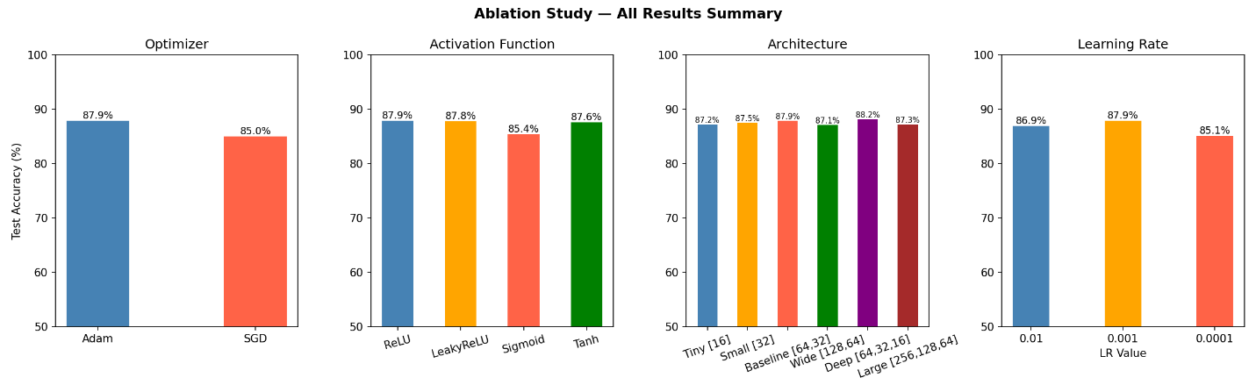
- Conclusion
This assignment demonstrated that a simple MLP network can effectively detect osteoporosis using routine non-invasive clinical features, achieving 87.90% test accuracy on the NHANES dataset. The best performing configuration used a architecture with ReLU activation, Adam optimizer, and a learning rate of 0.001.
Ablation studies confirmed that Adam consistently outperforms SGD, ReLU is the most suitable activation function for this tabular dataset, and moderate architectures generalize best. Very deep networks overfit while very shallow networks underfit, validating the classic bias-variance tradeoff in practice.

