Act Report on @WeRateDogs

There was over 2300 tweets of cute dogs in @WeRateDogs database when I started, and that’s a lot of doggo’s , floofer’s, pupper’s and puppo’s for one man to handle. I knew there are some retweets in this database and some of the tweets itself were not viable for analysis. I had to wrangle around to clean the database, match image predictions and move around few things. Finally I got to little less than 2000 dogs which I was about to rate.

14/10

If you ever saw tweets of @WeRateDogs you know how unusual their system of rating is, and how special perfect score of 14/10 is, how often do you really see it? Let’s see the ratings

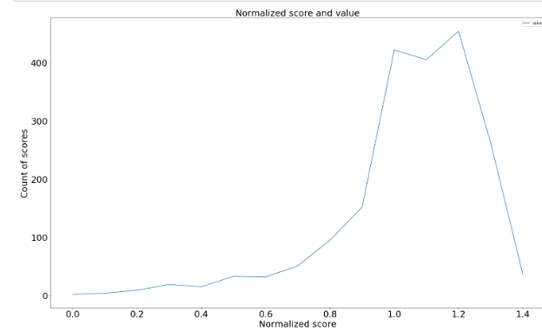

All of the dogs are cute and deserve special recognition. Most of the scores are between 0.9 (which is 9/10) and 1.3 (13/10). In this category there is 1695 dogs between this brackets. That stands for 85% of dogs receiving rating 9-13/10. Actually only 36 out of 2000 dogs received 14/10, top 1,8%. There was also some lower scores 0-5/10, I looked around briefly and these were pictures of different things, chicken, rug (with a Puddle lying on it), clearly tweets made just for laughs.

Charlie

Charlie – most popular name of the dog in the database. He accounted for 11 values in our dataset. Next on the podium were: Oliver, Lucy and Cooper each of them had 10 hits, and on he third place were Penny and Tucker. That’s really not that many dogs, right? As I noticed, people are not that keen to give name of the dog, I don’t know why.

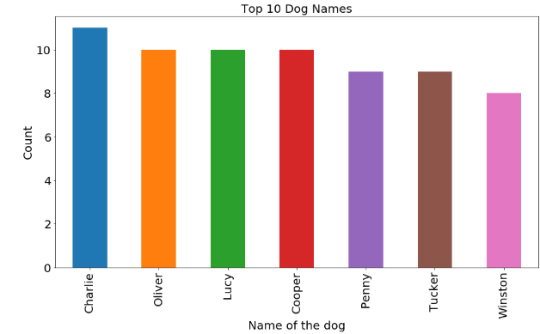

There was 601 tweets where name of the dog wasn’t included. Rest of the hits were fairly distributed

Retrievers everywhere

I had an image prediction feature which I could use to find out which race of the dog was featured on the picture. With 95% confidence set on the algorithm I found out that number 1 was Golden Retriever with 139 pictures followed by Labrador retriever with 95 pictures, number 3 on our list was taken by 88 pictures of Pembroke.

