Basic installation and configuration manual

Wired sensors
Wired sensors are simple. The Arduino Open Alarm system will initialize each pin in the Arduino assigned to a wired sensor with the internal pull-up resistor, so it will default to HIGH state (active). You have to connect your wired sensors so they are normally LOW (inactive, typically with a 10K resistor to ground), and they activate on HIGH (or open).

Magnetic sensors (typically door sensors) are simple switches so you only have to wire one end to GND and the other to an Arduino input digital pin with a 10K in series resistor.

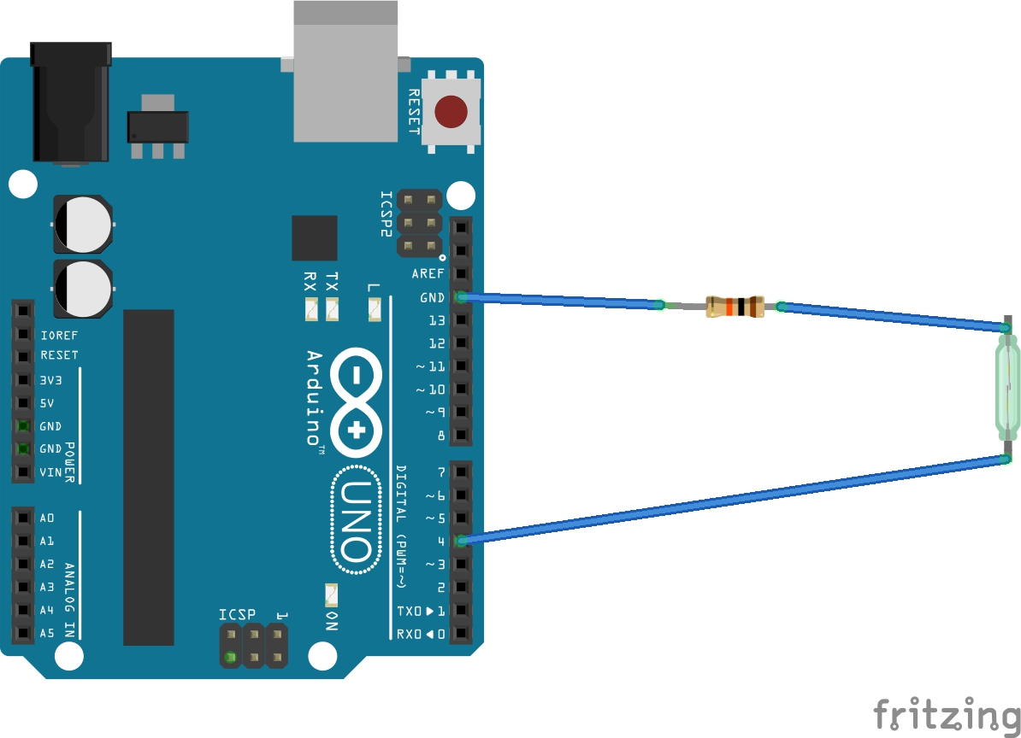

PIR sensors (moving detectors) are a little more complicated since they typically have a tamper sensor which detects when you open the sensor case. The typical connection is where you connect both the sensor and the tamper in series with a 10K resistor to GND.

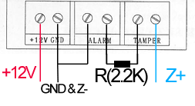

Remember typical PIR sensors are powered by 12v so you will need an external power supply for them (which you can also use to power up your Arduino board). If you decide to wire using a 3 wires cable, you need to unify grounds, otherwise, you can use your own Arduino GND connected to Z- (in the image) and avoid connecting Z- to GND as in it connected in the image. The 2.2K resistor can be replaced by a 10K resistor to reduce consumption a little. Connect Z+ to an Arduino digital input pin.

Keep in mind some of the Arduino board pins are reserved and although you can customize the reserved pins, it's recommended you at least leave pins 0, 1 & 2 unconnected for possible future uses (or USB connection).

Wireless sensors
Wireless sensors require a wireless RF receiver module connected to the Arduino. The way we will connect the RF receiver is so it triggers a hardware interrupt in the Arduino, typically connected to an interrupt enabled pin (pin 2 in our case).

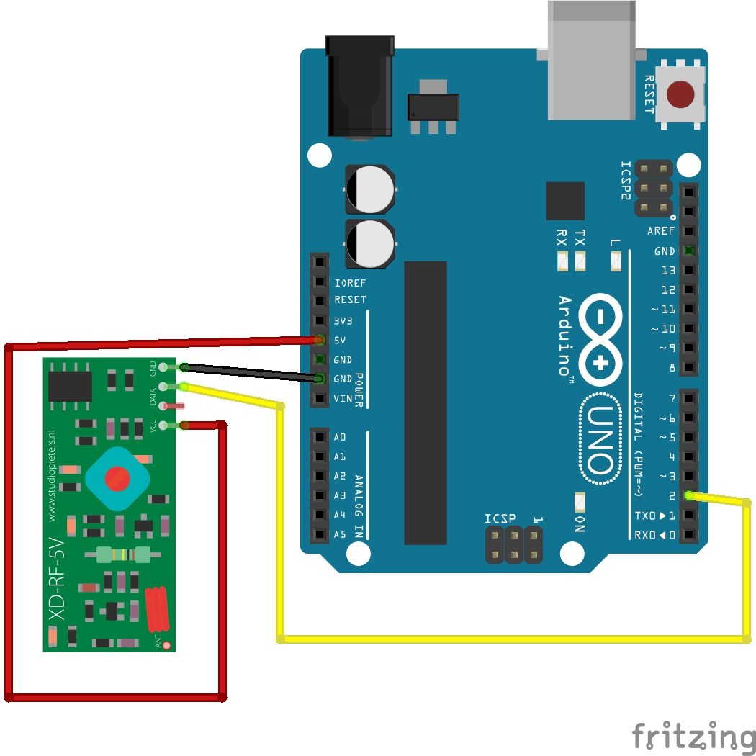

The RF receiver has to be of the same frequency of the alarm sensors you are about to integrate (typically 315Mhz or 433Mhz) and they all have to be of the same frequency. When adding sensors to your alarm, you have to turn them all off, and add them to the alarm by turning them on one by one, making sure the only sensor you turn on during the process of adding sensors to the alarm is the one you want the alarm to recognize.

