8/22/2020

**Software Application Specialist**

Continuing Education

Vanier College

Montreal

**Submitted To**

Mr. Adrian Constantin Onet

**Submitted By**

Mohammed Hassan Allahham

Abdus Sobhan Seikh

**VIDEO STREAMING DBMS Management System**

[Document subtitle]

**Contents:**

1. Define problem and constraints 2

2. Database design 3

3. Implementation and loading: 10

4. Test and evaluation 12

5. Produce the required information 14

6. Maintenance and evaluation 15

# 

# **Define problem and constraints**

**Problem**

VSDB will be used to develop a web-based application for movies that stores information regarding movies and shows for the clients. Since storage of information is very essential. There is need for a new database to be developed that will capture whole process of information flow regarding VSDB Objectives.

Constraint

The database developed might not be secured since technologies changes every second hence security penetration tactics may vary from time of development to time of deployment

**Objectives**

1. To develop a database that satisfies rules of normalization. i.e. 1NF, 2NF, 3NF
2. To develop a database that captures everything for video streaming website

**Scope and boundaries**

Scope: The database will capture information related to the clients, admin of the system, managers and the details related to the shows and film.

Boundary: The database will only cover the information related movies, shows and users of these features. The details outside this feature will not be captured by the database for example the issues related to web development of the website, they will not be implemented

# **Database design**

**Semantic database model:**

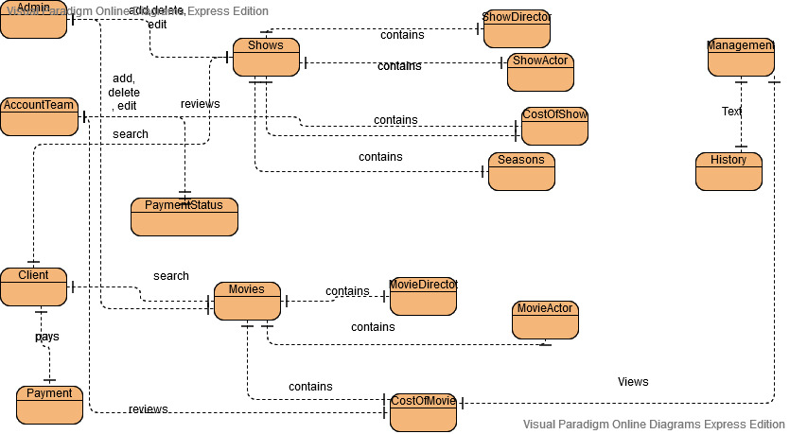

Fig: Showing the semantic database design

**Conceptual design:**

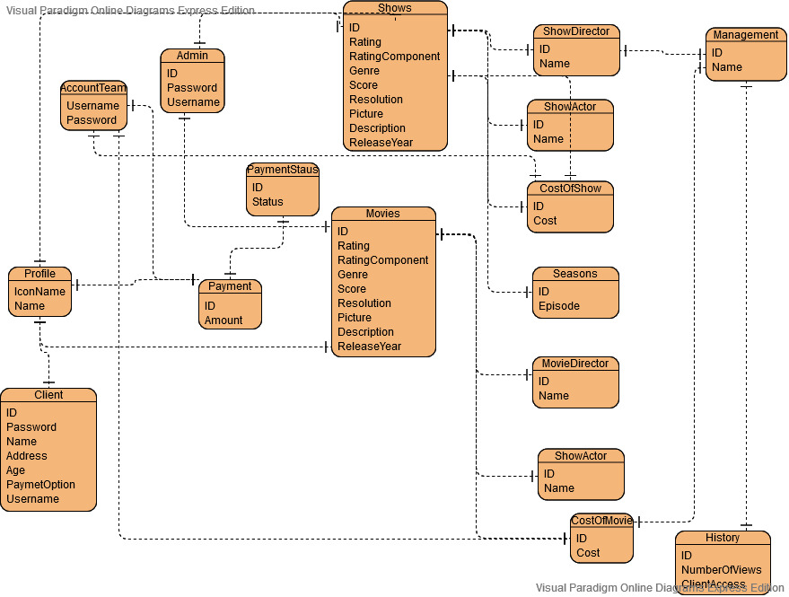

Fig: Showing conceptual database design

**DBMS selection**

MYSQLI

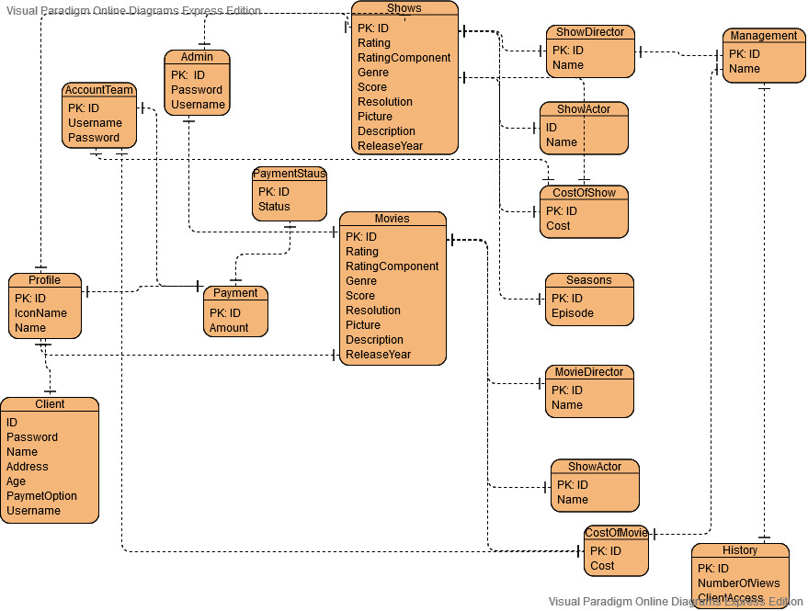**Physical design:**

Fig: Showing physical database design

**Create external Schema interface**

It refers to how each individual view specific contents on the database

1. **Admin view**

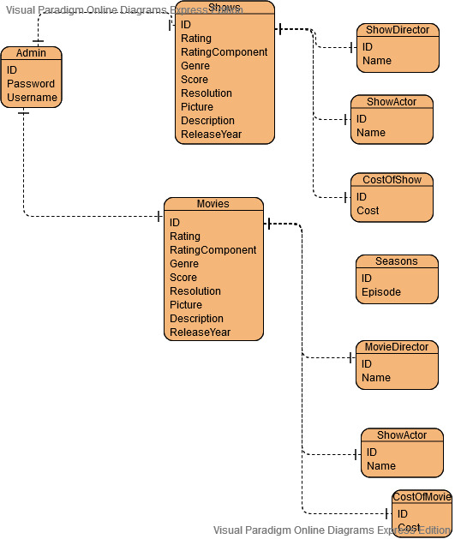

Fig: Showing admin interface tables

**(ii)Client view**

**Client interface:**

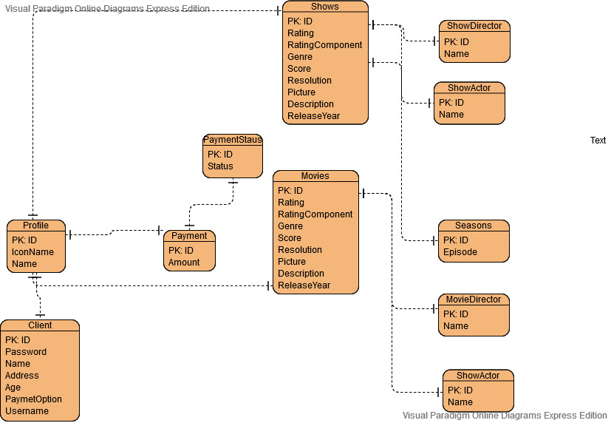

Fig: Showing client interface tables

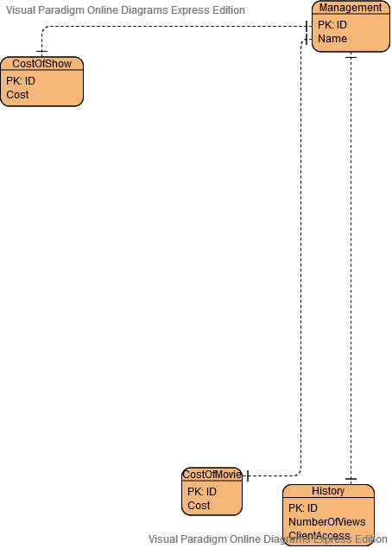**Management view:**

Fig: Showing the management interface

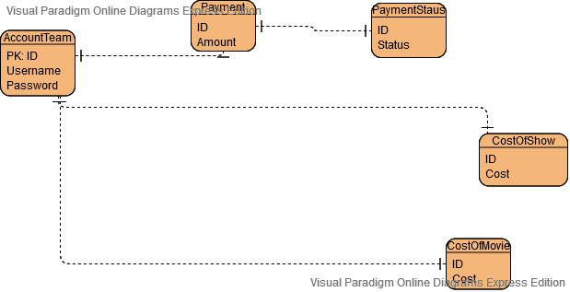**(iv) Account team view**

Fig: Showing the account team view of the system

# **Implementation and loading:**

**DBMS configuration parameters**

The database host will be the: Localhost

Username will be: root:

Password: will be blank

**Create database:**

The database given has implemented everything

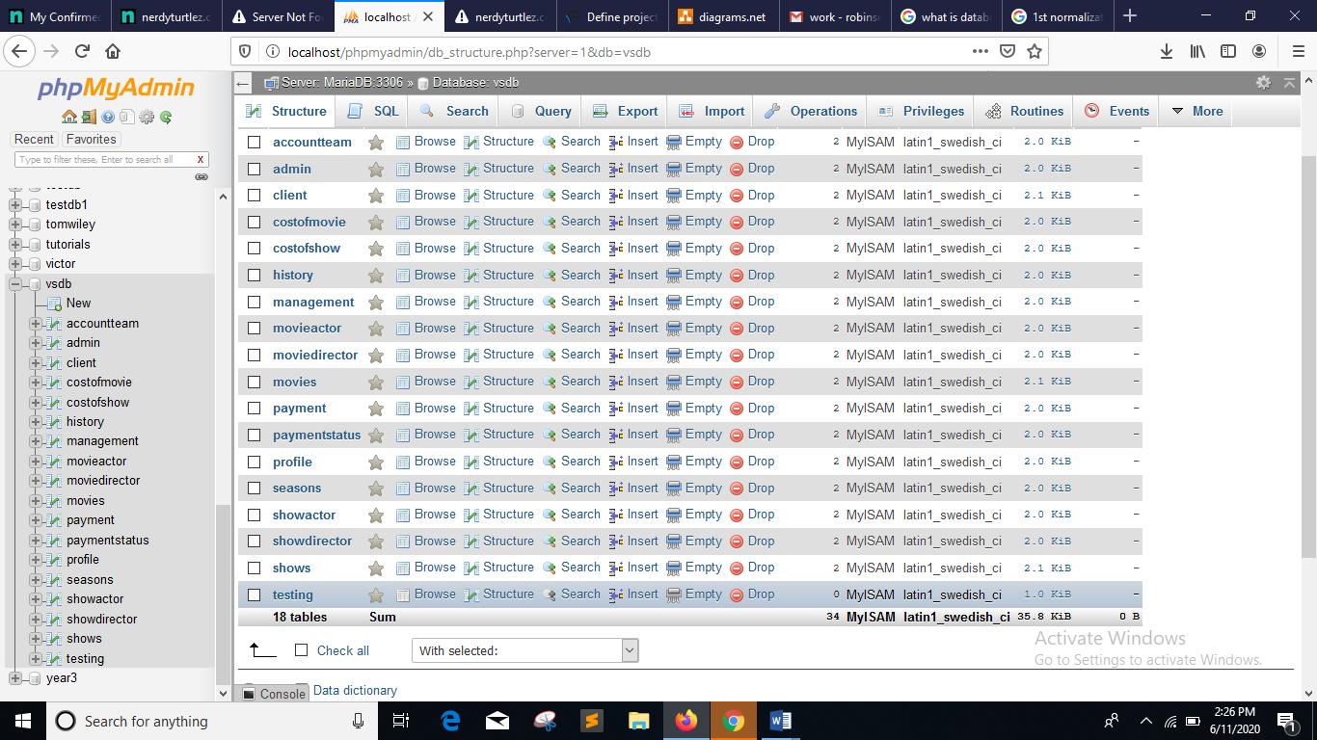

Data loading….

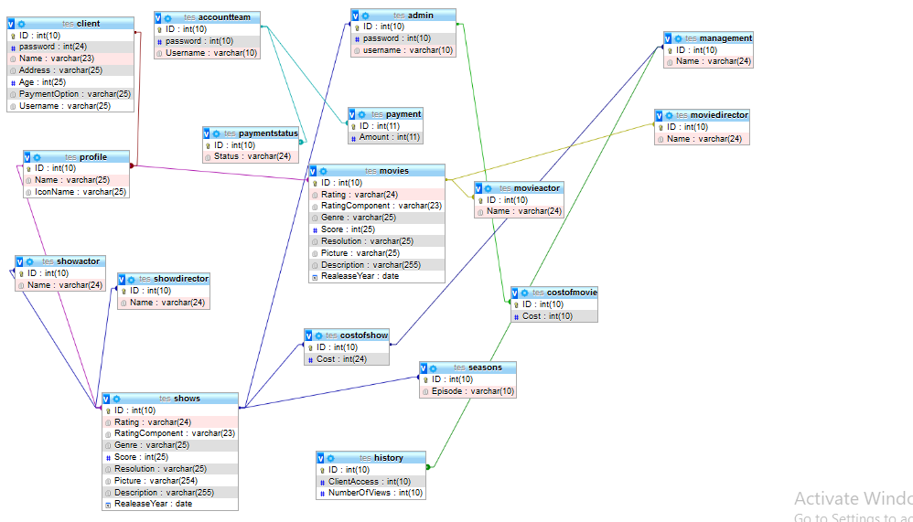**Implement external schema:**

**Loading data**

The text file attached shows data stored on the database called “data.txt”.

# **Test and evaluation**

The database schema has been tested and appears to be correct on the interface

**Admin and client detail testing to check data:**

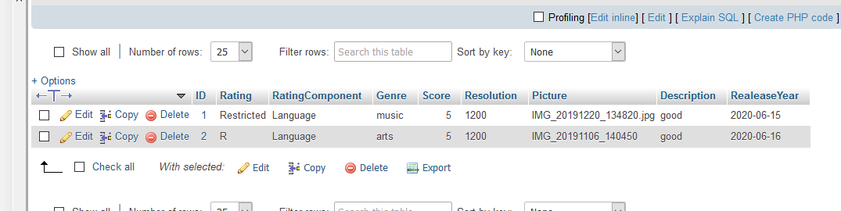

**Admin update of data:**

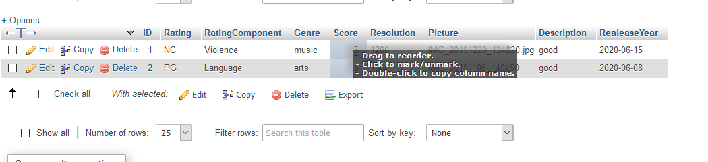

**Account team testing:**

The figure below shows table of cost, deposits and account status

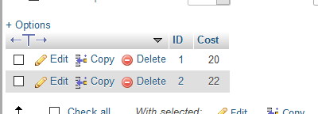

Fig: Showing cost table

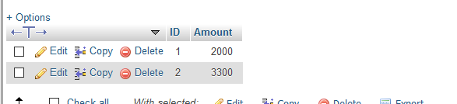

Fig: Showing payment table

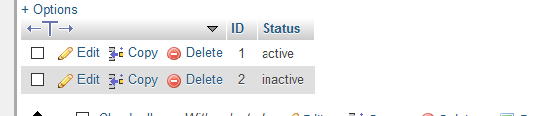

Fig: Showing payment status

**Managers testing:**

History table testing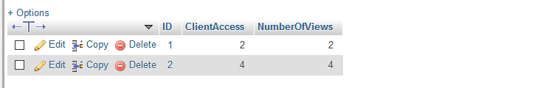

**Fine tune**

The necessary adjustments have been added on the database

**Evaluate the database:**

The Database obeyed the rules or normalization hence this led to avoidance of errors in developing the database like data redundancy

# **Produce the required information**

The information flow on the system is dependent on several user of the system like clients, admin, managers and account team.

The system admins enter the movies and the other details related to the move onto the table of movie/shows, then the admin add the necessary cost to movies/ show by creating other tables.

The client’s firsts registers and starts viewing the movie/show details on the database as he deposits amount on the payment database.

The manager, on other hand views the reports related to viewing history and cost of the movie

# **Maintenance and evaluation**

**Proposed changes**

1. The database should be able to give discounts for most frequent customers
2. The database should other entertainment mediums and sports
3. The database should allow rollbacks on the database