SafeAgentSOC Sprint 5 Report
Project: SafeAgentSOC
Sprint: Sprint 5 – Windows Adversary Emulation, Telemetry Validation, and Detection Gap Analysis
Environment: Wazuh + Sysmon + PowerShell Logging + MITRE Caldera + Atomic Red Team

1. Sprint Objectives
Sprint 5 focused on generating realistic Windows adversary telemetry using manual attack simulation, Atomic Red Team, and MITRE Caldera. The goal was to validate telemetry ingestion, measure SIEM visibility, identify semantic detection gaps, and build high-quality labeled security datasets for SafeAgentSOC.

2. Lab Infrastructure
- safesoc-win-01: Windows endpoint with Sysmon, Wazuh agent, PowerShell logging enabled
- safesoc-wazuh-01: Wazuh manager and dashboard
- safesoc-caldera-01: MITRE Caldera C2/adversary emulation server
- Atomic Red Team installed on Windows endpoint
- Sysmon Operational and PowerShell Operational event channels validated

3. Initial Problems Encountered
- Atomic Red Team install script URL returned 404 errors
- Caldera initially showed 0 agents deployed
- Wazuh initially appeared to miss Caldera behaviors
- Exporting alerts from the Wazuh dashboard only exported visible table columns rather than full JSON telemetry
- Wazuh ingested telemetry but semantically misclassified several behaviors

4. Atomic Red Team Integration
Atomic Red Team was installed manually after resolving module and repository path issues. The environment was validated using Invoke-AtomicTest and MITRE ATT&CK simulations including PowerShell execution, discovery, scheduled task creation, and archive/staging behaviors.

5. MITRE Caldera Integration
MITRE Caldera Sandcat agents were successfully deployed to safesoc-win-01 using HTTP contact communication. The agent executed multiple adversary profiles including file collection, local staging, archive creation, exfiltration over C2, and UAC bypass attempts.

6. Key Findings
- Telemetry generation worked correctly at the endpoint level
- Sysmon and PowerShell Operational logs successfully recorded attack behaviors
- Wazuh ingested telemetry but often generated low-severity or semantically inaccurate alerts
- Behavioral correlation was weak despite high-fidelity telemetry existing underneath
- Detection gaps were primarily semantic/rule-based rather than telemetry absence

7. Important Detection Gap Example
A Caldera exfiltration action uploaded staged.zip to the Caldera HTTP endpoint using PowerShell and System.Net.Http.HttpClient. Wazuh ingested the underlying Sysmon process creation event but classified the behavior as a low-severity PowerShell deletion alert instead of recognizing it as exfiltration over C2. This became a central example of the semantic interpretation gap SafeAgentSOC aims to address.

8. Caldera Campaign Summaries

C-WIN-01-CAL-R001 – Thief Adversary
This operation simulated data collection and staged exfiltration behavior. The campaign created a staging directory, searched for sensitive files, copied them into a staging area, compressed them into staged.zip, and exfiltrated the archive over the Caldera HTTP channel.
Observed MITRE techniques included:
- T1074.001 Local Data Staging
- T1005 Data from Local System
- T1560.001 Archive Collected Data
- T1041 Exfiltration Over C2 Channel

C-WIN-01-CAL-R002 – UAC Bypass Adversary
This operation simulated privilege escalation and UAC bypass techniques using Akagi64 and multiple Windows UAC bypass methods.
Observed MITRE techniques included:
- T1548.002 Abuse Elevation Control Mechanism: Bypass User Access Control

9. Evidence and Screenshots
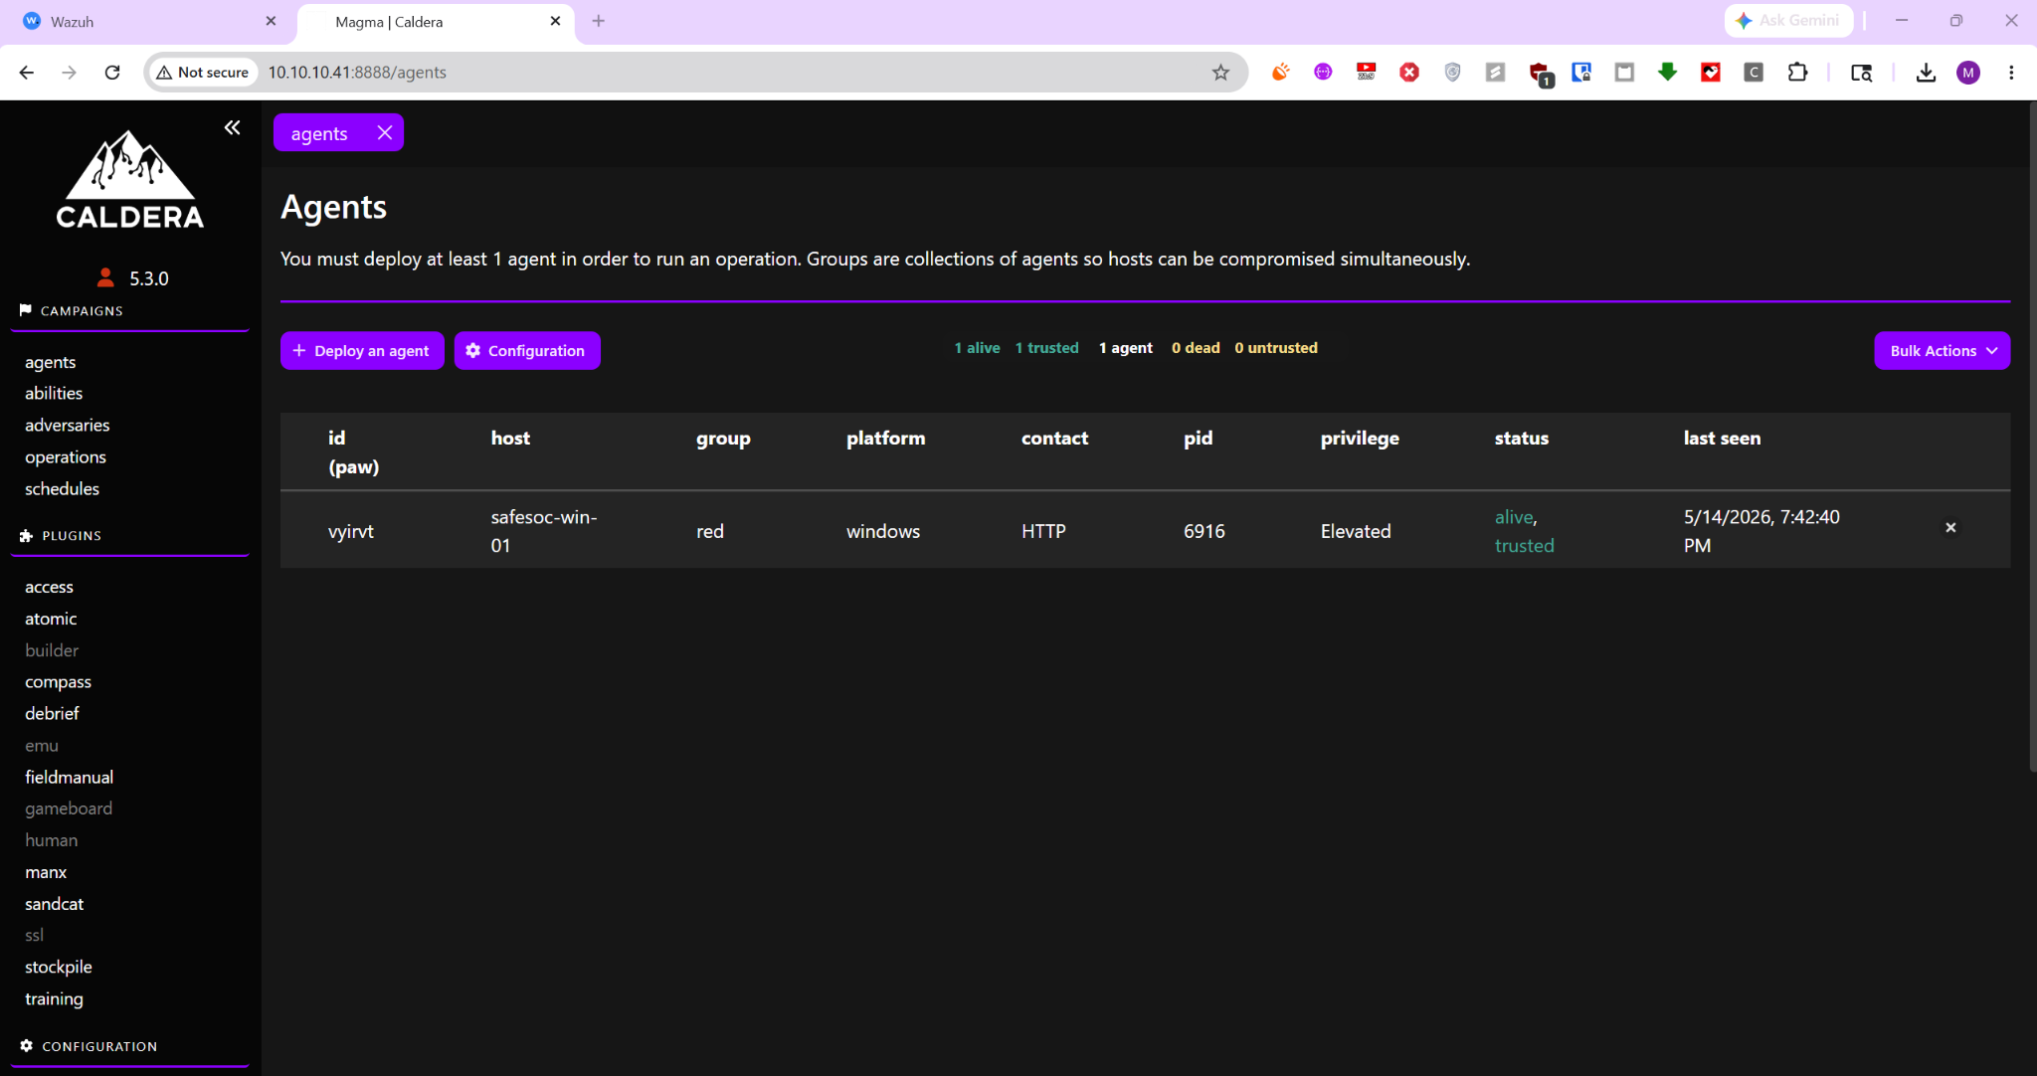
Caldera Sandcat Windows Agent Alive
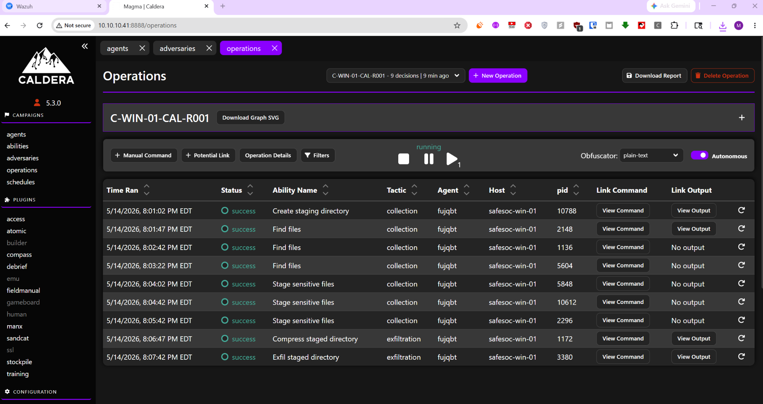
Caldera Campaign Operation
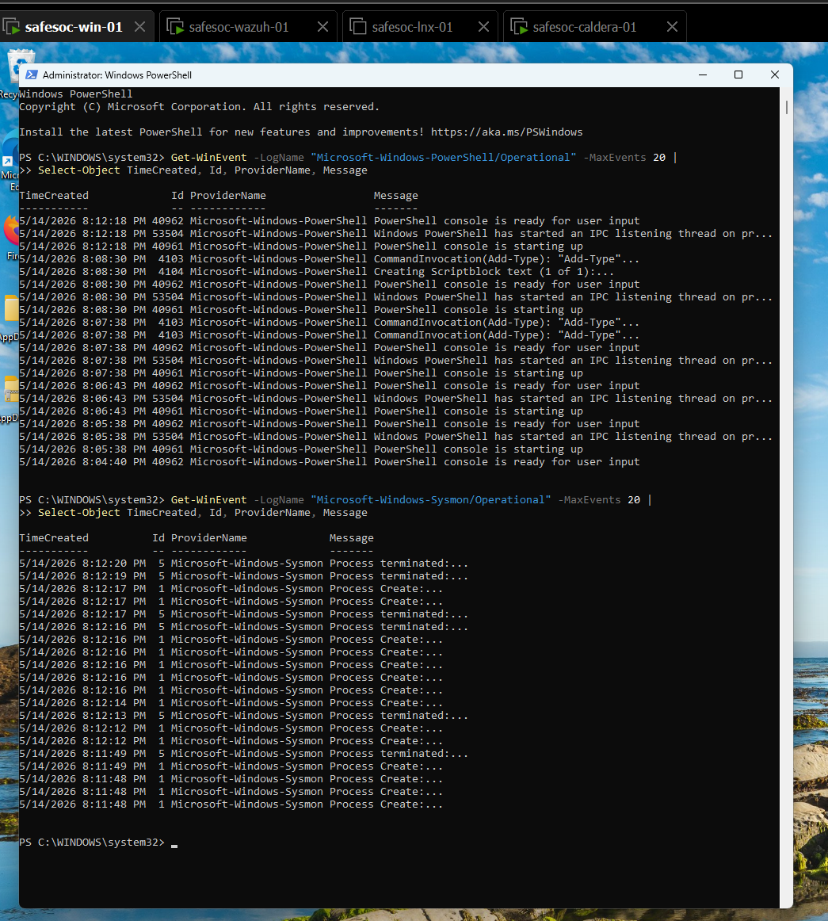
Local PowerShell and Sysmon Operational Logs
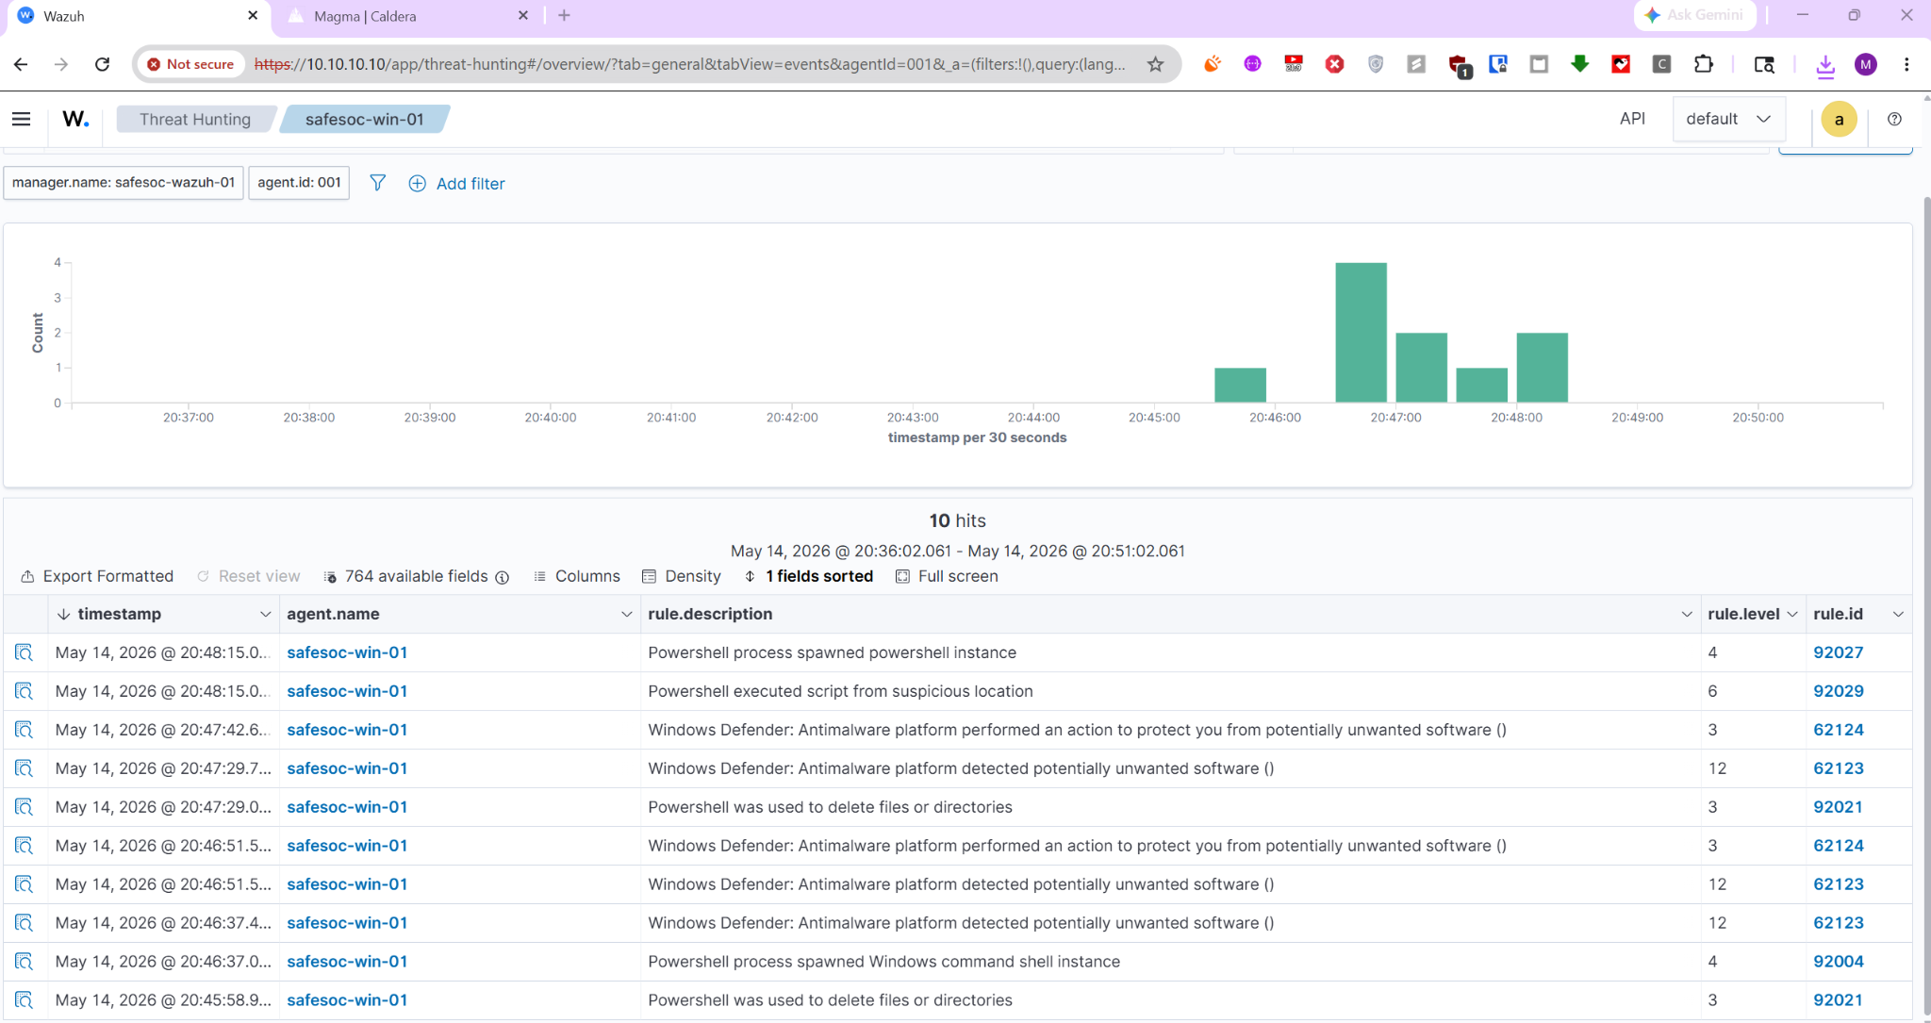
Wazuh Event Correlation and Alerts

10. Wazuh Analysis
Wazuh successfully ingested Sysmon and PowerShell Operational telemetry after the Windows event channels were explicitly configured inside ossec.conf. However, multiple Caldera behaviors were either weakly detected or mapped to generic low-severity rules.
Examples observed:
- Powershell process spawned powershell instance
- Powershell executed script from suspicious location
- Powershell was used to delete files or directories
- Windows Defender detected potentially unwanted software
These findings support the SafeAgentSOC hypothesis that modern SOC environments often suffer from semantic overload and weak behavioral interpretation despite having access to high-quality telemetry.

11. Lessons Learned
- Endpoint telemetry validation is critical before evaluating SIEM quality
- Caldera is highly effective for generating realistic ATT&CK-aligned datasets
- Wazuh provides strong telemetry ingestion capabilities but requires significant tuning and custom rules for contextual detection
- Detection gaps themselves are valuable labeled research artifacts
- Exporting raw alerts directly from alerts.json is superior to dashboard CSV exports

12. Conclusion
Sprint 5 successfully validated the SafeAgentSOC research direction. The environment produced realistic ATT&CK-aligned telemetry using Atomic Red Team and MITRE Caldera while simultaneously exposing important detection and semantic interpretation weaknesses inside the SIEM pipeline. These artifacts now form the basis for future dataset labeling, alert correlation, AI-assisted triage, and behavioral reasoning layers.

Appendix A – Referenced MITRE Techniques
T1005 – Data from Local System
T1041 – Exfiltration Over C2 Channel
T1070.003 – Clear Command History
T1074.001 – Local Data Staging
T1548.002 – Bypass User Access Control
T1560.001 – Archive Collected Data

