GoDaddy - Microbusiness Density Forecasting

Mohammad Solki

2023-02-28

# 1. Introduction

## 1.1. Goal of the Competition

The challenge in this competition is to forecast microbusiness activity across the United States, as measured by the density of microbusinesses in US counties. Microbusinesses are often too small or too new to show up in traditional economic data sources, but microbusiness activity may be correlated with other economic indicators of general interest.

This work will help policymakers gain visibility into microbusinesses, a growing trend of very small entities. Additional information will enable new policies and programs to improve the success and impact of these smallest of businesses.

GoDaddy’s Venture Forward team has gathered data on over 20 million microbusinesses in the United States, defined as businesses with an online presence and ten or fewer employees, to help policymakers understand the factors associated with these small businesses. While traditional economic data sources often miss these businesses, GoDaddy’s survey data can provide insights into this sector of the economy. The data can be used to improve predictions and inform decision-making to create more inclusive and resilient economies. The competition hosted by GoDaddy aims to empower entrepreneurs by giving them the tools they need to grow online and make a substantial impact on communities across the country.

Model accuracy will be evaluated on SMAPE (Symmetric mean absolute percentage error) between forecasts and actual values. "We define SMAPE = 0 when the actual and predicted values are both 0." (“Using Time Series to Predict Wikipedia Article Web Traffic - Dataiku”)

SMAPE formula is usually defined as follows:

where:

* is the number of observations in the time series
* is the forecasted value at time
* is the actual value at time
* denotes the absolute value of .

## 1.2. Datasets

A great deal of data is publicly available about counties and we have not attempted to gather it all here. You are strongly encouraged to use external data sources for features.

**train.csv**

* row_id An ID code for the row.
* cfips A unique identifier for each county using the Federal Information Processing System. The first two digits correspond to the state FIPS code, while the following 3 represent the county.
* county_name The written name of the county.
* state_name The name of the state.
* first_day_of_month The date of the first day of the month.
* microbusiness_density Microbusinesses per 100 people over the age of 18 in the given county. This is the target variable. The population figures used to calculate the density are on a two-year lag due to the pace of update provided by the U.S. Census Bureau, which provides the underlying population data annually. 2021 density figures are calculated using 2019 population figures, etc.
* active The raw count of microbusinesses in the county. Not provided for the test set.

**test.csv** Metadata for the submission rows. This file will remain unchanged throughout the competition.

* row_id An ID code for the row.
* cfips A unique identifier for each county using the Federal Information Processing System. The first two digits correspond to the state FIPS code, while the following 3 represent the county.
* first_day_of_month The date of the first day of the month.

**census_starter.csv** Examples of useful columns from the Census Bureau’s American Community Survey (ACS) at [data.census.gov](https://data.census.gov/). The percentage fields were derived from the raw counts provided by the ACS. All fields have a two year lag to match what information was avaiable at the time a given microbusiness data update was published.

* pct_bb_[year] The percentage of households in the county with access to broadband of any type. Derived from ACS table B28002: PRESENCE AND TYPES OF INTERNET SUBSCRIPTIONS IN HOUSEHOLD.
* cfips The CFIPS code.
* pct_college_[year] The percent of the population in the county over age 25 with a 4-year college degree. Derived from ACS table S1501: EDUCATIONAL ATTAINMENT.
* pct_foreign_born_[year] The percent of the population in the county born outside of the United States. Derived from ACS table DP02: SELECTED SOCIAL CHARACTERISTICS IN THE UNITED STATES.
* pct_it_workers_[year] The percent of the workforce in the county employed in information related industries. Derived from ACS table S2405: INDUSTRY BY OCCUPATION FOR THE CIVILIAN EMPLOYED POPULATION 16 YEARS AND OVER.
* median_hh_inc_[year] The median household income in the county. Derived from ACS table S1901: INCOME IN THE PAST 12 MONTHS (IN 2021 INFLATION-ADJUSTED DOLLARS).

## 1.3. Setup the Environment

First, we’ll set the working directory using **setwd()**, and then import the required libraries. As we proceed through the report the list of libraries might change.

# Set the working directory  
setwd("/Users/dreamer/Downloads/Godaddy/godaddy_microbusiness_forecasting")

# Importing the libraries  
  
# Recognize package conflicts  
library(conflicted)  
  
# Multi-purpose package for data import, tidying, manipulation, visualisation, and programming  
# Most common packages include: ggplot2, purrr, tibble, dplyr, tidyr, stringr, readr, forcats  
library(tidyverse)  
  
# Deal with missing data  
library(mice)  
  
# Related to plots  
library(maps)  
#library(ggmap)  
library(gridExtra)  
library(mapdata)  
library(ggcorrplot)  
library(corrplot)  
  
# Training  
library(caret)  
library(gbm)  
  
# Color palette  
library(viridis)  
  
# Future Selection   
#library(KernSmooth)  
library(glmnet)  
library(randomForest)  
library(rpart)  
  
# libraries required for calculating SMAPE  
library(forecast)  
library(Metrics)

# 3. Exploratory Data Analysis

## 3.1. Exploring the datasets

Explore the datasets to get a better understanding of the data.  
Load the **train**, **test**, and **census_starter** datasets into R dataframes.

# Load train.csv into a dataframe  
train_df <- read.csv("./datasets/train.csv")  
  
# Load test.csv into a dataframe  
test_df <- read.csv("./datasets/test.csv")  
  
# Load census_starter.csv into a dataframe  
census_df <- read.csv("./datasets/census_starter.csv")

After reading the CSV files into dataframes, we should check whether the data is loaded correctly or not. We can use the head() function of R to display the first few rows of the dataframes and tail() function to display the last rows. This will display the first and last six rows of the **train**, **test** and **census** dataframes. We can also use other R functions such as str() and summary() to get more information about the dataframes, such as column names, data types, and summary statistics.

# Display the first 6 rows of the dataframes  
head(train_df)

## row_id cfips county state first_day_of_month  
## 1 1001_2019-08-01 1001 Autauga County Alabama 2019-08-01  
## 2 1001_2019-09-01 1001 Autauga County Alabama 2019-09-01  
## 3 1001_2019-10-01 1001 Autauga County Alabama 2019-10-01  
## 4 1001_2019-11-01 1001 Autauga County Alabama 2019-11-01  
## 5 1001_2019-12-01 1001 Autauga County Alabama 2019-12-01  
## 6 1001_2020-01-01 1001 Autauga County Alabama 2020-01-01  
## microbusiness_density active  
## 1 3.007682 1249  
## 2 2.884870 1198  
## 3 3.055843 1269  
## 4 2.993233 1243  
## 5 2.993233 1243  
## 6 2.969090 1242

head(test_df)

## row_id cfips first_day_of_month  
## 1 1001_2022-11-01 1001 2022-11-01  
## 2 1003_2022-11-01 1003 2022-11-01  
## 3 1005_2022-11-01 1005 2022-11-01  
## 4 1007_2022-11-01 1007 2022-11-01  
## 5 1009_2022-11-01 1009 2022-11-01  
## 6 1011_2022-11-01 1011 2022-11-01

head(census_df)

## pct_bb_2017 pct_bb_2018 pct_bb_2019 pct_bb_2020 pct_bb_2021 cfips  
## 1 76.6 78.9 80.6 82.7 85.5 1001  
## 2 74.5 78.1 81.8 85.1 87.9 1003  
## 3 57.2 60.4 60.5 64.6 64.6 1005  
## 4 62.0 66.1 69.2 76.1 74.6 1007  
## 5 65.8 68.5 73.0 79.6 81.0 1009  
## 6 49.4 58.9 60.1 60.6 59.4 1011  
## pct_college_2017 pct_college_2018 pct_college_2019 pct_college_2020  
## 1 14.5 15.9 16.1 16.7  
## 2 20.4 20.7 21.0 20.2  
## 3 7.6 7.8 7.6 7.3  
## 4 8.1 7.6 6.5 7.4  
## 5 8.7 8.1 8.6 8.9  
## 6 6.6 7.4 7.4 6.1  
## pct_college_2021 pct_foreign_born_2017 pct_foreign_born_2018  
## 1 16.4 2.1 2.0  
## 2 20.6 3.2 3.4  
## 3 6.7 2.7 2.5  
## 4 7.9 1.0 1.4  
## 5 9.3 4.5 4.4  
## 6 8.1 1.8 0.9  
## pct_foreign_born_2019 pct_foreign_born_2020 pct_foreign_born_2021  
## 1 2.3 2.3 2.1  
## 2 3.7 3.4 3.5  
## 3 2.7 2.6 2.6  
## 4 1.5 1.6 1.1  
## 5 4.5 4.4 4.5  
## 6 0.7 1.5 1.2  
## pct_it_workers_2017 pct_it_workers_2018 pct_it_workers_2019  
## 1 1.3 1.1 0.7  
## 2 1.4 1.3 1.4  
## 3 0.5 0.3 0.8  
## 4 1.2 1.4 1.6  
## 5 1.3 1.4 0.9  
## 6 0.4 0.3 0.5  
## pct_it_workers_2020 pct_it_workers_2021 median_hh_inc_2017 median_hh_inc_2018  
## 1 0.6 1.1 55317 58786  
## 2 1.0 1.3 52562 55962  
## 3 1.1 0.8 33368 34186  
## 4 1.7 2.1 43404 45340  
## 5 1.1 0.9 47412 48695  
## 6 0.3 0.2 29655 32152  
## median_hh_inc_2019 median_hh_inc_2020 median_hh_inc_2021  
## 1 58731 57982 62660  
## 2 58320 61756 64346  
## 3 32525 34990 36422  
## 4 47542 51721 54277  
## 5 49358 48922 52830  
## 6 37785 33866 29063

# Display the last 6 rows of the dataframes  
tail(train_df)

## row_id cfips county state first_day_of_month  
## 122260 56045_2022-05-01 56045 Weston County Wyoming 2022-05-01  
## 122261 56045_2022-06-01 56045 Weston County Wyoming 2022-06-01  
## 122262 56045_2022-07-01 56045 Weston County Wyoming 2022-07-01  
## 122263 56045_2022-08-01 56045 Weston County Wyoming 2022-08-01  
## 122264 56045_2022-09-01 56045 Weston County Wyoming 2022-09-01  
## 122265 56045_2022-10-01 56045 Weston County Wyoming 2022-10-01  
## microbusiness_density active  
## 122260 1.803249 101  
## 122261 1.803249 101  
## 122262 1.803249 101  
## 122263 1.785395 100  
## 122264 1.785395 100  
## 122265 1.785395 100

tail(test_df)

## row_id cfips first_day_of_month  
## 25075 56035_2023-06-01 56035 2023-06-01  
## 25076 56037_2023-06-01 56037 2023-06-01  
## 25077 56039_2023-06-01 56039 2023-06-01  
## 25078 56041_2023-06-01 56041 2023-06-01  
## 25079 56043_2023-06-01 56043 2023-06-01  
## 25080 56045_2023-06-01 56045 2023-06-01

tail(census_df)

## pct_bb_2017 pct_bb_2018 pct_bb_2019 pct_bb_2020 pct_bb_2021 cfips  
## 3137 82.9 81.7 85.6 88.1 89.8 56035  
## 3138 82.2 82.4 84.0 86.7 88.4 56037  
## 3139 83.5 85.9 87.1 89.1 90.5 56039  
## 3140 83.8 88.2 89.5 91.4 90.6 56041  
## 3141 76.4 78.3 78.2 82.8 85.4 56043  
## 3142 71.1 73.3 76.8 79.7 81.3 56045  
## pct_college_2017 pct_college_2018 pct_college_2019 pct_college_2020  
## 3137 19.2 19.0 16.7 21.7  
## 3138 15.3 15.2 14.8 13.7  
## 3139 37.7 37.8 38.9 37.2  
## 3140 11.9 10.5 11.1 12.6  
## 3141 15.4 15.0 15.4 15.0  
## 3142 14.1 13.5 13.4 12.7  
## pct_college_2021 pct_foreign_born_2017 pct_foreign_born_2018  
## 3137 20.9 3.9 3.1  
## 3138 12.4 5.0 5.3  
## 3139 38.3 10.8 11.2  
## 3140 12.3 2.9 3.1  
## 3141 17.2 2.3 1.4  
## 3142 13.9 3.8 4.1  
## pct_foreign_born_2019 pct_foreign_born_2020 pct_foreign_born_2021  
## 3137 4.4 5.1 5.1  
## 3138 4.7 5.2 5.5  
## 3139 11.8 11.4 11.1  
## 3140 2.9 2.9 2.9  
## 3141 1.6 2.2 1.0  
## 3142 1.7 2.3 1.6  
## pct_it_workers_2017 pct_it_workers_2018 pct_it_workers_2019  
## 3137 0.1 0.0 0.0  
## 3138 0.6 0.6 1.0  
## 3139 0.7 1.2 1.4  
## 3140 1.2 1.2 1.4  
## 3141 1.3 1.0 0.9  
## 3142 0.6 0.6 0.0  
## pct_it_workers_2020 pct_it_workers_2021 median_hh_inc_2017  
## 3137 0.0 0.0 84911  
## 3138 0.9 1.0 71083  
## 3139 1.5 2.0 80049  
## 3140 1.7 0.9 54672  
## 3141 0.9 1.1 51362  
## 3142 0.0 0.0 59605  
## median_hh_inc_2018 median_hh_inc_2019 median_hh_inc_2020  
## 3137 78680 77403 78655  
## 3138 73008 74843 73384  
## 3139 83831 84678 87053  
## 3140 58235 63403 72458  
## 3141 53426 54158 57306  
## 3142 52867 57031 53333  
## median_hh_inc_2021  
## 3137 82342  
## 3138 76668  
## 3139 94498  
## 3140 75106  
## 3141 62271  
## 3142 65566

# Display information about the train dataframe  
str(train_df)

## 'data.frame': 122265 obs. of 7 variables:  
## $ row_id : chr "1001_2019-08-01" "1001_2019-09-01" "1001_2019-10-01" "1001_2019-11-01" ...  
## $ cfips : int 1001 1001 1001 1001 1001 1001 1001 1001 1001 1001 ...  
## $ county : chr "Autauga County" "Autauga County" "Autauga County" "Autauga County" ...  
## $ state : chr "Alabama" "Alabama" "Alabama" "Alabama" ...  
## $ first_day_of_month : chr "2019-08-01" "2019-09-01" "2019-10-01" "2019-11-01" ...  
## $ microbusiness_density: num 3.01 2.88 3.06 2.99 2.99 ...  
## $ active : int 1249 1198 1269 1243 1243 1242 1217 1227 1255 1257 ...

#cat(rep("=", 40), "\n") # Print a line of 40 equal signs  
summary(train_df)

## row_id cfips county state   
## Length:122265 Min. : 1001 Length:122265 Length:122265   
## Class :character 1st Qu.:18177 Class :character Class :character   
## Mode :character Median :29173 Mode :character Mode :character   
## Mean :30376   
## 3rd Qu.:45077   
## Max. :56045   
## first_day_of_month microbusiness_density active   
## Length:122265 Min. : 0.000 Min. : 0   
## Class :character 1st Qu.: 1.639 1st Qu.: 145   
## Mode :character Median : 2.587 Median : 488   
## Mean : 3.818 Mean : 6443   
## 3rd Qu.: 4.519 3rd Qu.: 2124   
## Max. :284.340 Max. :1167744

# Display information about the test dataframe  
str(test_df)

## 'data.frame': 25080 obs. of 3 variables:  
## $ row_id : chr "1001_2022-11-01" "1003_2022-11-01" "1005_2022-11-01" "1007_2022-11-01" ...  
## $ cfips : int 1001 1003 1005 1007 1009 1011 1013 1015 1017 1019 ...  
## $ first_day_of_month: chr "2022-11-01" "2022-11-01" "2022-11-01" "2022-11-01" ...

#cat(rep("=", 40), "\n") # Print a line of 40 equal signs  
summary(test_df)

## row_id cfips first_day_of_month  
## Length:25080 Min. : 1001 Length:25080   
## Class :character 1st Qu.:18177 Class :character   
## Mode :character Median :29173 Mode :character   
## Mean :30376   
## 3rd Qu.:45077   
## Max. :56045

# Display information about the census dataframe  
str(census_df)

## 'data.frame': 3142 obs. of 26 variables:  
## $ pct_bb_2017 : num 76.6 74.5 57.2 62 65.8 49.4 58.2 71 62.8 67.5 ...  
## $ pct_bb_2018 : num 78.9 78.1 60.4 66.1 68.5 58.9 62.1 73 66.5 68.6 ...  
## $ pct_bb_2019 : num 80.6 81.8 60.5 69.2 73 60.1 64.6 75.1 69.4 70.7 ...  
## $ pct_bb_2020 : num 82.7 85.1 64.6 76.1 79.6 60.6 73.6 79.8 74.5 75 ...  
## $ pct_bb_2021 : num 85.5 87.9 64.6 74.6 81 59.4 76.3 81.6 77.1 76.7 ...  
## $ cfips : int 1001 1003 1005 1007 1009 1011 1013 1015 1017 1019 ...  
## $ pct_college_2017 : num 14.5 20.4 7.6 8.1 8.7 6.6 9.6 10.2 9 6.6 ...  
## $ pct_college_2018 : num 15.9 20.7 7.8 7.6 8.1 7.4 9.7 10.2 9.3 6.8 ...  
## $ pct_college_2019 : num 16.1 21 7.6 6.5 8.6 7.4 9.7 10.5 9.5 6.6 ...  
## $ pct_college_2020 : num 16.7 20.2 7.3 7.4 8.9 6.1 10.1 10.5 10.5 6.3 ...  
## $ pct_college_2021 : num 16.4 20.6 6.7 7.9 9.3 8.1 8.1 11.4 9.6 6.2 ...  
## $ pct_foreign_born_2017: num 2.1 3.2 2.7 1 4.5 1.8 1 2.6 1.3 0.7 ...  
## $ pct_foreign_born_2018: num 2 3.4 2.5 1.4 4.4 0.9 1.4 2.7 1.4 0.8 ...  
## $ pct_foreign_born_2019: num 2.3 3.7 2.7 1.5 4.5 0.7 0.8 2.7 1.8 0.9 ...  
## $ pct_foreign_born_2020: num 2.3 3.4 2.6 1.6 4.4 1.5 1.9 2.5 1.9 1.9 ...  
## $ pct_foreign_born_2021: num 2.1 3.5 2.6 1.1 4.5 1.2 1.7 2.5 2 2 ...  
## $ pct_it_workers_2017 : num 1.3 1.4 0.5 1.2 1.3 0.4 1.1 1.4 2.4 1.4 ...  
## $ pct_it_workers_2018 : num 1.1 1.3 0.3 1.4 1.4 0.3 1.4 1.4 2.1 1.3 ...  
## $ pct_it_workers_2019 : num 0.7 1.4 0.8 1.6 0.9 0.5 1.7 1.2 2.1 1.2 ...  
## $ pct_it_workers_2020 : num 0.6 1 1.1 1.7 1.1 0.3 1.3 1 2.3 0.9 ...  
## $ pct_it_workers_2021 : num 1.1 1.3 0.8 2.1 0.9 0.2 1.4 1 1.8 0.4 ...  
## $ median_hh_inc_2017 : int 55317 52562 33368 43404 47412 29655 36326 43686 37342 40041 ...  
## $ median_hh_inc_2018 : num 58786 55962 34186 45340 48695 ...  
## $ median_hh_inc_2019 : int 58731 58320 32525 47542 49358 37785 40688 47255 42289 41919 ...  
## $ median_hh_inc_2020 : num 57982 61756 34990 51721 48922 ...  
## $ median_hh_inc_2021 : num 62660 64346 36422 54277 52830 ...

#cat(rep("=", 40), "\n") # Print a line of 40 equal signs  
summary(census_df)

## pct_bb_2017 pct_bb_2018 pct_bb_2019 pct_bb_2020   
## Min. :24.50 Min. :25.70 Min. :34.80 Min. :33.30   
## 1st Qu.:64.20 1st Qu.:67.42 1st Qu.:70.50 1st Qu.:74.10   
## Median :70.70 Median :73.60 Median :76.45 Median :79.60   
## Mean :69.92 Mean :72.69 Mean :75.40 Mean :78.54   
## 3rd Qu.:76.40 3rd Qu.:78.80 3rd Qu.:81.40 3rd Qu.:84.10   
## Max. :94.60 Max. :95.50 Max. :96.00 Max. :97.10   
## NA's :1   
## pct_bb_2021 cfips pct_college_2017 pct_college_2018  
## Min. :37.00 Min. : 1001 Min. : 2.40 Min. : 0.00   
## 1st Qu.:76.40 1st Qu.:18178 1st Qu.: 9.70 1st Qu.: 9.90   
## Median :81.70 Median :29176 Median :12.80 Median :13.00   
## Mean :80.54 Mean :30384 Mean :13.81 Mean :14.01   
## 3rd Qu.:85.90 3rd Qu.:45080 3rd Qu.:16.80 3rd Qu.:17.10   
## Max. :97.60 Max. :56045 Max. :43.70 Max. :48.00   
## NA's :1   
## pct_college_2019 pct_college_2020 pct_college_2021 pct_foreign_born_2017  
## Min. : 0.00 Min. : 0.00 Min. : 0.00 Min. : 0.000   
## 1st Qu.:10.10 1st Qu.:10.50 1st Qu.:10.60 1st Qu.: 1.400   
## Median :13.25 Median :13.60 Median :13.80 Median : 2.700   
## Mean :14.24 Mean :14.63 Mean :14.85 Mean : 4.702   
## 3rd Qu.:17.30 3rd Qu.:17.90 3rd Qu.:18.00 3rd Qu.: 5.700   
## Max. :45.40 Max. :43.00 Max. :43.70 Max. :52.900   
## NA's :1 NA's :1   
## pct_foreign_born_2018 pct_foreign_born_2019 pct_foreign_born_2020  
## Min. : 0.000 Min. : 0.000 Min. : 0.000   
## 1st Qu.: 1.400 1st Qu.: 1.400 1st Qu.: 1.400   
## Median : 2.700 Median : 2.700 Median : 2.800   
## Mean : 4.725 Mean : 4.769 Mean : 4.749   
## 3rd Qu.: 5.700 3rd Qu.: 5.700 3rd Qu.: 5.700   
## Max. :53.300 Max. :53.700 Max. :54.000   
## NA's :1   
## pct_foreign_born_2021 pct_it_workers_2017 pct_it_workers_2018  
## Min. : 0.000 Min. : 0.000 Min. : 0.000   
## 1st Qu.: 1.400 1st Qu.: 0.800 1st Qu.: 0.800   
## Median : 2.700 Median : 1.300 Median : 1.300   
## Mean : 4.744 Mean : 1.427 Mean : 1.382   
## 3rd Qu.: 5.700 3rd Qu.: 1.900 3rd Qu.: 1.800   
## Max. :54.000 Max. :17.400 Max. :11.700   
## NA's :1 NA's :1   
## pct_it_workers_2019 pct_it_workers_2020 pct_it_workers_2021 median_hh_inc_2017  
## Min. : 0.000 Min. : 0.000 Min. : 0.000 Min. : 19264   
## 1st Qu.: 0.700 1st Qu.: 0.700 1st Qu.: 0.600 1st Qu.: 41123   
## Median : 1.200 Median : 1.200 Median : 1.100 Median : 48066   
## Mean : 1.339 Mean : 1.309 Mean : 1.273 Mean : 49754   
## 3rd Qu.: 1.800 3rd Qu.: 1.800 3rd Qu.: 1.700 3rd Qu.: 55764   
## Max. :10.500 Max. :15.200 Max. :15.200 Max. :129588   
## NA's :1 NA's :1   
## median_hh_inc_2018 median_hh_inc_2019 median_hh_inc_2020 median_hh_inc_2021  
## Min. : 20188 Min. : 21504 Min. : 22292 Min. : 17109   
## 1st Qu.: 42480 1st Qu.: 44155 1st Qu.: 45653 1st Qu.: 48180   
## Median : 49888 Median : 51758 Median : 52842 Median : 55907   
## Mean : 51583 Mean : 53476 Mean : 55012 Mean : 58223   
## 3rd Qu.: 57611 3rd Qu.: 59867 3rd Qu.: 61501 3rd Qu.: 64930   
## Max. :136268 Max. :142299 Max. :147111 Max. :156821   
## NA's :1 NA's :2 NA's :2

The data type of first_day_of_month column in **train_df** and **test_df** is *character*. We will convert the character to *Date* format.

# Change first_day_of_month data type to Date  
train_df$first_day_of_month <- as.Date(train_df$first_day_of_month)  
test_df$first_day_of_month <- as.Date(test_df$first_day_of_month)  
str(train_df$first_day_of_month)

## Date[1:122265], format: "2019-08-01" "2019-09-01" "2019-10-01" "2019-11-01" "2019-12-01" ...

## 3.2. Checking the Dataframes for Missing Values

The is.na() function is used to create a logical matrix where *TRUE* represents a missing value and *FALSE* represents a non-missing value. The colSums() function is then used to count the number of missing values in each column of the data frame. If the sum of a column is greater than 0, it means that there is at least one missing value in that column.

# Check for missing values in the train data frame  
colSums(is.na(train_df))

## row_id cfips county   
## 0 0 0   
## state first_day_of_month microbusiness_density   
## 0 0 0   
## active   
## 0

# Check for missing values in the test data frame  
colSums(is.na(test_df))

## row_id cfips first_day_of_month   
## 0 0 0

# Check for missing values in the census data frame  
colSums(is.na(census_df))

## pct_bb_2017 pct_bb_2018 pct_bb_2019   
## 0 0 0   
## pct_bb_2020 pct_bb_2021 cfips   
## 1 1 0   
## pct_college_2017 pct_college_2018 pct_college_2019   
## 0 0 0   
## pct_college_2020 pct_college_2021 pct_foreign_born_2017   
## 1 1 0   
## pct_foreign_born_2018 pct_foreign_born_2019 pct_foreign_born_2020   
## 0 0 1   
## pct_foreign_born_2021 pct_it_workers_2017 pct_it_workers_2018   
## 1 0 1   
## pct_it_workers_2019 pct_it_workers_2020 pct_it_workers_2021   
## 0 1 1   
## median_hh_inc_2017 median_hh_inc_2018 median_hh_inc_2019   
## 0 1 0   
## median_hh_inc_2020 median_hh_inc_2021   
## 2 2

#{r fig.width=7, fig.align='center', fig.height=4, out.width='100%'}  
# Calculate the number and percentage of missing values for each column  
missing_data <- census_df %>%  
 summarise_all(~ sum(is.na(.))) %>%  
 gather(variable, missing_count) %>%  
 mutate(missing_percent = missing_count/nrow(census_df)*100)  
  
# Create two plots side by side  
plot1 <- ggplot(missing_data, aes(x = missing_count, y = variable)) +  
 geom_bar(stat = "identity", fill = "steelblue") +  
 labs(x = "Number of missing values", y = "") +  
 ggtitle("Number of missing values in census_df") +  
 theme_gray()  
  
plot2 <- ggplot(missing_data, aes(x = missing_percent, y = variable)) +  
 geom_bar(stat = "identity", fill = "lightblue") +  
 labs(x = "Percentage of missing values", y = "") +  
 ggtitle("Percentage of missing values in census_df") +  
 theme_gray()  
  
# Arrange the two plots side by side  
grid.arrange(plot1, plot2, ncol = 2)

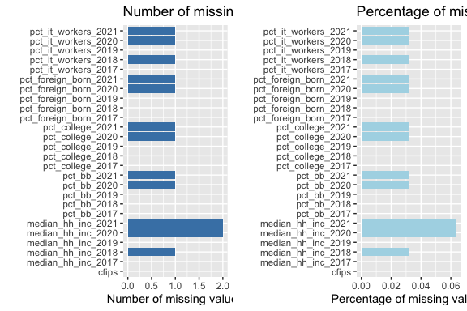

We use the complete.cases() function to determine which rows have complete data and which rows have missing values. This function returns a logical vector indicating which rows have no missing values. (“how to count observations used and deleted when using a regression in r”) Therefore, to identify the rows with missing values, we use the ! operator to negate the logical vector returned by complete.cases(). Then, we use the is.na() function to identify which columns have missing values for each missing row:

# Identify rows with missing values in census_df  
missing_rows <- which(!complete.cases(census_df))  
  
# Identify columns with missing values for each missing row  
for (i in missing_rows) {  
 cat("Row", i, "has missing values in columns:",  
 paste(names(census_df)[is.na(census_df[i,])], collapse = ", "), "\n")  
}

## Row 93 has missing values in columns: pct_bb_2020, pct_bb_2021, pct_college_2020, pct_college_2021, pct_foreign_born_2020, pct_foreign_born_2021, pct_it_workers_2020, pct_it_workers_2021, median_hh_inc_2020, median_hh_inc_2021   
## Row 1817 has missing values in columns: pct_it_workers_2018, median_hh_inc_2018   
## Row 2645 has missing values in columns: median_hh_inc_2020   
## Row 2674 has missing values in columns: median_hh_inc_2021

print(census_df[missing_rows,])

## pct_bb_2017 pct_bb_2018 pct_bb_2019 pct_bb_2020 pct_bb_2021 cfips  
## 93 80.5 79.1 80.4 NA NA 2261  
## 1817 49.1 52.1 57.6 60.7 63.5 35039  
## 2645 66.3 66.6 61.2 63.2 70.1 48243  
## 2674 64.5 72.7 73.3 96.8 97.0 48301  
## pct_college_2017 pct_college_2018 pct_college_2019 pct_college_2020  
## 93 23.1 19.0 16.5 NA  
## 1817 12.0 12.5 12.6 10.6  
## 2645 18.4 16.0 10.8 14.3  
## 2674 4.7 0.0 0.0 0.0  
## pct_college_2021 pct_foreign_born_2017 pct_foreign_born_2018  
## 93 NA 4.9 6.3  
## 1817 10.1 4.5 3.7  
## 2645 10.9 22.4 14.9  
## 2674 0.0 10.8 15.7  
## pct_foreign_born_2019 pct_foreign_born_2020 pct_foreign_born_2021  
## 93 6.6 NA NA  
## 1817 4.2 4.5 4.8  
## 2645 20.9 10.1 12.7  
## 2674 12.2 0.0 1.2  
## pct_it_workers_2017 pct_it_workers_2018 pct_it_workers_2019  
## 93 3.3 3.9 5.3  
## 1817 0.8 NA 0.8  
## 2645 0.0 0.0 0.0  
## 2674 0.0 0.0 0.0  
## pct_it_workers_2020 pct_it_workers_2021 median_hh_inc_2017  
## 93 NA NA 86019  
## 1817 0.4 0.7 33422  
## 2645 0.0 0.0 46534  
## 2674 0.0 0.0 80938  
## median_hh_inc_2018 median_hh_inc_2019 median_hh_inc_2020  
## 93 82306 79867 NA  
## 1817 NA 39952 42264  
## 2645 53194 53088 NA  
## 2674 81875 83750 44076  
## median_hh_inc_2021  
## 93 NA  
## 1817 46994  
## 2645 38659  
## 2674 NA

## 3.3. Dealing with Missing Values

The **mice** package implements a method to deal with missing data. The package creates multiple imputations (replacement values) for multivariate missing data.

We’ll use the mice package to impute missing values in the **census_df** dataframe with below arguments:

* *m*: The number of imputations to generate was set to 5, because, generally, *m* should be set to at least 5 for good imputation performance. Creating too many datasets will increase the computational load and may not necessarily lead to better results.
* *maxit*: The *maxit* value was set to 50 to allow for a larger number of iterations to ensure that the imputation algorithm converges and fills in missing values as accurately as possible.
* *method*: In this case, we are using *“pmm”* which stands for *Predictive Mean Matching*, because it is a flexible and widely used imputation method that works well with continuous variables. The method estimates the missing values by drawing from a set of observed values that have similar characteristics to the missing values.
* *print*: The print value is set to *FALSE* because this function prints a huge log output to console.

# Impute missing data using mice  
imputed_data <- mice(census_df, m = 5, maxit = 50, method = "pmm", print = FALSE)  
# Extract imputed data  
imputed_data <- complete(imputed_data)

# Check for missing values in imputed data  
colSums(is.na(imputed_data))

## pct_bb_2017 pct_bb_2018 pct_bb_2019   
## 0 0 0   
## pct_bb_2020 pct_bb_2021 cfips   
## 0 0 0   
## pct_college_2017 pct_college_2018 pct_college_2019   
## 0 0 0   
## pct_college_2020 pct_college_2021 pct_foreign_born_2017   
## 0 0 0   
## pct_foreign_born_2018 pct_foreign_born_2019 pct_foreign_born_2020   
## 0 0 0   
## pct_foreign_born_2021 pct_it_workers_2017 pct_it_workers_2018   
## 0 0 0   
## pct_it_workers_2019 pct_it_workers_2020 pct_it_workers_2021   
## 0 0 0   
## median_hh_inc_2017 median_hh_inc_2018 median_hh_inc_2019   
## 0 0 0   
## median_hh_inc_2020 median_hh_inc_2021   
## 0 0

# Check the filled missing values   
print(imputed_data[missing_rows,])

## pct_bb_2017 pct_bb_2018 pct_bb_2019 pct_bb_2020 pct_bb_2021 cfips  
## 93 80.5 79.1 80.4 80.8 81.0 2261  
## 1817 49.1 52.1 57.6 60.7 63.5 35039  
## 2645 66.3 66.6 61.2 63.2 70.1 48243  
## 2674 64.5 72.7 73.3 96.8 97.0 48301  
## pct_college_2017 pct_college_2018 pct_college_2019 pct_college_2020  
## 93 23.1 19.0 16.5 16.1  
## 1817 12.0 12.5 12.6 10.6  
## 2645 18.4 16.0 10.8 14.3  
## 2674 4.7 0.0 0.0 0.0  
## pct_college_2021 pct_foreign_born_2017 pct_foreign_born_2018  
## 93 14.4 4.9 6.3  
## 1817 10.1 4.5 3.7  
## 2645 10.9 22.4 14.9  
## 2674 0.0 10.8 15.7  
## pct_foreign_born_2019 pct_foreign_born_2020 pct_foreign_born_2021  
## 93 6.6 5.9 3.1  
## 1817 4.2 4.5 4.8  
## 2645 20.9 10.1 12.7  
## 2674 12.2 0.0 1.2  
## pct_it_workers_2017 pct_it_workers_2018 pct_it_workers_2019  
## 93 3.3 3.9 5.3  
## 1817 0.8 0.7 0.8  
## 2645 0.0 0.0 0.0  
## 2674 0.0 0.0 0.0  
## pct_it_workers_2020 pct_it_workers_2021 median_hh_inc_2017  
## 93 4.2 4.0 86019  
## 1817 0.4 0.7 33422  
## 2645 0.0 0.0 46534  
## 2674 0.0 0.0 80938  
## median_hh_inc_2018 median_hh_inc_2019 median_hh_inc_2020  
## 93 82306 79867 80668  
## 1817 36339 39952 42264  
## 2645 53194 53088 41469  
## 2674 81875 83750 44076  
## median_hh_inc_2021  
## 93 81817  
## 1817 46994  
## 2645 38659  
## 2674 49077

## 3.4. Checking the Time Frame of *train* and *test* Dataframes

After dealing with the missing values, we have to check the time frame provided in the **train** and **test** datasets.

index <- unique(train_df$first_day_of_month)  
print(index)

## [1] "2019-08-01" "2019-09-01" "2019-10-01" "2019-11-01" "2019-12-01"  
## [6] "2020-01-01" "2020-02-01" "2020-03-01" "2020-04-01" "2020-05-01"  
## [11] "2020-06-01" "2020-07-01" "2020-08-01" "2020-09-01" "2020-10-01"  
## [16] "2020-11-01" "2020-12-01" "2021-01-01" "2021-02-01" "2021-03-01"  
## [21] "2021-04-01" "2021-05-01" "2021-06-01" "2021-07-01" "2021-08-01"  
## [26] "2021-09-01" "2021-10-01" "2021-11-01" "2021-12-01" "2022-01-01"  
## [31] "2022-02-01" "2022-03-01" "2022-04-01" "2022-05-01" "2022-06-01"  
## [36] "2022-07-01" "2022-08-01" "2022-09-01" "2022-10-01"

The training data time frame includes 08/2019 to 10/2022

index <- unique(test_df$first_day_of_month)  
print(index)

## [1] "2022-11-01" "2022-12-01" "2023-01-01" "2023-02-01" "2023-03-01"  
## [6] "2023-04-01" "2023-05-01" "2023-06-01"

The prediction dates provided include 11/2022 to 06/2023

## 3.5. Adding New Columns to *train* and *test*

To make analysis easier and be able to group the data by year and month, we will use **substr()** function to extract the relevant characters of the first_day_of_month column, which is a string that contains the date in the format “YYYY-MM-DD”. Then, **as.integer()** function is used to convert the extracted year and month values from character strings to integers.

# Add year, month and year_month columns to train_df  
train_df$year <- as.integer(substr(train_df$first_day_of_month, 1, 4))  
train_df$month <- as.integer(substr(train_df$first_day_of_month, 6, 7))  
train_df$year_month <- substr(train_df$first_day_of_month, 1, 7)  
str(train_df)

## 'data.frame': 122265 obs. of 10 variables:  
## $ row_id : chr "1001_2019-08-01" "1001_2019-09-01" "1001_2019-10-01" "1001_2019-11-01" ...  
## $ cfips : int 1001 1001 1001 1001 1001 1001 1001 1001 1001 1001 ...  
## $ county : chr "Autauga County" "Autauga County" "Autauga County" "Autauga County" ...  
## $ state : chr "Alabama" "Alabama" "Alabama" "Alabama" ...  
## $ first_day_of_month : Date, format: "2019-08-01" "2019-09-01" ...  
## $ microbusiness_density: num 3.01 2.88 3.06 2.99 2.99 ...  
## $ active : int 1249 1198 1269 1243 1243 1242 1217 1227 1255 1257 ...  
## $ year : int 2019 2019 2019 2019 2019 2020 2020 2020 2020 2020 ...  
## $ month : int 8 9 10 11 12 1 2 3 4 5 ...  
## $ year_month : chr "2019-08" "2019-09" "2019-10" "2019-11" ...

# Add year, month and year_month columns to test_df  
test_df$year <- as.integer(substr(test_df$first_day_of_month, 1, 4))  
test_df$month <- as.integer(substr(test_df$first_day_of_month, 6, 7))  
test_df$year_month <- substr(test_df$first_day_of_month, 1, 7)

## 3.6. Merging the *train* and *imputed_data* datasets

The merging process is challenging because all data fields provided in the **imputed_data (**formerly **census_df)** dataframe have a two-year lag to match the data in the **train_df** dataframe. Also, the data provided in the **imputed_data** is on a yearly basis, but the data in the **train_df** dataframe is on a monthly basis. To merge these two dataframes, it is assumed that the yearly data provided is valid for all the months of the corresponding year. For example, data provided in the pct_bb_2017 is valid for all the months of *2019* in the **train_df**.

# Set variables of interest  
vars <- c("pct_bb", "pct_college", "pct_foreign_born", "pct_it_workers", "median_hh_inc")  
  
# Loop through variables and merge with train_df  
merged_df <- train_df  
  
for (var in vars) {  
 # Select columns and pivot longer  
 merged_df <- imputed_data %>%  
 select(cfips, paste0(var, "_2017"):paste0(var, "_2020")) %>%  
 pivot_longer(cols = starts_with(var),  
 names_to = "year",  
 values_to = var) %>%  
 # Modify year and month columns  
 mutate(year = as.integer(str_sub(year, -4)) + 2) %>%  
 uncount(12, .id = "month") %>%  
 mutate(month = month) %>%  
 # Merge with merged_df  
 merge(merged_df, by = c("cfips", "year", "month"), all.x = TRUE) %>%  
 arrange(cfips, row_id)   
}  
merged_df <- merged_df %>%  
 select(row_id, cfips, county, state, first_day_of_month, microbusiness_density, active, year_month, year, month, pct_bb, pct_college, pct_foreign_born, pct_it_workers, median_hh_inc)  
  
merged_test <- test_df  
for (var in vars) {  
 # Select columns and pivot longer  
 merged_test <- imputed_data %>%  
 select(cfips, paste0(var, "_2020"):paste0(var, "_2021")) %>%  
 pivot_longer(cols = starts_with(var),  
 names_to = "year",  
 values_to = var) %>%  
 # Modify year and month columns  
 mutate(year = as.integer(str_sub(year, -4)) + 2) %>%  
 uncount(12, .id = "month") %>%  
 mutate(month = month) %>%  
 # Merge with merged_df  
 merge(merged_test, by = c("cfips", "year", "month"), all.x = TRUE) %>%  
 arrange(cfips, row_id)   
}  
merged_test <- merged_test %>%  
 select(row_id, cfips, first_day_of_month, year_month, year, month, pct_bb, pct_college, pct_foreign_born, pct_it_workers, median_hh_inc)

colSums(is.na(merged_df))

## row_id cfips county   
## 28551 0 28551   
## state first_day_of_month microbusiness_density   
## 28551 28551 28551   
## active year_month year   
## 28551 28551 0   
## month pct_bb pct_college   
## 0 0 0   
## pct_foreign_born pct_it_workers median_hh_inc   
## 0 0 0

colSums(is.na(merged_test))

## row_id cfips first_day_of_month year_month   
## 50328 0 50328 50328   
## year month pct_bb pct_college   
## 0 0 0 0   
## pct_foreign_born pct_it_workers median_hh_inc   
## 0 0 0

Since the data from 1/2019 to 7/2019 and 11/2022 to 12/2022 is not available in **train_df** merging the data has created NA values in **merged_df** for those months. Now we have to remove the rows with missing values.

# remove NA values created in merged_df  
merged_df <- merged_df %>%  
 na.omit(merged_df)  
  
merged_test <- merged_test %>%  
 na.omit(merged_test)

colSums(is.na(merged_df))

## row_id cfips county   
## 0 0 0   
## state first_day_of_month microbusiness_density   
## 0 0 0   
## active year_month year   
## 0 0 0   
## month pct_bb pct_college   
## 0 0 0   
## pct_foreign_born pct_it_workers median_hh_inc   
## 0 0 0

colSums(is.na(merged_test))

## row_id cfips first_day_of_month year_month   
## 0 0 0 0   
## year month pct_bb pct_college   
## 0 0 0 0   
## pct_foreign_born pct_it_workers median_hh_inc   
## 0 0 0

summary(merged_df)

## row_id cfips county state   
## Length:122265 Min. : 1001 Length:122265 Length:122265   
## Class :character 1st Qu.:18177 Class :character Class :character   
## Mode :character Median :29173 Mode :character Mode :character   
## Mean :30376   
## 3rd Qu.:45077   
## Max. :56045   
## first_day_of_month microbusiness_density active   
## Min. :2019-08-01 Min. : 0.000 Min. : 0   
## 1st Qu.:2020-05-01 1st Qu.: 1.639 1st Qu.: 145   
## Median :2021-03-01 Median : 2.587 Median : 488   
## Mean :2021-03-01 Mean : 3.818 Mean : 6443   
## 3rd Qu.:2022-01-01 3rd Qu.: 4.519 3rd Qu.: 2124   
## Max. :2022-10-01 Max. :284.340 Max. :1167744   
## year_month year month pct_bb   
## Length:122265 Min. :2019 Min. : 1.000 Min. :24.50   
## Class :character 1st Qu.:2020 1st Qu.: 4.000 1st Qu.:69.30   
## Mode :character Median :2021 Median : 7.000 Median :75.80   
## Mean :2021 Mean : 6.692 Mean :74.69   
## 3rd Qu.:2022 3rd Qu.:10.000 3rd Qu.:81.20   
## Max. :2022 Max. :12.000 Max. :97.10   
## pct_college pct_foreign_born pct_it_workers median_hh_inc   
## Min. : 0.00 Min. : 0.000 Min. : 0.000 Min. : 19264   
## 1st Qu.:10.10 1st Qu.: 1.400 1st Qu.: 0.700 1st Qu.: 43505   
## Median :13.20 Median : 2.700 Median : 1.200 Median : 51094   
## Mean :14.22 Mean : 4.745 Mean : 1.356 Mean : 52830   
## 3rd Qu.:17.30 3rd Qu.: 5.700 3rd Qu.: 1.800 3rd Qu.: 59230   
## Max. :48.00 Max. :54.000 Max. :17.400 Max. :147111

## 3.7. Data Visualization

The main feature in this project is microbusiness_density provided in the **merged_df.** Also, the number of active microbusinesses is provided in the active column.

### 3.7.1. Overall Microbusiness Density and Count

First, we will plot overall microbusiness density and count of active microbusiness in the United States:

# Create plots  
p1 <- merged_df %>%  
 # Group merged_df by year_month  
 group_by(year_month) %>%  
 # calculate the mean value of microbusiness_density for each group  
 summarise(mean_microbusiness_density = mean(microbusiness_density)) %>%  
 ggplot(aes(x = year_month, y = mean_microbusiness_density, group = 1)) +  
 geom_line() +  
 labs(title = "Overall Microbusiness Density Average",  
 x = "Year-Month",  
 y = "Average Microbusiness Density") +  
 theme(axis.text.x = element_text(angle = 45, hjust = 1))  
  
p2 <- merged_df %>%  
 group_by(year_month) %>%  
 summarize(avg_active = mean(active)) %>%  
 ggplot(aes(x = year_month, y = avg_active)) +  
 geom_line(group = 1) +  
 labs(title = "Overall Active Microbusiness Count",  
 x = "Year-Month",   
 y = "Active") +  
 theme(axis.text.x = element_text(angle = 45, hjust = 1))  
  
  
# Display the plots  
grid.arrange(p1, p2, nrow = 2)

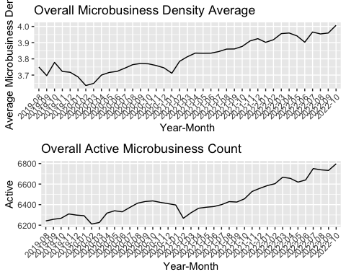

As expected, these two graphs show almost similar behavior. If we ignore the slight fluctuations of the two graphs, the general microbusiness density and count are growing over the whole time frame.

# Create plots  
p1 <- merged_df %>%  
 # Group merged_df by year_month  
 group_by(year_month) %>%  
 # calculate the median value of microbusiness_density for each group  
 summarise(median_microbusiness_density = median(microbusiness_density)) %>%  
 ggplot(aes(x = year_month, y = median_microbusiness_density, group = 1)) +  
 geom_line() +  
 labs(title = "Overall Microbusiness Density Median",  
 x = "Year-Month",  
 y = "Microbusiness Density Median") +  
 theme(axis.text.x = element_text(angle = 45, hjust = 1))  
  
p2 <- merged_df %>%  
 group_by(year_month) %>%  
 summarize(median_active = median(active)) %>%  
 ggplot(aes(x = year_month, y = median_active)) +  
 geom_line(group = 1) +  
 labs(title = "Overall Active Microbusiness Count Median",  
 x = "Year-Month",   
 y = "Active Median") +  
 theme(axis.text.x = element_text(angle = 45, hjust = 1))  
  
  
# Display the plots  
grid.arrange(p1, p2, nrow = 2)

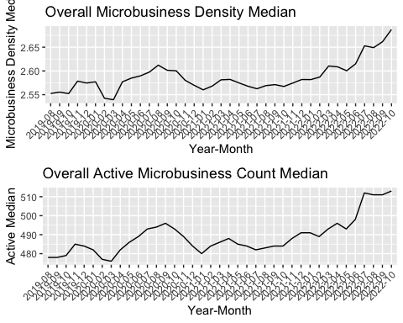

Then, we will examine the behavior of these two variables (*microbusiness density* and *active*) while grouping the data by month and year:

# Group merged_df by year and calculate the mean value of microbusiness_density and active for each group  
merged_df_mean_year <- merged_df %>%  
 group_by(year) %>%  
 summarize(avg_microbusiness_density = mean(microbusiness_density),  
 avg_active = mean(active))  
  
# Group merged_df by month and calculate the mean value of the microbusiness_density for each group  
merged_df_mean_month <- merged_df %>%  
 group_by(month) %>%  
 summarize(avg_microbusiness_density = mean(microbusiness_density),  
 avg_active = mean(active))  
  
# Plot the monthly mean values for microbusiness density  
p1 <-   
 ggplot(merged_df_mean_month, aes(x = month, y = avg_microbusiness_density)) +  
 geom_line() +  
 ggtitle("Average Monthly Microbusiness Density") +  
 xlab("Month") +  
 ylab("Avg Microbusiness Density") +  
 theme(axis.text.x = element_text(angle = 45, hjust = 1))  
  
# Plot the yearly mean values for microbusiness density  
p2 <-   
 ggplot(merged_df_mean_year, aes(x = year, y = avg_microbusiness_density)) +  
 geom_line() +  
 ggtitle("Average Yearly Microbusiness Density") +  
 xlab("Year") +  
 ylab("Avg Microbusiness Density") +  
 theme(axis.text.x = element_text(angle = 45, hjust = 1))  
  
# Plot the monthly mean values for active  
p3 <-   
 ggplot(merged_df_mean_month, aes(x = month, y = avg_active)) +  
 geom_line() +  
 ggtitle("Average Monthly Active Microbusiness Count") +  
 xlab("Month") +  
 ylab("Avg Microbusiness Count") +  
 theme(axis.text.x = element_text(angle = 45, hjust = 1))  
  
# Plot the yearly mean values for active  
p4 <-   
 ggplot(merged_df_mean_year, aes(x = year, y = avg_active)) +  
 geom_line() +  
 ggtitle("Average Yearly Active Microbusiness Count") +  
 xlab("Year") +  
 ylab("Avg Microbusiness Count") +  
 theme(axis.text.x = element_text(angle = 45, hjust = 1))   
  
# Display the plots side by side  
grid.arrange(p2, p1, p4, p3, nrow = 2, ncol = 2)

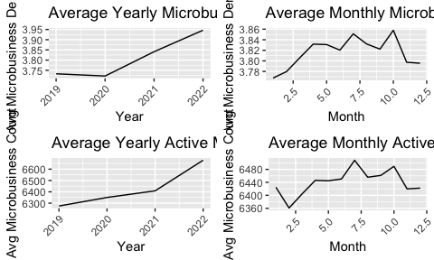

The left plots show that the average microbusiness density has increased slightly over the years, starting at approximately 3.73 in 2019 and reaching 3.94 in 2022. On the other hand, the average active count has also increased, starting at approximately 6274 in 2019 and reaching 6679 in 2022. In comparison, the right plots show fluctuations in the monthly averages for both variables. Generally, it follows a slightly upward trend over the year, with some peak values observed in July and October for the microbusiness density and active count, respectively. These peak values may represent seasonal variations, indicating that microbusinesses are more active during certain months. Overall, the plot shows some correlation between the monthly average values of microbusiness_density and active count, indicating that common factors may influence both variables.

# Create a grid of box plots  
ggplot(merged_df, aes(x=year_month, y=microbusiness_density)) +  
 geom_boxplot() +  
 labs(x="Year-Month", y="Microbusiness Density") +  
 ggtitle("Overall Microbusiness Density Average") +  
 theme(axis.text.x = element_text(angle = 45, hjust = 1))

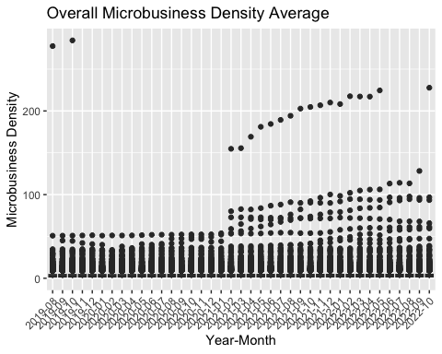

Above plot is not very informative because the small values are obscured by the larger ones. Therefore, using a logarithmic scale on the Y-axis can help to reduce this distortion and provide a more informative visualization of the data.

# Create a grid of box plots  
ggplot(merged_df, aes(x=year_month, y=microbusiness_density)) +  
 geom_boxplot() +  
 scale_y_log10() +  
 labs(x="Year-Month", y="Microbusiness Density") +  
 ggtitle("Overall Microbusiness Density Average") +  
 theme(axis.text.x = element_text(angle = 45, hjust = 1))

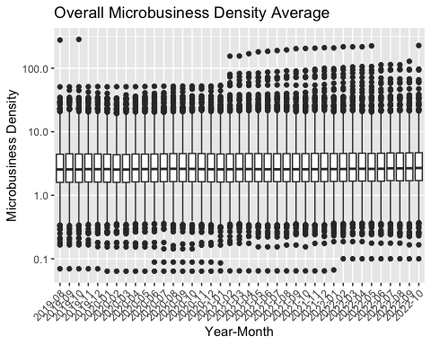

### 3.7.2. Economic Regional Divisions

The Bureau of Economic Analysis (BEA) divides the United States into eight distinct economic regions[1].

These regions are based on similarities in economic characteristics such as industry composition, income levels, and employment patterns. The eight regions are:

1. **New England**: Connecticut, Maine, Massachusetts, New Hampshire, Rhode Island, and Vermont.

* *The economy in this region is largely based on manufacturing, healthcare, education, and finance.*

1. **Mideast**: Delaware, Maryland, New Jersey, New York, Pennsylvania, and the District of Columbia.

* *The region has a diverse economy, with a mix of manufacturing, finance, healthcare, and professional services.*

1. **Great Lakes**: Illinois, Indiana, Michigan, Ohio, and Wisconsin.

* *The region has a strong manufacturing base, particularly in the automotive industry, and also has a significant healthcare sector.*

1. **Plains**: Iowa, Kansas, Minnesota, Missouri, Nebraska, North Dakota, and South Dakota.

* *Agriculture and energy production are major industries in this region, along with manufacturing and healthcare.*

1. **Southeast**: Alabama, Arkansas, Florida, Georgia, Kentucky, Louisiana, Mississippi, North Carolina, South Carolina, Tennessee, Virginia, and West Virginia.

* *The Southeast has a diverse economy, with significant industries in healthcare, finance, and manufacturing, as well as tourism and agriculture.*

1. **Southwest**: Arizona, New Mexico, Oklahoma, and Texas.

* *The region has a strong energy sector, particularly in oil and gas production, and also has significant industries in manufacturing, healthcare, and finance.*

1. **Rocky Mountain**: Colorado, Idaho, Montana, Utah, and Wyoming.

* *The region is known for its natural resources, particularly in mining and energy production, as well as tourism, healthcare, and manufacturing.*

1. **Far West**: Alaska, California, Hawaii, Nevada, Oregon, and Washington.

* *This region has a diverse economy, with significant industries in technology, finance, healthcare, and manufacturing, as well as tourism and agriculture.*

To draw the map for the BEA regions, first, we need to convert state and county columns in **merged_df** to lowercase letters. Merging two dataframes will cause problems because the data from **map_data()** will be in lowercase letters.

# Convert state and county columns in merged_df to lowercase  
merged_df <- merged_df %>%   
 mutate(state = tolower(state)) %>%  
 mutate(county = tolower(county))

Then, we’ll create a new column in **merged_df** named region and assign region values based on state column:

# Create a new column named region and initialize all values as NA  
merged_df$region <- NA  
  
# Assign region values based on state column  
for (i in 1:nrow(merged_df)) {  
 if (merged_df$state[i] %in% c("connecticut", "maine", "massachusetts", "new hampshire", "rhode island", "vermont")) {  
 merged_df$region[i] <- "new england"  
 } else if (merged_df$state[i] %in% c("delaware", "maryland", "new jersey", "new york", "pennsylvania", "district of columbia")) {  
 merged_df$region[i] <- "mideast"  
 } else if (merged_df$state[i] %in% c("illinois", "indiana", "michigan", "ohio", "wisconsin")) {  
 merged_df$region[i] <- "great lakes"  
 } else if (merged_df$state[i] %in% c("iowa", "kansas", "minnesota", "missouri", "nebraska", "north dakota", "south dakota")) {  
 merged_df$region[i] <- "plains"  
 } else if (merged_df$state[i] %in% c("alabama", "arkansas", "florida", "georgia", "kentucky", "louisiana", "mississippi", "north carolina", "south carolina", "tennessee", "virginia", "west virginia")) {  
 merged_df$region[i] <- "southeast"  
 } else if (merged_df$state[i] %in% c("arizona", "new mexico", "oklahoma", "texas")) {  
 merged_df$region[i] <- "southwest"  
 } else if (merged_df$state[i] %in% c("colorado", "idaho", "montana", "utah", "wyoming")) {  
 merged_df$region[i] <- "rocky mountain"  
 } else if (merged_df$state[i] %in% c("alaska", "california", "hawaii", "nevada", "oregon", "washington")) {  
 merged_df$region[i] <- "far west"  
 } else {  
 merged_df$region[i] <- "other"  
 }  
}

# Print all the unique values in the region column  
unique(merged_df$region)

## [1] "southeast" "far west" "southwest" "rocky mountain"  
## [5] "new england" "mideast" "great lakes" "plains"

Now that the data in the dataframe matches the **map_data()** output, we appoint each state to the region it belongs to and then use **ggplot()** to draw the map:

# Get the map of the United States  
us_map <- map_data("state")  
  
# Create a lookup table for state abbreviations and their corresponding full names  
state_names <- data.frame(state = state.abb, name = tolower(state.name))  
  
# Map the regions to the states  
region_map <- us_map %>%  
#left_join(state_names, by = c("region" = "state")) %>%  
 left_join(state_names, by = c("region" = "name")) %>%  
# merge(us_map, state_names, by.x=c("region"), by.y=c("name")) %>%  
 mutate(region =   
 ifelse(region %in% c("connecticut", "maine", "massachusetts", "new hampshire", "rhode island", "vermont"), "New England",  
 ifelse(region %in% c("delaware", "maryland", "new jersey", "new york", "pennsylvania", "district of columbia"), "Mideast",  
 ifelse(region %in% c("illinois", "indiana", "michigan", "ohio", "wisconsin"), "Great Lakes",  
 ifelse(region %in% c("iowa", "kansas", "minnesota", "missouri", "nebraska", "north dakota", "south dakota"), "Plains",  
 ifelse(region %in% c("alabama", "arkansas", "florida", "georgia", "kentucky", "louisiana", "mississippi", "north carolina", "south carolina", "tennessee", "virginia", "west virginia"), "Southeast",  
 ifelse(region %in% c("arizona", "new mexico", "oklahoma", "texas"), "Southwest",  
 ifelse(region %in% c("colorado", "idaho", "montana", "utah", "wyoming"), "Rocky Mountain",  
 ifelse(region %in% c("alaska", "california", "hawaii", "nevada", "oregon", "washington"), "Far West", NA  
 )))))))))  
   
  
# Summarize the data to get the center coordinates of each state  
#state_centers <- region_map %>%   
# group_by(state) %>%   
# summarise(long = mean(long), lat = mean(lat))  
# add labels  
states <- aggregate(cbind(long, lat) ~ region, data=us_map,   
 FUN=function(x)mean(range(x)))  
states$group <- c("AL", "AR", "AZ", "CA", "CO", "CT", "DE", "DC", "FL", "GA", "IA",   
 "ID", "IL", "IN", "KS", "KY", "LA", "MA", "MD", "ME", "MI", "MN",   
 "MO", "MS", "MT", "NC", "ND", "NE", "NH", "NJ", "NM", "NV", "NY",   
 "OH", "OK", "OR", "PA", "RI", "SC", "SD", "TN", "TX", "UT", "VA",   
 "VT", "WA", "WI", "WV", "WY")  
  
# names(states)[names(states) == "region"] <- "group"  
  
  
#Plot the map  
ggplot(region_map, aes(x = long, y = lat, group = group, fill = region)) +  
 geom_polygon(color = "black", show.legend = TRUE) +  
# geom_text(aes(label = state), data = region_map, size = 3, vjust = 2, hjust = 2) +  
# geom_text(aes(label = state), data = state_centers, size = 2, vjust = 2, hjust = 2) +  
 geom_text(data = states, aes(long, lat, label = group), size = 2.5, inherit.aes = FALSE, color = "white", fontface = "bold") +  
# scale_fill_gradient(low = "white", high = "darkred") +  
# scale_fill_manual(values = viridis(n = 60), na.value = "gray") +  
 labs(title = "Bureau of Economic Analysis Regional Divisions Map", fill = "Region") +  
# geom_text(aes(x = long, y = lat, label = state), data = state_centers, size = 3, color = "white") +  
 theme_void() +  
 theme(panel.background = element_rect(fill = "gray75", color = NA))

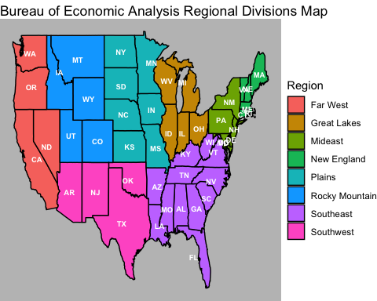

# Group merged_df by region and calculate average microbusiness density  
merged_df %>%  
 group_by(region) %>%  
 summarize(avg_density = mean(microbusiness_density)) %>%  
  
 # Create bar plot of average density by region  
 ggplot(aes(x = region, y = avg_density)) +  
 geom_bar(stat = "identity") +  
   
 # Add plot title and axis labels  
 labs(title = "Average Microbusiness Density Per Region",  
 x = "Region", y = "Avg Density") +  
   
 # Apply a black and white theme to the plot  
 theme_bw()

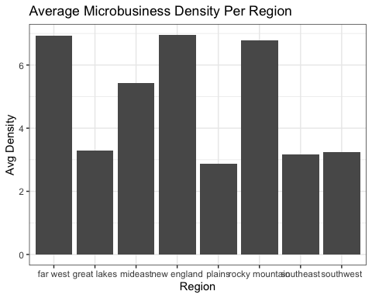

According to the above plot *New England* has the highest average microbusiness density, followed by *Farwest* and *Rocky Mountain* respectively, with a tiny difference, valuing more than 6.75. In contrast, *plains* has the lowest average microbusiness density, followed by *Southeast* and *Southwest*, all valued under 3.25. We can use a choropleth map to get a better view on the above information.

# choropleth map  
# Group merged_df by region and calculate average microbusiness density  
avg_density <- merged_df %>%  
 group_by(region) %>%  
 summarize(avg_density = mean(microbusiness_density))  
  
# Create a lookup table for state abbreviations and their corresponding full names  
state_names <- data.frame(state = state.abb, name = tolower(state.name))  
  
# Lowercase region column of region_map  
region_map <- region_map %>%   
 mutate(region = tolower(region))   
  
# Merge the average density data with the region_map data  
plot_data <- merge(region_map, avg_density, by = "region") %>%  
 arrange(order)  
  
# Coordinates of the center of regions  
bea_regions <- data.frame(  
 group = c("New England", "Mideast", "Great Lakes", "Plains",   
 "Southeast", "Southwest", "Rocky Mountain", "Far West"),  
 x = c(-71.8, -76.9, -86.6, -98.5, -82.4, -106.4, -111.1, -119.8),  
 y = c(42.2, 39, 43.4, 39.8, 32.6, 34.3, 44.4, 38.4)  
)  
  
# Create the plot   
ggplot(plot_data, aes(x = long, y = lat, group = group, fill = avg_density)) +  
 geom_polygon(color = "black") +  
 geom_label(data = bea_regions,  
 aes(x = x, y = y, label = group),  
 size = 3, fontface = "bold",   
 label.padding = unit(0.2, "lines"),  
 label.size = 0.2,  
 fill = "gray75", color = "black") +  
   
 scale_fill_gradient(low = "gray85", high = "darkred") +  
 # scale_fill_viridis(name = "Avg Density", na.value = "gray") +  
 labs(title = "Average Microbusiness Density Per Region", fill = "Avg Density") +  
 theme_void()

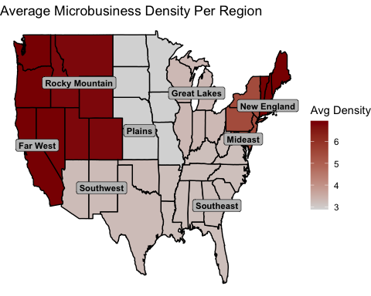

# theme(panel.background = element_rect(fill = "gray90", color = NA))

Although, we can only see only one parameter on above map. To have a better look on the distribution, central tendency, spread, and variability of the microbusiness_density variable, we can use boxplots.

# Aggregate data by region  
df_by_region <- aggregate(microbusiness_density ~ region, merged_df, median)  
  
# Create boxplot  
ggplot(merged_df, aes(x = region, y = microbusiness_density)) +  
 geom_boxplot() +  
 labs(x = "Region", y = "Microbusiness Density") +  
 # Arrange plots in grid  
 facet_wrap(~ region, scales = "free", nrow = 2)

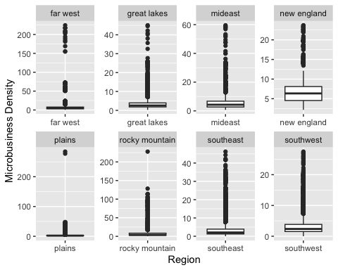

Above plots are not very informative because the small values are obscured by the larger ones. Therefore, using a logarithmic scale on the Y-axis can help to reduce this distortion and provide a more informative visualization of the data.

# Create a grid of box plots  
ggplot(merged_df, aes(x=region, y=microbusiness_density)) +  
 geom_boxplot() +  
 scale_y_log10() +  
 labs(x="Region", y="Microbusiness Density") +  
 ggtitle("Microbusiness Density by Region")

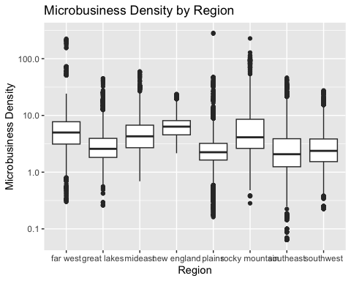

These boxplots are more informative, because using a logarithmic scale on the Y-axis helps to better reveal the differences and similarities between regions that helps to highlight any potential patterns or trends in the data. Some of the points that can be inferred from this boxplot include:

* All regions have at least some microbusiness activity. Because minimum microbusiness density is greater than 0 in all regions.
* The median microbusiness density is highest in the *New England* region, followed by the *Far West* and the *Mideast* regions.
* The 3rd quartile microbusiness density is highest in the *Rocky Mountain* region, followed by the *New England* and the *Far West* regions.
* The maximum microbusiness density is highest in the *Plains* region, followed by the *Rocky Mountain* and the *Far West* regions.
* The mean microbusiness density is highest in the *New England* region, followed by the *Far West* and the *Rocky Mountain* regions.
* The interquartile range (IQR = the difference between the 1st and 3rd quartiles) of microbusiness density is widest in the *Rocky Mountain* region, indicating that there is a greater range of microbusiness density in that region. In contrast, the IQR is narrowest in the *Plains* region.

# by(merged_df$microbusiness_density, merged_df$region, summary)

# Aggregate microbusiness density by state  
state_avg <- aggregate(microbusiness_density ~ state, data = merged_df, FUN = mean)  
  
# Load US map data  
us_map <- map_data("state")  
  
# Merge state_avg with us_map based on region and state  
map_data <- merge(us_map, state_avg, by.x = "region", by.y = "state")  
  
# Create a heatmap of microbusiness density by state  
ggplot(map_data, aes(x = long, y = lat, group = group, fill = microbusiness_density)) +  
 geom_polygon() +  
 scale_fill_gradient(low = "white", high = "darkgreen") +  
 coord_map() +  
 labs(title = "Average Microbusiness Density per State", fill = "Density") +  
 theme_void() +  
 theme(panel.background = element_rect(fill = "lightblue", color = NA))

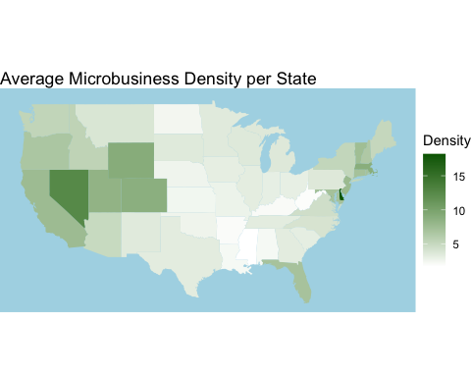

# Create a grid of box plots  
ggplot(merged_df, aes(x=state, y=microbusiness_density)) +  
 geom_boxplot(colour = "darkblue", outlier.colour = "pink") +  
 scale_y_log10() +  
 labs(x="State", y="Microbusiness Density") +  
 ggtitle("Microbusiness Density by State") +  
 theme_classic() +  
 theme(axis.text.x = element_text(angle = 90, hjust = 1, vjust = 0.3))

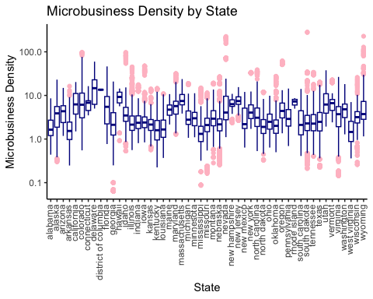

# {r fig.width = 10 ,fig.height = 12, out.width='100%', fig.align='center'}  
# Aggregate microbusiness density by county  
  
#county_avg <- merged_df %>%  
# group_by(cfips, county) %>%  
# summarise(microbusiness_density = mean(microbusiness_density))  
  
county_avg <- aggregate(microbusiness_density ~ county + state, data = merged_df, FUN = mean)  
  
# Get rid of county, city, and parish in the end of county names  
county_avg$county <- gsub(" county", "", county_avg$county)  
county_avg$county <- gsub(" city", "", county_avg$county)  
county_avg$county <- gsub(" parish", "", county_avg$county)  
  
  
# Load US county map data  
us_map <- map_data("county")  
  
# Merge county_avg with us_map based on region and county  
map_data <- merge(us_map, county_avg, by.x = c("subregion", "region"), by.y = c("county", "state")) %>%  
 arrange(order)  
  
# Create a heatmap of microbusiness density by county using ggplot2  
ggplot(map_data, aes(x = long, y = lat, group = group, fill = microbusiness_density)) +  
 geom_polygon() +  
 scale_fill_gradient(low = "lightblue", high = "navyblue") +  
 coord_map() +  
 labs(title = "Average Microbusiness Density per County", fill = "Density") +  
 theme_void() +  
 theme(panel.background = element_rect(fill = "gray85", color = NA))

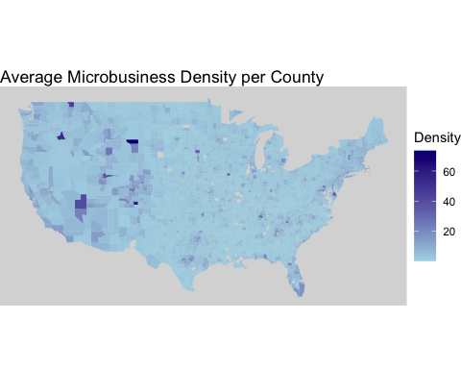

str(merged_df)

## 'data.frame': 122265 obs. of 16 variables:  
## $ row_id : chr "1001_2019-08-01" "1001_2019-09-01" "1001_2019-10-01" "1001_2019-11-01" ...  
## $ cfips : int 1001 1001 1001 1001 1001 1001 1001 1001 1001 1001 ...  
## $ county : chr "autauga county" "autauga county" "autauga county" "autauga county" ...  
## $ state : chr "alabama" "alabama" "alabama" "alabama" ...  
## $ first_day_of_month : Date, format: "2019-08-01" "2019-09-01" ...  
## $ microbusiness_density: num 3.01 2.88 3.06 2.99 2.99 ...  
## $ active : int 1249 1198 1269 1243 1243 1242 1217 1227 1255 1257 ...  
## $ year_month : chr "2019-08" "2019-09" "2019-10" "2019-11" ...  
## $ year : num 2019 2019 2019 2019 2019 ...  
## $ month : int 8 9 10 11 12 1 2 3 4 5 ...  
## $ pct_bb : num 76.6 76.6 76.6 76.6 76.6 78.9 78.9 78.9 78.9 78.9 ...  
## $ pct_college : num 14.5 14.5 14.5 14.5 14.5 15.9 15.9 15.9 15.9 15.9 ...  
## $ pct_foreign_born : num 2.1 2.1 2.1 2.1 2.1 2 2 2 2 2 ...  
## $ pct_it_workers : num 1.3 1.3 1.3 1.3 1.3 1.1 1.1 1.1 1.1 1.1 ...  
## $ median_hh_inc : num 55317 55317 55317 55317 55317 ...  
## $ region : chr "southeast" "southeast" "southeast" "southeast" ...  
## - attr(*, "na.action")= 'omit' Named int [1:28551] 40 41 42 43 44 45 46 47 48 88 ...  
## ..- attr(*, "names")= chr [1:28551] "40" "41" "42" "43" ...

Boxplots are a visualization tool that provide insights into the central tendency and spread of a dataset, as well as identify outliers and skewness. They are useful for detecting anomalies and comparing variable distributions in a dataset, providing valuable insights into data distribution for exploratory data analysis.

ggplot(merged_df, aes(y = microbusiness_density)) +  
# ggplot(merged_df, aes(x=region, y=microbusiness_density)) +  
 geom_boxplot(colour = "blue") +  
 scale_y_log10() +  
 labs(y="Microbusiness Density") +  
 ggtitle("Microbusiness Density") +  
 theme_classic()

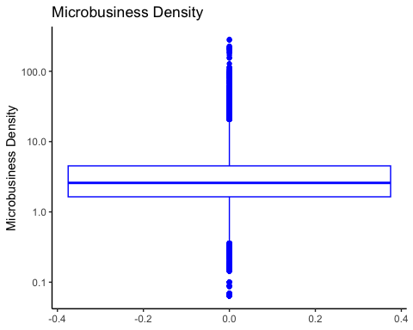

# Create a grid of box plots  
par(mfrow=c(3,2))  
p1 <- ggplot(merged_df, aes(x=region, y=median_hh_inc)) +  
 geom_boxplot(outlier.colour = "orange") +  
 scale_y_log10() +  
 labs(x="Region", y="Median Household Income") +  
 ggtitle("Median Household Income by Region") +  
 theme_classic() +  
 theme(axis.text.x = element_text(angle = 45, hjust = 1))  
  
p2 <- ggplot(merged_df, aes(x=region, y=pct_college)) +  
 geom_boxplot(outlier.colour = "orange") +  
 scale_y_log10() +  
 labs(x="Region", y="Percentage with College Education") +  
 ggtitle("Percentage with College Education by Region") +  
 theme_classic() +  
 theme(axis.text.x = element_text(angle = 45, hjust = 1))  
  
p3 <- ggplot(merged_df, aes(x=region, y=pct_foreign_born)) +  
 geom_boxplot(outlier.colour = "orange") +  
 scale_y_log10() +  
 labs(x="Region", y="Percentage of Foreign-born Residents") +  
 ggtitle("Percentage of Foreign-born Residents by Region") +  
 theme_classic() +  
 theme(axis.text.x = element_text(angle = 45, hjust = 1))  
  
p4 <- ggplot(merged_df, aes(x=region, y=pct_it_workers)) +  
 geom_boxplot(outlier.colour = "orange") +  
 scale_y_log10() +  
 labs(x="Region", y="Percentage of IT Workers") +  
 ggtitle("Percentage of IT Workers by Region") +  
 theme_classic() +  
 theme(axis.text.x = element_text(angle = 45, hjust = 1))  
  
p5 <- ggplot(merged_df, aes(x=region, y=pct_bb)) +  
 geom_boxplot(outlier.colour = "orange") +  
 scale_y_log10() +  
 labs(x="Region", y="Percentage of Broadband Access") +  
 ggtitle("Percentage of Broadband Access by Region") +  
 theme_classic() +  
 theme(axis.text.x = element_text(angle = 45, hjust = 1))  
  
  
grid.arrange(p1, p2, p3, p4, p5, nrow = 5)

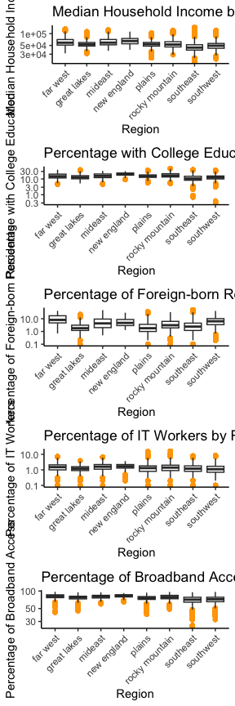

# Create a grid of box plots  
  
p1 <- ggplot(merged_df, aes(x=state, y=median_hh_inc)) +  
 geom_boxplot(outlier.colour = "orange") +  
 scale_y_log10() +  
 labs(x="State", y="Median Household Income") +  
 ggtitle("Median Household Income by State") +  
 theme_classic() +  
 theme(axis.text.x = element_text(angle = 90, hjust = 1, vjust = 0.3))  
  
p2 <- ggplot(merged_df, aes(x=state, y=pct_college)) +  
 geom_boxplot(outlier.colour = "orange") +  
 scale_y_log10() +  
 labs(x="State", y="Percentage with College Education") +  
 ggtitle("Percentage with College Education by State") +  
 theme_classic() +  
 theme(axis.text.x = element_text(angle = 90, hjust = 1, vjust = 0.3))  
  
p3 <- ggplot(merged_df, aes(x=state, y=pct_foreign_born)) +  
 geom_boxplot(outlier.colour = "orange") +  
 scale_y_log10() +  
 labs(x="State", y="Percentage of Foreign-born Residents") +  
 ggtitle("Percentage of Foreign-born Residents by State") +  
 theme_classic() +  
 theme(axis.text.x = element_text(angle = 90, hjust = 1, vjust = 0.3))  
  
p4 <- ggplot(merged_df, aes(x=state, y=pct_it_workers)) +  
 geom_boxplot(outlier.colour = "orange") +  
 scale_y_log10() +  
 labs(x="State", y="Percentage of IT Workers") +  
 ggtitle("Percentage of IT Workers by State") +  
 theme_classic() +  
 theme(axis.text.x = element_text(angle = 90, hjust = 1, vjust = 0.3))  
  
p5 <- ggplot(merged_df, aes(x=state, y=pct_bb)) +  
 geom_boxplot(outlier.colour = "orange") +  
 scale_y_log10() +  
 labs(x="State", y="Percentage of Broadband Access") +  
 ggtitle("Percentage of Broadband Access by State") +  
 theme_classic() +  
 theme(axis.text.x = element_text(angle = 90, hjust = 1, vjust = 0.3))  
  
grid.arrange(p1, p2, p3, p4, p5, nrow = 5)

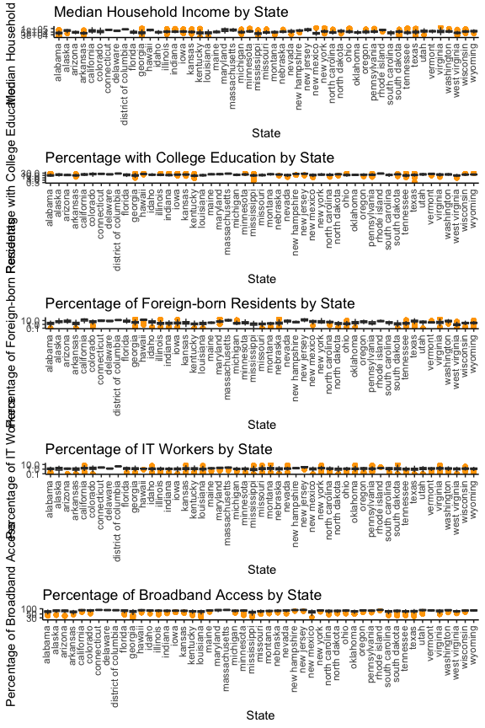

# choropleth map with 5 variables  
# Group merged_df by region and calculate average variables  
avg_variables <- merged_df %>%  
group_by(region) %>%  
summarize(avg_pct_bb = mean(pct_bb),  
avg_pct_college = mean(pct_college),  
avg_pct_foreign_born = mean(pct_foreign_born),  
avg_pct_it_workers = mean(pct_it_workers),  
avg_median_hh_inc = mean(median_hh_inc))  
  
# Create a lookup table for state abbreviations and their corresponding full names  
state_names <- data.frame(state = state.abb, name = tolower(state.name))  
  
# Lowercase region column of region_map  
region_map <- region_map %>%  
mutate(region = tolower(region))  
  
# Merge the average density data with the region_map data  
plot_data <- merge(region_map, avg_variables, by = "region") %>%  
arrange(order)  
  
# Coordinates of the center of regions  
bea_regions <- data.frame(  
group = c("New England", "Mideast", "Great Lakes", "Plains",  
"Southeast", "Southwest", "Rocky Mountain", "Far West"),  
x = c(-71.8, -76.9, -86.6, -98.5, -82.4, -106.4, -111.1, -119.8),  
y = c(42.2, 39, 43.4, 39.8, 32.6, 34.3, 44.4, 38.4)  
)  
  
# Create the plot with a grid of 5 rows and 1 column  
p1 <- ggplot(plot_data, aes(x = long, y = lat, group = group, fill = avg_pct_bb)) +  
geom_polygon(color = "black") +  
 geom_label(data = bea_regions,  
 aes(x = x, y = y, label = group),  
 size = 3, fontface = "bold",   
 label.padding = unit(0.2, "lines"),  
 label.size = 0.2,  
 fill = "gray75", color = "black") +  
scale_fill_gradient(low = "gray85", high = "darkred") +  
labs(title = "Average Percent of Broadband Access Per Region", fill = "Avg Density") +  
theme_void()  
  
p2 <- ggplot(plot_data, aes(x = long, y = lat, group = group, fill = avg_pct_college)) +  
geom_polygon(color = "black") +  
 geom_label(data = bea_regions,  
 aes(x = x, y = y, label = group),  
 size = 3, fontface = "bold",   
 label.padding = unit(0.2, "lines"),  
 label.size = 0.2,  
 fill = "gray75", color = "black") +  
scale_fill_gradient(low = "gray85", high = "darkred") +  
labs(title = "Average Percent of College Graduates Per Region", fill = "Avg Percent") +  
theme_void()  
  
p3 <- ggplot(plot_data, aes(x = long, y = lat, group = group, fill = avg_pct_foreign_born)) +  
geom_polygon(color = "black") +  
 geom_label(data = bea_regions,  
 aes(x = x, y = y, label = group),  
 size = 3, fontface = "bold",   
 label.padding = unit(0.2, "lines"),  
 label.size = 0.2,  
 fill = "gray75", color = "black") +  
scale_fill_gradient(low = "gray85", high = "darkred") +  
labs(title = "Average Percent of Foreign-Born Population Per Region", fill = "Avg Percent") +  
theme_void()  
  
p4 <- ggplot(plot_data, aes(x = long, y = lat, group = group, fill = avg_pct_it_workers)) +  
geom_polygon(color = "black") +  
 geom_label(data = bea_regions,  
 aes(x = x, y = y, label = group),  
 size = 3, fontface = "bold",   
 label.padding = unit(0.2, "lines"),  
 label.size = 0.2,  
 fill = "gray75", color = "black") +  
scale_fill_gradient(low = "gray85", high = "darkred") +  
labs(title = "Average Percent of IT Workers Per Region", fill = "Avg Percent") +  
theme_void()  
  
p5 <- ggplot(plot_data, aes(x = long, y = lat, group = group, fill = avg_median_hh_inc)) +  
geom_polygon(color = "black") +  
 geom_label(data = bea_regions,  
 aes(x = x, y = y, label = group),  
 size = 3, fontface = "bold",   
 label.padding = unit(0.2, "lines"),  
 label.size = 0.2,  
 fill = "gray75", color = "black") +  
scale_fill_gradient(low = "gray85", high = "darkred") +  
labs(title = "Average Median Household Income Per Region", fill = "Avg inc") +  
theme_void()  
  
grid.arrange(p1, p2, p3, p4, p5, nrow = 5)

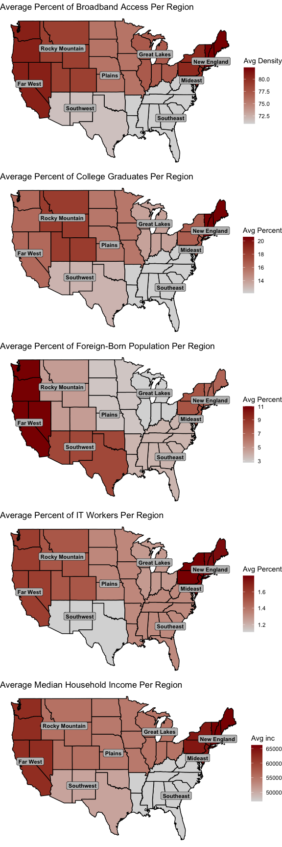

state_avg <- aggregate(cbind(pct_bb, pct_college, pct_foreign_born, pct_it_workers, median_hh_inc) ~ state, data = merged_df, FUN = mean)  
  
  
#Load US state map data  
us_map <- map_data("state")  
  
#Merge state_avg with us_map based on region and state  
map_data <- merge(us_map, state_avg, by.x = c("region"), by.y = c("state")) %>%  
arrange(order)  
  
#Create a grid of heatmaps for each variable  
grid_arrange_shared_legend <- function(...) {  
plots <- list(...)  
g <- ggplotGrob(plots[[1]] + theme(legend.position="bottom"))$grobs  
legend <- g[[which(sapply(g, function(x) x$name) == "guide-box")]]  
lheight <- sum(legend$height)  
grid.arrange(  
do.call(arrangeGrob, lapply(plots, function(x)  
x + theme(legend.position="none") + theme(panel.background = element_rect(fill = "gray85", color = NA)))  
),  
bottom = legend,  
ncol = 5,  
heights = rep((unit(1, "npc") - lheight) / length(plots), length(plots))  
)  
}  
  
heatmap_bb <- ggplot(map_data, aes(x = long, y = lat, group = group, fill = pct_bb)) +  
 geom_polygon() +  
 scale_fill_gradient(low = "white", high = "darkgreen") +  
 coord_map() +  
 labs(title = "Percent of Broadband Access per State", fill = "Percent") +  
 theme_void()  
  
heatmap_college <-   
 ggplot(map_data, aes(x = long, y = lat, group = group, fill = pct_college)) +  
 geom_polygon() +  
 scale_fill_gradient(low = "white", high = "darkgreen") +  
 coord_map() +  
 labs(title = "Percent of Population with College Education per State", fill = "Percent") +  
 theme_void()  
  
heatmap_foreign_born <-   
 ggplot(map_data, aes(x = long, y = lat, group = group, fill = pct_foreign_born)) +  
 geom_polygon() +  
 scale_fill_gradient(low = "white", high = "darkgreen") +  
 coord_map() +  
 labs(title = "Percent of Foreign-born Population per State", fill = "Percent") +  
 theme_void()  
  
heatmap_it_workers <-   
 ggplot(map_data, aes(x = long, y = lat, group = group, fill = pct_it_workers)) +  
 geom_polygon() +  
 scale_fill_gradient(low = "white", high = "darkgreen") +  
 coord_map() +  
 labs(title = "Percent of IT Workers per State", fill = "Percent") +  
 theme_void()  
heatmap_inc <-   
 ggplot(map_data, aes(x = long, y = lat, group = group, fill = median_hh_inc)) +  
 geom_polygon() +  
 scale_fill_gradient(low = "white", high = "darkgreen") +  
 coord_map() +  
 labs(title = "Median Household Income per State", fill = "Dollars") +  
 theme_void()  
  
#Plot the grid of heatmaps  
#grid_arrange_shared_legend(heatmap_bb, heatmap_college, heatmap_foreign_born, heatmap_it_workers, heatmap_inc)  
grid.arrange(heatmap_bb, heatmap_college, heatmap_foreign_born, heatmap_it_workers, heatmap_inc, nrow = 5)

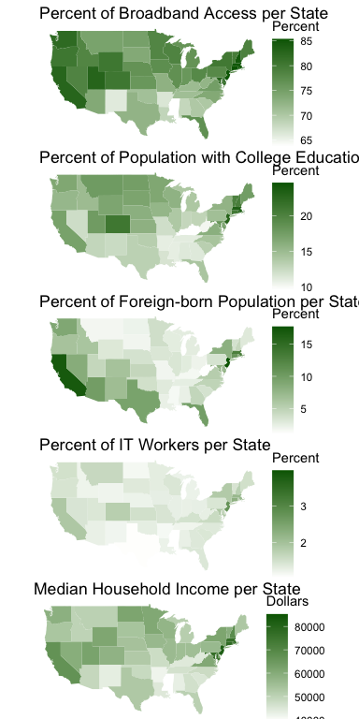

county_avg <- aggregate(cbind(pct_bb, pct_college, pct_foreign_born, pct_it_workers, median_hh_inc) ~ county + state, data = merged_df, FUN = mean)  
  
#Get rid of county, city, and parish in the end of county names  
county_avg$county <- gsub(" county", "", county_avg$county)  
county_avg$county <- gsub(" city", "", county_avg$county)  
county_avg$county <- gsub(" parish", "", county_avg$county)  
  
#Load US county map data  
us_map <- map_data("county")  
  
#Merge county_avg with us_map based on region and county  
map_data <- merge(us_map, county_avg, by.x = c("subregion", "region"), by.y = c("county", "state")) %>%  
arrange(order)  
  
#Create a grid of heatmaps for each variable  
grid_arrange_shared_legend <- function(...) {  
plots <- list(...)  
g <- ggplotGrob(plots[[1]] + theme(legend.position="bottom"))$grobs  
legend <- g[[which(sapply(g, function(x) x$name) == "guide-box")]]  
lheight <- sum(legend$height)  
grid.arrange(  
do.call(arrangeGrob, lapply(plots, function(x)  
x + theme(legend.position="none") + theme(panel.background = element_rect(fill = "gray85", color = NA)))  
),  
bottom = legend,  
ncol = 5,  
heights = rep((unit(1, "npc") - lheight) / length(plots), length(plots))  
)  
}  
  
heatmap_bb <- ggplot(map_data, aes(x = long, y = lat, group = group, fill = pct_bb)) +  
 geom_polygon() +  
 scale_fill_gradient(low = "lightblue", high = "navyblue") +  
 coord_map() +  
 labs(title = "Percent of Broadband Access per County", fill = "Percent") +  
 theme_void()  
  
heatmap_college <-   
 ggplot(map_data, aes(x = long, y = lat, group = group, fill = pct_college)) +  
 geom_polygon() +  
 scale_fill_gradient(low = "lightblue", high = "navyblue") +  
 coord_map() +  
 labs(title = "Percent of Population with College Education per County", fill = "Percent") +  
 theme_void()  
  
heatmap_foreign_born <-   
 ggplot(map_data, aes(x = long, y = lat, group = group, fill = pct_foreign_born)) +  
 geom_polygon() +  
 scale_fill_gradient(low = "lightblue", high = "navyblue") +  
 coord_map() +  
 labs(title = "Percent of Foreign-born Population per County", fill = "Percent") +  
 theme_void()  
  
heatmap_it_workers <-   
 ggplot(map_data, aes(x = long, y = lat, group = group, fill = pct_it_workers)) +  
 geom_polygon() +  
 scale_fill_gradient(low = "lightblue", high = "navyblue") +  
 coord_map() +  
 labs(title = "Percent of IT Workers per County", fill = "Percent") +  
 theme_void()  
heatmap_inc <-   
 ggplot(map_data, aes(x = long, y = lat, group = group, fill = median_hh_inc)) +  
 geom_polygon() +  
 scale_fill_gradient(low = "lightblue", high = "navyblue") +  
 coord_map() +  
 labs(title = "Median Household Income per County", fill = "Dollars") +  
 theme_void()  
  
#Plot the grid of heatmaps  
#grid_arrange_shared_legend(heatmap_bb, heatmap_college, heatmap_foreign_born, heatmap_it_workers, heatmap_inc)  
grid.arrange(heatmap_bb, heatmap_college, heatmap_foreign_born, heatmap_it_workers, heatmap_inc, nrow = 5)

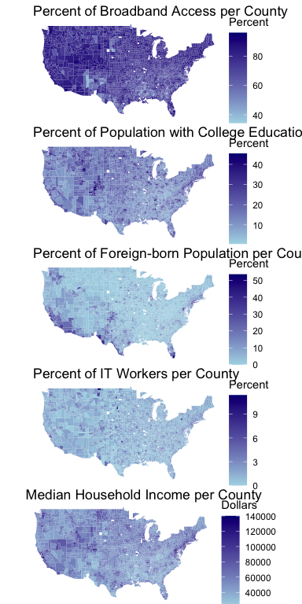

par(mfrow=c(2,3)) # set plot layout to 3 rows and 2 columns  
boxplot(merged_df$median_hh_inc, col = "pink", main = "Median Household Income")  
boxplot(merged_df$pct_college, col = "pink", main = "Percentage with College Education")  
boxplot(merged_df$pct_foreign_born, col = "pink", main = "Percentage of Foreign-born Residents")  
boxplot(merged_df$pct_it_workers, col = "pink", main = "Percentage of IT Workers")  
boxplot(merged_df$pct_bb, col = "pink", main = "Percentage of Broadband Access")  
#boxplot(merged_df$active, col = "pink", main = "Active Microbusiness Count")

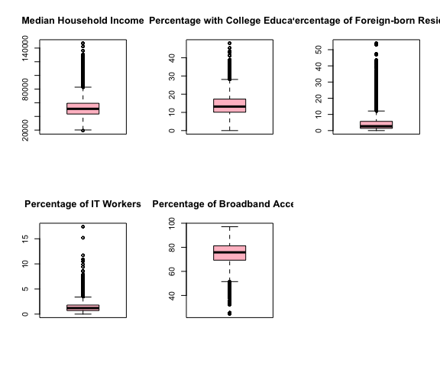

### 

## 3.8. Outlier Detection

Outlier detection is an important step in data analysis, as outliers can significantly affect the results of statistical analyses. There are several methods to detect outliers depending on the distribution of the data.

The Shapiro-Wilk normality test is a statistical test used to determine if a given dataset follows a normal distribution. We will perform a Shapiro-Wilk normality test on a random sample of 5000 observations from the microbusiness_density column of **merged_df** dataframe. To run this test we first set the seed value using **set.seed()** function to a specific random seed to ensure that the results are reproducible if the code is run again. Then, we weill use the **shapiro.test()** function to perform the Shapiro-Wilk normality test on the **sample_data** object. The function returns the test statistic (W) and the p-value. A W value closer to 1 indicates that the data is more normally distributed, while a W value closer to 0 indicates greater deviation from normality. If the p-value is less than the significance level (typically 0.05), then the null hypothesis (that the sample data is normally distributed) is rejected in favor of the alternative hypothesis (that the sample data is not normally distributed).

# Sample 5000 observations from microbusiness_density column  
set.seed(92) # Set seed for reproducibility  
sample_data <- sample(merged_df$microbusiness_density, 5000)  
  
# Perform Shapiro-Wilk test on sample_data  
shapiro.test(sample_data)

##   
## Shapiro-Wilk normality test  
##   
## data: sample_data  
## W = 0.55179, p-value < 2.2e-16

The test resulted in a W statistic of 0.55179 and a p-value of less than 2.2e-16. Based on the results of the Shapiro-Wilk normality test, it can be concluded that the **sample_data** is not normally distributed.

To have a better visual on distribution of the data we will use a bell curve, a boxplot, and a Q-Q plot on microbusiness_density.

# Calculate the mean and standard deviation of 'microbusiness_density'  
mean_density <- mean(merged_df$microbusiness_density)  
sd_density <- sd(merged_df$microbusiness_density)  
  
# Create a range of values for the x-axis  
x_values <- seq(mean_density - 3*sd_density, mean_density + 3*sd_density, length.out = 1000)  
  
# Create a bell curve with mean and standard deviation calculated above  
y_values <- dnorm(x_values, mean = mean_density, sd = sd_density)  
  
# Combine the 'x_values' and 'y_values' into a data frame  
density_df <- data.frame(x = x_values, y = y_values)  
  
# Create a boxplot   
boxplot <- ggplot(data = merged_df, aes(x = "", y = merged_df$microbusiness_density)) +  
 geom_boxplot(fill = "skyblue") +  
 scale_y_log10() +  
 labs(x = "", y = "Microbusiness Density (logarithmic)") +  
 ggtitle("Boxplot for Microbusiness Density")  
  
# Create a Q-Q plot and add a diagonal line  
qqplot <- ggplot(data = merged_df, aes(sample = microbusiness_density)) +   
 stat_qq() +   
 stat_qq_line(colour = "red") +  
 labs(x = "Theoretical Normal Quantiles", y = "Observed Quantiles") +  
 ggtitle("Q-Q Plot for Microbusiness Density")  
  
# Create a histogram and add the bell curve  
densityplot <- ggplot(data = merged_df, aes(x = microbusiness_density)) +  
 geom_histogram(aes(y = after_stat(density)), bins = 30, colour = "black", fill = "white") +  
 geom_line(data = density_df, aes(x = x, y = y), colour = "red", linewidth = 1) +  
 labs(x = "Microbusiness Density", y = "Density") +  
 ggtitle("Distribution of Microbusiness Density")  
  
# Arrange the plots in one row using the 'grid.arrange' function from the 'gridExtra' package  
grid.arrange(densityplot, boxplot, qqplot, ncol = 3, widths = c(2, 1, 2))

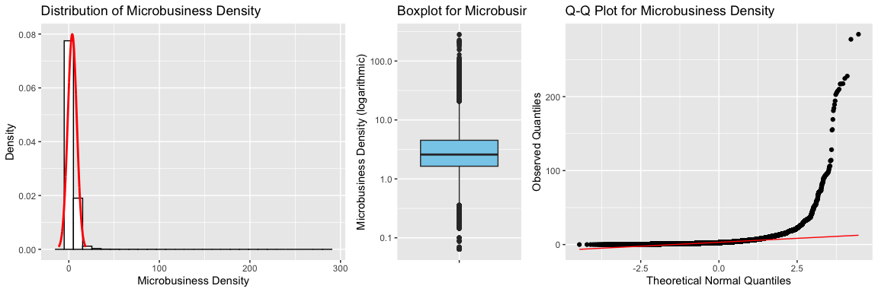

The above distribution plot explains that the dataset is right-skewed. The boxplot shows some data points away from the upper whisker; hence outliers are present in microbusiness_density. Q-Q plot’s alignment is away from the 45-degree angle depicting outliers in the dataset.

Since the data is right-skewed and not normally distributed, a common approach to detecting outliers is to use the interquartile range (IQR) method. Now, we have to find the boundary of minimum and maximum values, out of which data would be considered an outlier.

The decision range approach involves setting a range of values outside of which any observations are considered outliers. One common approach is to use the interquartile range (IQR) to define the decision range. The IQR is calculated as the difference between the third quartile (Q3) and the first quartile (Q1) of the data.

The decision range is then defined as the range from to . Any observations that fall outside of this range are considered outliers. This method is useful for identifying potential outliers in a dataset and can help to ensure that statistical analyses are robust and accurate.

quartiles <- quantile(merged_df$microbusiness_density, probs = seq(0, 1, 0.25), na.rm = FALSE,  
 names = TRUE, type = 7, digits = 6)  
quartiles

## 0% 25% 50% 75% 100%   
## 0.000000 1.639344 2.586543 4.519231 284.340030

# Calculate IQR of microbusiness_density column  
q <- quantile(merged_df$microbusiness_density, c(0.25, 0.75))  
iqr <- q[2] - q[1]  
  
# Calculate lower and upper bounds for outliers  
lower_bound <- q[1] - 1.5*iqr  
upper_bound <- q[2] + 1.5*iqr  
  
# Count number of outliers  
num_outliers <- sum(merged_df$microbusiness_density < lower_bound | merged_df$microbusiness_density > upper_bound)  
  
# Calculate percent of outliers  
percent_outliers <- num_outliers / length(merged_df$microbusiness_density) * 100  
  
# Print results  
cat("Number of outliers:", num_outliers, "\n")

## Number of outliers: 8746

cat("Percent of outliers:", percent_outliers, "%\n")

## Percent of outliers: 7.153315 %

# Create new dataframe without outliers  
merged_df_new <- merged_df[merged_df$microbusiness_density >= lower_bound & merged_df$microbusiness_density <= upper_bound,]  
  
# Print number of rows removed  
cat("Number of rows removed:", nrow(merged_df) - nrow(merged_df_new), "\n")

## Number of rows removed: 8746

# Calculate the mean and standard deviation of 'microbusiness_density'  
mean_density <- mean(merged_df_new$microbusiness_density)  
sd_density <- sd(merged_df_new$microbusiness_density)  
  
# Create a range of values for the x-axis  
x_values <- seq(mean_density - 3*sd_density, mean_density + 3*sd_density, length.out = 1000)  
  
# Create a bell curve with mean and standard deviation calculated above  
y_values <- dnorm(x_values, mean = mean_density, sd = sd_density)  
  
# Combine the 'x_values' and 'y_values' into a data frame  
density_df <- data.frame(x = x_values, y = y_values)  
  
# Create a boxplot  
boxplot <- ggplot(data = merged_df_new, aes(x = "", y = merged_df_new$microbusiness_density)) +  
 geom_boxplot(fill = "skyblue") +  
# scale_y_log10() +  
 labs(x = "", y = "Microbusiness Density") +  
 ggtitle("Boxplot for Microbusiness Density")  
  
# Create a Q-Q plot and add a diagonal line  
qqplot <- ggplot(data = merged_df_new, aes(sample = microbusiness_density)) +   
 stat_qq() +   
 stat_qq_line(colour = "red") +  
 labs(x = "Theoretical Normal Quantiles", y = "Observed Quantiles") +  
 ggtitle("Q-Q Plot for Microbusiness Density")  
  
# Create a bell curve and add the bell curve   
densityplot <- ggplot(data = merged_df_new, aes(x = microbusiness_density)) +  
 geom_histogram(aes(y = after_stat(density)), bins = 30, colour = "black", fill = "white") +  
 geom_line(data = density_df, aes(x = x, y = y), colour = "red", linewidth = 1) +  
 labs(x = "Microbusiness Density", y = "Density") +  
 ggtitle("Distribution of Microbusiness Density")  
  
# Arrange the plots in one row  
grid.arrange(densityplot, boxplot, qqplot, ncol = 3, widths = c(2, 1, 2))

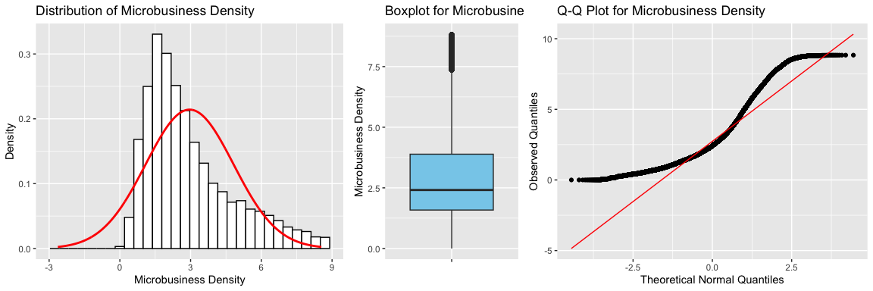

# Calculate IQR of microbusiness_density column  
q <- quantile(merged_df_new$microbusiness_density, c(0.25, 0.75))  
iqr <- q[2] - q[1]  
  
# Calculate lower and upper bounds for outliers  
lower_bound <- q[1] - 1.5*iqr  
upper_bound <- q[2] + 1.5*iqr  
  
# Count number of outliers  
num_outliers <- sum(merged_df_new$microbusiness_density < lower_bound | merged_df_new$microbusiness_density > upper_bound)  
  
# Calculate percent of outliers  
percent_outliers <- num_outliers / length(merged_df_new$microbusiness_density) * 100  
  
# Print results  
cat("Number of outliers:", num_outliers, "\n")

## Number of outliers: 3946

cat("Percent of outliers:", percent_outliers, "%\n")

## Percent of outliers: 3.47607 %

# Create new dataframe without outliers  
merged_df_clean <- merged_df_new[merged_df_new$microbusiness_density >= lower_bound & merged_df_new$microbusiness_density <= upper_bound,]  
  
# Print number of rows removed  
cat("Number of rows removed:", nrow(merged_df_new) - nrow(merged_df_clean), "\n")

## Number of rows removed: 3946

cat("Total rows removed:", nrow(merged_df) - nrow(merged_df_clean))

## Total rows removed: 12692

# Calculate the mean and standard deviation of 'microbusiness_density'  
mean_density <- mean(merged_df_clean$microbusiness_density)  
sd_density <- sd(merged_df_clean$microbusiness_density)  
  
# Create a range of values for the x-axis  
x_values <- seq(mean_density - 3*sd_density, mean_density + 3*sd_density, length.out = 1000)  
  
# Create a bell curve with mean and standard deviation calculated above  
y_values <- dnorm(x_values, mean = mean_density, sd = sd_density)  
  
# Combine the 'x_values' and 'y_values' into a data frame  
density_df <- data.frame(x = x_values, y = y_values)  
  
# Create a boxplot  
boxplot <- ggplot(data = merged_df_clean, aes(x = "", y = merged_df_clean$microbusiness_density)) +  
 geom_boxplot(fill = "skyblue") +  
# scale_y_log10() +  
 labs(x = "", y = "Microbusiness Density") +  
 ggtitle("Boxplot for Microbusiness Density")  
  
# Create a Q-Q plot and add a diagonal line  
qqplot <- ggplot(data = merged_df_clean, aes(sample = microbusiness_density)) +   
 stat_qq() +   
 stat_qq_line(colour = "red") +  
 labs(x = "Theoretical Normal Quantiles", y = "Observed Quantiles") +  
 ggtitle("Q-Q Plot for Microbusiness Density")  
  
# Create a histogram and add the bell curve  
densityplot <- ggplot(data = merged_df_clean, aes(x = microbusiness_density)) +  
 geom_histogram(aes(y = after_stat(density)), bins = 30, colour = "black", fill = "white") +  
 geom_line(data = density_df, aes(x = x, y = y), colour = "red", linewidth = 1) +  
 labs(x = "Microbusiness Density", y = "Density") +  
 ggtitle("Distribution of Microbusiness Density")  
  
# Arrange the plots in one row using the 'grid.arrange' function from the 'gridExtra' package  
grid.arrange(densityplot, boxplot, qqplot, ncol = 3, widths = c(2, 1, 2))

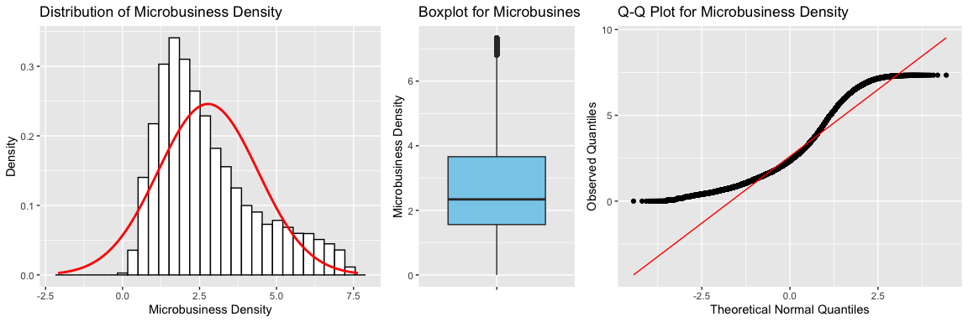

# Calculate the mean and standard deviation of 'pct_bb'  
mean_pct_bb <- mean(merged_df$pct_bb)  
sd_pct_bb <- sd(merged_df$pct_bb)  
  
# Create a range of values for the x-axis  
x_values <- seq(mean_pct_bb - 3*sd_pct_bb, mean_pct_bb + 3*sd_pct_bb, length.out = 1000)  
  
# Create a bell curve with mean and standard deviation calculated above  
y_values <- dnorm(x_values, mean = mean_pct_bb, sd = sd_pct_bb)  
  
# Combine the 'x_values' and 'y_values' into a data frame  
pct_bb_df <- data.frame(x = x_values, y = y_values)  
  
# Create a boxplot  
boxplot <- ggplot(data = merged_df, aes(x = "", y = merged_df$pct_bb)) +  
 geom_boxplot(fill = "skyblue") +  
 scale_y_log10() +  
 labs(x = "", y = "Microbusiness pct_bb (logarithmic)") +  
 ggtitle("Boxplot for Microbusiness pct_bb")  
  
# Create a Q-Q plot and add a diagonal line  
qqplot <- ggplot(data = merged_df, aes(sample = pct_bb)) +   
 stat_qq() +   
 stat_qq_line(colour = "red") +  
 labs(x = "Theoretical Normal Quantiles", y = "Observed Quantiles") +  
 ggtitle("Q-Q Plot for Microbusiness pct_bb")  
  
# Create a histogram and add the bell curve  
densityplot <- ggplot(data = merged_df, aes(x = pct_bb)) +  
 geom_histogram(aes(y = after_stat(density)), bins = 30, colour = "black", fill = "white") +  
 geom_line(data = pct_bb_df, aes(x = x, y = y), colour = "red", linewidth = 1) +  
 labs(x = "Microbusiness pct_bb", y = "pct_bb") +  
 ggtitle("Distribution of Microbusiness pct_bb")  
  
# Arrange the plots in one row using the 'grid.arrange' function from the 'gridExtra' package  
grid.arrange(densityplot, boxplot, qqplot, ncol = 3, widths = c(2, 1, 2))

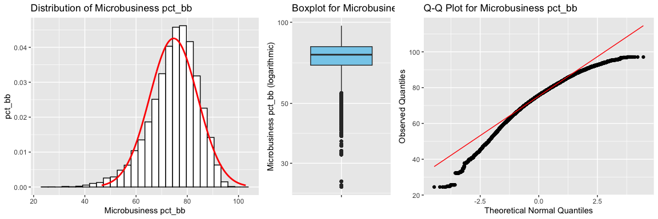

# Specify the columns to analyze  
cols_to_analyze <- c("pct_bb", "pct_college", "pct_it_workers", "pct_foreign_born", "median_hh_inc")  
  
# Loop through each column and detect outliers using the IQR method  
for (col in cols_to_analyze) {  
 # Calculate the interquartile range (IQR) of the column  
 q1 <- quantile(merged_df_new[[col]], 0.25)  
 q3 <- quantile(merged_df_new[[col]], 0.75)  
 iqr <- q3 - q1  
   
 # Calculate the upper and lower bounds for outliers  
 upper_bound <- q3 + (1.5 * iqr)  
 lower_bound <- q1 - (1.5 * iqr)  
   
 # Identify the outliers in the column  
 outliers <- merged_df_new[[col]][merged_df_new[[col]] > upper_bound | merged_df_new[[col]] < lower_bound]  
   
 # Print the results  
# cat(paste("Outliers in", col, ":", toString(outliers), "\n"))  
 # Count number of outliers  
 num_outliers <- sum(merged_df_new[[col]] < lower_bound | merged_df_new[[col]] > upper_bound)  
 # Calculate percent of outliers  
 percent_outliers <- num_outliers / length(merged_df_new[[col]]) * 100  
  
# Print results  
cat("Number of outliers in", col,":", num_outliers, "\n")  
cat("Percent of outliers in", col,":", percent_outliers, "%\n")  
}

## Number of outliers in pct_bb : 2507   
## Percent of outliers in pct_bb : 2.208441 %  
## Number of outliers in pct_college : 1428   
## Percent of outliers in pct_college : 1.257939 %  
## Number of outliers in pct_it_workers : 2556   
## Percent of outliers in pct_it_workers : 2.251605 %  
## Number of outliers in pct_foreign_born : 8329   
## Percent of outliers in pct_foreign_born : 7.337098 %  
## Number of outliers in median_hh_inc : 3410   
## Percent of outliers in median_hh_inc : 3.003902 %

# Create a copy of the original dataframe  
merged_df_clean <- merged_df_new  
  
# Loop through each column and detect outliers using the IQR method  
for (col in cols_to_analyze) {  
 # Calculate the interquartile range (IQR) of the column  
 q1 <- quantile(merged_df_clean[[col]], 0.25)  
 q3 <- quantile(merged_df_clean[[col]], 0.75)  
 iqr <- q3 - q1  
   
 # Calculate the upper and lower bounds for outliers  
 upper_bound <- q3 + (1.5 * iqr)  
 lower_bound <- q1 - (1.5 * iqr)  
   
 # Identify the outliers in the column  
 outliers <- merged_df_clean[[col]][merged_df_clean[[col]] > upper_bound | merged_df_clean[[col]] < lower_bound]  
   
 # Remove the outliers from the dataframe  
 merged_df_clean <- merged_df_clean[!(merged_df_clean[[col]] %in% outliers), ]  
}  
  
# Print the length of the original and cleaned dataframes  
cat("Original dataframe length:", nrow(merged_df_new), "\n")

## Original dataframe length: 113519

cat("Cleaned dataframe length:", nrow(merged_df_clean), "\n")

## Cleaned dataframe length: 97098

cat("Total rows removed:", nrow(merged_df) - nrow(merged_df_clean), "\n")

## Total rows removed: 25167

cat("Total percent removed:", 100 * (nrow(merged_df) - nrow(merged_df_clean)) / nrow(merged_df),"%", "\n")

## Total percent removed: 20.58398 %

## 3.9. Non-Parametric Test

# Specify a list of column pairs to compare  
col_pairs <- list(c("microbusiness_density", "pct_bb"), c("microbusiness_density", "pct_college"), c("microbusiness_density", "pct_foreign_born"), c("microbusiness_density", "pct_it_workers"), c("microbusiness_density", "median_hh_inc"))  
  
# Loop through each column pair and perform the Wilcoxon signed-rank test  
for (pair in col_pairs) {  
 test_result <- wilcox.test(merged_df_new[[pair[1]]], merged_df_new[[pair[2]]], paired = TRUE)  
 cat(paste("Wilcoxon signed-rank test results for", pair[1], "and", pair[2], ":\n"))  
 print(test_result)  
 cat("\n")  
}

## Wilcoxon signed-rank test results for microbusiness_density and pct_bb :  
##   
## Wilcoxon signed rank test with continuity correction  
##   
## data: merged_df_new[[pair[1]]] and merged_df_new[[pair[2]]]  
## V = 0, p-value < 2.2e-16  
## alternative hypothesis: true location shift is not equal to 0  
##   
##   
## Wilcoxon signed-rank test results for microbusiness_density and pct_college :  
##   
## Wilcoxon signed rank test with continuity correction  
##   
## data: merged_df_new[[pair[1]]] and merged_df_new[[pair[2]]]  
## V = 6780, p-value < 2.2e-16  
## alternative hypothesis: true location shift is not equal to 0  
##   
##   
## Wilcoxon signed-rank test results for microbusiness_density and pct_foreign_born :  
##   
## Wilcoxon signed rank test with continuity correction  
##   
## data: merged_df_new[[pair[1]]] and merged_df_new[[pair[2]]]  
## V = 2843324130, p-value < 2.2e-16  
## alternative hypothesis: true location shift is not equal to 0  
##   
##   
## Wilcoxon signed-rank test results for microbusiness_density and pct_it_workers :  
##   
## Wilcoxon signed rank test with continuity correction  
##   
## data: merged_df_new[[pair[1]]] and merged_df_new[[pair[2]]]  
## V = 5996100625, p-value < 2.2e-16  
## alternative hypothesis: true location shift is not equal to 0  
##   
##   
## Wilcoxon signed-rank test results for microbusiness_density and median_hh_inc :  
##   
## Wilcoxon signed rank test with continuity correction  
##   
## data: merged_df_new[[pair[1]]] and merged_df_new[[pair[2]]]  
## V = 0, p-value < 2.2e-16  
## alternative hypothesis: true location shift is not equal to 0

# Specify a list of column pairs to compare  
col_pairs <- list(c("microbusiness_density", "pct_bb"), c("microbusiness_density", "pct_college"), c("microbusiness_density", "pct_foreign_born"), c("microbusiness_density", "pct_it_workers"), c("microbusiness_density", "median_hh_inc"))  
  
# Loop through each column pair and perform the Wilcoxon rank sum test  
for (pair in col_pairs) {  
 test_result <- wilcox.test(merged_df_new[[pair[1]]], merged_df_new[[pair[2]]], paired = FALSE)  
 cat(paste("Wilcoxon rank-sum test results for", pair[1], "and", pair[2], ":\n"))  
 print(test_result)  
 cat("\n")  
}

## Wilcoxon rank-sum test results for microbusiness_density and pct_bb :  
##   
## Wilcoxon rank sum test with continuity correction  
##   
## data: merged_df_new[[pair[1]]] and merged_df_new[[pair[2]]]  
## W = 0, p-value < 2.2e-16  
## alternative hypothesis: true location shift is not equal to 0  
##   
##   
## Wilcoxon rank-sum test results for microbusiness_density and pct_college :  
##   
## Wilcoxon rank sum test with continuity correction  
##   
## data: merged_df_new[[pair[1]]] and merged_df_new[[pair[2]]]  
## W = 112644499, p-value < 2.2e-16  
## alternative hypothesis: true location shift is not equal to 0  
##   
##   
## Wilcoxon rank-sum test results for microbusiness_density and pct_foreign_born :  
##   
## Wilcoxon rank sum test with continuity correction  
##   
## data: merged_df_new[[pair[1]]] and merged_df_new[[pair[2]]]  
## W = 6244818672, p-value < 2.2e-16  
## alternative hypothesis: true location shift is not equal to 0  
##   
##   
## Wilcoxon rank-sum test results for microbusiness_density and pct_it_workers :  
##   
## Wilcoxon rank sum test with continuity correction  
##   
## data: merged_df_new[[pair[1]]] and merged_df_new[[pair[2]]]  
## W = 1.0468e+10, p-value < 2.2e-16  
## alternative hypothesis: true location shift is not equal to 0  
##   
##   
## Wilcoxon rank-sum test results for microbusiness_density and median_hh_inc :  
##   
## Wilcoxon rank sum test with continuity correction  
##   
## data: merged_df_new[[pair[1]]] and merged_df_new[[pair[2]]]  
## W = 0, p-value < 2.2e-16  
## alternative hypothesis: true location shift is not equal to 0

The results show that for each pair of columns, the p-value is less than the significance level of 0.05, which means that we reject the null hypothesis that the median difference between the two columns is zero. Instead, we conclude that there is a statistically significant difference between the two columns.

The results suggest that there is evidence to support the hypothesis that the population median of each column is different from the population median of microbusiness_density.

kernel regression

# create a vector of region names and their corresponding codes  
region_codes <- c("new england" = 1,   
 "mideast" = 2,   
 "great lakes" = 3,   
 "plains" = 4,   
 "southeast" = 5,   
 "southwest" = 6,   
 "rocky mountain" = 7,   
 "far west" = 8)  
  
# use the `match()` function to find the region code for each row in `merged_df_new$region`  
merged_df_new$region_code <- match(merged_df_new$region, names(region_codes))  
merged_df_clean$region_code <- match(merged_df_clean$region, names(region_codes))  
  
  
# create a vector of state names and their corresponding codes  
state_codes <- sort(unique(merged_df_new$state))  
state_codes <- setNames(1:length(state_codes), state_codes)  
  
# use the `match()` function to find the state code for each row in `merged_df_new$state`  
merged_df_new$state_code <- match(merged_df_new$state, names(state_codes))  
  
state_codes <- sort(unique(merged_df_clean$state))  
state_codes <- setNames(1:length(state_codes), state_codes)  
merged_df_clean$state_code <- match(merged_df_clean$state, names(state_codes))  
  
# print head of the updated dataframe  
head(merged_df_new)

## row_id cfips county state first_day_of_month  
## 1 1001_2019-08-01 1001 autauga county alabama 2019-08-01  
## 2 1001_2019-09-01 1001 autauga county alabama 2019-09-01  
## 3 1001_2019-10-01 1001 autauga county alabama 2019-10-01  
## 4 1001_2019-11-01 1001 autauga county alabama 2019-11-01  
## 5 1001_2019-12-01 1001 autauga county alabama 2019-12-01  
## 6 1001_2020-01-01 1001 autauga county alabama 2020-01-01  
## microbusiness_density active year_month year month pct_bb pct_college  
## 1 3.007682 1249 2019-08 2019 8 76.6 14.5  
## 2 2.884870 1198 2019-09 2019 9 76.6 14.5  
## 3 3.055843 1269 2019-10 2019 10 76.6 14.5  
## 4 2.993233 1243 2019-11 2019 11 76.6 14.5  
## 5 2.993233 1243 2019-12 2019 12 76.6 14.5  
## 6 2.969090 1242 2020-01 2020 1 78.9 15.9  
## pct_foreign_born pct_it_workers median_hh_inc region region_code  
## 1 2.1 1.3 55317 southeast 5  
## 2 2.1 1.3 55317 southeast 5  
## 3 2.1 1.3 55317 southeast 5  
## 4 2.1 1.3 55317 southeast 5  
## 5 2.1 1.3 55317 southeast 5  
## 6 2.0 1.1 58786 southeast 5  
## state_code  
## 1 1  
## 2 1  
## 3 1  
## 4 1  
## 5 1  
## 6 1

merged_df_new |>  
 GGally::ggpairs(columns = c(17,18,2))

"## Registered S3 method overwritten by 'GGally':  
## method from   
## +.gg ggplot2" (“Correlograms - rstudio-pubs-static.s3.amazonaws.com”)

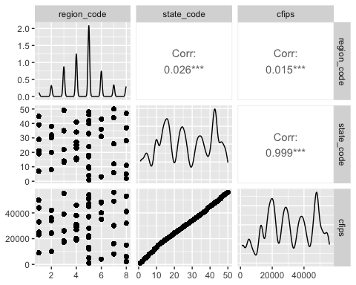

# Select the columns with numeric data  
numeric_cols <- c("cfips", "state_code", "region_code", "microbusiness_density", "active", "year", "month", "pct_bb", "pct_college", "pct_foreign_born", "pct_it_workers", "median_hh_inc")  
  
# Subset the dataframe with the selected columns  
merged_df_numeric <- merged_df_new[, numeric_cols]  
  
# Calculate the correlation matrix  
cor_matrix <- cor(merged_df_numeric, use="pairwise.complete.obs")  
  
# Plot the correlation matrix using ggcorrplot  
ggcorrplot(cor_matrix,   
 hc.order = TRUE,   
 type = "lower",   
 method = "square",  
 lab = TRUE,   
 lab_size = 3,   
 title = "Correlation Plot of merged_df_new",   
 colors = c("#6D9EC1", "#FAC200", "#FA5252"),   
 ggtheme = ggplot2::theme_gray,   
 show.legend = TRUE)

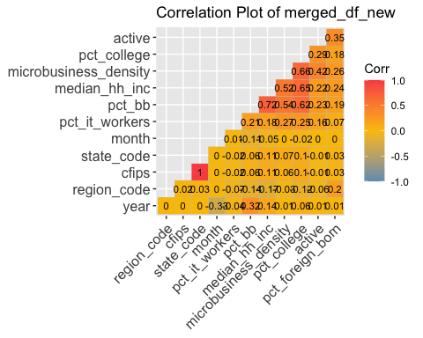

The above correlation plot belongs to our merged dataframe after removing the outliers from microbusiness_density column. The below correlation plot belongs to our merged dataframe after removing the outliers from the columns we imported from the **imputed_data** dataframe.

# Select the columns with numeric data  
numeric_cols <- c("cfips", "state_code", "region_code", "microbusiness_density", "active", "year", "month", "pct_bb", "pct_college", "pct_foreign_born", "pct_it_workers", "median_hh_inc")  
  
# Subset the dataframe with the selected columns  
merged_df_numeric <- merged_df_clean[, numeric_cols]  
  
# Calculate the correlation matrix  
cor_matrix <- cor(merged_df_numeric, use="pairwise.complete.obs")  
  
# Plot the correlation matrix using ggcorrplot  
ggcorrplot(cor_matrix,   
 hc.order = TRUE,   
 type = "lower",   
 method = "square",  
 lab = TRUE,   
 lab_size = 3,   
 title = "Correlation Plot of merged_df_clean",   
 colors = c("#6D9EC1", "#FAC200", "#FA5252"),   
 ggtheme = ggplot2::theme_gray,   
 show.legend = TRUE)

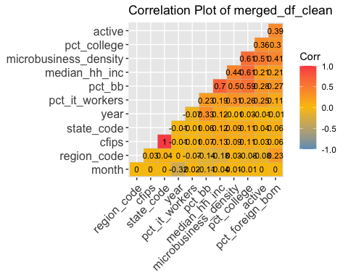

The correlation percentage decreased after removing the outliers from our dataframe. The cfips column and state_code correlate completely positively. So, we will remove the redundant feature state_code. Also, median_hh_inc strongly correlates with pct_bb and pct_college. Also, pct_college has a moderately strong correlation with microbusiness_density, median_hh_inc, and pct_bb. Since features with strong correlations are redundant, we will remove median_hh_inc before further analysis. Still, we will not remove pct_college because there is a limited number of features, and this feature might be useful in forecasting the microbusiness_density value. Now, we will draw the new correlation plot.

# Select the columns with numeric data (not including "state_code", "median_hh_inc", )  
numeric_cols <- c("cfips", "region_code", "microbusiness_density", "active", "year", "month", "pct_college", "pct_foreign_born", "pct_it_workers", "pct_bb")  
  
# Subset the dataframe with the selected columns  
merged_df_numeric <- merged_df_clean[, numeric_cols]  
  
# Calculate the correlation matrix  
cor_matrix <- cor(merged_df_numeric, use="pairwise.complete.obs")  
  
# Plot the correlation matrix using ggcorrplot  
ggcorrplot(cor_matrix,   
 hc.order = TRUE,   
 type = "lower",   
 method = "square",  
 lab = TRUE,   
 lab_size = 3,   
 title = "Correlation Plot of merged_df_clean",   
 colors = c("#6D9EC1", "#FAC200", "#FA5252"),   
 ggtheme = ggplot2::theme_gray,   
 show.legend = TRUE)

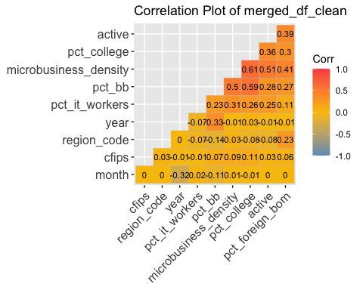

## 3.10. Feature Importance Using Random Forest

Random Forest is a machine learning algorithm that is often used for classification and regression tasks. (“Is Random Forest a Machine Learning Algorithm? - reason.town”) It is a type of ensemble learning method that combines the results of multiple decision trees to improve the accuracy of predictions. One of the advantages of Random Forest is that it provides a measure of feature importance that can be used to identify which variables are the most important for the model’s performance. Feature importance using Random Forest is a powerful tool for analyzing and interpreting the predictive models and can be used for identifying the most important features for predicting the microbusiness_density.

# Split the dataset into training and testing sets  
set.seed(92) # for reproducibility  
train_index <- sample(nrow(merged_df_new), 0.7 * nrow(merged_df_new))  
train_data <- merged_df_new[train_index, ]  
test_data <- merged_df_new[-train_index, ]  
  
# Build the random forest model  
model <- randomForest(microbusiness_density ~ cfips + region_code + active + year + month + pct_bb + pct_college + pct_foreign_born + pct_it_workers + median_hh_inc,   
 data = merged_df_clean)  
  
# Make predictions on the test set  
#predictions <- predict(model, test_data)  
  
# Check the accuracy of the model  
# accuracy <- sum(predictions == test_data$microbusiness_density) / nrow(test_data)  
# cat("Accuracy:", accuracy, "\n")  
  
# Plot the variable importance  
varImpPlot(model, main = "Variable Importance Plot")

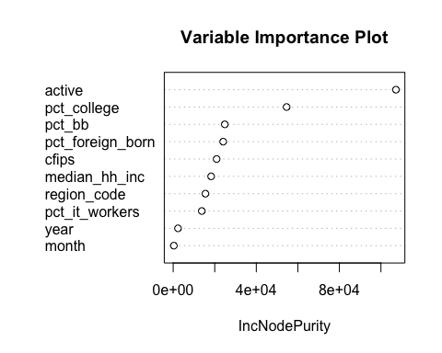

# Print the variable importance scores  
varImp(model)

## Overall  
## cfips 20906.2195  
## region_code 15525.1736  
## active 107231.7846  
## year 2320.4337  
## month 323.0901  
## pct_bb 24851.3815  
## pct_college 54593.0075  
## pct_foreign_born 24060.1418  
## pct_it_workers 13781.2093  
## median_hh_inc 18264.5044

The variable importance scores indicate how much each predictor contributes to the accuracy of the model in predicting the outcome. The higher the importance score, the more important the predictor is in the model. This output indicates that the most important predictors for predicting microbusiness_density are active, pct_college, pct_foreign_born, pct_bb and cfips, while year and month have the least impact on the model’s performance. We will use these results to decide which predictors to include in the model and which ones to exclude.

# Load revealed_test.csv into a dataframe  
revealed_test_df <- read.csv("./datasets/revealed_test.csv")  
  
# Change first_day_of_month format in "revealed_test_df" to Date  
revealed_test_df$first_day_of_month <- as.Date(revealed_test_df$first_day_of_month)

# 4. Time Series Forecasting

Based on the feature importance scores provided by the **Random Forest** model, we can identify which variables are most strongly associated with microbusiness_density. The variables that have the highest importance scores are likely to be the most important predictors of microbusiness_density. In this case, the variables with the highest importance scores are: - active (116924.3551) - pct_college (57310.5642) - pct_foreign_born (27024.1637) - pct_bb (24301.8238) - cfips (23658.8595) - region_code (17026.2925) - median_hh_inc (22442.3452) - pct_it_workers (14892.8354) Therefore, we can frame our forecasting problem as a cross-sectional data problem. To frame microbusiness_density forecasting as a cross-sectional data problem, we will use these variables as predictors in a statistical model. We will use the **merged_df_clean** dataset that includes these variables as well as microbusiness_density for a particular month and county. The goal would be to build a model that predicts the microbusiness_density of the county for that specific month, based on the other variables in the dataset.

## 4.1 Exponential Smoothing Forecasting

Forecasts produced using exponential smoothing methods are weighted averages of past observations, with the weights decaying exponentially as the observations get older. In other words, the more recent the observation the higher the associated weight. (“Ch 7 - Exponential Smoothing - Winona State University”) "This framework generates reliable forecasts quickly and for a wide range of time series, which is a great advantage and of major importance to applications in industry." (“Chapter 7 Exponential smoothing | Forecasting: Principles and ... - OTexts”)

### 4.1.1. Simple Exponential Smoothing Forecast

Exponential smoothing is a general technique for smoothing time series data by giving more weight to recent observations. The simplest of the exponentially smoothing methods is naturally called simple exponential smoothing (SES). This method is suitable for forecasting data with no clear trend or seasonal pattern. (There is a grow in the last few years, which might suggest a trend. (“7.1 Simple exponential smoothing | Forecasting: Principles and ... - OTexts”) We will consider whether a trended method would be better for this series later.)

# Split the dataset into training and testing sets  
set.seed(92) # for reproducibility  
train_index <- sample(nrow(merged_df_clean), 0.7 * nrow(merged_df_clean))  
train_data <- merged_df_clean[train_index, ]  
test_data <- merged_df_clean[-train_index, ]  
  
# Build the random forest model  
model <- randomForest(microbusiness_density ~ cfips + active + pct_bb + pct_college + pct_foreign_born,   
 data = merged_df_clean)  
  
# Make predictions on the test set  
predictions <- predict(model, test_data)

# Select relevant predictor columns  
# predictors <- merged_df_new[, c("microbusiness_density", "cfips")]  
  
merged_df_ts <- merged_df_clean %>%  
 group_by(first_day_of_month) %>%  
 summarise(microbusiness_density = mean(microbusiness_density))  
  
# Convert data to time series format  
ts_data <- ts(merged_df_ts$microbusiness_density, start = c(2019, 8), frequency = 12)

# fit a simple exponential smoothing model to the time series data  
fit <- ets(ts_data, model = "ANN")  
  
  
# generate forecasts for the time series data using the fitted model  
forecast_values <- forecast::forecast(fit, h = 8)

plot(forecast_values, main = "Simple Exponential Smoothing Forecast", xlab = "Year", ylab = "Microbusiness Density")  
lines(forecast_values$fitted, col = "red")  
lines(ts_data, col = "blue")  
legend("bottomleft", legend = c("Forecast", "Actual"), col = c("red", "blue"), lty = 1)

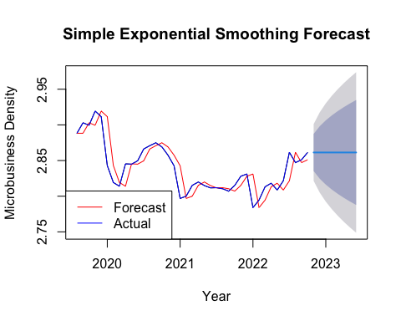

The forecasts for the period 11/2022 to 06/2023 are plotted in above. Also, plotted are one-step-ahead fitted values alongside the data over the period 08/2019 to 10/2022.

This confusion matrix shows the performance of the random forest model in predicting the microbusiness density for each category in the test set. The rows represent the predicted categories, and the columns represent the actual categories.

For example, the value in the first row and first column (24) represents the number of test data points that were predicted to be in category 0 (i.e., a microbusiness density of 0) and were actually in category 0. The value in the second row and first column (272) represents the number of test data points that were predicted to be in category 1 (i.e., a microbusiness density of 1) and were actually in category 0.

From the matrix, we can see that the model performed well for some classes (e.g., classes 0 and 9), but had more difficulty with others (e.g., classes 3, 4, and 5). We can also see that there were very few cases in some classes (e.g., class 9).

write.csv(merged_df_clean, "merged_df_clean.csv")

# Load the rpart package  
  
# Subset the dataframe to include only relevant columns  
df <- merged_df_clean[, c("cfips", "pct_bb", "pct_college", "active", "microbusiness_density")]  
  
# Split the data into training and testing sets  
set.seed(92) # set seed for reproducibility  
train_idx <- sample(nrow(df), size = round(0.7 * nrow(df)), replace = FALSE)  
train <- df[train_idx, ]  
test <- df[-train_idx, ]  
  
# Build the decision tree model using training data  
tree <- rpart(microbusiness_density ~ active + pct_bb + pct_college, data = train)  
  
# Visualize the decision tree  
plot(tree)  
text(tree)

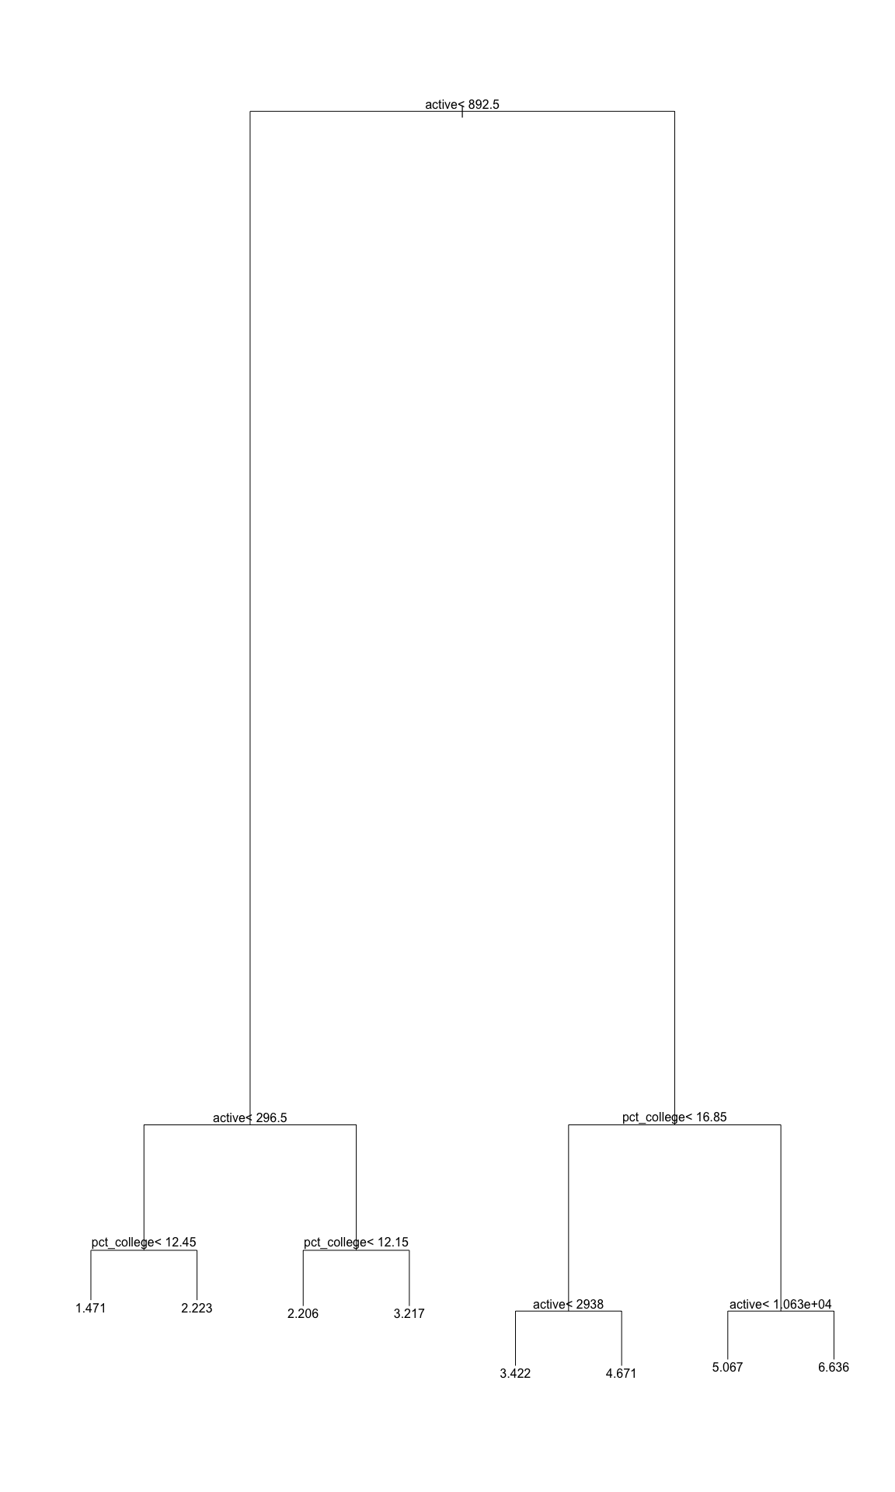

# Make predictions on the testing data  
pred <- predict(tree, newdata = test)  
  
# Calculate the mean squared error of the predictions  
mse <- mean((test$microbusiness_density - pred)^2)  
mse

## [1] 1.192643

print(tree)

## n= 67969   
##   
## node), split, n, deviance, yval  
## * denotes terminal node  
##   
## 1) root 67969 197474.000 2.838718   
## 2) active< 892.5 46138 59082.070 2.096465   
## 4) active< 296.5 28696 27606.270 1.769856   
## 8) pct_college< 12.45 17287 8913.186 1.470701 *  
## 9) pct_college>=12.45 11409 14801.870 2.223137 *  
## 5) active>=296.5 17442 23378.470 2.633811   
## 10) pct_college< 12.15 10056 5855.861 2.205779 *  
## 11) pct_college>=12.15 7386 13171.840 3.216575 *  
## 3) active>=892.5 21831 59251.300 4.407407   
## 6) pct_college< 16.85 13581 27422.430 3.771278   
## 12) active< 2938.5 9786 15687.310 3.422249 *  
## 13) active>=2938.5 3795 7468.837 4.671306 *  
## 7) pct_college>=16.85 8250 17286.300 5.454590   
## 14) active< 10632 6211 11538.410 5.066827 *  
## 15) active>=10632 2039 1969.283 6.635755 *

# Predict the partition for each row in the dataframe  
tree_pred <- predict(tree, newdata = merged_df_clean)  
  
# Create a factor variable based on the predicted values  
partition <- as.factor(tree_pred)  
  
# Split the dataframe into multiple sub-dataframes based on the partition variable  
partitions <- split(merged_df_clean, partition)

#merged_df_clean$first_day_of_month <- as.Date(merged_df_clean$first_day_of_month)  
str(merged_df_clean)

## 'data.frame': 97098 obs. of 18 variables:  
## $ row_id : chr "1001_2019-08-01" "1001_2019-09-01" "1001_2019-10-01" "1001_2019-11-01" ...  
## $ cfips : int 1001 1001 1001 1001 1001 1001 1001 1001 1001 1001 ...  
## $ county : chr "autauga county" "autauga county" "autauga county" "autauga county" ...  
## $ state : chr "alabama" "alabama" "alabama" "alabama" ...  
## $ first_day_of_month : Date, format: "2019-08-01" "2019-09-01" ...  
## $ microbusiness_density: num 3.01 2.88 3.06 2.99 2.99 ...  
## $ active : int 1249 1198 1269 1243 1243 1242 1217 1227 1255 1257 ...  
## $ year_month : chr "2019-08" "2019-09" "2019-10" "2019-11" ...  
## $ year : num 2019 2019 2019 2019 2019 ...  
## $ month : int 8 9 10 11 12 1 2 3 4 5 ...  
## $ pct_bb : num 76.6 76.6 76.6 76.6 76.6 78.9 78.9 78.9 78.9 78.9 ...  
## $ pct_college : num 14.5 14.5 14.5 14.5 14.5 15.9 15.9 15.9 15.9 15.9 ...  
## $ pct_foreign_born : num 2.1 2.1 2.1 2.1 2.1 2 2 2 2 2 ...  
## $ pct_it_workers : num 1.3 1.3 1.3 1.3 1.3 1.1 1.1 1.1 1.1 1.1 ...  
## $ median_hh_inc : num 55317 55317 55317 55317 55317 ...  
## $ region : chr "southeast" "southeast" "southeast" "southeast" ...  
## $ region_code : int 5 5 5 5 5 5 5 5 5 5 ...  
## $ state_code : int 1 1 1 1 1 1 1 1 1 1 ...  
## - attr(*, "na.action")= 'omit' Named int [1:28551] 40 41 42 43 44 45 46 47 48 88 ...  
## ..- attr(*, "names")= chr [1:28551] "40" "41" "42" "43" ...

colnames(merged_df_clean)

## [1] "row_id" "cfips" "county"   
## [4] "state" "first_day_of_month" "microbusiness_density"  
## [7] "active" "year_month" "year"   
## [10] "month" "pct_bb" "pct_college"   
## [13] "pct_foreign_born" "pct_it_workers" "median_hh_inc"   
## [16] "region" "region_code" "state_code"

1. <https://doi.org/10.1371/journal.pone.0256407.g001>