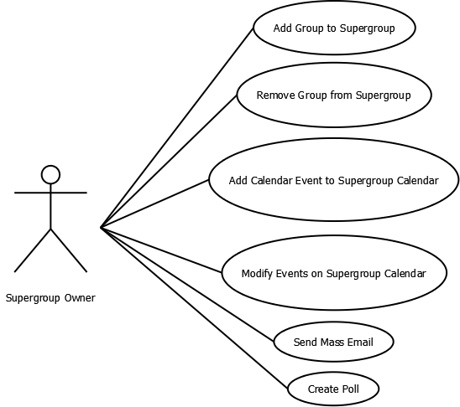

|  |
| --- |
| **Add Group to Supergroup**  Actor: Supergroup Owner.  Goal: Add a group to a Supergroup.  Precondition: User is an owner of an already existing Supergroup.  Summary: Owner clicks Add Group to Supergroup, and finds a group to add.  Steps:   1. Choose “Add Group to Supergroup” from menu bar. 2. Search through a group listing for the group to add. 3. Click Add.   Alternative: Owner clicks cancel in Step 2. |

|  |
| --- |
| **Remove Group from Supergroup**  Actor: Supergroup Owner.  Goal: Remove a group from a Supergroup.  Precondition: User is an owner of an already existing Supergroup, and the group to be removed is within  the Supergroup.  Summary: Owner clicks Remove Group from Supergroup, and finds a group to remove.  Steps:   1. Choose “Remove Group from Supergroup” from menu bar. 2. Search through a list of groups in the Supergroup and find the one to remove. 3. Click Remove.   Alternative: Owner clicks cancel in Step 2. |

|  |
| --- |
| **Add Calendar Event to Supergroup Calendar**  Actor: Supergroup Owner.  Goal: Add a Calendar Event to the Supergroup Calendar.  Precondition: User is an owner of an already existing Supergroup.  Summary: Owner clicks Add Calendar Event, fills in the information for the event, and clicks Ok.  Steps:   1. Choose “Add Calendar Event” in the menu bar. 2. Fill in Event Name, Date, Time, Location, and Description. 3. Click Ok.   Alternative: Owner clicks cancel in Step 2. |

|  |
| --- |
| **Modify Event on Supergroup Calendar**  Actor: Supergroup Owner.  Goal: Modify a Calendar Event on the Supergroup Calendar.  Precondition: User is an owner of an already existing Supergroup and the event already exists on the  Calendar.  Summary: Owner clicks Modify Calendar Event, edits the information for the event, and clicks Ok.  Steps:   1. Choose “Modify Calendar Event” in the menu bar. 2. Modify the Event’s information as needed. 3. Click Ok.   Alternative: Owner clicks cancel in Step 2. |

|  |
| --- |
| **Create Poll**  Actor: Supergroup Owner.  Goal: Create a Poll for the Supergroup’s Members to vote in.  Precondition: User is an owner of an already existing Supergroup.  Summary: Owner clicks Create Poll, fills in the Poll Description, fills in the Poll options, chooses who can  vote in the Poll and clicks Ok.  Steps:   1. Choose “Create Poll” in the menu bar. 2. Fill in Poll Name & Description. 3. Create choices to vote on in the Poll. 4. Choose who can vote in the poll (i.e. All Members, Group Owners, Both) 5. Click Ok.   Alternative: Owner clicks cancel in Step 2, 3, or 4. |

|  |
| --- |
| **Send Mass Email**  Actor: Supergroup Owner.  Goal: Send an Email to all Group Owners, Users, or Specific People within the Supergroup.  Precondition: User is an owner of an already existing Supergroup.  Summary: Owner clicks Send Email, writes email to send, chooses who to send it to and clicks Send.  Steps:   1. Choose “Send Email” in the menu bar. 2. Write the Email to be sent. 3. Choose who to send the Email to (i.e. All Members, All Group Owners, Both, or Specific Members) 4. Click Send.   Alternative: Owner clicks cancel in Step 2 or 3. |