Michael Solwold

Mason Spoelhof

Group 3

This is the main page of the website. Each group panel has a drop-down box that contains a description of the event type.

Each tab has a request to join button as well as information about the group. If you made a post, there will be an “Edit” button to change the details of the post.

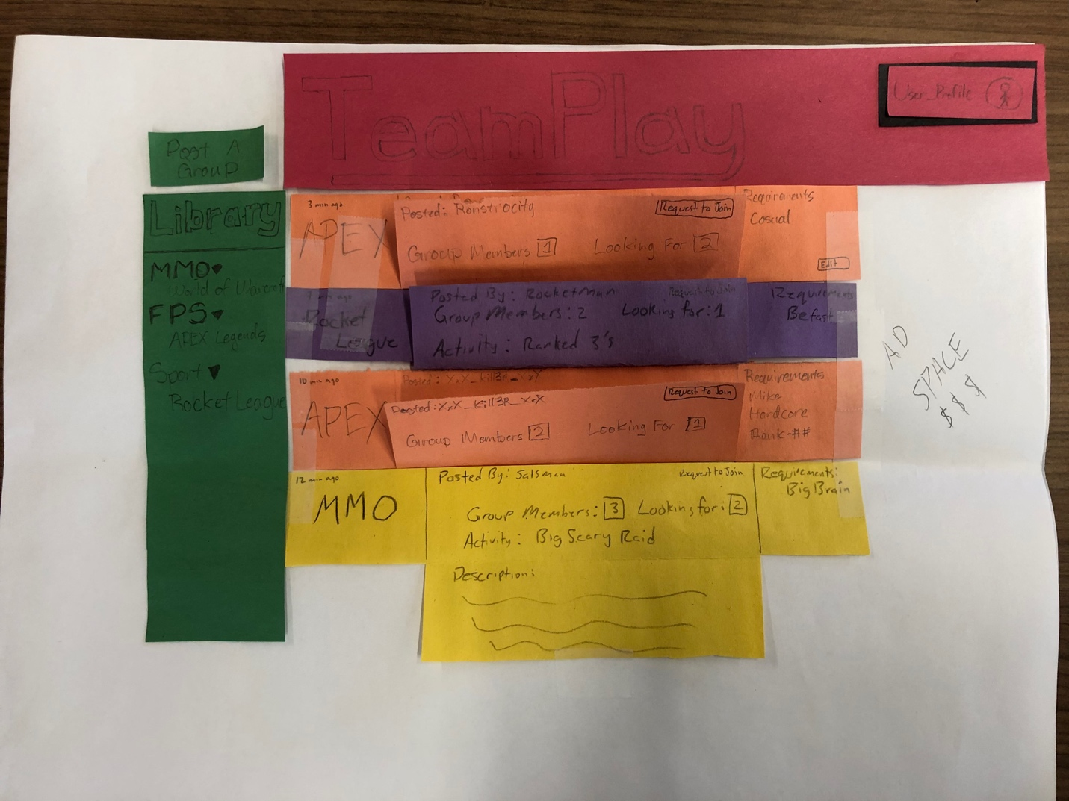

When you press the post a group button, this dialog box will pop up. It allows you to enter various pieces of information including a description that will be included in the drop-down box and requirements for joining such as skill level, microphone, level, etc.

Not included in picture: the submit button on the popup panel for creating a group.

**Briefing:**

Our product is a website designed to help PC gamers find groups for a game which does not rely on in game matchmaking in order to help make a more impactful gaming experience. This allows the gamer to establish friendships from this service creating lasting groups for playing various games.

**Scenario Tasks**

1. Sort groups based on what they are searching for
   1. “For this task I would like you to sort the listings/posts to a game or games you’d like to play. How would you do that based on what you see presented?”
2. Select and join a group
   1. “Now that you’ve sorted the posts based on your interests, how would you join a group/game? Please think out loud as you interact with the product.”
3. Create a Looking for Players post
   1. Now that you have looked at posts, I would like you to create a post.
   2. “Good, now as you fill out the form please feel free to think aloud and ask questions.”