Required tools
- Cassandra
- Data stax
Steps
- Run Cassandra – find script in bin directory
- Open data stax

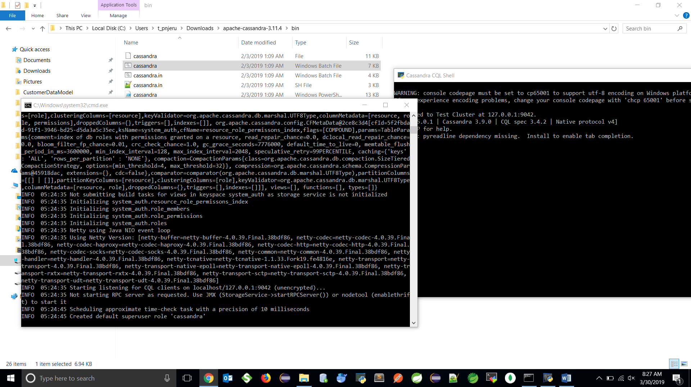

Datastax

