MAASAI MARA UNIVERSITY CHRISTIAN UNION ONLINE MANAGEMENT SYSTEM

ACKNOWLEDGEMENT
I would like to acknowledge Joram Murithi for coming up with the whole idea, Joyce Njoki for previewing and proofreading the system and documentations, and for her ideas and support in prayers. I also acknowledge Migwi Nd’ungu for proofreading and coding parts of the interface, John Murithi for his ideas and prayers, Betty Kanana for Testing and preparing various documents, my Dad for financial support and most important The Almighty God for He was the driver all through.

Table of Contents
MAASAI MARA UNIVERSITY CHRISTIAN UNION ONLINE MANAGEMENT SYSTEM 1
ACKNOWLEDGEMENT 1
FULLY FUNCTIONAL PARTS 3
PROPOSED FUNCTIONALITY 3
TECHNOLOGIES USED 3
THE APPLICATION 4
STUDENT PORTAL 4
ADMIN PORTAL 7
REFERENCES 18

FULLY FUNCTIONAL PARTS
- Student portal
- Admin portal

PROPOSED FUNCTIONALITY
- Leaders portal

TECHNOLOGIES USED
- Language: JavaEE( Java Enterprise Edition) , Here MVC model has been used.
MVC model at a glance
The MVC model (Model Controller View) is a famous model in Object oriented programming. It separate the concerns as illustrated below.
The View
This is the part that users interacts with, in our case it’s made of Java server Pages (Jsp).For example, say a fill-in form.
The Controller
This sits in between the view and the Model, data in validated here before submission into the database, the part resides in the server side. It’s made of servlets containers which are deployed using either deployment descriptor or annotations.
The Model
This part interacts with the database directly, it’s made up of Data Access Objects (DAOs) in conjunction with some Plane Old Java Objects (POJOs).

- Database and server
This application uses Postgres database and Wildfly (JBOSS) Server. For deployment apache ant is used
- Caching and Scheduling
Frequently used data is cached in a memory, and tasks that are curried out oftenly are scheduled

THE APPLICATION

STUDENT PORTAL
It has two parts
- Student registration part
- Student activation part
Student Registration
Below is the Screenshot of the Registration form
Photo1:
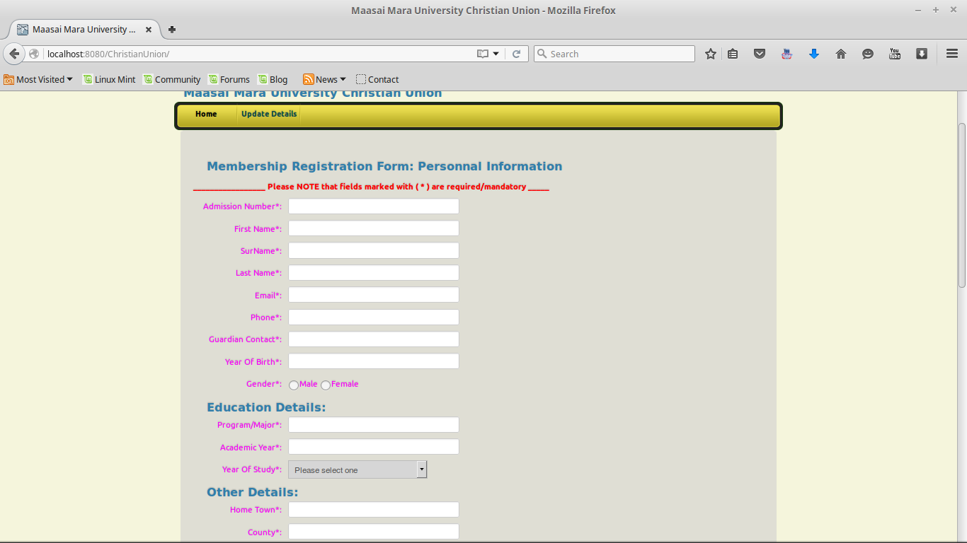

Photo2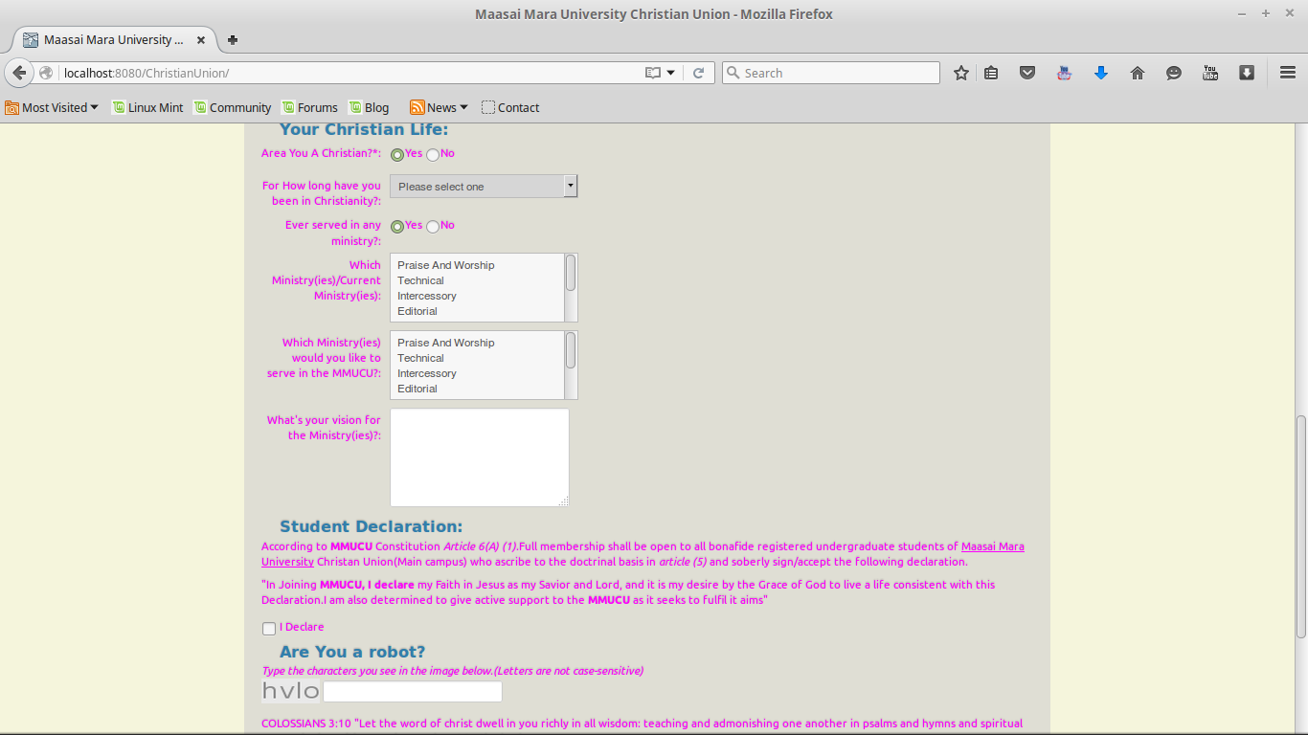
Photo 3: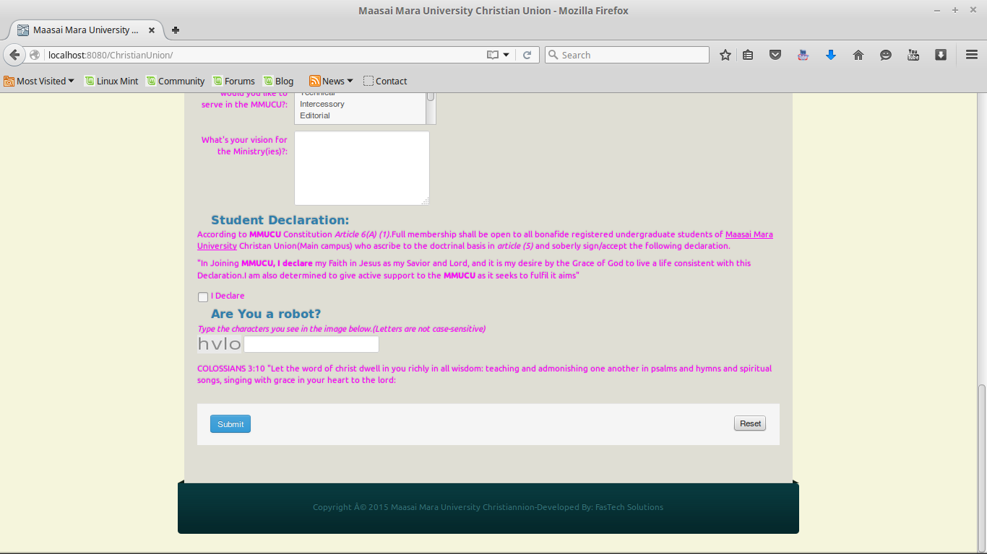

Student activation form
Photo4:
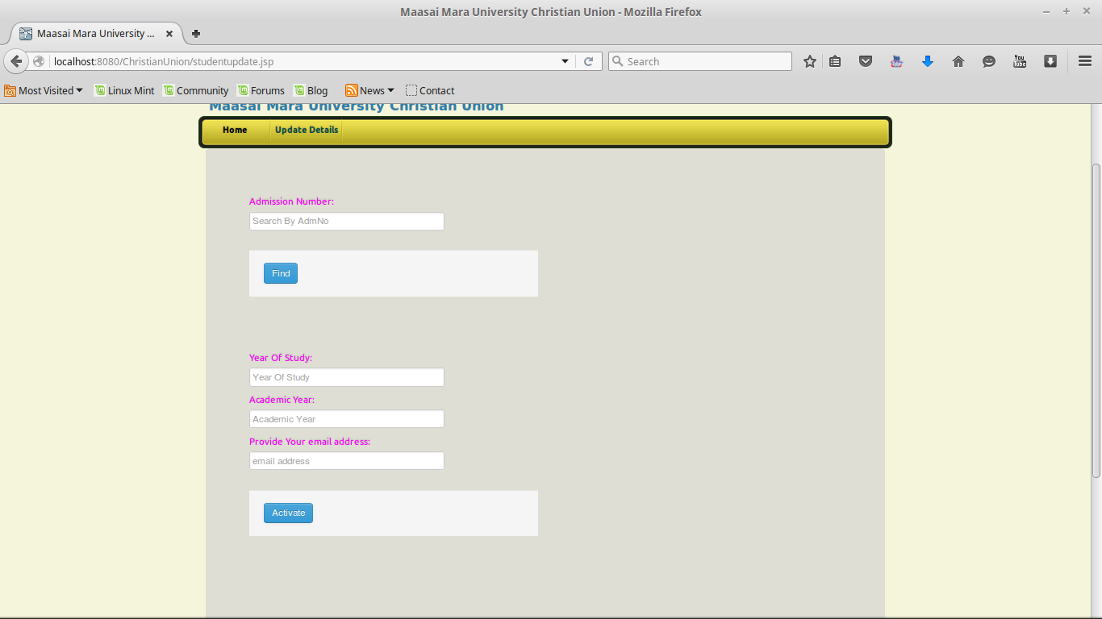

ADMIN PORTAL
This is the main Part of the system
Landing page
Phpto1
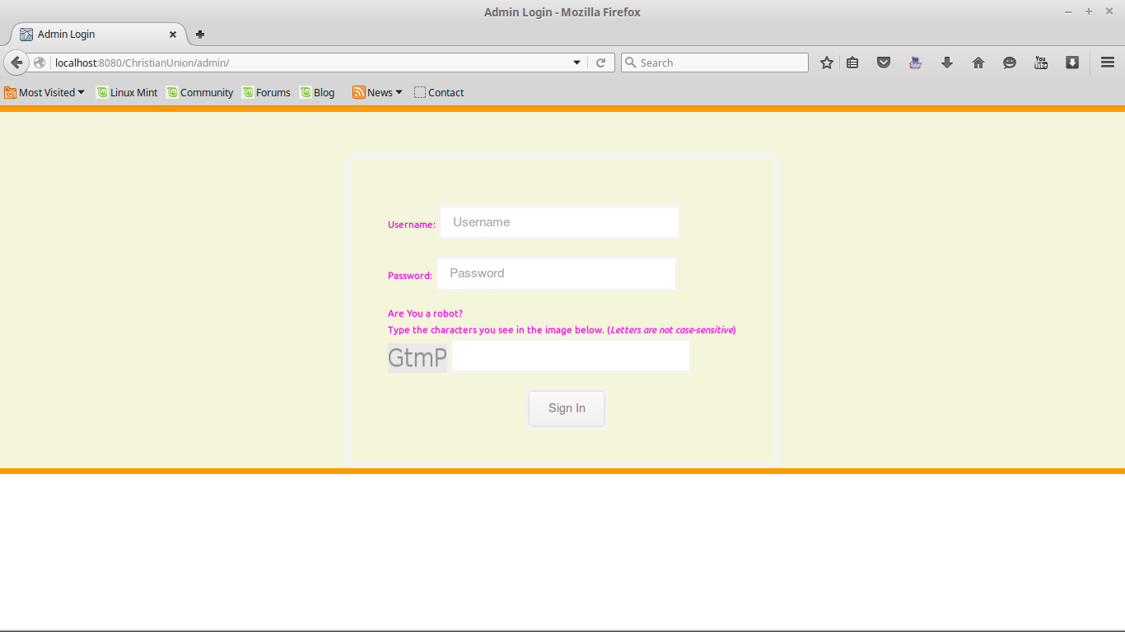

Photo2:
View the students
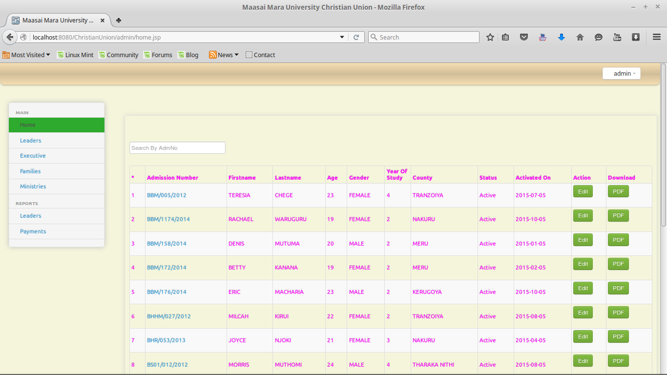
Photo3
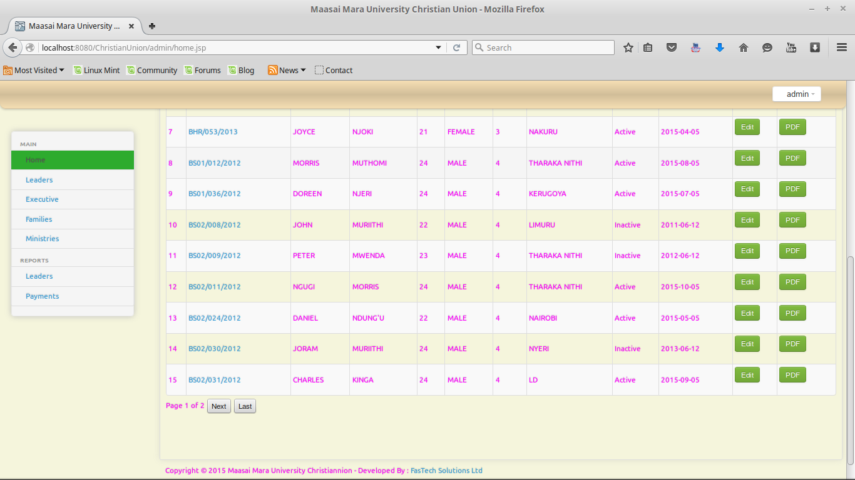

Student more details
Photo4:
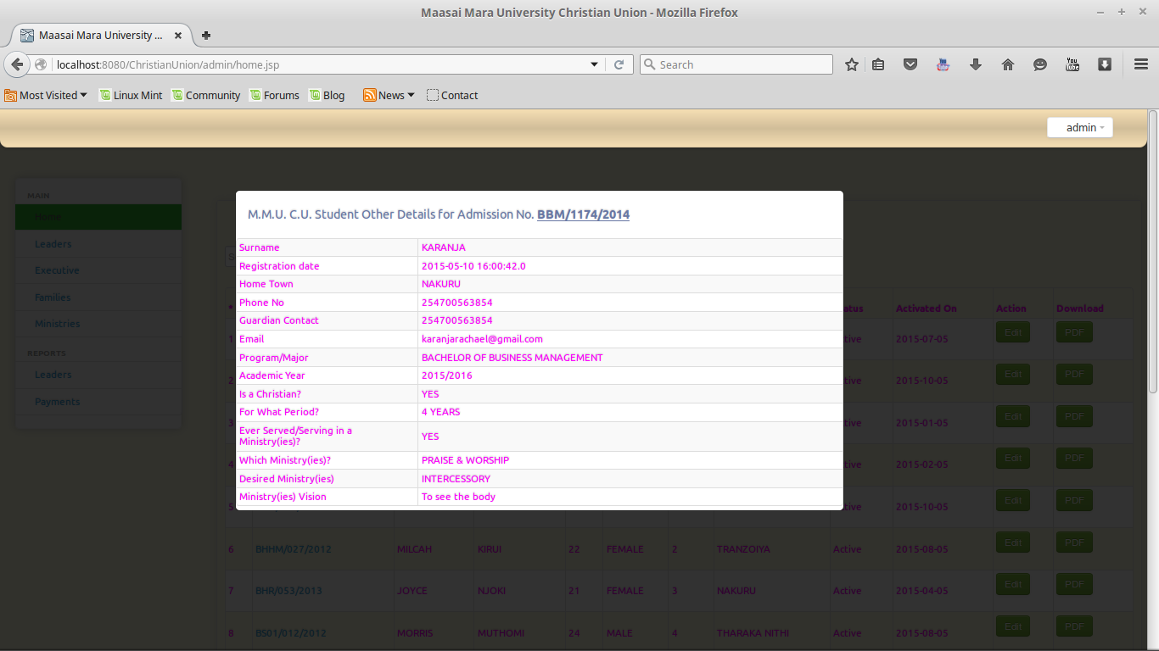

Search student
Photo5:
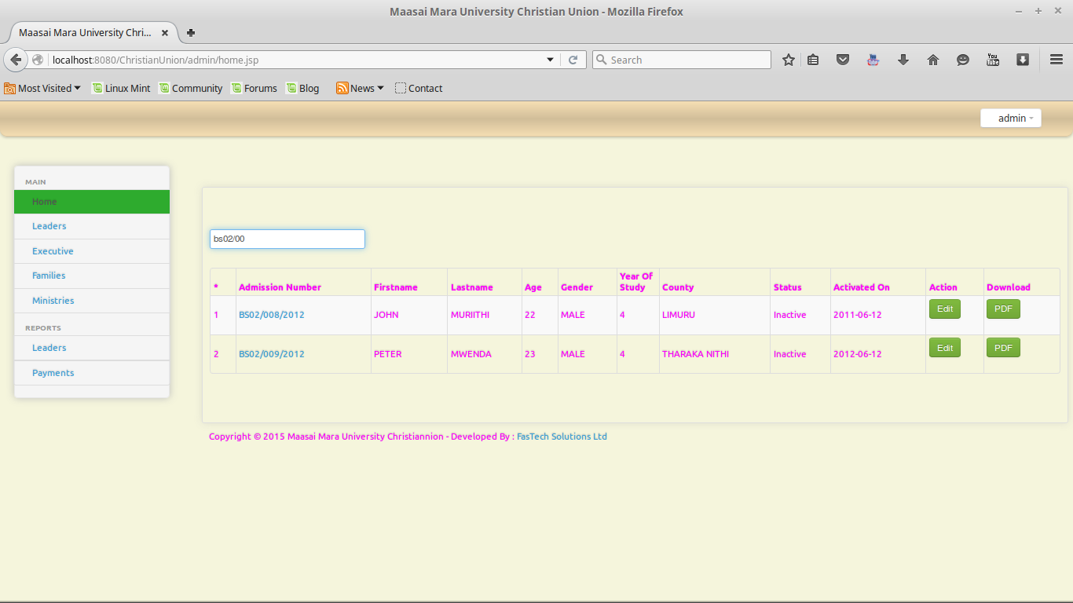

Edit/Update student
Photo6:
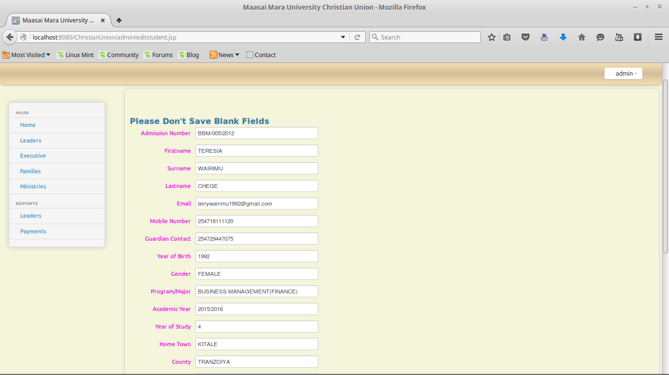

Leaders and leaders’ registration
Photo7
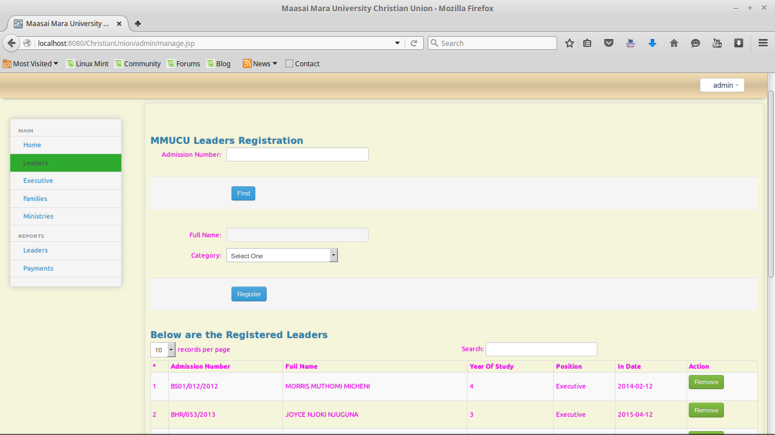
Photo8:
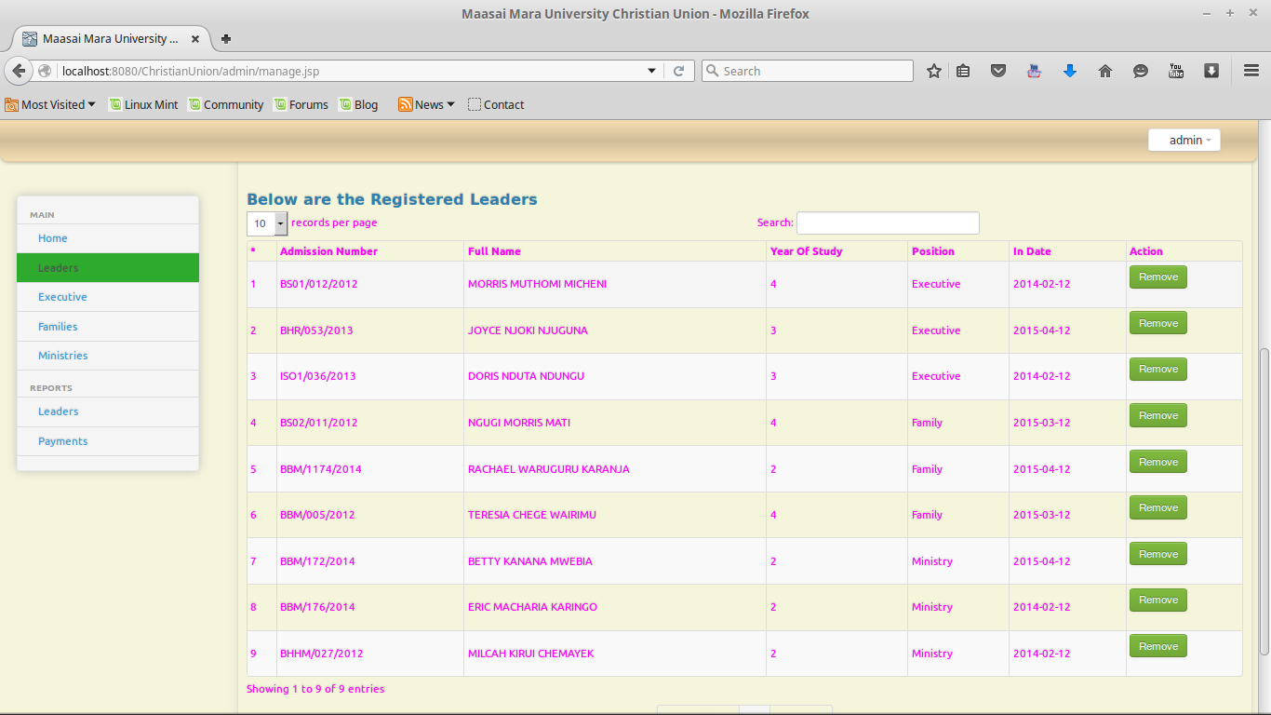

Executive Registration
photo9
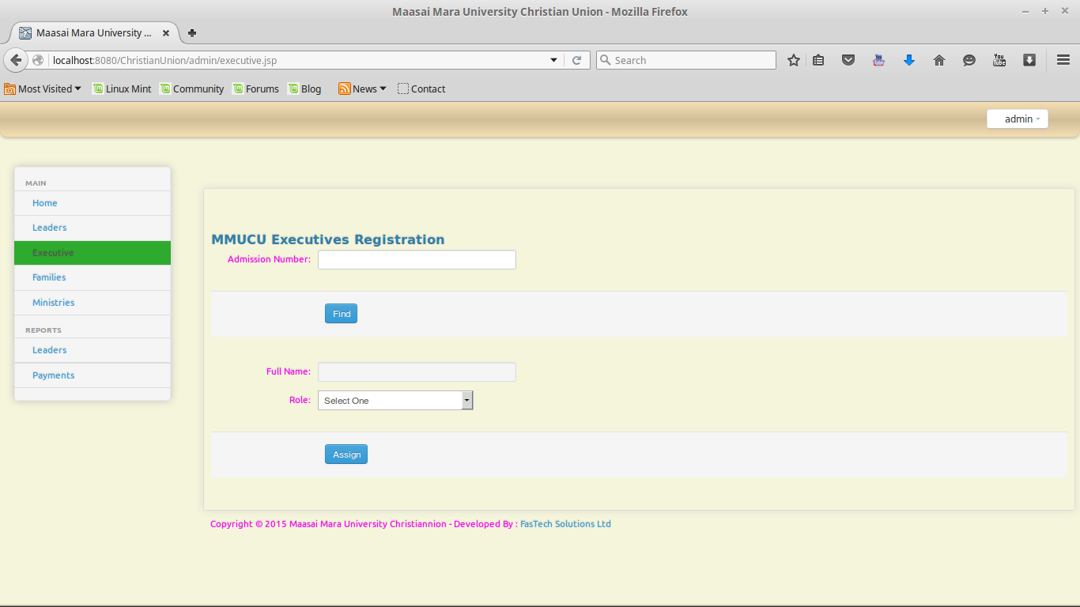
Family Leaders’ Registration
Photo10
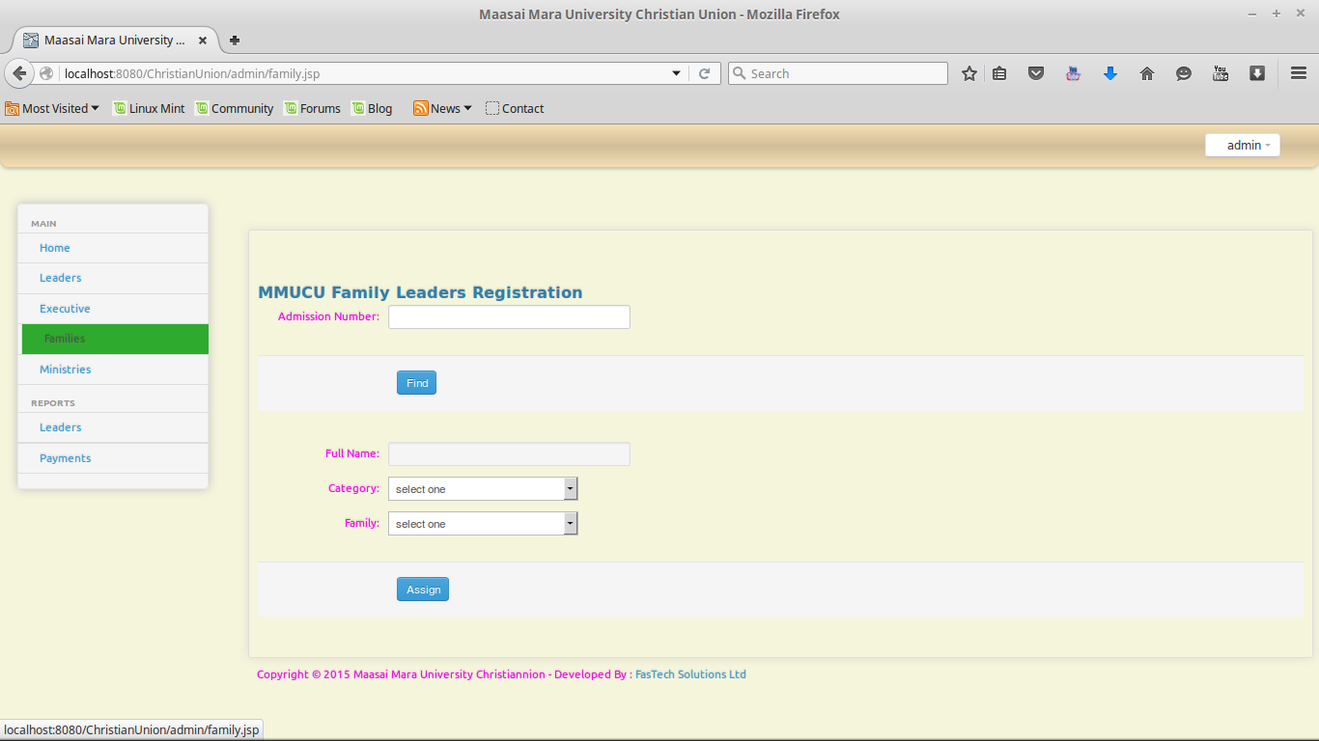

Ministry Leaders’ registration
Photo11
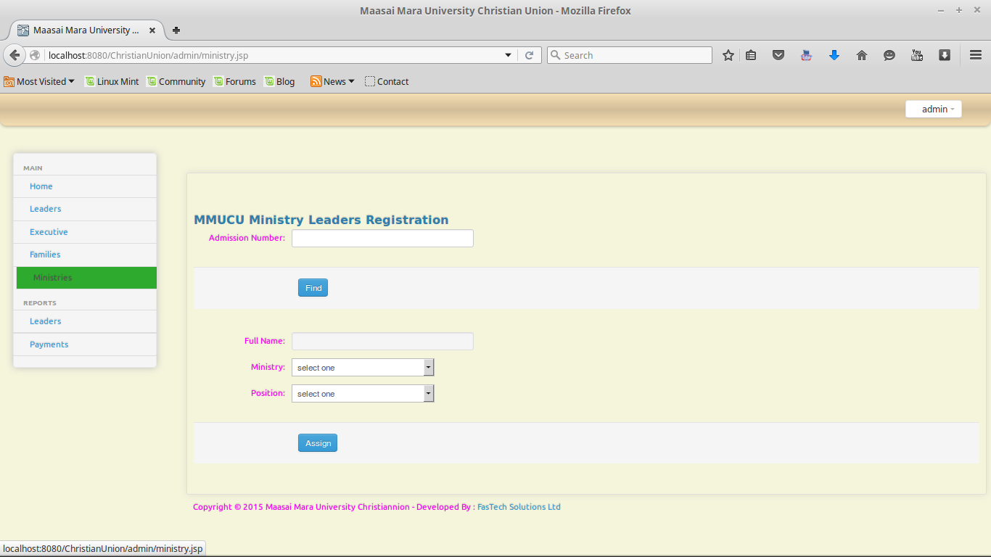

Leaders List
Photo12
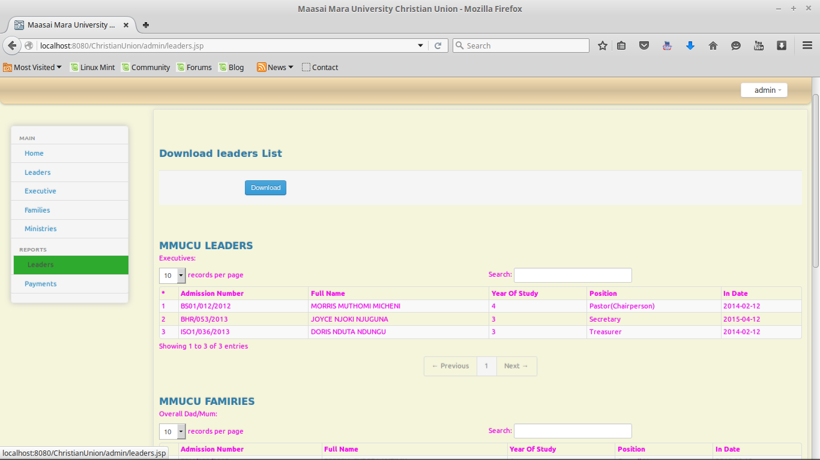
Photo13
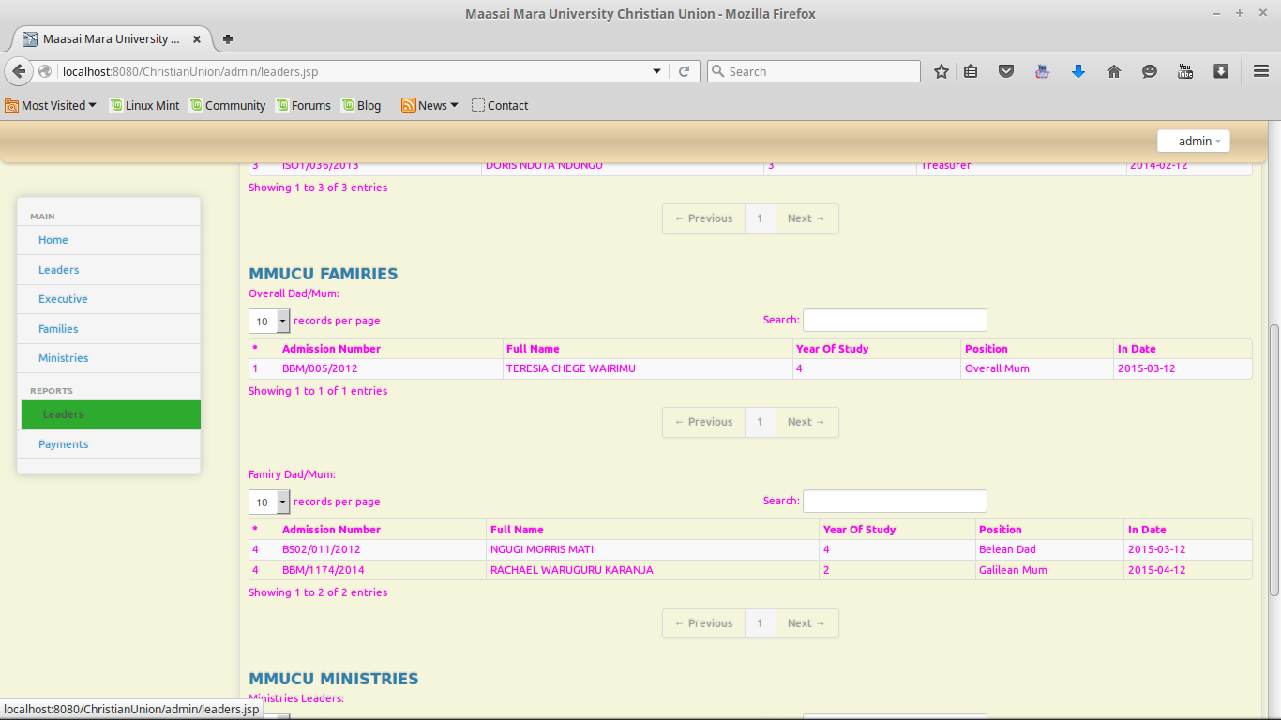

Photo 14
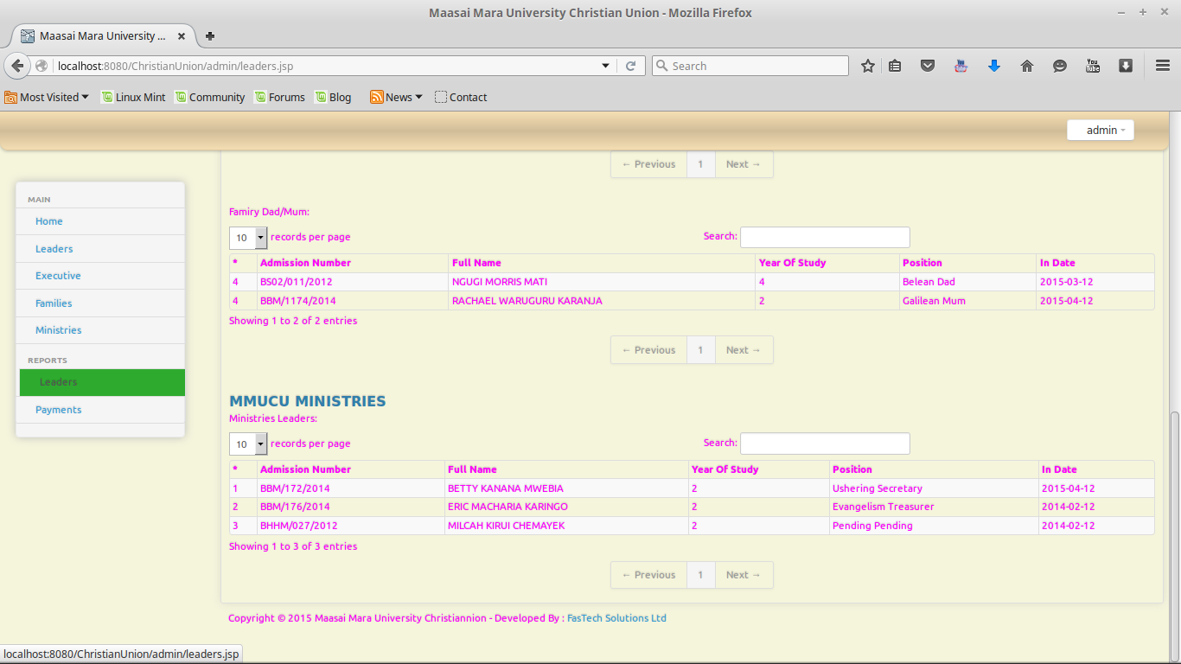

Reports
Student report
Photo15
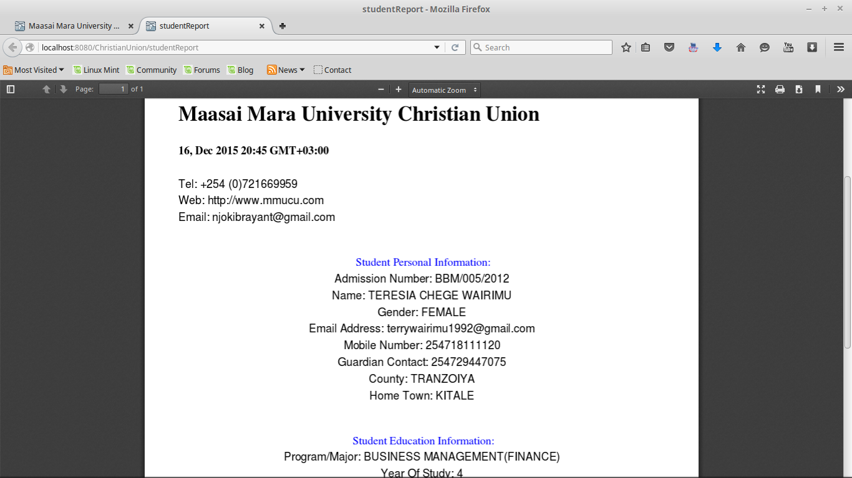

Leaders Report
Photo16
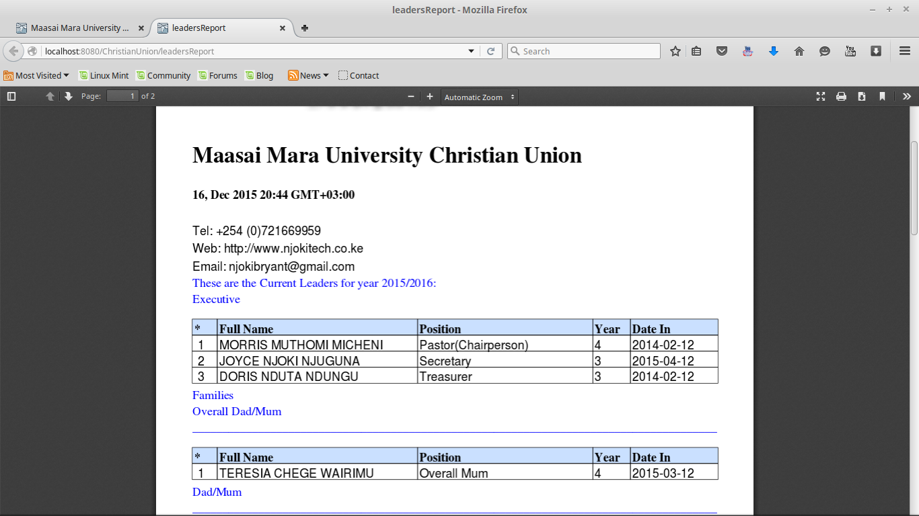

That’s the MMUCU system at a glance.

REFERENCES
(wakahe, 2010)

