Bakery Ordering System

Group Name: G5 | Misha Sondhi, Shubhkiran Kaur Kaler, Pawanpreet Kaur

Project Proposal

PROG24178

2018

Contents

Introduction 2

Motivation 2

Purpose 2

Component 2

Wireframes 3

Data Model Diagram 5

Domain Class Diagram 6

# Introduction

## Motivation

1. **Learning**: This project will serve as a learning milestone for my journey through JavaFX
2. **Meaningful** **Application**: This project will give a sense of achievement by building a real world meaningful application that can be used in day to day life.
3. **Challenge**: This application includes complex business logic (as per my standards) and can act a solid ground for introduction to solve real world problems which I will face during my employment.

## Purpose

1. **Ease of use**: I will try to implement knowledge gathered from Interactive user design course to build a user friendly application that will take minutes to master.
2. **Touch friendly**: According to my research most such applications are installed on a touch sensitive computers. I aim to make the application design touch friendly so that it can be adopted quickly.

## Component

1. **Login Screen**: Bakery associate or manager can use their username and password to login into the application. Based on their login I will determine their role and allow only managers to view the daily report.
2. **Main Point of Sale Screen**: This will hold components to take an order, print invoices and receive payments.
3. **Report Screen**: This will provide a daily, weekly or monthly sales report for managers.
4. **Database**: We will be using MS Access as our data repository.

# Wireframes

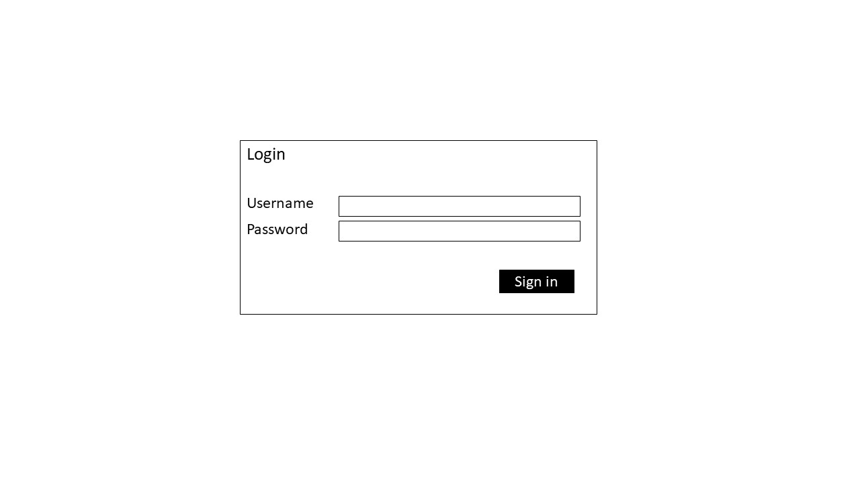

Figure 1Login screen

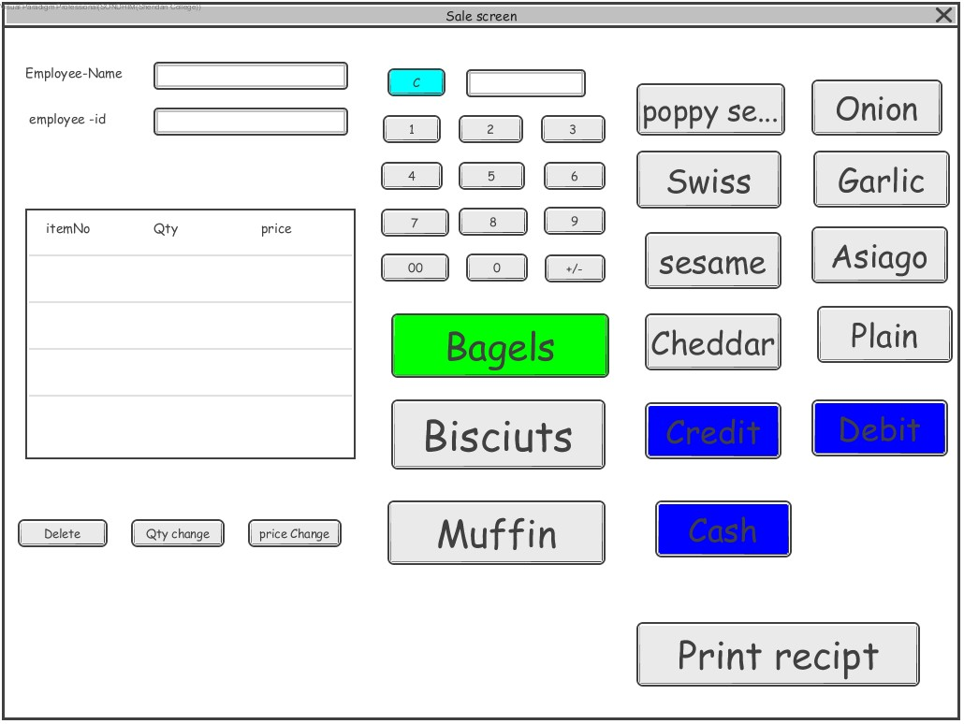

Figure 2Sale home screen wireframe

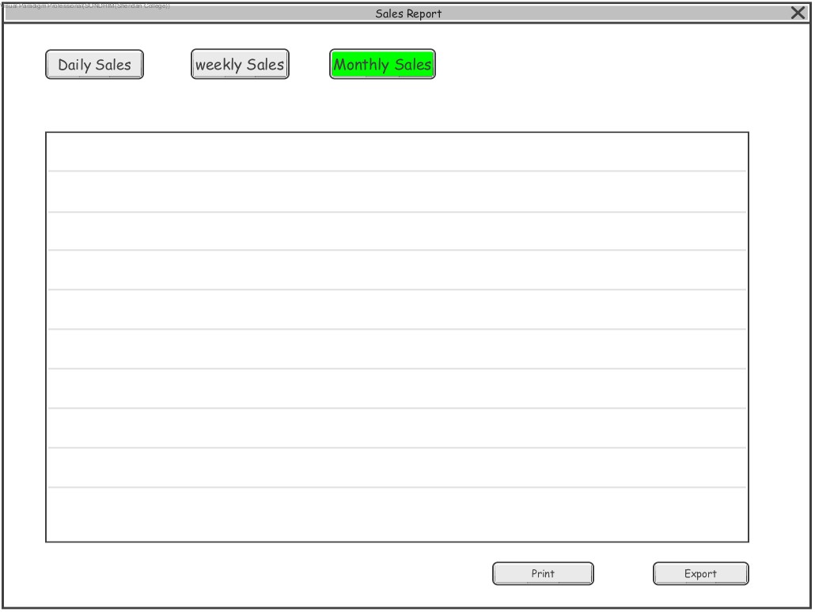

Figure 3Reports screen wireframe

# Data Model Diagram

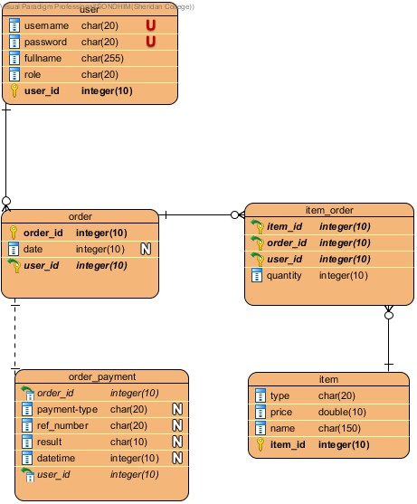

# Domain Class Diagram

