Bot Summary

It is a simple chatbaot that will find if a specific book entered by user is in the catalogue (DynamoDB table). If a book is available then chatbot would return a book as well as its author name stored in the table.

**Bot name**: CheckBookAvailibility

### **Output voice**: Salli

**Session Timeout**: 2 mins

**Intent**: BookAvailibility

**Sample Utterances**: “I want a Book”

**Slot**: BookName

**Slot Prompt**: “Which Book?”

**Confirmation Prompt**

* Confirm: “Are you sure you want to read a book {BookName}?”
* Cancel (if the user says "no"): “Okay. Goodbye.”

**Fulfilment AWS Lambda function**: checkBookInCatalogue

### **Error handling**

#### Clarification prompts

“Sorry, I could not understand. Please try saying 'I want a book'”

“Sorry, can you please repeat that?”

#### Maximum number of retries: 2

#### Hang-up phrase

“Sorry, I could not understand. Goodbye.”

**CheckBookAvailibility** bot Editor screen-shots that includes user created Intents, Slots, Sample utterances, Confirmation prompt, Lambda fulfilment function and Error handling.

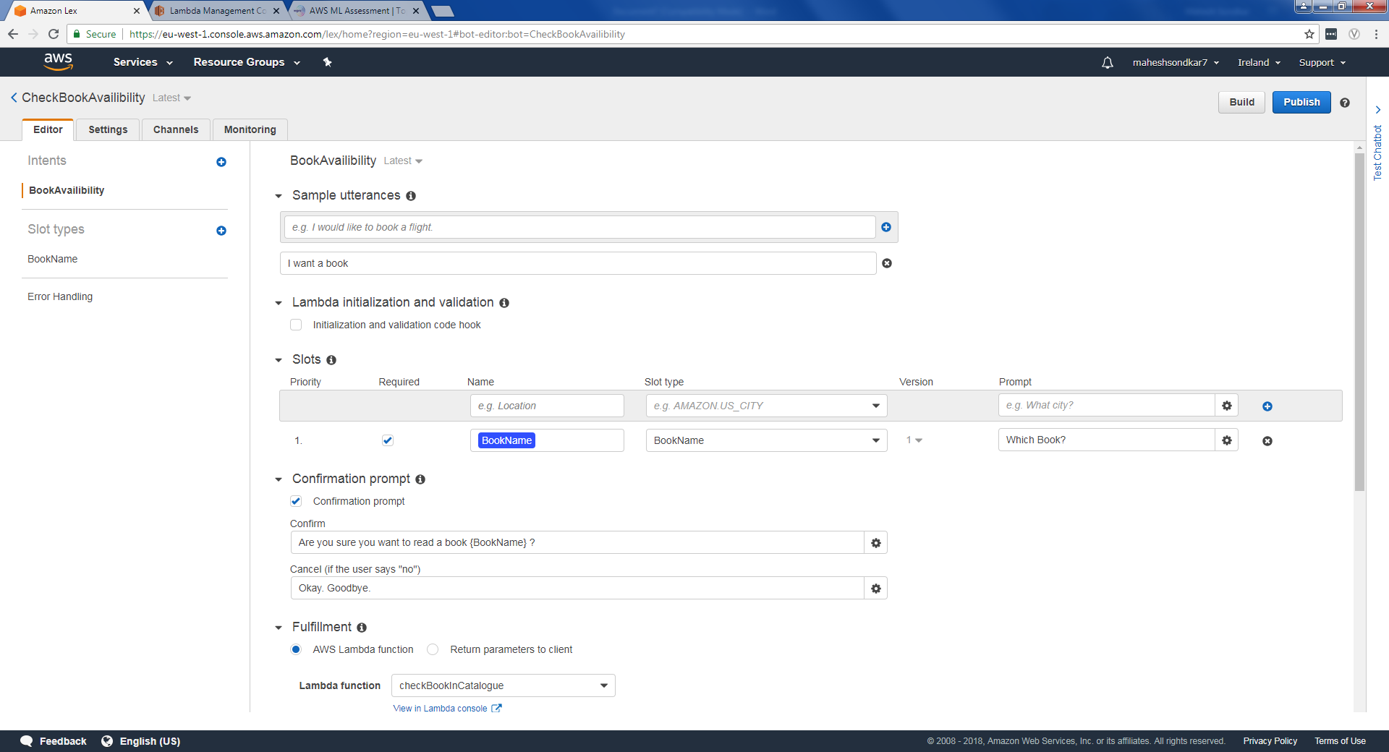

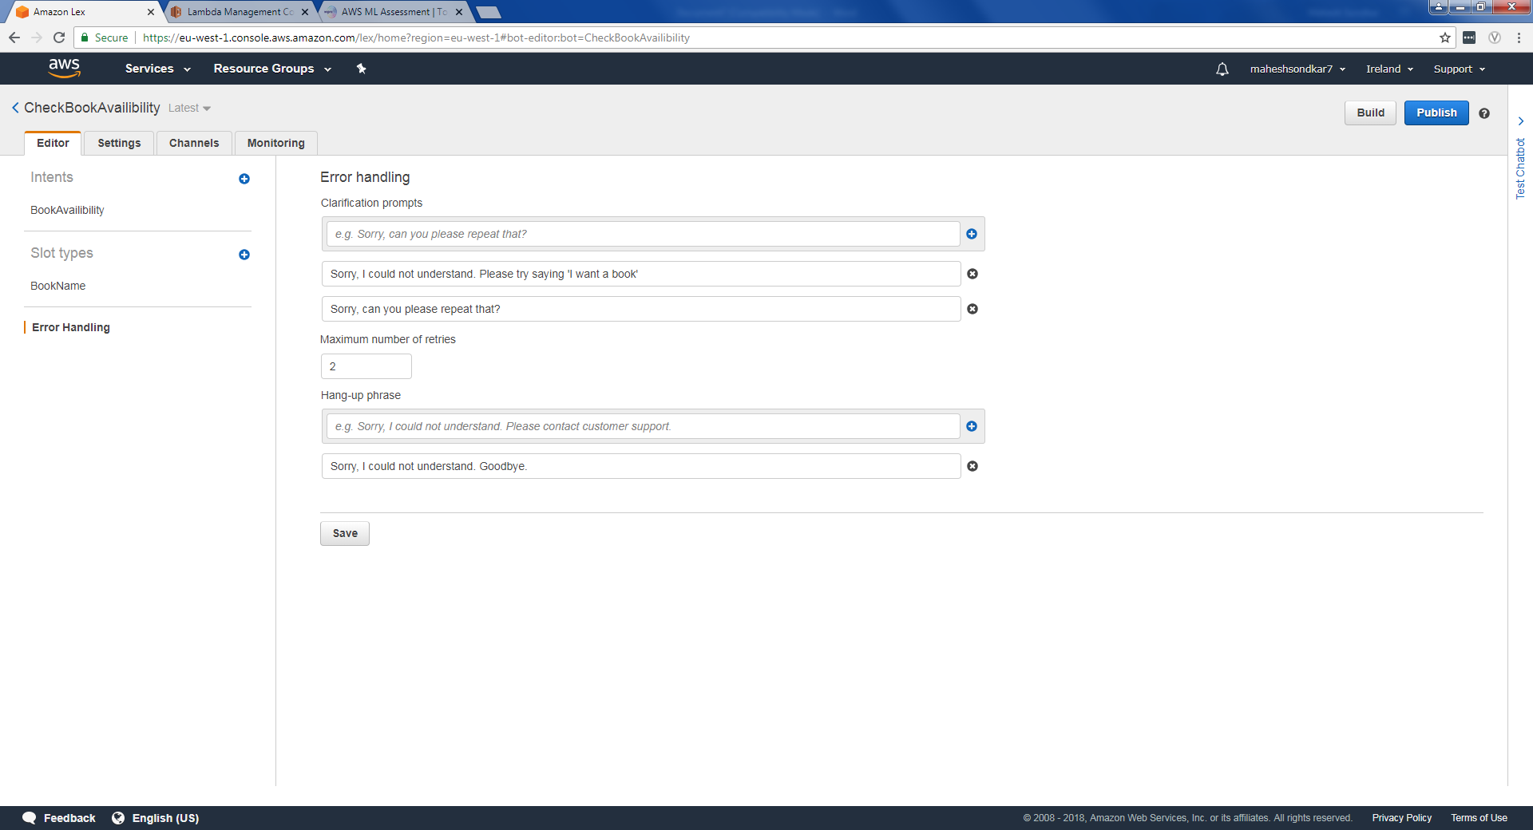

CheckBookInCatalogue lambda function

This python function retrieves a book name entered by user and then query DynamoDB table to check a book availability. Finally, it constructs a response message.

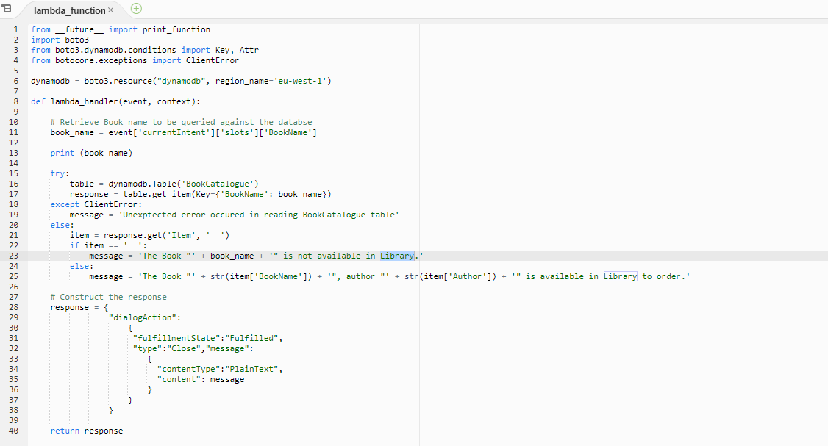

‘BookCatalogue’ DynamoDB table

This table contains book and author name.

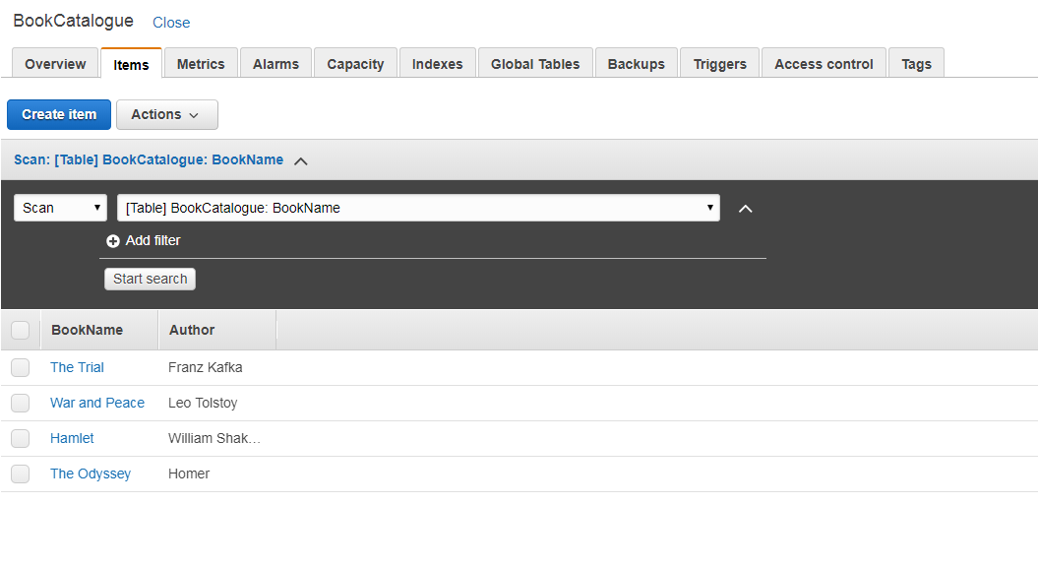

CheckBookAvailibility Trials

1. Error Handling

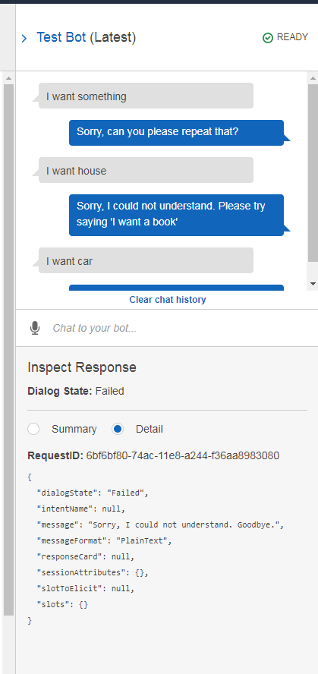

1. Positive case

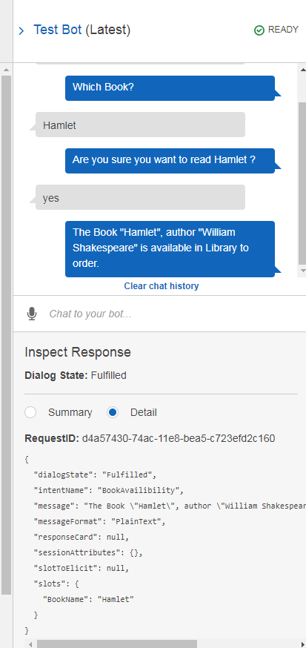

1. Negative case

