Unit 1 Homework Submission: Kickstart My Chart Maria Soria

5/27/2019

**1.** Given the provided data, I came to the following three conclusions about Kickstarter campaigns:

* Projects within certain categories had higher rates of success than others. For example, though 53% of all projects included in this data set were successful, 77% of the projects in the music category were successful. Conversely, none of the projects in the journalism category were successful, as shown in the table below:

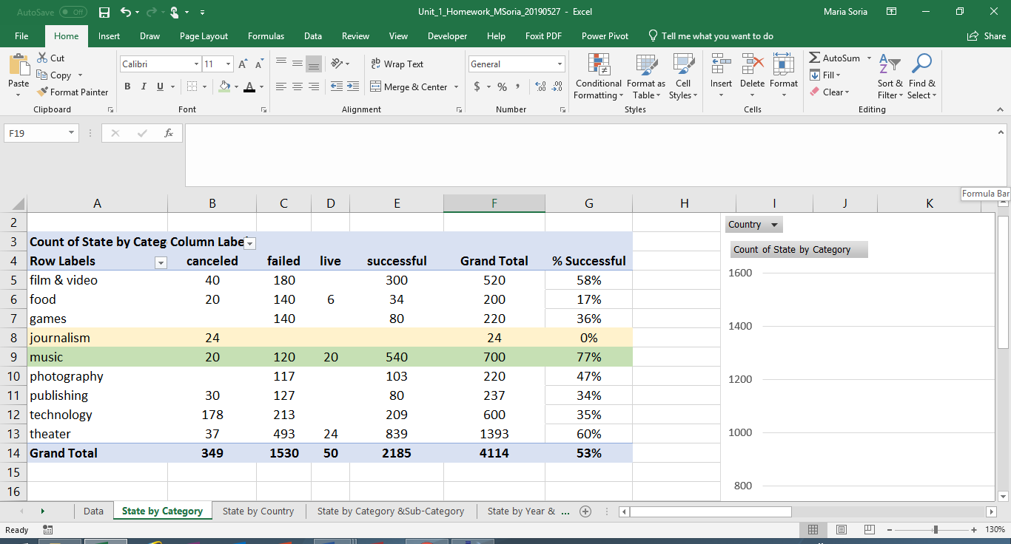

* At first glance it would appear that some countries had higher rates of successful projects, as illustrated in the table below:

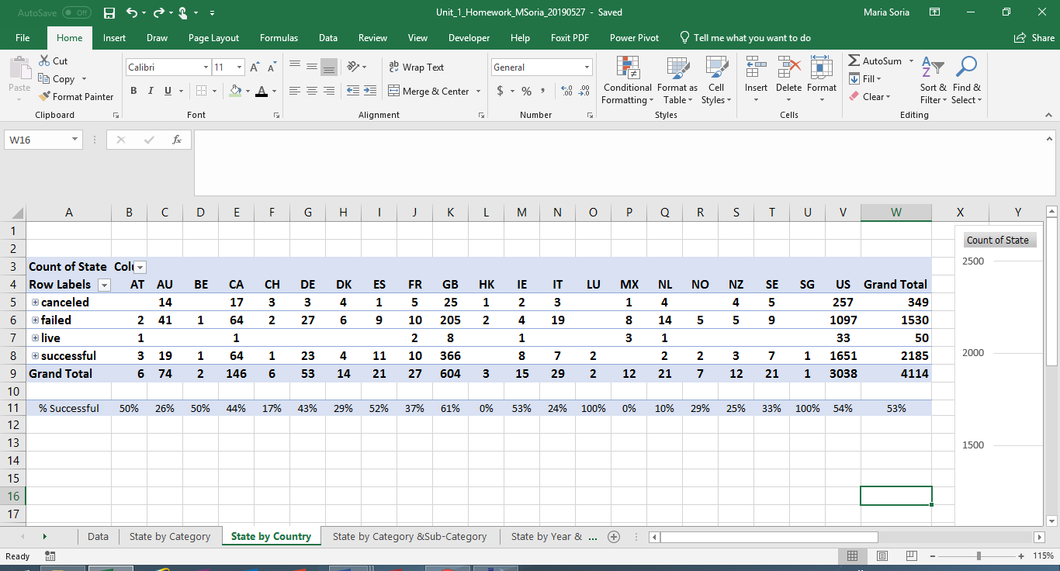

However, it should be noted that the United States (US) had almost 75% (3,038 of 4,114) of all projects. Moreover, 54% of the projects in the US were successful and 53% of all projects were successful. There is a strong relationship between the overall success rate and that of projects in the US as the US has the largest sample population.

* Lastly, there appears to be a relationship between the goal amount and success rate. The graph below illustrates that there is an inverse relationship between success rate and goal amount up to approximately $20,000 – the success rate decreases as the goal amount increases. Similarly, the graph also illustrates that same inverse relationship between success rate and goal amount for projects with goal amounts greater than approximately $45,000. However, the success rate is greater than the failure rate for projects with goal amounts less than $20,000 and the opposite applies for projects with goal amounts greater than $45,000, where the failure rate is higher than the success rate as shown in the graph below:

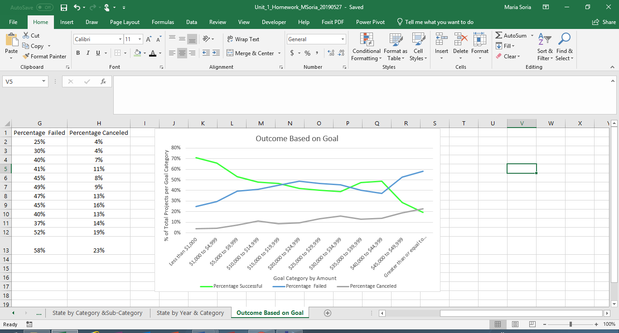

**2.** As with all datasets, there are limitations. In this case I believe one of the limitations is not having any information about the project sponsors or donors. It would be useful to have demographic data (e.g. income, education, etc.) on the sponsors as they are a major factor in whether a project succeeds. Furthermore, it would be useful to potential sponsors to have demographic data on donors.

**3.** Other possible tables and/or graphs that could be useful include probability distribution curves, which could provide further insight into the probability of success.