
ACADEMIC OPERATING GUIDE

Role workflows
and access
  - How semester decisions move through campus delivery, faculty planning and the student view.
01  Global academic setup | 02  Campus delivery | 03  Teaching execution | 04  Read-only student view

Operating principle
Authority flows downward by role and campus scope. Progress, exceptions and reports flow upward. Every person sees only the campuses, batches and subjects assigned to them.
- Administrator / Program Manager — all campuses
- Campus Manager — assigned campus
- Faculty and Visiting Faculty — assigned subjects and classes
- Student — enrolled campus and batch, read only

01 · END-TO-END FLOW

From semester setup to the student view
  - The platform connects administrative planning, campus scheduling and classroom delivery in one controlled chain.
Figure 1 · End-to-end academic delivery flow
What changes downstream: A calendar or exam-window change recalculates affected classes, planned dates, available teaching hours, progress and exam readiness before it reaches the student view.

02 · ACCESS HIERARCHY

Authority follows campus and subject scope
  - Each role receives the minimum scope needed to complete its part of the academic workflow.
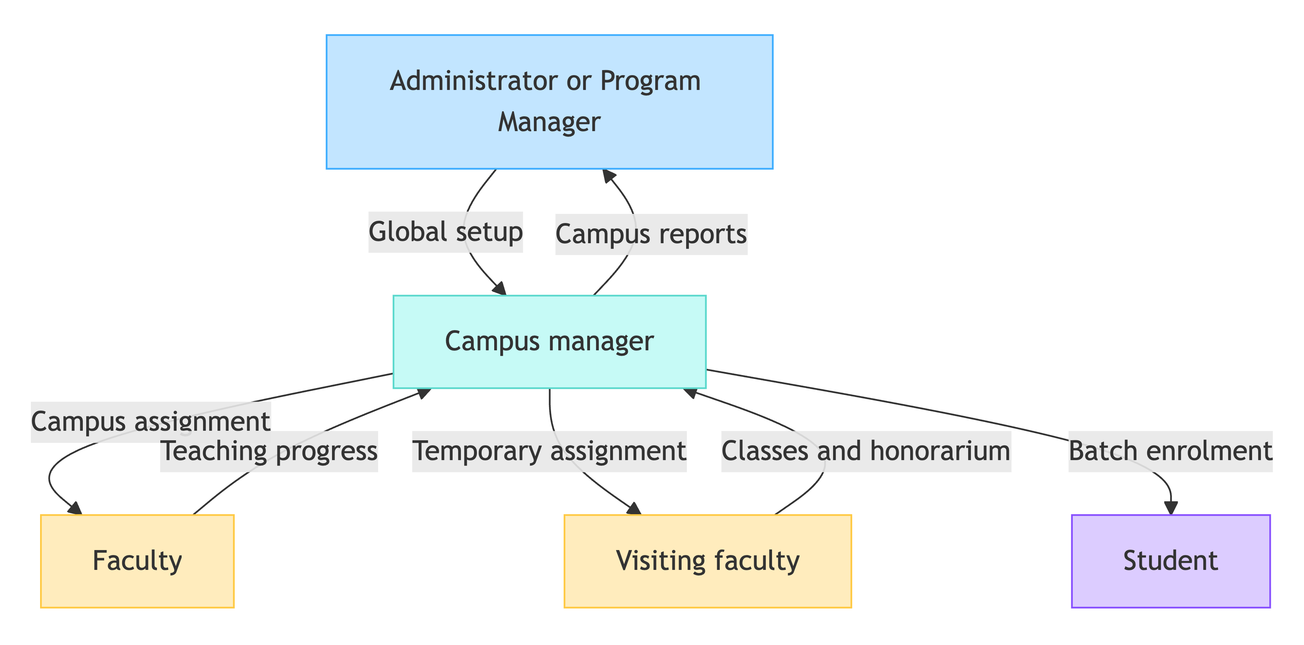
Figure 2 · Role hierarchy and reporting paths
Global | Campus | Assigned work
Administrator and Program Manager configure all campuses and review cross-campus intelligence. | Campus Managers operate only inside their assigned campus and manage delivery. | Faculty see assigned teaching; students see enrolled subjects and outcomes.
03 · ROLE GUIDE

Leadership and campus operations
  - Administrative roles establish the academic structure and keep delivery aligned when conditions change.
Administrator / Program Manager · All campuses
Can do  - Create semesters and maintain calendars, holidays, working days and exam windows.  - Create subjects; manage users, campus managers and campus assignments.  - Review notifications, reports, exports, audit history and AI summaries. | Can see  - Cross-campus progress and teaching delivery.  - Faculty activity and exam readiness.  - Campus, subject, batch and track analytics across the organisation.

Campus Manager · Assigned campus
Can do  - Create or link subjects, batches and people; assign faculty to subjects.  - Upload and edit the full timetable, alter a particular class, and add extra classes.  - Maintain permitted calendar changes and manage visiting-faculty per-class rates. | Can see  - Campus subjects, timetable, lecture delivery and faculty activity.  - Progress, exam readiness, notifications and campus reports.  - Visiting-faculty class counts, approved payments and honorarium totals.

04 · ROLE GUIDE

Teaching and student experience
  - Teaching roles convert assigned hours into lesson plans and recorded delivery; students receive the resulting read-only view.
Faculty · Assigned subjects only
Can do  - Upload a partial or full-semester lesson plan and manage planned dates.  - Record daily lecture delivery and respond to schedule-change notifications.  - Use optional WhatsApp logging when that integration is enabled. | Can see  - Assigned hours, upcoming classes, covered and pending topics.  - Subject progress, buffer ratio, exam readiness, AI insights and own reports.  - Notifications only for assigned subjects and teaching actions.

Visiting Faculty · Assigned subjects and classes
Can do  - Follow the Faculty workflow after receiving subject access.  - Record classes actually delivered for approval and payment. | Can see  - Assigned hours, timetable and subject plan.  - Personal delivered-class count; honorarium is calculated per approved class.

Student · Enrolled campus and batch · read only
Can do  - No academic editing or access-management actions. | Can see  - Enrolled subjects and assigned teachers.  - Covered and upcoming topics, exam dates and syllabus scope.

05 · CHANGE MANAGEMENT

Calendar changes trigger targeted updates
  - The system identifies impact first, asks the responsible faculty member when a teaching decision is required, and then refreshes dependent views.
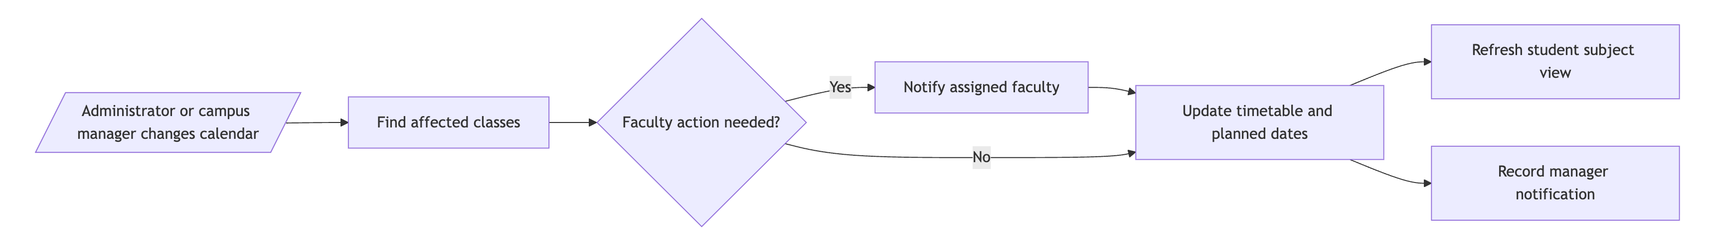
Figure 3 · Impact, decision and notification flow
1 Detect | 2 Decide | 3 Re-align | 4 Notify
Find every future class affected by the calendar or exam-window change. | Ask the assigned faculty member when topic order or recovery timing needs a choice. | Update timetable dates, available hours and linked lesson-plan timing. | Show the result to the right faculty, manager, administrator and students.

06 · PERMISSION REFERENCE

What each role may access
  - The interface and API apply the same role and scope checks. A visible control is never the security boundary.
Capability | Admin | Campus manager | Faculty | Student
All-campus analytics | Full | — | — | —
Assigned-campus operations | Full | Full | — | Read only
Semester and calendar maintenance | Full | Assigned campus | — | —
Subject and faculty assignment | Full | Assigned campus | — | —
Timetable management | Full | Assigned campus | View assigned | View enrolled
Lesson plans and lecture logs | Review | Review campus | Own subjects | View outcomes
Reports | All campuses | Assigned campus | Own teaching | —
Notifications | Global / escalated | Campus | Assigned subjects | Relevant results

Permission principles
- Campus managers cannot manage another campus.
- Faculty cannot view or edit another faculty member’s subject unless separately assigned.
- Students cannot edit calendars, timetables, plans, logs, progress or user access.
- Changes to teaching history retain the responsible user and time for review.

