# Exercises: Advanced Relations

This document defines the **exercise assignments** for the ["Databases Advanced – EF Core" course @ Software University](https://softuni.bg/trainings/1741/databases-advanced-entity-framework-october-2017).

## Bills Payment System

Your task is to create a database for **Bills Payment System**, using the **Code First** approach. In the database, we should keep information about the **users** (**first name, last name, email, password, payment methods**). Every **payment method** should have an **id**, an **owner**, a **type** and a **credit** **card** or a **bank** **account** connected to it. There are **two types** of billing details – **credit card** and **bank account**. The credit card has **expiration date**, a **limit** andanamountof **money owed**. The **bank** **account** has a **balance**, a **bank name** and a **SWIFT** **code**.

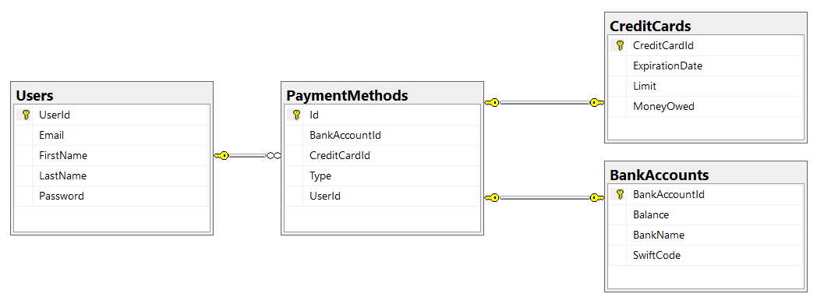

Create the configuration of each model in a new class, implementing the IEntityTypeConfiguration interface. Your solution should look similar to this:

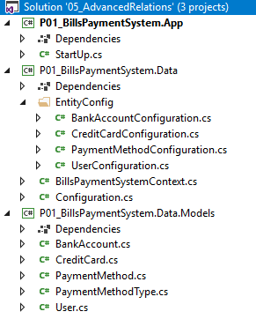

### Constraints

Your **namespaces** should be:

* P01_BillsPaymentSystem – for your Startup class, if you have one
* P01_BillsPaymentSystem.Data – for your DbContext
* P01_BillsPaymentSystem.Data.Models – for your models

Your **models** should be:

* BillsPaymentSystemContext – your DbContext
* User:
  + UserId
  + FirstName (up to 50 characters, unicode)
  + LastName (up to 50 characters, unicode)
  + Email (up to 80 characters, non-unicode)
  + Password (up to 25 characters, non-unicode)
* CreditCard:
  + CreditCardId
  + Limit
  + MoneyOwed
  + LimitLeft (calculated property, not included in the database)
  + ExpirationDate
* BankAccount:
  + BankAccountId
  + Balance
  + BankName (up to 50 characters, unicode)
  + SWIFT Code (up to 20 characters, non-unicode)
* PaymentMethod:
  + Id - PK
  + Type – enum (BankAccount, CreditCard)
  + UserId
  + BankAccountId
  + CreditCardId

**Everything** is required! Only **PaymentMethod**’s **BankAccountId** and **CreditCardId** should be **nullable**,and you should make sure that always **one** of them **is** **null** and the **other** **one** is **not** (add a **CHECK** constraint).

Make sure that **every** **record** in the **PaymentMethods** table has a unique combination of **UserId**, **BankAccountId** and **CreditCardId**!

## Seed Some Data

Make a **Seed**() method to seed some data into the **BillsPaymentSystem** database.

## User Details

Create a **console** **app** that retrieves from the database a **user** and all of his **payment** **methods** by a given **user id**, and prints them on the console in the format:

|  |
| --- |
| User: Guy Gilbert  Bank Accounts:  -- ID: 1  --- Balance: 2000.00  --- Bank: Unicredit Bulbank  --- SWIFT: UNCRBGSF  -- ID: 2  --- Balance: 1000.00  --- Bank: First Investment Bank  --- SWIFT: FINVBGSF  Credit Cards:  -- ID: 1  --- Limit: 800.00  --- Money Owed: 100.00  --- Limit Left:: 700.00  --- Expiration Date: 2020/03 |

First, list the user’s **bank** **accounts** and then – his **credit** **cards**. If **no** such **user** exist, print "User with id {**userId**} not found!" instead.

## Pay Bills

Add **Withdraw**() and **Deposit**() methods to the **BankAccount** and **CreditCard** classes, and make sure they are the only way you can change the **Balance**, **MoneyOwed** and **Limit** properties. Then create a **PayBills**(int userId, decimal amount) method that uses all of a user’s payment methods to pay his bills. Start with his **bank** **accounts**, ordered by id, and then his **credit** **cards**, ordered by **id**. If the user doesn’t have enough money available, don’t withdraw anything and print "Insufficient funds!" to the console.