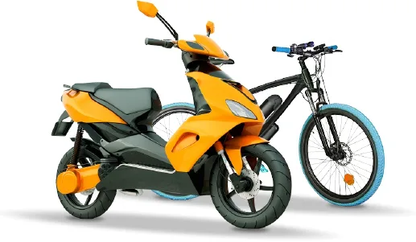
Presentation of easyLi's
products

French Designer and manufacturer of custom-made energy storage solutions
- e-Mobility
Manufacturing / operating fleets of electric bikes, cargo bikes, motor scooters, go karts, pallet trucks… is your business ?
easyLi is your energy storage partner from system specifications (range, power, weight, form factor…) to delivery to your premises of “Made in France” Lithium-ion battery systems specially designed for your applications.
- Onboard and Off-Grid energy
Is powering mobile equipment for many hours your challenge ? Operating electric powered devices on a 24/7 basis far from any stable power grid ?
In partnership with your technical and marketing teams, we create and deliver the tailor-made energy solutions which perfectly meet your expectations of running time, weight, cost...
- Smart building
Looking for customized energy storage solutions for residential, commercial or industrial buildings ?
easyLi is your trustworthy advisor for engineering studies and business plans before designing and supplying the turnkey solar storage systems that will make your energy efficiency targets a reality. For home storage applications, no doubt that our all-in-one Storelio is the solution.

Technical and manufacturing expertise
Based on a proven track record of industrial achievement, easyLi gather all engineering skills and laboratory and production equipment in order to design, develop and manufacture energy storage solutions delivering best performance and overall value.
Hands-on knowledge of any rechargeable Lithium chemistries : Lithium-ion, Lithium Iron Phosphate, Lithium Titanate…
Development and qualification of electronic control and power units fully integrated in our energy storage systems : battery management systems (BMS), energy management systems (EMS), charging systems, power conversion systems (PCS), multi-protocol communication modules…
Ruggedized design capabilities to handle harsh operating conditions including shocks, vibrations, water projections…

To your sustainable development
easyLi promotes social and environmental responsibility practices. Whenever possible, we offer maintenance and reconditioning services to extend the operating life span of our products. At your request, we support you in designing and implementing end of life product collection and recycling schemes to meet and exceed national and international regulations.

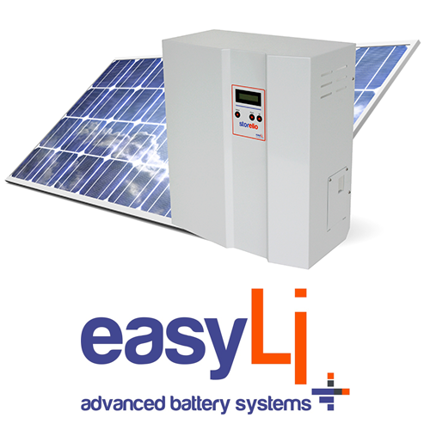
Storelio : advanced energy systems
Storelio is a range of all-in-one home energy storage systems with built-in solar inventer, very long life easyLi Lithium-ion battery and smart energy management system. Associating ready-to-plug and maintenance free features to trendy and modular design, Storelio is the answer to energy independence expectations of a growing number of environmentally conscious homeowners.

