Monocular depth estimation 실습 정리

1. Depth estimation pipeline

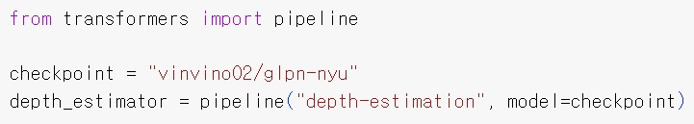

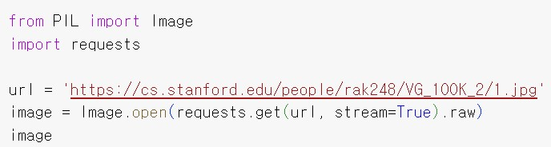

C:\Users\minseo\AppData\Local\Packages\Microsoft.Windows.Photos_8wekyb3d8bbwe\TempState\ShareServiceTempFolder\depth_estimation3.jpeg

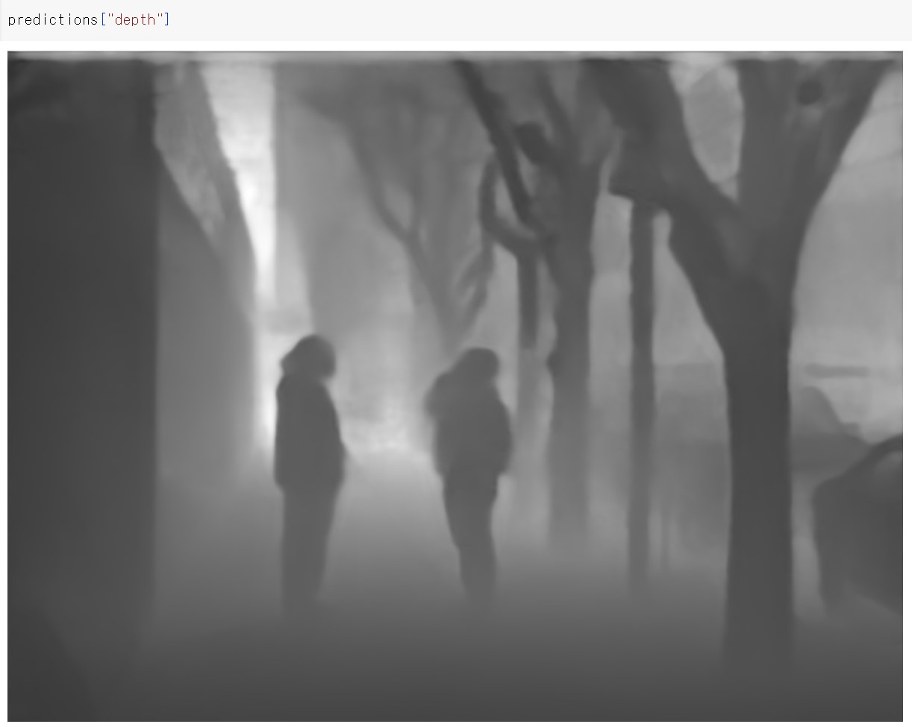

2. Depth estimation inference by hand

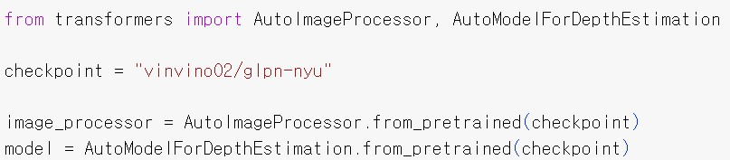

C:\Users\minseo\AppData\Local\Packages\Microsoft.Windows.Photos_8wekyb3d8bbwe\TempState\ShareServiceTempFolder\depth_estimation6.jpeg

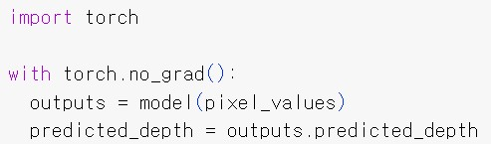

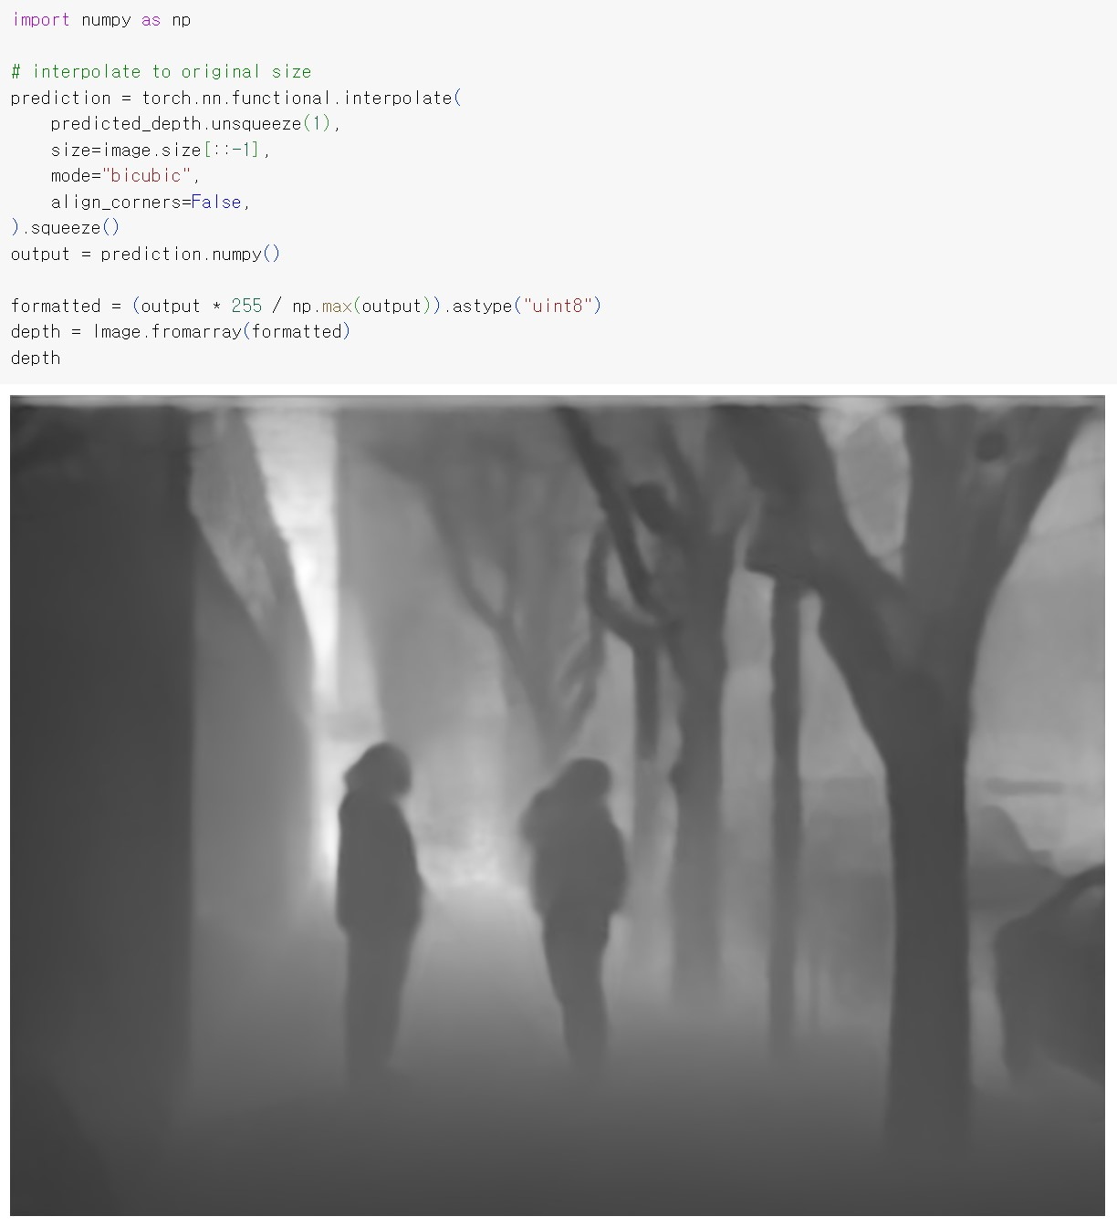

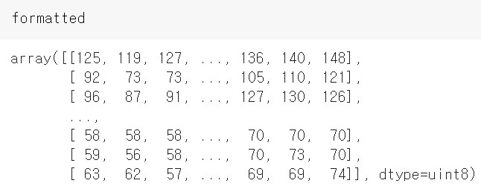

* formatted: image의 각 pixel별 depth estimation을 포함한 array

[Proposal]

loss function: E ||(predicted depth estimation) - (ground-truth depth estimation)||

(predicted depth estimation: canonical sg2im를 통해 생성된 depth image,

ground-truth depth estimation: monocular depth image를 통해 생성된 depth image)