Clock Generation on Cmod-S7

Contents
1 Theory 2
2 Clocking Wizard usage 5

Theory

An MMCM (Mixed-Mode Clock Manager) is a specialized, hardware-defined intellectual property (IP) block embedded within modern AMD/Xilinx FPGAs designed for advanced clock synthesis, frequency modification, and conditioning. It serves as the primary component inside the FPGA's Clock Management Tile (CMT) to handle complex timing requirements across the entire chip.

Multi-region clock-capable I/O (MRCC)

The Cmod S7 includes a 12 MHz crystal oscillator connected to pin M9 (an MRCC input on bank 14). This clock is intended to be used as a general purpose system clock. The clock can drive MMCMs to generate clocks of various frequencies and with known phase relationships that may be needed throughout a design. The 12 MHz input clock cannot directly drive a PLL because they have a minimum input frequency of 19 MHz. Some rules restrict which MMCMs and PLLs may be driven by the 12 MHz input clock. For a full description of these rules and of the capabilities of the Spartan-7 clocking resources, refer to Xilinx UG472, titled “7 Series FPGAs Clocking Resources User Guide”.
Xilinx offers the Clocking Wizard IP core to help users generate the different clocks required for a specific design. This wizard will properly instantiate the needed MMCMs and PLLs based on the desired frequencies and phase relationships specified by the user. The wizard will then output an easy-to-use wrapper component around these clocking resources that can be inserted into the user’s design. The clocking wizard can be accessed from within the Vivado and IP Integrator tools.

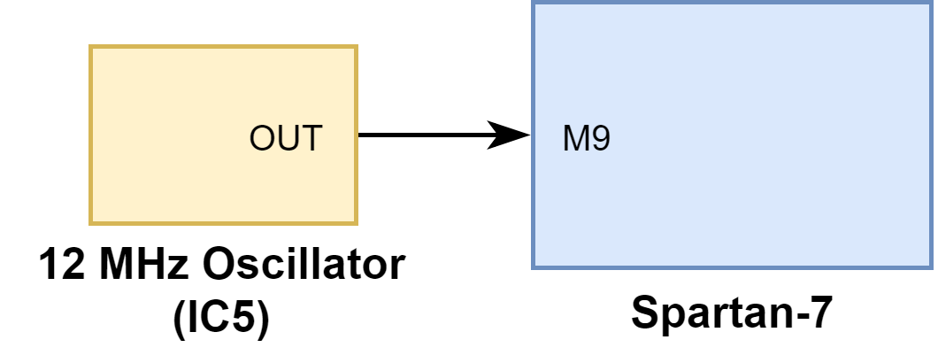

Source:
https://digilent.com/reference/programmable-logic/cmod-s7/reference-manual

7 Series FPGAs Clocking Resources Guide:
https://docs.amd.com/v/u/en-US/ug472_7Series_Clocking

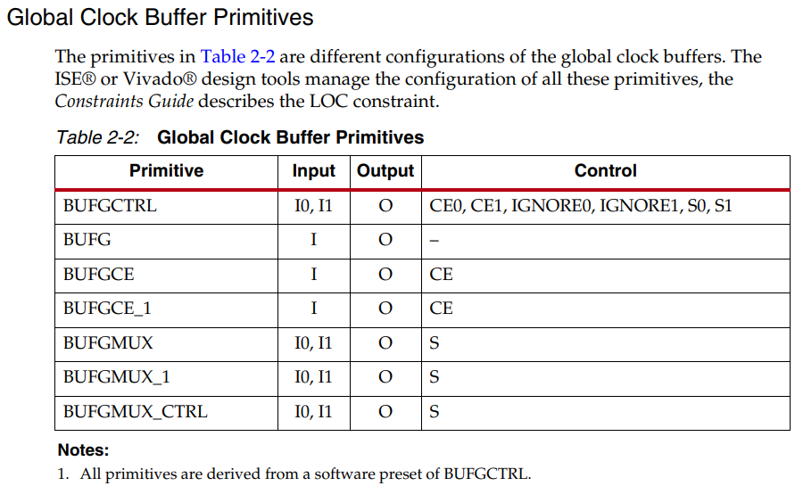

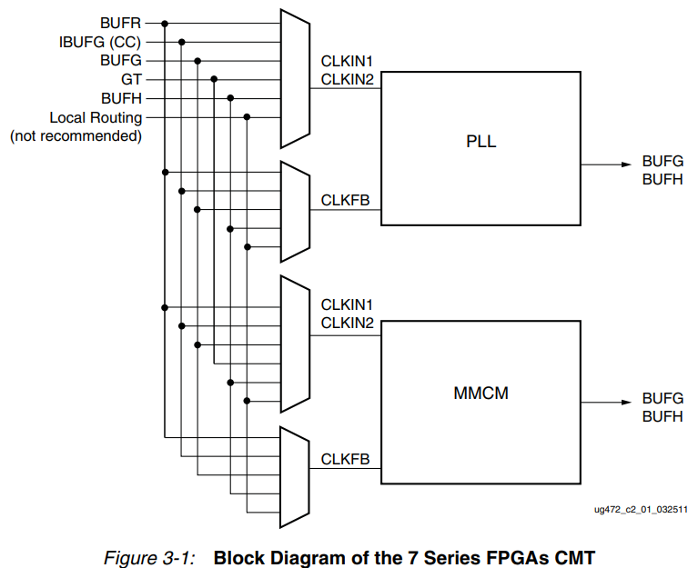

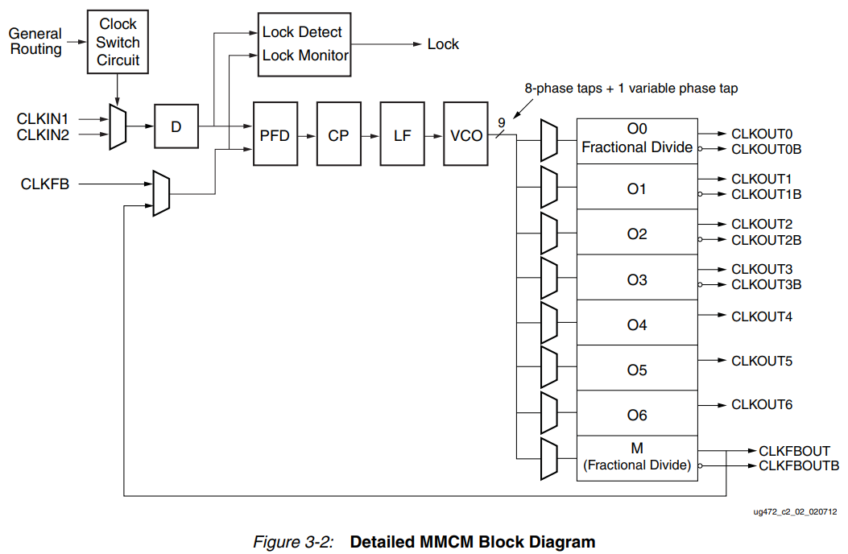

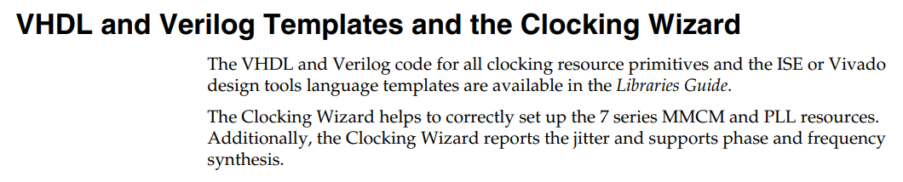

Clocking Wizard usage

Demo projects repository for Cmod-S7: https://github.com/digilent/cmod-s7/tree/25/OOB/master

Clocking Wizard usage:
https://www.realdigital.org/doc/ae6ce4fbf81065307776fd9d0911ec7d

