Lifting Spirits
Game Design Document
Update: Built in two weeks by a five-person team for the Macrow Spring Jam 2026 (theme: Seamless Loop). Placed 3rd out of 209 submissions.

Overview
Lifting Spirits is a 2D vertical climbing game (an “up-scroller” rather than a side-scroller) in which Lua, a wingless faerie born at the roots of the Great Tree, climbs toward the summit to help her best friend Clover, the newly chosen Spirit Guardian, complete the final trial of the Guardian ceremony. Movement is slow and methodical. The player manages a limited stamina bar to find the most efficient path between platforms. With each ascent, Lua comes closer and closer to achieving her goal before falling back to the bottom and trying again. On the third attempt, Lua reaches the top and successfully helps Clover complete the Guardian ceremony.

Pillars
- Calm and methodical. No jump button, no sprint. Movement should feel calm and relaxed. Not a precision platformer.
- Seamless Loop. At the end of each ascent, Lua will fall back to the bottom and must start over. This should not feel like “game over, try again” but as the natural progression of the story, with the ascent changing for a fresh experience each time.
- Spirit Community. The spirits you meet while climbing are a core part of each section. Their dialogue progresses the narrative and world building, and they will ultimately provide Lua with items needed to complete the tea ritual.

Gameplay

Core Loop
Each level starts with the player standing at the bottom of a section of the tree. Platforms are placed across the trunk above. The player climbs from platform to platform, spending stamina while gripping the trunk to climb and recovering it when standing on solid ground, until they reach the top of the section.

Climbing and Stamina
- Grip: Holding Spacebar grips the face of the tree. While gripping, the player moves up, down, left, and right (W/A/S/D or arrow keys).
- Hoisting: When the player reaches a platform from below, they automatically pull themselves up to stand on it.
- Stamina: A stamina bar above Lua’s head determines how far she can climb. When it empties, she loses her grip and falls. After the first ascent, Lua will receive an item to increase her stamina somewhat.
- Recovery: Standing on solid ground refills stamina quickly.
- Falling: Releasing Spacebar, or running out of stamina, makes the player fall until they land on a platform below or return to the start of the level.

No Jump Button
The game intentionally has no jump. Movement is slow and methodical, rewarding a sustained climb along the most efficient path instead of quick running and jumping. For the same reason, grounded movement is a slow walk (no run, no sprint).

Controls
Action | Input | Context
Walk left / right | A / D or ←/→ | Grounded
Grip (hold to climb) | Spacebar (hold) | Next to the trunk
Climb directionally | W/A/S/D or arrow keys | While gripping
Release / drop | Release Spacebar | While gripping

Climbing feel reference (at around 40:05)

Camera
The full width of the tree is always on screen, so the camera is locked horizontally. It follows the player vertically as they climb and as they fall.

Level Design

Structure
The tree has three sections, and the player climbs it three times (three ascents), for nine unique levels. Ascents 2 and 3 add a fourth area: the canopy at the top of the tree, used for cutscenes.
- Ascent 1: The player reaches the top but doesn’t have enough stamina to finish the climb, and falls back to the ground.
- Ascent 2: The player reaches the canopy, but the wind blows them off and they fall again.
- Ascent 3: The player reaches the canopy with the items collected from the spirits and helps the guardian complete the tea ritual.

Sections and Mechanics

Section 1 — Roots and Lower Trunk
This is the simplest section on every ascent, introducing the basic platforms the player climbs between.

Section 2 — Mid-Tree (Uninhabited)
The wild, uninhabited middle of the tree, rising above the surrounding forest canopy. Introduces the vine ladder:
- Climbing a vine ladder costs no stamina.
- Each vine hangs from a platform and leads straight up to it, so reaching a vine while low on stamina is as safe as reaching the next platform.
- Vines slightly increase vertical climb speed (horizontal speed is unchanged) mainly for game feel.

Section 3 — Upper Neighborhood
The well-kept, affluent neighborhood near the top, lined with spirit houses. Introduces hedge walls:
- Hedges block the player from below and from the sides.
- The player can pass through them from above, so they can’t be used as platforms.
- Hedges form maze-like passages the player must climb over and around to reach the next platform.

Canopy (Ascents 2 and 3)
A cutscene area at the top of the tree. It changes from bare to full spring bloom during the final cutscene.

Visuals / Art Direction

Setting
- Theme: A magical, fairy filled forest.
- Keywords: Mystical, mysterious, enchanting, thriving, lush, serene.
- The Great Tree: A massive tree in the spirit of Studio Ghibli, Zelda, Ori, etc.
- Features: Gnarled roots at the base, darker and cooler, forming a sturdy foundation for several spirit colonies. Blossoming flora, fauna, and branches in the middle. A clearing at the top where the Guardian resides.
- Settlements: Spirit colonies live on different parts of the tree. Each colony looks distinct and takes on the form of its community (see Narrative).

Early concept art for the Great Tree and a spirit settlement built into its base:
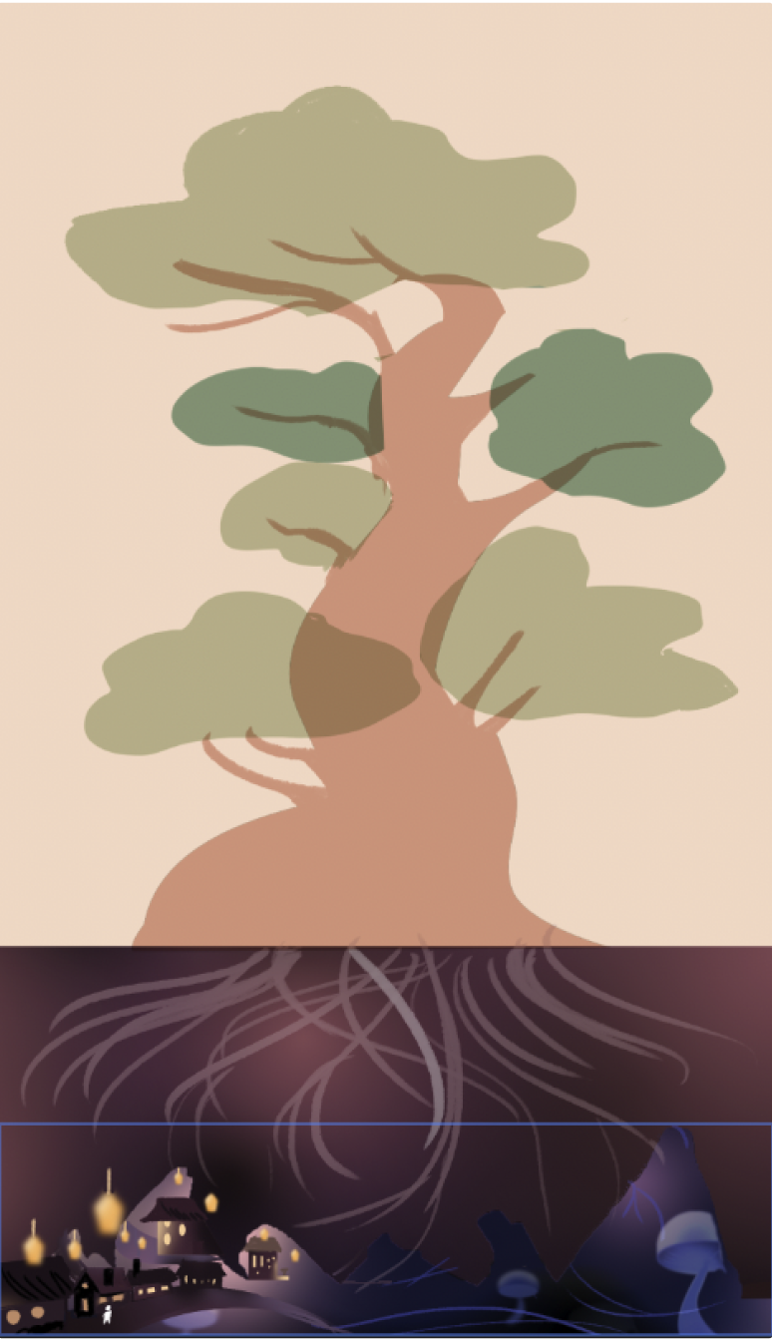

Environment
Section | Palette | Look and feel | Platforms
1: Roots | Dark tones, deep shadow | Mossy forest floor at the base of the tree, lots of glowing particle effects in the style of Princess Mononoke | Bright glowing mushroom caps that stand out clearly
2: Mid-tree | Reds, browns, greens | The wild, untamed middle of the tree, with vines and branches | Branches and vine ladders
3: Neighborhood | Whites, light blues, purples | Ornate and regal. Crisp lines, carefully maintained by the spirits who live there | Platforms and hedge walls

Lighting and particle reference

First section visual reference:
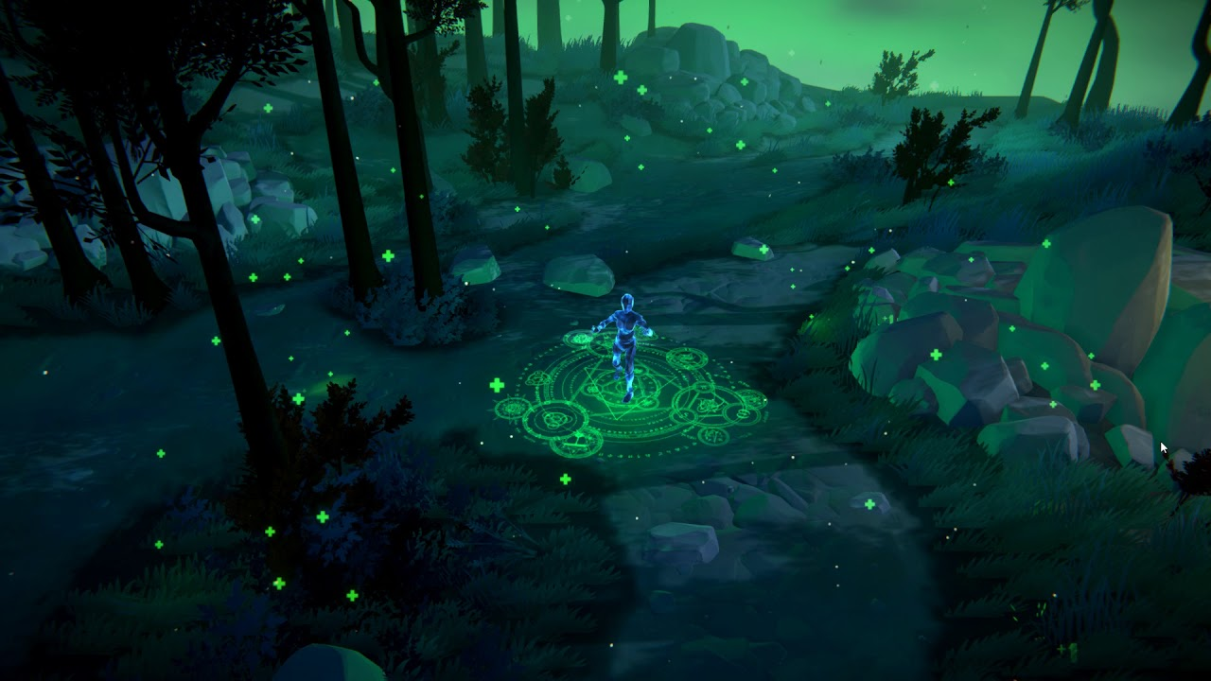
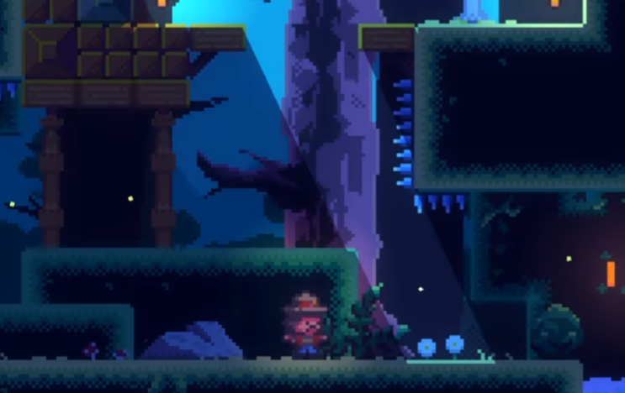

Second section visual reference:
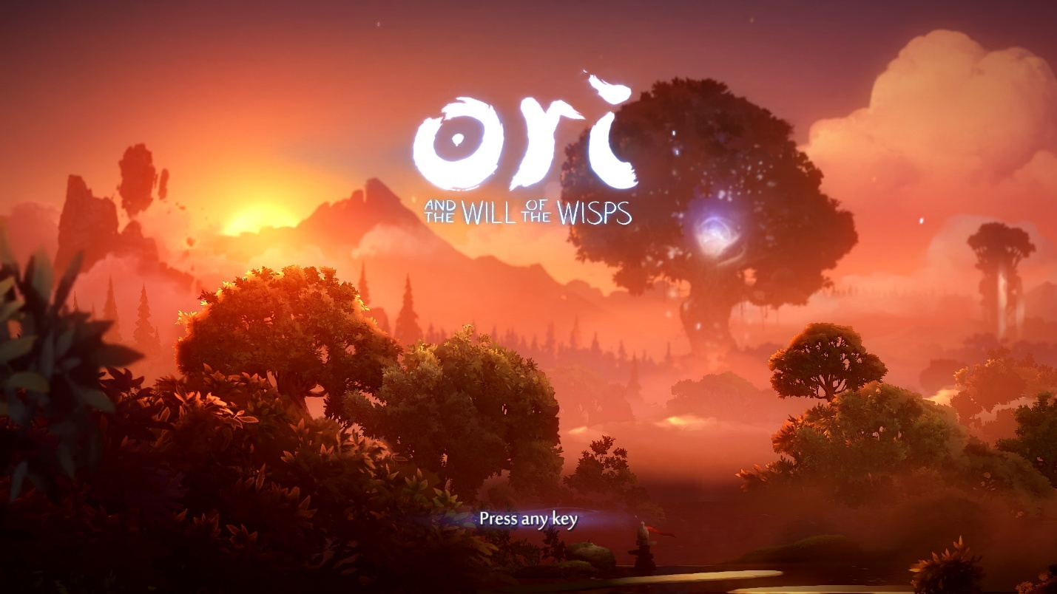

Third section visual reference:
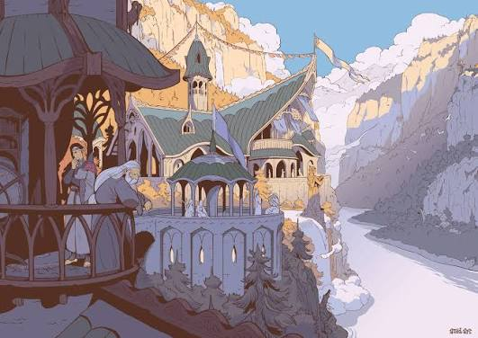

Canopy Progression
The canopy at the top of the tree changes across ascents, from bare and wintry to full spring bloom by the final ascent, reflecting the Guardian’s state and the tree’s recovery.

Falling Cutscene
After each failed ascent, a short cutscene plays of Lua drifting softly down through the air, eyes closed. The tone is somber and serene reflecting that she has not yet reached her goal. The screen fades to black, a soft landing in a pile of leaves is heard over the black, and the scene fades back in at the start of Section 1.

Characters
Lots of distinct spirit designs based on plants as well as classical looking fairies (Tinker Bell, etc.). Lua (the player) needs walk, climb, idle, fall, and hoist animations. NPCs need an idle loop (static poses as the scope fallback.)

Narrative

Themes
Core themes:
- Friendship
- Community
- Tension between the top and bottom dwellers
Supporting themes (side stories): conflict resolution, recognizing and celebrating differences, the joy of helping others.

Lore
The Great Tree is the oldest tree in this mystical forest. Every tree in the forest is nourished by the spirits that live on it and reflects the emotional state and well-being of its ecosystem.
Every spirit born on the tree is considered important and contributes to servicing the tree on which they live. Everyone must work together to keep life harmonious. Regardless, occasionally “class divisions” and tensions flare up between the rootbound colonies at the bottom of the tree and the sophisticated faerie colonies at the top of the tree.
The tree chooses a Spirit Guardian to protect it and its community. The Guardian carries special importance, sworn to watch over the tree until death.
Of the Great Tree’s many traditions, none is more important than the Spring Festival. It celebrates renewal and, when the time comes, welcomes a newly appointed Guardian. A new Guardian must pass many trials to prove they are worthy. The last is brewing sacred tea in a ceremony.
The tree’s newest Guardian is failing this final trial, and without realizing it, their mood is affecting the tree and everyone who lives on it. The choice of the new Guardian has also caused tension among the colonies.

Characters

Lua (Player Character)
- Race: Rootbound, from one of the colonies at the base of the tree
- Attitude: Silent protagonist
- Conflict: She wants to help her best friend become the Guardian, but her friend doesn’t want her help.

Clover (The Spirit Guardian)
- Race: Royal Faerie, from the Faerie Spirit colony at the top of the tree
- Keywords: Dutiful, precocious, insecure
- Biography: Lua’s best friend. They come from a line of Spirit Guardians and have known since birth that the role would be theirs. Now that the time has come, they’ve isolated themselves at the top of the tree to focus on the final trial, shutting out anyone who might disrupt it. Lua must lift their spirits and show them what being a Guardian truly means.
- Conflict: They want to complete the ceremony but don’t understand why it isn’t working. They want to be a great Guardian but haven’t yet grasped what the role really means.

Shrooman
- Race: Rootbound mushroom spirit
- Keywords: Homebody, cautious, somewhat grumpy
- Biography: A long-time inhabitant of the bottom of the tree. He, like other rootbound spirits, is distrustful of the spirits higher up in the tree, and nervous about the idea of Lua attempting to climb.
- Conflict: He is not completely convinced that Clover was the right choice to be the next guardian. However, as Lua progresses and talks to him more, he warms up to the idea and ultimately provides his support to Lua and Clover
- Narrative Usage: A primary purpose of Shrooman’s dialogue will be to expand upon Lua’s character and background.

Fauna
- Race: Flower spirit
- Keywords: Bratty, jealous, self-conscious
- Biography: An inhabitant of the mid-tree. Fauna is said to have the most beautiful petals of any flower spirit. She is also a friend of Clover’s but is clearly upset that Lua is closer to Clover than she is.
- Conflict: At first, she is rude to Lua out of jealousy but opens up to her as she accepts that Lua is doing everything she can to aid Clover. She eventually supports Lua herself.
- Narrative Usage: A primary purpose of Fauna’s dialogue will be to expand upon Clover’s character and background.

Bumblebark
- Race: Gnome spirit
- Keywords: Wise, accepting, intelligent
- Biography: A long-time inhabitant of the top of the tree. Bumblebark is deeply knowledgeable about the tree’s history. Unlike some treetop spirits, Bumblebark does not look down on Rootbound spirits, and while he is surprised that Lua made it to the top, he is welcoming from the start.
- Conflict: Nostalgic for an earlier time in the tree’s history, if that can be considered conflict. His personality does not change much as the story progresses.
- Narrative Usage: A primary purpose of Bumblebark’s dialogue will be to expand upon the worldbuilding and history of the Great Tree.

Funguy
- Race: Rootbound mushroom spirit
- Keywords: Wild, excitable, bro-y
- Biography: Funguy is introduced at the start of the second ascent. After seeing Lua attempt to climb the tree, he is inspired to do the same. He is encountered again midway through the third ascent as he progresses on his own ascent.
- Conflict: After being stuck at the bottom of the tree with the other Rootbound spirits his whole life he is called to adventure by Lua’s ascent, stepping out of his comfort zone to ascend the tree himself.
- Narrative Usage: Funguy is primarily a comedic relief/gag character.

Spirit Colonies (NPCs)
Spirit colonies have settled in different parts of the Great Tree. Each takes pride in its heritage and the skills it contributes, and each takes on the form of its community:
Colony | Location on tree | Role in the tree | Personality
Mushroom/Rootbound | Roots | The “least advanced” colony of spirits. They nurture and protect the base of the tree and mostly stick to themselves. | Simple, non-adventurous (Hobbits in the Shire)
Flower/Petal | Mid-tree | Living in the middle of the tree, they often try to associate themselves more with society at the top of the tree. They maintain the tree’s majestic image. | Proud and refined, yet fragile, image/beauty obsessed
Gnomes/Faerie | Top/Canopy | The most advanced, humanoid spirits. They oversee the tree’s health and maintain a high-class society. | Bourgois, sophisticated, a little self-important

Sounds / Music

Style
Damp, mossy, spirit-forest ambience — think the forest areas of The Legend of Zelda series.

Sound Effects
- Climbing
- Soft footsteps
- Fall and landing
- Wind rush (second fall)
- Forest ambience loop
- Leaf-pile landing (fall cutscene)

Adaptive Music System
The score is one song built from layered melodies, with one melody per section. Each melody starts after the player speaks with that section’s NPC and reflects that NPC’s personality. For example, the Mushroom spirit’s melody is whimsical, bouncy, and playful.
On the final ascent, the melodies no longer stop at the end of each section. Instead, they stack as the player climbs, so every layer is playing by the time they reach the top. This symbolizes the tree’s inhabitants coming together to help the Guardian brew the tea.

