Chapter | #
DATA DRIVEN DESIGN OPTIMIZATION METHODOLOGY

D. KNIGHTª, H. ZHAO^{b}, T. ICOZ^{c}, Y. JALURIA^{d}
^{a,b,c,d}Rutgers University, MAE Dept., Piscataway, NJ, 08854, USA
Abstract. Engineering design optimization using concurrent integrated experiment and simulation is a Dynamic Data Driven Application Systems (DDDAS) approach wherein remote experiment and simulation can be synergistically utilized in real-time to achieve better designs in less time than conventional methods. The Data Driven Design Optimization Methodology (DDDOM) being developed for engineering design is described in this paper as well as a software system that is being developed to realize DDDOM together with applications. A nozzle problem is being used to demonstrate the concept of DDDOM and an application of DDDOM is illustrated in this paper.
Keywords. Dynamic Data Driven Application Systems (DDDAS), Data Driven Design Optimization Methodology (DDDOM)

INTRODUCTION

The concept of Dynamic Data Driven Application Systems (DDDAS) [1] entails an application system capable of accepting and effectively utilizing data in real time (i.e., during the execution of the application software). In this paper the DDDAS concept is applied to engineering design optimization. Many software systems currently utilize static input data, i.e., input data that are specified a priori. The key concept of DDDAS, as applied here, is the generalization of application software systems to dynamically utilize real-time data arising from remote experiment and simulation, and to control such remote experiment and simulation to improve the performance of the application software system. The basic concept of the present study, illustrated schematically in Fig. 1 and described in detail in Section 4, is to dynamically integrate experiment and simulation (e.g., using the NSF TeraGrid) to achieve better engineering designs in a shorter time. In this manner, the engineering design process is dynamically driven by both experiment and simulation in a concurrent manner.
In the following sections, we describe the general engineering design optimization problem, the conventional approach and our Dynamic Data Driven Application Systems to such optimizations, a demonstration example and a preliminary realistic application.
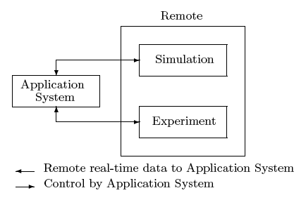
Figure 1. Use of remote experiment and simulation in application software

Design Optimization

The general engineering design optimization problem is defined as
min f_{j}(x) for j = 1, m (1)
subject to
d_{k} ≤ 0 for k = 1, l (2)
where
f = (f₁, … , f_{m})^{T} (3)
is the vector of objective functions and
d = (d₁, … , d_{l})^{T} (4)
is the vector of constraints and
x = (x₁, … , x_{n})^{T} (5)
is the vector of design variables. The solution to the general engineering design problem is the set of non-dominated designs known as the Pareto Set [2]. Within this set of designs, improvement in one design criterion f_{j} can only be achieved at the expense of the degradation in the performance of one or more design criteria.

Conventional engineering design optimization

Engineering design can derive great benefit from the Dynamic Data Driven Application Systems concept. Remote real-time input from high performance computing resources (e.g., NSF Teragrid) and experiment (e.g., using capability for rapid fabrication of new experimental configurations) can produce a better design in shorter time with lower cost than the conventional approach. Fig. 2 illustrates the conventional approach to engineering design. An initial design is typically evaluated using simulation software executing on local computer resources. An example is Computational Fluid Dynamics (CFD) simulation using one of the several available commercial CFD software packages (e.g., FLUENT [3], GASP [4], STAR-CD [5]). The results of the simulation are reviewed by the designer and additional simulations performed as needed. An experiment is then planned and executed, and the results compared with the simulation. The process is iterated until a satisfactory design has been achieved. A major limitation of the conventional approach is the absence of synergistic real-time use of remote experimental data and high performance computer resources (e.g., the NSF TeraGrid).
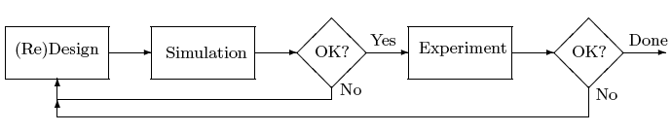Figure 2. Conventional approach to engineering design

Data driven design optimization methodology

We are developing an integrated software system, denoted Data Driven Design Optimization Methodology (DDDOM), to synergistically incorporate remote experiment and simulation into an automated design optimization methodology, as illustrated in Fig. 3.
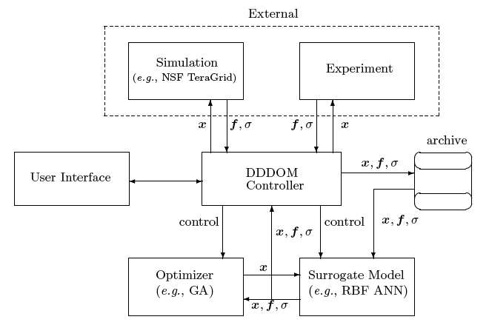
Figure 3. Data Driven Design Optimization Methodology (DDDOM)

Assumptions

The DDDOM pursued in the work presented herein is based on the fol-lowing assumptions:
Concurrency: Experiment and simulation occur simultaneously or near-simultaneously. For simplicity, we assume that constant computational resources (i.e., the number of processors) and experimental resources (i.e., a wind tunnel) are concurrently available. This assumption can, of course, be relaxed.
Simulation Independence: It is assumed that the computational resource required for a simulation is independent of whether the geometric or non-geometric variables are changed. This differs from experiment wherein a change in the geometry typically requires fabrication and instrumentation of a new model.
Estimation of Uncertainty: It is assumed that there is an estimated uncertainty for each objective function f_{j} obtained through either experiment or simulation.

Overview

The DDDOM Methodology is comprised of six elements, as illustrated in Fig. 3, and are summarized below.
Optimizer: A design optimization algorithm is utilized to search the design space to determine the optimal design (or designs [Pareto Set] for multi-criteria design optimization). Both local (i.e., gradient-based) and global (i.e., stochastic-based) algorithms can be used. Examples are CFSQP [6] and GADO [7], respectively.
Surrogate Model: Surrogate Models (SMs) of the objective functions f_{j} are developed during the design optimization using experiment and simulation. These models are used by the optimizer to search for the optimal design(s). Examples of Surrogate Models are Response Surface Methods (RSMs) [8] and Artificial Neural Networks (ANNs) [9].
Simulation: The simulation module represents the software code utilized to estimate the objective functions f_{j} for a given design. The simulation module also provides an estimate of the uncertainty in the prediction of the f_{j} by comparison of selected designs with experiment or previous simulations of known accuracy.
Experiment: The experiment module represents the experiments which are performed simultaneously or near-simultaneously with the simulations. The experiment module also provides an estimate of the uncertainty in the measurement of the f_{j}.
DDDOM Controller: The DDDOM Controller provides direction and control of the design optimization process. Its principle functions are the initiation and monitoring of the simulation and experiment, and selection of the designs for evaluation by experiment and simulation. It is the central element of the DDDOM. The DDDOM Controller is written in Perl [10].
User Interface: The user interface provides for the user to access the DDDOM. It initiates both experiments and simulations, monitors them and controls the optimization process.

Programming Language

The DDDOM Controller is the core part of the DDDOM. It controls the overall operations of the DDDOM cycle. Its basic function is to initiate and monitor the design optimization, and to direct the simulations and experiments needed to build and update the surrogate models. The DDDOM Controller must deal with executable codes, link different files and directories, and connect to databases. The user interface is the access to the DDDOM Controller and must be closely combined with the DDDOM Controller. It should be user-friendly, block-structured and well documented. Based on these functions, the programming language should be chosen carefully to accomplish all these requirements. The programming language selected here is Perl and Perl/Tk [11][12].

dEVELOPMENT OF dddom software system

Enabling DDDAS capabilities requires software support to enable dynamic streaming of data into executing simulation and dynamic invocation of models. The DDDOM software system, mainly the user interface, DDDOM Controller and a preliminary application, are developed as part of the work presented herein. The simulation code, the optimizer, the Surrogate Model and the experiments are incorporated into the DDDOM Controller. The User Interface built for the DDDOM Controller provides easy access to all these elements. An objective of the User Interface is to minimize the effort required to deal with the simulation codes. There are input panels for both the simulation code and the optimization software to set up the parameters. There are also buttons to control the launch of each simulation code and the optimization software.

A CONCEPTUAL EXAMPLE

A demonstration of five minutes duration has been developed to illustrate the concept and principle of operation of the DDDOM. The limited duration of the demonstration precludes the actual use of Rapid Prototyping, which typically requires several hours for fabrication of the prototype for experiments. Therefore, to illustrate the capabilities developed here, we have selected a single experimental configuration. Nonetheless, the experiment provides data to the DDDOM Controller in real time, and the Controller directs the experiment, thereby illustrating the DDDOM concept.
The specific problem is defined as follows. Consider the flow of air in a converging-diverging nozzle attached to a stagnation chamber as illustrated in Fig. 4. The nozzle is designed on the basis of one-dimensional inviscid gas dynamics to achieve Mach 2 at the exit assuming isentropic expansion throughout the nozzle.

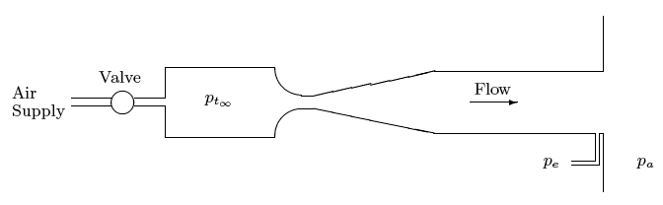
Figure 4. Experimental configuration of nozzle

Depending upon the ratio of the stagnation pressure p_{t∞} to ambient pressure p_{a}, the flow in the diverging section of the nozzle can be 1) subsonic everywhere, 2) supersonic and subsonic with a normal shock at some location in the diverging section, and 3) supersonic everywhere [13]. In the latter case, the theoretical exit Mach number is two. A one-dimensional simulation based upon inviscid gas dynamics [14] indicates that the exit pressure ratio p_{e} vs stagnation pressure p_{t∞} behaves as shown by the curve denoted Simulation in Fig. 5. This behavior is idealized, however, due to the neglect of the viscous boundary layer on the nozzle walls and the effect of the interaction of the normal shock wave (if it exists) with the boundary layers. Consequently, the actual exit pressure p_{e} vs. stagnation pressure p_{t∞} curve differs substantially from the idealized shape.
The objective of the optimization is to determine the stagnation pressure p_{t∞} that yields the minimum exit pressure p_{e} for a fixed ambient pressure p_{a}. Although this is a single design objective problem, it illustrates the funda-mental concepts of DDDOM. Due to the physical assumptions inherent in the simulation code, the p_{e} vs. p_{t∞} function obtained from the simulation can be significantly in error. This is an intentional choice to force the DDDOM Controller to build and refine the Surrogate Model utilizing both simulation and dynamic incorporation of experimental data to determine the optimum value of p_{t∞} (i.e., the value of p_{t∞} that yields the minimum value of p_{e}). The dynamic updating of the Surrogate Model using real time experimental data is an implementation of the Dynamic Data Driven Application Systems idea.

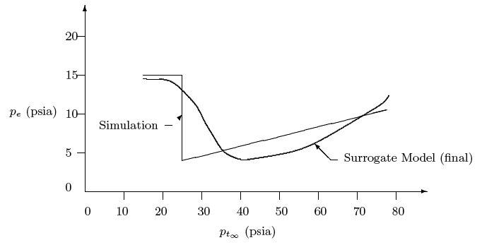
Figure 5. Exit pressure p_{e} vs. stagnation pressure p_{t∞}
The experiment is located at Rutgers University and controlled by a workstation. The DDDOM is executed on a separate workstation and communicates via high speed Ethernet. A National Instrument LabView Virtual Instrument (VI) program [15] executes on a workstation adjacent to the experiment. The VI continually monitors an input file on the workstation, which contains a specified value of stagnation pressure p_{t∞} and adjusts the stagnation pressure by means of a servo-controlled valve to the specified value. The VI thereafter writes the measured values of the stagnation pressure p_{t∞}’ (which differs from the specified p_{t∞} due to “play” in the valve) and exit pressure p_{e}’ on a file on the workstation. The DDDOM Controller manages the optimization problem by the following sequence:
- The Surrogate Model is initialized using the one-dimensional inviscid simulation code.
- The optimizer (a Genetic Algorithm) determines the minimum of the p_{t∞} vs p_{e} curve using the current Surrogate Model.
- A value of p_{t∞} is chosen for the experiment. In the early stages of the optimization, the value determined in step no. 2 is chosen with a probability of 0.5; otherwise, a random value is chosen within the overall range of experimentally possible values of p_{t∞} (i.e., 15 psi to 60 psi). This procedure avoids premature convergence to an exit pressure that is not the actual minimum.
- A file is transferred to the workstation containing an identification number and the prescribed value of p_{t∞}.
- The VI on the workstation reads the file, changes the experimental total pressure to the specified value within experimental tolerance, and writes the identification number, the actual experimental total pressure p_{t∞}’ and exit pressure p_{e}’ to the file.
- The DDDOM Controller accesses the file and reads the experimental values of p_{t∞}’ and p_{e}’. The Surrogate Model database is updated with this data and the nearest value to p_{t∞}’ in the database, which was generated by the simulation code, is removed. This step is the implementation of the Dynamic Data Driven Application Systems concept where the model is updated in real-time using experimental data.
- The convergence of the Surrogate Model is checked. If it is not converged, the procedure is repeated beginning at step no. 2.
The demonstration requires approximately five minutes. The initial and final Surrogate Models are shown in Fig. 5. The real-time updating of the Surrogate Model and the convergence to the design objective (i.e., determining the value of p_{t∞} that minimizes p_{e}) is an implementation of the Dynamic Data Driven Application Systems idea.

application: Optimal design of cooling system

Using the developed DDDOM software, we investigated the optimal design of cooling system for electronic components.

Problem Description

Thermal management in cooling of electronic equipment is the main technical problem in obtaining faster, smaller and more reliable electronic systems. The need to attain efficient and effective heat dissipation at the chip level has increased dramatically over the last few years due to improvements in microprocessor technology. A full understanding of the fluid flow and heat transfer characteristics becomes crucial for developing future electronic systems [16].
As a case study we considered two-dimensional mixed convection heat transfer over two isothermal protruding heating elements which simulate electronic components, located at the bottom surface of a horizontal channel. The schematic representation of the system is illustrated in Fig. 6. Air is the coolant fluid. The bottom plate is insulated and the top plate is kept at the ambient temperature of the incoming airflow. Each heat source has the fixed temperature T_{h}. The flow conditions are defined by the mean Reynolds number (Re),
Re = u_{m}h/ν (6)
the Grashof number (Gr)
Gr = gβH³(T_{h} —T_{amb})/ν² (7)
and the Prandtl number (Pr). Depending on the values of Re and Gr, the flow may be laminar, transitional or turbulent.
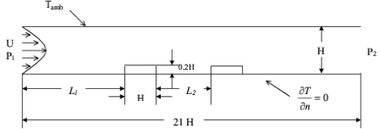
Figure 6. Schematic of two-dimensional channel with two heat sources
The optimization problem is to find the optimum heat source locations for fixed Re and Gr numbers such that the pressure drop ΔP = P₁ – P₂ will be minimized, which leads to minimum fan power and cost. For the present, Gr and Re numbers are fixed at 5000 and 600 respectively. The design variables are L₁ and L₂, shown in Fig. 6. The geometric parameters of the two heat sources are fixed with height = 0.2H and width = H.
Depending on the value of the Reynolds number Re and Grashof number Gr, the flow may be laminar, transitional or turbulent. The Surrogate Model can be initially defined using the simulation code for laminar, transitional and turbulent flow conditions. However, the simulation code (like other CFD codes of this type) has limited accuracy for transitional and turbulent flow conditions, and its error is not known a priori. Thus, the Surrogate Model must be revised and updated using experiment for transitional and turbulent flow conditions. This is the implementation of the Dynamic Data Driven Applications Systems concept for this problem.
The need to integrate experiment and simulation in the design optimization in a concurrent manner makes this an excellent candidate for the DDDOM methodology. The dynamic interaction of experiment and simulation is its principal feature as a Dynamic Data Driven Application System. In this paper, we present the design optimization for conditions of laminar flow, and only the simulation is incorporated into the DDDOM. Future work (see Section 8) will incorporate the experiment and simulation into the DDDOM.
The simulations were performed using a numerical code developed earlier [17] for laminar flow over flush mounted heat source and subsequently modified for protruding heat sources. The numerical code uses the finite volume method (FVM) to solve the mass, momentum and energy equations using primitive variables. The governing partial differential equations are solved by the Alternating Direction Implicit (ADI) method. The pressure field is calculated with an approach similar to the SIMPLER [18] algorithm. A non-uniform, staggered grid system, having 201x31 grid points, is used for the computations.
In order to ensure proper operation of the flow simulation code, the following constraints for the heat source locations are set for the optimization.
L₁ ≥ 3H (8)
L₂ ≥ 0.5H (9)
L₁ + L₂ < 14H (10)
The first constraint (8) allows the use of a fixed inflow boundary condition of fully developed laminar flow. The second constraint (9) insures that there is sufficient grid resolution within the gap between the first and second heat sources for the fixed number of grid points used in the simulations. The third constraint (10) insures that the combined length of the two heat sources does not interfere with the zero-gradient downstream boundary condition.

Grid Refinement Study

We performed a grid refinement study for one case before performing the optimization in order to establish the accuracy of the simulations. Table 1 shows the results of the grid refinement where ΔP is non-dimensionalized by ρu_{m}² and u_{m} is the average velocity of the incoming flow. From the results, the accuracy of the predicted pressure drop is approximately 2%.
Table 1. Results of Grid Refinement
Gridx | Gridy | ΔP/ρ u_{m}²
201 | 31 | 0.557
403 | 63 | 0.565

Optimization with CFSQP and Simulation Code

In this optimization loop, the optimization software used is CFSQP (C code for Feasible Sequential Quadratic Programming). CFSQP represents the state-of-the-art of gradient-based optimization software. It is a set of C functions for the minimization of the maximum of a set of smooth objective functions (possibly a single one) subject to non-linear equality and inequality constraints, linear equality and inequality constraints, and simple bounds on the variables. In addition, CFSQP contains special provisions for efficiently handling problems with many sequentially related objective/constraints, and greatly reducing computational effort. The user has the option to choose either a monotone line search algorithm, which requires that the objective function decreases at each iteration, or choose a non-monotone line search, which requires a decrease of the objective function within at most four iterations. The user must provide functions to compute the respective gradients or require that CFSQP estimates them by forward finite difference method. In our optimization, the non-monotone line search is chosen and the forward finite difference method is used to calculate the gradients.
In order to accurately estimate the gradients, the perturbation size Δx in the design variables L₁ and L₂ must be greater than the grid spacing used in the calculation. We ran the code to see how the perturbation size Δx in L₁ and L₂ influences the pressure drop ΔP. On the basis of this study, the perturbation size is chosen to be fifteen times the streamwise grid spacing.
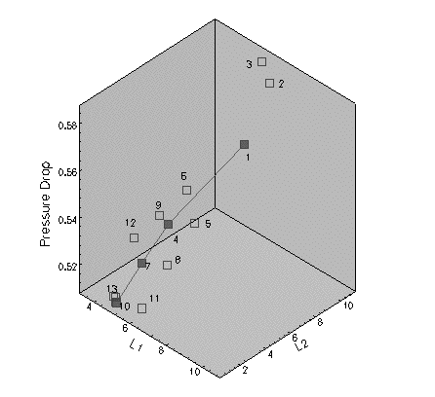
Figure 7. History of optimization, ΔP/ρu_{m}² vs. L₁, L₂
After determining these conditions, we performed the optimization. The optimization history is shown in Fig. 7. In the figure, the line with the filled square points shows the search history. The blank square points are those used to calculate the gradient of the objective function. The best locations obtained are L₁ = 5.18H and L₂ = 0.5H, marked by “10”. We also choose two other cases (“1” and “4”). The locations of the three cases are shown in Table 2. The corresponding streamlines are shown in Figs. 8, 9 and 10, respectively. The minimum pressure drop is achieved when the two heat sources are placed as close together as permitted by the constrait L₂ ≥ 0.5H.
Table 2. Three Cases of Heat Source Location and Corresponding Pressure Drop
Case | L₁/H | L₂/H | ΔP/ρu_{m}²
1 | 9.30 | 4.7 | 0.585
4 | 6.77 | 2.36 | 0.547
10 (optimum) | 5.18 | 0.50 | 0.513

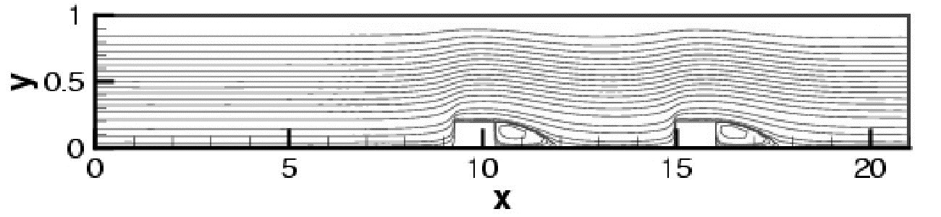
Figure 8. Streamlines for case 1
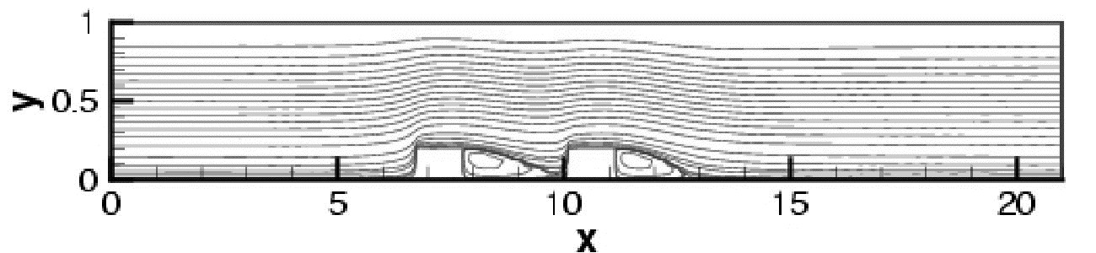
Figure 9. Streamlines for case 2
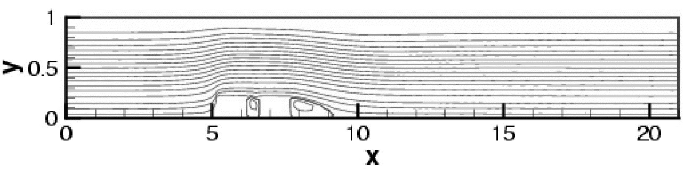
Figure 10. Streamlines for case 3

Optimization within DDDOM

In this optimization loop, we employ our DDDOM software in the test problem. The loop is shown in Fig. 11. It consists of the User Interface, DDDOM controller, Experiment Design module, simulation code, computer resources, Surrogate Model and optimizer (GADO). Parameters are set through the User Interface. Then the DDDOM controller sends these parameters to different modules and controls their execution. In the Experiment Design module, we select sampling points in the design space. A sphere packing method is used to generate the sampling points to achieve a “maximin” design “in which the minimum distance between any two design points is maximized” [19]. Gosset [20], “a general purpose program for constructing experimental designs”, is used to generate the packing points. A total of 25 points are generated to pack the whole design space. Next, the simulation code is called to perform calculations at these points. With the aid of computer resources, the calculations at those 25 points are done in parallel. Those 25 points are provided to the Surrogate Model as observations. The Response Surface Methodology (RSM) is chosen as the Surrogate Model. A second order RSM is employed. After the RSM is trained, the optimizer calls the RSM to perform the optimization. The optimization software is “GADO”, which is a genetic algorithm for continuous design optimization. For the test problem, the results are shown in Table 3. The response surface obtained together with the 25 sampling points is shown in Fig. 12.
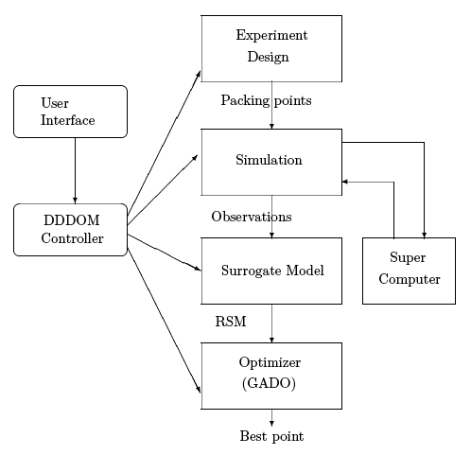
Figure 11. Optimization Loop
Table 3. Results from optimization within DDDOM
Correlation coefficient, RR | 0.9490
Adjusted correlation coefficient RR_{a} | 0.9356
Best point | L₁ = 5.48H, L₂ = 0.5H, ΔP/ρu_{m}²= 0.519

Results obtained from the two optimization loops are comparable. Since the function surface has a small variation in the variable L₁ in the vicinity of the optimal point, the difference between these two best points is not significant.
The optimization using the DDDOM with the Surrogate Model (i.e., the RSM) has two major advantages over the optimization using the gradient-based optimizer alone (i.e., without the DDDOM and its Surrogate Model). First, the RSM datapoints (generated by the simulation code) are obtained simultaneously (i.e., in parallel), thereby reducing the calendar time required for creation of this information. In the first loop, the datapoints used for the optimization have to be calculated sequentially by the simulation code. Second, the RSM can directly incorporate experimental data (as performed in the conceptual example in Section 6), thereby enabling the full DDDOM paradigm of concurrent integrated experiment and simulation in design optimization. The incorporation of experimental data into the DDDOM for this application is in progress.

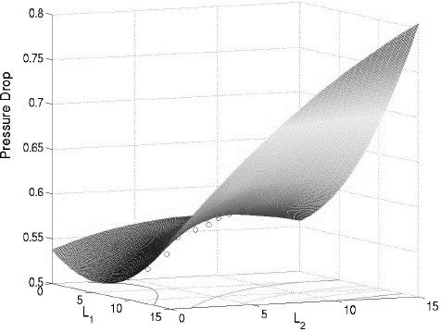

Figure 12. Response surface

FUTURE WORK

In the future, we will continue to enhance the DDDOM software system to use the Dynamic Data Driven Application Systems concept more effectively. Our next step will be the incorporation of experimental data into the DDDOM Surrogate model for the problem of optimal design of the cooling of electronic components (Fig. 6). This will enable us to perform optimization studies at a higher Reynolds number where the flow is transitional or turbulent and simulation codes have limited accuracy. In this manner, a more effective design will be achieved over a broader range of design conditions (e.g., higher Reynolds number and Grashof number). Also, other simulation codes (e.g., GASP and Fluent), grid generation codes (e.g., Gridpro [21]) and CAD codes (e.g., Pro/Engineer [22]) will be incorporated into the DDDOM. This will enable a more extensive range of engineering design problems to be solved using the DDDOM. Finally, we will incorporate Multicriteria Design Optimization (MDO) into the DDDOM to extend its breadth of applicability. Later, we will investigate two other applications: optimal design of a subsonic submerged inlet and a lumbar vertebral spinal structure.

CONCLUSION

Data Driven Design Optimization Methodology (DDDOM) is an example of a Dynamic Data Driven Application System (DDDAS) that combines optimization, simulation and experiment dynamically to yield the desirable design more efficiently and faster than the traditional sequential design loop. The concurrent integration of experiment and simulation in design optimization is a dynamic, data driven process that achieves more effective designs in a shorter time. In the present paper, a nozzle problem is presented as a demonstration of the concept of the DDDOM as a DDDAS. In addition, the application of DDDOM to the optimal design of a cooling of electronic components problem is presented. Results are shown for the optimization under laminar flow conditions using simulation to define the performance of the design. Current work is focused on extending the operational regime to transitional and turbulent flow wherein experiment is needed, in addition to simulation, to achieve an optimal design, and thus illustrate the advantage of the DDDOM as a Dynamic Data Driven Application System.

Acknowledgments

This research is supported by the National Science Foundation under Grant No. NSF-CTS-0121058 monitored by Drs. Frederica Darema, C. F. Chen and Michael Plesniak.

REFERENCES

1. http://www.cise.nsf.gov/eia/dddas
2. K. Deb. (2001). Multi-Objective Optimization Using Evolutionary Algorithms. John Wiley & Sons, New York.
3. Fluent Inc. (2003). Centerra Resource Park, 10 Cavendish Court, Lebanon, NH. http://www.fluent.com
4. Aerosoft Inc. (1996). General Aerodynamic Simulation Program User Manual.
5. http://www.cd-adapco.com
6. C. Lawrence, J. Zhou, & J. Tits. (1994). User's Guide for CFSQP Version 2.1. Univ of Maryland, Electrical Engineering Dept & Institute for Systems Research.
7. K. Rasheed. (1998). GADO: A Genetic Algorithm for Continuous Design Optimization. Technical Report DCS-TR-352. Department of Computer Science, Rutgers University, New Brunswick, NJ.
8. H. R. Myers, D. C. Montgomery. (2002). Response Surface Methodology. John Wiley & Sons, Inc, New York.
9. J. Hertz, A. Krogh, & R. Palmer. (1991). Introduction to the Theory of Neural Computation. Lecture Notes Vol~I, Santa Fe Institute Studies in the Sciences of Complexity. Perseus Publishing Cambridge, MA.
10. L. Wall, T. Christiansen, & J. Orwant. (2000). Programming Perl. O'Reilly and Associates, Sebastopol, CA.
11. T. Christiansen, N. Torkington. (1998). Perl Cookbook. O'Reilly and Associates, Sebastopol, CA.
12. S. Lidie, N. Walsh. (2002). Mastering Perl/Tk. O'Reilly and Associates, Sebastopol, CA.
13. Anderson, J. Modern Compressible Flow with Historical Perspective. McGraw Hill (2003), New York.
14. H. Liepmann, A. Roshko. (1957). Elements of Gas Dynamics. John Wiley & Sons, New York.
15. J. Travis. (2002). LabVIEW for Everyone. Prentice Hall , Upper Saddle River, NJ.
16. F. P. Incropera. (1988). Convection Heat Transfer in Electronic Equipment Cooling. Journal of Heat Transfer, Vol. 110, pp. 1097-1111.
17. Q. Wang. (2002). Instability and Heat Transfer in Mixed Convection Flow in a Horizontal Duct with Application to Cooling of Electronic Systems. Ph.D. Thesis. Rutgers - The State University of New Jersey, Mechanical and Aerospace Engineering Department, Piscataway, NJ.
18. S. V. Patankar. Numerical Heat Transfer and Fluid Flow. Hemisphere, New York, pp. 126-134.
19. F. A. Hamprecht, T. Walter, & G. van Wilfred. (2002). Chemical Library Subset Selection Algorithms: a Unified Derivation Using Spatial Statistics. J. Chem. Inf. Comput. Sci. 2002, 42, pp. 414-428
20. N. J. Sloane, R. H. Hardin. (2003). Gosset: a General-purpose Program for Designing Experiments. http://www.research.att.com/~njas/gosset/
21. Program Development Corporation. (1998). GridPro/az3000 User's Guide and Reference Manual. White Plain, New York
22. Parametric Technology Corporation. (1996). Pro/Engineer User's Guide.

