Employee Resignation Prediction
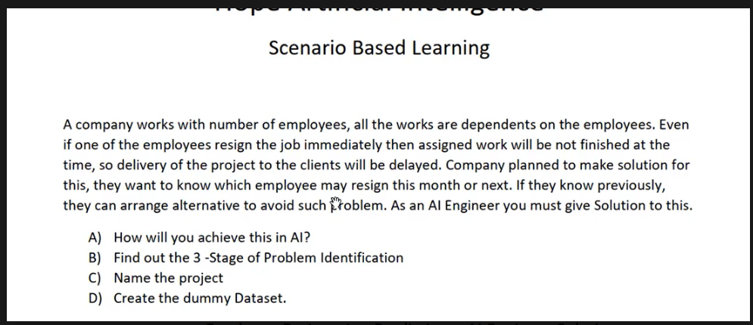

1. What is the problem?
The company depends on employees to complete projects. If an employee resigns suddenly, assigned work may be delayed and project delivery may be affected.
The company therefore wants an early warning: which employees may have a higher likelihood of voluntary resignation during a defined future period, such as the next 30, 60 or 90 days?
Simple meaning
We are not trying to know the future with certainty. We use historical data to estimate risk early enough for appropriate workforce planning.

2. What does the AI need to learn?
We need historical employee records where we know what happened later.
Employee | Overtime | Satisfaction | Hike % | Resigned?
E001 | 10 hrs | 8/10 | 10% | No
E002 | 40 hrs | 3/10 | 3% | Yes
E003 | 15 hrs | 8/10 | 8% | No
E004 | 45 hrs | 2/10 | 2% | Yes

The AI looks at many historical examples and learns patterns associated with the known outcome. The small table is only a dummy teaching example.

3. What type of AI problem is this?
Question | Answer
Do we have historical examples? | Yes
Do we know the historical outcome? | Yes – resigned / did not resign
Is the expected output a category? | Yes
Learning type | Supervised Learning
ML problem type | Classification
Classification type | Binary Classification (Yes / No)

Important
This is NOT Regression. Regression predicts a numerical value such as salary or price. This scenario predicts a category: Yes or No.

4. 3-stage problem identification
Stage | What we ask | Answer
Stage 1 – Domain Selection | What AI/ML domain fits? | Machine Learning
Stage 2 – Learning Type | Do we have historical inputs and known answers? | Supervised Learning
Stage 3 – Problem Type | What output are we predicting? | Classification

Final: Machine Learning → Supervised Learning → Classification

5. What are Features (X)?
Features are employee information given to the model to help it make a prediction. They are also called input variables or independent variables.
Feature | Example | Purpose
Tenure | 4.5 years | Length of service
Overtime | 35 hours/month | Workload indicator
Satisfaction | 4/10 | Reported engagement
Salary hike | 3% | Recent pay change
Months since promotion | 48 | Promotion gap
Project tenure | 30 months | Time on current project

Remember
X = the information we give the model. Not every available HR field should automatically be used; features need privacy, legal and fairness review.

6. What is the Target (y)?
The target is the answer we want the model to predict.
Target | Meaning
Resigned_90_Days = 0 | Did not voluntarily resign within the defined 90-day window
Resigned_90_Days = 1 | Did voluntarily resign within the defined 90-day window

X = Employee features | y = Resigned_90_Days

7. Dummy Dataset
Emp_ID | Tenure | Project Months | Overtime Hrs | Hike % | Satisfaction | Workload | Resigned_90_Days
E001 | 2.5 | 8 | 12 | 10 | 8 | 5 | 0
E002 | 7.0 | 36 | 40 | 3 | 3 | 9 | 1
E003 | 4.0 | 20 | 15 | 8 | 7 | 6 | 0
E004 | 1.5 | 14 | 45 | 2 | 2 | 9 | 1
E005 | 8.0 | 48 | 10 | 12 | 9 | 4 | 0
E006 | 3.0 | 30 | 35 | 4 | 4 | 8 | 1
E007 | 5.5 | 24 | 18 | 9 | 8 | 5 | 0
E008 | 2.0 | 10 | 38 | 3 | 3 | 9 | 1

Important
This is dummy teaching data. It is not evidence that these factors cause resignation.

8. How does the AI learn?
- Give the model many historical employee records.
- For each historical record, provide the employee features and the actual outcome.
- The algorithm searches for mathematical relationships between inputs and known outcomes.
- The result is a trained model that can estimate the outcome for a new employee.
Historical data → Training → Trained model

9. How does it predict a new employee?
Feature | Example value
Tenure | 3.5 years
Project tenure | 28 months
Overtime | 42 hours/month
Salary hike | 3%
Satisfaction | 3/10
Workload | 9/10

New employee → Features (X) → Trained model → Probability / Prediction

10. What does 72% mean?
The model may return 0.72. Multiplying by 100 gives 72%. This is an estimated probability for the positive class based on the model and its training data.
Model output | Simple interpretation
0.20 | 20%
0.50 | 50%
0.72 | 72%
0.90 | 90%

Very important
72% does not mean the employee will definitely resign. It is a model estimate. Its usefulness depends on data quality, validation and probability calibration.

11. Beginner Memory Map
BUSINESS PROBLEM
↓
Can we identify employees who may resign?
↓
MACHINE LEARNING
↓
SUPERVISED LEARNING
↓
CLASSIFICATION
↓
X = Employee Features
y = Resigned_90_Days
↓
TRAIN MODEL
↓
NEW EMPLOYEE
↓
PREDICT PROBABILITY
↓
HR / WORKFORCE PLANNING REVIEW

12. What you should learn from this scenario
- Business problem
- Machine Learning
- Supervised Learning
- Classification
- Dataset
- Features / Input / X
- Target / Output / y
- Training
- Testing
- Prediction
- Probability

