Matthew Springer

10/11/16

Computer Graphics

Assignment 2

Screenshots

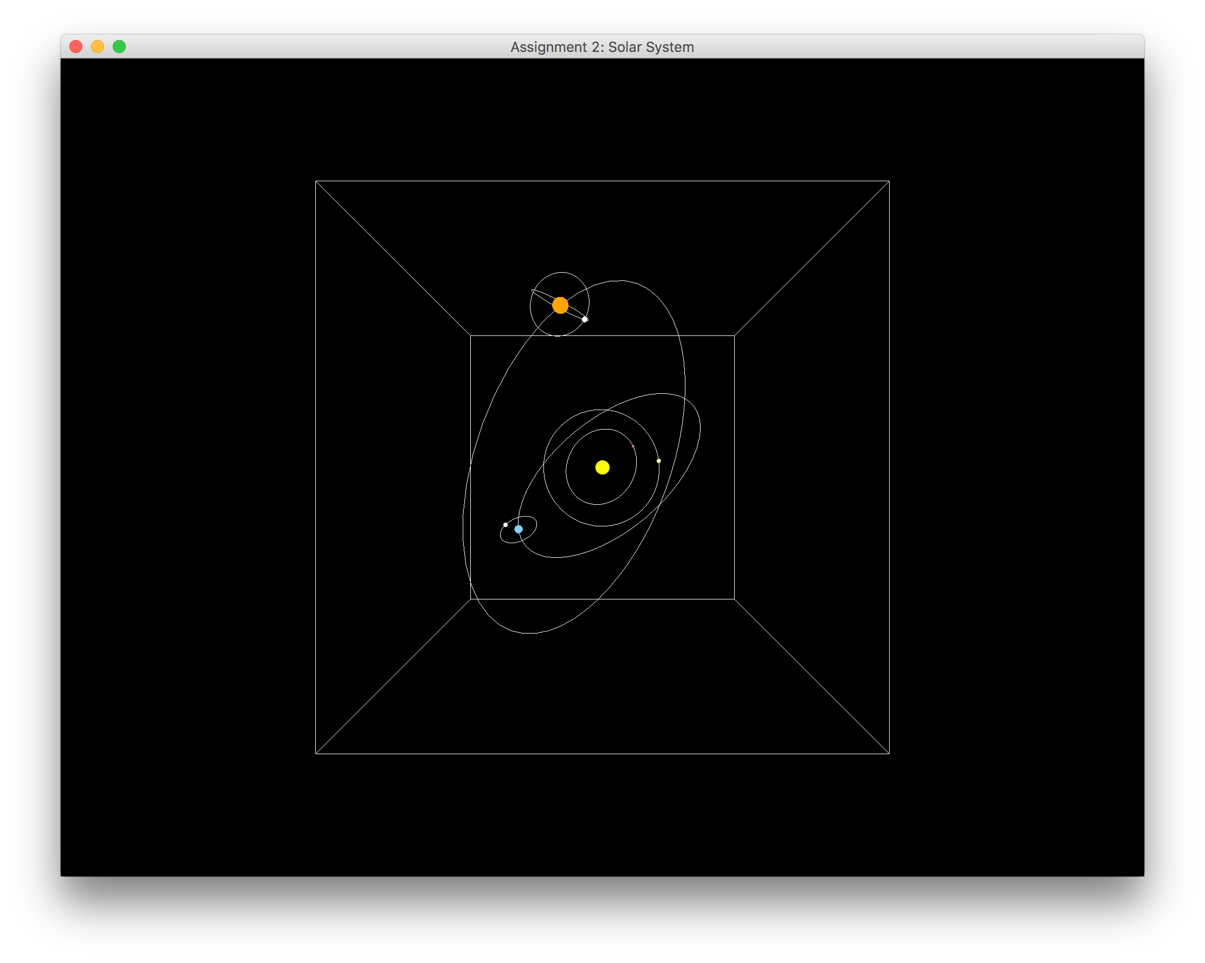

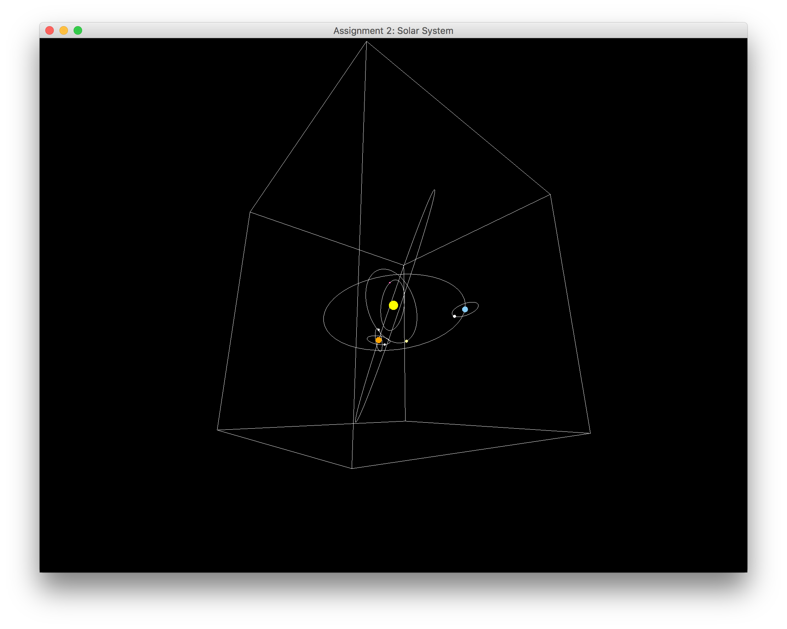

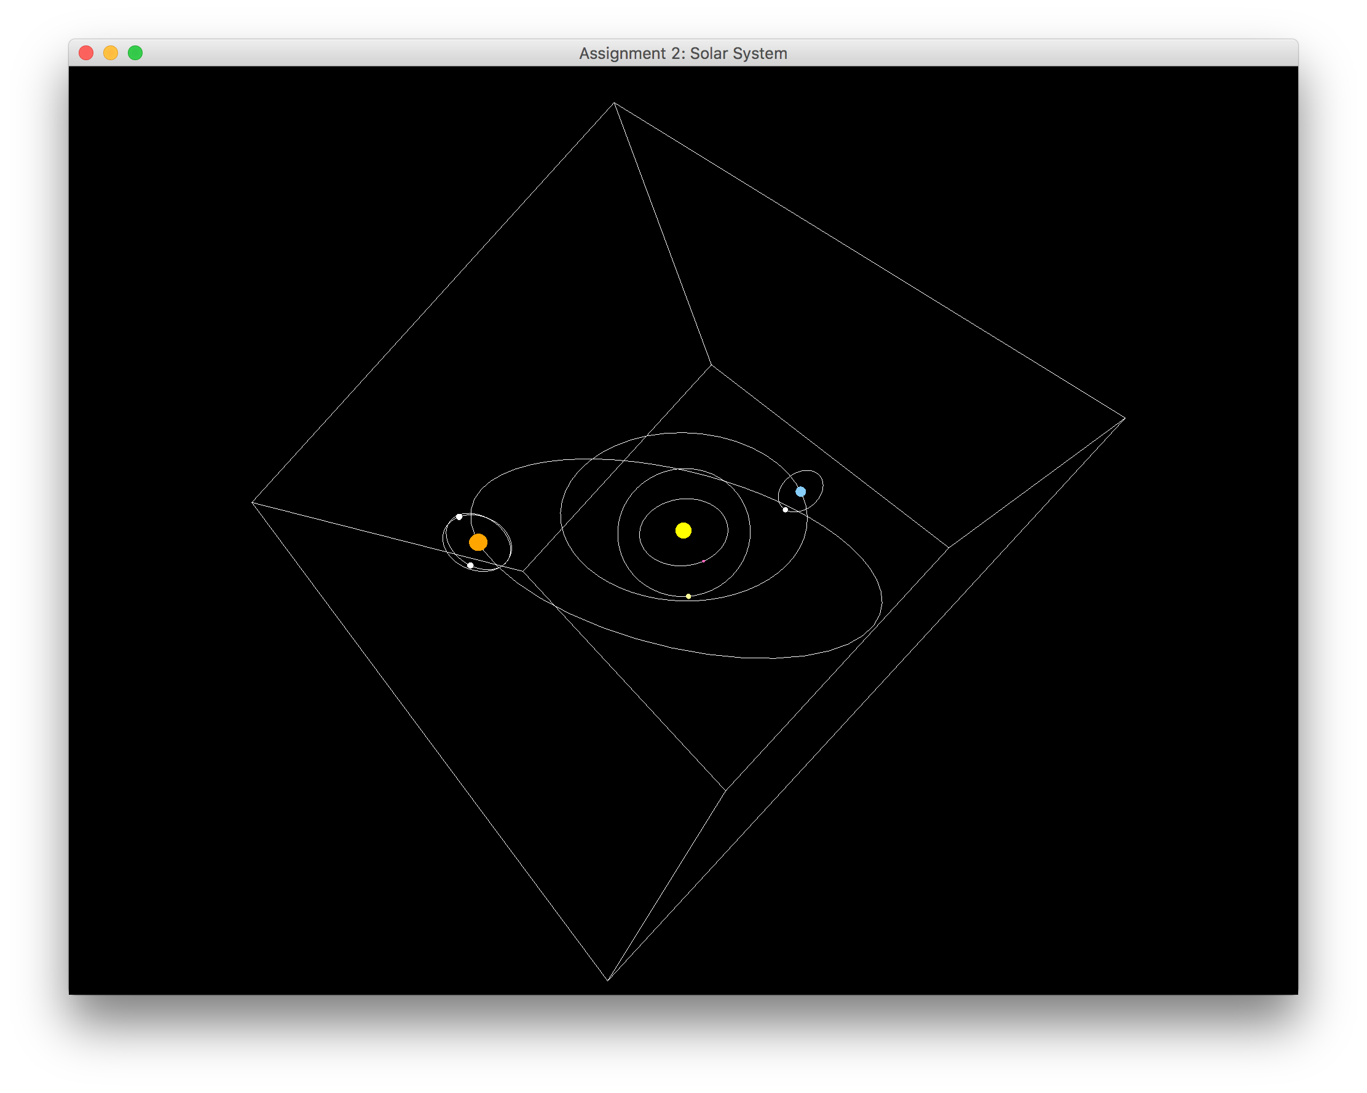

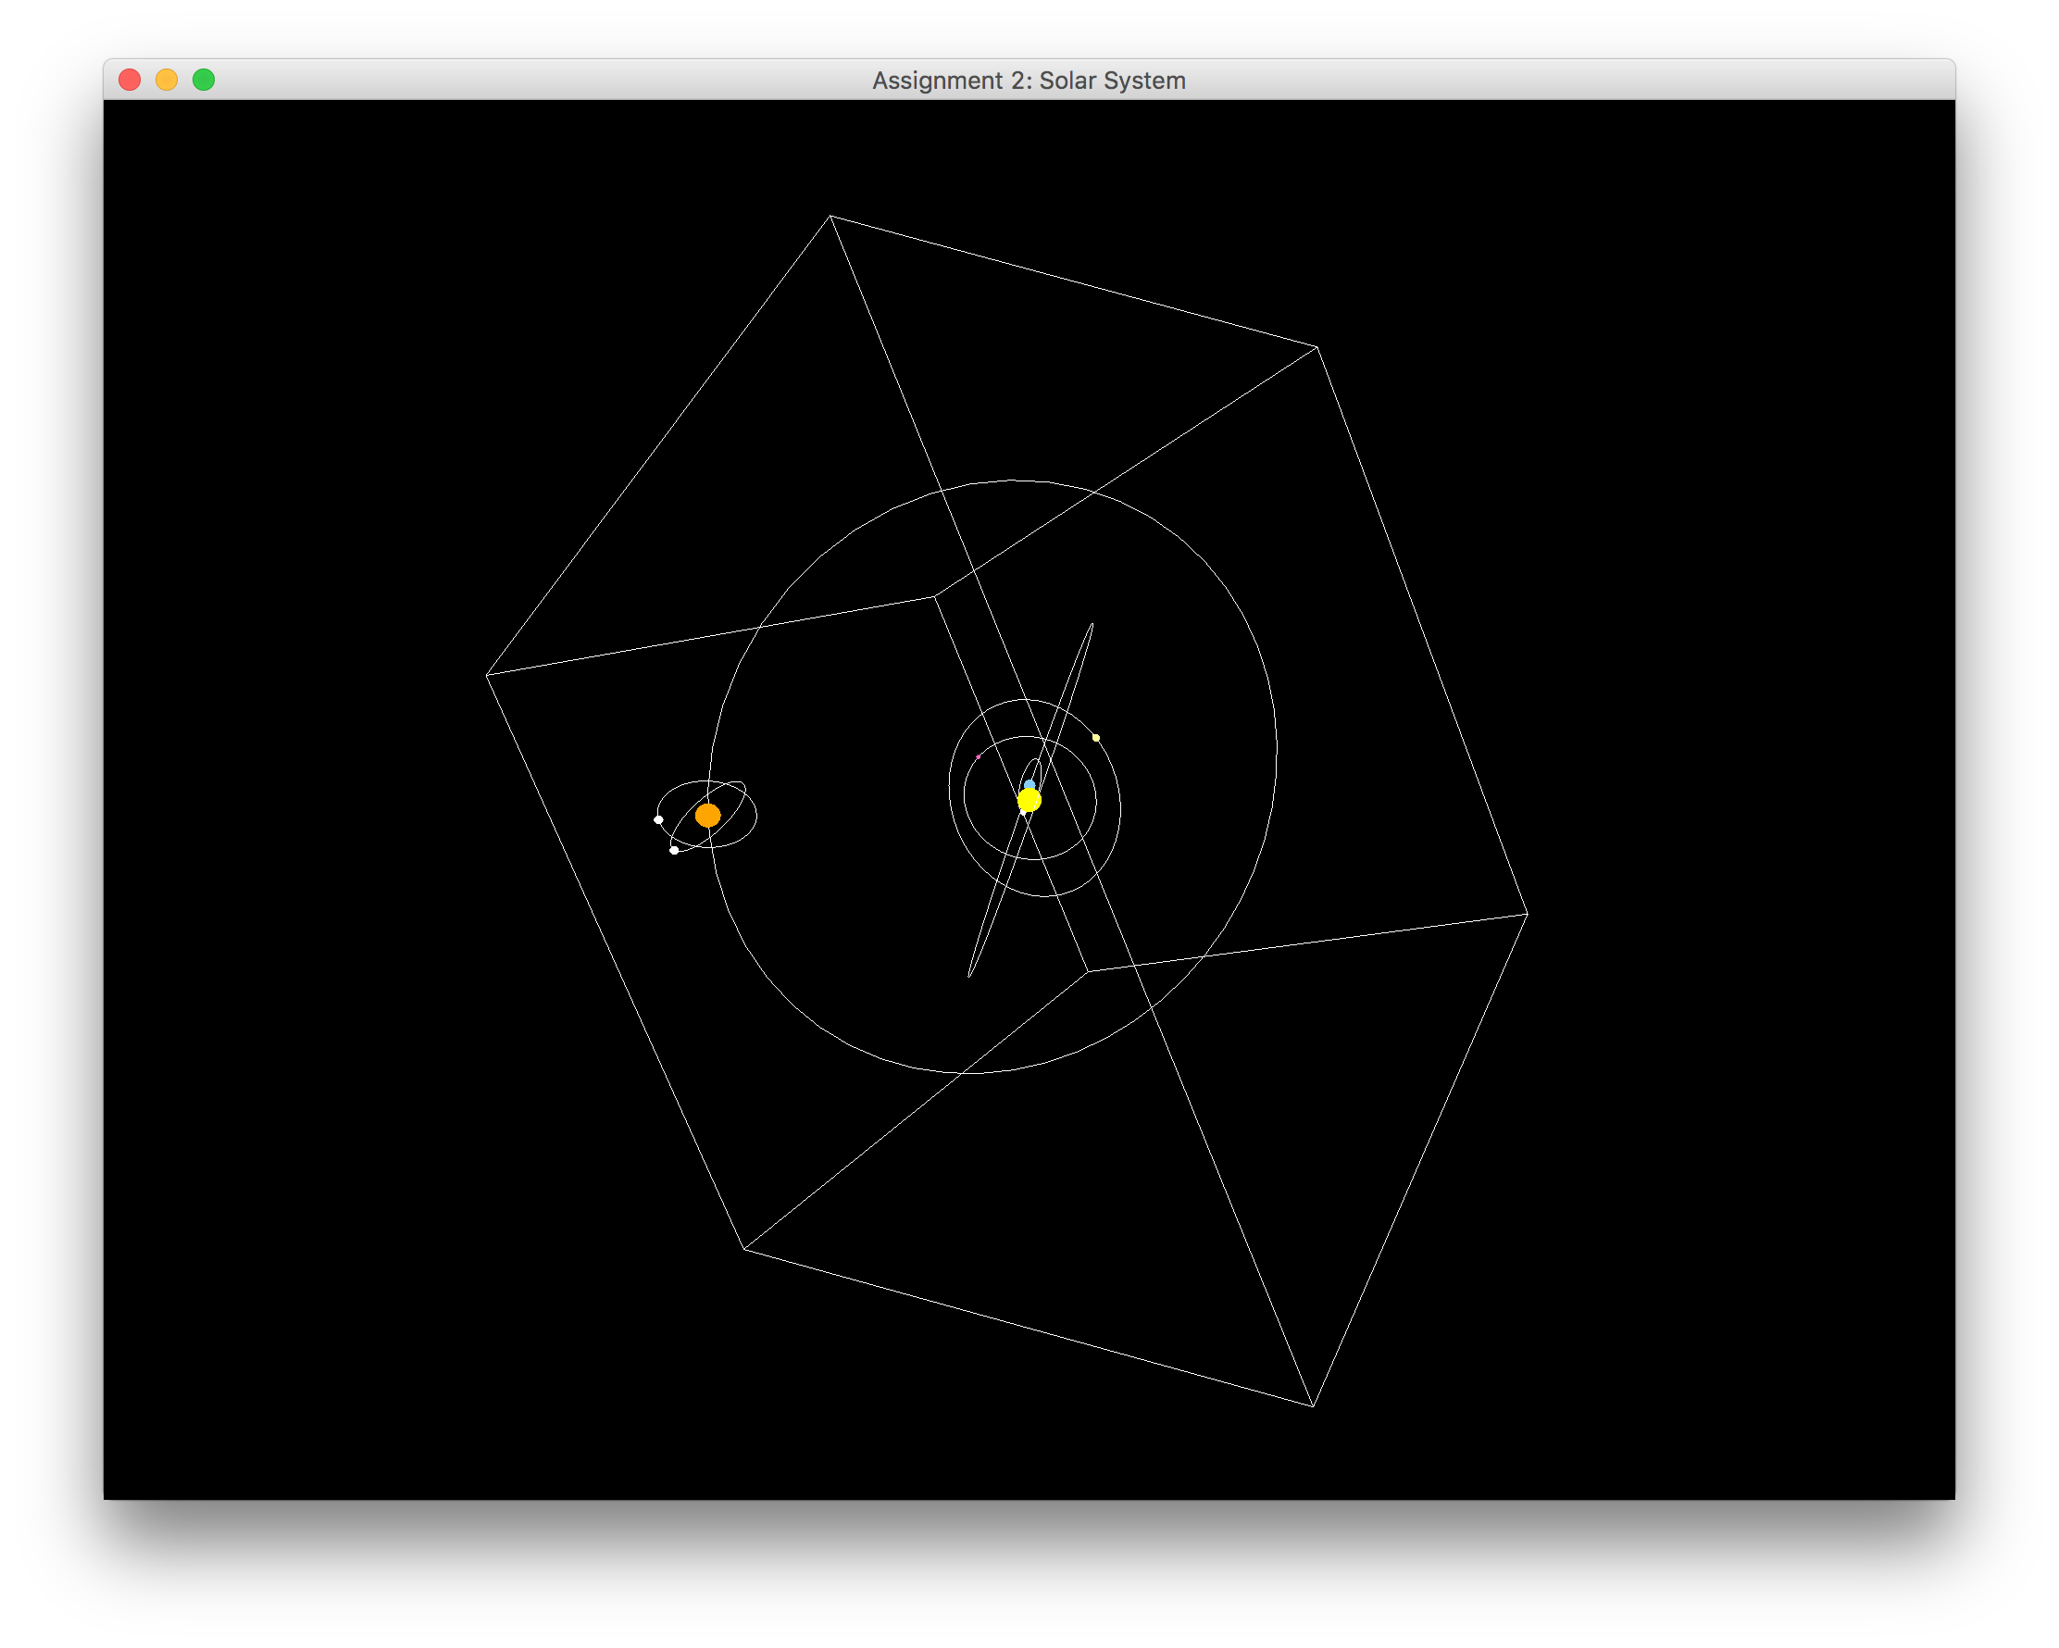

Manual:

While the program is running, users may manipulate the view using the trackball interface. Pressing down on the mouse and dragging the cursor will rotate the entire solar system proportionally to the horizontal and vertical distance from the first click to where the cursor is when the mouse is released.

Trackball Implementation:

To implement the trackball transformation, I first added a MouseListener to the JOGLFrame canvas. On the MouseDown event, the Listener would store the “startX” and “startY” coordinates. Then, on the MouseUp event, the Listener would store the “endX” and “endY” coordinates. These 4 coordinates are then passed to the View class’s method trackballRotation. To achieve the horizontal trackball rotation, we rotate the solar system about the Y axis, based on the vertical axis set by the lookAt method. We rotate about the Y axis by Math.toRadians(endX-startX). We then do the same for the vertical trackball rotation about the X axis by Math.toRadians(endY-startY). These are stored in a Matrix4f in the View class. Each additional rotation Matrix4f is then multiplied to the existing Matrix4f, which begins with the Identity Matrix4f.

When the draw method is called, the cumulative trackball transform is multiplied after the lookAt call, but before the individual planet transformations, resulting in the trackball transformation working during the program’s execution.