Matthew Springer

Lab 5 Pre-Lab Assignment

2/14/17

* 1. A PWM signal is a means of encoding information by adjusting the lengths of time that a wave is in its high state and low state. The pulse wave has a predetermined cycle length, and the duty cycle is the percentage of the length of a cycle that the wave spends in the ON position.
  2. 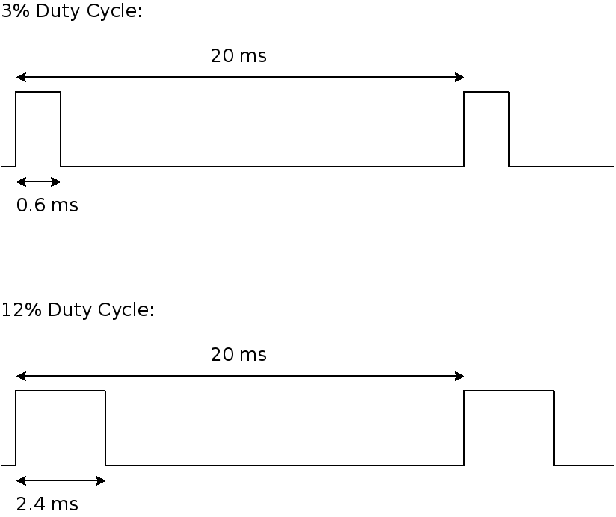

#include <iostream>

using namespace std;

/*

* @func degreeToOnDelay

* @param ser_pos the position of the servo (0-180 degrees)

* @return the time in microseconds that the PWM signal * should be on

*/

float degreeToOnDelay (float servo_pos) {

return (10 * servo_pos) + 600;

}

int main () {

float pos, cycle;

cout << "Please enter the current servo position (0-180): ";

cin >> pos;

cycle = degreeToOnDelay(pos);

cout << "The PWM signal should be on for " << cycle << " microseconds" << endl;

return 0;

}

bash-4.3$ echo "Hello"

Hello

bash-4.3$ echo "Hello" > message.txt

bash-4.3$ cat message.txt

Hello

bash-4.3$ echo "Hello" >> message.txt

bash-4.3$ cat message.txt

Hello

bash-4.3$ wc

Hello

How are you?

I am fine

3 7 29

bash-4.3$ wc < message.txt

2 2 12

In part 5.5, the '<' and '>' commands are used to write the appropriate port numbers to allow use of the robotic arm.