User story:

As a user, I want to add a new product into the system.

By clicking add product into adding product menu, input product information, and click add button. The system add one record into products table, and pops up one window saying adding product successful.

By clicking add product into adding product menu, input invalid product information, and click add button. The system pops up a window and reports the error.

As a user, I want to add a new customer into the system.

By clicking add customer into adding product menu, input customer information, and click add button. The system add one record into customers table, and pops up one window saying adding customer successful.

By clicking add product into adding product menu, input invalid customer information, and click add button. The system pops up a window and reports the error.

As a user, I want to add a purchase from a customer into the system.

By clicking add product into adding product menu, input purchase information, customer and product fields will be auto-completed if there is a corresponding record with respect to their ID, and then click add button. The system add one record into purchases table, and pops up one window saying adding purchase successful.

By clicking add product into adding product menu, input invalid purchase information, and click add button. The system pops up a window and reports the error.

User Interface

Different views:

MainView class:

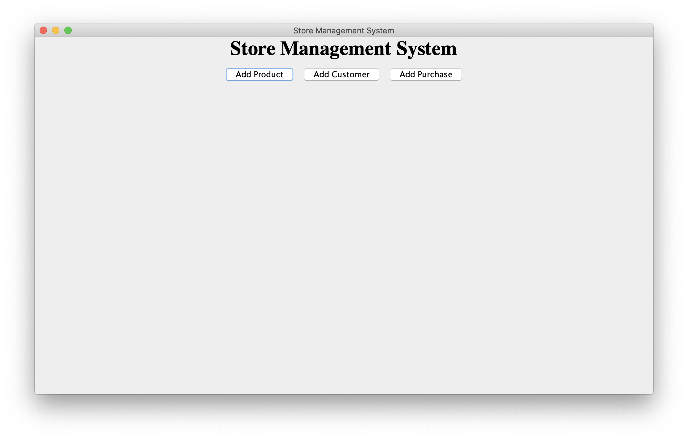

Add Product

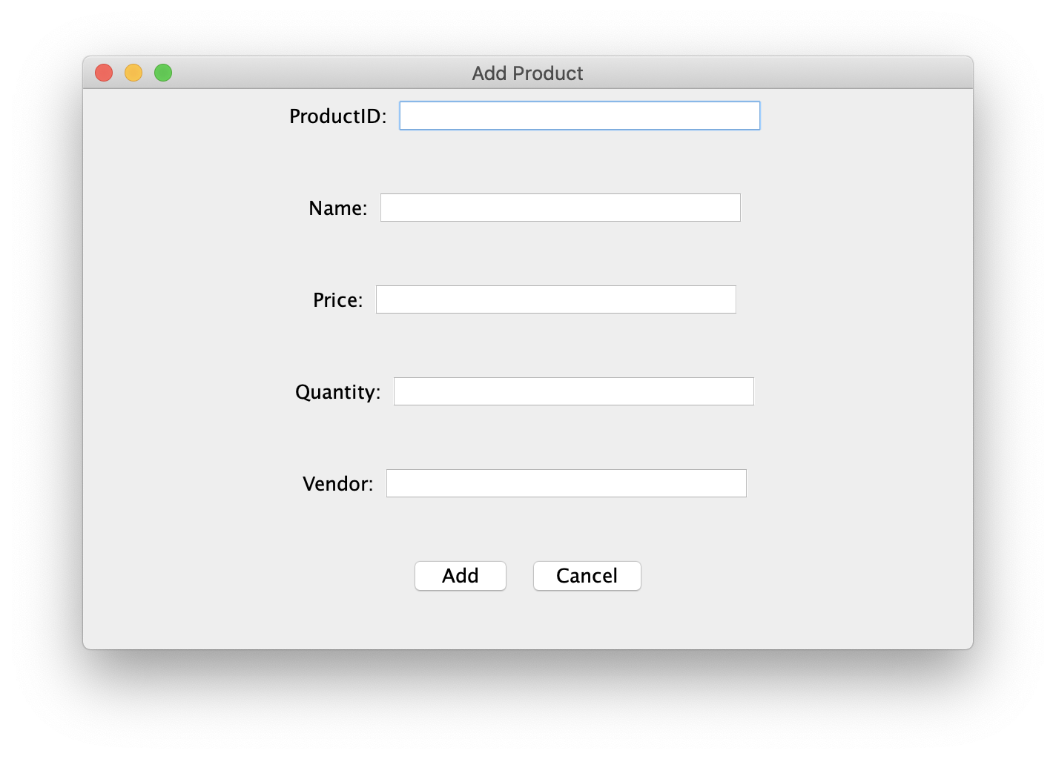

Add Customer

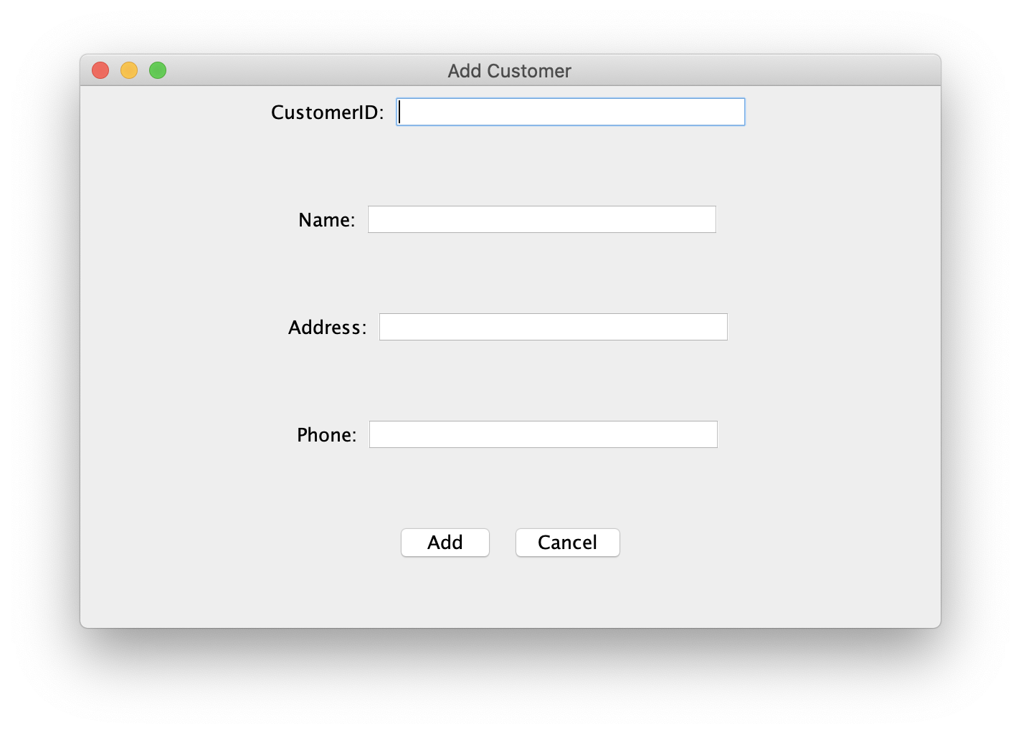

Add Purchase

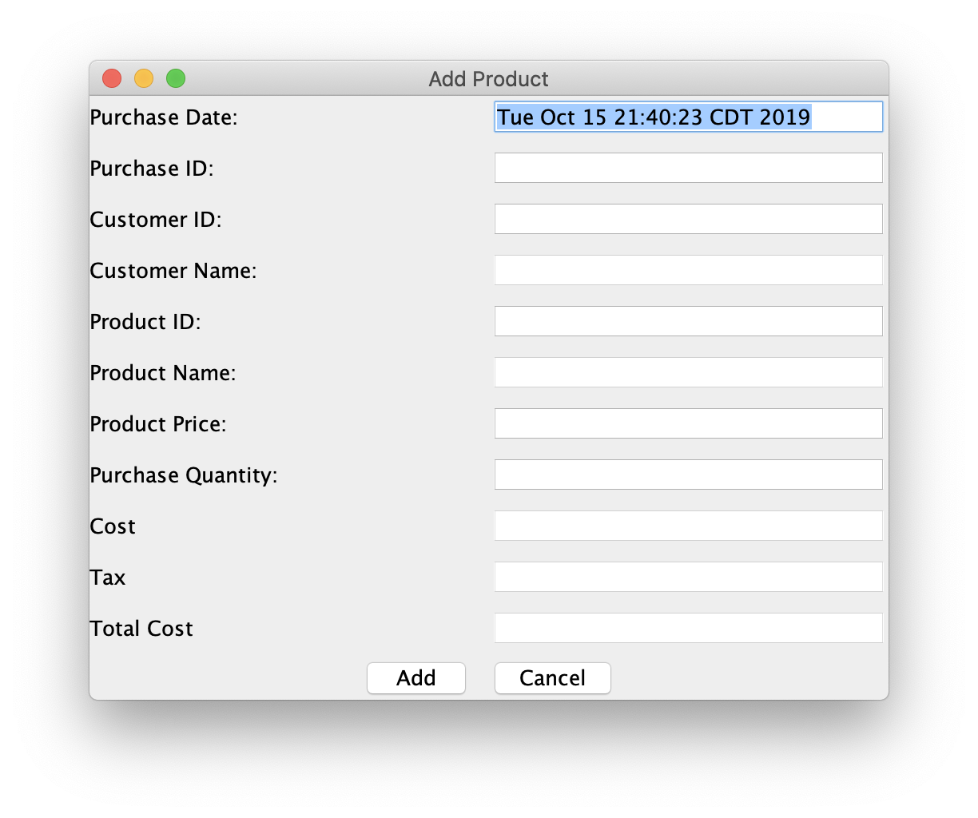

* Business Logic
* Data models for products, orders, customers

Class ProductModel: stores a product obj in memory

Class Customers: stores a customers obj in memory

Class Orders: stores a customers obj in memory

* Controllers for UI views

Class AddProductController: process user interaction with AddProductView class

Class AddCustomerController: process user interaction with AddProductView class

Class AddOrderController: process user interaction with AddProductView class

* Main application (setup data access, create views)

Class StoreManager

* Data Access

SQLiteDataAdaper class: load/save changes in data like customer etc

SQL queries:

I’m using GUI to add all the records into the database.

But for each query, it will be:

INSERT INTO Products (mProductID, mName, mPrice, mQuantity, mVendor) VALUES ()

INSERT INTO Customers (mCustomerID, mName, mPhone, mAddress) VALUES ()

INSERT INTO Purchases (mPurchaseID, mCustomerID, mProductID, mPrice, mQuantity, mTax, mTotalCost, mCost, mDate) VALUES()