User Stories

- As a user, I want to change my password and/or full name.

User should be able to see a box when they login, and be able to input new pwd and click change pwd to save the new pwd.

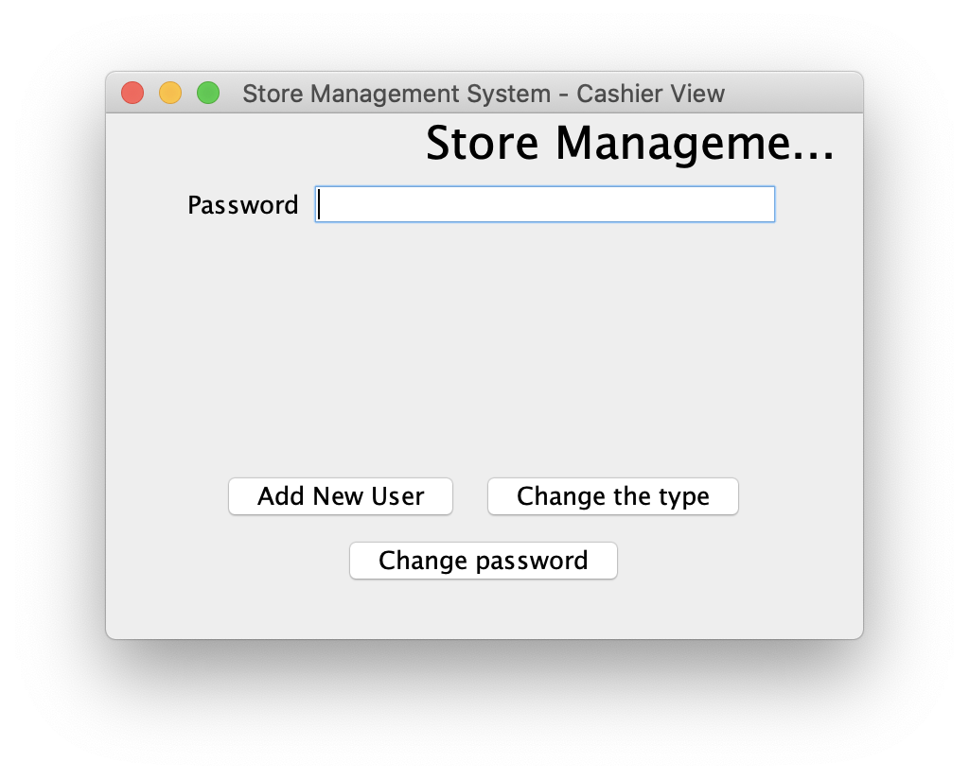

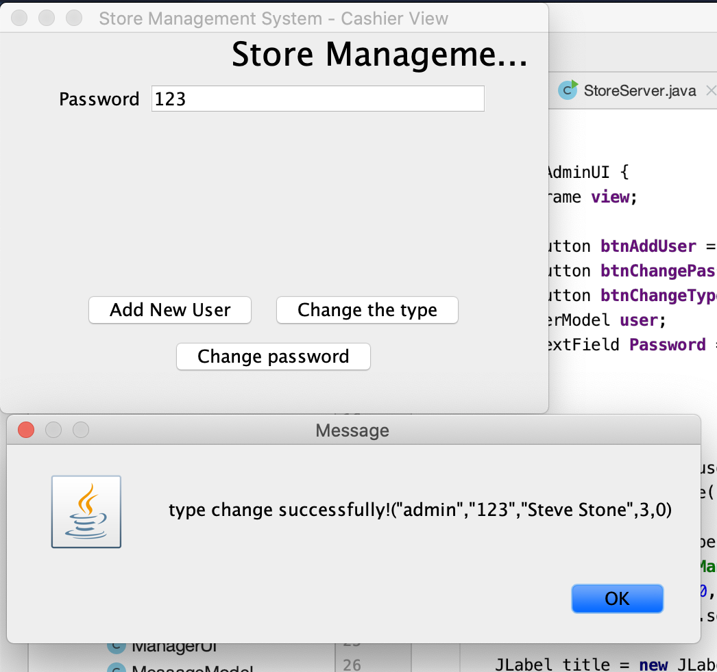

- As an admin, I want to add a new user into the system.

After login as admin, admin should be able to click on add new user. Afer new user UI pops up, admin should be able to input new user information and click add to add new user.

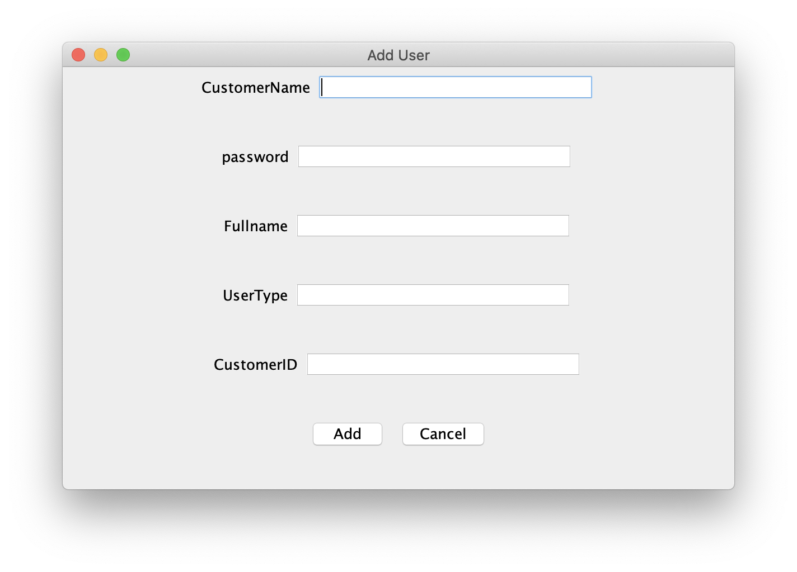

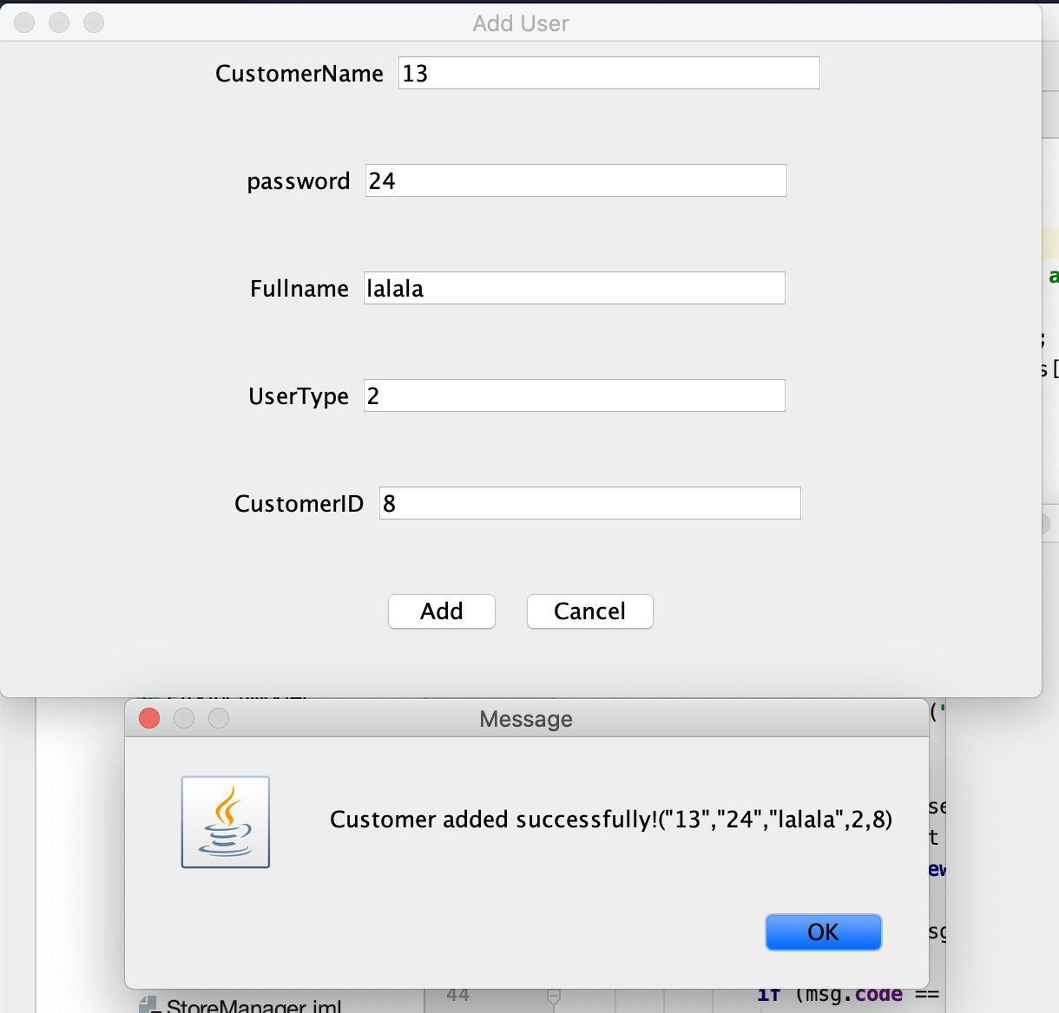  
- As an admin, I want to update the type/class of a user into the system (e.g., from cashier to manager).

After login, admin should be able to click change user type, and input user name, and updated user type. And then click update.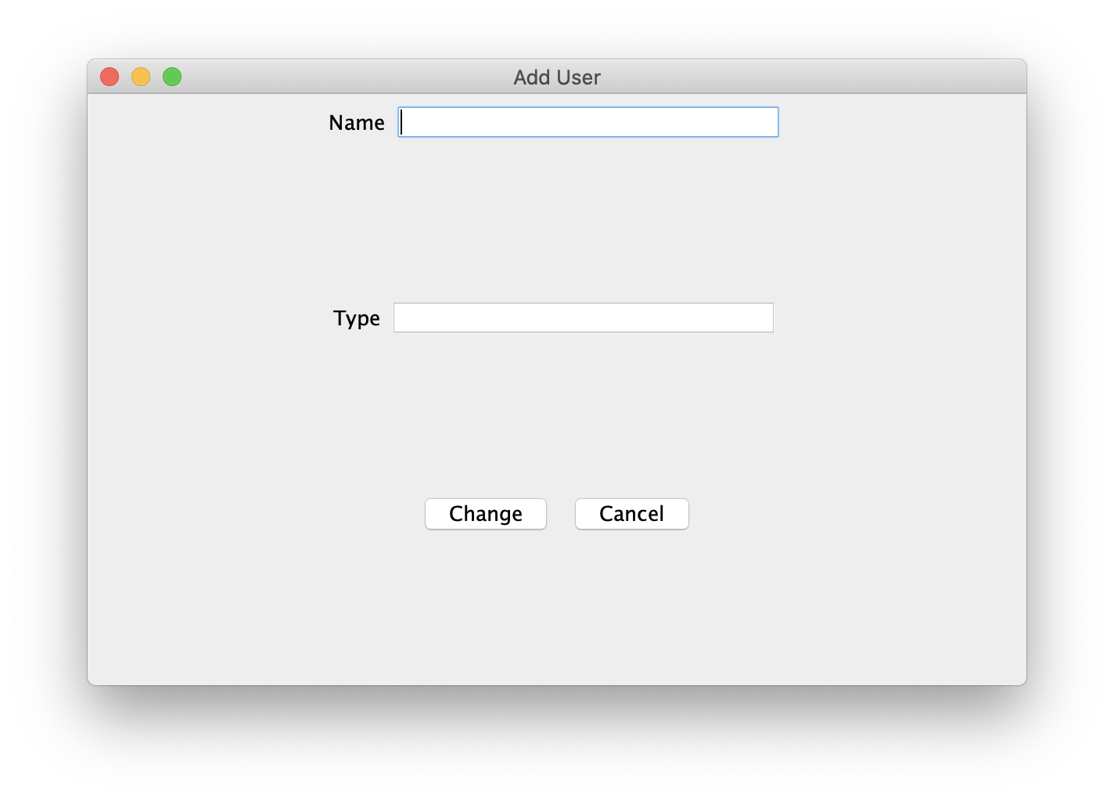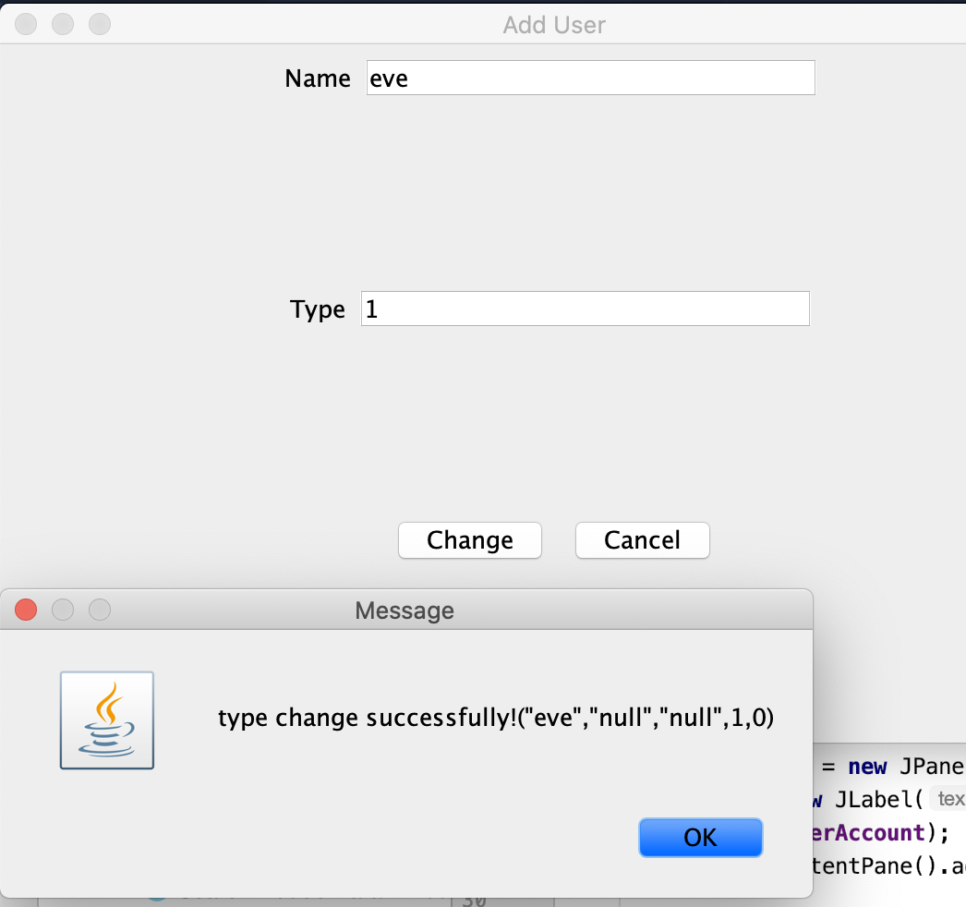

- As a manager, I want to add a new product or update a current product in the system.

User should be able to click Manage Product to enter manage product UI. User should be able to search by product ID and then update information, or enter new product information. And click save to update.

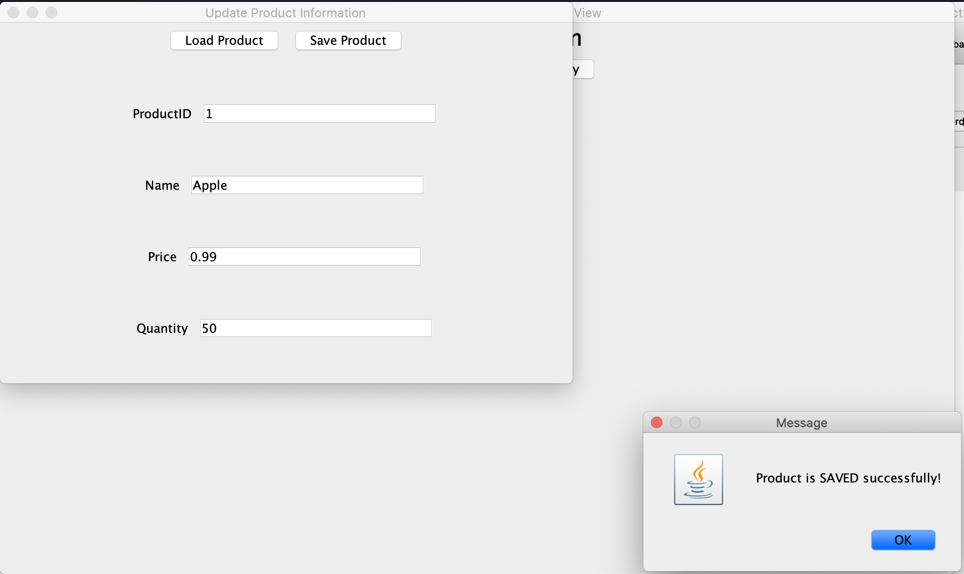

- As a manager, I want to view a summary report of sales from the system.

As a Manager, User to be able to click summary after login, then a window showing all purchase history should pop up.

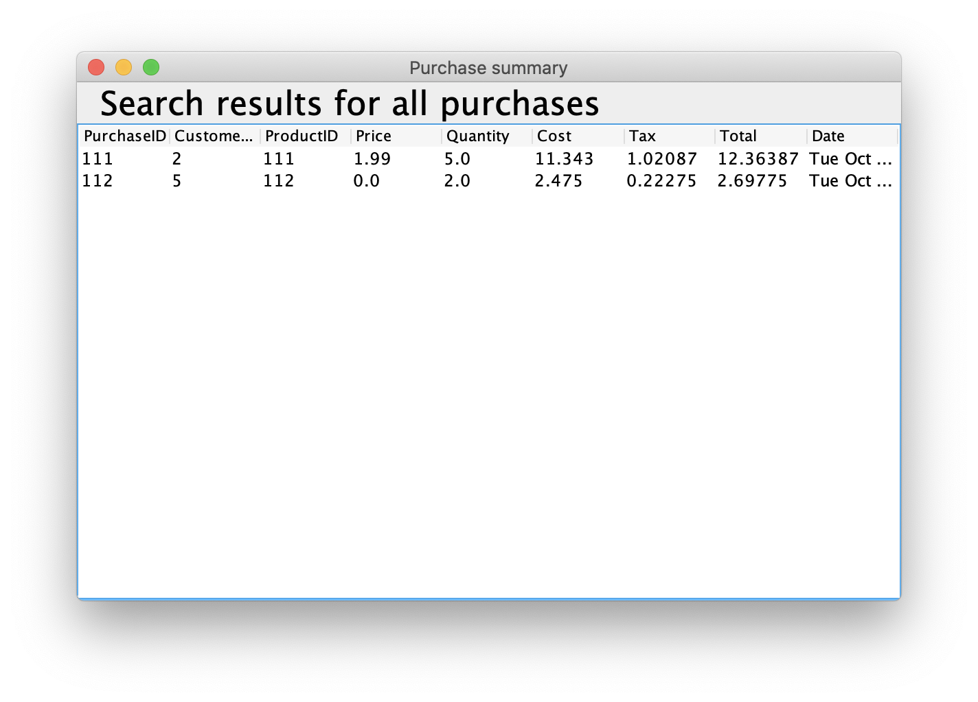

- As a cashier, I want to add a new customer or update a current customer in the system.

Cashier should be able to click add customer then input new customer information into the system, then click add to update.

  
- As a cashier, I want to add a new purchase or update a current purchase (only price and quantity) in the system.

User should be able to click add purchase to go into add purchase ui, then input all purchase information, clicking add to update.

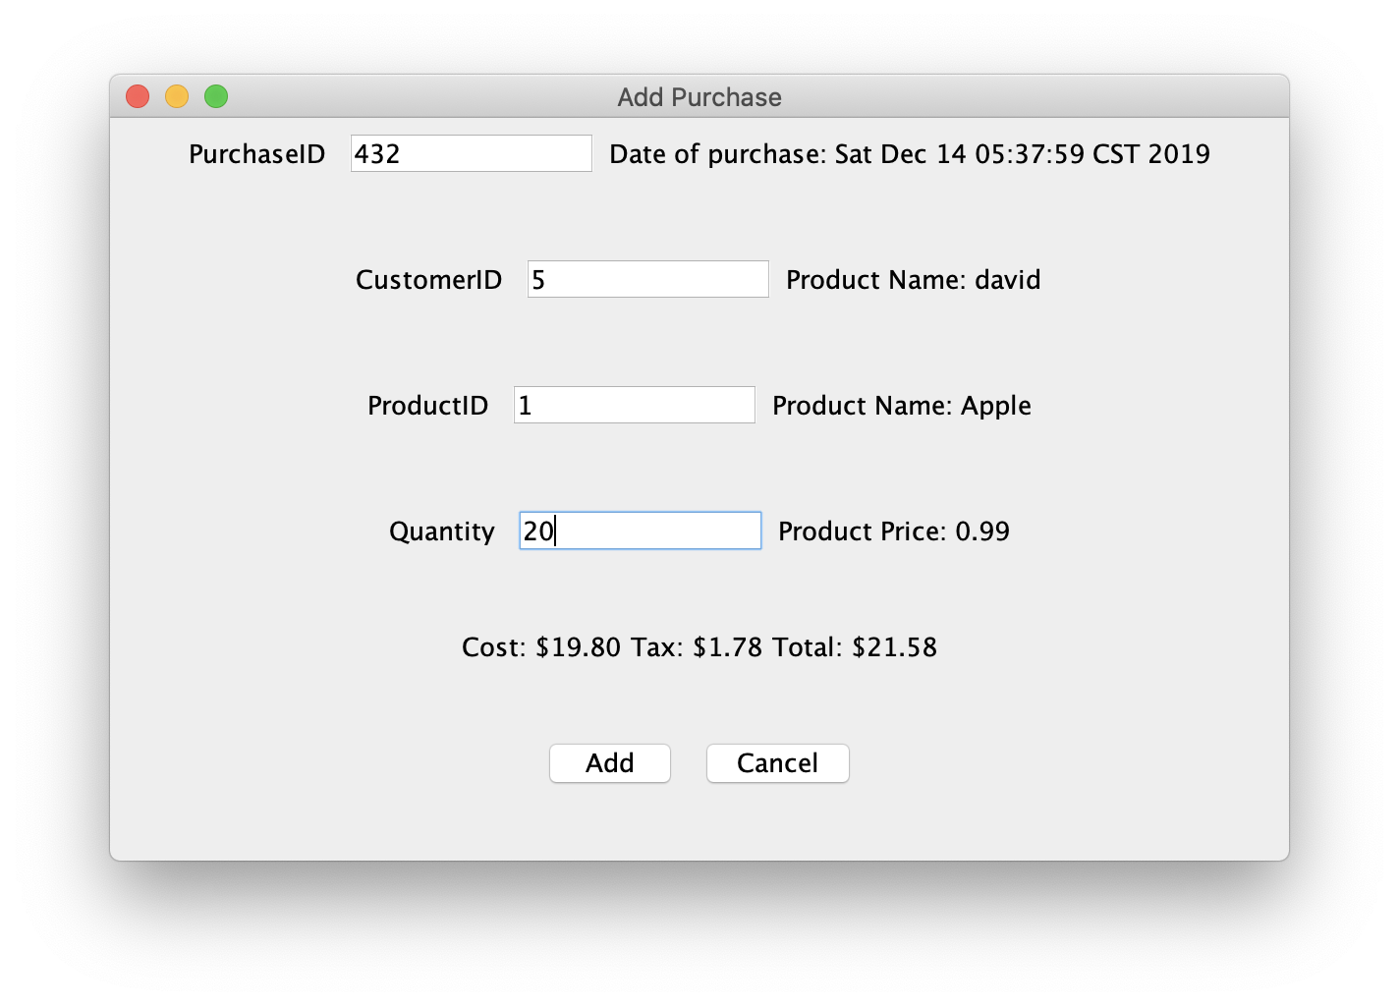  
- As a customer, I want to add a new purchase into the system.

As a customer , the procedure of adding purchase should be as same as cashier.

  
- As a customer, I want to view my purchase history into the system.

After loggin in as customer, user should be able to click view purchase history to see a window of all purchase history popping up.

