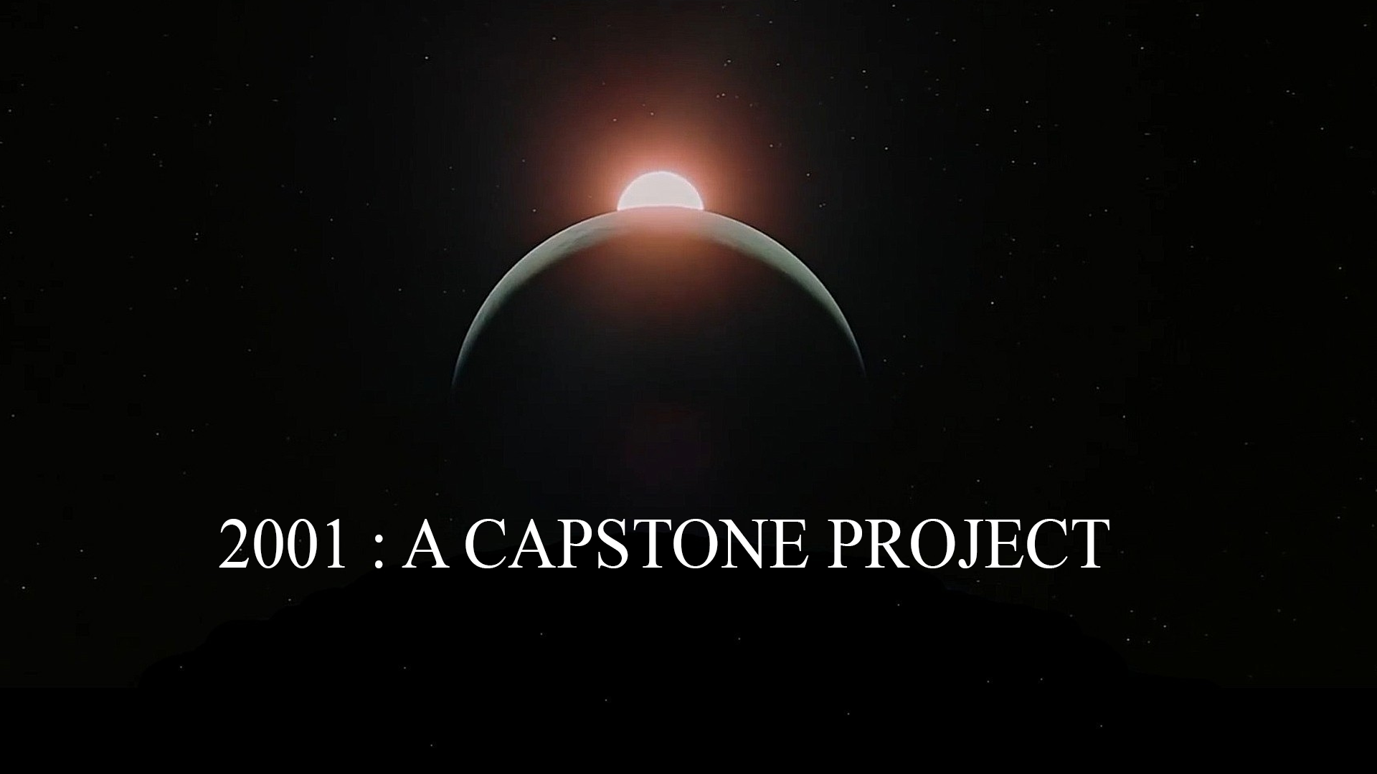

**The Crew**

Dustin Rios:

Karolina Hrysko:

William Minard:

Mitchell Battles:

Jackson Schaper:

Michael Rallo:

**Mission Statement**

Main Goal

Introduction

Requirements

-Hardware

-User