Use APIs to Connect Applications and Databases
APIs are the basis on which the entire world’s applications talk to each other and enable people to seamlessly perform actions on the internet.
Web developers use APIs to connect standalone applications when information and processes must flow between them. Using APIs enables web developers to work securely without exposing code and protected data, while also bridging the gap between different stand-alone applications.
Several API clients are available for development and testing, such as Postman. Applications such as Postman act as clients communicating with the API server during a website or application testing phase, so you can ensure the endpoint is working correctly and returning the required data. You must test the API to ensure that the following requirements are met:
- The correct headers, credentials, and parameters are being sent with the API request.
- The required data is received via the API response.
- The response is in the format you desire.
For example, a weather app on your phone would connect with the National Weather Service to display real-time weather data. In this case, the weather application connects to the National Weather Service API to provide real-time weather updates based on your selection.
To connect an application or a website to an API service, web developers perform the following steps:
- Identify the API service from which to fetch data.
In this example, fetch data from the Countries’ REST API, which is a public API that does not require authentication credentials.
- On the website, create dynamic fields with JavaScript, and note the API calls from the website page.
- Test the API calls from an application like Postman.
  - From the [Postman website](https://www.postman.com/), download and configure the Postman desktop application.
NOTE: While configuring the desktop application, follow the wizard instructions to create an account.
  - Test the API and ensure that the correct headers, credentials, and parameters are sent with the API request, that the required data is returned in the API response, and that the response is in the desired format.
  - Click New > HTTP Request.
  - From the list, select the HTTP method.
In this example, choose GET.

  - In the HTTP Request box, enter the following API query to retrieve information about the country of Japan:
https://restcountries.com/v3.1/name/japan
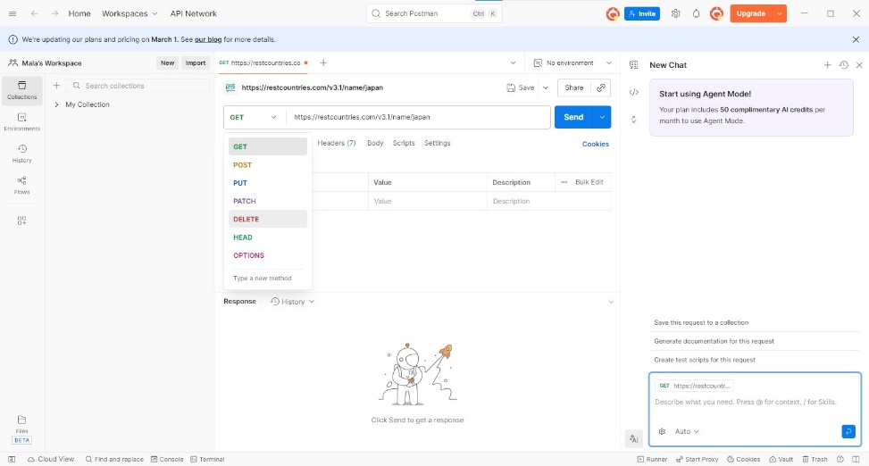
  - Click Send.
The results comprising details about the country of Japan appear in JSON format with a **200 OK** response.
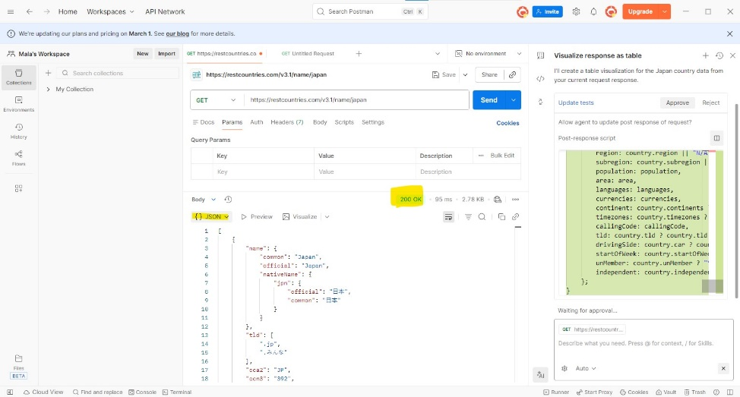
  - If the results are not satisfactory, modify the API call parameters and inputs.

- Reuse the modified API calls in the website’s JavaScript.
- Design the website so that the user inputs in the dynamic fields match the inputs in the API query.
In conclusion, while it may seem that data travels seamlessly between websites, web developers take many steps to ensure that the APIs that integrate two applications are accurate. For this, they first test their API calls before applying them to the website's JavaScript. Then they design the website user interface so that the user inputs match the API query, and the interface displays the response in a user-friendly format.

