

LAB WORKBOOK

21CS2214RB- Design and Analysis of Algorithms





LABORATORY WORKBOOK

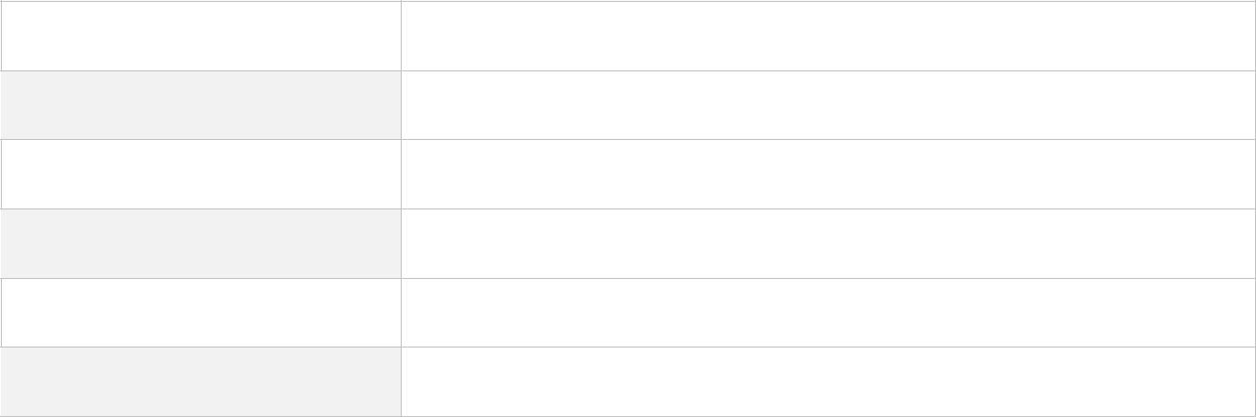
STUDENTNAME
REG.NO
YEAR SEMESTER SECTION FACULTY
Table of Contents
ORGANIZATION OF THE STUDENTLABWORKBOOK 3
LAB 01 6
LAB 02 6
LAB 03 12
LAB 04 19
LAB 05 25
LAB 06 31
LAB 07 37
LAB 08 42
LAB 09 49
LAB 10 54
LAB 11 59
LAB 12 63
LAB 13 77
LAB 14 82
LAB 15 67

Organization of the STUDENT LAB WORKBOOK

The laboratory framework includes a creative element but shifts the time-intensive aspects outside of the Two-Hour closed laboratory period. Within this structure, each laboratory includes three parts: Prelab, In-lab, and Post-lab.
- Pre-Lab
The Prelab exercise is a homework assignment that links the lecture with the laboratory period - typically takes 2 hours to complete. The goal is to synthesize the information they learn in lecture with material from their textbook to produce a working piece of software. Prelab Students attending a two-hour closed laboratory are expected to make a good-faith effort to complete the Prelab exercise before coming to the lab. Their work need not be perfect, but their effort must be real (roughly 80 percent correct).
- In-Lab

The In-lab section takes place during the actual laboratory period. The First hour of the laboratory period can be used to resolve any problems the students might have experienced in completing the Prelab exercises. The intent is to give constructive feedback so that students leave the lab with working Prelab software - a significant accomplishment on their part. During the second hour, students complete the In-lab exercise to reinforce the concepts learned in the Prelab. Students leave the lab having received feedback on their Prelab and In-lab work.
- Post-Lab
The last phase of each laboratory is a homework assignment that is done following the laboratory period. In the Post-lab, students analyze the efficiency or utility of a given system call. Each Post-lab exercise should take roughly 120 minutes to complete.

2021-22 EVEN SEMESTER LAB CONTINUOUS EVALUATION

S.  No. | Date | Experiment Name | In-Lab |  |  |  | Total (50M) | Faculty Signature
S.  No. | Date | Experiment Name | Logic (10M) | Execution (15M) | Result (15M) | Analysis (10M) | Total (50M) | Faculty Signature
1.
2.
3.
4.
5.
6.
7.
8.

2021-22 EVEN SEMESTER LAB CONTINUOUS EVALUATION

S.  No. | Date | Experiment Name | In-Lab |  |  |  | Total (50M) | Faculty Signature
S.  No. | Date | Experiment Name | Logic (10M) | Execution (15M) | Result (15M) | Analysis (10M) | Total (50M) | Faculty Signature
9.
10.
11.
12.
13.
14.
15.

LAB SESSION 01:

INTRODUCTION TO ALGORITHMS & ASYMPTOTIC NOTATIONS

Date of the Session: / / Time of the Session: to

Pre-Lab:

- During lockdown Aravind gets bored by his daily routine while scrolling youtube he found an algorithm that looks different Aravind is very crazy about algorithms, but he cannot solve algorithms of multiple loops so that he structed and need your help to find the time complexity of that algorithm

Algorithm that was found on internet:
Algoritm KLU(int n)
{
int count=0;
for(int i=1;i<n;i=i*2)
{
for(int j=n;j>0;j=j/3)
{
for(int k=0;k<n;k++)
{
Count++;
}
}
}
}

- Garry is an interviewer, so he prepared a bunch of questions for the students. He focused on algorithms. Among all the questions the easiest question is what is the time complexity of the following C function is so can answer to this?
int recursive(int n) { if(n==1)
return (1);
else
return(recursive (n-1) + recursive (n-1));}
}

- Kamal has 2 algorithms and he also know their time functions. Now he wants to analyze which one is greater function? But Kamal do not know how to compare two-time functions. Your task is to analyze the given two-time functions and judge which one is greater and justify with your solution

- T1(n) = (log(n^2)*log(n)) T2(n) = log(n*(logn)^10)

- T1(n) = 3*(n)^(sqrt(n)) T2(n) = (2)^(sqrt(n)*logn) (consider logn with base 2)

In-Lab:
- Angelina is an intelligent girl, every time she wins in any contest or programme, and solves complex problems so I want to give her a challenge problem that is. Sort an array of strings according to string lengths. If you are smarter than her, try to solve the problem faster than her?
Input
You are smart looking
Output
You are looking smart

- Arnav is the Assistant Professor of Computer science department so he just ask to interact with the students and helps the students to solve the complex problems in an easier way so, the problem given by the sir is sort an array according to count of set bits?
Example:
Input: arr[] = {1, 2, 3, 4, 5, 6};
Output: 3 5 6 1 2 4
Explanation:
3 - 0011
5 - 0101
6 - 0110
1 - 0001
2 - 0010
4 - 0100
hence the non-increasing sorted order is
{3, 5, 6}, {1, 2, 4}

Post-Lab:
- Given an array arr[] of N strings, the task is to sort these strings according to the number of upper-case letters in them try to use zip function to get the format.
Input arr[] = {poiNtEr, aRRAy, cOde, foR}
Output: [('cOde', 1), ('foR', 1), ('poiNtEr', 2), ('aRRAy', 3)]

“aRRAy” R, R, A->3 Upper Case Letters
“poiNtEr” N, E->2 Upper Case Letters
“cOde” O->2 Upper Case Letters
“foR” R->3 Upper Case Letters

- In KLU streets we have lots of electrical poles.
Note: all poles are sorted with respective to their heights.

Professor Govind given the H = height of one pole to Mothi then asked him to print the position of that pole, here we consider index as a position. Mothi is particularly good at algorithms, so he written an algorithm to find that position. But he is extremely poor at finding time complexity. Your task is to help your friend Mothi to analyze the time complexity of the given problem.

Int BinarySearch (int a, int low, int high, int tar)
{
int mid;
if (low > high) return 0;
mid = floor((low + high)/2)
if (a[mid] == tar)
return mid;
else if (tar < a[mid])
return BinarySearch (a, low, mid-1, tar)
else
return BinarySearch (a, mid+1, high, tar)
}


(For Evaluator’s use only)
Signature of the Evaluator Date of Evaluation:

Comment of the Evaluator (if Any) | Evaluator’s Observation
Marks Secured: out of
Full Name of the Evaluator:

LAB SESSION 02:

Date of the Session: / / Time of the Session: to

Pre-Lab:

1) Given a text txt[0..n-1] and a pattern pat[0..m-1], write a function search (char pat [], char
txt[]) that prints all occurrences of pat[] in txt[] using naïve string algorithm?(assume that n > m)
Input
txt[] = "THIS IS A TEST TEXT"
pat[] = "TEST"
Output
Pattern found at index 10
Input
txt[] = "AABAACAADAABAABA"
pat[] = "AABA"
Output
Pattern found at index 0
Pattern found at index 9

- Discuss the Rabin Karp algorithm for string matching and explain time complexity of the algorithm?

In-Lab:
1) Write a program for Naïve method to check whether a pattern is present in a string or not. Using clock function find execution time and calculate the time complexity of the program.
Sample program with function which calculate execution time:

#include<stdio.h>
#include<time.h>
void fun()
{
//some statements here
}
int main()
{
//calculate time taken by fun()
clock_t t;
t=clock();
fun();
t=clock()-t;
double time_taken=((double)t)/CLOCK_PER_SEC; //in seconds
printf(“fun() took %f seconds to execute \n”,time_taken);
return 0;
}

- Nick is working in a photo studio where his boss has given him a task to arrange the photos of family members. He is French and he do not know English somehow, he managed to send the list of names to you (his friend). Help Nick to sort the photos.
(Note: implement the odd even merge algorithm)
Input
5
Neil Katherine Harry Stefan Dennis
Output

Dennis Harry Katherine Neil Stefan

Post-Lab:
- Given a pattern of length- 5 window, find the valid match in the given text by step-by-step process using Rabin-Karp algorithm
Pattern: 2 1 9 3 6
Modulus: 21
Index: 0 1 2 3 4 5 6 7 8 9 10 11 12 13 14 15 16 17 18 19 20 21
Text: 9 2 7 2 1 8 3 0 5 7 1 2 1 2 1 9 3 6 2 3 9 7

- Jacob is sharing his information with his friend secretly in a chat. But he thinks that message should not understandable to anyone only for him and his friend. So he sent the message in the following format.
Input
a1b2c3d4e
Output
abbdcfdhe
Explanation:
The digits are replaced as follows:
- s[1] -> shift('a',1) = 'b'
- s[3] -> shift('b',2) = 'd'
- s[5] -> shift('c',3) = 'f'
- s[7] -> shift('d',4) = 'h'

(For Evaluator’s use only)
Signature of the Evaluator Date of Evaluation:

Comment of the Evaluator (if Any) | Evaluator’s Observation
Marks Secured: out of
Full Name of the Evaluator:

LAB SESSION 03

Date of the Session: / / Time of the Session: to

Pre-Lab:

- Trace out the output of the following using Merge sort.10, 49, 32, 67, 45, 4, 7, 2, 1, 51, 78, 34, 89, 87, 36, 29, 3, 9, 11.

- Write a divide and conquer algorithm for finding the maximum and minimum in the sequence of numbers. Find the time complexity.
{35, 52, 15, 78, 24, 87,12}

In-Lab:
- Jack’s Aunt and family treat him badly and make him work all the time. Dudley, his cousin got homework from school and he as usual handed it over to Jack but Jack has a lot of work and his own homework to do.
The homework is to solve the problems which are numbered in numerical he tries to solve random question after solving random questions he did not put those questions in order Dudley will return in a time of n*log n Jack has to arrange them as soon as possible. Help Jack to solve this problem so that he can go on and do his own homework.
Example
Input
9
15,5,24,8,1,3,16,10,20
Output
1, 3, 5, 8, 10, 15, 16, 20, 24

- A group of 9 friends are playing a game, rules of the game are as follows: Each member will be assigned with a number and the sequence goes like e.g.: 7,6,10,5,9,2,1,15,7.
Now they will be sorted in ascending order in such a way that tallest one will be sorted first. Now your task is to find the order of indices based on initial position of the given sequence and print the order of indices at the end of the iteration.

Post-Lab:

- Suppose a merge sort algorithm, for input size 64, takes 30 secs in the worst case. What is the maximum input size that can be calculated in 6 minutes (approximately)?

- Trace out the output of the following using Quick sort.10, 49, 32, 67, 45, 4, 7, 2, 1, 51, 78, 34, 89, 87, 36, 29, 3, 9, 11.

(For Evaluator’s use only)
Signature of the Evaluator Date of Evaluation:

Comment of the Evaluator (if Any) | Evaluator’s Observation
Marks Secured: out of
Full Name of the Evaluator:

LAB SESSION 04:

Date of the Session: _ / / Time of the Session: _ to

Pre-Lab:

- You are given 2 matrices of any size N*N. Write a program to find the product of the two matrixes using divide and conquer method..

- China had recently banned cryptocurrency. Due to this cryptocurrency cost has fallen drastically. Mr. Lee has lost a lot so he could not afford a stock advisor. He came to you (his friend) for help. He has the prices of stock on i’th day. Help him to find the maximum profit he can achieve. You may complete as many transactions as you like.
Input
7
[1,2,3,4,5,6,7]
Output
6
Explanation:
Buy the stock on 1st day at cost 1Rupee and sell the stock on 7th day at cost 7 Rupee and get profit of 6 rupees.

In-Lab:

Trace the output of the following matrix multiplication using Strassen’s Multiplication Method
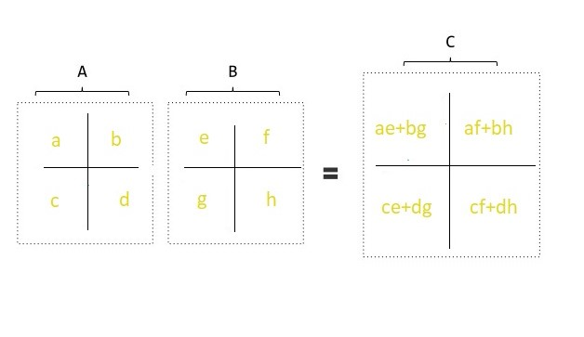
A, B and C are the Matrices of Size NxN
a, b, c and d are the sub-Matrices of A of size N/2xN/2
e, f, g and h are the sub-Matrices of B of size N/2xN/2

- Mr. Leo is working in a construction where they had to fencing around trees in a field. The owner has asked a rough estimate to do fencing in that field such all the trees lie inside that region. Consider yourself as a cost estimator who works under Mr. Leo. You are given location of all the trees, and you need to find the points that include this fencing. You need to output the trees that are included in the fencing.
Input:
points = [[1,1], [2,2], [2,0], [2,4], [3,3], [4,2]]
Output:
[[1,1], [2,0], [3,3], [2,4], [4,2]]

Post-Lab:

- Mr. Ravi Kumar owns a fruit market. In the market there are many sellers who are selling many kinds of fruits. More than one fruits seller can sell same kind of fruit. Mr. Ravi Kumar wants to arrange their information in the sorted order based on their names of the sellers and id of the fruits. You must arrange the same type of fruits in the same order as original order.
0-mangoes 1-apples
[Hint: Use counting sort algorithm]
Input
4
[[0, c], [1, b], [0, a], [1, d]]
Output

[[0, a], [0, c], [1, b], [1, d]]

- Given a set of points in the plane, apply convex hull algorithm to the given points and explain it step by step process.

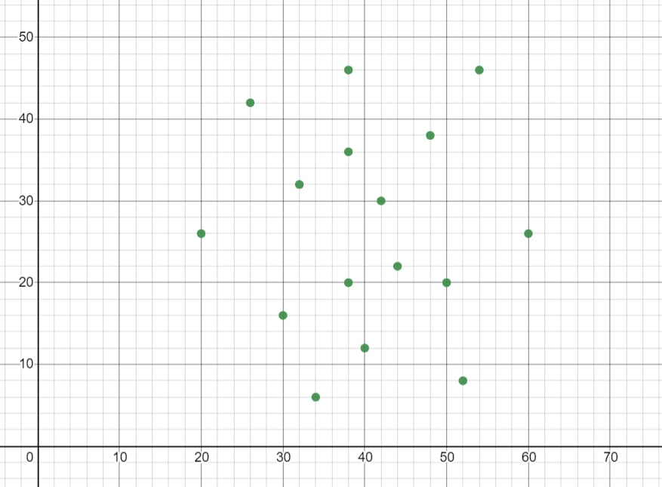

(For Evaluator’s use only)
Signature of the Evaluator Date of Evaluation:

Comment of the Evaluator (if Any) | Evaluator’s Observation
Marks Secured: out of
Full Name of the Evaluator:

LAB SESSION 05:

Date of the Session: / / Time of the Session: to

Pre-Lab:

- Explain why 0-1 Knapsack problems cannot be solved using greedy method unlike fractional knapsack.

- Categorize the following algorithms.
Prims’s Algorithm
Kruskal’s Algorithm
Dijkstra’s algorithm –

In-Lab:

- Given an array of size n that has the following specifications:
a. Each element in the array contains either a police officer or a thief.
b. Each police officer can catch only one thief.
c. A police officer cannot catch a thief who is more than K units away from the police officer.

We need to find the maximum number of thieves that can be caught.
Input
arr [] = {'P', 'T', 'T', 'P', 'T'},
k = 1.
Output
2
Here maximum 2 thieves can be caught; first police officer catches first thief and second police officer can catch either second or third thief.

2) Given an array of jobs where every job has a deadline and associated profit if the job is finished before the deadline. It is also given that every job takes a single unit of time, so the minimum possible deadline for any job is 1. How to maximize total profit if only one job can be scheduled at a time.
Input
4
Job ID Deadline Profit
a 4 20
b 1 10
c 1 40
d 1 30
Output
60
profit sequence of jobs is c, a

Post-Lab:

1. Suppose the letters a, b, c, d, e, f have probabilities 1/2, 1/4, 1/8, 1/16, 1/32, 1/32 respectively. Which of the following is the Huffman code for the letter a, b, c, d, e, f?

2. Consider the weights and values of items listed below. Note that there is only one unit of each item.

Items No | Weight (in kgs) | Value(in Rupees)
1 | 10 | 60
2 | 7 | 28
3 | 4 | 20
4 | 2 | 24

The task is to pick a subset of these items such that their total weight is no more than 11 Kgs and their total value is maximized. Moreover, no item may be split. The total value of items picked by an optimal algorithm is denoted by Vopt. A greedy algorithm sorts the items by their value-to-weight ratios in descending order and packs them greedily, starting from the first item in the ordered list. The total value of items picked by the greedy algorithm is denoted by Vgreedy.The value of Vopt − Vgreedy will be ______.

(For Evaluator’s use only)
Signature of the Evaluator Date of Evaluation:

Comment of the Evaluator (if Any) | Evaluator’s Observation
Marks Secured: out of
Full Name of the Evaluator:

LAB SESSION 06:

Date of the Session: / / Time of the Session: to

Pre-Lab:

- Our TASC has the information that a scientist has gone crazy and was planning a gas leakage in Delhi. We do not know the exact location where he was planning to do this attack. When Srikanth Tiwari tried to catch him, The Scientist tried to kill himself and has gone into coma in this process. Now no one knows the location of the attack except he has kept all the information in a file in his private server, but it is encoded using Huffman coding. So, help NIA decode the information. Given the root of the graph and the encoded information write a function to decode it. The function will have input parameters of root node and encoded string.
Input
Encoded String-1001011
Output
ABACA

In-Lab:

- You are a Human resource manager working in a Startup. You are tasked with to utilize the best of the working professionals to get the maximum profit for different jobs of a Project.
An array of jobs is given where every job has a deadline and associated profit if the job is finished
before the deadline. It is also given that every job takes single unit of time, so the minimum possible
deadline for any job is 1.How to maximize total profit if only one job can be scheduled at a time.
Write a code for the following problem.
Input
7
a b c d e f g
3 4 4 2 3 1 2
35 30 25 20 15 12 5
Output
110
d c a b

- Surya is a student at KL University, He is currently standing in the C-Block. He has 8 friends who are situated at different Blocks (Places) inside the university and he wishes to talk to each of them in person. The distances are represented on the undirected graph which is provided below. He wishes to take the shortest distance for each place from his location. Help him in meeting every one of his friends by developing a program that can determine the shortest distance between the C-Block and every other place on the graph. Remember that the path is not required.
Hint: Use Dijkstra’s algorithm to calculate the distances between the C-Block and every other place
Output for the same is provided along with the question.
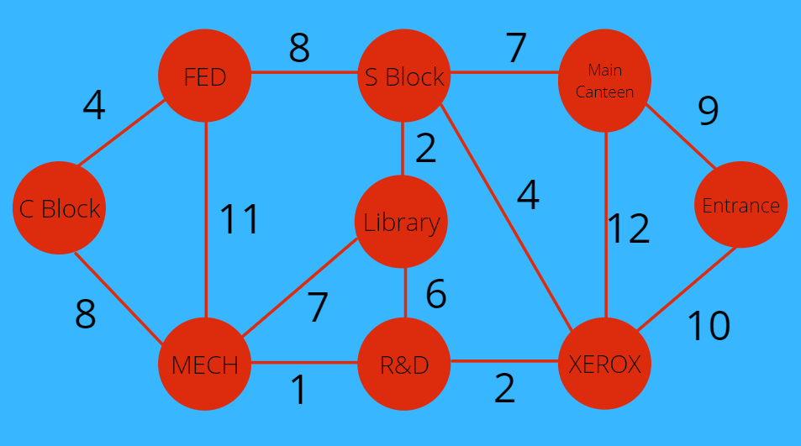

Output:
Vertex Distance from Source
C Block 0
FED Block 4
S Block 12
Main Canteen 19
Entrance 21
Xerox 11
R&D Block 9
Mech Block 8
Library 14

Post-Lab:
1. Mr. Tripathi is a network cable operator. He now shifted to a new city where he needs to work on designing the cable lines to each street/colony. Given the graph and each node represents a street, help him to design an optimal cable line using prim's algorithm. Write a program to solve this.
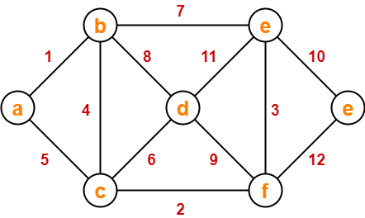

- Mr.Tripathi done with designing the cable lines but now there comes a new task, that is working on street lines. Help him again to find weight of the graph using Kruskal algorithm. Write a program to solve this.
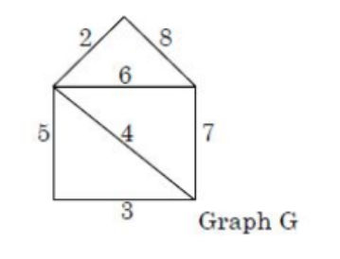

(For Evaluator’s use only)
Signature of the Evaluator Date of Evaluation:

Comment of the Evaluator (if Any) | Evaluator’s Observation
Marks Secured: out of
Full Name of the Evaluator:

LAB SESSION 07:

Date of the Session: / / Time of the Session: to

Pre-Lab:
- A student named Satish is eagerly waiting to attend tomorrow’s class. As he searched the concepts of tomorrow’s lecture in the course handout and started solving the problems, in the middle he was stroked in the concept of strings because he was poor in this concept so help him so solve the problem, given two strings str1 and str2 and below operations that can performed on str1. Find minimum number of edits (operations) required to convert ‘str1’ into ‘str2’.
1. Insert
2.Remove
3.Replace
Input
str1 = "cat", str2 = "cut"
Output
1
We can convert str1 into str2 by replacing 'a' with 'u'.
Input
str1 = "sunday", str2 = "saturday"
Output
3

- Given N numbers n1,n2,…nN and Q queries q1,q2,…qQ. Your task is to print Q (Q< j <numbers) f1,f2,…fQ, corresponding to query qj1 max(n1=fj ,n2 ,...nq) using dynamic programming.
Input
5 3
5 4 8 6 9
2 3 5
Output
5 8 9
In-Lab

Teacher: good morning students!!!

Students: good morning mam

Teacher: Today topic is binary tree. Does anyone know what is binary tree?

Students: no mam

Teacher: In computer science, a binary tree is a tree data structure in which each node has at most two children, which are referred to as the left child and the right child. Satish you completed this topic yesterday can you explain this topic?

Satish: Sure, mam but I got doubt this concept, do anyone help me in solving this the question was Given a binary tree, find whether if a given Binary Tree is Balanced?

- SIRI studies at KL University and a person who is interested in Dynamic Programming, she created a question for you to solve. she decided to give a question related to palindrome, you need to use dynamic programming to solve this problem brute force is not allowed since she hates waiting too long to find the answer. The question follows like this find the longest palindromic subsequence.
(Unlike substrings, subsequences are not required to occupy consecutive positions within the original string.)
Input
ABBDCACB
Output
The length of the longest palindromic subsequence is 5
The longest palindromic subsequence is BCACB

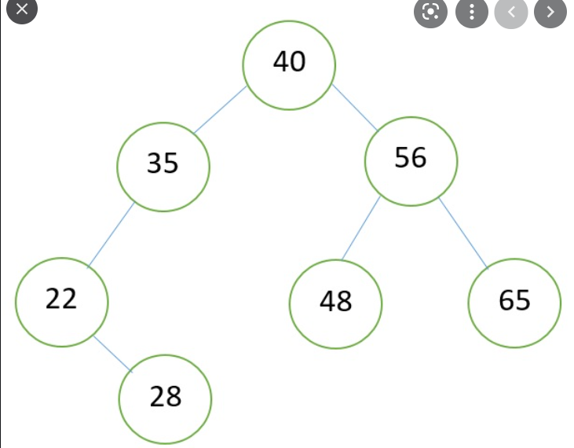

- SIRI studies at KL University and a person who is interested in Dynamic Programming, she created a question for you to solve. she decided to give a question related to palindrome, you need to use dynamic programming to solve this problem brute force is not allowed since she hates waiting too long to find the answer. The question follows like this find the longest palindromic subsequence.
(Unlike substrings, subsequences are not required to occupy consecutive positions within the original string.)
Input
ABBDCACB
Output
The length of the longest palindromic subsequence is 5
The longest palindromic subsequence is BCACB

Post-Lab:

- Bhanu and Teju are playing dice game where there are N dice with M faces and the dice are numbered from 1 to M. A person wins the game if the sum of the faces of dice adds up to a value X. you are playing on Bhanu’s team, and It is Teju’s turn now.
You are supposed to find number of ways your opponent can win the game where N, M and X are provided as input. Use Dynamic programming to solve the problem.
Using DP (Dynamic programming) to find the number of ways to get sum X.
Input
M = 2
N = 2
X = 3
Output
2

(For Evaluator’s use only)
Signature of the Evaluator Date of Evaluation:

Comment of the Evaluator (if Any) | Evaluator’s Observation
MarksSecured: outof
Full Name of the Evaluator:

LAB SESSION 08:

Date of the Session: / / Time of the Session: to

Pre-Lab:

- Your father brought you a ticket to world tour. You have a choice to go to three places, your father knows the places you wanted to travel so he made a graph with the measuring distances from home. Now you start from your place (1: Source) to other places as shown in the graph below apply TSP to find shortest path to visit all places and return to home. (Ex: 2: London, 3: Paris, 4: Singapore)

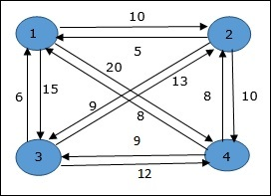

In-Lab:

- Emma has a graph which represents a flow network where every edge has a capacity. Also given two vertices source s and sink t in the graph, fin the maximum possible flow from s to t with following constraints:
a. Flow on an edge does not exceed the given capacity of the edge.
b. Incoming flow is equal to outgoing flow for every vertex except s and t.

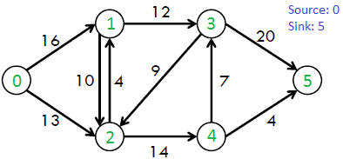
Find the Maximum flow using the graph and by implementing the code.

- Your friend works in a comparable way to a Travelling salesperson ― he always travels to new cities to sell his delicious dishes.
Today, your friend is planning to visit N cities (numbered 1 through N). There is a direct way to travel between each pair of cities. Each city has a specific temperature; let us denote the temperature in the i-th city by Ci. Your friend has a fixed temperature tolerance D with the following meaning: for each pair of cities an and b, he may travel from city a directly to city b only if |Ca−Cb|≤D, otherwise he would catch a heavy flu because of the sudden change in temperature.
Your friend starts from city 1. Is he able to visit all N cities in such a way that each city is visited exactly once?
Notes:
1. Your friend is not able to travel through a city without visiting it.
2. City 1 is visited at the beginning.
It is not necessary to be able to travel directly to city 1 from the last city Your friend’s visits.
Input
2
5 3
3 2 1 4 5
5 4
10 1 3 2 9
Output
Yes
No

Post-Lab:

- Mani is poor at playing chess, he was asked to arrange “N” Queens on the chess board in such a way that no two queens are allowed to kill each other. Since he is poor at chess you were asked to arrange them on behalf of him. (You must use Backtracking Approach)

- KL University is starting next week. There are S subjects in total, and you need to choose K of them to attend each day, you required number of credits to pass the semester. There are N+1 buildings. Your hostel is in building number 0. Subject j is taught in building Bj. After each subject, you have a break, during which you go back to your hostel. There are M bidirectional paths of length 1 which connects building b1 to building b2. Find the minimum total distance you need to travel each day if you choose your subjects correctly.
Input
2 3 2 2
0 1
1 2
2 0
1 2
Output
4

(For Evaluator’s use only)
Signature of the Evaluator Date of Evaluation:

Comment of the Evaluator (if Any) | Evaluator’s Observation
Marks Secured: out of
Full Name of the Evaluator:

LAB SESSION 09:

Date of the Session: / / Time of the Session: to

Pre-Lab:

What is Back Tracking methodology and when can we use Back tracking, explain with an example?

- Mr. Anumula went to the Ice-Cream Parlor. He will be with certain amount of money to buy ice-creams. When he goes to the counter for ordering the Ice-cream, there will be displayed with the items and its cost, respectively. He will be checking which items he can buy according to the money. Print "YES" if he can buy the Ice-Creams without leaving one rupee also otherwise print "NO".
Input
costs= [100, 70, 50, 180, 120, 200, 150]
Total Money=300
Output
YES
In-Lab:

A Set A = {1,2,3,4,5,6,7} having n=7 elements and find all the possible subsets whose sum is m=10 and draw state space tree for above problem.

- Given an undirected graph and N colors, the problem is to find if it is possible to color the graph with at most N colors, which means assigning colors to the vertices of the graph such that no two adjacent vertices of the graph are colored with the same color.
Print "Possible" if it is possible to color the graph as mentioned above, else print "Not Possible".
Input
1
3 2
0 2
1 2
2
Output
Possible

Post-Lab:

- Kiran is a very obedient boy and helping others is a habit of him. He will do any work with dedication his teacher assigns him a work to generate all permutations of given word. Since he is busy helping others, you are asked to help him to complete his work on behalf of him. (Use Backtracking Concept)

- Mr. Sai joined for as an assistant at a school where he was given a job to arrange schedules for the subject n1, n2, n3, n4, n5, n6, n7, n8. Help him schedule the timetable from the given information.
Let this be the schedule:
Here for everyone hour there are many subjects competing. Use backtracking and create a schedule where each subject is assigned to a specific hour in a day. In the schedule ‘1’ represents that the subject is competing for that hour.
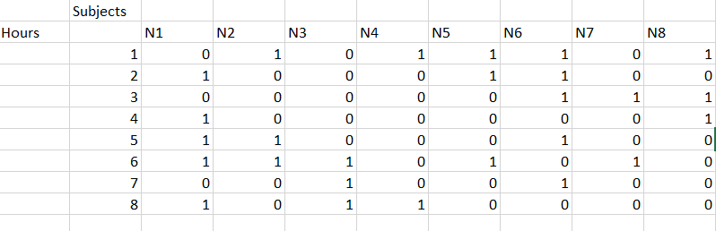

(For Evaluator’s use only)
Signature of the Evaluator Date of Evaluation:

Comment of the Evaluator (if Any) | Evaluator’s Observation
Marks Secured:______ out of_____
Full Name of the Evaluator:

LAB SESSION 10:

Date of the Session: / / Time of the Session: to

Pre-Lab:

1)Given a set of cities and distance between every pair of cities, the problem is to find the shortest possible route that visits every city exactly once and returns to the starting point. Note the difference between Hamiltonian Cycle and TSP. The Hamiltonian cycle problem is to find if there exist a tour that visits every city exactly once. Here we know that Hamiltonian Tour exists (because the graph is complete) and in fact many such tours exist, the problem is to find a minimum weight Hamiltonian Cycle.

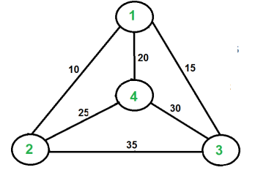

For example, consider the graph shown in figure on right side. A TSP tour in the graph is 1-2-
4-3-1. The cost of the tour is 10+25+30+15 which is 80.
The problem is a famous NP hard problem. There is no polynomial time know solution for this problem. Find the different solutions for the traveling salesman problem.

In-Lab:

- From Our Galaxy nearly 10^9+7 trillion kilometers far away, there exists a parallel Universe of Light called the Smolen of cosmos where each planet is called a Temp. There are total N temps. Unlike humans, the extraterrestrial can travel from one temp to another through Cosmic Bridges and the distance observed by them between any two temps is 0 units
But the year 2012, proved to be a curse for extraterrestrial. This year, a Mega Star Urus struck their Universe and damaged many Cosmic Bridges. However, the God of Light ensured that for any two distinct temps t1 and t2 there exists exactly one unique path through Cosmic Bridges, but the distance between two directly connected temps through a Bridge has now increased to 1 unit.
To prevail the existence of this Universe, the God of Light carved himself into exactly N extraterrestrial which now rule the N temps and are independent of each other. One by one, the ith extraterrestrial (0≤i≤N−1) transmits Light pulses through the network of Cosmic Bridges and determines the sum of distances to the remaining N−1 extraterrestrial.
Can you help them find these quantities so they can reunite into God of Light again?
Input
5
0 2
0 3
1 3
3 4
Output
6 8 9 5 8

- 2 years ahead, you planned a road trip as a reunion with all your classmates. You planned to visit N places in total, the list of their coordinates (arr []) are given in sorted order. You start the tour from the left most location and strictly move towards the right and then upon reaching the right most location, the tour goes strictly from right to left-back to the starting location. Find the minimum distance of the tour so that you can save time and fuel.
Input
N = 7
arr[][] = {{0, 6}, {1 0}, {2 3}, {5 4}, {6 1}, {7 5}, {8 2}}
Output
25.582

Post-Lab:
- Jane has very less Marks in Dynamic programming test conducted by his teacher. So, the teacher had given a problem about optimal Binary Search Tree which should be solved using Dynamic Programming by the next class. Since, he is very weak in Dynamic programming you must help him to solve the problem. The problem can be described as follows: An unsorted data of keys and their frequencies are given to you and some queries where each query contains two integers which describe the Range of the indices (index range) for which you must print the root of that Optimal Binary Search Tree. Tasks: (i)You should Find the Cost of the optimal BST (Binary Search Tree)by considering all the keys and print the value in a new Line. (ii)Find and print the root of the Optimal BST formed by the range of indices (keys index range) given by each sub-query. The first line contains integer 'n' which describes the size of the keys. The second line contains values of keys. The third Line contains values about frequencies of each key. The fourth Line is an integer 'm' which describes no of queries. The following lines contains two integers describing the range for each query. Print the cost of the Optimal BST by considering all the keys. For each Query print the root of the Optimal BST based on the given range
Input
4
12 10 20 21
2
03
01
Output
Cost of Optimal BST is 144
20
10

- You are offered N pay packages by various companies, Congratulations! You can only select 2 unique groups of packages each with a total of at least K. Select the 2 groups such that you choose minimum number of companies adding up to the total of K.
Input
arr[] = {2, 4, 5, 6, 7, 8}, K = 16
Output
6
Explanation:
The subsets {2, 6, 8} and {4, 5, 7} are the two smallest subsets with sum K (= 16).
Therefore, the sum of the lengths of both these subsets = 3 + 3 = 6.4

(For Evaluator’s use only)
Signature of the Evaluator Date of Evaluation:

Comment of the Evaluator (if Any) | Evaluator’s Observation
Marks Secured:______ out of______
Full Name of the Evaluator:

LAB SESSION 11:

Date of the Session: / / Time of the Session: to

Pre-Lab:
- Match the data structure used to generate branch and bound strategy.
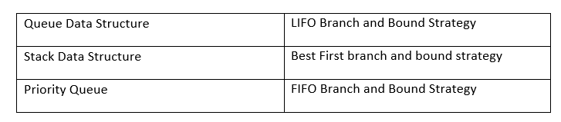

- You are given a knapsack that can carry a maximum weight of 60. There are 4 items with weights {20, 30, 40, 70} and values {70, 80, 90, 200}. What is the maximum value of the items you can carry using the knapsack?

In-Lab:

- A Professor is teaching about Binary Numbers. He wants to know all the possible binary numbers of a given length. Help the Professor to generate all the set of binary strings of length N in ascending order using Branch and Bound Technique.
Input
N = 3
Output
000
001
010
011
100
101
110
111
Explanation:
Numbers with 3 binary digits are
0, 1, 2, 3, 4, 5, 6, 7

- You are in a supermarket shopping for fruits with huge discounts. There are N varieties of fruits available each with a weight C and discount P. Now, select K fruits in a way that maximizes the discount. You only have a bag which can carry a weight of W.
Input
N = 5
P [] = {2, 7, 1, 5, 3}C [] = {2, 5, 2, 3, 4}, W = 8, K = 2.
Output
12
Explanation:
Here, the maximum possible profit is when we take 2 items: item2 (P[1] = 7 and C[1] = 5) and item4 (P[3] = 5 and C[3] = 3).
Hence, maximum profit = 7 + 5 = 12

Post-Lab:
- Given an array of positive elements, you must flip the sign of some of its elements such that the resultant sum of the elements of array should be minimum non-negative (as close to zero as possible). Return the minimum no. of elements whose sign needs to be flipped such that the resultant sum is minimum non-negative. Note that the sum of all the array elements will not exceed 104.
Input
arr [] = {15, 10, 6}
Output
1
Here, we will flip the sign of 15
and the resultant sum will be 1.

- There are some processes that need to be executed. The amount of load that process causes a server that runs it, is being represented by a single integer. The total load caused on a server is the sum of the loads of all the processes that run on that server. You have at your disposal two servers, on which the mentioned processes can be run. Your goal is to distribute given processes between those two servers in a way that, the absolute difference of their loads will be minimized.
Given an array of A[] of N integers, which represents loads caused by successive processes, the task is to print the minimum absolute difference of server loads.
Input
A[] = {1, 2, 3, 4, 5}
Output
1
Explanation:
Distribute the processes with loads {1, 2, 4} on the first server and {3, 5} on the second server, so that their total loads will be 7 and 8, respectively.
The difference of their loads will be equal to 1.

(For Evaluator’s use only)
Signature of the Evaluator Date of Evaluation:

Comment of the Evaluator (if Any) | Evaluator’s Observation
Marks Secured:______ out of _______
Full Name of the Evaluator:

LAB SESSION 12:

Date of the Session: / / Time of the Session: to

Pre-Lab:

- Read the following conversation
Jaya: Travelling salesman problem is a NP hard problem.
Hema: I do not think so
Jaya: No, I am so sure that Travelling Salesman problem is a NP hard problem.
Hema: …!!
You are Jaya’s friend. Help her prove her statement.

- Consider the two graphs and find out the node cover for the each of the graphs and specify the maximum node cover.
- 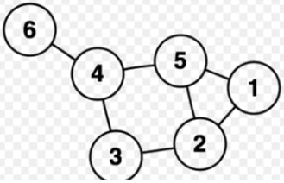
- 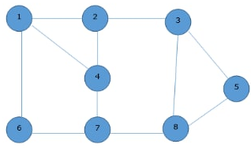

In-Lab:

- Raju prepares for the examination, but he got stuck into a concept called "NP-HARD AND "NP-COMPLETE PROBLEMS" on Nondeterministic Algorithms. So, help Raju to score good marks. Help him to define the Nondeterministic algorithms by sorting an array.

- Karthik and Bavya are trying to implement a program that helps a transportation company use its container to maximum efficiency, as part of their CS project.
Few objects are more valuable than others. Each object has a certain weight. The transportation company wants to fill the container so that the value of the container (sum of value of objects in the container) is maximum, while total weight of the objects does not exceed the container's capacity.
As the outcome is not fixed, this is a non-deterministic problem. This is a knapsack problem as we must maximize value within the given weight limit.
So, to understand the problem well and implement it, help them in finding non-deterministic knapsack algorithm.

Post-Lab:
- Hema: Hamiltonian Path is NP-Complete.
Jaya: Well, prove that!
Hema: I will prove and let you know.
Help Hema to try and prove that Hamilton Path is NP-Complete

- Hemanth was unable to answer the following question in exam. Here is the question, help Hemanth to find P1 solution. Find the total cost to find the P1 solution
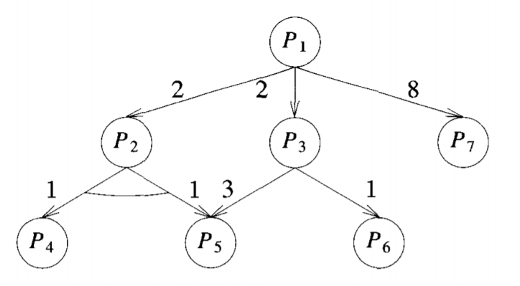

(For Evaluator’s use only)
Signature of the Evaluator Date of Evaluation:

Comment of the Evaluator (if Any) | Evaluator’s Observation
Marks Secured:_______ out of ________
Full Name of the Evaluator:

LAB SESSION 13:

Date of the Session: / / Time of the Session: to

Pre-Lab:
1)Given an array of integers A and a positive integer k, find whether it is possible to divide this array into sets of k consecutive numbers. Return True if it is possible otherwise return False.
Input:
A = [1,2,3,3,4,4,5,6], k = 4
Output
True
Explanation: Array can be divided into [1,2,3,4] and [3,4,5,6].
Input
A = [3,2,1,2,3,4,3,4,5,9,10,11], k = 3
Output
True
Explanation: Array can be divided into [1,2,3], [2,3,4], [3,4,5] and [9,10,11].
Input
A = [3,3,2,2,1,1], k = 3
Output
True
Input
A = [1,2,3,4], k = 3
Output
False
Explanation: Each array should be divided in subarrays of size 3.

2) Given a string Str of characters from 1 to 9. Your task is print a string Str1 of numbers using dynamic programming such that
a. |Str1|=|Str|
b. The ith character of Str1 is the number of even characters from ith position to last position of Str.
Input
475854637834259
Output
766655433322100

In-Lab:

- Raju has very less Marks in Dynamic programming test conducted by his teacher. So, the teacher had given a problem about optimal Binary Search Tree which should be solved using Dynamic Programming by the next class. Since, he is very weak in Dynamic programming you must help him to solve the problem. The problem can be described as follows:
An unsorted data of keys and their frequencies are given to you and some queries where each query contains two integers which describe the range of the indices (index range) for which you must print the root of that Optimal Binary Search Tree.
Input
4
12 10 20 21
8 34 50 1
2
0 3
0 1
Output
Cost of Optimal BST is 144
20
1

- Karthik was given a problem in an online interview, but he cannot solve the solution help him solve the question. There are n students whose ids vary between 0 to 9 digits; two students can have same id's. You will be given x numbers which also vary from 0 to 9. You need to find the total number of student id's subsets which contains all the x numbers.
Input
333
1
3
Output
6

Post-Lab:
1) Define a group of length N as a sequence of N numbers, consisting of all the numbers from 1 to N in any order. An oppgroup of a group (let say P) is a sequence of numbers in which the ith number is the position of number i in the original group, 1<= i<= N.i.e., if group 2 5 1 4 3, oppgroupis 3 1 5 4 2. Given a number N, find the number of distinct groups of length N which cannot be distinguished from their oppgroups.
Input
1
3
Output
4

2)Given a string S of length N consisting of digits 1 to 9and an integer K. Determine the number of ways to partition the string S such that each segment value is less than K. If there is no way to perform partition on the string, then print 0.
Input
a)5 6
34212
b)2 21
11
c)5 22
34212
Output
a)1
b)2
c)3

(For Evaluator’s use only)
Signature of the Evaluator Date of Evaluation:

Comment of the Evaluator (if Any) | Evaluator’s Observation
Marks Secured:_______ out of ______
Full Name of the Evaluator:

LAB SESSION 14:

Date of the Session: / / Time of the Session: to

Pre-Lab:

Find out Graph traversals by using BFS and DFS to the following graph.
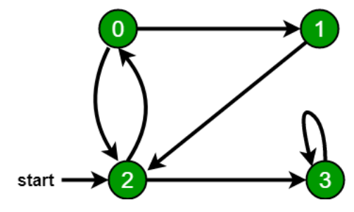

In-Lab:

- Dark Peace is volunteer in VISION 2K17.ChiefCO gave him a task to complete it before the CODEGEEKS which is on 11th march. ChiefCo asks DarkPeace to do the work as soon as possible. So, to complete the task as soon as possible Dark Peace asks you to help him. You will be given two set of length N and M. Your task is to find whether the subset is present in the first set whose sum of elements is equal to the member of the set. You must check for every member of the second set. Print Yes if subset is present and if not present print No and if the member exceeds the maximum sum of Input
3 3
1 7 4
10 14 4
Output
No -1 Yes
Explanation
For first member no subset gives sum to 10 so we print No. For second since maximum sum is 12 and 14 is greater than 12 so we print -1. For last subset {4} exits whose sum is equal to 4 and hence we print Yes

Post-Lab:
- The subset sum problem is an important problem in computer science. Below we will provide a simple algorithm for solving this problem. The challenge is to determine if there is some subset of numbers in an array that can sum up to some number S. These algorithms can both be implemented to solve Array Addition I and Array Addition.
Simple (Naive) solution
The algorithm for the exponential time, naive solution, is as follows: First we will generate
every possible set (the power set), and then check if the sum of any of these sets equals the
sum S. For example: arr = [1, 2, 3] sum = 5
All possible sets:[] [1] [2] [3] [1, 2] [1, 3] [2, 3] [1, 2, 3]
We can see that we can get a sum of 5 by adding the elements in the set [2, 3]. To generate all possible sets of an array, we will implement the following algorithm:
(1) The initial power set only contains the empty set: [[]]
(2) We loop through each element in the array and add it to every element in the powerset.
(3) Then we take the union of these two sets.
(4) Once we get the power set, we check to see if the sum equals our goal S.
Example
arr = [1, 2, 3] sum = 5 sets = [[]]
Step 1: Add 1 to the power set [[], [1]]
Step 2: Add 2 to the power set [[], [1], [1, 2], [2]]
Step 3: Add 3 to the power set [[], [1], [1, 2], [2], [1, 3], [2, 3], [1, 2, 3], [3]]

(For Evaluator’s use only)
Signature of the Evaluator Date of Evaluation:

Comment of the Evaluator (if Any) | Evaluator’s Observation
Marks Secured: ______ out of ______
Full Name of the Evaluator:

LAB SESSION 15:

Date of the Session: / / Time of the Session: to

Pre-Lab:

- Write a recursive approach to get maximum profit value with Ex-tended knapsack problem.
Input
N = 5, P[] = {2, 7, 1, 5, 3}, C[] = {2, 5, 2, 3, 4}, W = 8, K = 2.
Output
12
Explanation:
Here, the maximum possible profit is when we take 2 items: item2 (P[1] = 7 and C[1] = 5) and item4 (P[3] = 5 and C[3] = 3). Hence, maximum profit = 7 + 5 = 12
Input
N = 5, P[] = {2, 7, 1, 5, 3}, C[] = {2, 5, 2, 3, 4}, W = 1, K = 2
Output
0
Explanation: All weights are greater than 1. Hence, no item can be picked.
In-Lab:

- Danny has a possible list of passwords of Manny's Facebook account. All passwords length is odd. But Danny knows that Manny is a huge fan of palindromes. So, his password and reverse of his password both should be in the list. You must print the length of Manny's password and its middle character.
Note: The solution will be unique.
Input
4
abc
def
feg
cba
Output:
3

As a health expert, Vinay is keeping a close watch on the ongoing pandemic of coronavirus disease (COVID-19). He thought of a different situation where there are 26 types of viruses, named "aorona", "borona", "corona", …, "zorona”. You are given a string S with length N. There are N people (numbered 1 through N) and for each valid i, the i-th person is infected by exactly one type of virus named Siorona (i.e., "corona" with the first letter replaced by the i-th character of S).

You should answer Q queries. In each query:

You are given an integer C denoting the number of available isolation centers.

Each isolation center has an infinite capacity, but with the restriction that two people infected with the same type of virus cannot stay in the same isolation center.

There is also a pending queue with an infinite capacity and there are no restrictions on which people can be in the pending queue

Initially, the isolation centers and pending queue are empty.

Each of the N people should be placed in either the pending queue or one of the isolation centers.

Since Vinay is busy finding a vaccine, he asks Swapnil to find a way to place the people in the pending queue and isolation centers such that the number of people in the pending queue is the smallest possible.

Help Swapnil find the size of the pending queue in that case.

Input

1

20 2

stayinghomesaveslife

1

3

Output

6

0

Explanation
Example case 1: In the pending queue for the first query, there should be 2 people with "eorona", 2
with "sorona", 1 with "aorona" and 1 with "iorona".

(Writing space for In-Lab)

Post-Lab:

- Lisa is a school student teacher gave her an assignment to check whether the pattern is there or not in each text and, she mentioned that it is have solve by using Kmp algorithm so when a mismatch come other some matches in your search if she prints the number of letters that we can neglect before then she will get good marks so help her by writing a code.
Input
ABABDABACDABABCABAB
ABABCABAB
Output
we don‟t match before 2 letters because they will match anyway
we don‟t match before 0 letters because they will match anyway
we don‟t match before 1 letter because they will match anyway
we don‟t match before 0 letters because they will match anyway
Found pattern at index 10

(For Evaluator’s use only)
Signature of the Evaluator Date of Evaluation:

Comment of the Evaluator (if Any) | Evaluator’s Observation
Marks Secured: out of
Full Name of the Evaluator:

