Title: **Selenium Tutorial**

Table of Contents

What you are going to learn? 2

Install Java SDK and JRE 2

Steps to install Java SDK 2

Install Eclipse IDE 3

Create a new Java Selenium Project: 5

Add Jar Files to Eclipse Build Path 6

Downloading Driver files for Browsers 7

Run a simple Selenium Scripts from Local Drive 7

Revisions 9

**Selenium Tutorial**

# What you are going to learn?

* + Install Java Software Development Kit(SDK) And Java Run Time Environment (JRE)
  + Install Eclipse IDE
  + Create Java Project in Eclipse
  + Copy Jar files into Java Eclipse
  + Run a Simple Selenium Script

# Install Java SDK and JRE

To Run Selenium codes in Local machine Java Software Development Kit needs to installed. Both Java SDK and Java Run Time Environments are necessary in order to execute scripts.

## Steps to install Java SDK

1. Go to the following website: <http://www.oracle.com/technetwork/java/javase/downloads/jdk8-downloads-2133151.html>
2. Perform the following steps

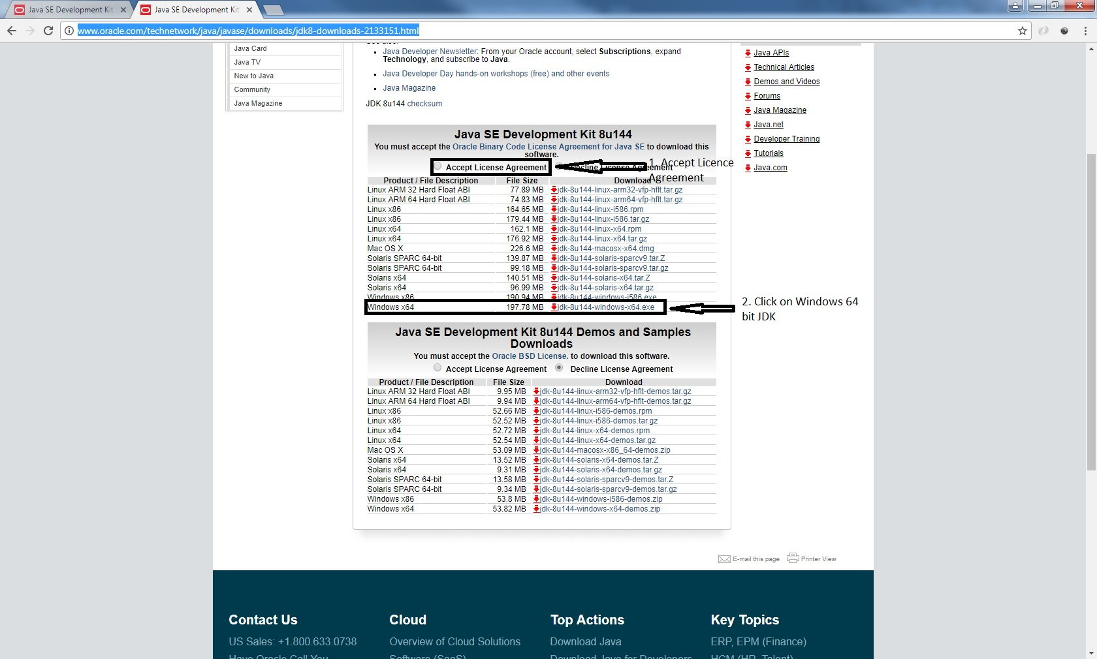

1. After the download, go to the download folder and select the Jar file jdk-8u144-windows-x64.exe
2. Double click on it
3. Perform the following steps mentioned below

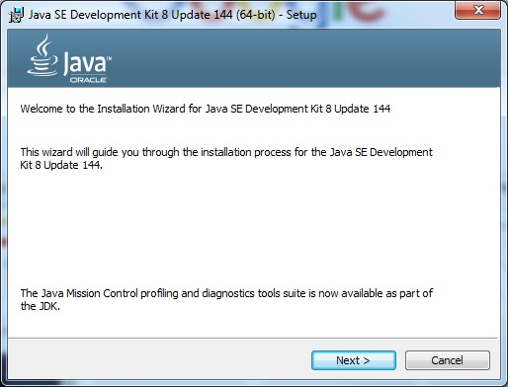

1. 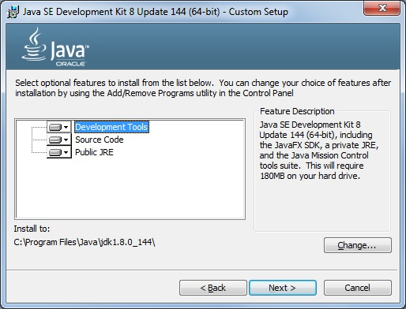
2. After the installation, system will get rebooted. This Completes the JAVA SDK and JRE Installation.

# Install Eclipse IDE

1. Go to the following website

<http://www.eclipse.org/downloads/eclipse-packages/>

1. 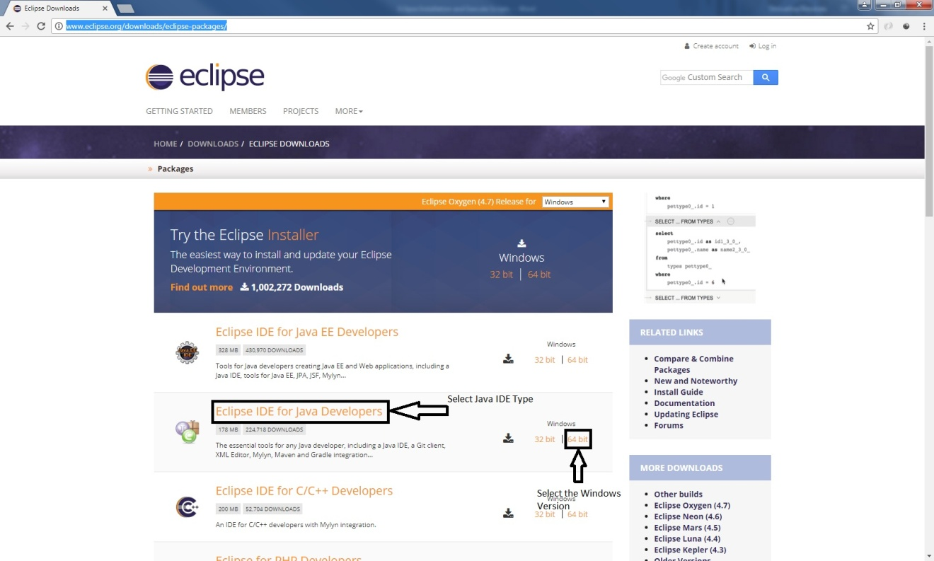
2. Download the zip file. After the Download, extract contents in the zip file to a new folder. New folder will look like the following

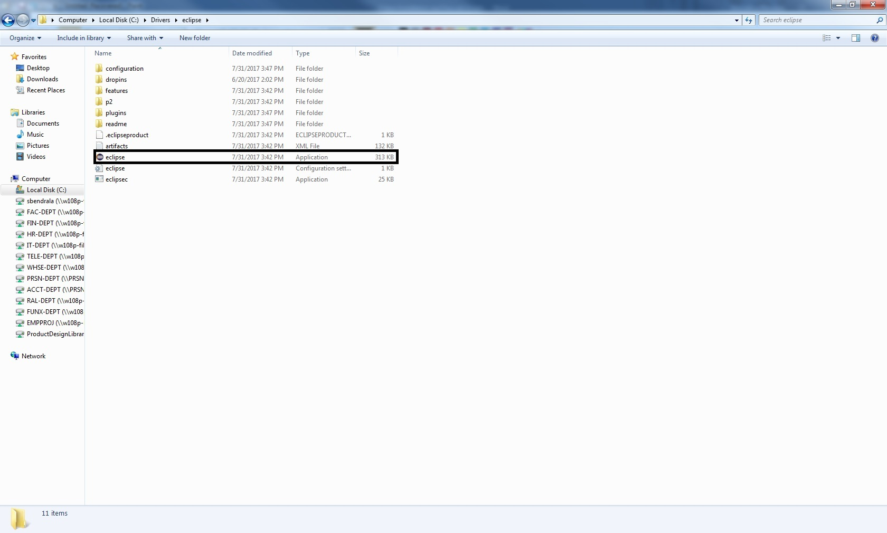

1. Double click on the eclipse.exe icon highlighted above.
2. 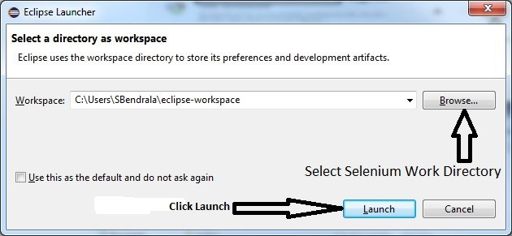

# Create a new Java Selenium Project:

1. Go to the following in Eclipse home page File 🡪 New 🡪 Java Project

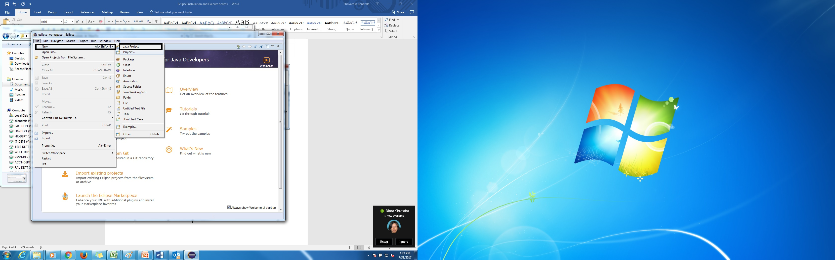

1. 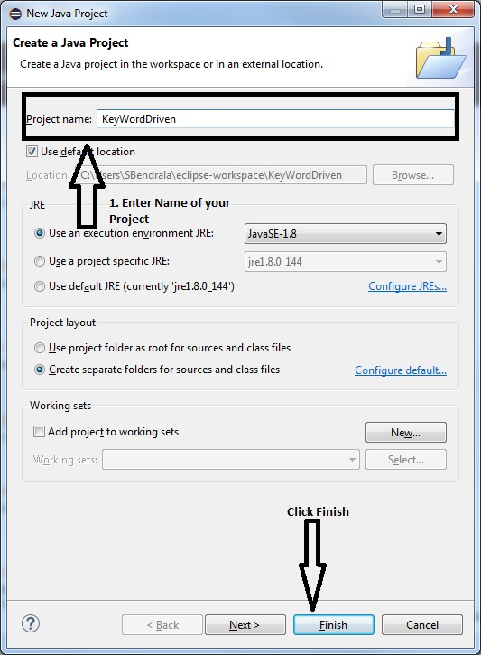
2. Eclipse will look the following

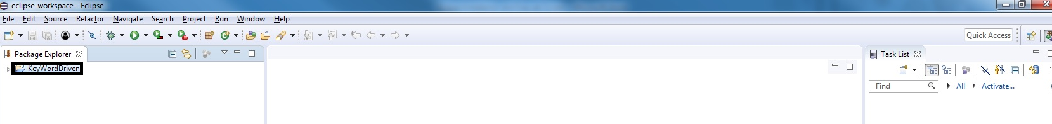

# Add Jar Files to Eclipse Build Path

Jar files are nothing but a package which contains set of several java class files. Jar files can be compared to a library which contains books (Java classes) belong to several categories.

Jar files can be used to extend the functionality of our existing Java codes.

We are using following Categories of Jar files in our project

1. Selenium: This is the core library from which selenium automation can be done
2. Apache POI: This is used to extract Excel data into Java Selenium
3. Extent Logs: This is used to create Detailed Log Results
4. Apache Log4j: Create detailed text log files

* How to add jar files to the existing project?

1. Right click on your current active project and click on Properties.

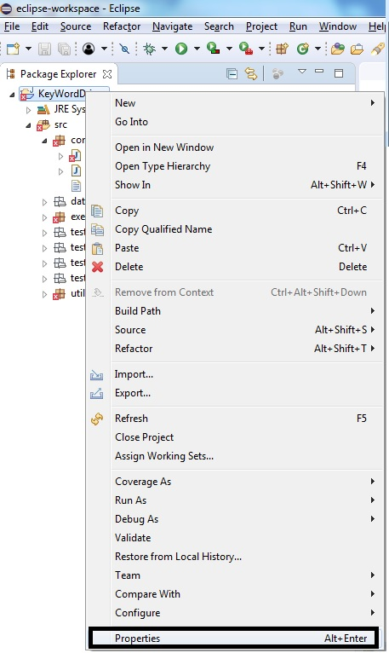

1. Go to Java Build Path 🡪 Libraries 🡪 Click on add External Jars

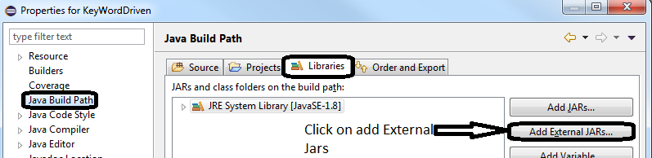

1. Uploaded the jar files from local folder
2. Click Apply and Close
3. Wait for the Eclipse to build/add all Jar files into Java Library.
4. Hover to Bottom Right Tab in your Eclipse, If your build is successful, it should display 0 errors.

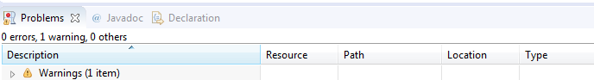

Note: Warnings are acceptable in Java Eclipse but errors prevent the code from running.

# Downloading Driver files for Browsers

1. Create a new folder called ‘*Drivers’* in your C Drive
2. Download softwarefrom Internet and place in this path

# Run a simple Selenium Scripts from Local Drive

1. Go to ‘*KeyWordDriven’ Project in the* Eclipse project
2. Right Click on New🡪Class
3. Give the Name of the class as ‘*SeleniumBasics’*
4. Click ‘*Finish’*
5. 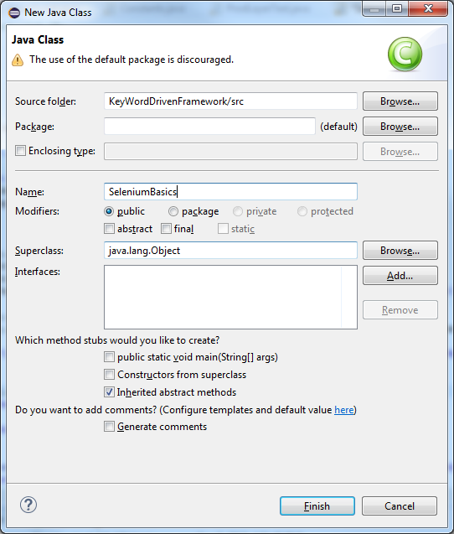
6. Copy ‘*SeleniumBasics.java*’ from Google drive and copy it in your Local Drive
7. Open ‘*SeleniumBasics.java*’ from notepad and copy the entire code
8. Paste this source code into Eclipse

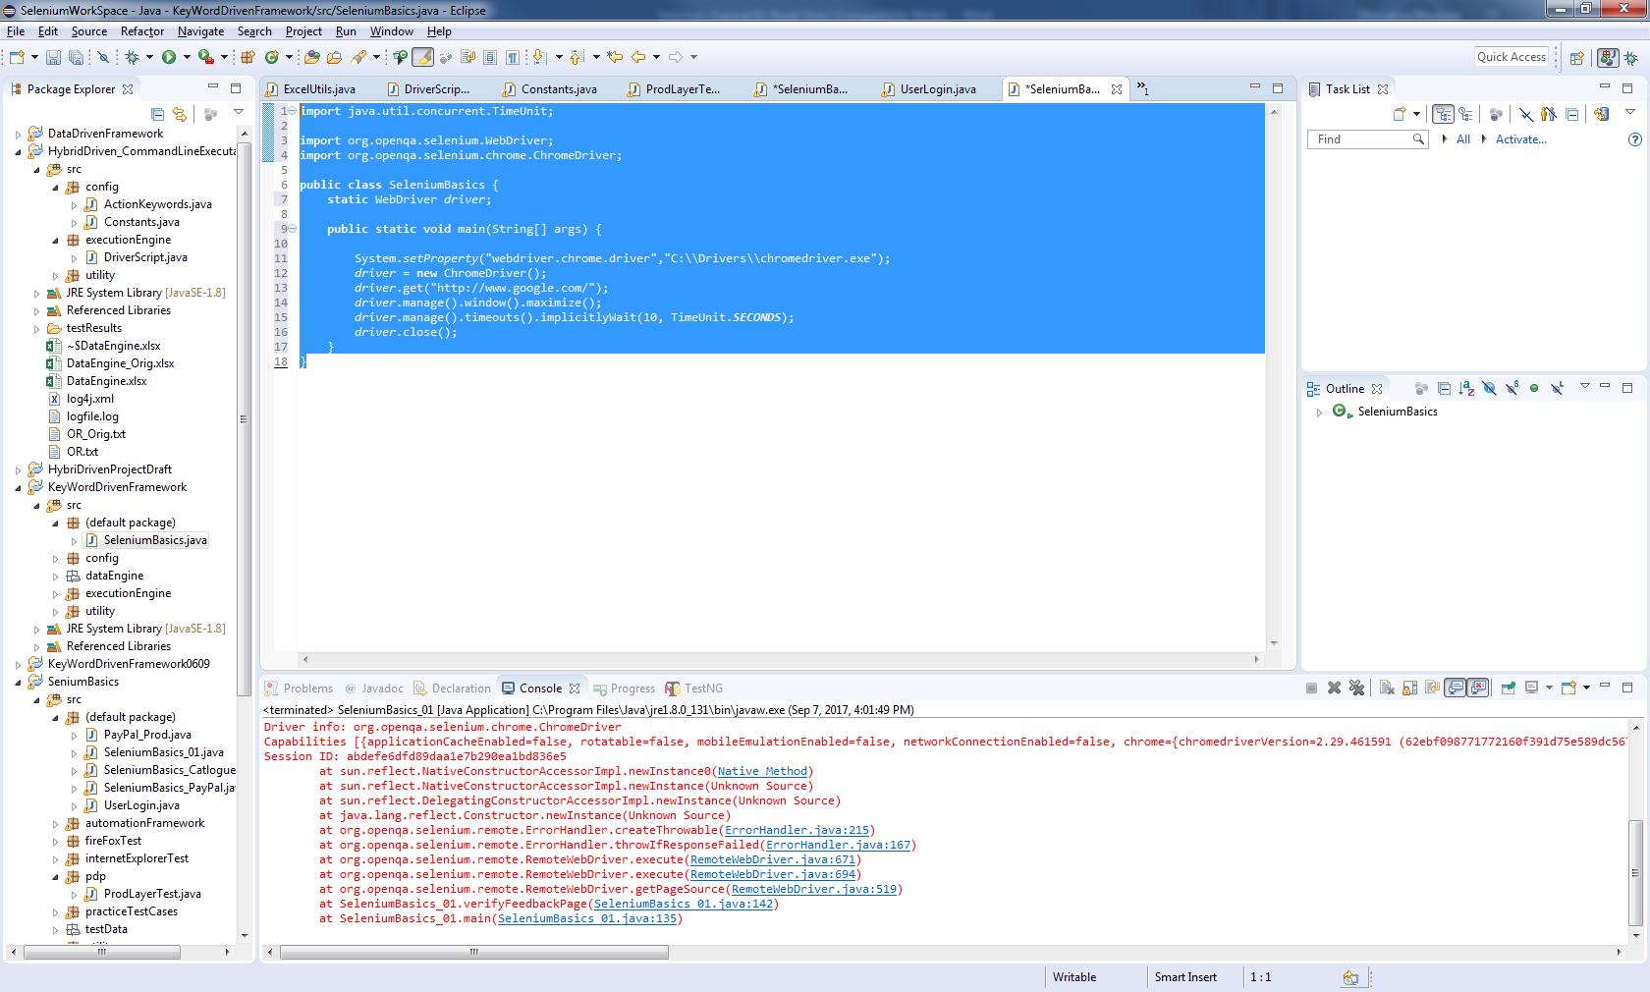

1. Click on ‘*Run’*

**YAY! You have successfully completed Your Tutorial in Selenium!**

|  |  |  |
| --- | --- | --- |
| Revisions | | |
| **Author** | **Date** | **Description** |
| Shrivathsa Bendrala | 2/4/2018 | Initial Release |
|  |  |  |