Table of Contents

**Main Parts to run Databricks notebook from Control-M:** 2

**Databricks job:** 2

**AZ Login:** 3

**Create YAML File:** 3

**Copy on-prem source files to Azure Cloud:** 3

**Azpipr app:** 3

**Control-M job creation:** 4

**Sample Code for Examples:** 4

**Control-M Orchestration for Databricks**

# **Main Parts to run Databricks notebook from Control-M:**

## **Databricks job:**

Let’s assume we have a databricks notebook with script(s) written in their cells and a job is created under <workflows>.

The below job: DAS_HCM_TEST_JOB is created for POC to show case running databricks notebook from Control-M Job.

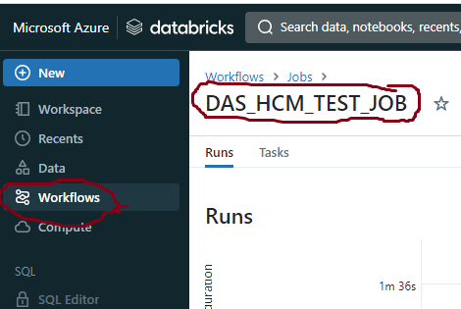

When the job is created, it assigns an ID to the job as you see below.

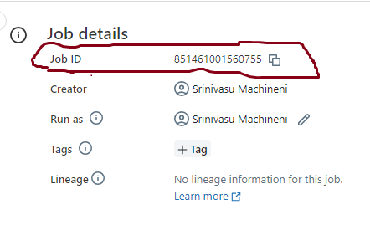

Link to the databricks notebook @ DEV : [https://adb-7704615097133693.13.azuredatabricks.net/?o=7704615097133693#notebook/1336572539334954/command/1336572539334955](https://adb-7704615097133693.13.azuredatabricks.net/?o=7704615097133693%23notebook/1336572539334954/command/1336572539334955)

(When the below job is executed , it will run the above databricks notebook)

Link to the job: <https://adb-7704615097133693.13.azuredatabricks.net/?o=7704615097133693#job/851461001560755>

## **AZ Login:**

You need to login Azure environment in the shell wrapper script by providing username and password.

The <az login> command is part of the az CLI (Command-Line Interface) for Microsoft Azure, which is the official Command-Line Interface provided by Microsoft for managing Azure resources and services. The <az login> command is used to authenticate and log in to the Azure cloud platform.

Ex:

az login -u $service_account -p $service_account_password

## **Create YAML File:**

Create yaml file with the information such as job_ID and any other parameters that are needed to pass on to the databricks notebook.

create_yaml() {

input_params="parameters: {\"job_id\":\"$databricks_job_id\"}"

echo "jobs:" > $runtime_yml_file

echo " job1:" >> $runtime_yml_file

echo " pipeline: ${job_name} " >> $runtime_yml_file

echo " $input_params" >> $runtime_yml_file

}

In the above create_yaml function:

$databricks_job_id => 851461001560755

$job_name => DAS_HCM_TEST_JOB

$runtime_yml_file => /path_on_azure_edge_server/<databricks_job_name>.yaml

## **Copy on-prem source files to Azure Cloud:**

If you receive source files on Azure VM for your application, make sure you copy them from Azure VM to Azure Cloud for databricks notebook to access them as below.

## Function that copies files from Azure VM to azure Cloud.

copy_files_2_azure() {

# it will loop through the files in the directory to copy each file to azure cloud one at a time.

for FILE in ${sourced}/*

do

az storage blob upload --account-name app0000672156pdevnc307 --container-name hcmconsumption-dev --auth-mode login --file ${FILE} --name /hcm/carelon_poc/scenario-1/csv/$(basename "${FILE}")

done

}

In the above function: copy_files_2_azure,

$source_dir => directory name on Azure VM in which source files are available.

${FILE} => Represents path/file_name that are in the $source_dir location.

--account-name => Azure Storage account name

--container-name => Container name of the Azure Storage account

--name => Folder/sub-folder/file_name in the Azure Storage account’s Container.

## **Azpipr app:**

Azpipr is a script developed by HCSC team to connect to databricks from Azure VM and is made available on Azure VMs. You can invoke this app by simply calling as azpipr

# This below function will call azpipr to run the databricks notebook in the specific environment (DEV/TEST/PROD).

Call_azpipr() {

azpipr_cmd="azpipr run -w "$databricks_host" -f "$runtime_yml_file" --scope "AZURE_DATABRICKS" --auth-method CLI"

$azpipr_cmd

}

Here,

$databricks_host => "adb-7704615097133693.13" ( it is DEV databricks env)

$runtime_yml_file => /path_on_azure_VM/yaml_file_name ( this was created above under create yaml file section)

At a minimum, we need the above code in the shell wrapper script on Azure VM to be able to execute the databricks notebook from Control-M

## **Control-M job creation:**

When you create a job in control-m, you will mention the shell wrapper script to the command.

You will select NPID: a6721026 to Run As @ Dev environment.

You will select NPID: a6721021 to Run As @ Test environment.

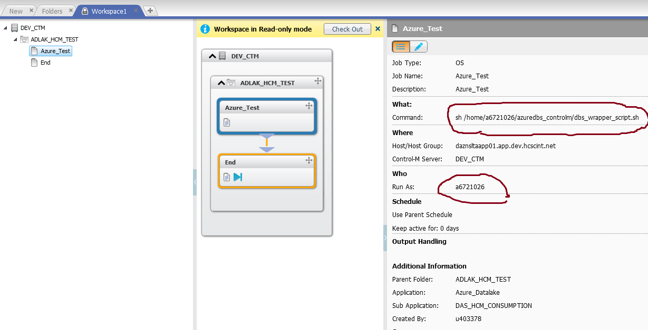

# **Sample Code for Examples:**

