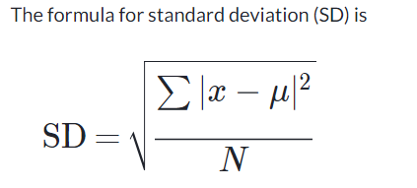

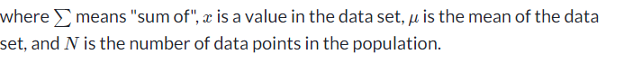

Data set is $1550, $1700, $900, $850, $1000, $950

1.Find the mean

Mean= (1550+1700+900+850+1000+950)/6=1158.33

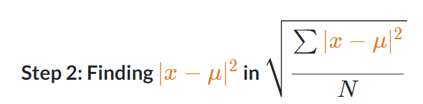

(1550-1158.33) \*\*2=153405.3889

(1700-1158.33) \*\*2=293406.3889

(900-1158.33) \*\*2=66734.3889

(850-1158.33) \*\*2=95067.3889

(1000-1158.33) \*\*2=25068.3889

(950-1158.33) \*\*2=43401.3889

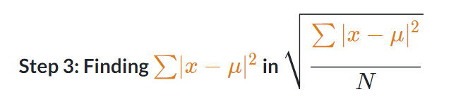

153405.3889+293406.3889+66734.3889+95067.3889+25068.3889+43401.3889=677083.334

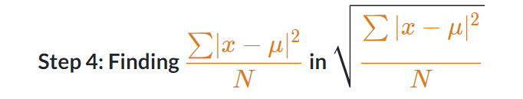

Here we need to use:N-1 because we are calculating for Population.

677083.334/5=135416.66668

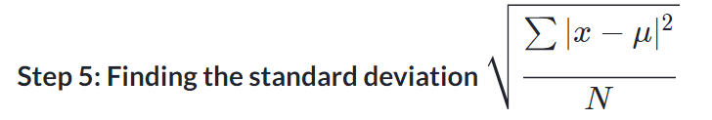

Square root of (135416.66668) =367.990

Standard Deviation is 367.990

(1550-1158.33) \*\*2=