3, 21, 98, 203, 17, 9

**Variance**

The Variance is defined as:

The average of the squared differences from the Mean.

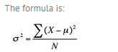

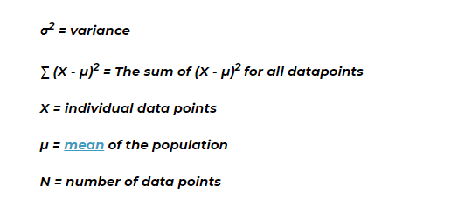

Calculate the mean (µ) :58.5

Conduct the subtraction in each parenthesis:

(3-58.5)=55.5

(21-58.5)=37.5

(98-58.5)=39.5

(203-58.5)=144.5

(17-58.5)=-41.5

(9-58.5)=49.5

Square all the above and add.

3080.25+1406.25+1560.25+20880.25+1722.25+2450.25=31099.5

Divide above number by no of date items. = 31099.5/5

Variance is: 6219.9