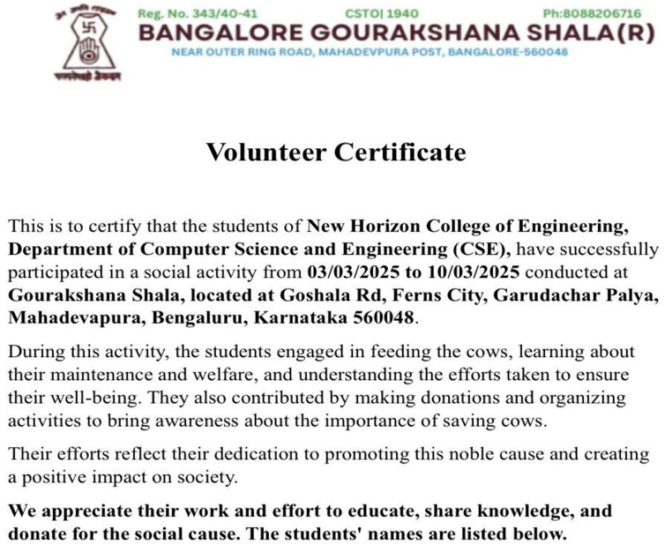
1.Srikanta Mishra [1NH21CS239]
2.K N Srikanth [1NH21CE025]
