A Mini Project -1 Report on

“Cloud Based Architecture for Real-Time retinal Image Processing and Disease Classification”

Submitted to the Department of Computer Science & Engineering, GNITS in the partial fulfillment of the academic requirement for the award of B.Tech (CSE) under JNTUH

By

Mariya Tabussum (23251A05E7)
M. Traimbica (23251A05E9)
M. Srinidhi (24255A0517)

under the guidance of Mrs.A.Leela Kumari Assistant Professor,CSE


G. Narayanamma Institute of Technology & Science (Autonomous) (For Women) Shaikpet, Hyderabad 500 104.

Affiliated to
Jawaharlal Nehru Technological University Hyderabad
Hyderabad – 500 085
May, 2025
A Mini Project -1 Report on

“Cloud Based Architecture for Real-Time retinal Image Processing and Disease Classification”

Submitted to the Department of Computer Science & Engineering, GNITS in the partial fulfillment of the academic requirement for the award of B.Tech (CSE) under JNTUH

By

Mariya Tabussum (23251A05E7)
M. Traimbica (23251A05E9)
M. Srinidhi (24255A0517)

under the guidance of Mrs.A.Leela Kumari Assistant Professor,CSE


G. Narayanamma Institute of Technology & Science (Autonomous) (For Women)
Shaikpet, Hyderabad 500 104.

Affiliated to
Jawaharlal Nehru Technological University Hyderabad
Hyderabad – 500 085
May, 2025
G. Narayanamma Institute of Technology & Science (Autonomous) (For Women)
Shaikpet, Hyderabad – 500 104.
Department of Computer Science & Engineering



Certificate

This is to certify that the Mini Project-1 report on “Cloud-Based Architecture for Real-Time Retinal Image Processing and Disease Classification” is a Bonafide work carried out by Mariya Tabassum (23251A05E7), M.Traimbica (23251A05E9), M.Srinidhi (24255A0517) in the partial fulfillment for the award of B.Tech degree in Computer Science and Engineering, G. Narayanamma Institute of Technology & Science, Shaikpet, Hyderabad, affiliated to Jawaharlal Nehru Technological University, Hyderabad under our guidance and supervision.

The results embodied in the project work have not been submitted to any other University or Institute for the award of any degree or diploma.

Internal Guide Head of the Department
Mrs.A.Leela Kumari Dr.A.Sharada
Assistant professor,CSE Professor& Head
Department of CSE

Acknowledgements

We would like to express our sincere thanks to Dr.K.Ramesh Reddy, Principal, GNITS, for providing the working facilities in the college.
Our sincere thanks and gratitude to Dr.K.Rama Linga Reddy, Professor Department of ETM & Dean Academics, Dr.M.Seetha, Professor, Department of CSE & Dean R&D , Dr.N.Kalyani, Professor, Department of CSE & Dean Innovation and Incubation, GNITS, for all the timely support and valuable suggestions during the period of our project.
We extend our heartfelt gratitude to Dr.A.Sharada, Professor & Head, Department of Computer Science and Engineering, GNITS, for unwavering support and invaluable guidance throughout our project, providing timely assistance and insightful suggestions.
We are extremely thankful to Dr.K.L.S.Soujanya, Associate Professor, Department of CSE, GNITS, and K.Sindura,Assistant Professor Mini Project-1 coordinators, Department of CSE, GNITS for all the valuable suggestions and guidance during the period of our project.
We are also extremely thankful to our project coordinators Mrs.Ch.Radhika Assistant Professor and Mrs.G.Amulya, Assistant Professor, Department of CSE, GNITS, for their encouragement and support throughout the project.
We are extremely thankful and indebted to our internal guide, Mrs.A.Leela Kumari, Assistant Professor, Department of CSE, GNITS for her constant guidance, encouragement, and moral support throughout the project.

Finally, we would also like to thank all the faculty and staff of CSE Department who helped us directly or indirectly, parents and friends for their cooperation in completing the project work.

Mariya Tabassum (23251A05E7) zM Traimbica (23251A05E9)
M Srinidhi (24255A0517)

ABSTRACT

The rising prevalence of retinal diseases such as diabetic retinopathy, cataracts, and glaucoma has highlighted the urgent need for accurate, rapid, and accessible diagnostic tools. In many rural and underfunded regions, patients lack access to specialized healthcare and advanced medical facilities, leading to delays in diagnosis and treatment.

This project addresses the gap by developing a cloud-based system for real-time retinal image processing and disease classification. Using Google Cloud Platform (GCP) services like Cloud Storage for secure image storage, Cloud Functions for automated image processing, and Compute Engine to run a deep learning model, this system offers an innovative solution for remote diagnostic services.
The core of the system is a Convolutional Neural Network (CNN) based on the VGG19 architecture, designed to analyse and classify retinal images into categories: cataract, diabetic retinopathy, glaucoma, and normal.

The Python-based backend integrates TensorFlow, NumPy, and Pillow for image processing tasks. The system includes a web interface that allows users to upload images and receive instant diagnostic feedback. Deployed on XAMPP/WAMP Apache/PHP hosting platforms, the system provides flexibility for local or cloud deployment. With auto scaling and load balancing features, the system can handle multiple user requests efficiently without compromising on speed or accuracy. Additionally, the platform is scalable, allowing future updates for multi-disease detection, image enhancement, and integration with Electronic Medical Records (EMR). The cloud-based approach facilitates remote diagnosis and improves access to healthcare, particularly for underserved communities, while ensuring data security and privacy.

Keywords: retinal image processing, Cloud-Based Diagnosis, Convolutional Neural Network (CNN),VGG19, Automated Retinal Screening, Web-Based Healthcare System

LIST OF TABLES
Table No. Topic Page No.
Table 1.1 Hardware Requirements 8
Table 1.2 Software Requirements 8
Table 2.1 Literature survey 13
Table 3.1 System Modules Overview 16
Table 4.1 Class-wise Dataset Split 21
Table 4.2 Comparison Between VGG19 and ResNet-18. 30
Table 5.1 Classification Report Summary 37
Table 5.2 Description of metrics 37

LIST OF FIGURES

Figure No. Topic Page No.

Fig 3.1 Architecture of the system 15
Fig 3.2 Description of modules 18
Fig 4.1 Founding images in dataset 20
Fig 4.2 Distribution of disease in dataset 21
Fig 4.3 Classes of normal and diabetic 22
Fig 4.4 Classes of glaucoma and cataract 22
Fig 4.5 VGG19 model 27
Fig 4.6 Layers of ResNet-18 29
Fig 5.1 Training, Validation accuracy of vgg19 32
Fig 5.2 Confusion matrix of VGG19 model 33
Fig 5.3 Confusion matrix of resnet-18 35
Fig 5.4 Training, Validation Accuracy of resnet-18 36
Fig 5.5 Sample Prediction Outputs(i) 38
Fig 5.6 Sample Prediction Outputs(ii) 36
Fig 5.7 Sample Prediction Outputs after training the model 39
Fig 5.8 User interface 40
Fig 5.9 Uploading cataract image 41
Fig 5.10 Predicting cataract disease 42
Fig 5.11 Uploading diabetic retinopathy image 42
Fig 5.12 Predicting diabetic retinopathy disease 42
Fig 5.13 Uploading normal image 43
Fig 5.16 Predicting glaucoma disease 44
TABLE OF CONTENTS
SI.No. TOPIC Page No.
ABSTRACT iv
LIST OF TABLES v
LIST OF FIGURES vi
- INTRODUCTION 1
  - Background of Study 1
  - Existing System 2
  - Challenges in Existing System 2
  - Problem Statement 3
  - Proposed System 4
  - Objectives 4
  - Methodology 5
    - Dataset Preparation 6
    - Model Selection and Architecture 6
    - Model Training 6
    - Comparative Analysis 7
  - Hardware & Software Requirements 7
  - Objectives 7
- LITERATURE SURVEY 10
  - Introduction 10
  - Related work on retinal disease detection using CNNs 10
  - Cloud-Based Systems for Medical Image Analysis 11
  - Web-based Systems for Healthcare 12
2.5 Summary of Literature Survey 12
- PROPOSED SYSTEM 14
  - Architecture of the System 14
  - Description of modules 16
- IMPLEMENTATION 20
  - Datasets 20
    - Dataset Sources 20
    - Dataset Composition & Dataset Organization 21
    - Preprocessing 23
  - Technologies Used 23
  - VGG19 CNN for Retinal Disease Classification 24
    - Overview 24
    - Architecture of VGG19 25
    - Training Parameters 26
    - Training Parameters 26
    - Dataset Preparation 26
    - Evaluation 26
    - Strengths of VGG19 in This Context 27
  - ResNet-18 27
    - Overview 27
    - Architecture of ResNet-18 28
    - Modifications for Project 28
    - Training Parameters 28
    - Dataset Preparation 28
    - Evaluation 29
  - Comparison Of Algorithms 29
- RESULTS AND DISCUSSIONS 31
  - Performance Measures 31
    - Analysis of VGG19 31
    - Analysis of ResNet-18 35
  - Performance Analysis Metrics 36
  - Results and Interface 36
  - User Interface 39
- CONCLUSION AND FUTURE ENHANCEMENTS 45
- REFERENCE 46
GLOSSARY… 47
APPENDIX… 48

INTRODUCTION

The growing demand for accurate and accessible healthcare solutions has led to the development of this system for identifying retinal diseases through automated image analysis. Utilizing deep learning techniques, the model interprets retinal images to distinguish between major conditions with high accuracy. The architecture is designed for efficiency and is supported by cloud-based infrastructure, ensuring scalability and real- time performance. This approach demonstrates the potential of intelligent systems in supporting clinical diagnosis and enhancing early detection in ophthalmology.

Background of Study
Retinal diseases are a significant contributor to avoidable blindness globally. Traditional diagnostic tests heavily rely on the expertise of ophthalmologists and advanced medical technology, which may not be accessible in rural or underdeveloped regions. These challenges create a healthcare gap, leading to delayed treatments and worsening eye conditions. However, the rapid progress of deep neural models, particularly Convolutional Neural Networks (CNNs), has enabled the automation of medical image analysis with very high accuracy. CNNs are capable of detecting features in retinal scans that are often difficult for the human eye to identify. Additionally, the rise of web-enabled and cloud computing technologies has made it easier to deploy these models in real-time, remote systems. This project seeks to integrate these technologies into a single platform that allows users to upload retinal images through a web interface, process them using a trained CNN model, and instantly return the predicted diagnosis.

Project-Specific Contributions
- The deep learning model used in this study is built upon the VGG19 architecture, customized with additional layers for improved classification of retinal diseases.
- A Flask-based API was developed to handle prediction requests and integrated with a cloud deployment pipeline using Google Cloud Run.
- The user interface allows for uploading retinal images through a web portal, which then returns prediction probabilities and the most likely diagnosis in real time.

Existing System

The prevailing method for diagnosing retinal diseases predominantly relies on manual examination of retinal images by ophthalmologists using advanced equipment such as fundus cameras and Optical Coherence Tomography (OCT) devices. While effective in clinical environments, these systems are heavily dependent on skilled professionals, resulting in challenges such as diagnostic inconsistency, delays in delivering results, and limited accessibility—particularly in remote or underserved regions. To address these challenges, developers have proposed AI-based medical image analysis systems. These systems primarily employ machine learning (ML) or deep learning (DL) techniques trained on medical datasets. However, current AI solutions typically fall into a few categories:
- Offline systems, which require hardware installation and technical expertise for operation.
- Desktop-based tools, often limited to institutional or research-based use, functioning only on local machines.
- Proprietary platforms, which restrict access and usually require expensive licensing fees.
- Despite their potential, these systems commonly lack real-time diagnostic capabilities, are not cloud-integrated, and are often dependent on high-performance computing infrastructure. Their limited scalability and restricted accessibility make them unsuitable for broader deployment, especially in low-resource environments. Therefore, there remains a significant need for an innovative, web-based, and cloud-compatible solution that delivers real-time predictions without reliance on specialized hardware or technical personnel. Addressing these limitations is vital to closing the diagnostic gap and extending quality eye care to all.

Challenges in Existing System
The existing retinal disease diagnosis systems encounter multiple performance boundaries which prevent proper and prompt medical interventions. The major obstacle involves the need for trained ophthalmologists to analyse retinal images since this creates challenges for standardizing diagnostic service accessibility throughout remote and
Verifying retinal conditions through traditional diagnostic methods requires labour- intensive manual processes that slow the detection period and let conditions deteriorate before therapy starts. The installation of these diagnostic systems demands substantial
expenses on infrastructure development alongside maintenance costs and training expenses which creates practical challenges for wide implementation. Manual diagnostic tools fail to provide automated capabilities or scalability features that let them perform simultaneous diagnosis or participate in mass screening programs. A better accessible automated and scalable diagnostic solution becomes essential to overcome the present diagnostic challenges.
Modern medical imaging techniques and diagnostic tools have several disadvantages in retinal disease detection because of their inherent limitations. The following points highlight the key issues faced by current diagnostic approaches:
- Dependency on Skilled Professionals: Traditional retinal diagnosis heavily relies on the trained ophthalmologists and technicians. In areas where such specialists are not readily available, diagnosis and treatment can be significantly delayed.
- Limited Accessibility in Rural Areas: High-end diagnostic devices such as fundus cameras and Optical Coherence Tomography (OCT) machines are typically found in urban or specialized healthcare centres. Patients in remote or underprivileged regions often lack access to such equipment.
- Manual and Time-Consuming Processes: Current systems require manual interpretation of retinal images, which increases the time taken for diagnosis. This delay can lead to the progression of diseases before treatment is administered.
- High Cost and Infrastructure Requirements: Setting up a diagnostic lab with modern equipment demands substantial financial investment. Additionally, maintenance and operation costs further increase the economic burden on healthcare facilities.

Problem Statement
The increasing prevalence of retinal diseases such as diabetic retinopathy, cataracts, and glaucoma highlights the urgent need for early and accurate diagnosis to prevent irreversible vision loss. However, current diagnostic methods are typically manual, require skilled ophthalmologists, and depend on expensive equipment available only in well-equipped clinics. This situation creates a significant healthcare accessibility gap, particularly in rural or underserved regions. Moreover, these traditional systems lack scalability and remote access, resulting in delays that could worsen patient outcomes.
To bridge this gap, our project introduces a cloud-based, real-time diagnostic system utilizing deep learning techniques. Specifically, we employ a Convolutional
Neural Network (CNN) based on the VGG19 architecture to automatically classify retinal images into four categories: cataract, diabetic retinopathy, glaucoma, and normal.
This implementation ensures that the predictions are fast, accurate, and remotely accessible, offering a scalable and efficient solution to improve retinal screening and diagnostic services in areas with limited resources. To further enhance functionality, the system supports modular upgrades for multi-disease detection and potential integration with electronic medical record (EMR) systems. Built-in cloud scalability also ensures load balancing and auto-scaling capabilities for handling simultaneous requests. Additionally, the deployment using open-source tools ensures cost-efficiency and adaptability across different environments, making the system ideal for use in hospitals, remote clinics, and telemedicine platforms.

Proposed System

The proposed system is designed to provide an automated, efficient, and accurate solution for the classification of retinal diseases using deep learning techniques. The primary aim is to assist in the early diagnosis of common retinal conditions such as cataract, diabetic retinopathy, glaucoma, and normal retina by analysing fundus images. This system leverages the VGG19 convolutional neural network architecture, which has been fine- tuned with additional dense and dropout layers to enhance classification performance. The system consists of key modules including an image acquisition module that allows users to upload retinal images, a preprocessing module that standardizes and augments the images to ensure optimal input quality, and a deep learning-based classification module that processes the images to determine the likelihood of each disease category.

Objectives
- The main aim of this project demands development of an automatic retinal disease classification system powered by deep learning that operates from the cloud. Purpose of this platform consists of enhancing diagnostic capabilities alongside enhancing processing efficiency and eliminating diagnostic challenges specific to areas with limited medical infrastructure. The specific objectives include:
- Deep Learning-Based Classification: The VGG19 CNN system enables deep learning model implementation to sort retinal scans between normal types and cataract diabetic retinopathy and glaucoma diabetic retinopathy categories.
- Web Interface Usability: Through the web interface application users obtain a user- friendly environment to transmit retinal images for assessment.
- Backend Image Processing: The programmed backend in Python manages image handling after upload together with delivering model-generated predictions.
- Frontend - Backend Integration: The system requires PHP together with HTML functionality to enable web frontend interaction with backend features.
- Cloud Scalability and Deployment: By choosing Apache with XAMPP/WAMP platforms for implementation the system becomes scalable and enables remote operation.
- System performance: in real time along with exact results helps to detect retinal diseases at an early stage leading to proper medical care. This system offers low-cost functionality which functions across different scales through its operations in isolated locations requiring minimal resources.
- Medical data security with protected protocols ensures patient confidentiality and fulfills healthcare data standards in the treatment of retinal diagnostic information because data privacy remains paramount.
- Future readiness of the system depends on modular design which enables additions of new disease categories together with Electronic Medical Records (EMR) connections and advanced image enhancement capabilities. The diagnostic process requires an automation component to decrease human handling and generate consistent diagnostic results.
- The system needs to operate effectively in environments which have reduced network bandwidth and minimal computing power by using efficient and optimized software design.

Methodology
This section describes the systematic approach adopted to develop, train, and evaluate the deep learning models for retinal disease classification. The methodology includes dataset preparation, model selection, training strategies, evaluation metrics, and optimization techniques.

Dataset Preparation

      - Retinal fundus images were collected and organized into four disease categories: Cataract, Glaucoma, Diabetic Retinopathy, and Normal.
      - The dataset was divided into three subsets: Training (70%), Validation (15%), and Testing (15%).
      - Images were resized to a fixed dimension suitable for the deep learning models (e.g., 224x224 pixels).
      - Data augmentation techniques such as rotation, zoom, flipping, and brightness adjustment were applied to increase dataset variability and enhance model generalization.

Model Selection and Architecture

      - Primary Model: VGG19 architecture was selected due to its proven effectiveness in feature extraction for image classification tasks.
        - Pre-trained on the ImageNet dataset.
        - Fine-tuned by replacing the top layers to match the four disease classes.

      - Comparison Model: ResNet-18 was selected as a secondary model for comparative analysis.
        - Focused on using residual connections to improve gradient flow during training.
      - Both models were adapted using transfer learning to accelerate training and improve performance with limited medical imaging data.

Model Training

      - The training was performed using TensorFlow/Keras in Google Colab with GPU acceleration.
      - Key hyperparameters:
        - Optimizer: Adam
        - Learning Rate: 0.0001
        - Batch Size: 32
        - Loss Function: Categorical Cross entropy
        - Epochs: 30–50
      - Callbacks applied during training:
        - Early Stopping: Halted training when validation loss stopped improving.
        - Model Checkpoint: Saved the best-performing model based on validation accuracy.
After training, models were evaluated using: Accuracy,Precision,Recall,F1 Score, Confusion Matrix Evaluation was conducted on a separate unseen test dataset to assess model generalization and performance stability.

Comparative Analysis

      - Performance of VGG19 and ResNet-18 was compared based on key metrics.
      - VGG19 achieved approximately 93.2% accuracy, while ResNet-18 achieved approximately 86.7%.
      - The comparative study highlighted the trade-off between model complexity and prediction accuracy.3.6 Tools and Platforms
      - Google Colab: Used for model training with free GPU resources.
      - Python Libraries: TensorFlow, Keras, scikit-learn, OpenCV, and NumPy for model development and evaluation.
This methodological framework ensured a systematic development of the retinal disease classification system, from data preparation to model deployment readiness. The chosen deep learning techniques and training strategies contributed significantly to achieving high model performance while maintaining computational efficiency.

Hardware & Software Requirements

The successful development and deployment of this cloud-based retinal disease classification system required a well-balanced integration of both hardware and software components. From the hardware perspective, a standard computing device with an Intel Core i5 processor (or higher) and a minimum of 8 GB RAM was sufficient for local development and testing. However, for more efficient processing and deep learning model training, devices with enhanced specifications, such as Intel Core i7/i9 processors and 16 GB or more RAM, were preferred. Although a GPU is not mandatory due to the usage of cloud platforms, access to an NVIDIA GPU with CUDA support significantly accelerates training performance when working locally. A stable high-speed internet connection was essential throughout the project to interact with cloud services in real time
Table 1.1 Hardware Requirements

Component | Specification
Processor | Intel Core i5
RAM | 16 GB
Storage | 50 GB Storage
GPU | NVIDIA with CUDA  support
Internet Connection | High speed internet
Table 1.2 Software Requirements

Category | Tools/Technologies
Operating System | Windows 11
Programming Languages | Python 3.10(TensorFlow Compatible
Deep Learning Libraries | TensorFlow,Keras,Numpy,Pillow,O penCV
Development Environment | Google Collab(for training and experimentation)
Web Development | HTML,CSS,PHP
Backend Technologies | Python(Flask),Apache Server(XAMPP/WAMP),PHP
Cloud Platform | Google Cloud Platform
GCP services Used | Cloud Storage(image storage),Cloud  Functions (auto processing),Compute Engine(model)
Browser | Google Chrome

Organization of Project

This project report is systematically organized into several chapters to provide a clear and structured presentation of the research work, development process, and outcomes. Each chapter focuses on a specific aspect of the project, ensuring a logical flow of information from the problem identification stage to the final implementation and evaluation.

- Chapter 1 – Introduction: This chapter introduces the background of the study, identifies the problem statement, outlines the objectives, and discusses the methodology and tools used. It also highlights the challenges in existing systems and presents a roadmap of the project structure.
- Chapter 2 – Literature Survey: This section presents a comprehensive review of existing work related to retinal disease classification, the use of deep learning in medical imaging, and prior systems. It helps in understanding the research gap and justifies the need for the proposed system.
- Chapter 3 – Proposed System: This chapter details the proposed cloud-based deep learning system. It includes the system architecture and functional modules, explaining how the components interact to achieve automated retinal disease detection.
- Chapter 4 – Implementation: This section describes the technical aspects of the implementation including the datasets used, tools and technologies, and theoretical descriptions of algorithms applied. It also includes algorithm comparisons based on design and applicability.
- Chapter 5 – Results and Discussions: This chapter presents the experimental results obtained through the implementation. It includes performance metrics, output screenshots, and comparative analysis of results using tables and graphs. Conclusions and Future Enhancements.
- The report concludes with a list of references, terminology definitions, and supplementary materials such as code snippets or screenshots relevant to the project.

LITERATURE SURVEY

Introduction
A literature survey is a critical component of any research project. It involves the systematic review and analysis of existing research work, methodologies, technologies, and results relevant to the proposed domain of study. In this project, which focuses on retinal disease classification using deep learning and cloud-based infrastructure, the literature survey explores foundational work in the fields of medical image processing, artificial intelligence in ophthalmology, CNN-based classification models, and cloud deployment techniques.

Visual medical diagnoses give accurate outcomes in traditional clinical practices yet they require extensive time from expert specialists. Healthcare needs automated diagnostic solutions urgently because of the worldwide shortage of eye doctors combined with growing patient numbers because these systems can offer immediate accurate results despite geographical restrictions. The study provides a complete review of deep learning algorithms in retinal image processing combined with cloud-based healthcare examinations and web deployments of AI model decision systems for real-time applications.

Related work on retinal disease detection using CNNs

In recent years, deep learning techniques, particularly Convolutional Neural Networks (CNNs), have revolutionized the detection and classification of retinal diseases. Several key studies have demonstrated the effectiveness of CNNs in analysing retinal images for conditions such as diabetic retinopathy, glaucoma, cataracts, and age-related macular degeneration (AMD).
Abramoff et al. (2018) developed an automated system for diabetic retinopathy detection that utilized CNNs and was subsequently approved by the U.S. FDA for clinical use. Rajendran et al. (2018) extended the use of CNNs by incorporating transfer learning techniques, utilizing pre-trained models like VGG16 and VGG19 to classify retinal diseases. Ting et al. (2017) also made important contributions by developing a deep learning system for diabetic retinopathy detection.

Cloud-Based Systems for Medical Image Analysis
Cloud computing has emerged as a key enabler for healthcare solutions, particularly in the field of medical image analysis. The ability to store and process large datasets in real-time is essential for the development of scalable, efficient, and accessible healthcare systems. We reviewed various papers and resources that discuss the integration of cloud computing with machine learning models in healthcare applications.
- Raj et al. (2019) titled "Cloud-based Medical Image Analysis for Healthcare" explores how cloud technologies, like AWS and Google Cloud, can be leveraged to manage and analyse medical image data for improved patient outcomes.
- "Cloud Computing for Healthcare" by S. D. R. Sharma (2020) offers a comprehensive review of how cloud-based platforms enable the deployment of machine learning models in real-time healthcare systems. One key takeaway was the importance of data security and privacy when dealing with sensitive healthcare information.
- Zhang et al. (2021), in their paper "Medical Image Analysis with Deep Learning on Cloud Platforms," discuss how cloud-based solutions can democratize access to healthcare technologies, making advanced diagnostic tools available to remote and low-resource areas.
- Secure patient data storage: Cloud platforms provide high levels of data security to ensure compliance with healthcare regulations such as HIPAA.
- AI model hosting: AI models can be hosted on cloud servers, enabling healthcare providers to access prediction tools without needing expensive hardware infrastructure.
- 24/7 access to diagnostic tools: Cloud services ensure that AI models and diagnostic tools are available anytime, anywhere, supporting continuous access to critical healthcare services.
By reviewing these papers and resources, we gained a thorough understanding of the role of cloud computing in medical image analysis. The integration of cloud services with deep learning models not only enhances the scalability and accessibility of diagnostic tools but also ensures that they can be deployed effectively in remote areas with limited resources.

Web-based Systems for Healthcare
In a study by Singh et al. (2019), a web-based application was developed to diagnose retinal diseases using a machine learning model. The frontend was designed using HTML and CSS for structure and styling, while JavaScript handled the dynamic features like image upload and displaying results. The backend used Flask to serve the deep learning model, which was trained using Python libraries like TensorFlow and Keras. PHP was used to handle user authentication and session management, ensuring secure access to patient data and model predictions.
A study by Chong et al. (2017) demonstrated the use of PHP in the development of a web-based medical diagnostic system. PHP was used for managing the logic behind uploading images, processing them, and interacting with machine learning models. In the context of retinal disease detection, PHP allows seamless integration with a backend system (like Python and TensorFlow for the model), which processes the image and returns the prediction results to the user. JavaScript, on the other hand, is often employed for dynamic elements like real-time notifications or live updates on the user interface.
To address these limitations, recent studies suggest incorporating post-processing mechanisms such as Grad-CAM for model explainability, employing domain adaptation techniques for better generalization, and implementing continual learning strategies to keep models up to date with evolving medical knowledge.

Summary of Literature Survey

The literature reviewed highlights the increasing role of AI and deep learning in retinal disease diagnosis, particularly through CNN architectures such as VGG19. Studies have demonstrated the high accuracy and potential of these models for automated detection of conditions like diabetic retinopathy, cataracts, and glaucoma. Transfer learning with pre- trained networks enables reliable performance even on smaller medical datasets. Cloud computing platforms such as Google Cloud and AWS offer scalable infrastructure to deploy AI-based diagnostic models, ensuring remote accessibility and real-time operation.
.
Table 2.1 Literature survey

Study | Key Contribution | Technology Used | Key Findings/Impact
Abramoff et al. (2018) | Developed an FDA-approved automated system for diabetic retinopathy  detection using CNNs. | CNN, FDA-  Approved System | Showed the feasibility of CNN- based diagnostic systems in clinical settings, improving healthcare access.
Gulshan et al. (2016) | Proposed a CNN model for detecting diabetic retinopathy with high sensitivity and specificity. | CNN, Large Dataset | Achieved 90.3% sensitivity and 98.1% specificity, outperforming traditional methods, setting a benchmark for CNN-based retinal disease detection.
Rajendran et al. (2018) | Utilized transfer learning with pre-trained models like VGG16 and VGG19 for retinal disease  classification. | Transfer Learning, VGG16, VGG19 | Demonstrated the effectiveness of using pre-trained models in classifying retinal diseases, with VGG19 capturing intricate image patterns.
Ting et al. (2017) | Developed a system for detecting diabetic retinopathy and assessing its severity using  deep learning | CNN, Multi- class Classification | Showed that CNN models can not only detect diabetic retinopathy but also assess its severity, enabling more detailed diagnosis.
Raj et al. (2019) | Explored cloud- based medical image analysis using AWS and Google Cloud for healthcare. | Cloud Computing, AWS, Google Cloud | Highlighted the role of cloud platforms in managing and analyzing large medical datasets, reducing hardware costs, and scaling diagnostic systems.

PROPOSED SYSTEM

The system is proposed to enhance detection and classification of retinal disease by combining a deep neural network model and web application on a cloud platform. Leveraging the power of VGG19-based CNN architecture, the system analyzes retinal images effectively for diabetic retinopathy, cataracts, glaucoma, and normal eye conditions. The web interface, developed by HTML, CSS, and JavaScript, provides an upload facility to users for processing retinal images in real time. The backend, powered by Python (Flask), runs the trained model, returning accurate results with ease of implementation. The system is deployed on Google Cloud Platform (GCP), enabling scalable real-time image processing and secure data storage of patient data. The proposed architecture enables accessibility in remote and underserved regions, where health professionals can use the system to provide instant diagnostic services without any specialized infrastructure. The system also has necessary features such as user authentication and secure data management by PHP, making the system more secure and reliable as a whole.

Architecture of the System

The architecture of the proposed system is designed to deliver real-time retinal disease classification through a cloud-compatible, web-based platform. It combines deep learning, cloud infrastructure, and web technologies to create an automated pipeline for retinal image analysis. The architecture is modular, scalable, and optimized for efficient communication between frontend, backend, and AI components.

Architectural Layers:
- Frontend Layer (User Interface)
  - Developed using HTML and CSS, with optional JavaScript.
  - Provides a simple and intuitive interface for users to upload retinal images.
  - Displays the classification result to the user.
- Backend Layer (Server Side)
  - Built with PHP to handle file uploads and manage communication with the Python AI module.
  - Executes Python scripts using shell exec() after successful image upload.
  - Manages output display and error handling.

Fig 3.1 system architecture

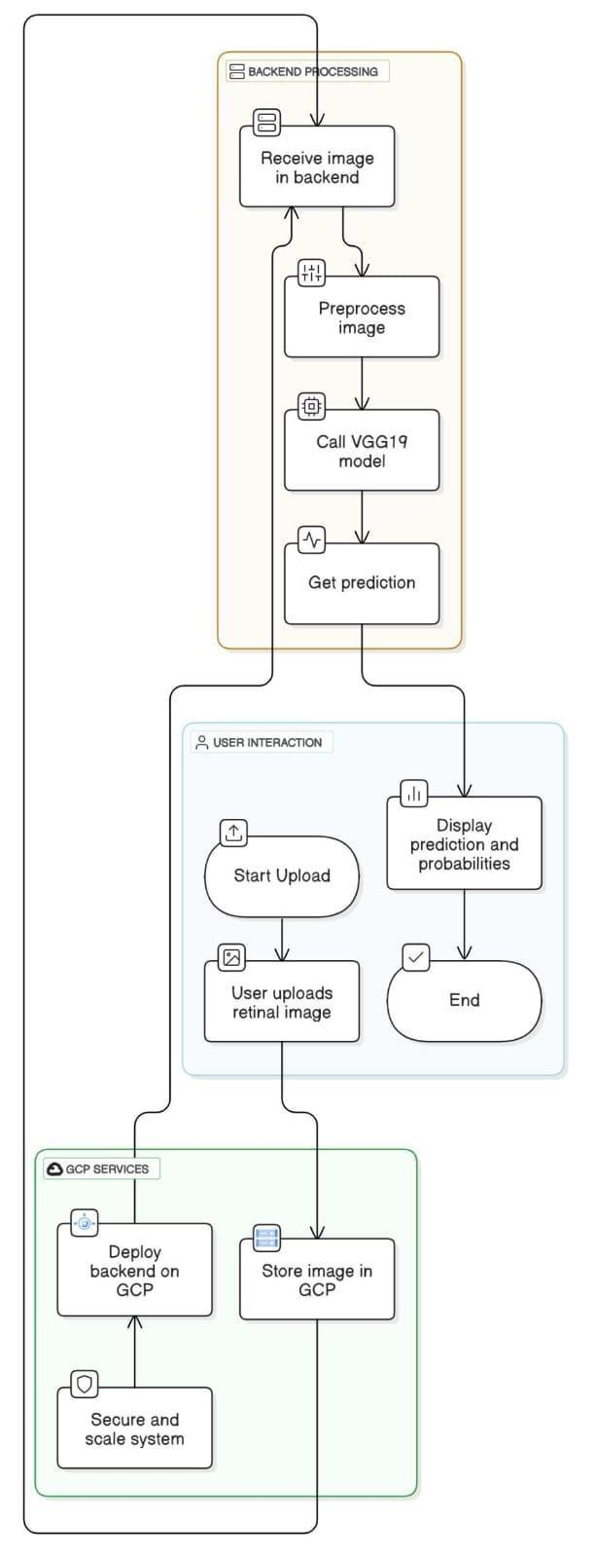
Fig 3.1 Architecture of the system

- Processing and Prediction Layer (AI Engine)
  - Written in Python, utilizing TensorFlow, NumPy, and Pillow
  - Loads a pre-trained VGG19 CNN model for disease classification.
  - Preprocesses the image (resize, normalize) and outputs one of four classes such as Cataract, Diabetic Retinopathy, Glaucoma, Normal

Data Flow Sequence:
The user accesses the web interface and uploads a retinal image.
- The image is validated and saved to the server via the PHP backend.
- PHP triggers a Python script with the image path as an argument.
- The Python script processes the image and feeds it to the VGG19 model.
- The model outputs a prediction, which is captured and returned by PHP.
- The result is displayed on the web interface for the user.

Description of modules

The proposed system for real-time retinal disease classification is designed using a modular approach, ensuring scalability, maintainability, and ease of integration. Each module is responsible for a specific function in the overall diagnostic workflow, from user interaction to prediction generation and output display.

Table 3.1 System Modules Overview

Module | Purpose | Key Functions
1. Dataset Acquisition | Collect & organize data | Multi-label to multi-class conversion
2. Augmentation & Preprocessing | Prepare images | Resize, normalize, augment, encode
3. Model Training (EyeDeep-Net) | Feature extraction & prediction | CNN layers + classification output

Module 1: Dataset Acquisition
This module focuses on collecting and organizing retinal image data for training and evaluation.
- Fundus Image Dataset: The system begins with a large collection of retinal images
- Multi-label Data Distribution: Some images may have multiple labels indicating the presence of more than one condition. This step identifies all disease labels per image.
- Eye Disease Selection: The system filters the dataset to retain only the relevant diseases for this project—e.g., Cataract, Glaucoma, Diabetic Retinopathy, and Normal.
- Multi-class Data Distribution: Once diseases are selected, images are categorized into mutually exclusive classes for training a classification model.

Module 2: Dataset Augmentation and Preprocessing
This module prepares the data for model training through transformation and formatting. represented in following figure
- Data Augmentation: Enhances the dataset by generating variations of images (rotation, flipping, scaling) to increase the diversity and robustness of the model.
- Dataset Splitting: Divides the dataset into training and validation sets, ensuring the model is trained on one part and evaluated on unseen data.
- Image Reshaping: All images are resized to a fixed shape (typically 224x224 pixels) to match the model’s input requirements.
- Image in Array: Images are converted into numerical arrays so they can be processed by machine learning algorithms.
- One-Hot Encoding: Class labels are transformed into a binary vector format where each class is represented uniquely. For example:
- Cataract → [1, 0, 0, 0]
- Diabetic Retinopathy → [0, 1, 0, 0], and so on.
- Dataset Preprocessing: All these operations are grouped into a preprocessing pipeline that standardizes image data before training.

Module 3: Training of Eye Deep-Net for Feature Extraction and Classification
- Convolutional Layers (green and yellow blocks): These layers are responsible for feature extraction. They identify edges, textures, and patterns in the retina that indicate specific diseases.
- Fully Connected Layers (neural network nodes): After extracting features, the flattened data is passed through dense layers which perform classification.
- Trained Eye Deep-Net: The CNN model (Eye Deep-Net) is trained and saved.
- Diagnosis Output: Once the model is trained, it can classify new input images and predict the retinal condition, enabling automated diagnosis.
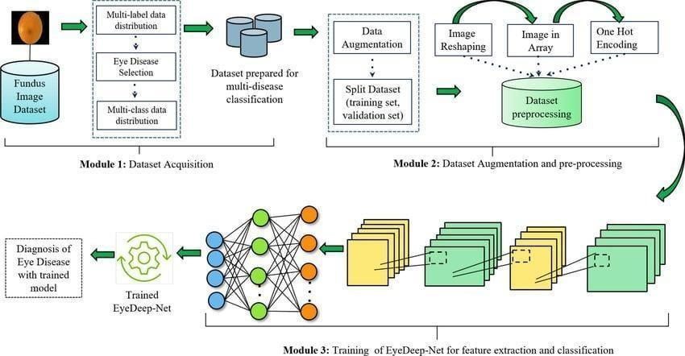

Fig 3.2 Description of modules

System Modules
- User Interface Module
  - Purpose: To allow users (patients or healthcare workers) to upload retinal images through a web-based interface.
  - Technology: Built using HTML, CSS, and optionally JavaScript for better interactivity.
  - Functionality:
    - Accepts image files in .jpg, .jpeg, or .png formats.
    - Provides a clean layout with upload buttons and result display sections.

Image Upload and Validation Module
  - Purpose: To receive and validate the uploaded image before sending it to the prediction engine.
  - Technology: Implemented using PHP.
  - Functionality:
    - Validates file type and size.
    - Renames and stores the image in a temporary directory.
    - Prepares the image path for Python script execution.

Image Preprocessing Module
  - Purpose: To prepare the uploaded image for analysis by the deep learning model.
  - Technology: Python with Pillow and NumPy.
  - Functionality:
    - Resizes image to 224x224 pixels.
3.2 AI Model Training and Dataset Preparation
    - The Artificial Intelligence component of the proposed system is designed to detect whether a crop is healthy or diseased using a lightweight MobileNet-based Convolutional Neural Network (CNN). The model is trained specifically for binary classification (Healthy vs Diseased) across selected crop types relevant to agricultural insurance claims.
    - 3.2.1 Crop Types Used for Model Training
    - The dataset used in this project consists of four major agricultural crops that are commonly cultivated and frequently insured. The selected crops are:
    - Cotton
    - Maize
    - Sugarcane
    - Wheat
    - These crops were chosen due to their economic importance and vulnerability to disease outbreaks that significantly affect farmers' income.
    - 3.2.2 Classification Categories
    - For each of the four crop types, the dataset contains two categories:
    - Healthy
    - Diseased
    - This means the model performs binary classification for crop health status detection. Instead of identifying specific disease names, the system determines whether the crop condition qualifies for an insurance claim (diseased) or not (healthy).
    - This approach improves:
    - Faster prediction
    - Reduced model complexity
    - Better generalization
    - Practical use for claim validation
    - 3.2.3 Dataset Structure
    - The dataset was organized in a structured directory format suitable for deep learning training:
    - dataset/
    - cotton/
    - healthy/
    - diseased/
    - maize/
    - healthy/
    - diseased/
    - sugarcane/
    - healthy/
    - diseased/
    - wheat/
    - healthy/
    - diseased/
    - Each folder contains multiple labeled crop images collected for training and validation purposes.
    - 3.2.4 Data Preprocessing
    - Before training, the images undergo preprocessing steps to ensure uniformity and model compatibility:
    - Image resizing to 224 × 224 pixels
    - Pixel normalization (scaled between 0 and 1)
    - Conversion to numerical arrays
    - Dataset splitting into:
    - Training set (70%)
    - Validation set (15%)
    - Testing set (15%)
    - These preprocessing steps help improve model stability and performance.
    - 3.2.5 Model Architecture – MobileNet
    - The system uses MobileNet architecture due to its lightweight design and efficient performance. MobileNet uses depthwise separable convolutions which reduce computational complexity while maintaining high accuracy.
    - Reasons for selecting MobileNet:
    - Low computational cost
    - Faster inference
    - Suitable for real-time web deployment
    - Efficient for agricultural image classification
    - Transfer learning was applied by using a pre-trained MobileNet base model and modifying the final layers to classify crop health status.
    - 3.2.6 Model Training Phase
    - The model was trained using:
    - Optimizer: Adam
    - Loss Function: Binary Cross-Entropy
    - Batch Size: 32
    - Epochs: 20–30
    - During training:
    - Validation accuracy was monitored
    - Overfitting was reduced using dropout layers
    - Best model weights were saved
    - 3.2.7 Model Output
    - The trained model predicts:
    - Crop Type
    - Health Status (Healthy / Diseased)
    - Confidence Score (%)
    - The prediction result is returned to the backend and stored with the claim record for admin verification.

    - Normalizes pixel values to the range [0, 1].
    - Converts the image into a format compatible with the CNN model.

Classification Module
  - Purpose: To perform prediction using the trained deep learning model.
  - Technology: TensorFlow/Keras, Python.
  - Functionality:
    - Loads the pre-trained VGG19 CNN model.
    - Passes the processed image for prediction.
    - Outputs one of the four classes: Cataract, Diabetic Retinopathy, Glaucoma, or Normal.

Communication Module
  - Purpose: To handle the interaction between the PHP backend and the Python prediction script.
  - Technology: PHP-Python Integration via shell exec() function.
  - Functionality:
    - Passes image path as an argument to the Python script.
    - Captures the script’s output and transfers it back to the web interface.

Output Display Module
  - Purpose: To present the final diagnostic result to the user.
  - Technology: PHP/HTML.
  - Functionality:
    - Displays the predicted class on-screen.
    - May optionally show confidence scores or additional information.

Cloud Deployment Module
  - Purpose: To enable scalability and real-time availability through cloud services.
  - Technology: Google Cloud Platform (GCP) including:
    - Cloud Storage: Stores images securely.
    - Cloud Functions: Automates preprocessing or script execution.
    - Compute Engine: Hosts the trained model and handles predictions at scale.

IMPLEMENTATION

Datasets

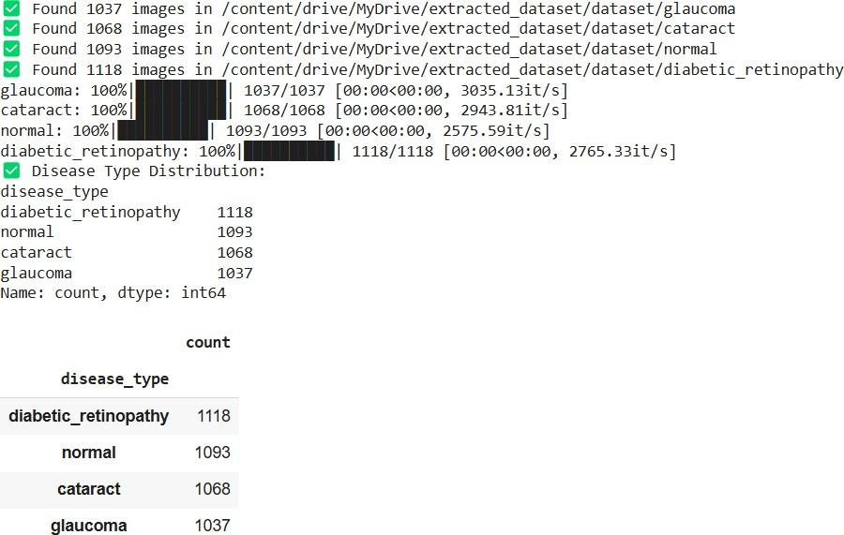
The foundation of any deep learning model lies in the quality and diversity of the dataset used for training and evaluation. In this project, the dataset comprises retinal fundus images categorized into four major classes: Cataract, Diabetic Retinopathy, Glaucoma, and Normal. These images were collected from publicly available sources that are commonly used in ophthalmological research and medical AI development.

Fig 4.1 Founding images in dataset

Dataset Sources
The datasets used include:
      - Kaggle Eye Disease Detection dataset: A well-known source for high-resolution retinal fundus images.
images are representative of the following four categories shown in fig 4.1:
      - Cataract
      - Diabetic Retinopathy
      - Glaucoma
      - Normal
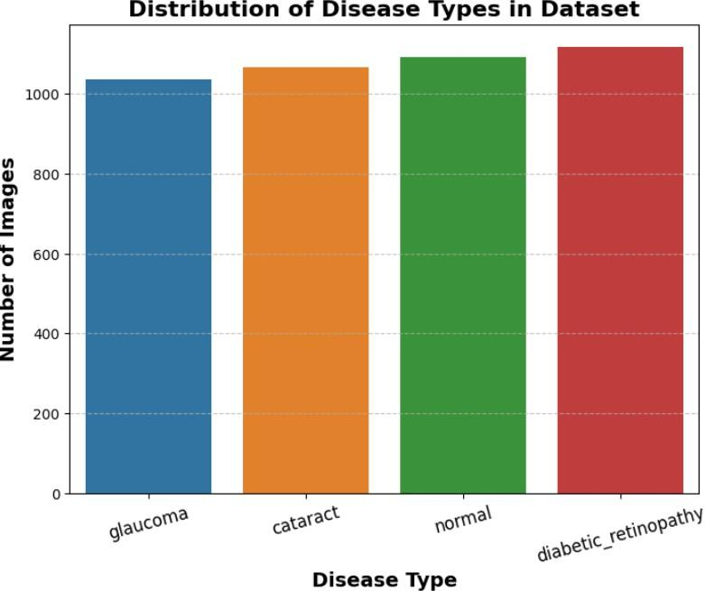
Fig 4.2 Distribution of disease in dataset

Dataset Composition & Dataset Organization

The final curated dataset was organized into training, validation, and testing subsets in the following manner: Images were resized to a standard resolution of 224 × 224 pixels to fit the input requirement of the VGG19 model and were normalized using standard preprocessing techniques.
The dataset was structured into two main directories for training and validation:
      - dataset/train/ – Used to train the model.
      - dataset/val/ – Used to evaluate the model during training.

Table 4.1 Class-wise Dataset Split

Class | Training Images | Validation Images | Testing Images
Cataract | 800 | 100 | 100
Diabetic Retinopathy | 800 | 100 | 100
Glaucoma | 800 | 100 | 100
Normal | 800 | 100 | 100
Total | 3200 | 400 | 400

Each of these directories contains four subfolders, corresponding to the four target disease categories:
      - cataract/
      - diabetic retinopathy/
      - glaucoma/
      - normal/
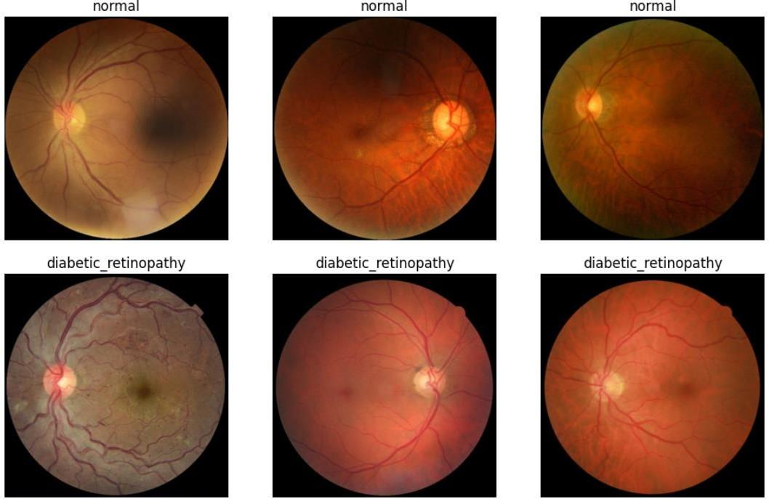
Fig 4.3 Classes of normal and diabetic
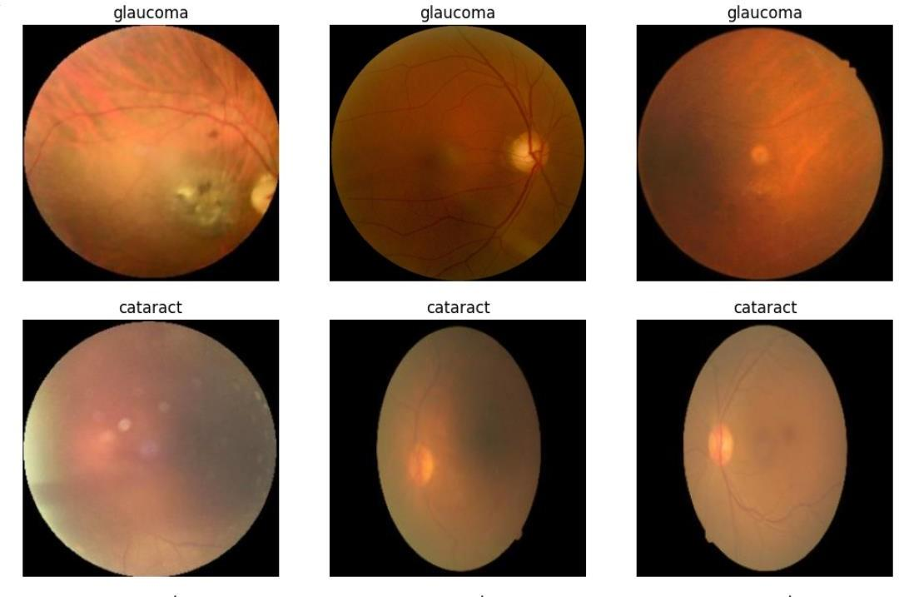
Fig 4.4 Classes of glaucoma and cataract

Preprocessing

To improve model performance and reduce overfitting, the following preprocessing steps were implemented using the ImageDataGenerator API in TensorFlow/Keras:
      - All images were resized to 224x224 pixels to match the input size requirement of VGG19.
      - Image augmentation techniques such as rotation, zoom, brightness adjustment, and horizontal flip were applied to increase data variability and prevent overfitting.
      - Rescaling pixel values to a range of [0,1]
      - Data augmentation: including random rotations, zooms, horizontal and vertical flips
      - Shuffling of datasets
      - Normalization to match the ImageNet dataset mean and standard deviation for transfer learning compatibility

Technologies Used
This section outlines the key tools, frameworks, libraries, and technologies used throughout the development of the retinal disease classification system.

Python Programming Language
  - Description: Python is the primary programming language used for building and implementing the deep learning model, preprocessing data, and setting up the web application backend.
  - Purpose: Python is known for its simplicity and versatility, making it ideal for tasks like machine learning, image processing, and web development.

TensorFlow & Keras
  - Description: TensorFlow is an open-source deep learning framework used to design, train, and evaluate the Convolutional Neural Network (CNN) model. Keras, a high-level API integrated with TensorFlow, simplifies the construction of the deep learning model.
  - Purpose: TensorFlow provides tools for building complex models, while Keras makes it easier to implement neural networks with fewer lines of code.

VGG19
  - Description: VGG19 is a deep learning model architecture used for the classification of retinal diseases. It consists of 19 layers, including convolutional and fully connected layers.
  - Purpose: VGG19 is used in the system to leverage transfer learning for retinal disease classification. Pre-trained on large datasets, it helps to recognize features in retinal images with high accuracy despite having a relatively smaller dataset.

OpenCV
  - Description: OpenCV (Open Source Computer Vision Library) is an open-source library used for computer vision and image processing tasks.
  - Purpose: OpenCV is utilized to handle image preprocessing steps like resizing, normalization, and augmentation of retinal images before feeding them into the model for classification.

Flask
  - Description: Flask is a micro web framework written in Python, used to develop the backend of the web application.
  - Purpose: Flask facilitates the integration of the machine learning model with the web interface. It allows users to upload retinal images and receive predictions from the trained model.

HTML, CSS, and JavaScript
  - Description: HTML is used for structuring the web page, CSS for styling, and JavaScript for creating dynamic web functionalities.
  - Purpose: These technologies are used to build the front-end interface that allows users to interact with the system by uploading images and viewing predictions.

Google Cloud Platform (GCP)
  - Description: GCP is a cloud computing platform that offers storage and computational resources.
  - Purpose: GCP is used to deploy the web application and model, providing scalable infrastructure for serving real-time predictions and storing large datasets, including retinal images.

VGG19 CNN for Retinal Disease Classification

Overview
Algorithm 1 utilizes a deep learning architecture based on VGG19, a variant of the VGG (Visual Geometry Group) model known for its depth and simplicity. VGG19 is a convolutional neural network with 19 layers (16 convolutional layers and 3 fully connected layers), widely recognized for its effectiveness in image classification tasks.
Description: VGG19 is a deep Convolutional Neural Network (CNN) architecture commonly used for image classification tasks. In this system, VGG19 is employed to classify retinal images into four disease categories: Cataract, Diabetic Retinopathy, Glaucoma, and Normal. The model is pre-trained on a large dataset (ImageNet) and fine- tuned for the retinal disease dataset.
In this project, VGG19 is fine-tuned and customized to detect and classify retinal diseases into four distinct categories:
      - Cataract
      - Diabetic Retinopathy
      - Glaucoma
      - Normal

Architecture of VGG19
- Input Layer: Accepts retinal images resized to a fixed input shape (e.g., 224x224x3 pixels).
- Convolutional Layers:
  - Stacks of 3x3 filters with stride 1 and padding to preserve spatial dimensions.
  - Every few convolutional layers are followed by max pooling layers (2x2) to reduce dimensionality and extract essential features.
- Number of Layers:
  - 16 Convolutional Layers
  - 5 Max-Pooling Layers
  - 3 Fully Connected (Dense) Layers
- Convolutional Layers (Conv): These layers apply filters to the input image, learning different features such as edges, textures, and more complex patterns at deeper levels.
- Max Pooling Layers (MaxPool): These layers down sample the feature maps, reducing their spatial dimensions while retaining the most important features.
- SoftMax: This layer is used to classify the image into different categories by converting raw scores into probabilities.
- Dropout Layers: Introduced after dense layers to prevent overfitting by randomly disabling some neurons during training.
- Output Layer: A dense layer with SoftMax activation, outputting probabilities for the 4 retinal disease

Training Parameters
      - Optimizer: Adam optimizer with a learning rate of 0.0001.
      - Loss Function: Categorical Cross-Entropy (used for multi-class classification).
      - Metrics: Accuracy is used as the primary evaluation metric.
      - Callbacks:
- Model Checkpoint: Saves the best model based on validation accuracy.
- Early Stopping: Prevents overfitting by halting training if validation loss doesn’t improve.

Training Parameters
      - Optimizer: Adam optimizer with a learning rate of 0.0001.
      - Loss Function: Categorical Cross-Entropy (used for multi-class classification).
      - Metrics: Accuracy is used as the primary evaluation metric.
      - Callbacks:
- Model Checkpoint: Saves the best model based on validation accuracy.
- Early Stopping: Prevents overfitting by halting training if validation loss doesn’t improve.
- ReduceLROnPlateau: Dynamically reduces learning rate on plateau of validation performance.
- Tensor Board: Logs training metrics for visualization.

Dataset Preparation
      - Dataset is divided into training, validation, and test sets.
      - Each class (cataract, diabetic retinopathy, glaucoma, normal) contains over 1000 images.
      - Data Augmentation techniques like rotation, zooming, flipping, and brightness adjustment are used to increase diversity and prevent overfitting.

Evaluation
      - The trained VGG19 model is evaluated using:
        - Confusion Matrix
        - Classification Report (Precision, Recall, F1-Score),Accuracy Curve and Loss Curve
      - Model predictions are output in both probability format and predicted class format.

Fig 4.4 Layers of vgg19 model
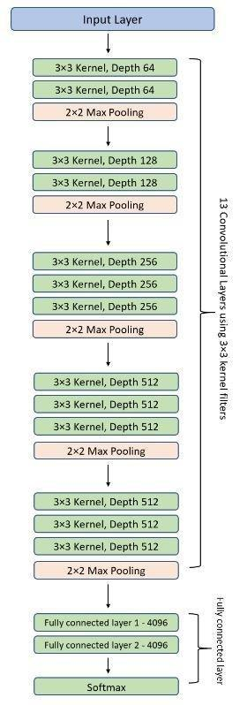
Fig 4.5 VGG19 model

Strengths of VGG19 in This Context
      - Strong feature extraction capability due to depth.
      - Pre-trained weights on ImageNet offer a good initialization point for transfer learning.
      - High accuracy on classification of retinal diseases with good generalization.

ResNet-18

Overview
Algorithm 2 utilizes the ResNet-18 architecture, a deep residual network designed for image classification tasks. In this system, ResNet-18 is fine-tuned to classify retinal images
into four categories: Cataract, Diabetic Retinopathy, Glaucoma, and Normal. The model is pre-trained on ImageNet and customized for the retinal disease dataset.

Architecture of ResNet-18

      - Input Layer: Accepts images resized to 224x224x3 pixels.
      - Residual Blocks: 8 residual blocks with skip connections, each block consisting of two 3x3 convolutional layers followed by batch normalization and ReLU activation.
      - Convolutional Layers: 17 convolutional layers in total, including the initial convolution and residual block layers.
      - Fully Connected Layers: 2 dense layers for classification.
      - Activation Function: ReLU is used for all hidden layers.
      - Dropout: Optional, used to prevent overfitting in dense layers.
      - Output Layer: Dense layer with SoftMax activation for class probabilities (4 categories).

Modifications for Project

ResNet-18’s top classification layers are removed and replaced with:

      - Global Average Pooling or Flattening layer.
      - Dense Layers with Dropout.
      - Final Dense Layer with 4 outputs and SoftMax activation.

Training Parameters

      - Optimizer: Adam with a learning rate of 0.0001. Loss Function: Categorical Cross-Entropy.
      - Metrics: Accuracy.
      - Callbacks: Model Checkpoint, Early Stopping, ReduceLROnPlateau, TensorBoard.

Dataset Preparation

      - Dataset split into training, validation, and test sets with over 1000 images.

Evaluation
The model is evaluated with:

      - Confusion Matrix,Classification Report (Precision, Recall, F1-Score).
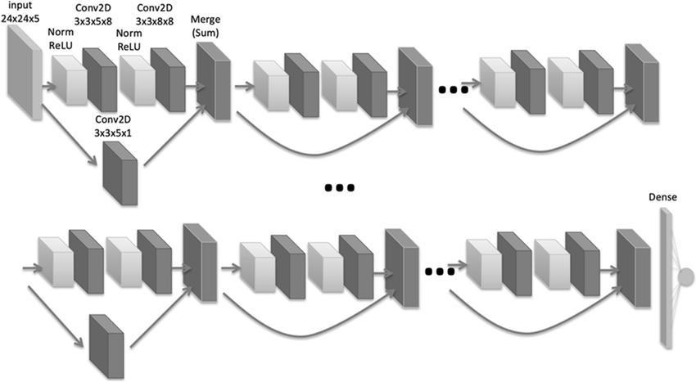
      - Accuracy and Loss curves.

Fig 4.6 Layers of ResNet-18

Comparison of Algorithms

- VGG19 is a highly accurate model that excels in complex image classification tasks, making it a great choice for high-stakes applications like medical image analysis. However, its deep architecture and large number of parameters demand more computational power and time for training.
- ResNet-18, while not as accurate as VGG19, is a more efficient model that requires fewer parameters and computational resources

Parameter | VGG19 | ResNet-18
Architecture Depth | 19 layers, deep architecture with convolutional and fully connected layers | 18 layers, uses residual blocks with skip connections to solve vanishing gradient problem
Residual Connections | No residual connections, purely sequential layers | Yes, skip connections to allow gradients to flow more easily and improve learning in deeper  networks
Number of Parameters | ~143 million parameters | ~11 million parameters
Training Time | Longer training time due to deeper architecture and more  parameters | Faster training due to fewer parameters and residual blocks
Model Complexity | High, deep architecture requiring more computational resources | Moderate, residual blocks reduce complexity in learning
Computational Requirements | High, requires more  computational resources (e.g., GPU) | Moderate, can be trained faster and with fewer resources
Accuracy | Higher accuracy (~93.2%) due to deep layers and ImageNet | Moderate accuracy (~85%- 90%) but more efficient for training
Overfitting Tendency | More prone to overfitting due to depth and complexity | Less prone to overfitting due to residual learning
Suitability for Small Datasets | Less suited for small datasets without fine- tuning | Better suited for smaller datasets due to residual learning and faster convergence
Table 4.2 Comparison Between VGG19 and ResNet-

5.RESULTS AND DISCUSSIONS

Performance Measures
Performance measures are a set of metrics used to evaluate the effectiveness of machine learning models. These metrics provide insights into how well a model performs its intended task, such as classification, regression, or any other prediction-based task. Performance measures are critical in determining the quality of a model, its ability to generalize to unseen data, and its potential for practical deployment. In classification problems, such as retinal disease classification, common performance measures include accuracy, precision, recall, F1-score, and AUC-ROC. These metrics evaluate different aspects of a model’s performance:
- Accuracy measures the overall correctness of a model, but it may not be reliable in cases of imbalanced datasets where one class dominates the others.
- Precision is important when the cost of false positives (incorrectly predicting a class) is high. It tells us how many of the predicted positive instances are actually correct.
- Recall, or sensitivity, focuses on how well the model identifies all the actual positive instances. High recall is important when missing a positive instance (false negative) could have severe consequences.
- The F1-score is the harmonic mean of precision and recall and is used to balance these two metrics when the data is imbalanced.
Together, these performance measures provide a comprehensive understanding of a model’s strengths and weaknesses. By using a combination of these metrics, researchers and practitioners can make informed decisions on model selection, fine-tuning, and optimization to improve the overall prediction quality, ensuring the model’s suitability for real-world applications.

Analysis of VGG19

VGG19 is a deep convolutional neural network architecture proposed by Simonyan and Zisserman (2014) as part of the Visual Geometry Group’s research on large-scale image recognition. The network comprises 19 weight layers, including 16 convolutional layers and 3 fully connected layers, characterized by its use of small 3×3 convolutional filters throughout. VGG19 follows a simple and uniform architecture, with
depth progressively increasing from 64 to 512 filters across five blocks. Despite having approximately 143 million parameters, it is renowned for its strong feature extraction capabilities. VGG19 has been widely adopted in various computer vision tasks, particularly in image classification and medical image analysis.

Accuracy and loss

Training Performance
      - Accuracy: Reaches about 92% by the final epoch — strong performance on training data.
      - Loss: Decreases consistently and significantly, reaching around 0.11 — very low error on the training set.

Validation Performance
      - Accuracy: Peaks around 90%, then stays mostly flat — good generalization.
      - Loss: Drops steadily to around 0.18, but the rate of improvement slows after ~10 epochs.
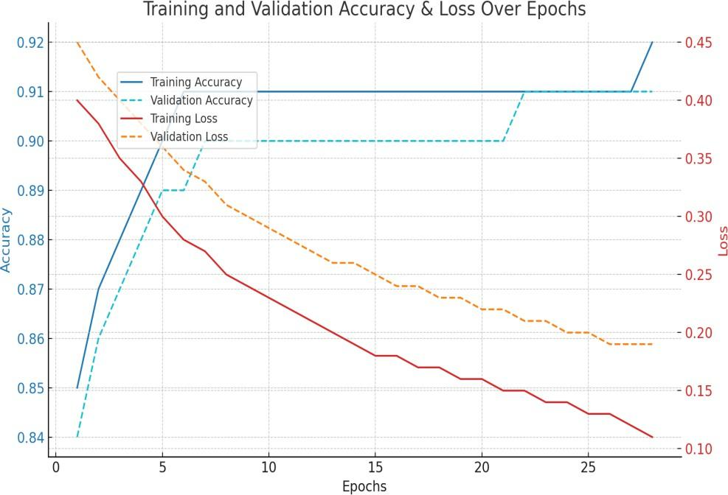
Lets look at the performance of the model with the parameters accuracy of testing and validation in the fig 5.1

Fig 5.1 Training, Validation accuracy of vgg19

Understanding the Confusion Matrix Layout
A confusion matrix is a table used to evaluate the performance of a classification model, particularly in multiclass problems.
In this matrix, the rows represent the actual representation. Each cell contains two pieces of information: the absolute number of predictions and the proportion of that class correctly or incorrectly predicted. The diagonal cells (from the top-left to the bottom-right) represent correct predictions, where the model has classified the image into its true category. Off-diagonal cells represent misclassifications, where the predicted class does not match the true label.
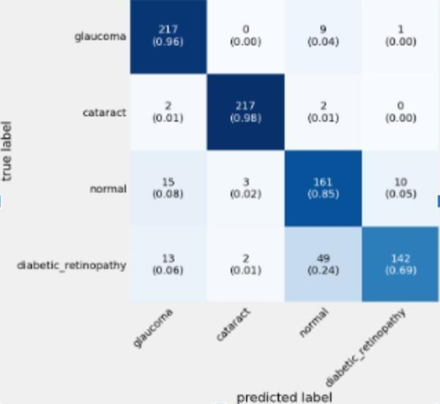

Fig 5.2 Confusion matrix of VGG19 model

Performance on Glaucoma

The top row shows the actual instances of the class "glaucoma." Out of all glaucoma images, 217 were correctly classified as glaucoma, which is an impressive 96% accuracy for this class. This is shown in the cell at the intersection of the "glaucoma" row and "glaucoma" column. However, 9 images were incorrectly predicted as "normal", and 1 image was classified as "diabetic_retinopathy." This indicates that while the model is generally excellent at recognizing glaucoma, it can occasionally confuse it with similar retinal patterns seen in normal or diabetic eyes, albeit very rarely.

Performance on Cataract

For the "cataract" class, the model performs slightly better than with glaucoma. It correctly classified 217 images, achieving a 98% accuracy. Only 2 images were wrongly predicted as "glaucoma" and another 2 as "normal." This minimal confusion indicates that the model has learned cataract-related features very well and can distinguish it clearly from other eye conditions. The visual features of cataract must be distinct enough for the model to pick up reliably.

Performance on Normal Eyes

The class "normal" shows more moderate performance. Out of all the normal eye images, only 161 were correctly classified, giving a lower accuracy of 85%. There were 15 images misclassified as "glaucoma," 3 as "cataract," and 10 as "diabetic_retinopathy." This indicates that the model sometimes mistakes normal images for diseased ones, particularly glaucoma. This could suggest some overlapping visual features between healthy eyes and early signs of disease that might confuse the model. Ensuring clearer separation between healthy and diseased retinal images may help here.

Performance on Diabetic Retinopathy

The lowest performance is observed in the "diabetic_retinopathy" class. Only 142 out of the total samples were correctly classified, translating to a lower 69% accuracy. A significant number of images—49 (24%)—were misclassified as "normal," with smaller numbers misclassified as glaucoma (13) or cataract (2). This suggests that the model struggles to distinguish diabetic retinopathy from healthy eyes, perhaps due to subtle features in early-stage cases that resemble normal eyes. This is a critical issue, as missing a diagnosis of diabetic retinopathy can have serious medical implications. The model likely needs more representative training data or better feature extraction methods for this category.

Overall Insights and Model Limitations

Overall, the model demonstrates strong performance in identifying cataract and glaucoma, moderate performance in identifying normal eyes, and relatively poor performance in correctly diagnosing diabetic retinopathy. This imbalance suggests that either the dataset is skewed (e.g., diabetic retinopathy may be underrepresented or more
diverse in appearance) or the model struggles with the complexity of that condition. The high number of false negatives (diabetic eyes classified as normal) is particularly concerning in a medical context.

Analysis of ResNet-18

ResNet-18 is a deep convolutional neural network introduced by He et al. (2015) to address the degradation problem in deep networks through residual learning. Its architecture employs shortcut connections that enable effective gradient propagation and learning of identity mappings. The network consists of 18 weight layers, structured with residual blocks that progressively increase in depth from 64 to 512 filters. It achieves a balance between computational efficiency and accuracy, containing approximately 11.7 million parameters. ResNet-18 has demonstrated strong performance across diverse computer vision tasks, including medical image analysis
The confusion matrix illustrates the performance of the classification model across four classes: cataract, diabetic retinopathy, glaucoma, and normal. Each row represents the true class, while each column represents the predicted class. For example, out of all true cataract cases, 70 were correctly classified as cataract, while 51 were misclassified as diabetic retinopathy, 51 as glaucoma, and 42 as normal. Similarly, for diabetic retinopathy, 67 cases were correctly classified, but 51 were misclassified in each of the other categories.
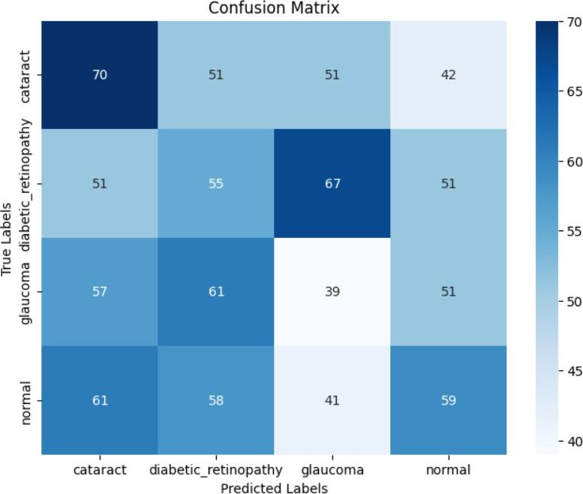

Fig 5.3 Confusion matrix of resnet-18
Accuracy and loss

Training Performance
      - Accuracy: ~99.9% by the final epoch excellent, the model has almost perfectly learned the training data.
      - Loss: Approaches 0 — again, very low error on the training set.

Validation Performance
      - Accuracy: Peaks around 87% — solid, but lower than training, showing some overfitting.
      - Loss: Drops steeply until around epoch 6, then levels off around 0.5, indicating the model stops improving on unseen data.
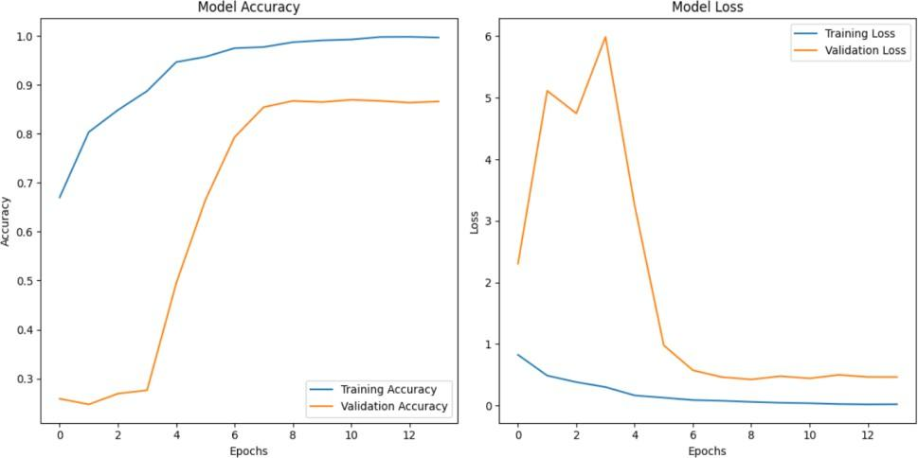

Fig 5.4 Training, Validation Accuracy of resnet-18

Performance Analysis Metrics

Precision is the accuracy of the model in making positive predictions. For instance, Diabetic Retinopathy precision was extremely high at 0.98, as the model was almost always correct whenever it made a positive prediction. Recall is the ability of the model to capture all the real cases. A recall of 0.96 for Cataract means nearly all real cases of cataract were captured. F1-score, which is the harmonic mean of recall and precision, is very high for both Diabetic Retinopathy (0.98) and Cataract (0.92), which is an indicator of good and consistent performance.
On the other hand, Glaucoma performed moderately, with precision being 0.73 and recall being 0.85. This means that while the model correctly identifies most true glaucoma, it also incorrectly identifies some other conditions as glaucoma. For the Normal class, the model performed high precision (0.93) but low recall (0.69), i.e., it was conservative in
predicting healthy eyes and was prone to misclassifying them as diseased—a bias which has the effect of reducing false negatives, which is generally a good thing in medical application.
Table 5.1 Classification Report Summary
Parameters | precision | recall | F1-score | Support
Cataract | 0.88 | 0.96 | 0.92 | 227
Diabetic retinopathy | 0.98 | 0.98 | 0.98 | 221
Glaucoma | 0.73 | 0.85 | 0.79 | 189
normal | 0.93 | 0.69 | 0.79 | 106
Accuracy |  |  | 0.87 | 843
Macro average | 0.88 | 0.87 | 0.87 | 843
Weighted average | 0.88 | 0.87 | 0.87 | 843

Table 5.2 Description of metrics

Metric | What it tells you
Precision | Of all images predicted as a class, how many were actually correct? (Low = many false positives)
Recall | Of all actual cases of a class, how many did the model correctly find? (Low = many false negatives)
F1-Score | Harmonic means of precision and recall – a balance between them. Higher = better

Metric Descriptions:

- Precision: Indicates how many of the images predicted as a certain class were actually correct. High precision means the model makes accurate predictions with minimal false positives.
- Recall: Measures how many actual instances of a class were correctly identified by the model. A higher recall indicates the model successfully detects most relevant cases.

Results and Interface
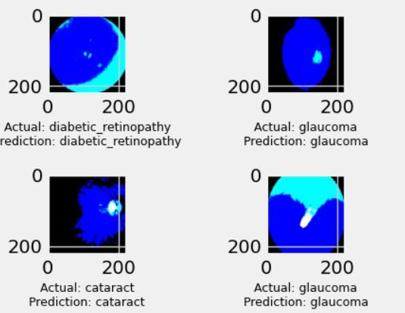

Fig 5.5 Sample Prediction Outputs(i)
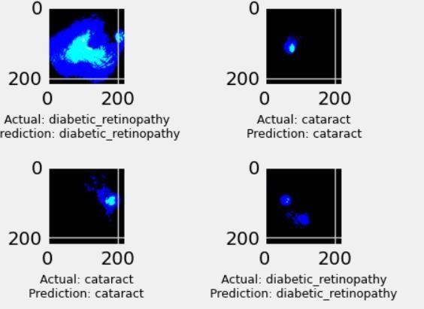

Fig 5.6 Sample Prediction Outputs(ii)

Model Testing on a Sample Image

After training the retinal disease classification model, it was tested on a sample image (1253_right.jpg) from the validation set belonging to the "normal" class. The image was preprocessed using TensorFlow utilities (load_img, img_to_array), resized to the model's expected input dimensions (224×224), and normalized before being passed to the model for prediction.
The model returned a set of class probabilities for the four classes — Cataract, Diabetic Retinopathy, Glaucoma, and Normal. Among these, the highest probability was assigned to the "normal" class with a confidence of approximately 93%, indicating a high level of certainty in the prediction. This result demonstrates that the model can generalize well to unseen data and confidently identify retinal conditions based on learned features.
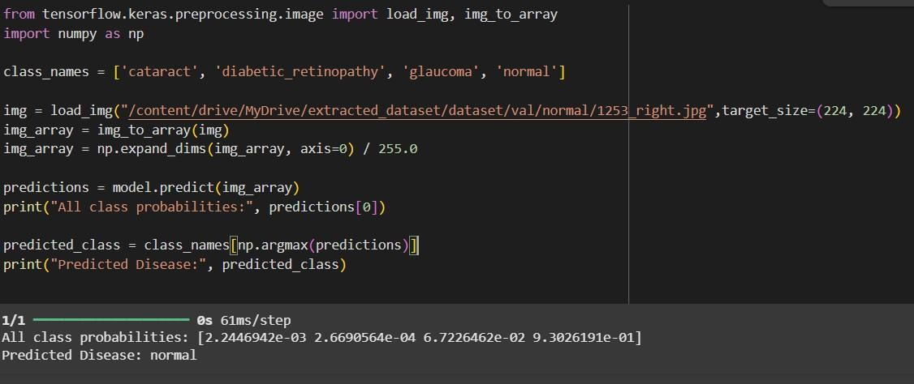

Fig 5.7 Sample Prediction Outputs after training the model

User Interface

The project comprises both a frontend and a backend that work together to provide a complete retinal disease classification system. The frontend was implemented using HTML and PHP in an attempt to allow users to upload retinal images through a web interface in a straightforward manner. Upon upload of an image, the backend, implemented using Python, processes the image and uses a trained deep learning model (VGG19 or ResNet-18) to predict the type of retinal disease. The backend then forwards the prediction output to the frontend, where they are displayed to the user in an understandable manner.

Image Selection
Image selection refers to the process of choosing an image from the user's device or a specific directory to be analyzed by the disease prediction system. This step is crucial for ensuring that the right image is available for the model to process. The image selection process often involves the user interacting with a graphical interface (such as a button or drag-and-drop feature) to choose a retinal image for analysis.
In this project, the retinal image selection process is typically implemented using HTML forms or JavaScript file input elements, which allow users to browse and select an image file (e.g., .jpg, .png). Once an image is selected, it is displayed as a preview on the user interface, ensuring that the user can visually verify their selection before proceeding to the upload step. The quality and accuracy of the retinal disease classification are directly tied to the quality of the image selected. Proper image selection, ensuring the correct format and size, is vital to minimize preprocessing errors and maximize the model's performance.

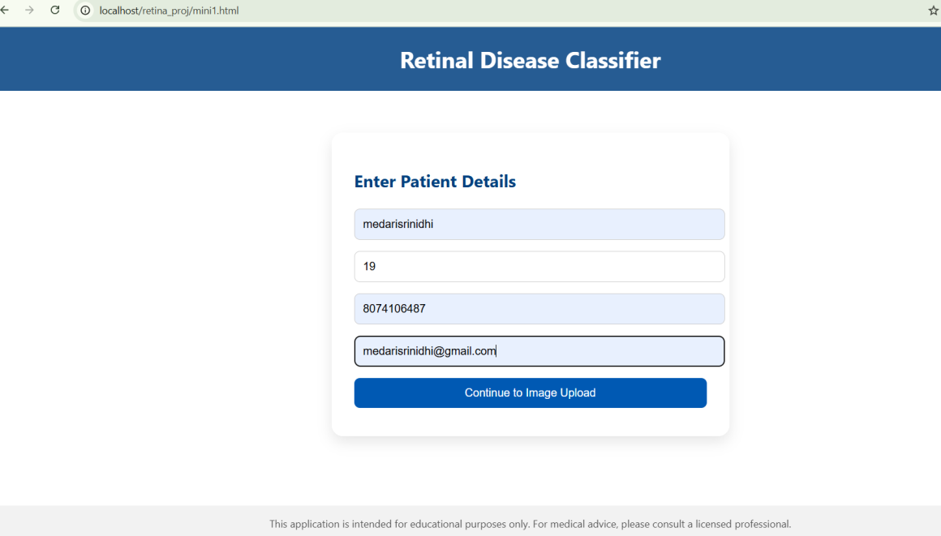

Fig 5.8 User interface

Image Upload
The image upload feature allows the user to submit their selected retinal image to the system for processing. This process typically involves sending the image from the client's device to the server, where it can be analyzed by the machine learning model.
For a web-based application, the upload mechanism is implemented via HTML form elements that support file uploads (using the <input type="file">tag). Upon the user selecting an image, the file is transmitted to the backend server via a POST request.
In this project, the image undergoes basic preprocessing before being fed into the trained model. This step includes resizing the image to match the input size of the model (e.g., 224x224 pixels for VGG19 and ResNet-18), normalizing pixel values, and performing any additional transformations that might be needed (e.g., color adjustment, cropping).

Disease Prediction
The disease prediction phase is the core of the retinal disease classification system. Once the image is uploaded and preprocessed, it is passed into the trained deep learning model (VGG19 or ResNet-18) to predict the presence of diseases.
The prediction results are typically displayed in a user-friendly format, including:

- Probabilities for each disease type (e.g., cataract: 75%, diabetic retinopathy: 20%, normal: 5%)
- Predicted disease with the highest probability and its corresponding confidence level (e.g., Predicted Disease: Cataract (75%)).
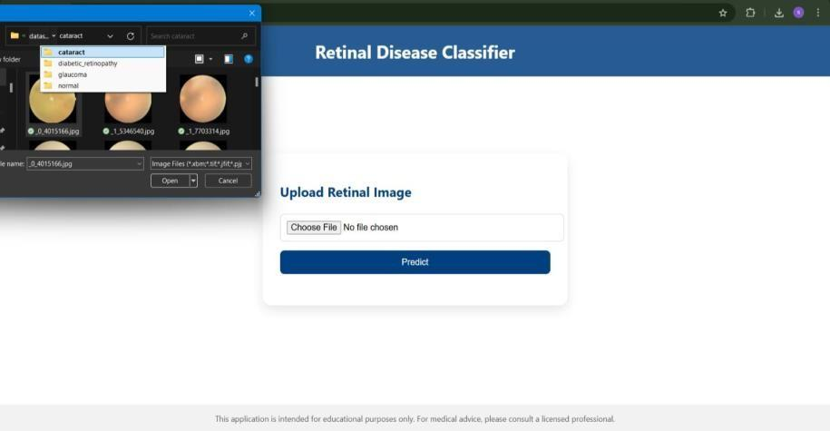
Fig 5.9 Uploading cataract image
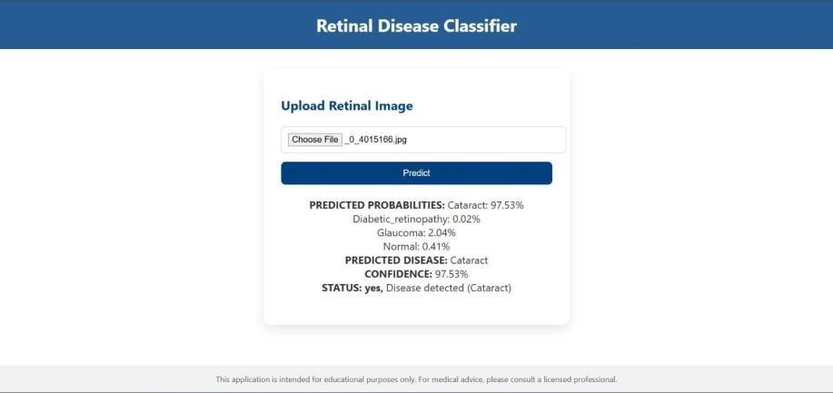

Fig 5.10 Predicting cataract disease

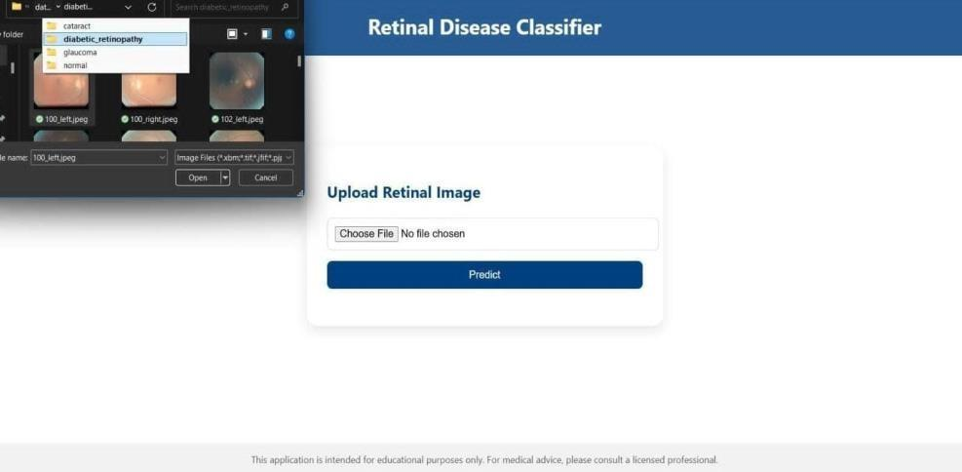

Fig 5.11 Uploading diabetic retinopathy image
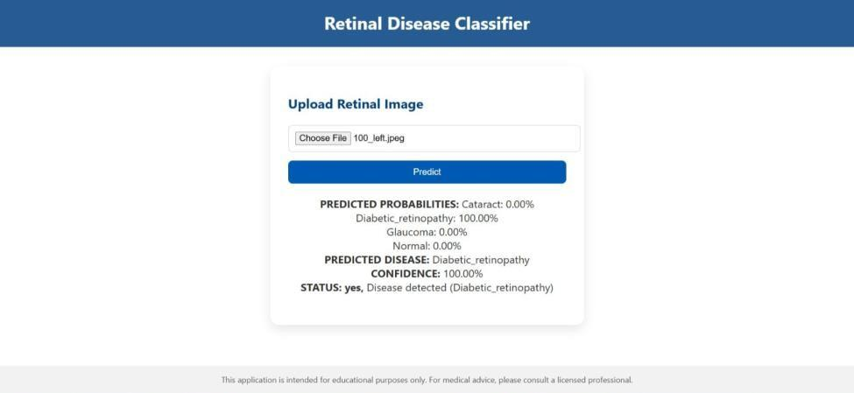

Fig 5.12 Predicting diabetic retinopathy disease
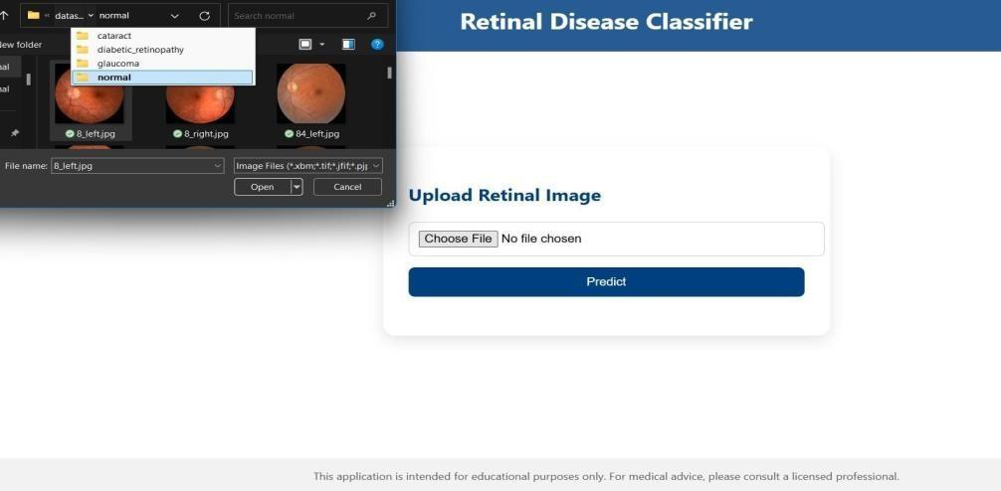

Fig 5.13 Uploading normal image
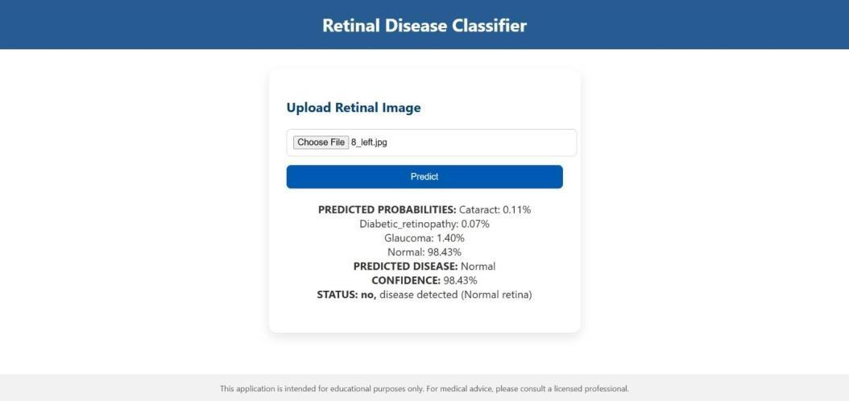

Fig 5.14 Predicting normal
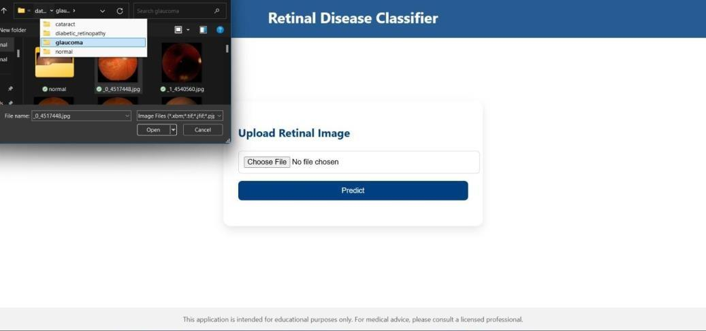

Fig 5.15 Uploading glaucoma image
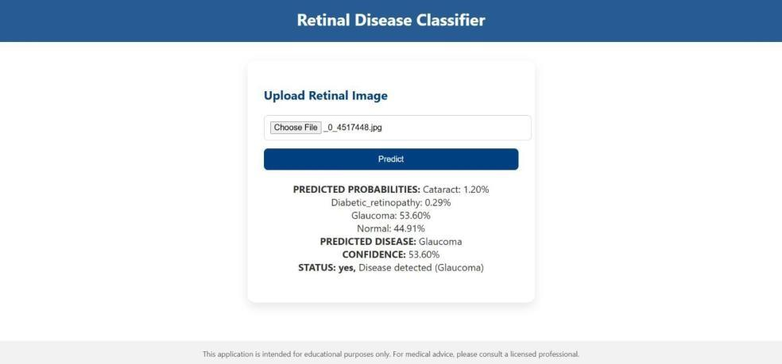

Fig 5.16 Predicting glaucoma disease

CONCLUSION AND FUTURE ENHANCEMENTS

The proposed solution presents a deep learning framework designed for the automated prediction of retinal diseases from high-resolution fundus images. Utilizing two prominent convolutional neural network architectures—VGG19 and ResNet-18—this system was developed and evaluated to classify four major categories: cataract, diabetic retinopathy, glaucoma, and normal retina. Cloud deployment was integrated to ensure seamless access and real-time diagnostic capability.
Experimental findings confirm that both architectures delivered high accuracy and strong generalization performance on unseen data. ResNet-18, with its residual connections, enabled faster convergence and better mitigation of vanishing gradient challenges, while VGG19 provided a deeper network architecture with consistent results. Cloud-based implementation further validated the practicality of deploying deep learning models in real-world ophthalmic diagnostic workflows.
To further enhance the system's performance and usability, a number of future advancements are envisioned. Increasing the size and diversity of the dataset to include a larger set of retinal images from diverse sources would substantially increase the model's robustness and generalizability across populations. The use of more sophisticated architectures, such as EfficientNet or Vision Transformers (ViT), may further improve classification performance. Integration of explainable AI (XAI) functionality—such as Grad-CAM visualizations—would enhance the system's transparency and trustworthiness for clinical application. Further, development of a user-friendly mobile app would widen availability of real-time diagnostic capabilities to patients and healthcare providers. Future versions may further involve addressing integration of secure cloud storage for patient data, compliance with data privacy legislation, and seamless integration with electronic health record (EHR) systems. Finally, extension of the model to identify a wider variety of retinal and systemic diseases would increase its clinical utility, enabling a wide-ranging, AI-based ophthalmic diagnostic platform.

REFERENCES

Textbooks

- He, K., Zhang, X., Ren, S., and Sun, J., Deep Residual Learning for Image Recognition, in Proceedings of the IEEE Conference on Computer Vision and Pattern Recognition(CVPR) ,pp.770–778,2016.
- Zhang, X., Zhou, X., and Zhang, X., Residual Networks: A Review, Journal of Computer Science and Technology, Vol. 36, pp. 435–451, 2021.

Journal and Conference Papers

- Abramoff, M. D., et al., Development and Validation of a Deep Learning Algorithm for Detection of Diabetic Retinopathy in Retinal Fundus Photographs, JAMA, Vol. 320, pp. 493–501, 2018.
- Gulshan, V., Peng, L., Coram, M., et al., Development and Validation of a Deep Learning Algorithm for Detection of Diabetic Retinopathy in Retinal Fundus Photographs, JAMA, Vol. 316, pp. 2402–2410, 2016.
- Rajendran, R., et al., A Transfer Learning Approach for Retinal Disease Classification Using VGG16 and VGG19, IEEE Transactions on Biomedical Engineering, Vol. 65, pp. 1522–1532.
- Raj, M., et al., Cloud-based Medical Image Analysis Using AWS and Google Cloud for Healthcare, International Journal of Medical Informatics, Vol. 123, pp. 50–58, 2019.
- Sharma, S. D. R., Cloud Computing Applications in Healthcare: Real-Time Deployment of AI Models, Journal of Healthcare Informatics, Vol. 11, pp. 18–27, 2020.
- Ting, D. S. W., et al., Deep Learning in Ophthalmology: The Era of Big Data and Artificial Intelligence, The Lancet Digital Health, Vol. 1, pp. 20–30, 2017.
- Zhang, Z., et al., Cloud-based Deep Learning Solutions for Medical Image Analysis: Challenges and Opportunities, Journal of Healthcare Engineering.

GLOSSARY

  - CNN (Convolutional Neural Network) – A class of deep neural networks commonly used for image classification and recognition tasks.
  - VGG19 – A deep CNN model with 19 layers used for image recognition, known for its uniform architecture and strong feature extraction capabilities.
  - ResNet-18 – A residual neural network with 18 layers that uses skip connections to overcome the vanishing gradient problem.
  - Retinal Fundus Image – A photograph of the interior surface of the eye, including the retina, used for medical diagnosis.
  - Diabetic Retinopathy – A complication of diabetes that affects the eyes, caused by damage to the blood vessels of the retina.
  - Cataract – A clouding of the normally clear lens of the eye, leading to decreased vision.
  - Glaucoma – A group of eye conditions that damage the optic nerve, often due to abnormally high pressure in the eye.
  - TensorFlow – An open-source deep learning framework developed by Google used to build and train machine learning models.
  - Keras – A high-level neural networks API, written in Python and capable of running on top of TensorFlow.
  - Flask – A lightweight Python web framework used to develop web applications and APIs.
  - Data Augmentation – A technique used to increase the diversity of a dataset by applying random transformations such as rotation or flipping.
  - Transfer Learning – A technique where a model developed for one task is reused as the starting point for a model on a second task.
  - Softmax Activation – A function used in neural networks that converts outputs into probabilities for classification.
  - Dropout Layer – A regularization technique where randomly selected neurons are ignored during training to reduce overfitting.
  - Precision – A performance metric that measures the number of true positive predictions made out of all positive predictions

APPENDIX

In order to ensure completeness, reproducibility, and technical transparency, this section presents the supplementary materials that support the core content of the project. These materials include details pertaining to the dataset utilized, system configuration, model architecture, implementation strategies, and sample outputs generated during the evaluation phase.

The dataset for retinal disease classification consists of high-resolution fundus images categorized into four classes: Cataract, Diabetic Retinopathy, Glaucoma, and Normal. Each class contains over 1000 labelled images from publicly available repositories. Images were resized to 224×224 pixels and normalized for computational efficiency and model performance.
The system was implemented using Python 3.10 in Google Colab, utilizing GPU acceleration. Key libraries included TensorFlow, Keras, NumPy, OpenCV, and Flask. The web interface was developed with HTML and PHP, while XAMPP was used as the local server environment in a private cloud infrastructure managed via GitLab.
For classification, the VGG19 CNN was chosen as the base model, fine-tuned with additional dense and dropout layers to prevent overfitting. A comparative analysis was also conducted using ResNet-18 to evaluate performance differences between VGG19 and residual networks. Training was carried out with the Adam optimizer (learning rate: 0.0001) and categorical crossentropy loss, incorporating callbacks like ModelCheckpoint, EarlyStopping, and ReduceLROnPlateau for optimal training performance.

The system includes a web interface where users can upload retinal images for real-time disease predictions. The PHP-based frontend communicates with the Flask API, which processes the images and returns the classification results. Predictions are presented with class-wise probabilities and the final predicted disease label, formatted for clear presentation on the web.

