Design

# Tools Used

* Java was the implementation choice
* Selenium Web Driver
* Appium
* Maven was used as a build tool and managing libraries repository
* Intellij IDE

# Project Structure

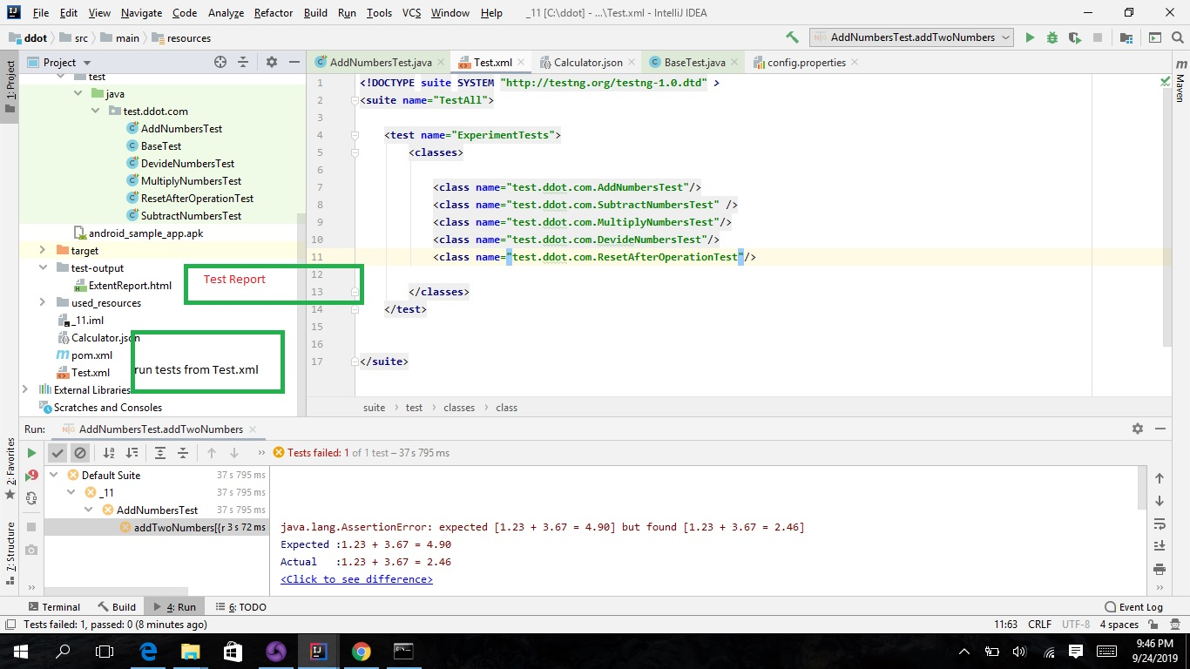

# Handling different Selenium Command

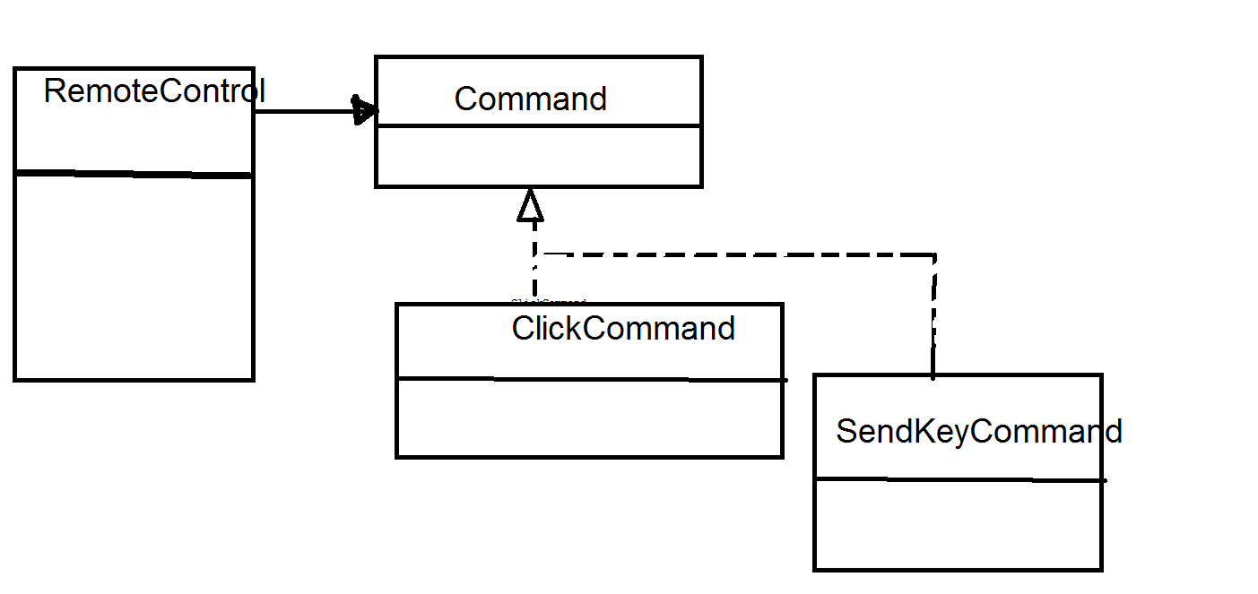

ClickCommand clickCommand = **new** ClickCommand(**driver**);  
SendKeysCommand sendKeysCommand = **new** SendKeysCommand(**driver**);  
CommandControl commandControl = **new** CommandControl();  
commandControl.setCommand(commandControl);

commandControl.performClick(**eles**.get(**"cookies"**));

# Web element Locators

Json File where used to carry the locators

[  
  
 {  
 **"name"**:**"leftvalue"**,  
 **"type"**:**"Id"**,  
 **"value"**:**"locator id"** },  
 {  
 **"name"**:**"rightvalue"**,  
 **"type"**:**"Id"**,  
 **"value"**:**"locator id 2"** }  
]

Every page Object pattern has a json file

When instantiating a new page object class the json is read in a map that contains element names as keys and By objects as values

# Data Driven Test Data

Test Data are kept in Excel files, we have 5 test, and corresponding to them are four Excel Files

dataProvider is used to load the test data from Excel Sheets

# Running Tests

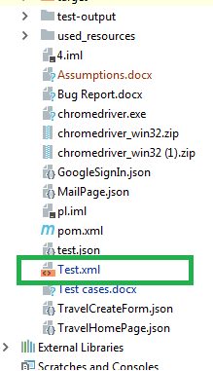

Test.xml is used to run all tests

# 

# References

<https://www.qaautomation.co.in/2019/01/extent-report-version-4-selenium-TestNG.html>