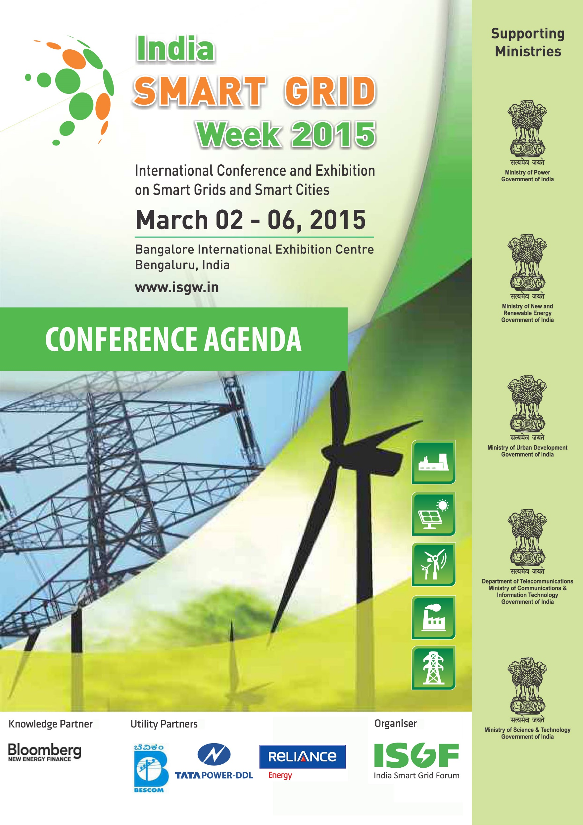


Supporting Ministries
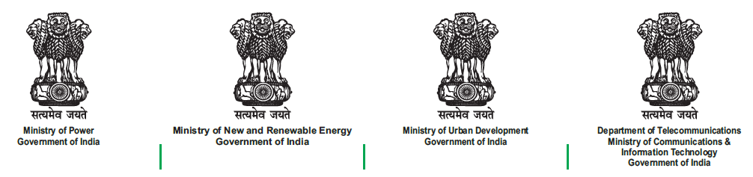

Partners




(U.S. Commercial Service supports the goals of this event, but does not endorse the specific products, or views of the participating organizations)

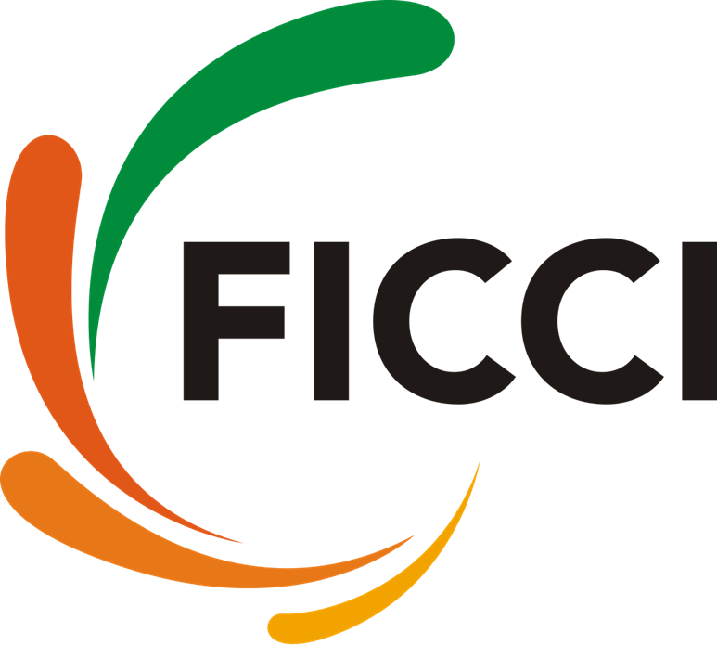




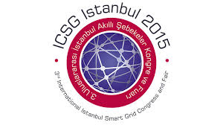

AGENDA - 02 March 2015

9.30-17:30  JW Marriot  Bengaluru | US-India Smart Grid Workshop sponsored by USTDA
08:30 – 09:30 | Registration for ISGW 2015 at Bangalore International Exhibition Centre (BIEC)
9:30 – 18:00 Smart Grid Tutorial & Master Classes: BIEC
9:30 – 11:00  (GULMOHAR) | Introduction to Smart Grids: Rahul Tongia, Brookings India & Pradeep Kumar Yemula, IIT-H
11:00 – 11:30 | Tea Break
11:30 - 13:00  (GULMOHAR) | Communication Technologies for Smart Grids and Smart Cities – Ajoy Rajani, Reliance Infra & Kishore Narang, Narnix
13:00 – 14:00 | Lunch Break (Lagoon Area)
14:00 - 18:00 | MASTER CLASSES (Parallel Tracks)
GULMOHAR | - IEC 61850 by Christoph Brunner, Chair of IEC Working Group on 61850 in TC-57
CASSIA | - Cyber Security by M. Zaki, NCIIPC, N. P. Singh, NCIIPC, Faruk Kazi, VJTI, Hem Thukral, ISGF
HIBISCUS | - Energy Storage Technologies by Rahul Walawalkar, IESA & Akshay Ahuja, ISGF
PARIJATHA | - Smart Microgrids by Terry Mohn, General Microgrids Inc & C. Amritha, ISGF
15.30 – 16.00 | Tea Break

AGENDA - 03 March 2015

08:30 – 09:30 | Registration for ISGW 2015
Session Time | Session Details
09:30 – 11:00 | Inaugural Session
GULMOHAR | Welcome Address: Pankaj Kumar Pandey, Managing Director, BESCOM
GULMOHAR | Special Address: Richard Schomberg, Chairman of Technical Committee of ISGW 2015
GULMOHAR | Special Address: Ravi Kumar, Additional Chief Secretary – Energy, Govt of Karnataka
GULMOHAR | Special Address: Sandy Sheard, Counsellor and Head - Energy, Climate & Growth Unit, British High Commission, New Delhi
GULMOHAR | Special Address: A.K. Mittal, Head – Telecommunications Engineering Centre
GULMOHAR | Presentation of highlights of the Knowledge Paper: Colin McKerracher, Bloomberg New Energy Finance
GULMOHAR | Release of Knowledge Paper on “Smart Grids in India” by the Chief Guest
GULMOHAR | Inaugural Address by the Chief Guest: Devendra Chaudhry, Special Secretary, Ministry of Power
GULMOHAR | Invitation to ISGW 2016: Praveer Sinha, CEO & ED, Tata Power Delhi Distribution (Host Utility)
 | Vote of Thanks: ISGF
11:00 – 11:15 | Inauguration of Exhibition by Chief Guest (Hall: JACARANDA)
11:15 – 11:30 | Tea Break
11:30 – 13:00  GULMOHAR | Plenary Session – 1: Smart Grid Projects Update, Lessons Learnt, Business Models and Key Emerging Trends  Chair: Devendra Chaudhry, Special Secretary, Ministry of Power  A) Developed Counties Perspectives:  1. Russell Conklin, US DoE & ISGAN  2. Mark van Stiphout, Deputy Head, Energy Technologies Unit, DG ENERGY, European Commission  3. Hiroshi Kuniyoshi, Executive Director, NEDO  4. Ja-yoon Koo, Ex-Chairman of Regulatory Commission, South Korea  B) Developing Countries Perspectives:  1. Henry Steingass, Regional Director for South & South East Asia, USTDA  2. Praveer Sinha, CEO & ED, Tata Power Delhi Distribution  3. Ravi Seethapathy, CIGRE
13:00 – 14:00 | Lunch Break (Lagoon Area)
14:00 - 15.:30  Track – A in GULMOHAR  Track-B in  CASSIA | Track A: Future Electricity Grid Supporting Low Carbon Energy Supply and Energy Security | Track B: Smart Energy – Vision for the Smart Grid Evolving Towards Smart Customers and Smart Cities /Communities
14:00 - 15.:30  Track – A in GULMOHAR  Track-B in  CASSIA | Session A1: Smart Generation and Integration  Chair: Tarun Kapoor, Joint Secretary, MNRE | Session B1: Smart Energy Market Design &  Regulatory Support  Chair: U.K. Panjiar, Chairman, Bihar Electricity Regulatory Commission
14:00 - 15.:30  Track – A in GULMOHAR  Track-B in  CASSIA | A1.1 Large-Capacity Renewable Energy Generation and Integration Challenges, PV Tariff Design and Way-forward: Owen R. Zinaman, NREL, USA  A1.2 Distributed Generation:  M. Rajagopalan, Market Development Director – Middle East Asia, Wartsila India  A1.3 Protection and Control of Integrated Smart Generation: Sivakumaran Govindarajan, Hindel Power  A1.4: Beyond AMI- From Smart Meters to Advanced Distribution Automation: Aitor Arzuaga, Laura Marron & Jon Garcia de Salazar, CG Automation  A1.5: IEC 61850 supporting Distributed Generation and Storage: Christoph Brunner, Chair of IEC Working Group on 61850 in TC-57 | B1.1 Introduction: Requirements for a Market Design supporting Smart Energy: Suedeen G Kelly, Partner – Akin Gump & Former Commissioner, FERC  B1.2 Integration of Distributed Generation Into An Unbundled Market: Christopher Villareal, California PUC  B1.3 Demand Response market (NegaWatt) potential in India: Christopher Hickman, CEO, Innovari Inc  B1.4 Model Smart Grid Regulations in India: Vijay Sonavane, Advisor, MERC & Vikas Gaba, KPMG  B.1.5 Envisioning Smart Grid Policy, Regulatory and Technical Framework: Ujjwal Deep Dahal, Bhutan Power Corporation  B1.6 Role of Microgrids in India’s Smart Grid Framework – Regulatory Support: Larisa Dobriansky, General Microgrids
15:30 – 16:00 | Tea Break
16:00 - 16:30  CASSIA | Presentation on IESS2047 by Yeshika Malik, Consultant, NITI Ayog, & Akshay Ahuja, ISGF
16:30 – 18:00  CASSIA | Plenary Session – 2: Brainstorming on Spectrum Requirements for IoT and M2M Communications in India  Chair: A.K. Mittal, Head – Telecommunication Engineering Centre  Panellist: Communication Technology Gurus from several countries
18:00-18:45  JACARANDA | Networking in the Exhibition Floor
18:45 – 21:30  GULMOHAR | European Union – India Smart Grids Networking Cocktails (Open to All)

PARALLEL EVENTS on 03 March 2015
Session Time | Luncheon Session Details
13:00 -16:30  FINE DINING ROOM, First Floor of FOOD COURT | ISGAN Annexe-6 (POWER T&D SYSTEMS) Workshop: Microgrids – A system approach for deployment of renewable energy  Workshop Chair: Bo Normark, ISGAN - Chair Annex 6  Expert Panel:  - Terry Mohn, General Microgrids Inc.  - Ken Hayles, Eskom, South Africa  - Nick Singh, Eskom, South Africa  - Anders Lindskog, SP Technical Research Institute of Sweden  - Rahul Walawalkar, India Energy Storage Alliance
14:00 -15:30 | Track D: Technical Paper Presentation
PARIJATHA | Session D1: Chair: Faruk Kazi, VJTI  - Secured Information Exchange In Smart Grid: Deepika Barik, Dibyaraj Krishna Behera, NIT, Rourkela  - Analysis of adaptive over current protection schemes for active distribution network: Harikrishna M, Sai Sasank K, Dr. Premalata Jena, IIT Roorkee  - Optimal Energy Scheduling for a Smart Home Integrated with Solar PV and Battery Energy Storage: Batchu Rajasekhar, Naran Pindoriya, IIT Gandhinagar  - Get smart with Smart Grids: Debasis Mohapatra, PwC  - Innovative Business Models for Smart Grid Deployments: Sudhanshu Gupta, Soumitra Pandey, E&Y  - Communication Backbone for the Smart Grid Infrastructure: Narang Kishor, Narnix

AGENDA - 04 March 2015

Session Time | Session Details
09:30 – 11:00  GULMOHAR | Plenary Session – 3: Smart Grid to Smart Cities and Smart Communities  Chair: Raj Vaswani, CTO, Silver Spring Networks  - Richard Schomberg, IEC Smart Energy Chairman & Vice President, EDF  - Brian Spear, Managing Director, Trilliant Asia Pacific  - Chandan Chaudhary, Managing Director, Dassault Systemes India  - Prashant Pradhan, Director, Smarter Planet Solutions, IBM  - Alok Chandna, India, Site Project Leader, Fuji Electric - Case Study of Kitakyushu City, Japan  - N. Venu, Head of Power Division, ABB  - R. R. Mehta, CEO, Reliance Infra
11:00 – 11:30 | Tea Break
11:30 – 13:00  Track – A in GULMOHAR  Track-B in  CASSIA | Track A: Future Electricity Grid Supporting Low Carbon Energy Supply and Energy Security |  | Track B: Smart Energy – Vision for the Smart Grid Evolving Towards Smart Customers and Smart Cities /Communities
11:30 – 13:00  Track – A in GULMOHAR  Track-B in  CASSIA | Session A2: Evolving Integrated Grid with Distributed Generation  Chair: Varsha Joshi, Joint Secretary, MNRE |  | Session B2: Smart Cities & Smart Homes and other Emerging Technology Trends  Chair: Tom Rowlandsree, Bloomberg New Energy Finance
11:30 – 13:00  Track – A in GULMOHAR  Track-B in  CASSIA | A2.1 Introduction: Tools for Forecasting, Scheduling and Dispatch of distributed generation; Renewable Energy Monitoring Centres etc.: Christophe ARNOULT (NICE GRID Coordinator)  A2.2 Renewable Energy Sources & Distributed Generation Resources - Challenges to Transmission System Operators and Distribution System Operators: Ravi Seethapathy, Smart Grid Canada  A2.3 Energy Storage solutions for Grid Stability: Rahul Walawalkar, IESA  A2.4 Smart Grids with WAMS & Synchrophasor Technology: N.S. Sodha, Ex-ED, Power Grid |  | B2.1 Internet of Things strategies for the Sustainable Smart City - Building an IPv6 Communications Canopy for the future: Bjorn Lindblom, CEO, Connode  B2.2 Intelligent Connectivity as Fabric of Smart Cities: Lalitha Suryanarayana, Qualcomm Technologies  B2.3 Evolution of the Smart Customer in Smart Cities: Rupendra Bhatnagar, SAP  B2.4 New Technology Trends: Girish Ghatikar, LBNL  B2.5 Case Studies: Barcelona Smart City - Sandeep Pathak, Schneider Electric India & ISGF BoG Member
13.00 - 14.00 | Lunch Break (Lagoon Area)
14.00 - 15.30  Track – A in  CASSIA  Track-B in  GULMOHAR | Track A: Future Electricity Grid Supporting Low Carbon Energy Supply and Energy Security | Track B: Smart Energy – Vision for the Smart Grid Evolving Towards Smart Customers and Smart Cities / Communities
14.00 - 15.30  Track – A in  CASSIA  Track-B in  GULMOHAR | Session A3: Smart Distribution - Evolution of the Distribution Grid  Chair: Jean Francois Faugeras, VP-EDF | Session B3: Smart Customer  Chair: B.N. Sharma, Joint Secretary, Ministry of Power, India
14.00 - 15.30  Track – A in  CASSIA  Track-B in  GULMOHAR | A3.1 Increasing the intelligence of the Distribution Grid to integrate distributed generation: Jean Francois Faugeras, VP-EDF  A3.2 Data Analytics for increased intelligence of Distribution Grid: Jim Connaughton, C3 Energy  A3.3 Consequences of distributed generation for distribution networks: Laurent Schmitt, Alstom Grid  A3.4 Smart Micro Grids – Why so relevant for India?: Terry Mohn, General Microgrids, USA  A3.5 Nanogrids: Ashok Das, SunMoksha Power | B3.1 Don't Leave Your Customers Behind - Learn How to Unlock Smart Meter Value for Consumers: Adam Welsh, OPOWER  B3.2 E-mobility and EV infrastructure solutions for India: Rajit Gadh, SMERC, UCLA  B3.3 Empowering the Smart Consumer: Shiv Kaushik, Cyan Technologies  B.3.4 Smart Metering with TVWS & Cloud: Prashant Shukla, National Technology Officer, Microsoft India  B3.5 Customer Engagement through Gamification: Anindya Pradhan, Krishna Prasad etal, TCS
15:30 – 16:00 | Tea Break
16:00 – 18:00  GULMOHAR | Plenary Session – 4: International Collaboration, Joint Research, Development and Deployment Projects to bring down costs  Chair: Agnese Cecchini, Editorial Director, Groupo Italienergia, Italy  - IEC: Frans Vreeswijk, General Secretary & CEO  - ISGAN: Russel L .Conklin  - NEDO: Hiroshi Kuniyoshi, Executive Director  - GSGF: Paddy Turnbull, Chairman (on Video)  - CIGRE: Ravi Seethapathy  - Financing of Smart Grid Projects: Lee Burrows, Managing Director, Vantage Point
18:00 –18:15  GULMOHAR | Screening of Documentary film by Energy Department of Odisha “Battling in Darkness”
18:15 – 19:00  JACARANDA | Networking Break and Exhibition Visit
19:00 – 22.00  LAGOON AREA | Cocktails, Cultural Program & Dinner

PARALLEL EVENTS on 04 March, 2015
Session Time | Session Details
11:30-15:30  FINE DINING ROOM  First Floor of FOOD COURT | Luncheon session - “Smart Regulations for Smart Grids” for Regulators and Policy Makers  Inauguration by Hon’ble Minister of Energy, Govt of Karnataka, Sh. D. K. Shivakumar  Speakers and Topics:  - Model Smart Grid Frameworks to support positive regulatory change to new technologies: Suedeen G.Kelly, Partner – Akin Gump & Former Commissioner, FERC  - Regulatory Examples from around the world to enable the Demand side. A discussion of many different countries and regulations and to see what has worked and what has not worked: Christopher Hickman, CEO, Innovari Inc  - Market Structures – How are the different markets working? From fully unbundled to vertically integrated, where have electricity grids been able to provide higher levels of reliability while maintaining affordable cost?: Paul Feldman, Director (and past Chairman), MISO  - Regulatory implications of amendments proposed in the Electricity Act 2003: Vijay Sonavane, Advisor, MERC  - Regulations for Separation of Carriage and Content - Experiences and Recommendations: Balawant Joshi, Managing Director, Edam Infra  - How the market views utility investments in Smart Grid?: Lee Burrows, Managing Director, Vantage Point
11:30-13:00 | Track D: Technical Paper Presentation
PARIJATHA | Session D2: Ganesh Das, Tata Power Delhi Distribution  - Considerations in Standardization for Demand Response Ready Air Conditioners in India: Nihar Shah, Girish Ghatikar, Nikit Abhyankar, Amol Phadke, LBNL  - Smart Metering and Demand Response: Sujay Kumar Saha, Vikas Arora, TPDDL  - Smart Metering Technology: The Evolving Economy of Smart Distribution: Priyamvada Chandel, Tripta Thakur, B.A. Sawale, CPRI Bhopal  - Study of DC Microgrid Accompanying with Renewable Energy Sources for Rural Application: Tathagata Sarkar, Tathagata Sarkar, Hiranmay Saha & Konika Das Bhattacharya, IIEST Shibpur  - The Grid+ project: connecting smart grid initiatives in the future European electricity grid: Pieter Vingerhoets & Kristof May, Energyville; Ronnie Belmans & Patrick Turnbull, GSGF  - Monitoring and analysis of Oscillations in Southern Regional grid: Sudeep M, T Muthukumar & S. P. Kumar, POSOCO
14:00 -15:30 | Track D: Technical Paper Presentation
PARIJATHA | Session D3: V.Shivakumar, CPRI  - Practical Approach to Predictive Analytics using IoT/Big Data – Asset Fitness Center: VSSN Srinivasa Murthy, B Sivarama Krishnan, Bahwan CyberTek  - Application of PHEVs for smart grid in Indian power sector: Eshwar Pisalkar, Parita Bhojani, Abhijeet Pathade, UPES  - Best Practices in Smart Metering Policy and Implementation: Apoorv Nagpal, Vivek Dhariwal, EVI  - Carefully designed Smart Grid / Metering programs can resolve developing world’s unique challenges: Sudhanshu Gupta, Soumitra Pandey, E&Y  - Dynamic Energy Management on Smart Micro Grid: Prasanna Vadana D, Sasi K Kottayil, Amrita University  - Leveraging AMI for Enhanced and Improved OMS: Sandeep Pathak, Schneider Electric

AGENDA - 05 March 2015

Session Time | Session Details
9:30 – 11:00  GULMOHAR | Plenary Session – 5: Emerging Technologies that New India should embrace for the Big Leap!  Chair: Rahul Tongia, Advisor to ISGF and Non-Resident Fellow, Brookings India  - Amory Lovins, Rocky Mountain Institute (on Video)  - Chris Hickman, Innovari, Inc.  - Hiroshi Ishiguro, Director of Intelligent Robotics Laboratory, Osaka University (on Video)  - Raj Vaswani, CTO, Silver Spring Networks
11:00 – 11:30 | Tea Break
11:30 – 13:00 | Technical Session-C: Cross Cutting Themes | Track B: Smart Energy – Vision for the Smart Grid Evolving Towards Smart Customers and Smart Cities /Communities
Track – C in GULMOHAR  Track - B in  CASSIA | Session C1: Standards and Inter-operability  Chair: Richard Schomberg, IEC Smart Energy Chairman & Vice President, EDF | Session B4: Smart Grid Communications and Cyber Security  Chair: Paul de Martini, Managing Director, New Port Consulting Group, USA
Track – C in GULMOHAR  Track - B in  CASSIA | C1.1Smart Grids Standardization Roadmap by EU: European Commission – Laurent Schmitt, Alstom Grid & Smart Grid Coordination Group, CEN/CENELEC-ETSI/ SGCG  C1.2 Smart Grid Architecture supporting Interoperability: Erfan Ibrahim, The Bit Bazar LLC (on Video)  C1.3 Smart Grid Standardization Efforts in India: D.Goswamy, BIS  C1.4 World Smart Energy Harmonization:  Richard Schomberg, IEC  C1.5 National Standards for Power Quality: Sujeet Mishra, RDSO, Indian Railways | B4.1 Communication Standards for Interoperability: Phil Beecher, Wi-SUN Alliance  B4.2 Last Mile Connectivity Solutions for Smart Grids and challenges in India: Ajoy Rajani, Reliance Infra  B4.3 Cyber Security for Smart Grids : Sachin Burman, Director, NCIIPC, India  B4.4: Distribution System – Automation Technologies and its Cyber Security: Vijayan S.R., ABB  B.4.5 Cyber Security for emerging Technologies & Smart Utilities: Manish Tiwari, Chief Information & Security Officer, Microsoft India
13:00 – 14:00 | Lunch Break (Lagoon Area)
14:00 – 16:00 | Track A:Future Electricity Grid Supporting Low Carbon Energy Supply and Energy Security | Track C: Cross-cutting Themes
Track – A in GULMOHAR  Track- C in  CASSIA | Session A4: Smart Metering  Chair: Colin McKerracher, Bloomberg New Energy Finance | Session C2: Smart Grid Projects – Case Studies  Chair: Girish Ghatikar, LBNL
Track – A in GULMOHAR  Track- C in  CASSIA | A4.1 Rollout challenges - worldwide experiences and lessons: BNEF Presentation  A4.2 Global Technology Trends: Eric Dresselhuys, Silver Spring Networks  A4.3 India's Smart Metering Market: Rahul Tongia, ISGF  A4.4 Smart Metering Case Study: Francesco Marini, Enel, Italy  A4.5 Unlocking the value of Smart Meters with Behavioural Science: Adam Welsh, OPOWER | C2.1 Large Scale EU Demonstration for Integration of Renewable and Smart (or grid) automation: Christophe ARNOULT, NICE GRID Coordinator  C2.2 Spotlight on Smart and Strong Electric Power Infrastructure: Bo Normak, Susanne Ackeby, ISGAN  C.2.3 Characterization and Effectiveness of Technologies for India’s Electric Grid Reliability and Energy Security: Girish Ghatikar, Ranjit Deshmukh, Rongxin Yin, LBNL & Ganesh Das, Tata Power Delhi Distribution  C2.4 Effective Customer Engagement for Smart Grid Project Success: Eco Grid EU and Nice Grid project examples: Rémy GARAUDE VERDIER , GRID4EU Coordinator
16:00 – 16:30 | Tea Break
16:30 – 17:30  GULMOHAR | Closing Ceremony of Conference and Exhibition  Chair: N. Murugesan, DG, CPRI  Panellists: Session Chairs

PARALLEL EVENTS on 05 March, 2015
Session Time | Session Details
11:30-15:30  FINE DINING ROOM  First Floor of FOOD COURT | Special Luncheon session and launch of ISGF’s Smart Utilities Group (SUG)  SUG is a voluntary forum for utilities to share their experiences and learn from each other on smarter initiatives and implementation of new technologies.  Agenda: Introduction and launch of SUG  - Election of a Chair for SUG  - Finalization of framework for SUG functioning  - Electricity Act 2003 Amendment (proposed) – Challenges to Regulators and Utilities: Vijay Sonavane, Advisor, MERC  - ISGF Presentation: Changes in Business Processes and IT Systems of Discoms with separation of Carriage and Content as envisaged in the Electricity Act 2003 Amendments: Rupendra Bhatnagar, General Secretary, ISGF
11:30-13:00 | Track D: Technical Paper Presentation
PARIJATHA | Session D4: Md.Umar Hashmi, IIT-B  - Energy Access in South Asia: Incubating Innovation in Rural Electrification through Off-grid Solutions: Abhijith Jayanthi, Sonnergie UG, Munich  - Fast Identification of Fault Location with Fault Passage Indicators under Network Reconfiguration: Pradeep Kumar Yemula, Viplav Chaitanya, IIT Hydrabad  - Open Automated Demand Response: Industry Value to Indian Utilities and Knowledge from the Deployment: Rajesh V. Poojary (Honeywell), Girish Ghatikar (LBNL), Ganesh Das (TPDDL)  - Power Management of a Hybrid Microgrid: Md. Umar Hashmi (IIT-B), Jayesh G. Priolkar, (Goa University)
14:00-15:30 | Track D: Technical Paper Presentation
PARIJATHA | Session D5: Narang Kishore, Narnix  - High availability automation network in Digital Substation using PRP and HSR redundancy protocol: Suraj Kumar Pardeshi (CG Global R&D Center)  - An Assessment of a Cost-effective Demand Response Scenario A case study for Jordan: Eg. Mazen alnabulsi, Ibrahim Hasasn(NEPCO)  - Real-Time Control Of Power Distribution using LT and HT Smart Grid Switches: G.V.Sukumara, Ashwin K. Gonibeed(PRAPATI Chennai & New York)  - Simulating a Connected Micro-Smart Grid: Himank Shanker, Amit Garg, Mayank Tibrewala, Shreya Chandra Shekar, Jyoti Maheshwari(IIM Ahmedabad)  - Estimation of Potential and Value of Demand Response for Industrial and Commercial Consumers in Delhi: Ranjit Deshmukh, Rongxin Yin, G. Ghatikar(LBNL)  - Automating LV Distribution Networks using sensor technologies: Jayant Sinha(ENZEN GLOBAL)

Media Partners











Gold Partner


Silver Partners








Bronze Partners








Utility Partners







Special Luncheon Partner Site Tours Partner Wi-Fi Partner

